Creating a Brochure, Flyer and Newsletter
Using Microsoft Publisher 2000 for
Windows 95/98/2000

Revised: 18 November 2002

Starting Publisher 2000

Note: You should be competent in a word processing program before you attempt this Tutorial.

Microsoft Publisher 2000 is a really neat program that allows you to create professional quality newsletters, brochures, flyers, postcards, calendars, award certificates, calling cards, paper airplanes, origami – and a whole lot more great things.

This tutorial will proceed from what we think is the easiest publication to the most complex. First we’ll create a flyer using Microsoft Publisher 2000. Then, we’ll create a brochure, and finally a newsletter. Each skill we learn in the flyer will be of use in the brochure. The flyer and brochure techniques will also be used in the newsletter. Your abilities will grow from publication to publication. You may save your publications on a formatted 3 ½ inch diskette. Or, you can save all of them on them on your hard drive.
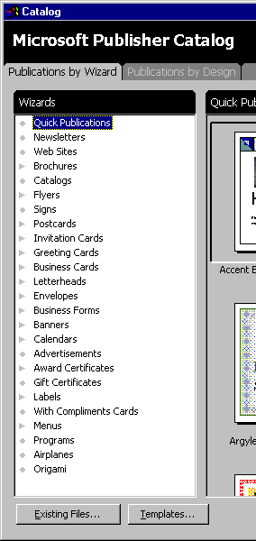

To load the Microsoft Publisher 2000 program, Double click on the Publisher 2000 icon on the main Windows screen, or click-on Start in the lower left corner of the screen, then click-on Programs, and then click on Microsoft Publisher

You should now be in the Microsoft Publisher 2000 initial main screen.

On the left side of the screen you will see the Microsoft Publisher Catalog (like the image on the right). The Wizards in Publisher are really great, so we’ll initially begin each publication with the appropriate Wizard.

Using the Microsoft Publisher Wizards

Click-on Newsletters in the Wizard list. On the right side of the screen you will now see Newsletter template design styles for a number of different newsletters (Accent Box, Arcs, etc.).
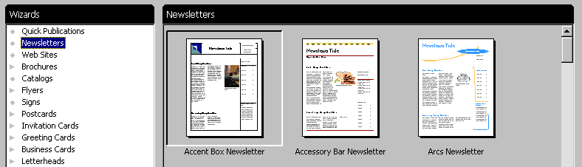

Elevator Bar
Use the “elevator bar” on the right side of the Newsletter area above to move up and down to see the various design templates.

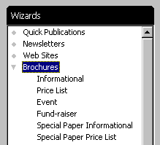
Next, click-on Brochures in the Wizards portion of the Microsoft Publisher Catalog. Notice, that when you do, a number of different types of brochures appear below the brochure selection (Informational, Price List, Event, etc). Use the elevator bar on the right of the Brochures area, which now appears, to view the various types of brochures. While you are doing this, notice the differences between the various types of brochures. As you move down the list you will notice that, as you come to a different group of brochures (like Event), that the brochure “type” on the left will become “highlighted in gray.”

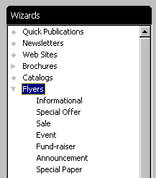

When you have viewed the brochures to your satisfaction, click-on Flyers in the Wizards portion as you did for Brochures and Newsletters. Notice again that there are several different types of flyers. Again, use the elevator bar on the right of Flyers to move down the various Flyer styles. Also notice that as you come to a new style that it will be highlighted in gray in the Wizards list under Flyers. Notice, as you view the various types of Flyers, that you can have those “little tear off things” with your phone number on the bottom. Neat.

Now, proceed down the Wizards list and click-on any of the publications in which you are interested – Postcards, Business Cards, Calendars, Award Certificates, Paper Airplanes – whatever you want to look at.

Creating a Flyer

As indicated, at the beginning of the tutorial, we think the Flyer is the easiest publication on which to begin. So, click-again on the Flyer category under Wizards (on the left of the screen). Your screen should look like the one below.

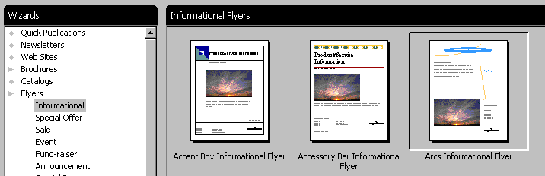
We’ll use the “Arcs” style for all of our publications. It is the one above on the right (arrow). Point to the Arcs Informational Flyer with your mouse and click-on it. It will appear, when you click-on it, that it is “indented” a little (like the one above). This indicates that you have selected this flyer.

Once you have selected the Arcs Informational Flyer, look at the lower right corner of the Microsoft Publisher Catalog. You will see a “button” that indicates “Start Wizard.” Point to this button with your mouse and click-on it.

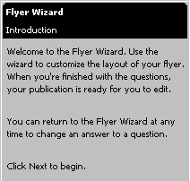
A new screen will now appear. On the left side you will see Flyer Wizard at the top (like the picture to the left).

On the right side of the screen you will see the Arcs Informational Flyer template that you will use to create your own flyer by using this Wizard.

Read the Introduction and notice at the end of the instructions it indicates to click-on the Next > to begin this Flyer Wizard.

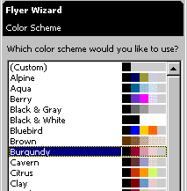

You will see the Next button below the Introduction (as seen to the right). Click-on Next >.

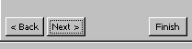

The Flyer Wizard Color Scheme will now appear (as shown on the last page). Use the elevator bar to move up and down the Color Schemes. As you move, click-on several of the color schemes. As you select the different Color Schemes, you will notice that the Flyer template on the right changes its Color Scheme to the one you selected in the Color Scheme on the left.

We’ll choose the Burgundy Color Scheme since these reflect our college colors.

Now click the Next>button, at the bottom of the Flyer Wizard again.

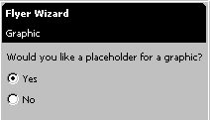
The Flyer Wizard Graphic screen appears (as on the left). Notice in the Flyer template on the right that there is a picture of a sunset. Now look at the Graphic Wizard on the left and notice that the “Yes circle” has a “dot” in it. Click-in the No circle. In a few seconds you will notice that the photograph disappears from the Flyer template on the right. So, you can see that you have the choice of having or not having, a photograph in your flyer. We’ll leave the photograph in our flyer, so click again in the Yes circle. The photograph will again appear.

Now click the Next>button, at the bottom of the Flyer Wizard again.

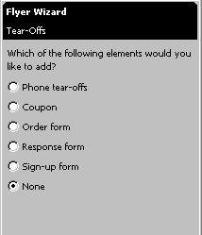
You now see Flyer Wizard Tear-Offs appear on the left. Notice that the default choice is None. As you did in the last Wizard, click-in each of the little circles to the left of the Tear-Off choices. As you click, look at the flyer template and notice how each Tear-Off selection appears in the flyer template on the right. For our first flyer we won’t use any Tear-Offs, so click in the little circle to the left of None. Later, when you have become proficient in Publisher, you can experiment with the various types of flyers.

Now click the Next> button, at the bottom of the Flyer Wizard again.

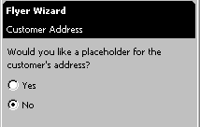
The Flyer Wizard Customer Address now appears on the left. Notice that you have a choice to insert a mailing address. Go ahead and click-in the little circle to the left of Yes. When you do, you will notice that as the flyer template on the right indicates that it has created a “back” page (page 2) to accommodate this address. This is in reality the opposite side of the paper on which you print the flyer.

When the Wizard creates the “back” page it let’s you know this with the information below. Click-on OK.
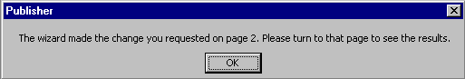

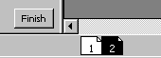
Notice now, at the bottom left of the screen that there are symbols that indicate that there are now a front and back to the flyer. Page 1 is the front, and Page 2 the back. It looks like the picture to the right. Click-on Page 2 and look at the page.

For now we’ll leave off any address. We’ll get into this later with the brochure and newsletter. So, click-back in the little circle to the left of No. The second, address page will disappear.

Now click the Next> button, at the bottom of the Flyer Wizard again.

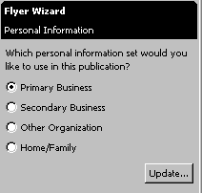
The Flyer Wizard Personal Information screen now appears (as shown at the left). When you first installed Office 2000 Professional, Premium or just the Publisher 2000, you should have been asked to enter your business, organization and personal addresses. If you did not do this, you can do it now. These addresses and this information will be used throughout all of the Microsoft Publisher 2000 publications. You don’t need to enter this information, as you will be able to edit any addresses, in any publication, as you create it. However, it sure is a lot easier to start with some basic addresses. So, go ahead and click-on the Update… button.

Saving your Flyer and other Microsoft Publications

Publisher 2000 may have already prompted you, to save your work. The first time that you save you will be asked where you want to save (on a floppy or hard disk) - just like in a word processor. If you have not been prompted to save - you will be. This is a really clever thing that Publisher does - kind of like the auto-save feature in word processors. Every now and then Publisher will encourage you to save. Always save when Publisher indicates to do so - unless your are fearless or know of some logical reason not to save. Once you have saved the first time, Publisher will update the publication file on which you are working. Again, this will occur as you are working on each publication.
The screen you see below will now appear.

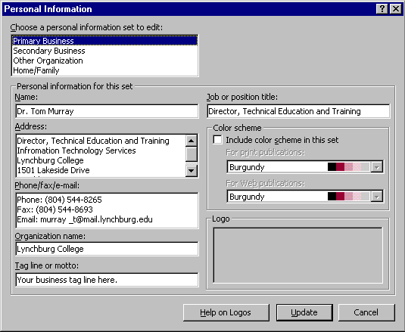

You can, logically, enter your information, as you desire, at any time. Notice that there are four choices for Personal Information (in the upper left corner): Primary and Secondary Business, Other Organization, and Home/Family. As you click-one each of these choices, new personal information can be entered in the area below.

You may update your information at this time, or wait until later. If you change any of the information, click-on the Update button at the bottom of the screen. If you simply desire to continue, at this time, click-on the Cancel button.

When you return to the Flyer Wizard Personal Information screen, you will notice that the Next> button is now “dimmed.” This indicates that there are no additional Wizards to use. So, click-on the Finish button.

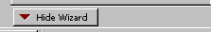
You will notice that the < Back, Next > and Finish buttons have disappeared. At the bottom of the Flyer Wizard you will notice a Hide Wizard Button (like the one on the right). To allow us more area in which to edit our Flyer, click-on the Hide Wizard button and the Flyer Wizard will disappear.

Notice that there is now a Show Wizard button - in case you desire to use the features of the Wizard later during the editing process. You may re-use the Flyer Wizard at any time. Now that the Flyer Wizard is gone, you will also notice that you do have more room to edit your Flyer.

Editing the Flyer

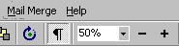
Take few minutes and look at the Flyer. At the current time you are able to view the entire flyer. At the top of the screen, under the Menu Bar, you will notice, under Help an area that indicates 50%. This tells you the size of the Flyer you are viewing. You'll find, as we continue through this tutorial in Microsoft Publisher, that it will really be helpful to view entire pages in the Flyer, Brochure and Newsletter. Other times, while we are editing a portion of each of these publications, it will be great if we can “zoom-in” on a specific object or area of the publication. If we can look at some text, an object or picture in a larger view, we will be able to edit the “thing” more easily.

Editing Titles

Notice the title area at the top. We’ll start our editing here. Point to the object and click-the left mouse button on the title object.

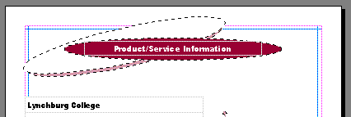

Click-on the Title Here

Note: whenever we indicate that you are to click-on an object in a publication, this means to click-the left mouse button.

Zoom-in and Zoom-out

You will notice that when you click-on the title, small squares appear on the four corners and four sides. We call these “grabbers.” We’ll work with these in a few moments. To make this task much easier, it would be really neat if we could ZOOM-IN on the title – so we’ll have a BIGGER object on which to work. If we can do this, our title will be much easier to work with. Now - a great key-touch. Whenever you want to zoom-in or out, simply tap the F9 Function key at the top of the keypad! Since we clicked-on the title, we will zoom-in on the title when we tap F9. Tap F9 now.

You will zoom-in on your title and your title should look like the image below.

Grabbers

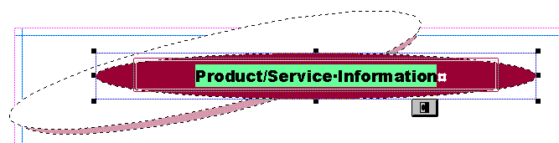
Notice that the zoom percentage now indicates 100%. It will be a lot easier to work with this large title.

Puzzle Pieces

First we’ll edit the title text. Point the cursor arrow just to the left of the P in Product in the title and click the left mouse button. You should see a vertical light-green flashing cursor. If you don’t see the cursor - try again. When you see the cursor, you will be in a “word processor edit mode.” Tap the Del (Delete) key until you have erased Product/Service Information. When you have done this, you will only see the light-green flashing cursor in the center of the title. Now type-in a title you would like for your flyer. We’ll use Lynchburg College – since that’s where we’re creating this tutorial.

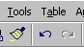
When you have done this, look at the title and see if you still have the “grabbers” on the sides and corners. If you do - fine. If you don’t, click-on the title again. Once you have the grabbers slowly move your mouse over the title area – do not click. You’ll notice that as your mouse moves over this area a number of different “assistants” appear and disappear. These assistants indicate when you can move and re-size the title. The little moving van indicates that if you click and hold down the left mouse button and then move the mouse (drag the mouse), you will see the “whole” title move. Try this. If you place the cursor over one of the grabbers, you will see a little box with arrows and the word resize. If you now click and hold down the left mouse button, and move (drag) the mouse a bit you will notice that the title gets a bit larger or smaller. If you “goof-up” it’s easy to get back to where you were. In the Button Bar below the Menu Bar there is a little, blue circular arrow. This is the undo button. If you click-on this button you will undo your last “click.” Try this, if you desire by clicking-on the circular, blue undo arrow. You’ll probably need this several times as we proceed through this tutorial. We sure did – many times.
Make sure that you can still see the grabbers. If you can’t – click-on the title. You may have noticed that just below the title there is a little box that looks like it has two linked puzzle pieces in it (see the arrow in the title image at the top of the last page). If you move the cursor arrow over these puzzle pieces and pause you will notice that a text help indicates “Ungroup Objects.” When you moved the title – everything moved – a group of objects. This is great if you desire to keep all of the objects together. If you want to move the individual objects that make up the group – then click-on the puzzle pieces. They will move apart – or ungroup. You can now click and move the individual objects as you want. Try this or don’t try this – your choice. When you're finished, if you desire to re-group the Text Block objects, all you have to do is click-on the puzzle pieces. They'll re-join into a single puzzle piece.

If you “goof” – don’t forget the undo arrow.

Changing Title and Title Text Colors

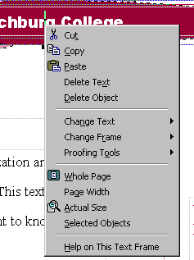
We’ll now do some RIGHT mouse button clicking. If you place the cursor arrow over any object in a Microsoft product and click the RIGHT mouse button, a “tailored” drop down menu appears with features “tailored” to the area/object on which you clicked. This is really neat. Many folks use this a lot – others are just discovering this feature. So, point the cursor arrow to the middle of you title text and click the RIGHT mouse button. A drop down menu (like the one to the right) appears. Notice, that at exact place where you clicked in the title, a corner of the menu box appears. This indicates exactly “where” you clicked. We’ll use this drop down menu to change the text color.

After you have right-clicked on the text, the menu box will remain on the screen until you either click somewhere else, or click-on one of the menu choices. Move your mouse cursor down the menu box until it is over Change Text (see above arrow). A group of choices for changing text appears like the picture below.
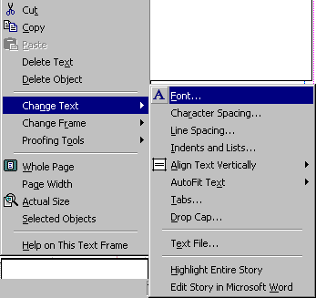

Now move the cursor from Change Text to the right over Font. Font will turn blue.

When this occurs, click-the left mouse button when it is over Font. The Font menu below will appear.

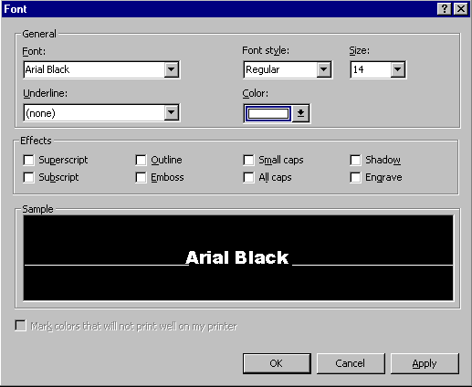

At the beginning of this tutorial we indicated that you should be competent in a word processing program. So, we will not spend a lot of time on editing and enhancing text in this tutorial. You can see from the Font menu above that the default font in this title is Ariel Black, font size 14. If you desire, you can change the font, font size, font color and add effects if you like. To do this simply click-on the small up-side-down triangles to the right of each effect and select the font changes you desire.

Don’t forget, just like when you are using the word processor, you have to highlight the text you desire to change. If you have not done this, simply return to the text box, highlight the text, click-right on the text, and return to the Font menu as you did a few moments ago.

Notice, if you change the color that the color scheme you selected is available to maintain uniformity throughout your Flyer. You may choose other colors if you desire.

Don't forget - if you make a mistake you can always click-on the blue undo arrow and try again.

Changing the Color of the Text Background Box
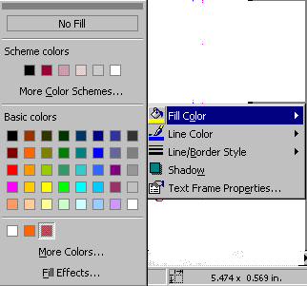
1.
You may also change the background colors in the text box if you desire. Again, point anywhere in the text box and click the right mouse button. The drop down menu box will again appear. This time however, select Change Frame and the menu box for frame changes will appear (like the one at the right). When you select Fill Color (See 1. at right.) the Fill Menu will appear.
You may select one of the Scheme Colors, change to a new color scheme (More Color Schemes), or one of the Basic Colors. More colors will activate the Microsoft Color Palette. Fill effects will give you a number of additional choices. Experiment with these if you desire.

Grouping and Ungrouping Groups of Objects

After you have made your text and background changes you may choose to ungroup the various objects that make up the title object group. We talked about this at the top of pages 8 and 9. One nice thing is, if you ungroup the objects, and move them, it makes editing, coloring and sizing the individual objects easier. After you have made any changes you desire, you can re-group the objects in any pattern you desire. Once you have done this you may again click on the two puzzle pieces. When you do, you will see the pieces re-join. This new group will now move as a single group.

Grouping Objects that are not Grouped

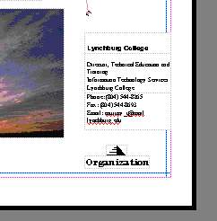

You should be “zoomed-in” on the title object at this point. If you are, tap the F9 function key to “zoom-out” so that you can again see the whole Flyer. If you can already see the Flyer, do not zoom-out. Now look at the lower right corner of the Flyer. You will see what appear to be several small text boxes. Click-on one of the boxes, and tap the F9 key to zoom-in on them.

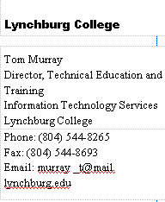
Your should now see something similar to the box on the right. The information you view was created by the data you entered in your personal or business information at the beginning of the tutorial. If you did not enter your changes to the default information, you will see the default information that was displayed in the Personal Information “box.” If you now desire to enter or change information in the Personal Information menu screen, click-on Show Wizard in the lower left corner of the screen, then click-on Personal Information and then on Update. This will change your information in this and future Publications. Neat! If you desire to change the information in this Flyer you may also do so in each text box. Notice that the information appears to be in three separate text boxes. Click-on each of these boxes. As you do, you will see sizing grabbers appear on each box. The top box has a title, the middle box has name and address information and the bottom box contains phone and e-mail information.

When you click on the top box, you will see a title. This title normally “fits” in the box and is OK. Some folks enter long titles and you may see a little box with an A and three periods along the bottom edge of the text box. This did not occur in our top box.

However, when we clicked–on our middle box, the little box with an A and three periods appears. This little box indicates a “text overflow,” which simply means that the box is too small for our address text. To fix this, we’ll have to enlarge our middle box. If you decide to make the middle box larger, you’ll have to be careful. If you enlarge it into either the top or bottom boxes, you may “cover the text” in these boxes. So, it’s normally best to “drag” the top box up a bit, by clicking on it, letting the “moving van” appear, then holding down the left mouse button, and dragging it up a bit. You can then drag it down when you are finished. Notice in our box that we don’t have the last part of our address. So, we’ll enlarge the box and complete the address.
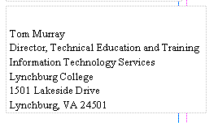
We noticed above that our address “wrapped” some of the “lines” of the Address (Training in the third line). So, after completing the address, we “widened” the text box so that the lines would not wrap.

When we did this we noticed that our text box “crossed over” the thin blue and pink lines that go around the border on all four sides of the Flyer page. These pink and blue lines represent the default borders that Microsoft Publisher places on each of its publications as a guide. Since we are a bit outside these lines, we’ll might get an error message when we print this Flyer indicating that we are outside the borders. This is no big deal, as the Flyer will print fine.

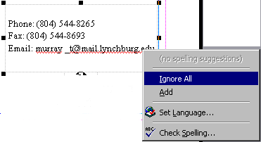
Now the bottom text box. If you are not in the “whole Flyer” view, tap F9 to zoom-out. Then, click-left on the bottom text box in the lower right corner to “mark it.” Then tap F9 to zoom-in again. If you are already in the lower right corner with the middle text box, simply click-on the bottom box. In the bottom text box you will notice that the e-mail address also wraps, and there is a “wavy” red line under the e-mail address (arrow 1.). The wavy red line indicates that the spell checker does not contain this “word” in the dictionary – logically. So, to “get rid of” the wavy red line, since our e-mail address is OK, we will right click-on the e-mail address. A drop down menu like the one on the left appears (arrow 2.). We then run our cursor over Ignore All and click the left mouse button. You will see that the wavy red line disappears. This still does not take care of the word wrap in our e-mail address. So, using the grabber’s on the sides, we'll widen the bottom text box until we can see our e-mail address on one line.
1.
2.

Now click-on each box and drag it until the three boxes are aligned the way you want them.

Grouping Ungrouped Text Boxes

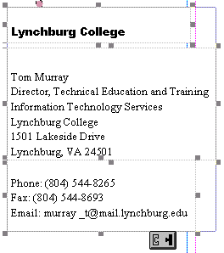
If you are satisfied that everything is OK, then you’re ready to move on. However, if you would like create a single group for these three boxes, so that when you click-on any of the boxes the whole group will move, you can do so by the following method. Make sure you are zoomed-out and can see all three boxes. If you can’t, use the elevator bars on the right and bottom of the screen until all three boxes are visible. Again make sure that the boxes are aligned exactly like you want them. Then click-on the first box. You will see the grabbers. Now – this is important – HOLD DOWN one of the Ctrl keys (next to the space bar on the keyboard). With the Ctrl key held down, move the cursor over the middle box and click the left mouse button. You should now see both the top and middle boxes with grabbers around them. You should also see the little box with the two puzzle pieces at the bottom right corner of the middle box. The puzzle pieces should be apart indicating that the top and middle boxes are not grouped. Don’t do anything yet – we’ll come back to the puzzle pieces after we have added the bottom box. Hold down the Ctrl key again and click-on the bottom box. Now all three boxes should have grabbers around the sides.
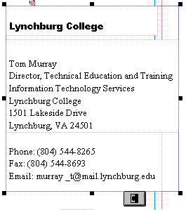
If they do not, repeat the above instructions above until the do. You should now see the puzzle pieces at the bottom of the bottom text box. Click left on the puzzle pieces. They should now join into a single piece as indicated by the arrow below. You will now see grabbers around the “entire” three text boxes. This indicates that when you move the single box, all three smaller text boxes will move together. Pretty neat. Microsoft Publisher was thinking ahead of you when it saw you “Ctrl click” each text box. It assumed you wanted to join them.

Changing and Editing Images and Photographs

You should now be in the zoomed-in view where you can only view the above group. Tap the F9 key to zoom-out so that you can view the entire Flyer. When you can see the entire Flyer you will see a photograph in the lower left portion of the Flyer. Click- on the photograph, then tap the F9 key to zoom-in again. Your image should look like the one below.
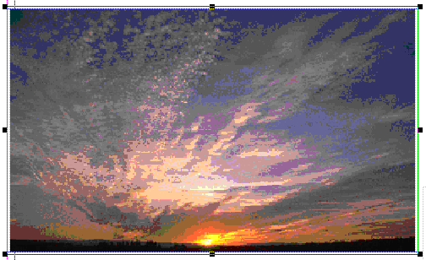

Let’s assume we desire to change the image to something more appropriate with our Flyer topic. So, point somewhere in the image and click the RIGHT mouse button.

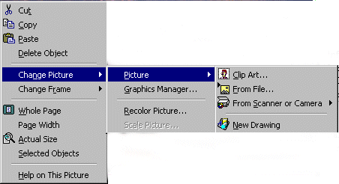

The left most drop down menu box above will appear. Move the cursor down to Change Picture. When the middle drop down menu box appears move the cursor over Picture. The right most drop down menu box will then appear. As you can see, the right menu box offers several choices. We’ll only deal with the top selection in this tutorial: Clip Art. When you become more advanced you can import your images directly from a scanner or digital camera or a file on your computer. Or, you can sketch them in another program.

First we’ll replace the picture with one that comes with the Microsoft Clip Art 2000 Gallery that is a part of Microsoft Publisher 2000. So, with the menu display above, move the cursor over Clip Art and click the left mouse button.

Note: when you first install the Microsoft Publisher 2000 or Office 2000 Professional or Premium programs, the installation program will ask if you desire to place all of the clip art in the Clip Art Gallery on your hard disk drive. If you answer yes, then a huge portion of your hard disk drive (700 MB) will be used for the clip art. Depending on how much hard disk space you have available, you may or may not desire to do this. In a way it’s no big deal as you can always place the CD in your CD drive and select the clip art you desire. Publisher 2000 will indicate when to do this. We’ll show you this as we continue.

Don't forget - if you make a mistake you can always click-on the blue undo arrow and try again.

When you click the left mouse button on Clip Art the following Insert Clip Art screen should appear.
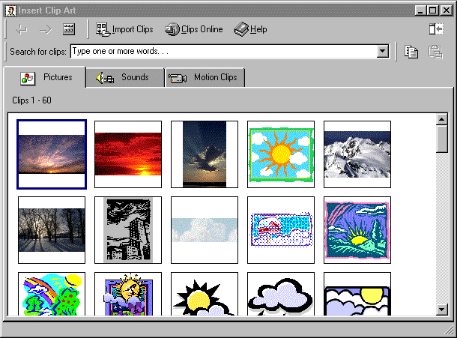
Notice in the upper left hand corner that the first image you see is the default photograph of the sunset picture in your Flyer. Publisher Clip Art assumes that you desire, since you indicated that you wanted to change the picture, that you would like to stay with a “sort of sky type of theme.” Notice how the other images are either photographs or drawings of “sky” things. Use the elevator bar on the right to move down and view these.

Just for the heck of it let’s say that our flyer has to do with the really great hamburger sandwiches that we sell at our charity art show – which this flyer announces. So, logically, we’d rather like to have something other than a sky photograph. Notice that there is an arrow in the Search for clips: area pointing to Type one or more words…

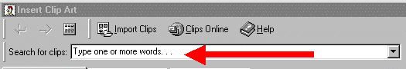

Click-in the Search for clips: area on Type one or more words… and you will see all of the words turn blue. When you see this, type in the word: hamburger and then tap the Enter key. You’ll now see a lot of clip art that shows images associated with hamburgers in some manner.
Insert Clip

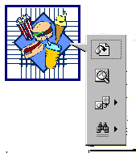
To replace our sunset image with one of the hamburger images you must first select an image and then click the left mouse button on it. When we first clicked on the image to the right a small button drop down menu appeared. The top button, (when you move your cursor over it) indicates: Insert Clip. So we clicked-on the top button.

We clicked on the image you see to the right, clicked the top button and got the error message below. (Remember how we indicated that if you did not install all of the clip art images on your hard drive that you would get an error message for clip art that was not installed on your hard drive? We’ll, this is the error message you get.)
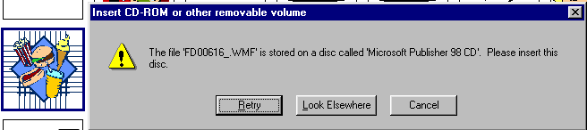

Notice how the error message twice indicates that you must insert your Publisher CD ROM. We’ll pretend that we don’t have the CD and click-on Cancel. Now we’ll select another image.

This time we’ll click-on a hamburger sandwich. It’s there! So, we click-on the hamburger and then on the Insert Clip button. The hamburger we selected now appears in place of the sunset photograph. If your Insert Clip Art screen does not close when you insert your image, click-on the small "X" in the upper right corner of the Insert Clip Art menu screen. Our Flyer now looks like the one on the right.

Another “Golly Gee” feature in Microsoft PowerPoint 2000 – Clips Online!

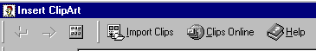
If the clip art images you saw are not enough clips for you – there are still more! You can go online from the Insert ClipArt Menu Screen and get even more clip art. Not only is everything in the ClipArt Gallery available – but even more! Above you will see the top of the button bar that appears when you access the Insert ClipArt Gallery. Notice, there is a button, which indicates: Clips Online (arrow). If you are online – click on the Clips Online button.
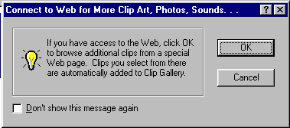
The information screen to the left will now appear. This screen just reminds you that you need to be on the Internet. When you click-on OK the browser you are using will go to the Microsoft Clips Online web page.

It will take a few moments, but the screen below will load.
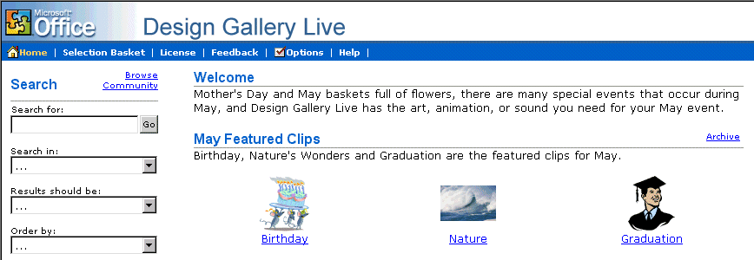
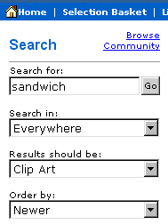

You’ll notice the arrow above points to Search. We filled in the Search for: and Search in: boxes as indicated in the image on the right. When we clicked on Go we received thirteen pages – 13 ! - of sandwich images – everything from hamburgers to subs! The neat thing is, if you use one of these images it is automatically added to your Insert ClipArt Gallery!

The top of the Design Gallery web page should look something like the one below. You can view each page by clicking on the >> at the top right of the page.

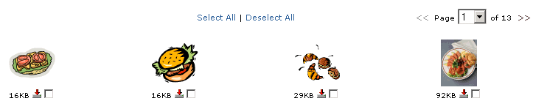


We chose a “hamburger” for our selection. When we clicked-in the little box our screen looked like the image at the right. When we clicked-in the box the check mark appeared and it indicated Download 1 Clip at the top of the screen.

If you select (click) several images, you will see the Download Clip increase as you click-on each box.
When you have selected all of the clips that you desire,
click-on the Download Clips link.

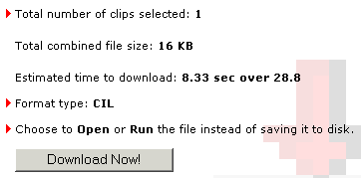
Your monitor screen should now be similar to the one on the left. It indicates how many clips you selected, how much disk space they require, and how long it will take to download them over a modem.

Click-on Download Now!

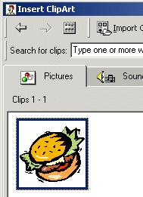

When the download is complete, a screen similar to the one on the right will appear.

Notice that the image you chose now appears in the Insert Clip Art Menu screen. But, if you want that image in the future, where is it “really” located in the Insert Clip Art Menu screen?
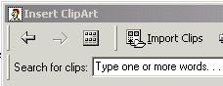
To locate your Downloaded images, click-on the All Categories button at the top of the Insert Clip Art Menu screen.

The Insert Clip Art Menu screen below will appear. Notice that there is a Downloaded Clips Button. Click-on this Downloaded Clips button and you will see all of the images you have downloaded.
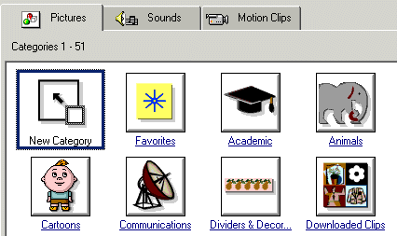

Note: Regular images will be on the Pictures Tab, Sounds will be on the Sounds Tab, and Animated Clips will be on the Motion Clips Tab.

Anytime, in the future, that you desire to use these clips, they will be in the Downloaded Clips area of your Insert Clip Art area. You would load them as we did on Page 17.
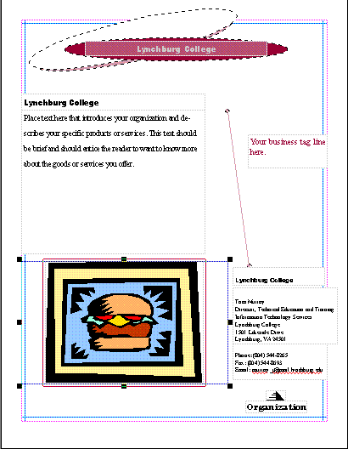

Save your work!

So, we’ve worked with the Title and Title Box at the top of the Flyer. Also, the three Personal Information Text Boxes in the lower right area, and the image. Now let’s replace and edit the text in the Text Box at the upper left of the Flyer.

Editing and Replacing Text in Text Boxes.

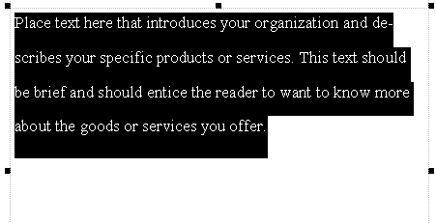
If, once again, you can see the entire Flyer, click-on the Text Box indicated above and tap the F9 key to zoom-in. Or, if you are already in the magnified view, move to the text box and click-on it. You should now see a text box like the one on the right.

Notice how the text in the box indicates the type of text that you should place in the text box area. Each Microsoft Publisher 2000 publication will have instructional text where appropriate.

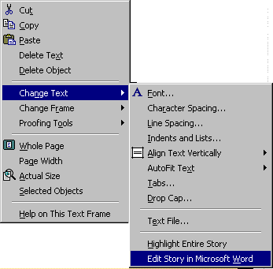
Now we’ll add some text about our wonderful hamburgers that we sell at the charity art show. To do this we’ll use a special Microsoft Publisher feature: Edit the text in Microsoft Word. First, point to the text box and right click-on the text. A drop down menu box like the one on the left appears. Move the cursor down to Change Text. When the right drop down menu appears, move the cursor down to Edit Story in Microsoft Word and click the left mouse button. Microsoft Word will now load and the text shown on the screen will be the text above.

Delete the above text in Microsoft Word and type-in the following:

Come to the Fifth Annual College Art Festival. In addition to great buys on wonderful works of art by the students, you can also purchase some of our fantastic and world-renowned hamburgers. Each burger is grilled to your specifications over our special charcoal chips.

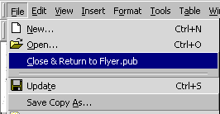
This text is being typed-in a special Microsoft Word screen. If you click on File in the Menu Bar at the top left area of Microsoft Word you will see a the drop down menu like the one to the right. When it appears you will see a unique selection: Close & Return to Flyer. pub. Click-on Close & Return to Flyer. Pub.

Microsoft Word will appear to close, and you will return to your Publisher Flyer text area. Notice that the text you edited in Microsoft Word now appears in the selected text box. If you decide to make more changes in this text, simply repeat the above instructions. Click anywhere in your text and click-right, and then follow the above instructions. You will again return to your text in Microsoft Word where you can make any additions and edit, as you desire.

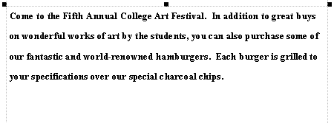
Your text box in the Flyer will look similar to the one on the left. You can change fonts, resize and color the text, just like you did previously. You can also resize the text box as well.

Don't forget - if you make a mistake you can always click-on the blue undo arrow and try again.

Logo Text and Logo Picture

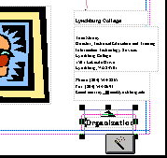

If you can see the whole Flyer you are where you should be at this point. If you can't, we'll zoom-out, as we have done before by tapping the F9 key. Now that you can view the entire Flyer, look in the lower right corner of the Flyer, just below the Personal Information Text Boxes - that we worked on before - there is a small box with the word Organization below a pyramid. Click-on this box. Then zoom-in again by tapping the F9 key.

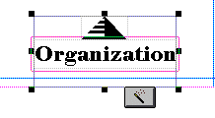
When you have zoomed-in, your image should look like the one to the left. This image looks similar to a "Grouped" set of boxes, but there are no "puzzle pieces." Instead, there appears to be a magic wand! I you move your cursor over the magic wand and pause you will see a Text Help box that indicates: Wizard: Click to start.

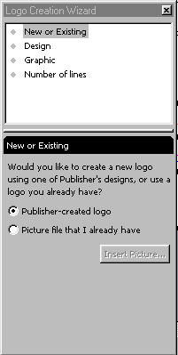

Go ahead and click-on the magic wand. You will now see a special menu screen for the Wizard that looks similar to the other Wizard menu screens that we used at the beginning of the Flyer creation. Notice that the top of the Wizard indicates Logo Creation Wizard. Below that you see: New or Existing, Design, Graphic, and Number of lines. At the bottom of the Wizard you see two choices: Publisher-created logo and Picture file that I already have. We can use these features to create our own logo that we can use on all our publications. Notice that the default for this Wizard is the New or Existing choice. We'll go to the next one: Design. Click-on Design. The following Logo Creation Wizard menu will appear.

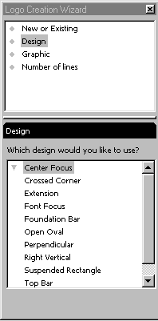
When this Logo Creation Wizard appears (like on the right) you'll see that Design is highlighted and that Design has replaced the New or Existing title in the lower half of the Wizard.

Beneath Design you see: Which design would you like to use? There are a number of design choices below. Go ahead and click-on each choice. As you click you will see the design of the original logo change. Select one that you like.

We'll choose Suspended Rectangle so our logo will look like the one below.

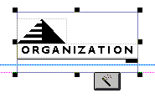

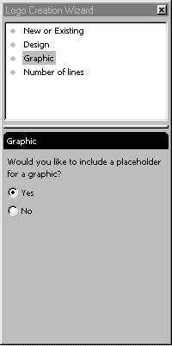
Now click-on the third choice: Graphic. The Logo Creation Wizard will now look like the one to the left. Notice the bottom portion of the Wizard asks if you desire to have a graphic in your logo.

Just to see how this works, click-in the little circle to the left of No. You'll see the logo change and remove the pyramid. We'll definitely want a logo in our publications, so click the small circle to the left of Yes and you'll see the pyramid re-appear.

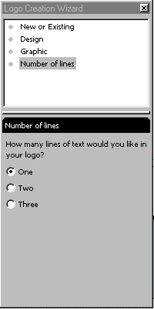
Now we'll click-on the fourth choice: Number of lines. Your Logo Creation Wizard should now look like the one to the right. Notice at the bottom of the Wizard that it asks if you want one, two or three lines in your logo. You decide how many you would like to have. For our logo we'll choose three and click-in the little circle to the left of Three.

Our logo now looks like the one below.

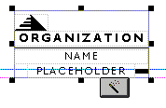

Now we'll replace the pyramid and text in the logo with something that indicates that this is our personal logo. This will be a bit tedious, as you might have to click where we indicate a number of times to select the pyramid and text if you keep the logo its current size. You can zoom-in even more if this will assist you in clicking-on the appropriate areas. As we indicated earlier in the tutorial, at the top of Publisher's Menu and Button Bars there is an area that indicates the "size" of your zoom-in or out. To make this task easier, click-on the little down triangle to the right of the current size and enlarge the image to 150% or 200%. Your logo will be much easier to work with once you've done this - if you care to do this. We zoomed-in on our logo 200% - you can compare the larger logo on the next page to the one above.
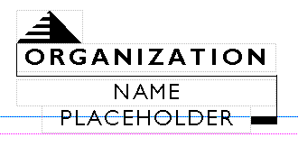
This 200% logo will be much easier to work with.
First we'll replace the pyramid with an appropriate piece of Clip Art. Carefully move your cursor over the pyramid and click the left mouse button to "identify" the pyramid. If you have done this correctly, a light pink line will go around the pyramid like the one below (to the left of the arrow below).

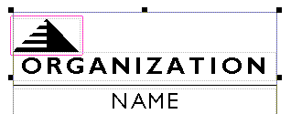
Once you have "identified" the pyramid, keep your cursor on the pyramid and click the right mouse button. The same drop down menus will appear that appeared when you were changing the sunset photo into a clip art (like the one below).

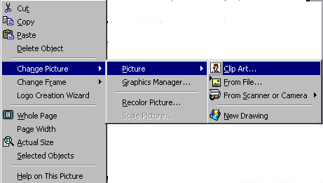
When the first menu appears, run the cursor down to Change Picture, then over to Picture, and finally over Clip Art. When the cursor is over Clip Art, click the left mouse button. The Insert Clip Art menu screen will appear with the pyramid as the default selection.

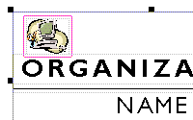
You can now choose any clip art you desire. Use the same techniques that you did on Page 16 and 17 above. We, for our tutorial Flyer, desire some sort of computer image. So we'll search until we find one. You search for the image you want in your logo and insert it in place of the pyramid. We'll insert our computer image. On the right you can see that we found a computer. Your image in the design you chose should look something like this.

Now we'll work with the text.
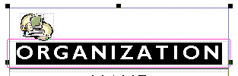
First we'll click-on the word ORGANIZATION in the title area. Yours should look something like the image at the right. This will work just like the Title and Personal Information Text Boxes we edited earlier. Delete ORGANIZATION in the box and enter the title you desire. We're going to use Information in this box and Technology Services in the text boxes below. Go ahead and make your changes to this box now. Change the Font, Size and color if you desire.

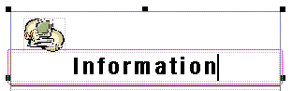
Our logo text box now looks like the one at the left. Now we'll edit the remainder of the logo text box.

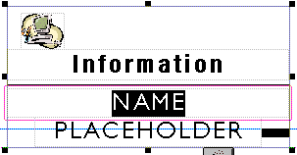

First we will highlight the top word NAME and then change it to Technology. Then we'll click-on the bottom box PLACEHOLDER, and change it to Services. Go ahead, on your own and enter your text in the logo text boxes.

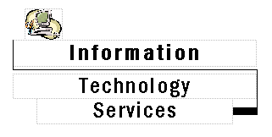

Our final logo box looks like the one at the left.

When you complete this task you might receive a message that asks if you want to add this new logo as your Personal Information logo. If this appears, answer Yes.
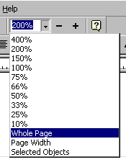
There is one more text box to go. Since we zoomed-in to 200%, the best way to now zoom-out is to go back to the Menu and Button Bars at the top of the Publisher screen and again click-on the small down triangle. When the drop down menu appears (like at the left), run the cursor down to Whole Page and click the left mouse button. This will "re-set" Publisher to the default zoom-out that we have been using.

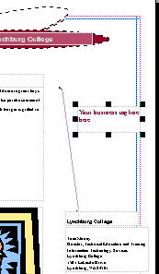
The final text box is located on the right side of the Flyer, about a third of the way down the page. The arrow on the right indicates this text area which has already been clicked-on. Go ahead and click-on this text box and then zoom-in by tapping F9. Your text box should look like the one below. Place whatever text you like in the box. Since we're on a hamburger "thing," we'll again tell everyone about our great "burgers." So, we'll type in: Best Burgers in the Burg (Since our college is located in Lynchburg, Virginia, the students call Lynchburg: "The Burg.")

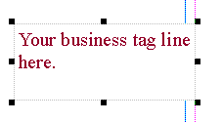



Our final text box looks like the one on the right.

Zoom-out one more time and look at your whole Flyer.

Printing Your Flyer

Printing your Flyer, or any publication, is very similar to printing in any word processor. In the Microsoft Office modules you can either click-on a small printer in upper left button bar or click-on File in the Menu Bar and then on Print in the drop down menu. One small, logical note. Many computer users seem to forget that you can only print color from a color printer. Frequently, users assume that if the computer has color on the screen the printer will print color.

Final Flyer Observations

All of the skills you learned in creating your Flyer can be used in the Brochure and Newsletter. All three publications have Title and Text Boxes, Personal Information Text Boxes, Images, Logos, text to edit or replace with other text. You may group or ungroup objects, change color schemes, and fonts. So, when these common tasks are also used in the Brochure or Newsletter we will not cover them again. We will only cover additional new skills in creating these new publications.

Don't forget to Save!
If you still have your Flyer open, please close it. Click-on File in the Menu Bar and then on Close. In most other Microsoft software the current document on which you are working can also be closed by clicking-on the small lower "X" in the upper right corner of the screen. In Publisher you do not have this "X," so if you click-on the single "X," It will completely exit from Publisher. If this happens it's no big deal. Simply start Publisher again and you will be ready to go.

Creating a Brochure

If you closed the Flyer, as indicated above, you will be in a Publisher screen that indicates Quick Publication Wizard on the left and has a single page in the working area on the right. To get back to the screen with all the publication choices, click-on File in the Menu Bar and then click-on new. You should now be back in the Microsoft Publisher Catalog screen. If you did not use File and New in the Menu Bar, and clicked-on the New Page button, the screen simply appeared to "blink." If you re-loaded Publisher, you're back in the Microsoft Publisher Catalog screen.

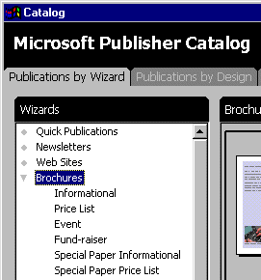

Look at the left side of the screen, under Microsoft Publisher Catalog, as you did when we chose Flyer, and run the cursor down to Brochure and click-on it.

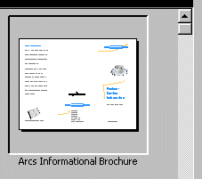

Now look in the upper row of Brochures on the right. We'll select the Arcs Informational Brochure just like we used the Arcs Informational Flyer.

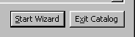
Once you have selected the Arcs Informational Brochure, it will appear "indented" like the view above. Now, just like you did with your Flyer, move to the bottom right of the screen and click-on Start Wizard.

Notice on the right side of the screen that a Brochure appears when this screen appears. Notice the pink and blue lines that indicate the "folds" for this Brochure. When this Brochure is completed, it will be folded twice so that it will be about the size of an envelope. Also, notice at the bottom of the brochure screen that there are two pages - one for each side of the sheet of paper that will make up the two sides of the Brochure. We'll return to edit each side when we have completed the Brochure Wizard.

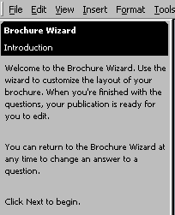
The Brochure Wizard will (and the Newsletter to follow) will work the same way that the Flyer Wizard worked. The initial Introduction view tells you something about this Wizard. Please read it and then click-on the Next > button to continue with this Wizard. Just like you did in the Flyer

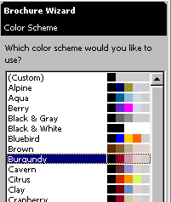

Once again the Color Scheme Wizard menu will appear. Again, you choose any color you desire. We'll again use the Burgundy Color Scheme. This will then change all of the default colors in the Brochure the same way that it did in the Flyer.

Once you have selected the color you desire - click-on the Next > button at the bottom again.

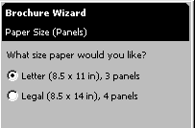
The next Brochure Wizard is different from any that you have seen before. This Wizard asks what size paper you desire to use for your Brochure: regular letter size or wide legal size. We'll leave our size at Letter.

Now click the Next > button again.

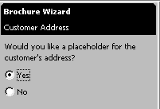
The Brochure Wizard now asks, as it did in the Flyer, if we would like a place to indicate our customer's addresses. We will answer Yes this time (click-in the little circle to the left of Yes). When you select Yes, watch the middle section of the Brochure on the right side of the screen. You will see the Title Box, Logo Box and Personal Information Boxes disappear and be replaced by a Return Address Box and Customer's Address Box. If you missed this, click-in the little circle to the left of No. Watch the right side. Click again to select Yes, and watch the right side. We'll talk more about these addresses when we edit the Brochure.

Click the Next > button at the bottom again.
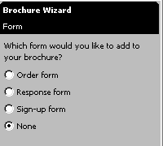
Notice in the Brochure Wizard Form that the current choice is None. Also notice that there are three other choices above None: Order form, Response form, and Sign-up form. Click-in the little circle to the left of each of these and watch the Brochure screen to the right. When you select Order form a blue bar will appear and indicate that changes are being made to the Brochure. When the process is complete, a Publisher information bar will appear like the one below indicating that you need to go to page 2 to see the Order form changes. So, click-on OK and the box will disappear, but you won't be "taken" to page 2.
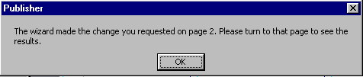

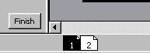
To do this you'll need to click-on the page 2 indicator below the Brochure. It looks like the image to the right. Click-on page 2 now.

Notice on the right side of the Brochure that an Order Form now appears. Now click in the Response form choice. The Order form on the right side of the Brochure becomes a Response form. Next click the Sign-up form choice and notice, once again, the right side of the Brochure. Finally, click on None, where we started. We’ll use None for the tutorial, but once you have mastered this tutorial you will have the skills to work with any of these forms and tailor them to your needs.

Don't forget - if you make a mistake you can always click-on the blue undo arrow and try again.
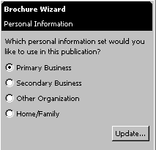
Click Next > one more time. Notice that the Wizard asks us to choose some form of Personal Information - exactly like the Flyer did. We’ll leave the choice as Primary Business. As with the Flyer, if you now desire to change this, click-on Update. Notice that we’re at the place where the only button left to choose is Finish. So, click-on the Finish button.

Once you’ve clicked-on the Finish button, notice that the Hide Wizard button is displayed. Go ahead and click-on the Hide Wizard just like you did for the Flyer. The Wizard will be available anytime we are editing the Brochure, if we click the Show Wizard button.

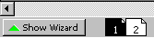
Now we can see more of the Brochure so it will be easier to edit. If you are not on page 1, click-on the page 1 button now.

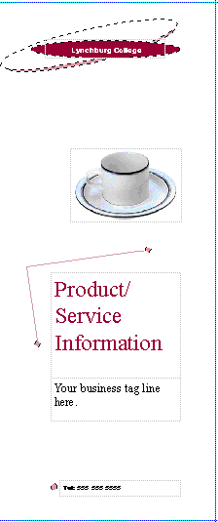
Title Box - Grouped

Notice that we have already mastered how to change everything in the right portion of the Brochure.
Clip Art

Text Box

Text Box

Text Box

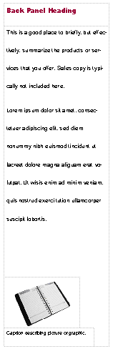
Now look at the left side Brochure panel. Again you have already mastered how to edit this panel. At the top is a Text Title box. In the middle is a double spaced text box. It is similar to the text box we edited in the Flyer where we used Microsoft Word. You can right click-on this text and choose to Change Text from the menu and then Edit Story in Microsoft Word. The bottom image is again Clip Art.

If you click-on the text below the image you will see that it is a caption for the picture. A caption is simply a text box “attached” to a picture. If you click-on the book below and then tap F9 to zoom-in on the book. You will see the puzzle pieces that indicate grouping and the text indicates that it is a caption. If you click and drag the image, you will see – logically – that the caption “moves” with the book – because they are grouped.

Edit the Title Box, the text or change the Clip Art and Caption. Do what every your feel like doing.

We’ll come back to the center section of page 1 after we look at the three panels on page 2. So, click-on page 2 at the bottom of the screen.

Notice, in the image of page 2, below that the left and center panels are essentially like the one above. They simply contain Heading Boxes, Text Boxes and Captioned Clip Art. The right panel has a Text Box and Captioned Clip Art. In the lower portion of the right panel you see a Personal Information Box – just like we mastered in the Flyer. So, you already know how to edit all of these “things.”
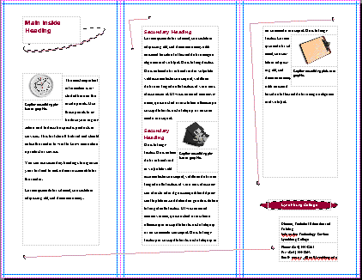

Don't forget - if you make a mistake you can always click-on the blue undo arrow and try again.

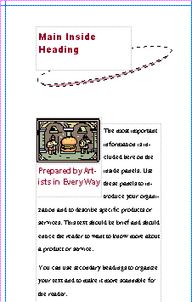
One more "neat thing" before we leave the Brochure. We've clicked one more time on page 2 of the brochure. Zoom-out in your Brochure and click-on the page 2 at the bottom. In the left panel of your brochure you originally had a clock with a text caption below the clock. We made some changes to our brochure to reflect our Art Center Hamburger Sale. At the left there is a picture a hamburger being guarded by two knights (we changed the clip-art like we've done before. Below the clip art we have also changed the caption as well.

New Neat Thing

If we click-on the picture and caption we immediately notice that they are a grouped object. So, when we click and drag them they stay together - nothing new - no big deal. However, when we drag the image and caption, no matter where we drag them, the text automatically wraps around them - this is the New Neat Thing

If you've forgotten how to drag the images - Simply click the left mouse button on the image, hold down the left mouse button, and move the mouse around a bit - this is called dragging.

Now, on your own drag your image around the left panel and notice the wrapping. Now! Drag your image to the middle panel and the same thing happens! Publisher has already wrapped every image in all publications like this - we think this is super - it sure saves a lot of time learning how to "wrap frames" like Publisher has done. Also notice that as you drag the image and caption from page to page, that if the image "pushes the text" that the text "flows" from panel to panel. We'll get into this a lot more in the Newsletter.

We thought you'd like to try this image dragging in a small brochure where you can "really" see the effects.

Merging Addresses from a Microsoft Publisher, Word or Access Database

The next few pages (to the end of the Brochure portion of the tutorial) we'll discuss utilizing a computer database to insert addresses into any publication - in this case the Brochure. Many folk's just "hand" address their Brochures or use mailing labels. You can do much more than this with a database.

If you desire to see how this is done with a database - read on. If not, you ca to skip to page 34 now.
Now back to the center panel of page 1 – the address panel. Click-on page 1 now.

We first clicked-on the center panel of page 1 and then zoomed-in. Then, we “rotated” (in this tutorial) the center panel to make it easier for you to “see” the panel and the addresses.

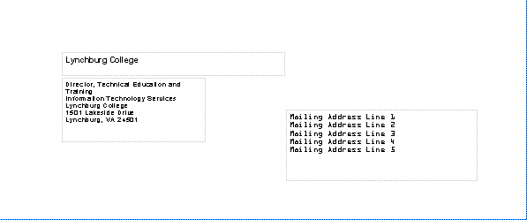

Address Area for Mail Merging

Notice that the “return” address comes from the Personal Information we entered. We can change this at any time. As soon as we click the Update button the publication, in which we are using any of our personal information, is automatically updated.

Now look at the Mailing Address Lines 1, 2, 3, etc. above. This is where you could paste a mailing label. Or, better yet, create a database in Microsoft Word, Publisher, or Access. Or, if you are very patient and have lots of time, you could individually type-in or write in each address, print page1, type-in another address, print page 1, and on, and on, and on.

We use Microsoft Access database for our brochures. There is a tutorial similar to this one that will assist you in becoming knowledgeable in Access. Just e-mail us and we’ll send you a copy or tell you how you can download it from our web site.

Now a quick illustration of what we are talking about. In the Menu Bar at the top of all publications, where a mailing address database might be used, is the word Mail Merge.
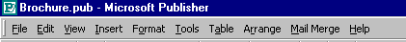

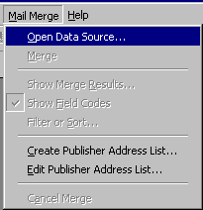

When we click-on Mail Merge in the Menu Bar, the following drop down menu appears. We created a database in the Microsoft Access tutorial. So, we’ll open this database by clicking-on Open Data Source… When we do, the menu on the next page appears.
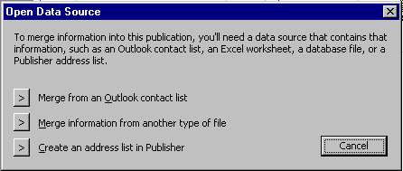

Notice in both the menus above that one of the choices is to Create an address list in Publisher. You can try this on your own. When you click-on this choice, a very easy to understand menu screen appears. You simply fill in the “blanks” as indicated and then use this list.

If you are using Microsoft Outlook as a part of your Personal Information Manager, and have entered addresses in the Address Book, you can also obtain your addresses from this source.

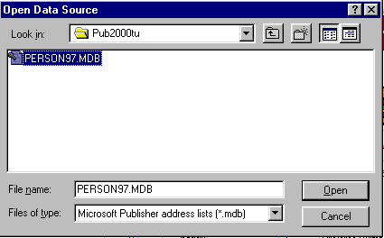
As indicated previously, we’ll use the Access database we created in the Access tutorial. So, we clicked-on Merge Information from another type of file. When we did, Microsoft Publisher went to look for database files on the hard disk of the computer and found the database on the right. Once you Open the database a list of fields appears. You then select each field that you desire to have in your address, and click to insert them into the Address Area for Mail Merging as shown below. The address area will now look something like the one below, after you have inserted the appropriate fields from the database.

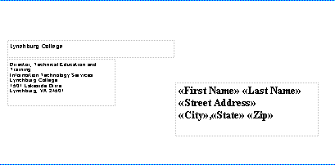

Notice how the "Field Names" from the Access database have replaced the default address lines.

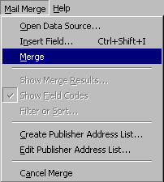
If we now click-on Mail Merge in the Menu Bar again, we see that Merge has become "active."

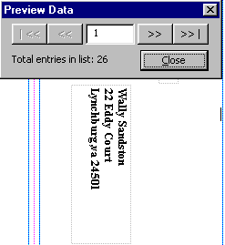
If we click-on Merge, the computer seems to pause, but it's really merging and addressing a brochure to each person in our database. When the merge is complete we see the following screen.

In this case there are 26 people in the database and we are looking at the first database record. We have purposely moved the Preview Data screen above the customer address box in our Publisher Brochure. If we click on the next button ( >> ), we would see the next person. If this was the last thing we needed to do before mailing our Brochures, and clicked-on Print, Publisher would now print 26 page 1's, one to each different customer.

Don't forget - if you make a mistake you can always click-on the blue undo arrow and try again.

Well that's about all for the Brochure. Now we'll move on to the Newsletter.

Zoom-out one more time and look at your whole Flyer.

Printing Your Brochure

Printing your Brochure, or any publication, is very similar to printing in any word processor. In the Microsoft Office modules you can either click-on a small printer in upper left button bar or click-on File in the Menu Bar and then on Print in the drop down menu. One small, logical note. Many computer users seem to forget that you can only print color from a color printer. Frequently, users assume that if the computer has color on the screen the printer will print color.

Don't forget to Save your Brochure.
Final Brochure Observations

All of the skills you learned in creating your Flyer and Brochure can be used in the Newsletter. All three publications have Title and Text Boxes, Personal Information Text Boxes, Images, Logos, text to edit or replace with other text. You may group or ungroup objects, change color schemes, and fonts. In the brochure we also covered addressing the brochures and objects with captions. So, when these common tasks are also used in the Newsletter we will not cover them again. We will only cover additional new skills in creating this last publication.

If you still have your Brochure open, please close it. Click-on File in the Menu Bar and then on Close. In most other Microsoft software the current document on which you are working can also be closed by clicking-on the small lower "X" in the upper right corner of the screen. In Publisher you do not have this "X," so if you click-on the single "X," It will completely exit from Publisher. If this occurs, it's no big deal. Simply start Publisher again and you will be ready to go.

Newsletters

If you closed the Brochure, as indicated above, you will be in a Publisher screen that indicates Quick Publication Wizard on the left and has a single page in the working area on the right. To get back to the screen with all the publication choices, click-on File in the Menu Bar and then click-on new. You should now be back in the Microsoft Publisher Catalog screen. If you did not use File and New in the Menu Bar, and clicked-on the New Page button, the screen simply appeared to "blink." If you re-loaded Publisher, your also back in the Microsoft Publisher Catalog screen.

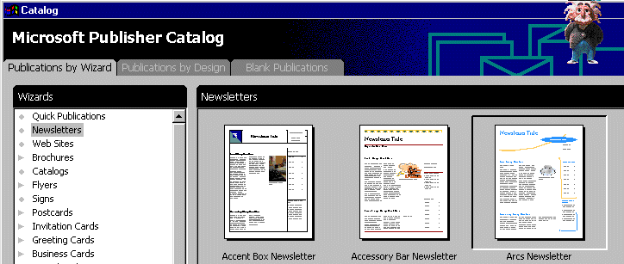

When the Microsoft Publisher Catalog appears, we'll click on Newsletters as indicated above. Then, as before, we’ll select the Arcs Newsletter on right side of the top row. Your screen should look like the one above. Now click-on the Start Wizard in the lower right corner of the screen like you have done for the Flyer and Brochure.
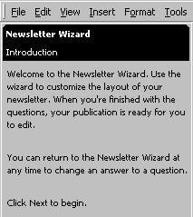
Again the initial Wizard screen furnishes screen furnishes information about the Newsletter. Read the text in the introduction, then click the Next > button at the bottom of the Newsletter Wizard. As before, you will now see the Newsletter Wizard Color Scheme menu. You choose the Color Scheme that you desire. We’ll select Burgundy again. After choosing your color scheme, click the Next > button at the bottom of the Wizard.

The next Newsletter Wizard asks you to choose the number of columns you desire in your newsletter.

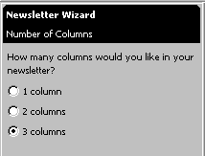
Notice that there are three choices. The current selection is three columns. You will notice that the Newsletter to the right of the Wizard, logically shows three columns. Now click-on the 1 column choice and watch the Newsletter at the right change to one column. Now try 2 columns. We’ll use three columns, so click-on 3 columns. By now you should see how neatly Publisher makes each change so that you can instantly see the results. Now click the Next > button at the bottom of the Wizard again.

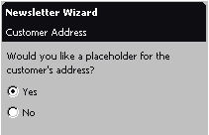

Since Newsletter can be mailed, we’ll click Yes in the Customer Address. You’ll notice that, again, the below Publisher information screen appears. It indicates that the Customer address will be on page 4. Click-on OK.

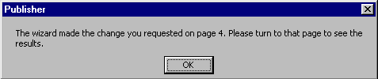

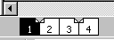
The Brochure we created had two sides. Notice, at the bottom of the Newsletter screen’ that there are four pages in this default Newsletter. You can easily add more pages as you desire. Click-on page 2, then 3, and then 4. Pause on each page and get a “feel” for its layout. Notice on the last page that the Customer Address area is the bottom half of the back page. Click on the Next > button again.
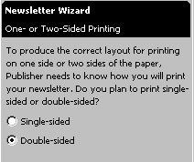
As you clicked through the pages of the Newsletter, you noticed that when you clicked-on page 2, that both pages 2 and 3 appeared together. You may print your Newsletters yourself, or at your college or business printing plant. Most will probably send their Newsletters out to a commercial printer. We have found that the commercial printers desire/require that you print each page separately. We’ll leave the layout of the tutorial Newsletter in the Double-sided default (indicated on the left) in order to illustrate something later.

The last Newsletter Wizard is again the Personal Information Wizard. As before, you can change your Personal Information or leave it as it is.

Click-on the Finish button and then on the Hide Wizard button as you did before. You will now be in a more “open” view for editing.

If you are not on page 1, click-on page 1 now.

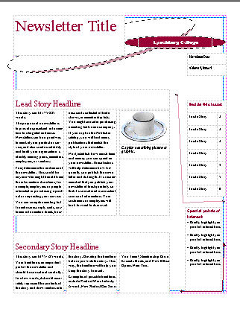
Notice that you have already mastered a number of the items on the front page of the Newsletter. In the top left is a simple
Text Box. You can change the Newsletter Title to your title. On the right at the top is another Grouped Text box like you mastered in the Flyer and Brochure. The coffee cup and caption are also familiar from the Brochure. The Lead Story Headline and Secondary Story Headline titles are simple text boxes. We will focus on the three column text boxes and two new boxes on the right edge of the first page of the Newsletter. The arrows to the left indicate these boxes. First we’ll look at the upper right box. Click-on the box and tap F9 to zoom-in on it.

Copying Titles from Headlines into Inside this issue:

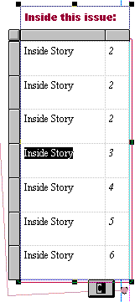
This is a Table of Contents for the Newsletter. We’ll go to page 2 in a minute and learn how to insert the title from a story that is on page 2. To go to page 2 click-on the page 2 “button” at the bottom of the screen.
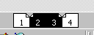

You will now be on pages 2 and 3. If you are not zoomed-out, tap the F9 key to do so now. Look at the upper left corner of page 2. Notice the title: Inside Story Headline. Click-on this title and then tap F9 to zoom-in.
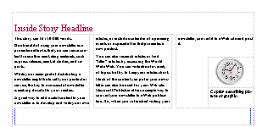

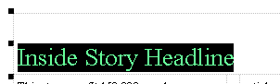

Replace this Inside Story Headline – a text box – with a headline of your choice. We’ll stick with our hamburger theme and our headline will be: Arts Make Best Burgers in the Burg.

Our Headline at the top of page 2 now looks like the one at the left. We’ll now “copy” this title to the Inside this issue table of contents on page 1. To do this, first highlight your title at the top of page 2. You can do this by highlighting your title at the top of page 2. Click to the left of the title, hold down the left mouse button, and move the cursor over your title. It should be highlighted like our title below. If you are unable to do this on your first attempt, try again until your highlight looks like the one below.
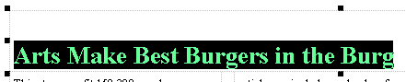
We’ll now copy this title to the Inside this issue Table of Contents on the first page.

Now that the text is highlighted we have two choices to copy this text.
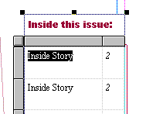
Method One: Click-on Edit in the Menu Bar and then, in the drop down menu, click-on Copy. Then click-on the page 1 button at the bottom. Move around the screen until you can see the Inside this issue: box. When you have located the box, highlight Inside Story in the top box. Then click-on Edit in the Menu Bar again, in the drop down menu that appears, click-on Paste. Some of your headline from page 2 will now show in this area (like the image below. .
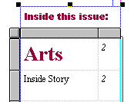
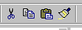
Method 2: Make sure that your headline is highlighted on page 2. Then you can click-on a Copy button in the button bar at the top left of the screen (instead of Edit-Copy in the Menu Bar). When you return to page 1, and highlight Inside Story as we did above, you can now click-on the Paste button, in the button bar, to paste the title into the text box.
Copy Paste
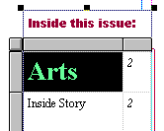
Now highlight your headline in the Inside this issue: box. It should look like the one to the right when you have done it correctly. It is obvious that the text font size is way to big for the box. So, we’ll have to make the text font smaller. At the top of the screen, on the left, in the button bar, is a font size area.

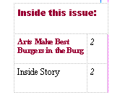
Click the small down triangle on the right side of the font size box and change the font size to 8 (as shown). Your headline title from page 2 should now fit nicely in this box (like the box at the right).

Text Overflow and Editing Your Newsletter Stories

A very important "thing" to keep in mind when you are working with Newsletters.

In any publisher product, when the text becomes "too big" to fit in the box where it is being entered, a small overflow indicator will appear as we've indicated earlier. The A… tells us that there are just too many words to fit in the text box were using. This is called Text Overflow.
When we are working with Newsletter stories you will find that the articles that you are typing will go "down" a newspaper type column, and when they get to the bottom of a column, they'll go to the top of the next column and go down, and so on. If you run out of room in any Newsletter article you will see the little A… at the bottom of the last column that is included in the story.

Since we are using Microsoft Publisher Wizard, the Arcs Newsletter has various "pre-sized" groups of columns for your stories. You might have noticed this when you were looking at each page of the Newsletter earlier. Now we'll concentrate on Text Overflow.

To show you how this is accomplished it might be best to be able to "see" this happen. So, if you are not zoomed-out, do so by tapping the F9 key. Once you can see the whole Newsletter, click-on the 2 or 3 page "button" at the bottom of the screen. When we used the Newsletter Wizard to create this Newsletter we "set the pages" so that you could see both pages 2 and 3 at the same time - we mentioned this during the Wizard. Well this is why we did it. The top of pages 2 and 3 should look something like those below (your Inside Story Headline may be different from the one we used).
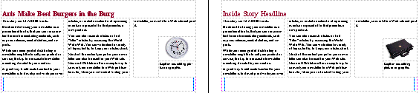

The first thing we'll do to show you Text Overflow is to create an area to "hold" the Text Overflow, when it occurs. To begin this process, click-in the story area at the top of page 3. It should be completely highlighted in black and look like the image below.

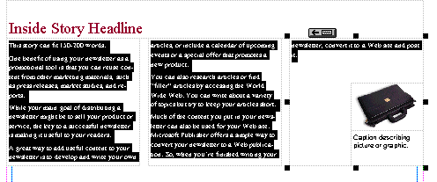

Before we delete this text, to create an area for Text Overflow, notice the little box in the upper right hand corner of the Inside Story Headline article above (arrow). This little box indicates that the text in the third column in the article "flowed" from the bottom of the second column in this story.
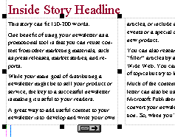
Now carefully click-on the bottom of the first column of the Inside Story Headline. You may have to try several times to get the image you see to the left. This indicates that this story, which begins in the left column, flows from the bottom of the column into column two (the middle column). Later, when you get used to seeing these little buttons at the top or bottom of story columns you'll be able to click-on them and, when you click, you will be "taken" to the next column where you can continue to enter text.

After you have successfully completed the above steps, click-again so that all of the text is highlighted in the story at the top of page 3 (picture at the bottom of page 39).

When all the text in the story is again highlighted, tap the Delete key to remove all of the text in this story. Your page 3 top story should now look like the image below.

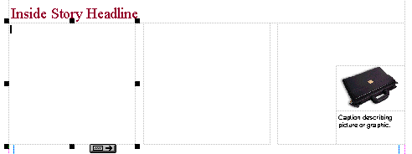

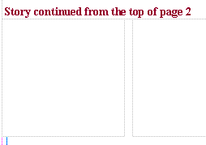
If you desire to delete the Inside Story Headline above, and/or replace it with other text, or leave it blank, you may do so. We're going to replace the text at the top of our page 3 with: Story continued from the top of page 2. Well make the font a little smaller since this is no longer a story headline. Our Text at the top of the first column on page 3 now reads and looks like the image to the left.

The top areas of pages 2 and 3 should now look like the image below.
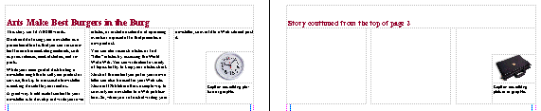

Now click anywhere in the story at the top of page 2. The entire story should be highlighted in black and look like the image below.
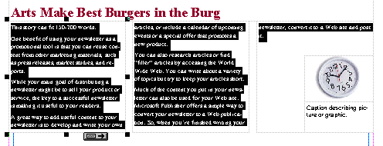

This is the story that we desire to edit until it becomes "too BIG" to fit in the three columns at the top of page 2. To begin the editing we'll do the same thing we did in the Flyer - edit our story in Microsoft Word. Right-click anywhere in the black highlighted area at the top of page 2. When the drop down menu appears move down to Change Text, and when the Change Text drop down menu appears, move down to the bottom choice: Edit Story in Microsoft Word. Microsoft Word will now load, just like it did for the Flyer. Read the text in this story in Microsoft Word. Publisher again uses this text to explain about how this Text Box area is used. It indicates that the story contained in the box is about 150-200 words long. So, later, when you are using this Publisher Newsletter template to create your own "real" Newsletter, you can type a story in Word, or any word processor, that is about 150 to 200 words long, and copy the story from your word processor into this space at the top of page 2.

Move to the end of the story, in Microsoft Word and type-in the following:

We are learning about how Text Overflow works. We can see that the text at the top of page 2 does not fill the three columns that make up this story. So, we are adding this text to create a Word Overflow condition. We'll keep typing until this occurs. Since the tutorial said to type all of this, the tutorial author must know how much text it takes to create a Text Overflow condition. We'll now click-on File in the Menu Bar above and then on and the click-on Close & Return to Newsletter.pub. (Note: the name the authors used for their Newsletter was Newsletter.pub - my menu will indicate the name of my Newsletter.)

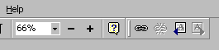
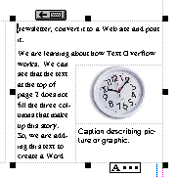
After you have chosen Close & Return to Newsletter.pub, you will see that your three text columns at the top of page 2 are "full." If you click-on the third column, and it may take a few tries to do this, you will eventually see the over flow condition which looks like the image to the left. At the bottom of the column you now see a Text Overflow indicator: A…. When you can see the indicator a small "chain link" will appear at the top of the screen in the right side of the button bar. This chain link only appears when there is a Text Overflow condition.


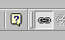
Now, click the left mouse button on the chain link. When you do the chain link will appear "depressed" (as seen in the picture to the left). Now move the mouse cursor over the text at the top of page 2. As you move it over the text you will notice the cursor "changes" to a little measuring cup that seems to be "full of alphabet characters" (you'll almost need a magnifying glass to see this). This "full cup" indicates that it contains the all Text Overflow from the text columns at the top of page 2. Anywhere you move on page 2 the cup will remain upright. Now, carefully move the cup over the empty text area you created at the top of page 3. As soon as you move the cursor over this empty area, you will see the cup "tip" a bit and will see the letters appear to be "pouring" from the cup (like the cup image on the right). This means that you can pour the Text Overflow into the area at the top of page 3. To do this, when you see the "spilling" cup in the page 3 blank area, click the left mouse button.
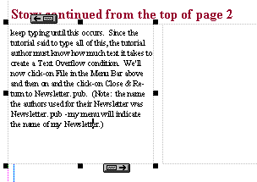

As soon as you click the button you will see the first column at the top of page three “fill” with the Text Overflow. Your text area at the top of page 3 will look similar to the one at the right.

Now we’ll look at the Newsletter, page by page, to determine if there are any other Publisher features that we have not covered in the Flyer, Brochure, and Newsletter. You are probably looking at the page 2 and 3 screen, since we just finished learning about Text Overflow. So, we’ll logically start on page 1, so click-on the page 1 button at the bottom of the screen.
To view page 1 better, tap the F9 key to zoom-out, if you cannot view the whole page.

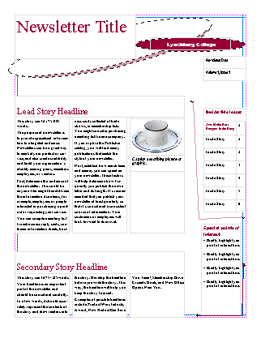

When we look at the first page of the Newsletter at the left there are only two things that we have not mentioned. However, you have already, mastered the skills to change them. The first is in the upper right corner, the second in the lower right corner (see arrows).

You already know how to change the Newsletter Title in the upper left corner, the Title Box in the upper right corner, the “cup” Clip Art and caption, and the two stories on the front page of the Newsletter. When we look at the other two “things,” you will see that you already know how to edit them as well.

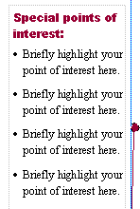
Special Points of Interest Text Box

Let’s look at the lower right text area first. Click-on this Text Box in the lower right corner first, and then tap F9 to zoom in on the box. When you get a closer look at this Special points of interest: Text Box you see that it is simply a standard text box, with bullets, which highlights topics in the Newsletter. So, as with any text box, all you have to do is change the text to focus on special articles in your Newsletter. No big deal! You can do this easily now.

Newsletter Date, Volume and Issue

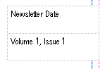
Now move up to the text box above the Special points of interest: text box. Again, no big deal. Another Text Box. This text box allows you to date your Newsletter, and enter the Volume and Issue numbers. An easy task for you at this stage.

Now let’s look at the second and third pages.
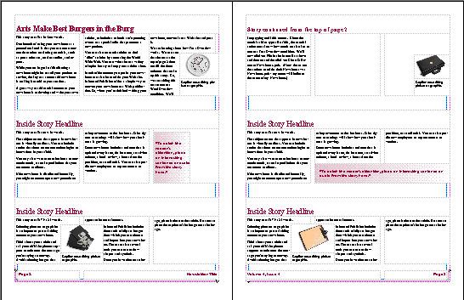

Again, no big deal for you, at this stage. Everything on these two pages are either articles, captioned clip art or text boxes. The only, slightly new “things” are the “color shaded” text boxes above (see arrows). Let’s take a moment to look at one of these.

Shaded Text Boxes

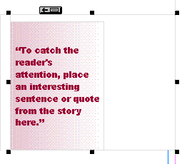

Editing the text in this Text Box is an easy task at this point. Notice, when you look at the text in Publisher that the font is colored in the color scheme you chose. More importantly now, notice that the Text Box itself has a “shading” in your color scheme across the text box.

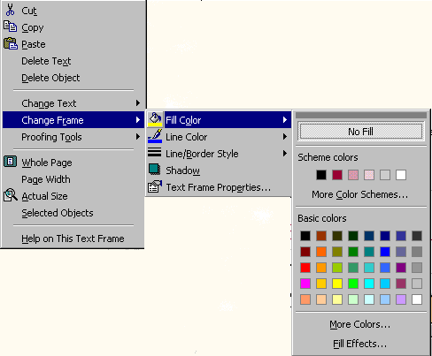
Click-right on the shaded text box. When you do, move the cursor down to Change Frame, when the next drop down menu appears, move the cursor across to Fill Color, and when the last drop down menu appears move the cursor down to Fill Effects… (see arrow) at the bottom of the drop down menu and click the left mouse button on Fill Effects…

The following menu will appear.

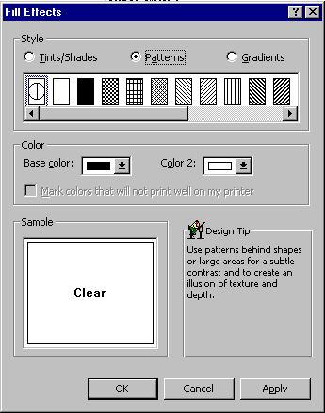

When you see this menu, click on the small circle next to Gradients (see arrow above).

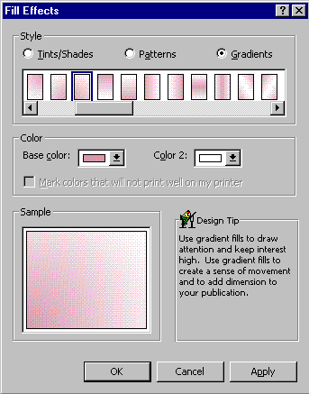

When you click on Gradients, the following menu screen appears. Normally you will need to click-on two areas: one or both colors and the elevator bar below the various gradient shades.

Go ahead and experiment. Each time you select a different gradient shade the Sample in the lower left corner will show you how your shading will appear. Also, when you select a different Base color: and Color 2: you will see the effects in the Sample area.

Go ahead and try a few Gradients. When you find one you like, click-on OK.

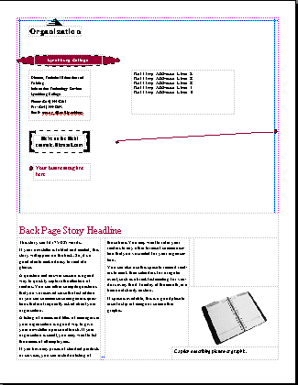

Now, zoom-out again by tapping the F9 key. Then click-on page 4 at the bottom of the screen. Notice that the top portion of page 4 contains a Title Grouped Box, a Logo Box, your home address box, and a Customer’s Address Box – all tasks that you have accomplished in the Flyer and Brochure.

The lower portion of page 4 is simply another “story” and captioned clip art box. Again something that you have mastered in this tutorial.

Congratulations. You have now successfully completed three publications

Some Final Notes:

Web Help

When you are working in Microsoft Publisher 2000, if you desire “instant” assistance on a feature in Publisher, there is a web connection in the program if you are “on-line.” If you click-on Help in the Menu bar and then click-on Microsoft Publisher Web Site, you will be linked to a main assistance screen for the Microsoft program in which your working. Often we find that someone else has already asked the same question – so a good first place to check is Frequently Asked Questions.

Publisher Design Gallery

You have utilized the features of each Wizard to design a Flyer, Brochure, and Newsletter. Many of the objects that were a part of the default publications can be easily accessed again, at any time you are editing a publication by clicking-on Insert in the Menu Bar and then on Design Gallery Object. A Microsoft Publisher Design Gallery screen will appear. And, just like the original Microsoft Publisher Catalog, it will have a number of selections in a Category column on the left that, when you click-on a choice (e.g. logos, coupons, etc.), samples of each Category will appear on the right side of the screen. You will see an Insert Object button in the lower right corner of the screen. To insert any of these objects in your publication you simply click the "place" where you desire to insert the object, open the Publisher Design Gallery, click-on the object you wish to insert, and then click-on the Insert Object button at the bottom. When you return to your publication, if you didn't place the object exactly where you wanted it - no big deal. With Publisher you can drag the object precisely where you want it. Neat!

Some Final Thoughts…

So, what’s left to learn – we’ll nothing except mastery of the various publications - by working with each of them?

When we decided to author a tutorial for Microsoft Publisher 2000 we had groups of faculty and staff at our college review, in groups with the author, all of the publications in the Catalog. After about 30 folks had worked with Publisher, for an average of 3 hours per group, they easily agreed that the skills they learned in mastering the Flyer, Brochure, and Newsletter allowed them to work easily with the other publications in the Catalog. They also agreed that these three publications were the ones they would use most frequently and would appreciate a publication-by-publication tutorial. So, the framework for this tutorial was created. During the Spring 2000 semester, over 100 additional students, staff and faculty worked in Publisher 2000 in small and medium sized groups. They also agreed to the content for this tutorial for the Flyer, Brochure and Newsletter.

You are the first “audience” to use this tutorial. I’m sure we have missed something or need to clarify some feature more completely. So, if you see something you don’t like, or that is unclear, or missing, just let us know at the e-mail address below.

What now?

If you desire to further your knowledge of Microsoft Publisher 2000, you might want to purchase a good advanced reference manual. The one we like best is Microsoft Press’s Running Microsoft Publisher 2000.

Commercial Printing of Publications

If you desire to send your publications to a commercial printer, Microsoft has a web site specifically established for this purpose. If you enter the Internet address below, you will be taken to the Microsoft Publisher 2000 Commercial Printing web site.

http://officeupdate.microsoft.com/publisher/prepress

We are currently working on an addendum to this tutorial that furnishes the “file layout – and required files” that our commercial printer’s desire. If you would like a copy please send an e-mail to the address below.

If you have any questions or comments please contact:

murray.t@lynchburg.edu

Thank you for your time and patience.

