Creating a Brochure, Flyer and Newsletter
Using Microsoft Publisher 2002 for
Windows 98/Me/2000/XP

Created: 21 May 2000

Starting Publisher 2002

Note: You should be competent in a word processing program before you attempt this Tutorial.

Microsoft Publisher 2002 is a really neat program that allows you to create professional quality newsletters, brochures, flyers, postcards, calendars, award certificates, calling cards, paper airplanes, origami – and a whole lot more great “things.”

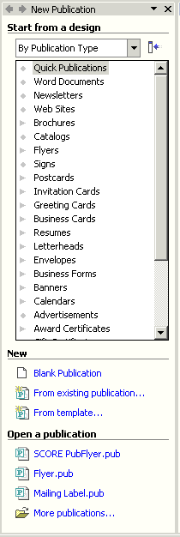
This tutorial will proceed from what we think is the easiest publication to the most complex. First we’ll create a flyer using Microsoft Publisher 2002. Then, we’ll create a brochure, and finally a newsletter. Each skill we learn in the flyer will be of use in the brochure. The flyer and brochure techniques will also be used in the newsletter. Your abilities will grow from publication to publication. You may save your publications on a formatted 3 ½ inch diskette. Or, you can save all of them on them on your hard drive.

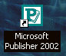
To load the Microsoft Publisher 2002 program, Double click on the Publisher 2002 icon on the main Windows screen, or click-on Start in the lower left corner of the screen, then click-on Programs, and then click on Microsoft Publisher

You should now be in the Microsoft Publisher 2002 main screen.

On the left side of the screen you will see the New Publication Task Pane (like the image on the right). We’ll use the Start from a design area to initially begin each publication.

For “old” Publisher users, the Task Pane is something new in Office XP/2002. It is used in all of their Office modules. It replaces the Microsoft Publisher Catalog that was a part of the initial Publisher 2000 screen. Once you get used to the Task Pane, and its flexibility, we think you’ll like it.

Using the Microsoft Publisher Start from a design list

Click-on Newsletters in the Start from a design list. On the right side of the screen you will now see Newsletter template design styles for a number of different newsletters (Accent Box, Arcs, etc.).

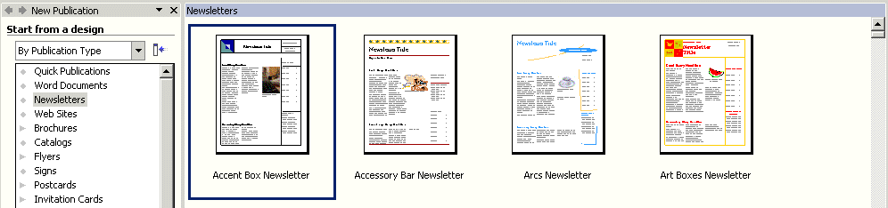
Elevator Bar
Use the “elevator bar” on the right side of the Newsletter area above to move up and down to see the various Newsletter design templates.

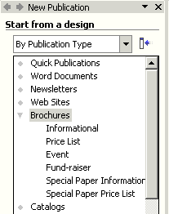

Next, click-on Brochures in the Start from a design portion of the Microsoft Publisher. Notice, that when you click, a number of different types of brochures appear below the brochure selection (Informational, Price List, Event, etc). Use the elevator bar on the right of the Brochures area, which now appears, to view the various types of brochures. While you are doing this, notice the differences between the various types of brochures. As you move down the list you will notice that, as you come to a different group of brochures (like Event), that the brochure “type” on the left will become “highlighted in gray.”

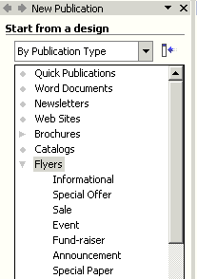

When you have viewed the brochures, to your satisfaction, click-on Flyers in the Start from a design portion as you did for Brochures and Newsletters. Notice again that there are several different types of flyers. Again, use the elevator bar on the right of Flyers to move down the various Flyer styles. Also notice that as you come to a new style that it will be highlighted in gray in the Start from a design list under Flyers. Notice, as you view the various types of Flyers, that you can have those “little tear off things” with your phone number on the bottom. Neat.

Now, proceed down the Start from a design list and click-on any of the publications in which you are interested – Postcards, Business Cards, Calendars, Award Certificates, Paper Airplanes – whatever you want to look at.

Creating a Flyer

As indicated, at the beginning of the tutorial, we think the Flyer is the easiest publication on which to begin. So, click on the Flyer category under Start from a design (on the left of the screen). Your screen should look like the one below.
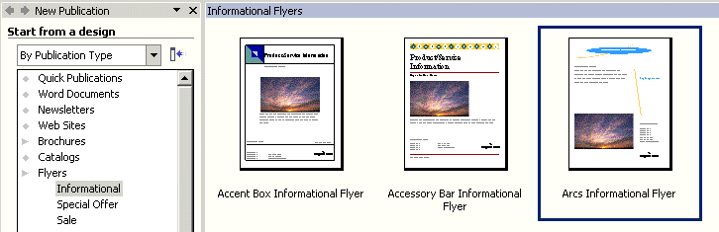

We’ll use the “Arcs Informational” style for all of our publications. It is the one above on the right (arrow). Point to the Arcs Informational Flyer with your mouse and click-on it. It will appear, when you click-on it, that it is “highlighted by a blue border around the selection (like the one above)”. This indicates that you have selected this flyer.

If this is the first time that you have used Publisher 2002, a Microsoft Publisher information screen will appear – like the one below. Click-on OK.

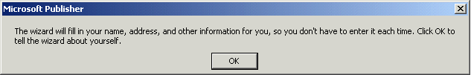

When you click OK, the below Personal Information screen will appear.

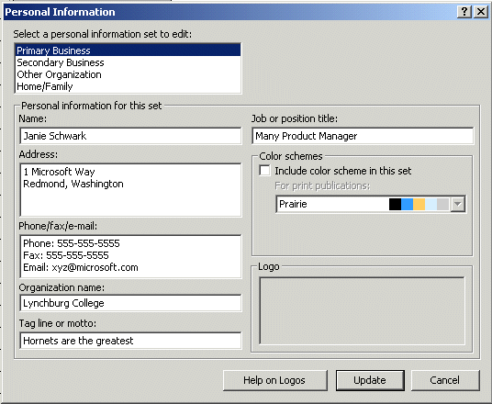

You can, logically, enter your information, as you desire, at any time. Notice that there are four choices for Personal Information (in the upper left corner): Primary and Secondary Business, Other Organization, and Home/Family. As you click-one each of these choices, new personal information can be entered in the area below.

You may update your information at this time, or wait until later. If you change any of the information, click-on the Update button at the bottom of the screen. If you simply desire to continue, at this time, click-on the Cancel button.

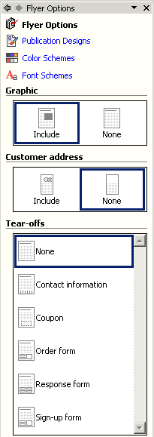

When the Personal Information menu screen closes, notice the Flyer Options Task Pane on the left of the screen has changed to reflect “choices” - on how to enhance your Flyer. We’ll start “at the top – and – work down the Task Pane.

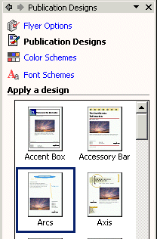
Click-on Publication Designs in the Flyer Options Task Pane. The Publication Designs Task Pane will open and replace the Flyer Options Task Pane.

Notice that Arcs is highlighted (by a blue border) – since that is the Flyer Design we selected.

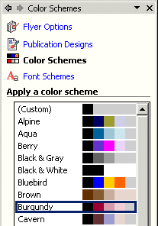

Next click-on the Color Schemes selection. The Color Schemes Task Pane at the right will appear.

Use the elevator bar to move up and down the Apply a color scheme area. As you move, click-on several of the color schemes. As you select the different Color Schemes, you will notice that the Flyer template on the right changes its Color Scheme to the one you selected in the Color Scheme on the left.

We’ll choose the Burgundy Color Scheme since these reflect our college colors.

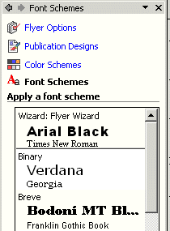

Next, click-on Font Schemes. The Font Schemes Task Pane at the left will appear. The default (original) settings for the this Flyer’s fonts are Arial and Times New Roman.

Use the elevator bar on the right of the Apply a font scheme area to select a font that you like.

We’ll stay with the default – Arial and Times New Roman.

Now return to the Flyer Options Task Pane

For you “old” Publisher users you can already see what we are talking about with the new Task Panes replacing the Wizards. The Flyer Options, Publication Designs, Color Schemes and Font Schemes replace these “old Wizards.”

Now look below the options that we just covered and notice that there are some graphic images that allow us more “choices” to enhance our Flyer. These also replace the Wizards.

Notice the first area under Graphic. This graphic area asks if we desire to keep the image that is currently a part of our default Flyer (the sunset image on the right of our screen). Go ahead and click-on None. You’ll see the graphic disappear on the Flyer. We’ll want a graphic for this tutorial, so click-on the Include area again.

Notice, under the Graphic area in the Flyer Options Task Pane, that a Customer Address area is available. Notice that you have a choice to include a Customer mailing address.

Click-on the Include button.

Several “things” will occur when you click-on Include.
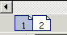
Notice, at the bottom left of the screen that there are symbols that indicate that there are now a front and back to the flyer. Page 1 is the front, and Page 2 the back. It looks like the picture to the right. Click-on Page 2 and look at the Page.

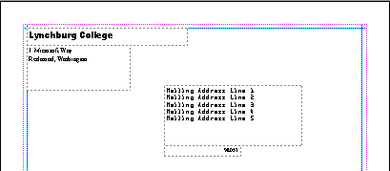
Notice that the information you entered in Primary Business, in the Personal Information menu screen (Page 4), now appears in the upper left corner of the “back” Page of the Flyer.

Notice also, that there is now a place for the address of the person who will receive the Flyer. We’ll “get into mail merges when we create our Brochure. It is a very simple thing to create a Microsoft Access database and merge the addresses into you Flyer – or any Publisher publication. The Microsoft-Lynchburg College Access tutorials explain how to create such a database. If you desire more information on this, simply e-mail the person whose address is on the last Page of this tutorial

For now, we’ll leave off any address. We’ll get into this later with the Brochure and Newsletter. So, click-on the None button in the Customer address area and the second Page will disappear.

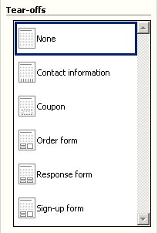
Now look for the Tear-offs area in the lower portion of the Flyer Options Task Pane (it looks like the image on the left. Notice that the default choice is None. Click-in each of the selections (Contact information, Coupon, Order form, etc.) under the Tear-off area. As you click, look at the flyer template and notice how each Tear-off selection appears in the flyer template on the right. Notice the the “tiny” picture to the left of each choice resembles the Flyer template in the screen to the right of the Task Pane. Neat!

For our first flyer we won’t use any Tear-Offs, so click-on None.

Later, when you have become proficient in Publisher, you can experiment with the various types of flyers.

Any time that you desire to change anything we’ve covered so far, simply click-on that selection in the Flyer Options Task Pane. It’s just that simple!

We’re now ready to work more “precisely” with our Flyer, but first it would be a good idea to save our Flyer.

Saving your Flyer and other Microsoft Publications

Publisher 2002 may have already prompted you, to save your work. If not, we’ll save our Flyer now. If Publisher has asked you to save your Flyer for the first time, you’ll be asked where you want to save (on a floppy or hard disk) - just like in a word processor. If you have not been prompted to save - you will be. This is a really clever thing that Publisher does - kind of like the auto-save feature in word processors. Every now and then Publisher will encourage you to save. Always save when Publisher indicates to do so - unless your are fearless or know of some logical reason not to save. Once you have saved the first time, Publisher will update the publication file on which you are working. Again, this will occur as you are working on each publication.

If you have not saved your Flyer at this point, let’s do so now. You can either click-on File in the Menu Bar and then on Save or Save As, or you can click-on the little Save diskette in the button bar. Either method will bring you to the Save As screen below.

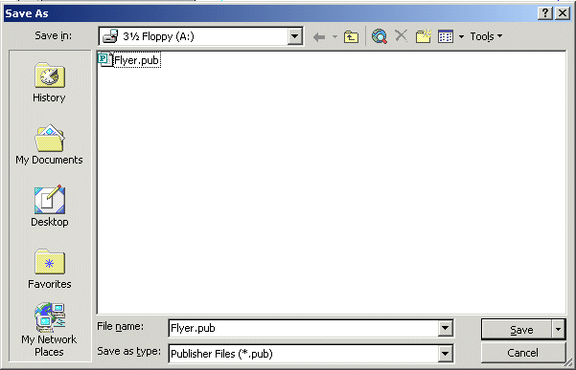

Notice that we are saving on our 3 ½ Floppy (A:) drive and that we have used the File name Flyer. When you decide on a drive (on which to save), name your file and click-on Save.
In Publisher 2000, a Wizard “area” was shown on the left side of the Publisher screen, where you now see the Flyer Options Task Pane. Many folks did not like having the Flyer Wizard “take up space,” so they closed the Wizard – to have more screen area to work on their publications. You can close the Flyer Options Task Pane – and make it appear again any time you desire.

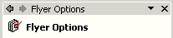
If you want to “close” the Flyer Options Task Pane simply point to the small “X” in the upper right corner of the Task Pane and click-on it.

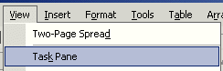
If you, at a later time desire to re-open the Task Pane and revise some of your choices, simply click-on View in the Menu Bar and then click Task Pane. Your Flyer Options Task Pane will again appear on the left. You can close and open this pane anytime.

Editing the Flyer

Take few minutes and look at the Flyer. At the current time you are able to view the entire flyer. At the top of the screen, under the Menu Bar, you will notice an area that indicates 50%. This tells you the size of the Flyer you are viewing. You'll find, as we continue through this tutorial in Microsoft Publisher 2002, that it will really be helpful to view entire Pages in the Flyer, Brochure and Newsletter. Other times, while we are editing a portion of each of these publications, it will be great if we can “zoom-in” on a specific object or area of the publication to enlarge it for editing. If we can look at some text, an object or picture in a larger view, we will be able to edit the “thing” more easily.

Editing Titles

Notice the title area at the top. We’ll start our editing here. Point to the object and click-the left mouse button on the title object.

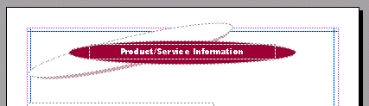

Click-on the Title

Note: whenever we indicate that you are to click-on an object in a publication, this means to click-the left mouse button.

Zoom-in and Zoom-out

You will notice, when you click-on the title, small circles appear on the four corners and four sides of the Title area. We call these “grabbers.” We’ll work with these in a few moments. To make this task much easier, it would be really neat if we could ZOOM-IN on the title – so we’ll have a BIGGER object on which to work. Whenever you want to zoom-in or out, simply tap the F9 Function key at the top of the keyboard! Since we clicked-on the title, we will zoom-in on the title when we tap F9. Tap F9 now.

You will zoom-in on your title and your title should look like the image below.

Grabbers
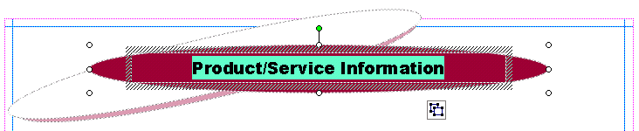

Group Object Pieces

Notice that the zoom percentage now indicates 100%. It will be a lot easier to work with this large title.

First we’ll edit the title text. Point the cursor arrow just to the left of the P in Product in the title and click the left mouse button. You should see a vertical light-green flashing cursor. If you don’t see the cursor - try again. When you see the cursor, you will be in a “word processor edit mode.” Tap the Del (Delete) key until you have erased Product/Service Information. When you have done this, you will only see the light-green flashing cursor in the center of the title. Now type-in a title you would like for your flyer. We’ll use Lynchburg College – since that’s where we’re creating this tutorial.

When you have done this, look at the title and see if you still have the “grabbers” on the sides and corners. If you do - fine. If you don’t, click-on the title again. Once you have the grabbers slowly move your mouse over the title area – do not click. You’ll notice that as your mouse moves over this area a number of different “assistants” appear and disappear. These assistants indicate when you can move and re-size the title. The little moving van indicates that if you click and hold down the left mouse button and then move the mouse (drag the mouse), you will see the “whole” title move. Try this. If you place the cursor over one of the grabbers, you will see a little box with arrows and the word resize. If you now click and hold down the left mouse button, and move (drag) the mouse a bit you will notice that the title gets a bit larger or smaller. If you “goof-up” it’s easy to get back to where you were. In the Button Bar below the Menu Bar there is a little, blue circular arrow. This is the undo button. If you click-on this button you will undo your last “click.” Try this, if you desire, by clicking-on the circular, blue undo arrow. You’ll probably need this several times as we proceed through this tutorial. We sure did – many times.


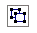
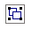
Make sure that you can still see the grabbers. If you can’t – click-on the title. You may have noticed that just below the title there is a little box that looks like it has two small boxes in it (see the arrow on the right). If you move the cursor arrow over these “boxes” and pause you will notice that a text help indicates “Ungroup Objects.” When you moved the title – everything moved – a group of objects. This is great if you desire to keep all of the objects together.

If you want to move the individual objects that make up the group – then click-on the boxes. They will move apart – or ungroup (see image at right). You can now click and move the individual objects as you want. Try this or don’t try this – your choice. If you do move the elliptical, colored background, or the text, you’ll notice that the Object Box disappears. When you're finished, if you desire to re-group the Text Block objects, all you have to do is click-on the Undo arrow until you have your title back the way you want it. You’ll notice at some point that the Object Box reappears and then groups the objects as one object. The Object Box will look like the upper box on the right when the title is regrouped. The Grouped and Ungrouped Object boxes don’t look that much different. So, be careful as you “click” the Undo button.
If you “goof” – don’t forget the undo arrow.

Changing Title and Title Text Colors

We’ll now do some RIGHT mouse button clicking. If you place the cursor arrow over any object in a Microsoft product and click the RIGHT mouse button, a “tailored” drop down menu appears with features “tailored” to the area/object on which you clicked. This is really neat. Many folks use this a lot – others are just discovering this feature. So, point the cursor arrow to the middle of you title text (make sure it’s highlighted) and click the RIGHT mouse button. A drop down menu (like the one below) will appear. Notice, that at exact place where you clicked in the title, a corner of the menu box appears. This indicates exactly “where” you clicked. We’ll use this drop down menu to change the text color.
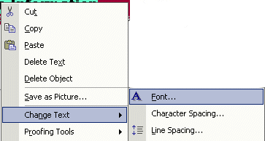
After you have right-clicked on the text, the menu box will remain on the screen until you either click somewhere else, or click-on one of the menu choices. Move your mouse cursor down the menu box until it is over Change Text (see left arrow). A group of choices for changing text appears (like the picture on the left).
Now move the cursor from Change Text to the right over Font. Font will turn blue.

When this occurs, click-the left mouse button when it is over Font. The Font menu below will appear.
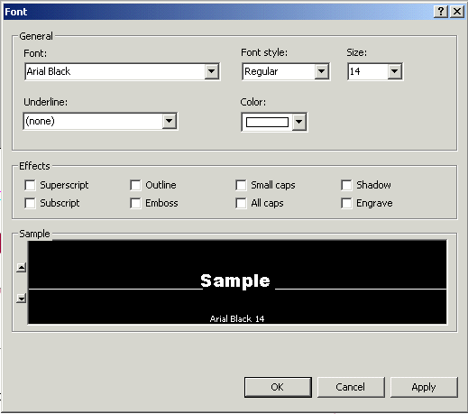
At the beginning of this tutorial we indicated that you should be competent in a word processing program. So, we will not spend a lot of time on editing and enhancing text in this tutorial. You can see from the Font menu above that the default font in this title is Ariel Black, font size 14. If you desire, you can change the font, font size, font color and add effects. To do this simply click-on the small down triangles to the right of each effect and select the font changes you desire.

Don’t forget, just like when you are using the word processor, you have to highlight the text you desire to change. If you have not done this, simply return to the text box, highlight the text, click-right on the text, and return to the Font menu as you did a few moments ago.

Notice, if you change the color, that the color scheme you selected is available to maintain uniformity throughout your Flyer. You may choose other colors if you desire.
Don't forget - if you make a mistake you can always click-on the blue undo arrow and try again.

Changing the Color of the Text Background Box
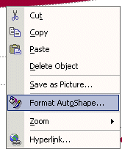
You may also change the background colors in the AutoShape (the colored oval around your text), if you desire. Again, carefully point to the edge of the colored oval and click the right mouse button. The drop down menu box to the right will appear. This right click has to be precise. You must see the menu to the right and choose Format AutoShape. If, after several “right clicks” you do not see this menu, ungroup the objects (like we did on Page 11). Then, right click on the oval and the menu at the right will appear. When you select Format AutoShape the menu below will appear.

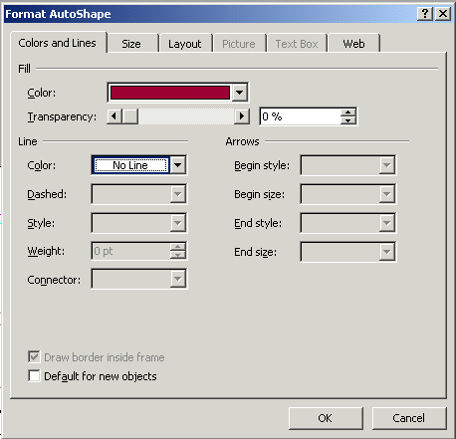

When the Format AutoShape menu at the left appears, you may change the Colors and Lines, Size, Layout, etc., as you desire.

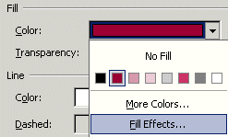
In the Format AutoShape menu above, if you choose to change the background color of the oval, you have a number of choices. If you click-on the down triangle to the right of Color in the Fill area, and then choose Fill Effects you will give you a number of additional choices. Experiment with these if you desire.

Grouping and Ungrouping Groups of Objects

After you have made your text and background changes you may choose to ungroup the various objects that make up the title object group. We talked about this at the top of Page 11. One nice thing is, if you ungroup the objects, and move them, it makes editing, coloring and sizing the individual objects easier. After you have made any changes you desire, you can re-group the objects in any pattern you desire. Once you have done this you may again click on the group objects button.
When you do, you will see the objects re-group. This new group will now move as a single group.

If you do not see the object buttons (above to the right), we’ll now explain how to group objects that are not grouped.

Grouping Objects that are not Grouped
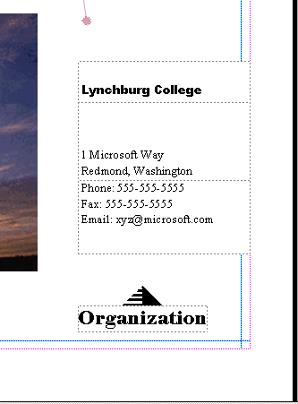
You should be “zoomed-in” on the title object at this point. If you are, tap the F9 function key to “zoom-out” so that you can again see the whole Flyer. If you can already see the Flyer, do not zoom-out. Now look at the lower right corner of the Flyer. You will see what appear to be several small text boxes. Click-on one of the boxes, and tap the F9 key to zoom-in on them.

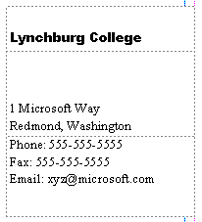

You should now see something similar to the image on the right. The information you view was created by the data you entered in your personal or business information at the beginning of the tutorial. If you did not enter your changes to the default information, you will see the default information that was displayed in the Personal Information “box.” If you now desire to enter or change information in the Personal Information menu screen, click-on Edit in the Menu Bar, then click-on Personal Information. Edit as you desire then click-on Update. This will change your information in this and future Publications. Neat! If you desire to change the information in this Flyer you may also do so in each text box. Notice that the information appears to be in three separate text boxes. Click-on each of these boxes. As you do, you will see sizing grabbers appear on each box. The top box has a title, the middle box has name and address information and the bottom box contains phone and e-mail information.

When you click on the top box, you will see a title. This title normally “fits” in the box and is OK. Some folks enter long titles and you may see a little box with an A and three periods along the bottom edge of the text box. This did not occur in our top box.

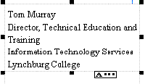
However, when we clicked–on our middle box, the little box with an A and three periods appears. This little box indicates a “text overflow,” which simply means that the box is too small for our address text. To fix this, we’ll have to enlarge our middle box. If you decide to make the middle box larger, you’ll have to be careful. If you enlarge it into either the top or bottom boxes, you may “cover the text” in these boxes. So, it’s normally best to “drag” the top box up a bit, by clicking on it, letting the “moving van” appear, then holding down the left mouse button, and dragging it up a bit. You can then drag it down when you are finished. Notice, in our box, that we don’t have the last part of our address. So, we’ll enlarge the box and complete the address.

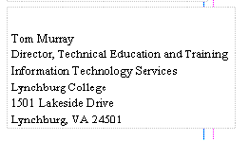
We noticed above that our address “wrapped” some of the “lines” of the Address (Training in the third line). So, after completing the address, we “widened” the text box so that the lines would not wrap. The image at the left is the enlarged image with all of the text showing.

When we did this we noticed that our text box “crossed over” the thin blue and pink lines that go around the border on all four sides of the Flyer Page. These pink and blue lines represent the default borders that Microsoft Publisher places on each of its publications as a guide. Since we are a bit outside these lines, we might get an error message when we print this Flyer indicating that we are outside the borders. This is no big deal, as the Flyer will print fine.

Note: you may see some spell check errors in each of the three text boxes. This is simply Publisher (through Microsoft Word) telling you that these words are not in the Word Dictionary. You will see a “wavy red underline” under each word that the dictionary does not recognize. As with Microsoft Word, you can simply right click-on the underlined word and see if the spell checker has the word in the dictionary. If it does, click-on the word. If not, you can choose to ignore the error or add the word to the dictionary.

Now click-on each box and drag it until the three boxes are aligned the way you want them.

Grouping Ungrouped Text Boxes

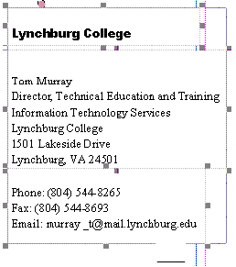
When you are satisfied that everything is OK (all the boxes are “lined-up” like the image on the left), then you’re ready to move on. To create a single group for these three boxes, so that when you click-on any of the boxes the whole group will move, you can do so by the following method below.

Make sure you can see all three boxes (like the image on the left). If you can’t, use the elevator bars on the right and bottom of the screen until all three boxes are visible. Again make sure that the boxes are aligned exactly like you want them. Then click the left mouse button lightly-on the first box. You will see the grabbers. Now – this is important – HOLD DOWN one of the Ctrl keys (next to the space bar on the keyboard). With the Ctrl key held down, move the cursor over the middle box and click the left mouse button. You should now see both the top and middle boxes with grabbers around them. You should also see the little box with the two object pieces at the bottom right corner of the middle box. The object pieces should be apart indicating that the top and middle boxes are not grouped. Don’t do anything yet – we’ll come back to the puzzle pieces after we have added the bottom box. Hold down the Ctrl key again and click-on the bottom box. Now all three boxes should have grabbers around the sides.

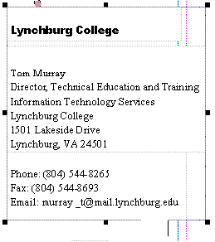
If they do not, repeat the above instructions above until the do. You should now see the ungrouped object pieces box at the bottom right corner of the bottom text box.

Click left on the ungrouped object pieces box. The objects should now join into a single piece that looks like the image on the left. The object grouping box, at the bottom of the boxes, should now look like the image on the right. You will now see grabbers around the “entire” three text boxes. This indicates that when you move the single box, all three smaller text boxes will move together. Pretty neat. Microsoft Publisher was thinking ahead of you when it saw you “Ctrl click” each text box. It assumed you wanted to join them.

Changing and Editing Images and Photographs

You should now be in the zoomed-in view where you can only view the group that you just grouped (on the last Page). Tap the F9 key to zoom-out so that you can view the entire Flyer. When you can see the entire Flyer you will see a photograph in the lower left portion of the Flyer. Click- on the photograph, then tap the F9 key to zoom-in again. Your image should look like the one below.



Let’s assume we desire to change the image to something more appropriate with our Flyer topic. So, point somewhere in the image, and click the LEFT mouse button. This will “mark” or “identify” the picture above – as the image we desire to replace.

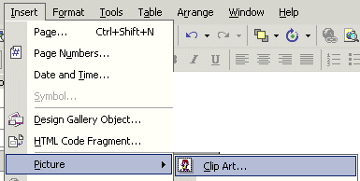

Click-on Insert in the Menu Bar, and then select Picture, and then Clip Art.

The Insert Clip Art Task Pane (at the top of the next Page) will appear on the left side of your screen.

Note: for users of Publisher 98 and 2000 this is a marked change in this software. You will no longer “see” the Change Picture – Picture – Clip Art screens that you saw previously. As indicated at the beginning of this tutorial, all Office XP/2002 modules now use the Task Panes for many features in previous Office versions.

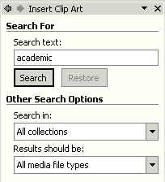

We’ll only deal with Clip Art in this tutorial. When you become more advanced you can import your images directly from a scanner or digital camera or a file on your computer. Or, you can sketch them in another program.

Notice at the top of the Insert Clip Art Task Pane (at the left) that there is a Search For area. We typed academic in the area below Search text and then clicked-on the Search button.

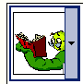
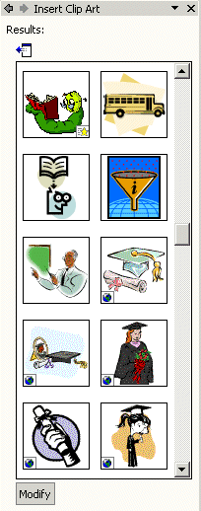
The Insert Clip Art Results Task Pane replaced the Search Task Pane. We searched on academic, and now see the images on the left. If we like one of the images, all we have to do is to move our mouse over the right edge of the image, and we’ll see a small down triangle appear (like the one above – we chose the bookworm)
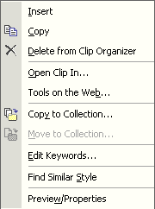

If we click-on the down triangle the menu screen on the right will appear. We have a number of choices. For now, we’ll select Insert.

Notice, at the top of the next Page that our bookworm is now on top of the old image.



All we have to do to remove the old picture is to click the left mouse button on the old picture (don’t click-on your image), and tap the Delete Key on the keyboard. When you do, you’ll see that your image is now the only image and that you can re-size and move it as you desire.

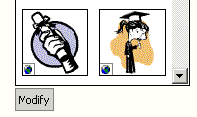
If you don’t like the image you chose and desire to do another Search, simply click-on the Modify button at the bottom of the Insert Clip Art Task Pane. This will take you back to the original Clip Art Task Pane so that you can try another search on a different topic.

Don't forget - if you make a mistake you can always click-on the blue undo arrow and try again.

Clips Online

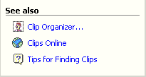
Now we’ll try something really neat – Clips Online.

Click-on the Clips Online button/link at the bottom of the Insert Clip Art Task Pane.
You may see an information screen similar to the one below, or you may go directly to the Clips Online Microsoft web Page.

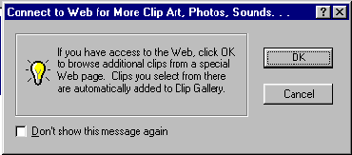

If you do see the above screen it is simply reminding you that you need to be on the Internet. When you click-on OK the browser you are using will go to the Microsoft Clips Online web Page.

It will take a few moments, but the Clips Online screen below will load.

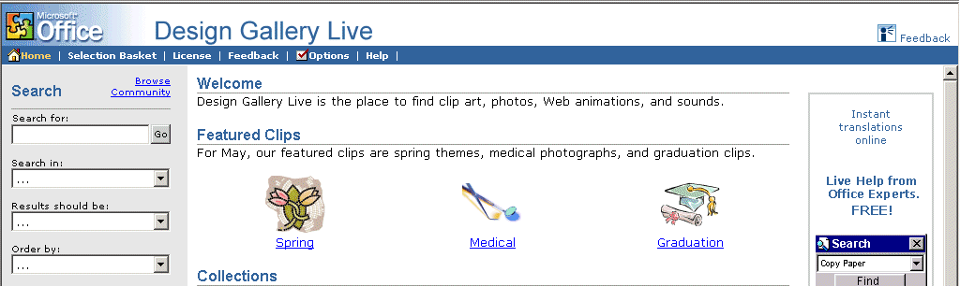

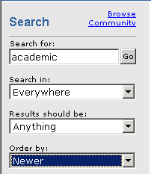

Notice that one of the arrows in the image at the right points to Search. To search for academic images we filled in the Search for: and Search in: boxes as indicated in the image on the right. To do this we clicked-on the small down triangles and selected the choices you see.

We clicked-on Go. We received eighty four Pages – 84 ! - of academic images! The top of the Design Gallery web Page should look something like the one below. You can view each Page by clicking on the >> at the top right of the Page.

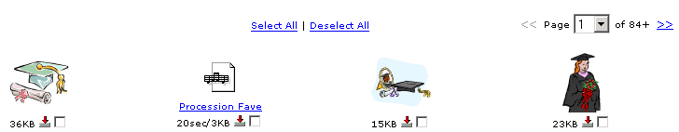

Notice the small “boxes” below each image. If you see an image, as you move through the Pages, that you would like to save for your “image collection,” click-in the small box and a check mark will appear.

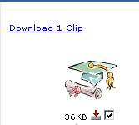
We chose a “graduation cap and diploma” for our selection. When we clicked-in the little box our screen looked like the image at the right. When we clicked-in the box the check mark appeared and it indicated Download 1 Clip at the top of the screen.

If you select (click) several images, you will see the Download Clip increase as you click-on each box.

When you have selected all of the clips that you desire, click-on the Download Clips link.

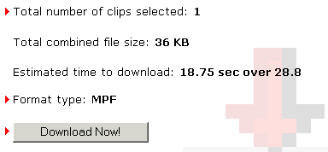
Your monitor screen should now be similar to the one on the left. It indicates how many clips you selected, how much disk space they require, and how long it will take to download them over a modem.

Click-on Download Now!

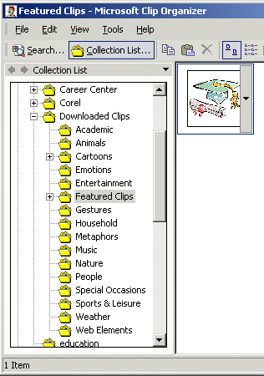

When the download is complete, a screen similar to the one on the right will appear. There are several things to notice here.

First, look at the top of the screen it indicates: Featured Clips-Microsoft Clip Organizer. This is important – you’ll see why in a few minutes.

Next, notice that the Featured Clips folder is highlighted in gray. This indicates that this downloaded image will be placed in the Featured Clips folder under Downloaded Clips.

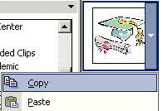

When you are ready to insert a clip in your presentation, move your cursor over the right side of the image you wish to insert and click-on the small down triangle.

Then, in the drop down menu that appears, select Copy.

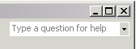

After you have clicked-on Copy, close the Microsoft Clip Organizer by clicking on the small “X” in the upper right corner of the Clip Organizer screen.

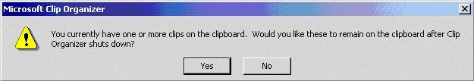
You may see a Microsoft Clip Organizer information screen appear (like the one below) which asks if you desire to retain images on your Clipboard.

Answer “Yes” if this screen appears.

You should now be back in the photograph area of your flyer.

Move your cursor anywhere in the photograph area of the Flyer and click the RIGHT mouse button (this simply causes a menu to appear). Click Paste. The picture you selected will now appear in the photograph area of your flyer. You could also click on Edit in the Menu Bar and then select Paste. The image you selected will now appear in your flyer.

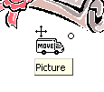
Our image looked like the one on the far right when we first pasted it into the flyer. To move your image around on the flyer move the cursor over the image until your cursor becomes a “small moving van.” When you see the four-arrow graphic (sort of like the one above and the moving van), click and hold down the left mouse button and move (drag) the image to a place on your flyer where you think it looks best.

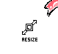
To make the image larger, or smaller, move your cursor over one of the small circles on one of the corners of the image. When your cursor is over a corner you will see a two-arrow cursor (similar to the one on the right). When you see this two-arrow cursor, click and hold down the left mouse button and move (drag) the cursor out or in until you have the size you desire. If you “grab” the circles in the middle of the top, bottom and left or right sides of the image, and move them, you will either make your image “skinny” or “fat.” So, most of the time, it’s best to use the corner circles.

Save your work!
Note: When you insert or paste images into Publisher publications, more often than not, they are copied or pasted on top of the prior image. This is not a problem. You can click-on the image that you do not desire and then tap the Delete key, or delete the first image before you insert or paste the new image.
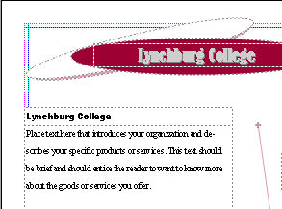

So, we’ve worked with the Title and Title Box at the top of the Flyer, the three Personal Information Text Boxes in the lower right area, and the image. Now let’s replace and edit the text in the Text Box at the upper left side of the Flyer. Tap the F9 key to zoom out (so you can see the entire flyer).

Editing and Replacing Text in Text Boxes.

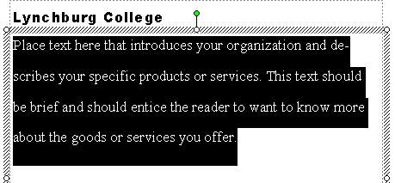
When you can see the entire Flyer, click-on the Text Box indicated above and tap the F9 key to zoom-in. Or, if you are already in the magnified view, move to the text box and click-on it. You should now see a text box like the one on the right.

Notice how the text in the box indicates the type of text that you should place in the text box area. Each Microsoft Publisher 2002 publication will have instructional text where appropriate.

Now we’ll add some text about our wonderful hamburgers that we sell at the arts festival on campus. To do this we’ll use a special Microsoft Publisher feature: Edit the text in Microsoft Word.

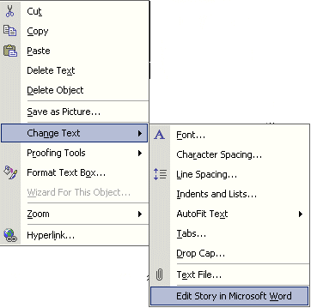

First, point to the text box and RIGHT click-on the text. A drop down menu box like the one on the left appears. Move the cursor down to Change Text. When the right drop down menu appears, move the cursor down to Edit Story in Microsoft Word and click the left mouse button. Microsoft Word will now load and the text shown on the screen will be the text above.

Delete the above text in Microsoft Word and type-in the following:

Come to the Fifth Annual College Art Festival. In addition to great buys on wonderful works of art by the students, you can also purchase some of our fantastic and world-renowned hamburgers. Each burger is grilled to your specifications over our special charcoal chips.

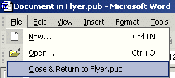
This text is being typed-in a special Microsoft Word screen. When you have finished typing the text above, click on File in the Menu Bar (at the top left area of Microsoft Word). You will see a drop down menu like the one to the right. When it appears you will see a unique selection: Close & Return to Flyer. pub. Click-on Close & Return to Flyer. pub.

Microsoft Word will appear to close, and you will return to your Publisher Flyer text area. Notice that the text you edited in Microsoft Word now appears in the selected text box. If you decide to make more changes in this text, simply repeat the above instructions. Click anywhere in your text and click-right, and then follow the above instructions. You will again return to your text in Microsoft Word where you can make any additions and edit, as you desire.

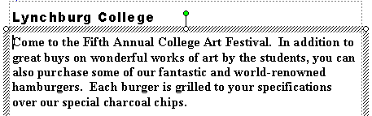
Your text box in the Flyer will look similar to the text on the left. You can change fonts, resize and color the text, just like you did previously. You can also resize the text box as well.

Don't forget - if you make a mistake you can always click-on the blue undo arrow and try again.

Logo Text and Logo Picture

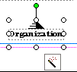
If you can see the whole Flyer you are where you should be at this point. If you can't see your entire flyer, we'll zoom-out, as we have done before by tapping the F9 key. Now that you can view the entire Flyer, look in the lower right corner of the Flyer, just below the Personal Information Text Boxes - that we worked on before - there is a small box with the word Organization below a pyramid. Click-on this box. Then zoom-in again by tapping the F9 key.

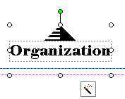
When you have zoomed-in, your image should look like the one to the left. This image looks similar to a "Grouped" set of boxes, but there are no "object boxes." Instead, there appears to be a magic wand! Move your cursor over the magic wand and pause you will see a Text Help box that indicates: Wizard: Click to start.

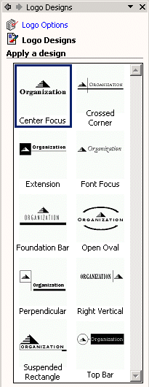
Go ahead and click-on the magic wand. You will now see a Logo Designs Task Pane appear on the left of your screen. This Task Pane looks similar to the other Task Panes that we used at the beginning of the Flyer creation. Notice that the top of the Task Pane indicates Logo Designs. Below that you see: Logo Options (in blue), Logo Designs, and Apply a design.

Notice, in the area below Apply a design, that “our” image (that we clicked on the flyer) is highlighted (outlined by a square). Notice all of the other choices below our Center Focus design.

Now click-on as many of the Logo Designs that you desire. As you click, you’ll see the design upon which you clicked, replace the design in your flyer. Click-until you find a design that you like.

We'll choose Suspended Rectangle so our logo will look like the one below.
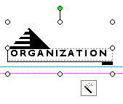
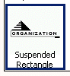
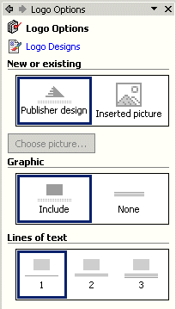

Now that we have selected our Logo design choice, click on the Logo Options (blue text) at the top of the Logo Designs Task Pane (above image).

The Logo Options Task Pane at the right appears, replacing the Logo Designs Task Pane. Notice that the Logo Designs selection is now blue (indicating that we can return to Logo Designs when we have finished with Logo Options.

Notice there are three areas in the Logo Options Task Pane: New or existing, Graphic, and Lines of Text. We’ll now work with each option.

Click-on Inserted picture. The Logo Options Task Pane will now look like the one at the right.
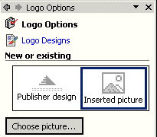

Notice, in your flyer, that the logo has been replaced by an image that looks like the one below.
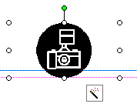

This indicates that you have a choice – you can have a logo with a picture and text, or just a picture. If you decide that you just want a picture, notice that the Choose Picture button at the bottom of the above left image has become “active.”
If you click-on this button you will be taken to the various drives (Floppy disk A:, Hard Drives C:, D:, etc) to select a picture.

If you want to use your Clip Organizer to insert a clip that you have in the Organizer, there is a Clip Organizer button in the Drawing Tool bar on the left side of your screen. If you click on this Clip Organizer button, the Organizer will appear and you can use it the same way we did on Page 22.

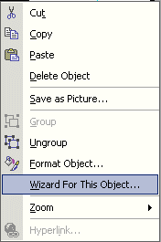
For this tutorial, we’ll use the Publisher design that we selected, so click again on Publisher Design in the Logo Options Task Pane. If you have been “creative” with your logo, you might not see the Logo Options Task Pane. To return to the Task Pane, RIGHT click-on the logo and select Wizard For This Object.
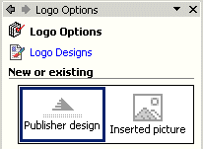
This will change your logo back to the Logo Options or Logo Designs Task Panes. If you are not in the Logo Options Task Pane, click-on Logo Options at the top of the Task Pane. Then select Publisher design. You will again see your Logo appear in your flyer.

Now look at the center section in the Logo Options Task Pane – Graphic.

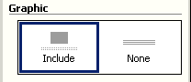
Notice that you have a choice to include or not include a graphic in your logo. Go ahead and click-on None. You’ll see the graphic disappear. Now click-on Include – we’ll want a graphic for this tutorial (to show you how to change the graphic)

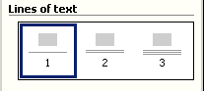
Now we'll look at the third area in the Logo Options Task Pane – Lines of text (see image at right). Notice that the Lines of text indicates one, two or three lines in your logo. You decide how many you would like to have. For our logo we'll choose three and click-in the three area.

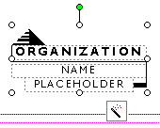

Our logo now looks like the one to the left. We moved it up and to the left a bit since it “overlapped” the pink and blue margins on the lower corner of the flyer.

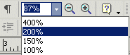
Now we'll replace the pyramid and text in the logo with something that indicates that this is our personal logo. This will be a bit tedious, as you might have to click where we indicate a number of times to select the pyramid and text - if you keep the logo its current size. We’ll zoom-in even more to assist us in clicking-on the appropriate areas. As we indicated earlier in the tutorial, at the top of Publisher's Menu and Button Bars there is an area that indicates the "size" of your zoom-in or out. To make this task easier, click-on the little down triangle to the right of the current size and enlarge the image to 200 %. Our logo will be much easier to work with once you've done this - if you care to do this. Your logo should look similar in size to the one below.
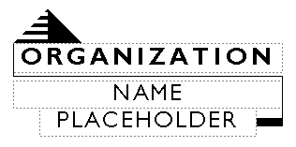

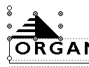
First, we'll replace the pyramid with an appropriate piece of Clip Art. Carefully move your cursor over the pyramid and click the left mouse button to "identify" the pyramid. If you have done this correctly, small circles will be located around the pyramid (like the one to the right).

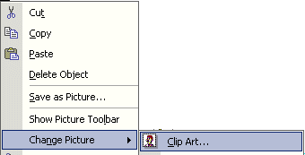
Once you have "identified" the pyramid, keep your cursor on the pyramid and click the right mouse button. A drop down menu will appear.

When the menu appears, move the cursor down to Change Picture, then over Clip Art. When the cursor is over Clip Art, click the left mouse button. The Insert Clip Art Task Pane will appear again.

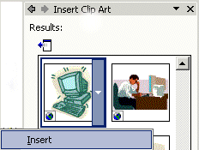
You may choose any clip art you desire. Use the same techniques that you did on Page 18. We, for our tutorial Flyer, desire some sort of computer image. So we'll search on the word computer (instead of academic like we did on Page 18). You search for the image you want in your logo and insert it in place of the pyramid. We found a computer image that we liked in our Insert Clip Art Task Pane. We'll insert our computer image. To do this we’ll click-on the small down triangle on the right side of our image choice, and then click-on Insert. On the right you can see that we found a computer. Your image in the Insert Clip Art Task Pane you chose should look something like the one above.

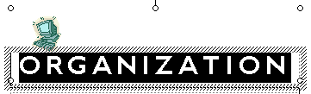
Now we'll work with the text.

First, click-on the word ORGANIZATION in the title area. Yours image should look something like the image at the right. This will work just like the Title and Personal Information Text Boxes we edited earlier. Delete ORGANIZATION in the box and enter the title you desire. We're going to use Information in this box and Technology Services in the text boxes below. Go ahead and make your changes to this box now. Change the Font, Size and color if you desire.

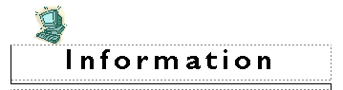
Our logo text box now looks like the one at the left. Now we'll edit the remainder of the logo text box.

Next, we’ll highlight NAME and then change it to Technology. Then we'll highlight the word PLACEHOLDER, and change it to Services. Go ahead, on your own, and enter your text in the logo text boxes.


Our final logo box looks like the one at the left.

When you complete this task you might receive a message that asks if you want to add this new logo as your Personal Information logo. If this appears, answer Yes.
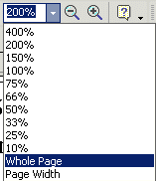

There is one more text box to go. Since we zoomed-in to 200%, the best way to now zoom-out is to go back to the Menu and Button Bars at the top of the Publisher screen and again click-on the small down triangle. When the drop down menu appears (like at the left), run the cursor down to Whole Page and click the left mouse button. This will "re-set" Publisher to the default zoom-out that we have been using.

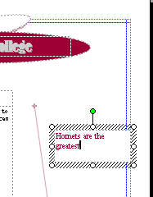
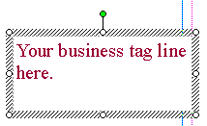
The final text box is located on the right side of the Flyer, about a third of the way down the Page. The arrow on the left indicates this text area which has already been clicked. Go ahead and click-on this text box and then zoom-in by tapping F9. Your text box should look like the one below. Place whatever text you like in the box. Since we're on a hamburger "thing," we'll again tell everyone about our great "burgers." So, we'll type in: Best Burgers in the Burg (Since our college is located in Lynchburg, Virginia, the students call Lynchburg: "The Burg.")
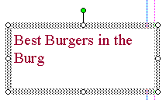

Our final text box looks like the one on the right.

Zoom-out ( F9 )one more time and look at your whole Flyer.

Printing Your Flyer

Printing your Flyer, or any publication, is very similar to printing in any word processor. In the Microsoft Office modules you can either click-on a small printer in upper button bar or click-on File in the Menu Bar and then on Print in the drop down menu. One small, logical note. Many computer users seem to forget that you can only print color from a color printer. Frequently, users assume that if the computer has color on the screen the printer will print color.

Final Flyer Observations

All of the skills you learned in creating your Flyer can be used in the Brochure and Newsletter. All three publications have Title and Text Boxes, Personal Information Text Boxes, Images, Logos, text to edit or replace with other text. You may group or ungroup objects, change color schemes, and fonts. So, when these common tasks are also used in the Brochure or Newsletter we will not cover them again. We will only cover additional new skills in creating these new publications.

Don't forget to Save!

If you still have your Flyer open, please close it. Click-on File in the Menu Bar and then on Close. In most other Microsoft software the current document on which you are working can also be closed by clicking-on the small lower "X" in the upper right corner of the screen. In Publisher you do not have this "X," so if you click-on the single "X," It will completely exit from Publisher. If this happens it's no big deal. Simply start Publisher again and you will be ready to go.

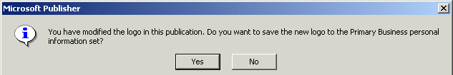
Note: as mentioned earlier, you may see the below information screen when you are closing the flyer. This simply asks if you want to replace the default logo with the logo you created. Answer “Yes” and your flyer will be saved and the logo in your Personal Information will be updated.

Creating a Brochure
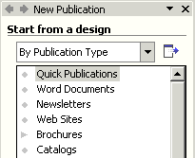

If you closed the Flyer, as indicated above, you will see the New Publication Task Pane on the left side of your screen. On the right side of your screen you will see a large piece of blank paper.

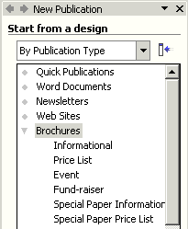

Look at the Start from a design area on the left side of the screen, and run the cursor down to Brochure and click-on it.

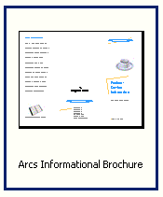
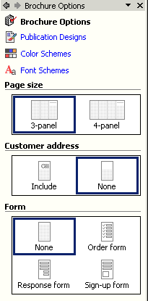
Now look in the upper row of Brochures on the right. We'll select the Arcs Informational Brochure just like we used the Arcs Informational Flyer.

To select the Arcs Informational Brochure, click on this choice. You will see the “blue square” around this selection.

As soon as you click-on Arcs Informational Brochure, the Brochure Options Task Pane will appear on the left side of your screen and the Arcs Informational Brochure template on the right side of your screen.

As with the Flyer Task Pane, take a few minutes to look at the Brochure Options Task Pane. Notice that Publication Designs, Color Schemes, and Font Schemes appear at the top of this Task Pane – just like they did in the Flyer Task Pane.
Notice on the right side of the screen that a Brochure appears when this screen appears. Notice the pink and blue lines that indicate the "folds" for this Brochure. When this Brochure is completed, it will be folded twice so that it will be about the size of an envelope. Also, notice at the bottom of the brochure screen that there are two Pages - one for each side of the sheet of paper that will make up the two sides of the Brochure. We'll return to edit each side when we have completed the Brochure Wizard.

The Brochure Options Task Pane (and the Newsletter to follow) will work the same way that the Flyer Options Task Pane worked.

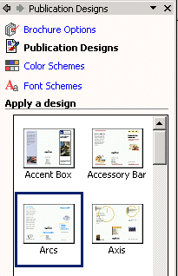

We’ll move “down” the list of choices in Brochure Options Task Pane (just as we did for the flyer).

We first clicked-on Publication Designs and the Publications Design Task Pane (for Brochures) opened as indicated at the left.

Since we chose Arcs Informational Design, our choice is indicated by the blue square surrounding Arcs.

We’ll stay with this design for this tutorial example. If, later on, you’d like to change your design, you can always go to the Publications Design Task Pane and do so.

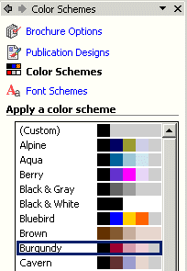

Next we’ll click-on Color Schemes. The Color Schemes Task Pane you see on the left will appear.

Again, you choose any color you desire. We'll again use the Burgundy Color Scheme. This will then change all of the default colors in the Brochure the same way that it did in the Flyer.

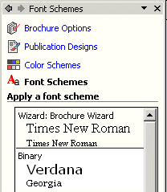
Now we’ll click-on the last choice in the Task Pane – Font Schemes.

As with the flyer, you have a choice of fonts for your brochure. When the Font Schemes Task Pane appears (on left), you may browse the choices and select any font you desire.

Well use the default font – Times New Roman.

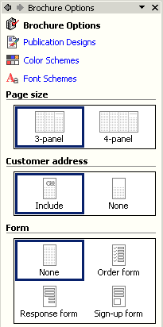

We’ll now return to the Brochure Options Task Pane.

This Task Pane asks what Paper size you desire to use for your brochure: regular letter size or wide legal size. The 3-panel brochure uses normal size (8 ½ x 11) paper and the 4-panel uses legal size paper (8 ½ x 14) paper. We’ll use the 3-panel Paper Size for our brochure.

The Brochure Options Task Pane next indicates that you can have a customer address in your brochure, as it did in the Flyer. We’ll click-on Include this time.

When you select Include, watch the middle section of the Brochure on the right side of the screen. You will see the Title Box, Logo Box and Personal Information Boxes disappear and be replaced by a Return Address Box and Customer's Address Box. If you missed this, click-None. Watch the right side. Click again to select Include, and watch the right side. We'll talk more about these addresses when we edit the Brochure.

Notice, in the Brochure Options Task Pane, that the current Form choice is None. Also notice that there are three other choices: Order form, Response form, and Sign-up form. To see the changes, click-on the small Page 2 “button” at the bottom of the screen. Watch as you click-on each choice. When you select Order form a blue bar will appear and indicate that changes are being made to the Brochure. When the process is complete, you will see the Order form changes. We’ll use None for our Brochure. So, we clicked-on None as our final Choice.
Don't forget - if you make a mistake you can always click-on the blue undo arrow and try again.

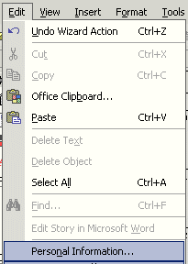

One last “thing” before we begin making changes to our brochure - Personal Information. Anytime you desire to change your Personal Information (like the Flyer) click-on Edit in the Menu Bar and the click- on Personal Information. This will take to the Personal Information Menu screen (Page 4). Anytime you desire to alter any of your information, simply “click” as indicated and change your information

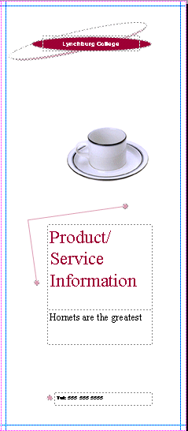
Now we’ll learn about the brochure. If you are not on Page 1, click-on the Page 1 button now.

Title Box - Grouped

Notice that we have already mastered how to change everything in the right portion of the Brochure.
Clip Art

Text Box

Text Box

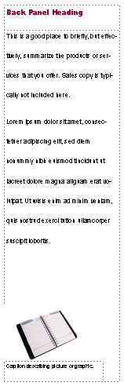
Now look at the left side Brochure panel. Again you have already mastered how to edit this panel. At the top is a Text Title box. In the middle is a double spaced text box. It is similar to the text box we edited in the Flyer where we used Microsoft Word. You can right click-on this text and choose to Change Text from the menu and then Edit Story in Microsoft Word. The bottom image is again Clip Art.

If you click-on the text below the image you will see that it is a caption for the picture. A caption is simply a text box “attached” to a picture. If you click-on the book below, and then tap the F9 key, you will zoom-in on the book. You will see the grouped object pieces that indicate grouping and the text indicates that it is a caption. If you click and drag the image, you will see – logically – that the caption “moves” with the book – because they are grouped.
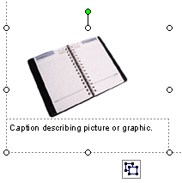

Edit the Title Box, the text or change the Clip Art and Caption. Do what every your feel like doing.

We’ll come back to the center section of Page 1 after we look at the three panels on Page 2. So, click-on Page 2 at the bottom of the screen.
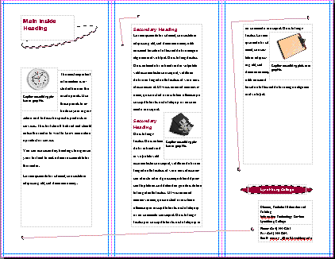
Notice, in the image of Page 2, (right) that the left and center panels are essentially like the one above. They simply contain Heading Boxes, Text Boxes and Captioned Clip Art. The right panel has a Text Box and Captioned Clip Art. In the lower portion of the right panel you see a Personal Information Box – just like we mastered in the Flyer. So, you already know how to edit all of these “things.”
Don't forget - if you make a mistake you can always click-on the blue undo arrow and try again.

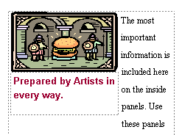
One more "neat thing" before we leave the Brochure. We've clicked one more time on Page 2 of the brochure. Zoom-out in your Brochure and click-on the Page 2 at the bottom. In the left panel of your brochure you originally had a clock with a text caption below the clock. We made some changes to our brochure to reflect our Art Center Hamburger Sale. At the left there is a picture of a hamburger being guarded by two knights (we changed the clip-art like we've done before. Below the clip art we have also changed the caption as well.
New Neat Thing

If we click-on the picture and caption we immediately notice that they are a grouped object. So, when we click and drag them they stay together - nothing new - no big deal. However, when we drag the image and caption, no matter where we drag them, the text automatically wraps around them - this is the New Neat Thing

If you've forgotten how to drag the images - Simply click the left mouse button on the image, hold down the left mouse button, and move the mouse around a bit - this is called dragging.

Now, on your own, drag your image around the left panel and notice the wrapping. Now! Drag your image to the middle panel and the same thing happens! Publisher has already wrapped every image in all publications like this - we think this is super - it sure saves a lot of time learning how to "wrap frames" like Publisher has done. Also notice that, as you drag, the image and caption from Page to Page, that if the image "pushes the text" that the text "flows" from panel to panel. We'll get into this a lot more in the Newsletter.

We thought you'd like to try this image dragging in a small brochure where you can "really" see the effects.

Merging Addresses from a Microsoft Publisher, Word or Access Database

The next few Pages will discuss utilizing a computer database to insert addresses into any publication - in this case the Brochure. Many folk's just "hand" address their Brochures or use mailing labels. You can do much more than this with a database.

If you desire to see how this is done with a database - read on. If not, you can to skip to Page 43 now.
Now back to the center panel of Page 1 – the address panel. Click-on Page 1 now.

We first clicked-on the center panel of Page 1 and then zoomed-in. Then, we “rotated” (in this tutorial) the center panel to make it easier for you to “see” the panel and the addresses.

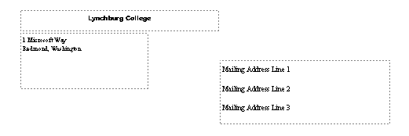

Address Area for Mail Merging

Notice that the “return” address comes from the Personal Information we entered. We can change this at any time (as we have indicated before)
.
Now look at the Mailing Address Lines 1, 2, 3, etc. above. This is where you can paste a mailing label. Or, better yet, create a database in Microsoft Word, Publisher, or Access. Or, if you are very patient and have lots of time, you could individually type-in or write in each address, print Page1, type-in another address, print Page 1, and on, and on, and on.

We use Microsoft Access database for our brochures. There is a tutorial similar to this one that will assist you in becoming knowledgeable in Access. Just e-mail us and we’ll send you a copy or tell you how you can download it from our web site.

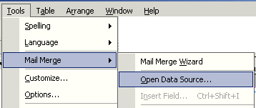
Now a quick illustration of what we are talking about. Click-on Tools in the Menu Bar, then click Mail Merge, and then click-on Open Data Source. In the Menu Bar of all Publisher 2002 publications, where a mailing address database might be used, has this Mail Merge feature.

When we click-on Open Data Source, the Select Data Source menu screen at the top of the next Page appeared. We’ll use and existing database that we have created on one of our Hard Drives. This database was created with the Access 2000 tutorial.
The below Select Data Source menu screen will appear. Notice that we clicked-on an Access database called Person 2000.mdb.

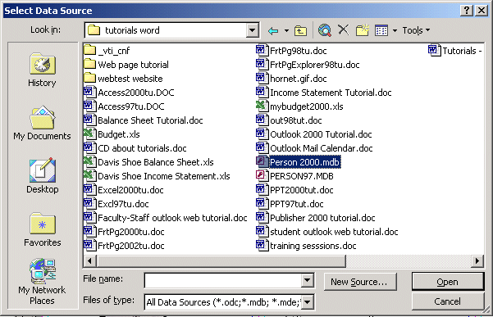
Once we’ve selected our database, we’ll click-on Open.

The below Select Table Access menu screen appears. One of the databases within our Person 2000 Access database is a database (table) called Personnel. We clicked-on Personnel and then clicked-on OK.

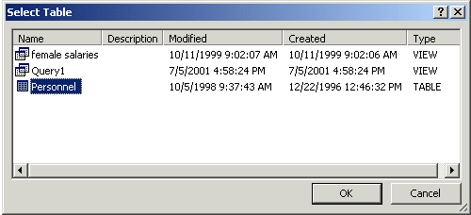

If you are using Microsoft Outlook as a part of your Personal Information Manager, and have entered addresses in the Address Book, you can also obtain your addresses from this source.

Next we’ll create our mailing address “label” (it will really be printed on each brochure, for each person in the database, as each brochure is printed).
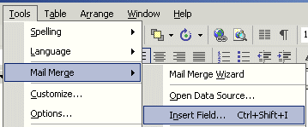

So, click-on Tools in the Menu Bar (again), and then click-on Mail Merge. But, this time, click-on Insert Field.

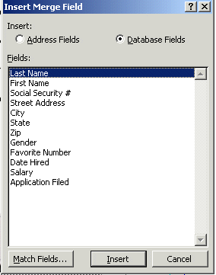
As indicated previously, we’ll use the Access database we created in the Access tutorial for our field names in this brochure.

When you click-on Insert Field the Insert Merge Field menu screen on the left appears. We’ll select fields from the list of fields on the left. You then select (click-on) each field that you desire to have in your address, and click-on Insert to insert them into the Address Area for Mail Merging as shown below. When you have finished inserting your fields, click-on the Cancel button.

The address area will now look something like the one below, after you have inserted the appropriate fields from the database.
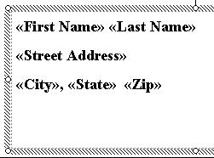

Notice how the "Field Names" from the Access database (above) have replaced the default address lines. You may have to do a little “editing” of the fields after you have closed the Insert Merge Field menu. Simply click-in the Address box area and adjust spacing, insert commas, etc. Line Spacing in Publisher 2002 is found in the Menu Bar. Click-on Format and then on Line Spacing.
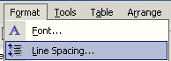

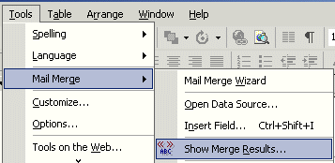
To create the merge of the names and addresses in our database to the brochure we need to do the following: click-on Tools in the Menu Bar, then click-on Mail Merge, and then click-on Show Merge Results.

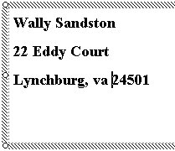

When we click-on Show Merge Results, several “things” happen very quickly. First, you’ll notice that the first name in the database appears in the address area (image on right).

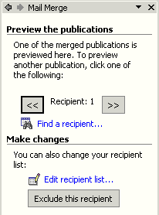

In this case there are 26 people in the database and we are looking at the first database record.

You’ll also see that a Mail Merge Task Pane has appeared on the left side of your screen (like the one at the left).

If we click on the next button ( >> ), we will see the next person.

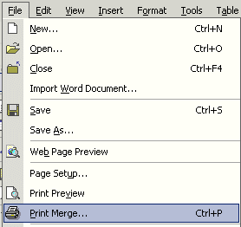

If we are satisfied with our results, we can now print our 26 brochures. Publisher 2002 “knows” that you desire to print a mail merged brochure. So, when you click-on Print in the Menu Bar, You’ll see a special print feature: Print Merge.

When you click-on Print Merge, the following Print Merge menu screen appears. Notice, that Publisher 2002 “knows” that there are 26 individual brochures to print. You can print all 26 or, you can print selected brochures by using the Entries from feature. When you are ready to print, click-on OK.
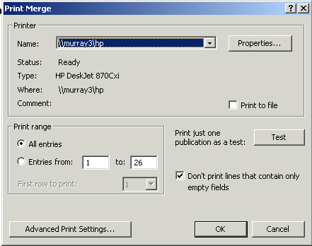

Don't forget - if you make a mistake you can always click-on the blue undo arrow and try again.

Well that's about all for the Brochure. Now we'll move on to the Newsletter.

Zoom-out one more time and look at your whole brochure.

Don't forget to Save your Brochure.

Final Brochure Observations

All of the skills you learned in creating your Flyer and Brochure can be used in the Newsletter. All three publications have Title and Text Boxes, Personal Information Text Boxes, Images, Logos, text to edit or replace with your text. You may group or ungroup objects, change color schemes, and fonts. In the brochure we also covered addressing the brochures and objects with captions. So, when these common tasks are used in the Newsletter we will not cover them again. We will only cover additional new skills in creating this last publication.
If you still have your Brochure open, please close it. Click-on File in the Menu Bar and then on Close. In most other Microsoft software the current document on which you are working can also be closed by clicking-on the small lower "X" in the upper right corner of the screen. In Publisher you do not have this "X," so if you click-on the single "X," It will completely exit from Publisher. If this occurs, it's no big deal. Simply start Publisher again and you will be ready to go.
Newsletters

If you closed the Brochure, as indicated above, you will see the New Publication Task Pane on the left side of your screen. On the right side of your screen you will see a large piece of blank paper.

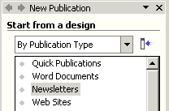
Look at the Start from a design area on the left side of the screen, and run the cursor down to Newsletters and click-on it.
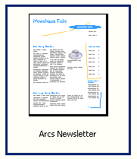

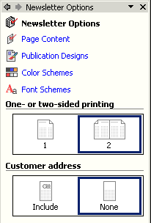
Now look in the upper row of Newsletters on the right. We'll select the Arcs Newsletter just like we used the Arcs Informational Flyer and Brochure.

To select the Arcs Newsletter, click-on this choice. You will see the “blue square” around this selection.

As soon as you click-on Arcs Newsletter, the Newsletter Options Task Pane will appear on the left side of your screen and the Arcs Newsletter template on the right side of your screen.

Take a few minutes to look at the Newsletter Options Task Pane. Notice that Page Content, Publication Designs, Color Schemes, and Font Schemes appear at the top of this Task Pane – just like they did in the Flyer and Brochure Task Panes.

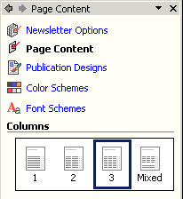
We’ll look at each selection in the Newsletter Options Task Pane. First, we’ll click-on Page Content.

Notice that there are four choices. The current selection is three columns. You will notice that the Newsletter to the right of the Page Content Task Pane, logically shows three columns. Now click-on the 1 column choice and watch the Newsletter at the right change to one column. Now try 2 columns. Finally try Mixed. By now you should see how neatly Publisher makes each change so that you can instantly see the results.

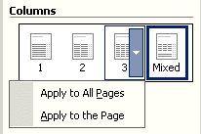
As you move your cursor over each choice and select it, you may notice that a small, down triangle appears on the right side of the first three choices. If you click-on the triangle, you’ll see that you can apply column changes to all Pages, or just on the Page you’ve selected. At the bottom of the screen you’ll notice that the default newsletter has four Pages (like the image below).

As you click-on the choices, also click-on the Pages and you’ll be able to see this “happen.”

The Apply to All Pages, Apply to the Page, and Mixed Pages are all NEW with Publisher 2002! Really neat and handy features.
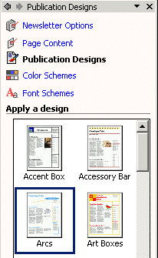

The next selection in the Newsletter Task Pane is Publication Designs. This is the same choice as Flyers and Brochures. At any time you can change the Design of your Newsletter. We’ll leave ours at Arcs for this tutorial. You can select whatever you desire.

We’ll use three columns, so please click-on 3 columns so you’ll “match us” for this tutorial. When you become more proficient with Publisher 2002, choose any design you desire.

You choose the Color Scheme and Font Scheme that you desire.. We’ll select Burgundy and Times New Roman again.
We’ll now return to the Newsletter Options Task Pane.

The Newsletter we created has four “sides.” Notice, at the bottom of the Newsletter screen’ that there are four Pages in this default Newsletter.

As you clicked through the Pages of the Newsletter, you noticed that when you clicked-on Page 2, that both Pages 2 and 3 appeared together. You may print your Newsletters yourself, or at your college or business printing plant. Many will probably send their Newsletters out to a commercial printer. We have found that the commercial printers desire/require that you print each Page separately.

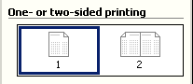
You’re commercial printer may ask that you send them each newsletter Page on a separate sheet of paper. That is what the One- or two-sided printing choice in the Newsletter Options Task Pane is for. To “see” what occurs if you need to do this, click-on the One Page choice.

A Microsoft Publisher menu screen will appear like the one below. Click-on Yes.
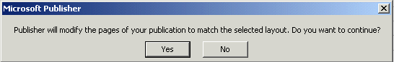

After you click-on Yes, look at the “new” formatting of your Pages at the bottom of the screen. They’ll look like the image on the right. Compare this image to the one above. Notice how the upper right corner of each Page is now “turned down.” This indicates that each Page will appear and be printed separately. Click-on each Page and you’ll see this is true.

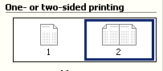
We’ll leave the layout of the tutorial Newsletter in the Double-sided default (indicated at the left) in order to illustrate something later. So, click-on 2 Page view and you’ll be returned to the original newsletter layout.

Click-on Page 4 at the bottom of the screen. Your Pages should now look like the image at the right. You’ll see Page 4 on the right side of your screen.

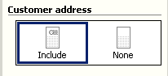
We can also have a mailing address in our newsletter, just like we did in our brochure. Click-on Include in the Customer address portion of the Newsletter Options Task Pane.

Now look at the last Page of your newsletter. You’ll see that an area for a mailing address has been added to the fourth Page. You can leave your Page 4 with an address area, or click-on None and have an area for an additional story.

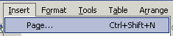
You can easily add more Pages to your newsletter as you desire. Simply click-on Insert in the Menu Bar and then click-on Page. An Insert Pages menu screen will appear. Publisher will insert two Pages if you click-on OK.

Click-on Page 2, then 3, and then 4. Pause on each Page and get a “feel” for its layout.
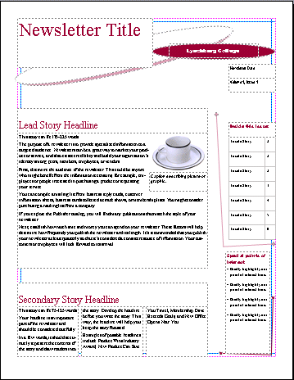
Now return to Page 1, click-on Page 1.

Notice that you have already mastered a number of the items on the front Page of the Newsletter. In the top left is a simple
Text Box. You can change the Newsletter Title to your title. On the right at the top is another Grouped Text box like you mastered in the Flyer and Brochure. The coffee cup and caption are also familiar from the Brochure. The Lead Story Headline and Secondary Story Headline titles are simple text boxes. We will focus on the three column text boxes and two new boxes on the right edge of the first Page of the Newsletter. The arrows to the left indicate these boxes. First we’ll look at the upper right box. Click-on the upper box and tap F9 to zoom-in on it.

Copying Titles from Headlines into Inside this issue:

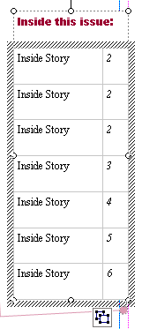

This is a Table of Contents for the Newsletter. We’ll go to Page 2 in a minute and learn how to insert the title from a story that is on Page 2. To go to Page 2 click-on the Page 2 “button” at the bottom of the screen.

You will now be on Pages 2 and 3. If you are not zoomed-out, tap the F9 key to do so now. Look at the upper left corner of Page 2. Notice the title: Inside Story Headline. Click-on this title and then tap F9 to zoom-in.

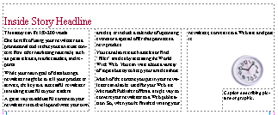

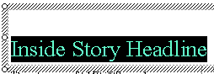
Replace this Inside Story Headline – a text box – with a headline of your choice. We’ll stick with our hamburger theme and our headline will be: Arts Make the Best Burgers in the Burg.

Our Headline at the top of Page 2 now looks like the one above. We’ll now “copy” this title to the Inside this issue table of contents on Page 1. To do this, first highlight your title at the top of Page 2. Click to the left of the title, hold down the left mouse button, and move the cursor over your title. It should be highlighted like our title at the top of the next page. If you are unable to do this on your first attempt, try again until your highlight looks like the one at the top of the next Page.
We’ll now copy this title to the Inside this issue Table of Contents on the first Page.


Now that the text is highlighted we have two choices to copy this text.

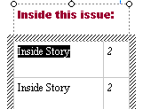
Method One: Click-on Edit in the Menu Bar and then, in the drop down menu, click-on Copy. Then click-on the Page 1 button at the bottom of the screen. Move around the screen until you can see the Inside this issue box. When you have located the box, highlight Inside Story in the top box. Then click-on Edit in the Menu Bar again, in the drop down menu that appears, click-on Paste. Some of your headline from Page 2 will now show in this area (like the image below).

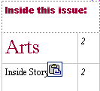
Method 2: Make sure that your headline is highlighted on Page 2. Then you can click-on the Copy button in the button bar at the top of the screen (instead of Edit-Copy in the Menu Bar). When you return to Page 1, and highlight Inside Story as we did above, you can now click-on the Paste button, in the button bar, to paste the title into the text box.
Copy Paste
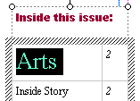

Now highlight your headline in the Inside this issue: box. It should look like the one to the right when you have done this correctly. It is obvious that the text font size is way too big for the box. So, we’ll have to make the text font smaller. At the top of the screen, on the left, in the button bar, is a font size area.

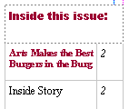

Click the small down triangle on the right side of the font size box and change the font size to 8 (as shown above). Your headline title from Page 2 should now fit nicely in this box (like the box at the right).

Text Overflow and Editing Your Newsletter Stories

A very important "thing" to keep in mind when you are working with Newsletters.

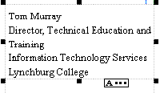
In any publisher product, when the text becomes "too big" to fit in the box where it is being entered, a small overflow indicator will appear as we've indicated earlier. The A… tells us that there are just too many words to fit in the text box were using. This is called Text Overflow.

When we are working with Newsletter stories we’ll find that the articles that we are typing will go "down" a newspaper type column, and when they get to the bottom of a column, they'll go to the top of the next column and go down, and so on. If you run out of room in any Newsletter article you will see the little A… at the bottom of the last column that is included in the story.

Microsoft Publisher 2002 Arcs Newsletter has various "pre-sized" groups of columns for your stories. You might have noticed this when you were looking at each Page of the Newsletter earlier. Now we'll concentrate on Text Overflow.

To show you how this is accomplished it might be best to be able to "see" this happen. So, if you are not zoomed-out, do so by tapping the F9 key. Once you can see the whole Newsletter, click-on the 2 or 3 Page "button" at the bottom of the screen. We used the Newsletter Options Task Pane to create this Newsletter and we "set the Pages" so that you could see both Pages 2 and 3 at the same time. This is why we did it. The top of Pages 2 and 3 should look something like those below (your Inside Story Headline may be different from the one we used).

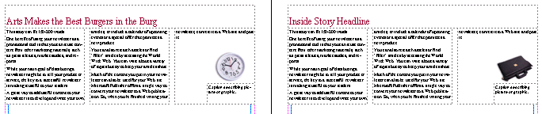

The first thing we'll do to show you Text Overflow is to create an area to "hold" the Text Overflow, when it occurs. To begin this process, click-in the story area at the top of Page 3 (see arrow above). The story at the top of Page 3 should be completely highlighted in black and look like the image at the top of the next page.

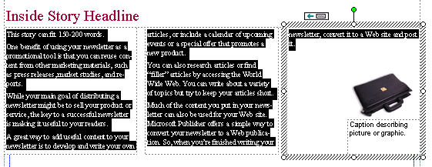

Before we delete this text, to create an area for Text Overflow, notice the little box in the upper right hand corner of the Inside Story Headline article above (arrow). This little box indicates that the text in the third column in the article "flowed" from the bottom of the second column in this story.
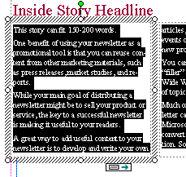

Now carefully click-on the bottom of the first column of the Inside Story Headline. You may have to try several times to get the image you see to the left. This indicates that this story, which begins in the left column, flows from the bottom of the column into column two (the middle column). Later, when you get used to seeing these little buttons at the top or bottom of story columns you'll be able to click-on them and, when you click, you will be "taken" to the next column where you can continue to enter text.

After you have successfully completed the above steps, click-again so that all of the text is highlighted in the story at the top of Page 3 (picture at the top of this page).

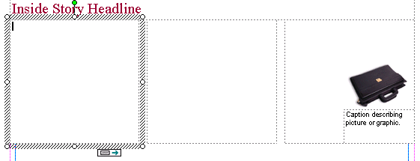
When all the text in the story is again highlighted, tap the Delete key to remove all of the text in this story. Your Page 3 top story should now look like the image below.

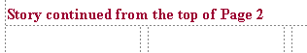
If you desire to delete the Inside Story Headline above, and/or replace it with other text, or leave it blank, you may do so. We're going to replace the text at the top of our Page 3 with: Story continued from the top of Page 2. Well make the font a little smaller since this is no longer a story headline. Our Text, at the top of the first column on Page 3, now looks like the image above.

The top areas of Pages 2 and 3 should now look like the image below.

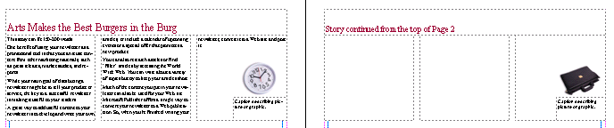

Now click anywhere in the story at the top of Page 2. The entire story should be highlighted in black and look like the image below.

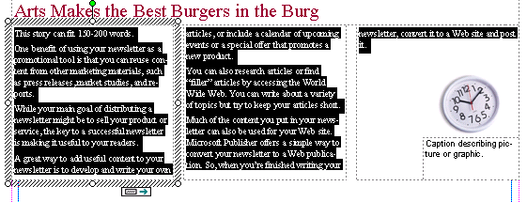

This is the story that we desire to edit until it becomes "too BIG" to fit in the three columns at the top of Page 2. To begin the editing we'll do the same thing we did in the Flyer - edit our story in Microsoft Word. RIGHT-click anywhere in the black highlighted area at the top of Page 2.
When the drop down menu appears move down to Change Text, and when the Change Text drop down menu appears, move down to the bottom choice: Edit Story in Microsoft Word. Microsoft Word will now load, just like it did for the Flyer. Read the text in this story in Microsoft Word. Publisher again uses this text to explain about how this Text Box area is used. It indicates that the story contained in the box is about 150-200 words long. So, later, when you are using this Publisher Newsletter template to create your own "real" Newsletter, you can type a story in Word, or any word processor, that is about 150 to 200 words long, and copy the story from your word processor into this space at the top of Page 2.

Move to the end of the story, in Microsoft Word and type-in the following:

We are learning about how Text Overflow works. We can see that the text at the top of Page 2 does not fill the three columns that make up this story. So, we are adding this text to create a Word Overflow condition. We'll keep typing until this occurs. Since the tutorial said to type all of this, the tutorial author must know how much text it takes to create a Text Overflow condition. We'll now click-on File in the Menu Bar above and then on and the click-on Close & Return to Newsletter.pub. (Note: the name the authors used for their Newsletter was Newsletter.pub - my menu will indicate the name of my Newsletter.)
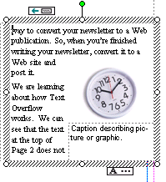
After you have chosen File - Close & Return to Newsletter.pub, you will see that your three text columns at the top of Page 2 are "full." If you click-on the third column, and it may take a few tries to do this, you will eventually see the over flow condition which looks like the image to the left. At the bottom of the column you now see a Text Overflow indicator: A…. When you can see the indicator a small "chain link" will appear at the top of the screen in the right side of the button bar. This chain link only appears when there is a Text Overflow condition.

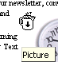

Now, click the left mouse button on the chain link. When you do the chain link will appear "depressed" (as seen in the picture to the left). Now move the mouse cursor over the text at the top of Page 2. As you move it over the text you will notice the cursor "changes" to a little measuring cup that seems to be "full of alphabet characters" (you'll almost need a magnifying glass to see this). This "full cup" indicates that it contains the all Text Overflow from the text columns at the top of Page 2. Anywhere you move on Page 2 the cup will remain upright. Now, carefully move the cup over the empty text area you created at the top of Page 3. As soon as you move the cursor over this empty area, you will see the cup "tip" a bit and will see the letters appear to be "pouring" from the cup (like the cup image on the right). This means that you can “pour” the Text Overflow into the area at the top of Page 3. To do this, when you see the "spilling" cup in the Page 3 blank area, click the left mouse button.
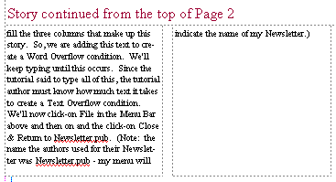

As soon as you click the button you will see the first column at the top of Page three “fill” with the Text Overflow. Your text area at the top of Page 3 will look similar to the one at the right.
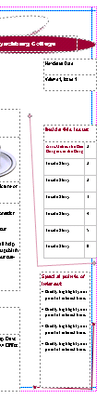
Now we’ll look at the Newsletter, Page by Page, to determine if there are any other Publisher features that we have not covered in the Flyer, Brochure, and Newsletter. You are probably looking at the Page 2 and 3 screen, since we just finished learning about Text Overflow. So, we’ll logically start on Page 1, so click-on the Page 1 button at the bottom of the screen.

To view Page 1 better, tap the F9 key to zoom-out, if you cannot view the whole Page.

When we look at the first Page of the Newsletter at the left there are only two things that we have not mentioned. However, you have already, mastered the skills to change them. The first is in the upper right corner, the second in the lower right corner (see arrows).

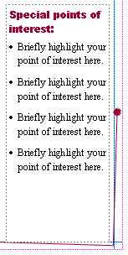
You already know how to change the Newsletter Title in the upper left corner, the Title Box in the upper right corner, the “cup” Clip Art and caption, and the two stories on the front Page of the Newsletter. When we look at the other two “things,” you will see that you already know how to edit them as well.

Special Points of Interest Text Box

Let’s look at the lower right text area first. Click-on this Text Box in the lower right corner, and then tap the F9 key to zoom in on the box. When you get a closer look at this Special points of interest Text Box you see that it is simply a standard text box, with bullets, which highlight topics in the Newsletter. So, as with any text box, all you have to do is change the text to focus on special articles in your Newsletter. No big deal! You can do this easily now.

Newsletter Date, Volume and Issue

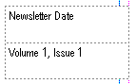
Now move up to the text box above the Special points of interest text box. Again, no big deal. Another Text Box. This text box allows you to date your Newsletter, and enter the Volume and Issue numbers. An easy task for you at this stage.

Now let’s look at the second and third Pages.
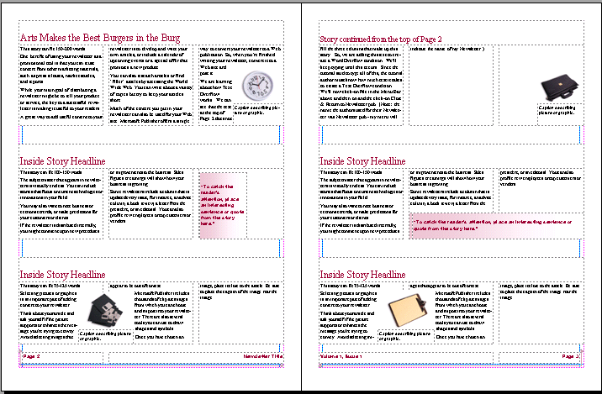

Again, no big deal for you. Everything on these two Pages is either an article, captioned clip art, or text box. The only, slightly new “things” are the “color shaded” text boxes above (see arrows in image at the bottom of the last page). Let’s take a moment to look at one of these. We’ll look at the image on Page two that is marked by the arrow on the last page.

Shaded Text Boxes
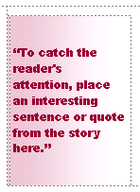
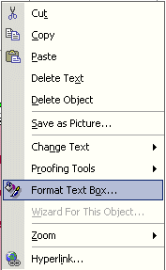
Editing the text in this Text Box is an easy task at this point. Notice, when you look at the text in Publisher that the font is colored in the color scheme you chose. More importantly, notice that the Text Box has “shading,” in your color scheme, across the text box.

Click-right on the shaded text box. Then, move your cursor down to Format Text Box and click the left mouse button.

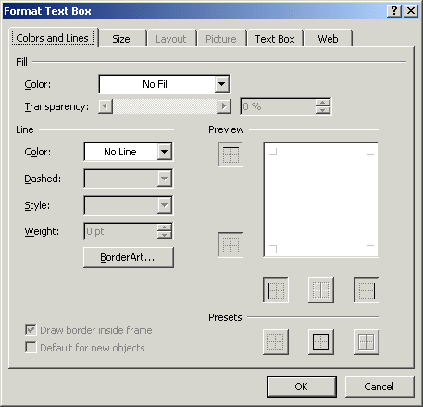
The following Format Text Box menu will appear.

Move your cursor over the small down triangle to the right of No Fill (see arrow on left). Click-on the triangle and the menu screen below will appear.
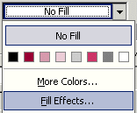

Click-on Fill Effects.

The following Fill Effects menu screen will appear.
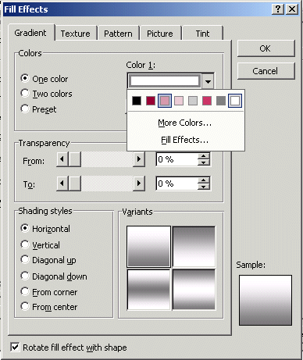

Click-in the small circle to the left of One color (see arrow).

A Color 1 “color box” will appear to the right of One color. Click-on the small down triangle on the right of the Color 1 box. You will see the color menu appear below the box. We selected the third color from the left. You can choose any color you desire for shading your text box (see arrows above on right).

When we selected this color, the Fill Effects menu screen “changed” to look like the one below.

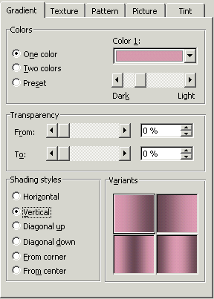

We noticed that the Variants area in the lower right corner of the menu screen changed to four variations with our color.

We then clicked-in the small circle to the left of Vertical. The screen changed to what you see on the left.

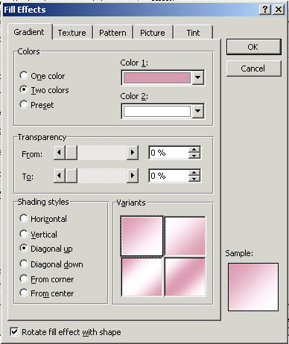

To complete our Fill Effects, we clicked-in the small circle to the left of Two colors.

We chose white as our second color.

We then moved down the menu screen and clicked in the small circle to the left of Diagonal up. The four Variants appeared in the lower right corner of our image.

We clicked-on the Variant in the upper left corner of the Variant area.

We liked this shading, so we then clicked OK.

Then click-on OK a second time.

Go ahead and experiment. Each time you select a different Shading style the Sample in the lower right corner will show you how your shading will appear. Also, when you select a different Base color: and Color 2: you will see the effects in the Sample area.

Go ahead and try a few Shading styles. When you find one you like, click-on OK.

Now, zoom-out again by tapping the F9 key. Then click-on Page 4 at the bottom of the screen.

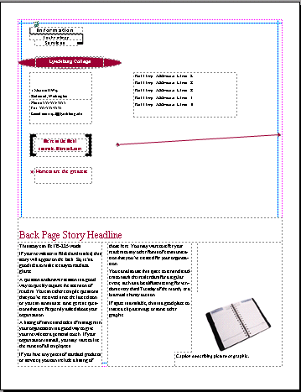

Notice that the top portion of Page 4 contains a Title Grouped Box, a Logo Box, your home address box, and a Customer’s Address Box – all tasks that you have accomplished in the Flyer and Brochure.

The lower portion of Page 4 is simply another “story” and captioned clip art box. Again something that you have mastered in this tutorial.

Don’t forget to SAVE!

Congratulations. You have now successfully completed three publications

Some Final Notes:

Web Help

When you are working in Microsoft Publisher 2002, if you desire “instant” assistance on a feature in Publisher, there is a web connection in the program if you are “on-line.” If you click-on Help in the Menu bar and then click-on Office on the Web, you will be linked to a main assistance screen for the Microsoft Office XP/2002. Simply click-on the link to the geographic area in which you are located, and the click-on Publisher. Often we find that someone else has already asked the same question – so a good first place to check is Frequently Asked Questions.

Publisher Design Gallery

You have utilized the features of each Task Pane to design a Flyer, Brochure, and Newsletter. Many of the objects that were a part of the default publications can be easily accessed again, at any time you are editing a publication by clicking-on Design Publications in the Task Pane.

What now?

If you desire to further your knowledge of Microsoft Publisher 2002, you might want to purchase a good advanced reference manual. The one we like best is Microsoft Press’s Microsoft Office XP – Inside Out.

If you have any questions or comments please contact:

murray.t@lynchburg.edu

Thank you for your time and patience.

