Caroline Myss

http://en.wikipedia.org/wiki/Caroline_Myss

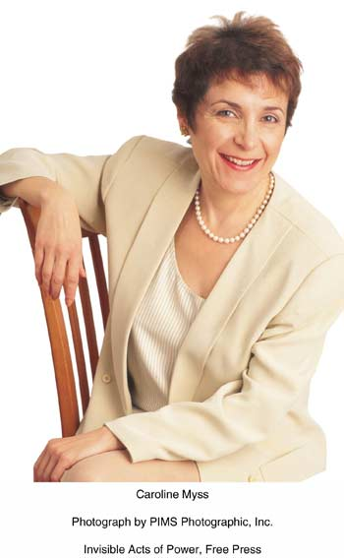

Caroline Myss (pronounced mace) is an American medical intuitive and mystic as well as the author of numerous books and audiotapes, including national bestsellers.^{[citation needed]}
Myss holds a Bachelor of Arts degree in journalism from the Saint Mary-of-the-Woods College in Indiana, and a master's degree in theology from Mundelein College. She also claims to hold a Ph.D in "intuition and energy medicine", but the degree was granted by Greenwich University, a now-defunct correspondence school that was never accred to deliver higher education awards by any recognised government accration authority.
She has collaborated extensively with Dr. Norman Shealy, an M.D. schooled at Harvard.^{[citation needed]} She tours internationally as a speaker on spirituality and lives in Chicago.

[] Books and recordings
- Anatomy of the Spirit
- Why People Don't Heal and How They Can
- Spiritual Madness
- Spiritual Power, Spiritual Practice
- Three Levels of Power and How to Use Them
- The Creation of Health
- Sacred Contracts: Awakening Your Divine Potential
- Invisible Acts of Power: Personal Choices that Create Miracles

[] External links
- Myss.com
- Caroline Myss MP3 audio - from Shift in Action, sponsored by Institute of Noetic Sciences
- Unproven Claims of Caroline Myss

==============================================================================================================================
END

