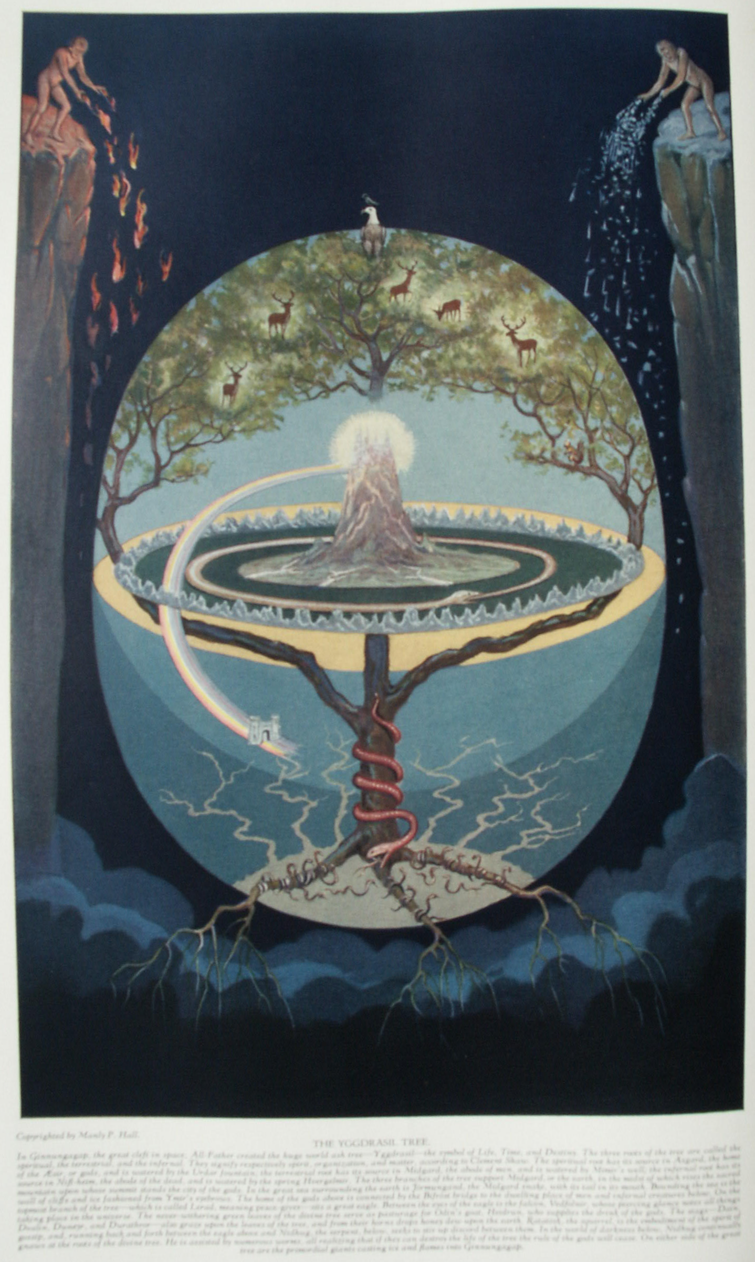

**Flowers, Plants, Fruits and Trees**

**The Secret Teachings of All Ages - Manly P. Hall 1928**

**FLOWERS, PLANTS, FRUITS, AND TREES  
The flower, a phallic symbol--The lotus blossom--The Scandinavian World Tree, Yggdrasil--The sprig of acacia--The juice of the grape--The magical powers of the mandrake.**

THE yoni and phallus were worshiped by nearly all ancient peoples as appropriate symbols of God's creative power. The Garden of Eden, the Ark, the Gate of the Temple, the Veil of the Mysteries, the *vesica piscis* or oval nimbus, and the Holy Grail are important yonic symbols; the pyramid, the obelisk, the cone, the candle, the tower, the Celtic monolith, the spire, the campanile, the Maypole, and the Sacred Spear are symbolic of the phallus. In treating the subject of Priapic worship, too many modern authors judge pagan standards by their own and wallow in the mire of self-created vulgarity. The Eleusinian Mysteries--the greatest of all the ancient secret societies--established one of the highest known standards of morality and ethics, and those criticizing their use of phallic symbols should ponder the trenchant words of King Edward III, "*Honi soit qui mal y pense*."

The obscene rites practiced by the later Bacchanalia and Dionysia were no more representative of the standards of purity originally upheld by the Mysteries than the orgies occasionally occurring among the adherents of Christianity till the eighteenth century were representative of primitive Christianity. Sir William Hamilton, British Minister at the Court of Naples, declares that in 1780, Isernia, a community of Christians in Italy, worshiped with phallic ceremonies the pagan god Priapus under the name of St. Cosmo. (See *Two Essays on the Worship of Priapus*, by Richard Payne Knight.)

Father, mother, and child constitute the natural trinity. The Mysteries glorified the home as the supreme institution consisting of this trinity functioning as a unit. Pythagoras likened the universe to the family, declaring that as the supreme fire of the universe was in the midst of its heavenly bodies, so, by analogy, the supreme fire of the world was upon its hearthstones. The Pythagorean and other schools of philosophy conceived the one divine nature of God to manifest itself in the threefold aspect of Father, Mother, and Child. These three constituted the Divine Family, whose dwelling place is creation and whose natural and peculiar symbol is the 47th problem of Euclid. God the Father is spirit, God the Mother is matter, and God the Child--the product of the two--represents the sum of living things born out of and constituting Nature. The seed of spirit is sown in the womb of matter, and by an immaculate (pure) conception the progeny is brought into being. Is not this the true mystery of the Madonna holding the Holy Babe in her arms? Who dares to say that such symbolism is improper? The mystery of life is the supreme mystery, revealed in all of its divine dignity and glorified as Nature's per feet achievement by the initiated sages and seers of all ages.

The prudery of today, however, declares this same mystery to be unfit for the consideration of holy-minded people. Contrary to the dictates of reason, a standard has been established which affirms that innocence bred of ignorance is more to be desired than virtue born of knowledge. Eventually, however, man will learn that he need never be ashamed of truth. Until he does learn this, he is false to his God, to his world, and to himself. In this respect, Christianity has woefully failed in its mission. While declaring man's body to be the living temple of the living God, in the same breath it asserts the substances and functions of this temple to be unclean and their study defiling to the sensitive sentiments of the righteous. By this unwholesome attitude, man's body--the house of God--is degraded and defamed. Yet the cross itself is the oldest of phallic emblems, and the lozenge-shaped windows of cathedrals are proof that yonic symbols have survived the destruction of the pagan Mysteries. The very structure of the church itself is permeated with phallicism. Remove from the Christian Church all emblems of Priapic origin and nothing is left, for even the earth upon which it stands was, because of its fertility, the first yonic symbol. As the presence of these emblems of the generative processes is either unknown or unheeded by the majority, the irony of the situation is not generally appreciated. Only those conversant with the secret language of antiquity are capable of understanding the divine significance of these emblems.

Flowers were chosen as symbols for many reasons. The great variety of flora made it possible to find some plant or flower which would be a suitable figure for nearly any abstract quality or condition. A plant might be chosen because of some myth connected with its origin, as the stories of Daphne and Narcissus; because of the peculiar environment in which it thrived, as the orchid and the fungus; because of its significant shape, as the passion flower and the Easter lily; because of its brilliance or fragrance, as the verbena and the sweet lavender; because it preserved its form indefinitely, as the everlasting flower; because of unusual characteristics as the sunflower and heliotrope, which have long been sacred because of their affinity for the sun.

The plant might also be considered worthy of veneration because from its crushed leaves, petals, stalks, or roots could be extracted healing unctions, essences, or drugs affecting the nature and intelligence of human beings--such as the poppy and the ancient herbs of prophecy. The plant might also be regarded as efficacious in the cure of many diseases because its fruit, leaves, petals, or roots bore a resemblance in shape or color to parts or organs of the human body. For example, the distilled juices of certain species of ferns, also the hairy moss growing upon oaks, and the thistledown were said to have the power of growing hair; the *dentaria*, which resembles a tooth in shape, was said to cure the toothache; and the *palma Christi* plant, because of its shape, cured all afflictions of the hands.

The blossom is really the reproductive system of the plant and is therefore singularly appropriate as a symbol of sexual purity--an absolute requisite of the ancient Mysteries. Thus the flower signifies this ideal of beauty and regeneration which must ultimately take the place of lust and degeneracy.

Of all symbolic flowers the locus blossom of India and Egypt and the rose of the Rosicrucians are the most important. In their symbolism these two flowers are considered identical. The esoteric doctrines for which the Eastern lotus stands have been perpetuated in modern Europe under the form of the rose. The rose and the lotus are yonic emblems, signifying primarily the maternal creative mystery, while the Easter lily is considered to be phallic.

The Brahmin and Egyptian initiates, who undoubtedly understood the secret systems of spiritual culture whereby the latent centers of cosmic energy in man may be stimulated, employed the lotus blossoms to represent the spinning vortices of spiritual energy located at various points along the spinal column and called *chakras*, or whirling wheels, by the Hindus. Seven of these *chakras* are of prime importance and have their individual correspondences in the nerve ganglia and plexuses. According to the secret schools, the sacral ganglion is called the four-petaled lotus; the prostatic plexus, the six-petaled lotus; the epigastric plexus and navel, the ten-petaled lotus; the cardiac plexus, the twelve-petaled lotus; the pharyngeal plexus, the sixteen-petaled locus; the cavernous plexus, the two-petaled lotus; and the pineal gland or adjacent unknown center, the thousand-petaled locus. The color, size, and number of petals upon the lotus are the keys to its symbolic import. A hint concerning the unfoldment of spiritual understanding according to the secret science of the Mysteries is found in the story of Aaron's rod that budded, and also in Wagner's great opera, *Tannhäuser*, where the budding staff of the Pope signifies the unfolding blossoms upon the sacred rod of the Mysteries--the spinal column.

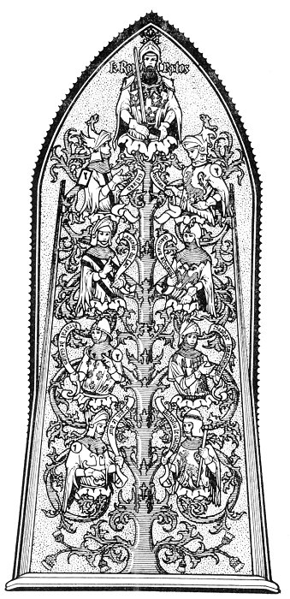  
THE TREE OF THE KNIGHTS OF THE ROUND TABLE.

*This remarkable example of the use of the tree in symbolism is from the Chateau de Pierrefonds in the little town of Pierrefonds, northern France. The eight side branches end in conventional cup-like flowers, from each of which rises the body of a knight carrying in his hand a ribbon bearing his name. The central stem is surmounted by a larger flower, from which emerges the body of King Arthur himself. The tree is a favorite motif in heraldry. The one trunk with its multitude of branches caused the tree to be frequently used in diagramming family lineage, from which practice has arisen the custom of terming such tables "family trees."*

The Rosicrucians used a garland of roses to signify the same spiritual vortices, which are referred to in the Bible as the seven lamps of the candlestick and the seven churches of Asia. In the 1642 edition of Sir Francis Bacon's *History of Henry the Seventh* is a frontispiece showing Lord Bacon with Rosicrucian roses for shoe buckles.

In the Hindu system of philosophy, each petal of the lotus bears a certain symbol which gives an added clue to the meaning of the flower. The Orientals also used the lotus plant to signify the growth of man through the three periods of human consciousness--ignorance, endeavor, and understanding. As the lotus exists in three elements (earth, water, and air) so man lives in three worlds--material, intellectual, and spiritual. As the plant, with its roots in the mud and the slime, grows upward through the water and finally blossoms forth in the light and air, so the spiritual growth of man is upward from the darkness of base action and desire into the light of truth and understanding, the water serving as a symbol of the ever-changing world of illusion through which the soul must pass in its struggle to reach the state of spiritual illumination. The rose and its Eastern equivalent, the lotus, like all beautiful flowers, represent spiritual unfoldment and attainment: hence, the Eastern deities are often shown seated upon the open petals of the lotus blossoms.

The lotus was also a universal motif in Egyptian art and architecture. The roofs of many temples were upheld by lotus columns, signifying the eternal wisdom; and the lotus-headed scepter--symbolic of self-unfoldment and divine prerogative--was often carried in religious processions. When the flower had nine petals, it was symbolic of man; when twelve, of the universe and the gods; when seven, of the planets and the law; when five, of the senses and the Mysteries; and when three, of the chief deities and the worlds. The heraldic rose of the Middle Ages generally has either five or ten petals thereby showing its relationship to the spiritual mystery of man through the Pythagorean pentad and decad.

**CULTUS ARBORUM**

The worship of trees as proxies of Divinity was prevalent throughout the ancient world. Temples were often built in the heart of sacred groves, and nocturnal ceremonials were conducted under the wide-spreading branches of great trees, fantastically decorated and festooned in honor of their patron deities. In many instances the trees themselves were believed to possess the attributes of divine power and intelligence, and therefore supplications were often addressed to them. The beauty, dignity, massiveness, and strength of oaks, elms, and cedars led to their adoption as symbols of power, integrity, permanence, virility, and divine protection.

Several ancient peoples--notably the Hindus and Scandinavians---regarded the Macrocosm, or Grand Universe, as a divine tree growing from a single seed sown in space. The Greeks, Persians, Chaldeans, and Japanese have legends describing the axle tree or reed upon which the earth revolves. Kapila declares the universe to be the eternal tree, Brahma, which springs from an imperceptible and intangible seed--the material monad. The mediæval Qabbalists represented creation as a tree with its roots in the reality of spirit and its branches in the illusion of tangible existence. The Sephirothic tree of the Qabbalah was therefore inverted, with its roots in heaven and its branches upon the earth. Madam Blavatsky notes that the Great Pyramid was considered to be a symbol of this inverted tree, with its root at the apex of the pyramid and its branches diverging in four streams towards the base.

The Scandinavian world-tree, Yggdrasil, supports on its branches nine spheres or worlds,--which the Egyptians symbolized by the nine stamens of the persea or avocado. All of these are enclosed within the mysterious tenth sphere or cosmic egg--the definitionless Cipher of the Mysteries. The Qabbalistic tree of the Jews also consists of nine branches, or worlds, emanating from the First Cause or Crown, which surrounds its emanations as the shell surrounds the egg. The single source of life and the endless diversity of its expression has a perfect analogy in the structure of the tree. The trunk represents the single origin of all diversity; the roots, deeply imbedded in the dark earth, are symbolic of divine nutriment; and its multiplicity of branches spreading from the central trunk represent the infinity of universal effects dependent upon a single cause.

The tree has also been accepted as symbolic of the Microcosm, that is, man. According to the esoteric doctrine, man first exists potentially within the body of the world-tree and later blossoms forth into objective manifestation upon its branches. According to an early Greek Mystery myth, the god Zeus fabricated the third race of men from ash trees. The serpent so often shown wound around the trunk of the tree usually signifies the mind--the power of thought--and is the eternal tempter or urge which leads all rational creatures to the ultimate discovery of reality and thus overthrows the rule of the gods. The serpent hidden in the foliage of the universal tree represents the cosmic mind; and in the human tree, the individualized intellect.

The concept that all life originates from seeds caused grain and various plants to be accepted as emblematic of the human spermatozoon, and the tree was therefore symbolic of organized life unfolding from its primitive germ. The growth of the universe from its primitive seed may be likened to the growth of the mighty oak from the tiny acorn. While the tree is apparently much greater than its own source, nevertheless that source contains potentially every branch, twig, and leaf which will later be objectively unfolded by the processes of growth.

Man's veneration for trees as symbols of the abstract qualities of wisdom and integrity also led him to designate as trees those individuals who possessed these divine qualities to an apparently superhuman degree. Highly illumined philosophers and priests were therefore often referred to as *trees* or *tree men*--for example, the Druids, whose name, according to one interpretation, signifies *the men of the oak trees*, or the initiates of certain Syrian Mysteries who were called *cedars*; in fact it is far more credible and probable that the famous *cedars of Lebanon*, cut down for the building of King Solomon's Temple, were really illumined, initiated sages. The mystic knows that the true supports of God's Glorious House were not the logs subject to decay but the immortal and imperishable intellects of the tree hierophants.

Trees are repeatedly mentioned in the Old and New Testaments, and in the scriptures of various pagan nations. The Tree of Life and the Tree of the Knowledge of Good and Evil mentioned in Genesis, the burning bush in which the angel appeared to Moses, the famous vine and fig tree of the New Testament, the grove of olives in the Garden of Gethsemane where Jesus went to pray, and the miraculous tree of Revelation, which bore twelve manners of fruit and whose leaves were for the healing of the nations, all bear witness to the esteem in which trees were held by the scribes of Holy Writ. Buddha received his illumination while under the *bodhi* tree, near Madras in India, and several of the Eastern gods are pictured sitting in meditation beneath the spreading branches of mighty trees. Many of the great sages and saviors carried wands, rods, or staves cut from the wood of sacred trees, as the rods of Moses and Aaron; Gungnir--the spear of Odin--cut from the Tree of Life; and the consecrated rod of Hermes, around which the fighting serpents entwined themselves.

The numerous uses which the ancients made of the tree and its products are factors in its symbolism. Its worship was, to a certain degree, based upon its usefulness. Of this J. P. Lundy writes: "Trees occupy such an important place in the economy of nature by way of attracting and retaining moisture, and shading the water-sources and the soil so as to prevent barrenness and desolation; the), are so useful to man for shade, for fruit, for medicine, for fuel, for building houses and ships, for furniture, for almost every department of life, that it is no wonder that some of the more conspicuous ones, such as the oak, the pine, the palm, and the sycamore, have been made sacred and used for worship." (See *Monumental Christianity*.)

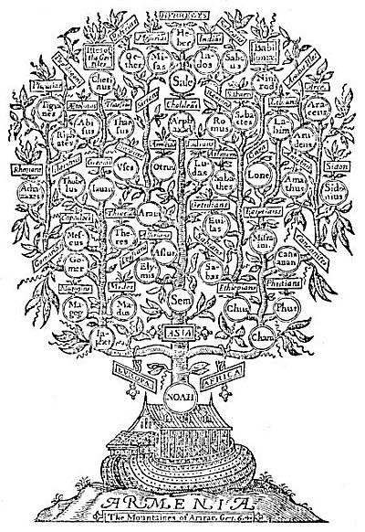  
THE TREE OF NOAH.

From the "*Breeches*" *Bible of 1599*.

*Most Bibles published during the Middle Ages contain a section devoted to genealogical tables showing the descent of humanity from Father Adam to the advent of Jesus Christ. The tree growing from the roof of the Ark represents the body of Noah and its three branches, his sons--Shem, Ham, and Japheth. The nations by the descendents of Noah's three sons are appropriately shown in the circles upon the branches of the tree. While such tables are hopelessly incorrect from a historical point of view, to the symbolist their allegorical interpretations are of inestimable importance.*

The early Fathers of the church sometimes used the tree to symbolize Christ. They believed that ultimately Christianity would grow up like a mighty oak and overshadow all other faiths of mankind. Because it annually discards its foliage, the tree was also looked upon as an appropriate emblem of resurrection and reincarnation, for though apparently dying each fall it blossomed forth again with renewed verdure each ensuing spring.

Under the appellations of the *Tree of Life* and the *Tree of the Knowledge of Good and Evil* is concealed the great arcanum of antiquity--the mystery of *equilibrium*. The *Tree of Life* represents the spiritual point of balance--the secret of immortality. The *Tree of the Knowledge of Good and Evil*, as its name implies, represents polarity, or unbalance--the secret of mortality. The Qabbalists reveal this by assigning the central column of their Sephirothic diagram to the *Tree of Life* and the two side branches to the *Tree of the Knowledge of Good and Evil*. "Unbalanced forces perish in the void," declares the secret work, and all is made known. The apple represents the knowledge of the procreative processes, by the awakening of which the material universe was established. The allegory of Adam and Eve in the Garden of Eden is a cosmic myth, revealing the methods of universal and individual establishment. The literal story, accepted for so many centuries by an unthinking world, is preposterous, but the creative mystery of which it is the symbol is one of Nature's profoundest verities. The Ophites (serpent worshipers) revered the Edenic snake because it was the cause of individual existence. Though humanity is still wandering in a world of good and evil, it will ultimately attain completion and eat of the fruit of the Tree of Life growing in the midst of the illusionary garden of worldly things. Thus the *Tree of Life* is also the appointed symbol of the Mysteries, and by partaking of its fruit man attains immortality.

The oak, the pine, the ash, the cypress, and the palm are the five trees of greatest symbolic importance. The Father God of the Mysteries was often worshiped under the form of an oak; the Savior God--frequently the World Martyr--in the form of a pine; the world axis and the divine nature in humanity in the form of an ash; the goddesses, or maternal principle, in the form of a cypress; and the positive pole of generation in the form of the inflorescence of the mate date palm. The pine cone is a phallic symbol of remote antiquity. The thyrsus of Bacchus--a long wand or staff surmounted by a pine cone or cluster of grapes and entwined with ivy or grape-vine leaves, sometimes ribbons--signifies that the wonders of Nature may only be accomplished by the aid of solar virility, as symbolized by the cone or grapes. In the Phrygian Mysteries, Atys--the ever-present sun-savior--dies under the branches of the pine tree (an allusion to the solar globe at the winter solstice) and for this reason the pine tree was sacred to his cult. This tree was also sacred in the Mysteries of Dionysos and Apollo.

Among the ancient Egyptians and Jews the acacia, or tamarisk, was held in the highest religious esteem; and among modern Masons, branches of acacia, cypress, cedar, or evergreen are still regarded as most significant emblems. The shittim-wood used by the children of Israel in the construction of the Tabernacle and the Ark of the Covenant was a species of acacia. In describing this sacred tree, Albert Pike has written: "The genuine acacia, also, is the thorny tamarisk, the same tree which grew around the body of Osiris. It was a sacred tree among the Arabs, who made of it the idol Al-Uzza, which Mohammed destroyed. It is abundant as a bush in the desert of Thur; and of it the 'crown of thorns' was composed, which was set on the forehead of Jesus of Nazareth. It is a fit type of immortality on account of its tenacity of life; for it has been known, when planted as a door-post, to take root again and shoot out budding boughs above the threshold." (See *Morals and Dogma*.)

It is quite possible that much of the veneration accorded the acacia is due to the peculiar attributes of the *mimosa*, or sensitive plant, with which it was often identified by the ancients. There is a Coptic legend to the effect that the sensitive plant was the first of all trees or shrubs to worship Christ. The rapid growth of the acacia and its beauty have also caused it to be regarded as emblematic of fecundity and generation.

The symbolism of the acacia is susceptible of four distinct interpretations: (1) it is the emblem of the vernal equinox--the annual resurrection of the solar deity; (2) under the form of the sensitive plant which shrinks from human touch, the acacia signifies purity and innocence, as one of the Greek meanings of its name implies; (3) it fittingly typifies human immortality and regeneration, and under the form of the evergreen represents that immortal part of man which survives the destruction of his visible nature; (4) it is the ancient and revered emblem of the Mysteries, and candidates entering the tortuous passageways in which the ceremonials were given carried in their hands branches of these sacred plants or small clusters of sanctified flowers.

Albert G. Mackey calls attention to the fact that each of the ancient Mysteries had its own peculiar plant sacred to the gods or goddesses in whose honor the rituals were celebrated. These sacred plants were later adopted as the symbols of the various degrees in which they were used. Thus, in the Mysteries of Adonis, lettuce was sacred; in the Brahmin and Egyptian rites, the lotus; among the Druids, the mistletoe; and among certain of the Greek Mysteries, the myrtle. (See *Encyclopædia of Freemasonry*.)

As the legend of CHiram Abiff is based upon the ancient Egyptian Mystery ritual of the murder and resurrection of Osiris, it is natural that the sprig of acacia should be preserved as symbolic of the resurrection of CHiram. The chest containing the body of Osiris was washed ashore near Byblos and lodged in the roots of a tamarisk, or acacia, which, growing into a mighty tree, enclosed within its trunk the body of the murdered god. This is undoubtedly the origin of the story that a sprig of acacia marks the grave of CHiram. The mystery of the evergreen marking the grave of the dead sun god is also perpetuated in the Christmas tree.

The apricot and quince are familiar yonic symbols, while the bunch of grapes and the fig are phallic. The pomegranate is the mystic fruit of the Eleusinian rites; by eating it, Prosperine bound herself to the realms of Pluto. The fruit here signifies the sensuous life which, once tasted, temporarily deprives man of immortality. Also on account of its vast number of seeds the pomegranate was often employed to represent natural fecundity. For the same reason, Jacob Bryant in his *Ancient Mythology* notes that the ancients recognized in this fruit an appropriate emblem of the Ark of the Deluge, which contained the seeds of the new human race. Among the ancient Mysteries the pomegranate was also considered to be a divine symbol of such peculiar significance that its true explanation could not be divulged. It was termed by the Cabiri "the forbidden secret." Many Greek gods and goddesses are depicted holding the fruit or flower of the pomegranate in their hands, evidently to signify that they are givers of life and plenty. Pomegranate capitals were placed upon the pillars of Jachin and Boaz standing in front of King Solomon's Temple; and by the order of Jehovah, pomegranate blossoms were embroidered upon the bottom of the High Priest's ephod.

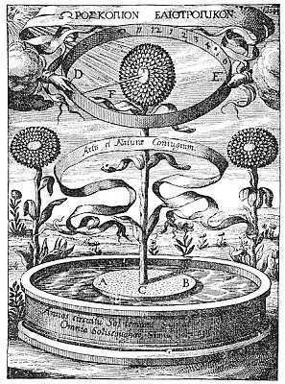  
THE SUNFLOWER.

From Kircher's *Magnes sive de Arte Magnetica Opus Tripartitum*.

*The above diagram illustrates a curious experiment in plant magnetism reproduced with several other experiments in Athanasius Kircher's rare volume on magnetism. Several plants were sacred to the ancient Egyptians, Greeks, and Hindus because of the peculiar effect which the sun exerted over them. As it is difficult for man to look upon the face of the sun without being blinded by the light, those plants which turned and deliberately faced the solar orb were considered typical of very highly advanced souls. Since the sun was regarded as the personification of the Supreme Deity, those forms of life over which it exercised marked influence were venerated as being sacred to Divinity. The sunflower, because of its plainly perceptible affinity for the sun, was given high rank among sacred plants.*

Strong wine made from the juice of the grape was looked upon as symbolic of the false life and false light of the universe, for it was produced by a false process--artificial fermentation. The rational faculties are clouded by strong drink, and the animal nature, liberated from bondage, controls the individual--facts which necessarily were of the greatest spiritual significance. As the lower nature is the eternal tempter seeking co lead man into excesses which inhibit the spiritual faculties, the grape and its product were used to symbolize the Adversary.

The juice of the grape was thought by the Egyptians to resemble human blood more closely than did any other substance. In fact, they believed that the grape secured its life from the blood of the dead who had been buried in the earth. According to Plutarch, "The priests of the sun at Heliopolis never carry any wine into their temples, * * * and if they made use of it at any time in their libations to the gods, it was not because they looked upon it as in its own nature acceptable to them; but they poured it upon their altars as the blood of those enemies who formerly had fought against them. For they look upon the vine to have first sprung out of the earth after it was fattened with the carcasses of those who fell in the wars against the gods. And this, say they, is the reason why drinking its juice in great quantities makes men mad and beside themselves, filling them as it were with the blood of their own ancestors." (See *Isis and Osiris*.)

Among some cults the state of intoxication was viewed as a condition somewhat akin to ecstasy, for the individual was believed to be possessed by the Universal Spirit of Life, whose chosen vehicle was the vine. In the Mysteries, the grape was often used to symbolize lust and debauchery because of its demoralizing effect upon the emotional nature. The fact was recognized, however, that fermentation was the certain evidence of the presence of the solar fire, hence the grape was accepted as the proper symbol of the Solar Spirit--the giver of divine enthusiasm. In a somewhat similar manner, Christians have accepted wine as the emblem of the blood of Christ, partaking of it in Holy Communion. Christ, the exoteric emblem of the Solar Spirit, said, "I am the vine." He was therefore worshiped with the wine of ecstasy in the same manner as were his pagan prototypes--Bacchus, Dionysos, Arys, and Adonis.

The *mandragora officinarum*, or mandrake, is accredited with possessing the most remarkable magical powers. Its narcotic properties were recognized by the Greeks, who employed it to deaden pain during surgical operations, and it has been identified also with *baaras*, the mystic herb used by the Jews for casting out demons. In the *Jewish Wars*, Josephus describes the method of securing the *baaras*, which he declares emits flashes of lightning and destroys all who seek to touch it, unless they proceed according to certain rules supposedly formulated by King Solomon himself.

The occult properties of the mandrake, while little understood, have been responsible for the adoption of the plant as a talisman capable of increasing the value or quantity of anything with which it was associated. As a phallic charm, the mandrake was considered to be an infallible cure for sterility. It was one of the Priapic symbols which the Knights Templars were accused of worshiping. The root of the plant closely resembles a human body and often bore the outlines of the human head, arms, or legs. This striking similarity between the body of man and the mandragora is one of the puzzles of natural science and is the real basis for the veneration in which this plant was held. In *Isis Unveiled*, Madam Blavatsky notes that the mandragora seems to occupy upon earth the point where the vegetable and animal kingdoms meet, as the zoophites and polypi do in die sea. This thought opens a vast field of speculation concerning the nature of this animal-plant.

According to a popular superstition, the mandrake shrank from being touched and, crying out with a human voice, clung desperately to the soil in which it was imbedded. Anyone who heard its cry while plucking it either immediately died or went mad. To circumvent this tragedy, it was customary to dig around the roots of the mandrake until the plant was thoroughly loosened and then to tie one end of a cord about the stalk and fasten the other end to a dog. The dog, obeying his master's call, thereupon dragged the root from the earth and became the victim of the mandragora curse. When once uprooted, the plant could be handled with immunity.

During the Middle Ages, mandrake charms brought great prices and an art was evolved by which the resemblance between the mandragora root and the human body was considerably accentuated. Like most superstitions, the belief in the peculiar powers of the mandrake was founded upon an ancient secret doctrine concerning the true nature of the plant. "It is slightly narcotic," says Eliphas Levi, "and an aphrodisiacal virtue was ascribed to it by the ancients, who represented it as being sought by Thessalian sorcerers for the composition of philtres. Is this root the umbilical vestige of our terrestrial origin, as a certain magical mysticism has suggested? We dare not affirm it seriously, but it is true all the same that man issued from the slime of earth and his first appearance must have been in the form of a rough sketch. The analogies of Nature compel us to admit the notion, at least as a possibility. The first men were, in this case, a family of gigantic, sensitive mandrogores, animated by the sun, who rooted themselves up from the earth." (See *Transcendental Magic*.)

The homely onion was revered by the Egyptians as a symbol of the universe because its rings and layers represented the concentric planes into which creation was divided according to the Hermetic Mysteries. It was also regarded as possessing great medicinal virtue. Because of peculiar properties resulting from its pungency, the garlic plant was a powerful agent in transcendental magic. To this day no better medium has been found for the treatment of obsession. Vampirism and certain forms of insanity--especially those resulting from mediumship and the influences of elemental larvæ--respond immediately to the use of garlic. In the Middle Ages, its presence in a house was believed to ward off all evil powers.

Trifoliate plants, such as the shamrock, were employed by many religious cults to represent the principle of the Trinity. St. Patrick is supposed to have used the shamrock to illustrate this doctrine of the triune Divinity. The reason for the additional sanctity conferred by a fourth leaf is that the fourth principle of the Trinity is man, and the presence of this leaf therefore signifies the redemption of humanity.

Wreaths were worn during initiation into the Mysteries and the reading of the sacred books to signify that these processes were consecrated to the deities. On the symbolism of wreaths, Richard Payne Knight writes: "Instead of beads, wreaths of foliage, generally of laurel, olive, myrtle, ivy, or oak, appear upon coins, sometimes encircling the symbolical figures, and sometimes as chaplets upon their heads. All these were sacred to some peculiar personifications of the deity, and significant of some particular attributes, and, in general, all evergreens were Dionysiac planes; that is, symbols of the generative power, signifying perpetuity of youth and vigor, as the circles of beads and diadems signify perpetuity of existence. (See *Symbolical Language of Ancient Art and Mythology*.)

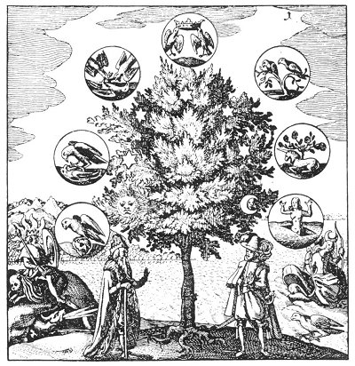  
THE TREE OF ALCHEMY.

From *Musæum Hermeticum Reformatum et Amplificatum*.

The alchemists were went to symbolize their metals by means of a tree, to indicate that all seven were branches dependent upon the single trunk of solar life. As the Seven Spirits depend upon God and are branches of a tree of which He is the root, trunk, and the spiritual earth from which the root derives its nourishment, so the single trunk of divine life and power nourishes all the multitudinous forms of which the universe is composed.

In *Gloria Mundi*, from which the above illustration is reproduced, there is contained an important thought concerning the plantlike growth of metals: "All trees, herbs, stones, metals, and minerals grow and attain to perfection without being necessarily touched by any human hand: for the seed is raised up from the ground, puts forth flowers, and bears fruit, simply through the agency of natural influences. As it is with plants, so it is with metals. While they lie in the heart of the earth, in their natural ore, they grow and are developed, day by day, through the influence of the four elements: their fire is the splendor of the Sun and Moon; the earth conceives in her womb the splendor of the Sun, and by it the seeds of the metals are well and equally warmed, just like the grain in the fields. * * * For as each tree of the field has its own peculiar shape, appearance, and fruit, so each mountain bears its own particular ore; those stones and that earth being the soil in which the metals grow." (See Translation of 1893.)

===================================================================================================================================================

END