Origins of Christianity and Other Religions, As Told in the World’s Oldest Language, Symbolism

“SUN YOU”

Know what you can see in God’s nature, expressed in the world around you.
Open your own eyes, believe what you can see and see the simple truths.
Is common sense still alive? It is reasonable to question.

By Joseph O. Gill June 2011
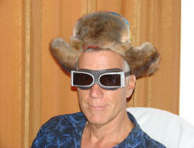

Joseph Gill has talked for over 8 hours on national syndicated talk radio shows with 6 to 7 million listeners about symbolism and the simple origins of our different religions. After many personal requests Joseph has put together this simple picture documentary article for easy understanding and has supplied references for those people wanting more information details. Go as far as you want.
This paper is given after 40 years of research in thousands of books and 50 years of travel 1961-2011; personally visiting hundreds of churches and temples in over 100 countries.

PLEASE FORWARD THIS ARTICLE TO ALL ON YOUR EMAIL LIST

Our SUN
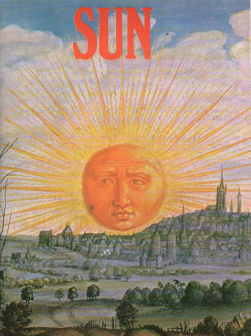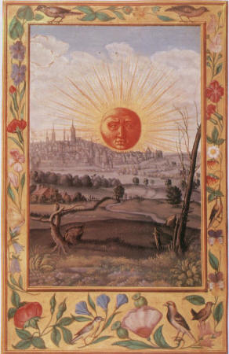
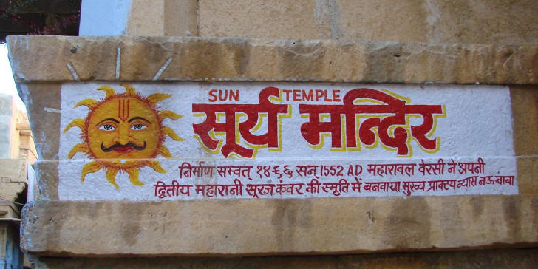


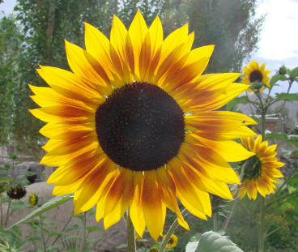

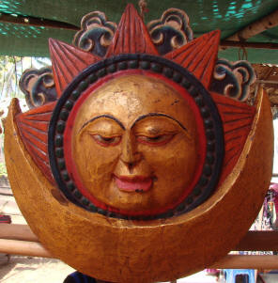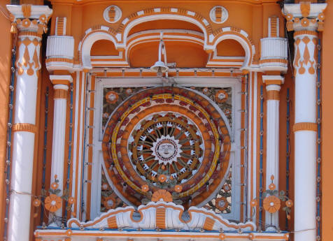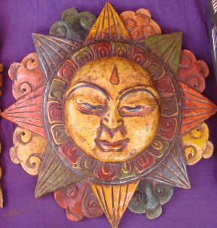

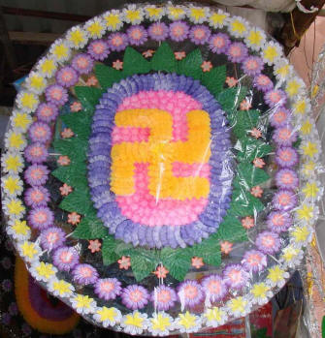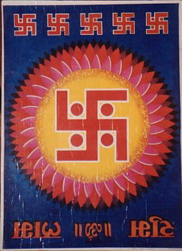

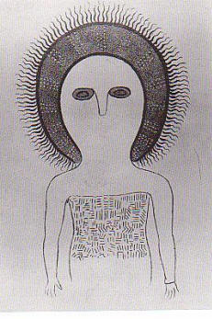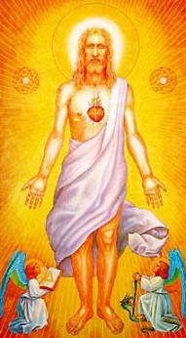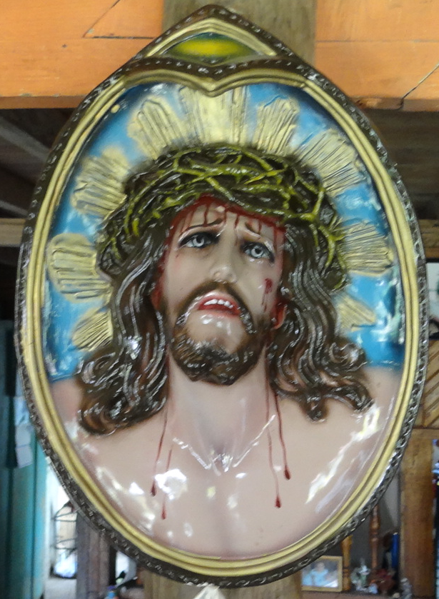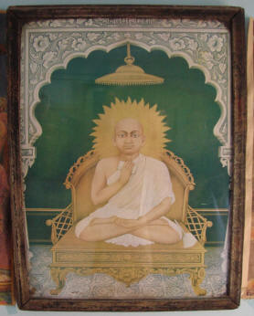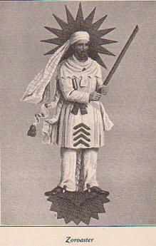
The SUN behind the head of all our worlds saviors, the Ancient One, Jesus, Buddha, Zoroaster, Brahma-Shiva-Vishnu, etc..
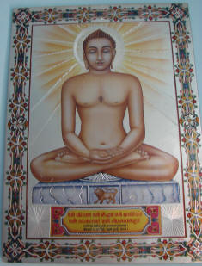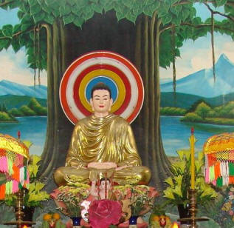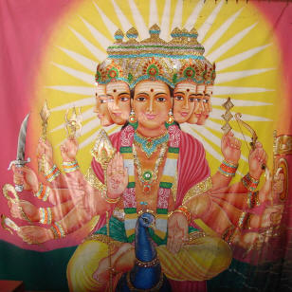

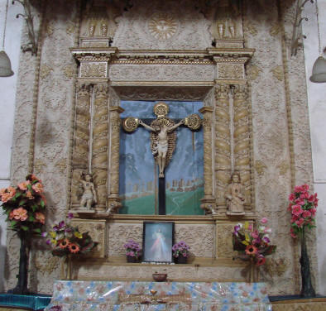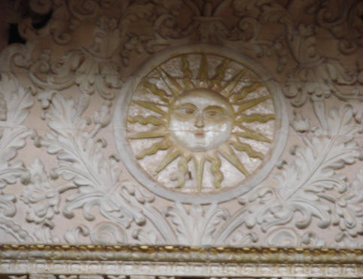
The SUN over the head of Jesus
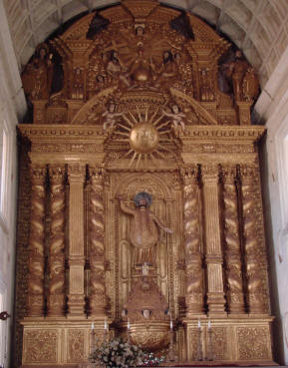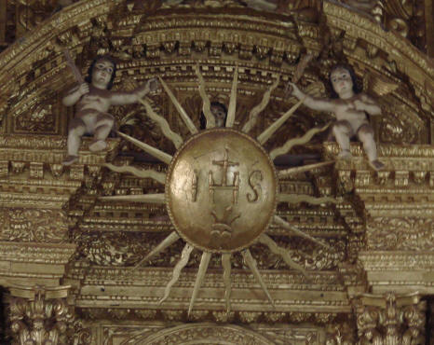

The one true Eye over us all, the SUN
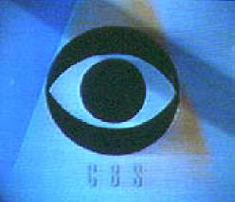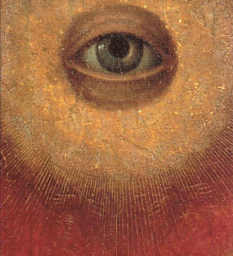
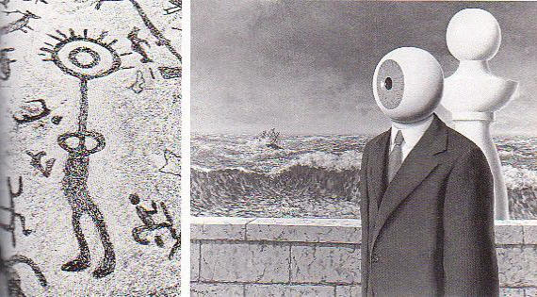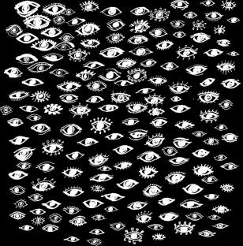
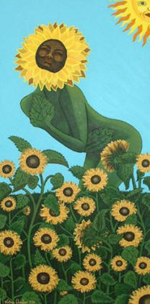
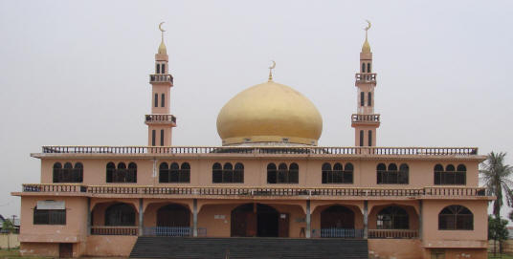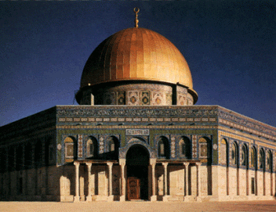
The golden dome of the SUN over all the world’s religions
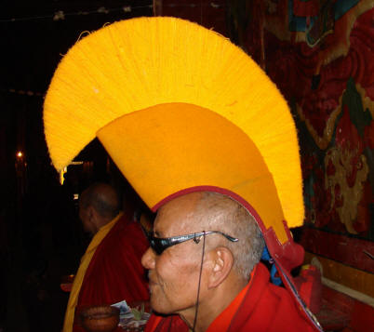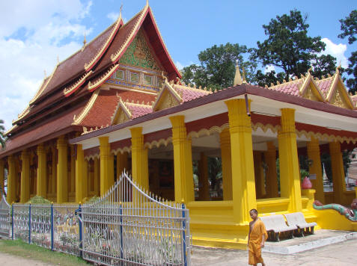
Colors of the rising & setting SUN
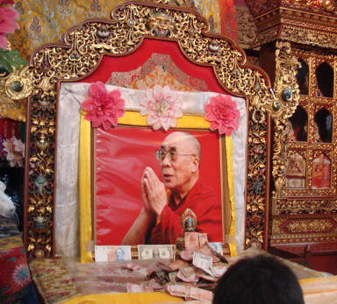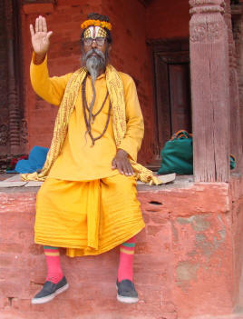

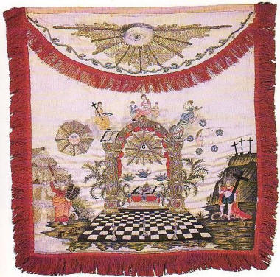
Our SUN

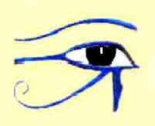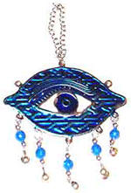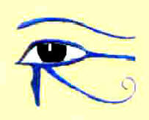
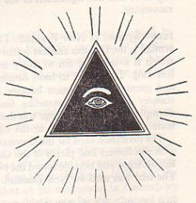

Ra the most ancient SUN God of Egypt, the Eye of God or our Eye in the Sky (Is-ra-el, Amen-Ra, Ra)
The symbol of the Eye appears in every culture worldwide.

-------------------------------------------------------------------------------------------------------------------------------------------------------------------------------------------
Who is this King of Glory? The SUN is the greatest gift from GOD/Allah/the Great Architect of the Universe to all Earthlings. It brings light & heat to the World, to see truth. Should we think of God’s great gift as less if it is not in our own image? Can we ever give our SUN too much glory? Without the SUN, creation could not survive and all life on Earth would perish, so we are all naturally SUN worshippers. Joseph Gill, Author

He maketh His SUN to rise on the evil and on the good. The Bible.

Ecclesiastes 11:7
Truly the light is sweet, and it is pleasant for the eyes to behold the SUN. . . The Bible

And the SUN had on a crown. Wrought of gilded thistledown, And a scarf of velvet vapor And a raveled rainbow gown; And his tinsel-tangled hair Tossed and lost upon the air Was glossier and flossier Than any anywhere. James Whitcomb Riley.

SUN, God's lidless eye! Horace Smith.

O SUN! of this great world both eye and soul. Milton.

Shines upon all men with impartial light. Cowley.

The glorious lamp of heaven, the SUN. Herrick.

The face of the SUN is not without expression, but it tells us precious little of what is in its heart. Deutsch, Armin J. Scientific American

(see more SUN QUOTES: below

“SUN YOU”

Symbolism, as I have understood it over the years of my study, are basic images from our own natural environment, used to insight certain specific feelings in our subconscious. Symbols are repeated over and over through all the world religions and into every aspect of our daily lives.
Amen-Ra is the ancient SUN god in Egypt, the eye in the sky, seer of truth. This is where we get “Amen” at the end of each of our Christian prayers. The gods Osiris & Isis who were the son and daughter of Ra, had a new born SUN they named Horus. When you go to the ocean shore and look out over the curvature of the Earth you say, “I see the horizon”. This is from where “Horus rises” (our SUN) each morning. Horus evolved through time into hesus, into isus, into jesus, the fishhook “J”, the time of Pisces.
In our sky are twelve constellations of stars or Houses called the “Zodiac” or “Circle of Animals”. Ancient peoples all watched the movements of the stars. Every 2150 years or so a new constellation rises from one house into the next house, with the morning savior, our SUN. The Jews ended the age of Taurus by destroying the golden bull, only to blow the rams horn bringing in the Armageddon, meaning the changing of an Age, into Aries. Jesus the fisherman symbolized by the 2 fish, hailed the arrival of the next house or constellation of Pisces; with the morning SUNrise of our savior, the SUN, the light of the world, the purifier, and bringer of the truth as light always shows us the truth. Jesus said in Book 41 Mark 014:013 “And he sendeth forth two of his disciples, and saith unto them, Go ye into the city, and there shall meet you a man bearing a pitcher of water: follow him” and again Jesus said inBook 42 Luke022:010 “And he said unto them, Behold, when ye are entered into the city, there shall a man meet you, bearing a pitcher of water; follow him into the house where he entereth in.” The man bearing the pitcher of water is the house or constellation called Aquarius our next guardian and bringer of our savior each morning, the SUN. The twelve signs of the zodiac are the twelve great teachers, the apostles, the twelve hours or guides of the day and night, with the SUN always in the middle as seen in every clock face.

The Zodiac (Circle of animals)
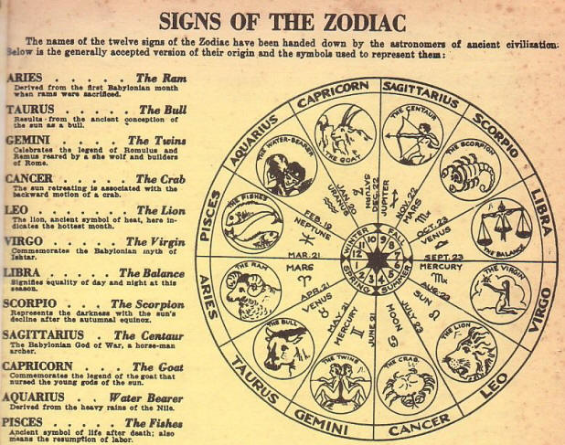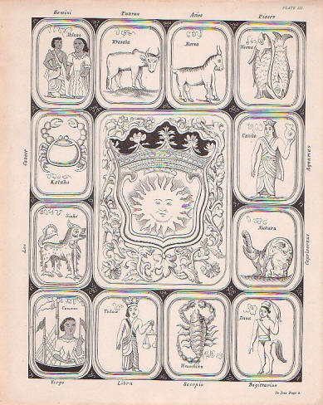
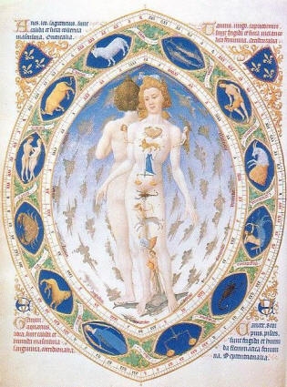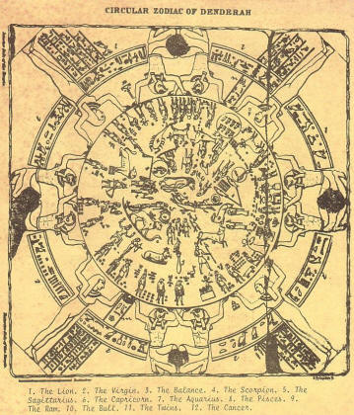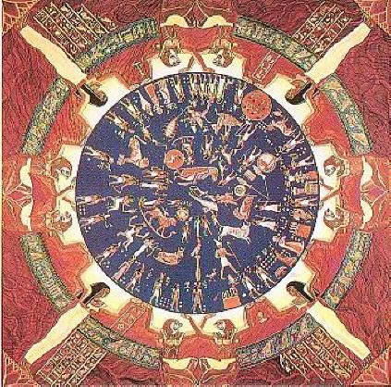
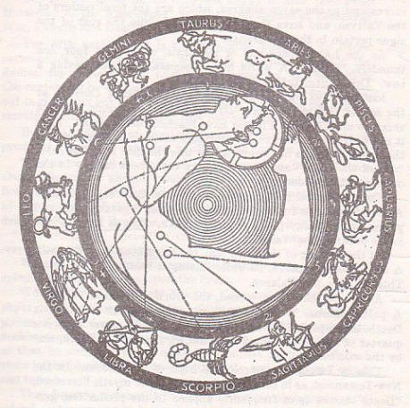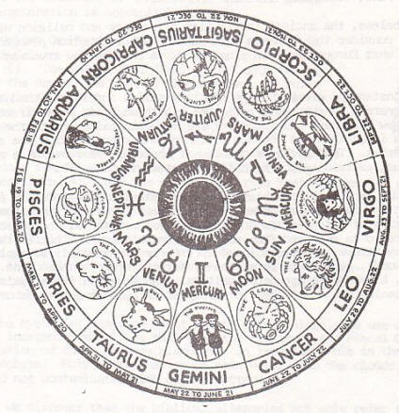
The Zodiac (Circle of animals)

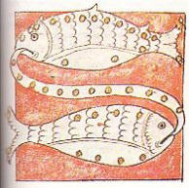

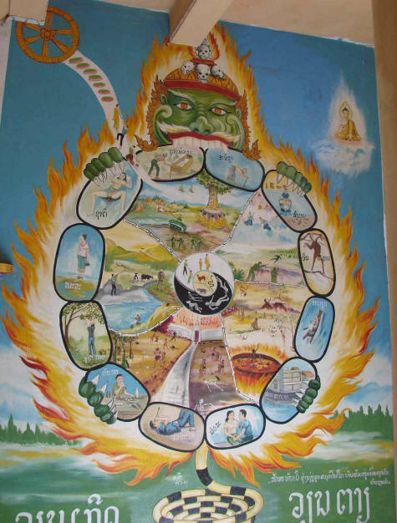
The SUN and 12 followers in Hinduism

The Christian faith originates from the more populated, colder northern hemisphere represented by the SUN when it falls down the sky in the “Fall” and sinks to the bottom where it seems to rest in Hell for three days. The SUN is then born again or springs up again on December 25, the exact day, minute & second that Jesus was said to be born on Christmas. Christians go to worship their savior every SUNday or SUN-Day or day of the SUN. The SUN then rises up or springs up again into the northern hemisphere during the season of Spring at Easter time. This is when the new stronger SUN brings light, heat, creation of new crops, baby animals, and truth in life. Jesus, SUN of God, was born of Mary the virgin. The SUN is cleansed by the blue water of Mar the name for oceans on all old maps and the origin of Mary, mermaid and Marianna Trench (the largest trench or vagina in the female Earth). When the SUN of God rises out of Mary he lights up the whole world, sees the truth and by fire and light cleanses all sins. Jesus the SUN, shines in a line across any body of blue water and is said to perform a miracle by walking on the water.

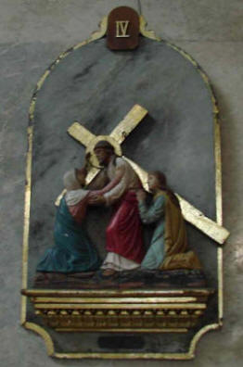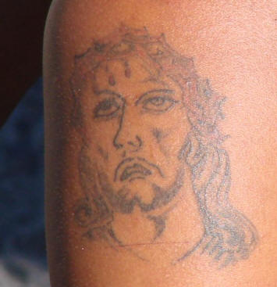
Sun walking on water The cross with squinted eyes The crown of thorns

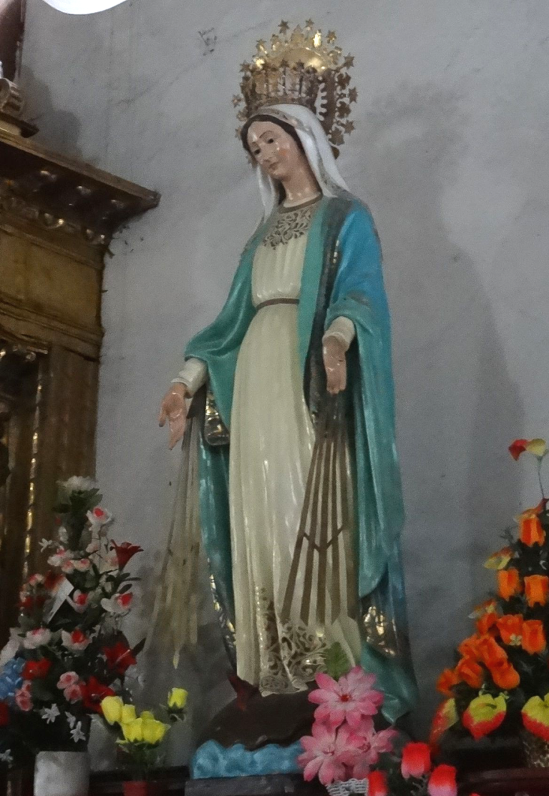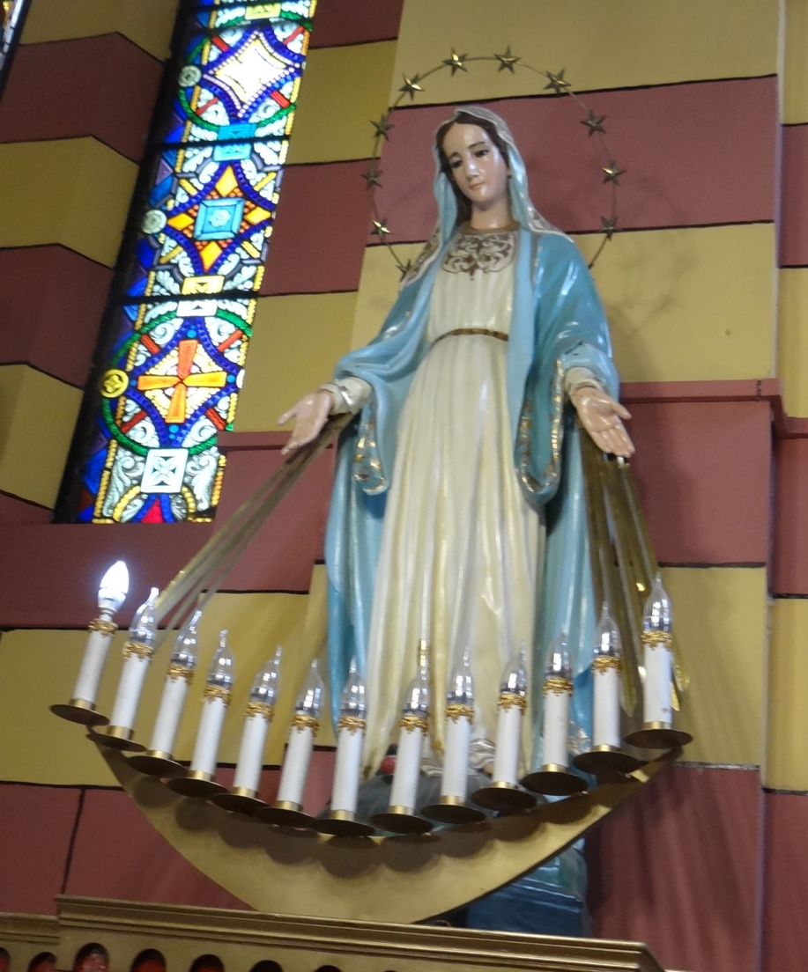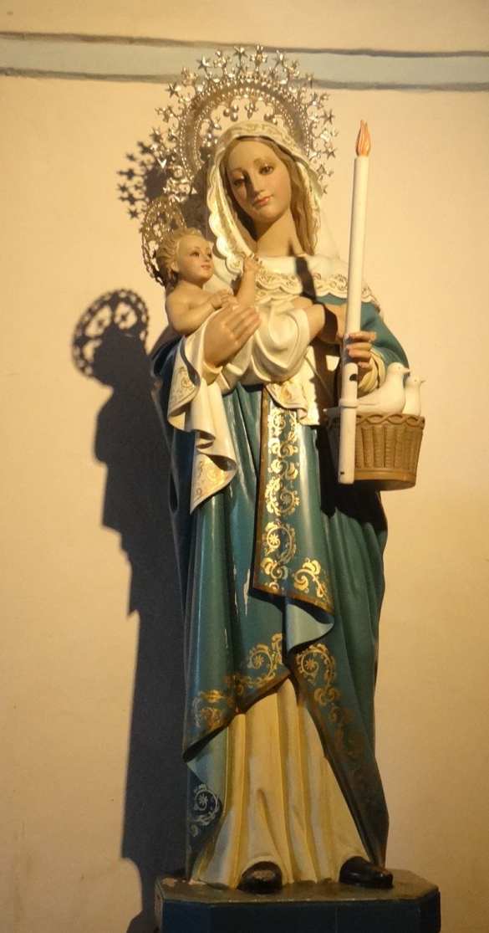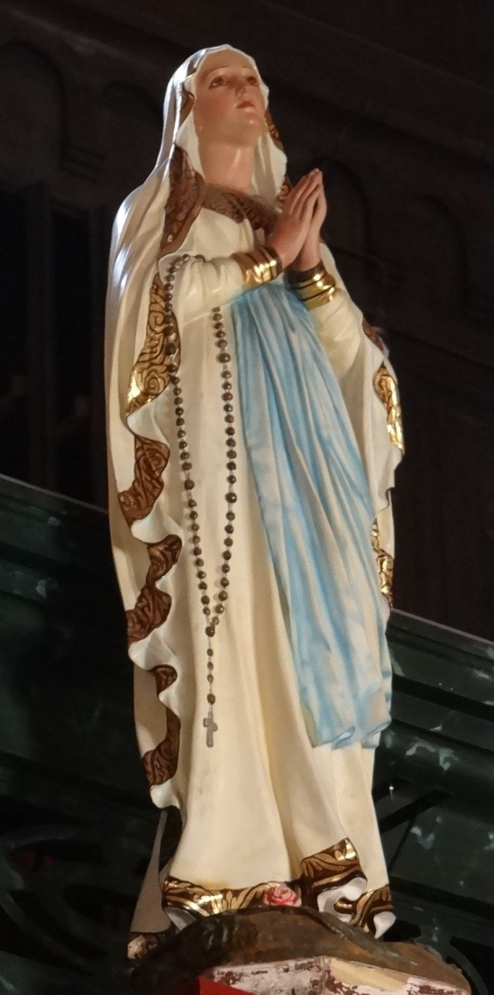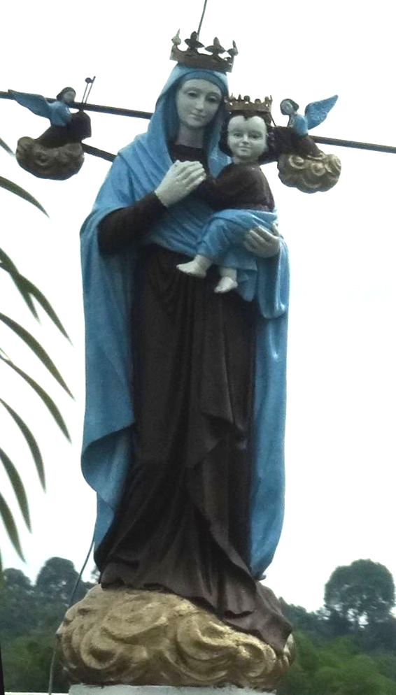
Did you ever notice how most all statues of Mary are clothed in blue, the color of the ocean & white the color of purity?

As Jesus, the SUN of God, rises upward or sets downward 20 or 30 degrees to the horizon (still in the tangent of our earth) we squint our eyes and try to see his beauty. Because of the rods and cones in all our human eyes (like light reflecting in a line off silk) we see a line going up & down across the SUN. There is also a second line going from right to left across the SUN forming in dry climates, thus a four equal armed cross called the Greek or Solar cross. When seen on a humid day, as humidity is heavy, the bottom of the four rays hangs down toward the ground forming the Latin cross. Often you can also see a halo around the SUN and several small glints of lines between each of the four main lines of the cross (the crown of thorns)just like you see in every Christian church cross. When the SUN is at this lower angle in our sky it appears gold, red, and orange. These are the same colors Christian, Buddhist, and Hindu priests wear, and the colors decorating their temples, all representing the SUN. When the SUN is at its zenith it is pure white. It is then shining straight down through the thinnest part of the atmosphere and it is called the destroyer, the same color worn by the Pope and the color of virginity or purity. The true trinity of the SUN is the morning SUN, Brahma, the midday SUN or the destroyer Shiva, and the setting SUN or the preserver, Vishnu. On the top of many churches we see the rooster or cock that welcomes the rising SUN and says farewell to the setting SUN of God.

The cross in some of its many forms
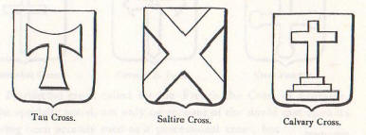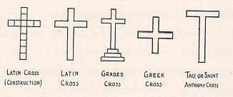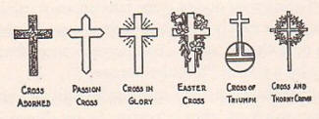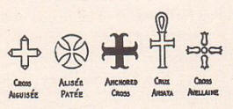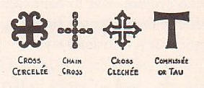
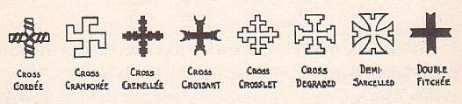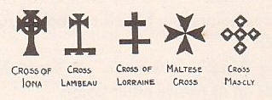
The cross in some of its many forms

The Rooster, ABRAXAS hails the morning and setting SUN of GOD

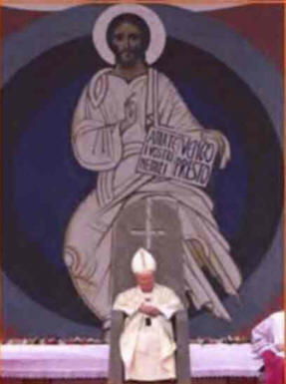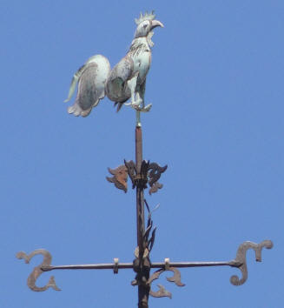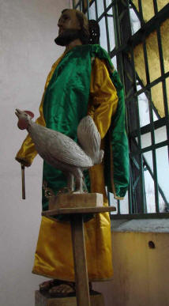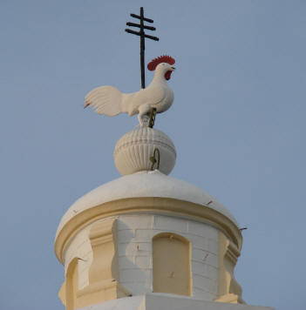
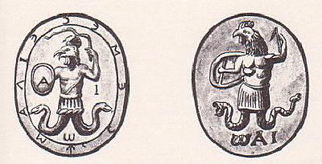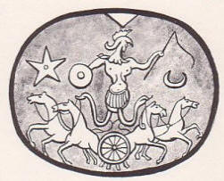
The Rooster, ABRAXAS, hails the morning and setting SUN of GOD

“SUN YOU”
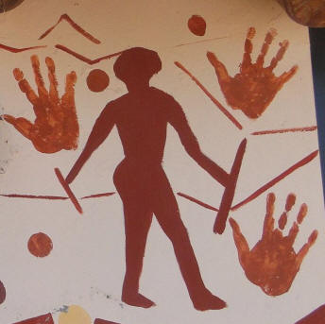

“SUN YOU”

In my 50 years of travel, around the world more than 30 times since 1961, visiting over 100 countries, I have observed symbolism worshipping the SUN. I see everywhere the Glory or crown of the rising King and Light of the World. The universal hand greeting, Hello! or Hi!, from the rising fingers of the morning SUN as it walks on any body of water, comes from the Greek Helios meaning SUN; as in the ancient city in Egypt, Heliopolis (city of the SUN), or the yellow beryl gem called heliotrope. This hand gesture from ancient cave paintings in Africa, Asia and the Americas dominates our modern world today, and means literally, “SUN You” or may the light of our SUN savior guide your daily journey. People who do not understand the origin of this, our most important symbol, often pass it and other major symbols as a simple sign of GOOD LUCK.

Orphan children of AIDS at a school in Lesotho, Southern Africa, giving a happy “Hello”, “SUN – YOU”!.

Christ, the anointed one, is also called “he who is covered with chiasm or sperm, the seeds of Creation”. Christ is the Lord and the word Lord evolves from the ancient phallic god Baal. Christ was sacrificed on the cross with two thieves. The thief on the left did not ask for forgiveness from the Lord so he shrank down and was not forgiven. The thief on the right asked for forgiveness and rose up with the Lord. Book 40 Matthew 027:038 “Then were there two thieves crucified with him, one on the right hand, and another on the left”. Book 41 Mark 015:027 “and with him they crucify two thieves; the one on his right hand, and the other on his left”, Book 40 Matthew 006:003 “But when thou doest alms, let not thy left hand know what thy right hand doeth”. In “Anatomy of the Human Body” by Henry Gray it explains that “the seminal vesicles on the left testicle of all men hangs lower than the right testicle”. When we get married people throw rice over the new couple. This symbolizes the sacrifice of the Lord, so that we can create our new babies, often called offspring (off-spring - as in the Spring). Our survival on Earth depends on the ‘pro-creation’ of our species and thus we are also worshippers of Creation. In ancient times we had no books. Men would cup their hand over their testicles or family jewels (that hold the biological memory of all their family before them) giving their testimony. Thus testicles give us the word testimony and the Old & New Testaments (testimonies) of the Bible. The true trinity of man is the penis and the two testicles called the ‘Tau’. The quaternary of humanity is represented by the ancient ankh of Egypt with the female oval womb on top and the ‘T’ or ‘Tau’ on the bottom representing the penis and two testicles or Creation.
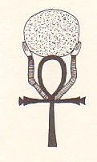
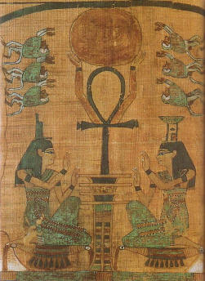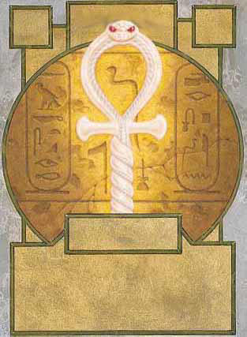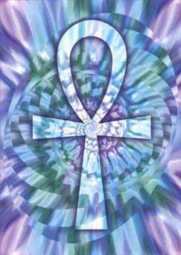
The ancient Egyptian Ankh


The two greatest creative powers, the SUN above & the phallus below.



AS ABOVE SO BELOW, CREATION

This quaternary is also seen in the Oval office in the White House in Washington, D.C. where the most important laws are signed by the President of the United States. Nearby the White House is the famous Washington Monument or largest penis in the world, the male; and the long reflecting pool representing Mary, Mar or water, the female.


Three pictures are worth three thousand words, George Washington’s Monument & what a monument indeed.


Phallic male authority hand symbol Buddhist phallic prayer hand symbol

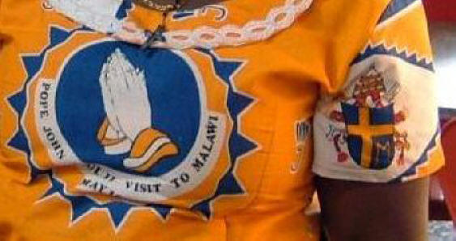
Three Roman Catholic women in Malawi, Africa, showing the Sun colors, saffron yellow & sky blue;
also showing the Sun symbol, and the Christian phallic prayer hand symbol in the center.

Bells ring in Christian churches, Buddhist & Hindu temples, with the shell of the oval female womb, and a clapper or knocker inside (i.e. being “knocked up”) representing the sexual union and the Creation of new life. As with many forms of symbolism the ringing of bells excites our subconscious and gets us off to church or temple.

The phallus in a few of its many forms
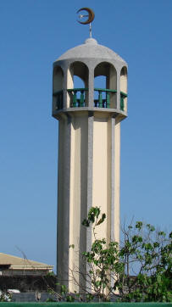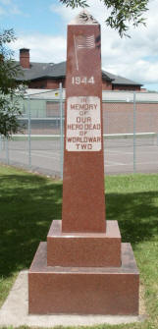

Almost every town worldwide has examples of the phallus rising, our sacrifice for future generations of our off-spring. You will be surprised when you start observing symbols around you.
Sex symbolism sells. We worship Creation.

Jesus of the SUN and Christos or Christ the Lord phallus were two separate religions that were united for the first time in 325AD by the Emperor Constantine, ‘God’ of Rome, at the famous second council of Nicaea held on the Black Sea. After this unification was done Constantine made himself both first pope of the Holy Roman Church and the first saint of the Church of Rome. Before 325 there are many references to “Jesus” & to “Christ” but there are no references to “Jesus Christ”. Religion is a word from religare, “to bind”, and keeps us from the freedom to have a direct personal relationship with GOD. This is the fundamental right of all living things including humans, without paying 10 percent of our income and taking one day each week to hear old personified myths of the SUN & phallus with no supporting historical records. Every crowned monarch in European history was crowned either by the Pope of Rome or The Church of England. Man made world religions with their bloody, dark past (such as the Inquisition) have formed the corrupt governments and the wars through humanity’s history.


Religion is a word from religare, “to bind”, and keeps us from the freedom of a direct relationship with GOD.

Man made religions were created to control us. May I not be bound by religion,
thus keeping me from a direct relationship with GOD, our Creators’ will.

OR ?
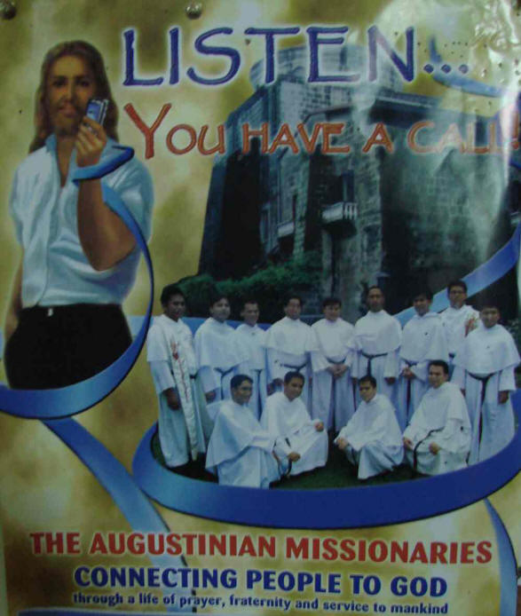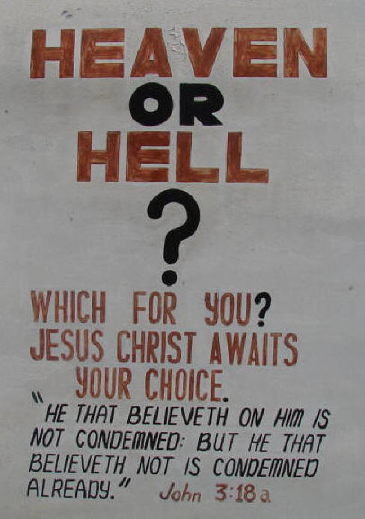
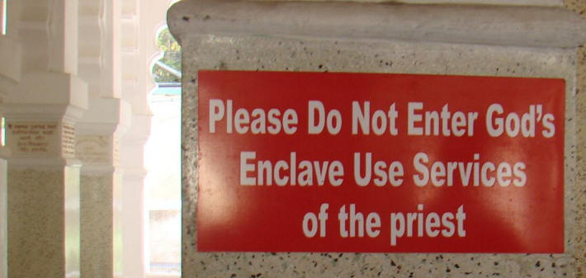

Fear or LOVE? God wants us to question our Faith. God is LOVE, Ignorance is Fear. I always
have had a close personal relationship with God, choosing spirituality not religion.

When you see something with your own eyes day after day, expressed in the most simple and clear way, do you know the truth? If the characteristics of the SUN throughout its yearly cycle duplicates the life of Jesus exactly, could it be that Jesus’ life is the personification of the SUN?
God exists. Man created Jesus, his churches and all the world religions. Man has caused destruction of the planet and wars between the world religions, even amongst fellow Christian churches. God loves us and offers a direct connection with each of us, no matter what color or creed. Look. See. Know God.

Joseph Gill has talked for over 8 hours on national syndicated talk radio shows with 6 to 7 million listeners about symbolism and the simple origins of our different religions. After many personal requests Joseph has put together this simple picture documentary article for easy understanding and has supplied references for those people wanting more information details. Go as far as you want.
This paper is given after 40 years of research in thousands of books and 50 years of travel 1961-2011; personally visiting hundreds of churches and temples in over 100 countries.

PLEASE FORWARD THIS ARTICLE TO ALL ON YOUR EMAIL LIST



Bibliography (author’s favorites):
Any of Jordan Maxwell in “Beliefs” is excellent
Bible Myths and Their Parallels in Other Religions - Thomas William Doane 1882 A.O
Symbols, Sex, and the Stars - Ernest Busenbark 1949, Forward by Jordan Maxwell 1997
The World's Sixteen Crucified Saviors - Kersey Graves 1915
The SUN Worshipers of Asia - by Charles D. Poston 1877 A.O
Any of the many works by Alvin Boyd Kuhn 1880-1963
Pagan & Christian Creeds – Edward Carpenter 1920
Rivers of Life, Vol 1 - by James George Roche Forlong 1883 A.O
Rivers of Life or Faiths of Man in all Lands - Synchronological Chart of the Religions of the World - by James George Roche Forlong 1883 A.O
Forgery in Christianity – Joseph Wheless 1930
Is it God’s Word – Joseph Wheless 1926
The Grammar of the Lotus, Classic Ornament and SUN Worship - William H. Goodyear 1891 A.O
Faiths of Mankind - A Cyclopedia of Religions, Vol. 1 – 3 - by James George Roche Forlong 1906
Aryan SUN-Myths, the Origin of Religions - by Charles Morris 1889 A.O
Ancient Faiths Embodied in Ancient Names, Vol 1-3 - by Thomas Inman 1872-1876 A.O
Thumbscrew and Rack, Torture toward Christianity - by George E. Macdonald
Zeitgeist ( Religion-911-Banking) - (The Movie 2007)
The Companion Guide to Zeitgeist, Part 1 - Acharya S
Conversations with God, vol 1 - Neale Donald Walsch 1992
Conversations with God, vol 2 - Neale Donald Walsch 1995
Conversations with God, vol 3 - Neale Donald Walsch 1998

Be Free, that is what God intended

Joseph O. Gill

Shell is the SUN - National Geographic, Shell Oil Advertisement Dec 2000
SUN symbolism is EVERYWHERE!

SUN QUOTES:
Bourdillon, Francis William
The night has a thousand eyes, and the day but one; Yet the light of the bright world dies, With the dying SUN (Son). Among the Flowers, and Other Poems
The Night Has a Thousand Eyes

Lawrence, D.H.
We and the cosmos are one. The cosmos is a vast body, of which we are still parts. The SUN is a great heart whose tremors run through our smallest veins.
Apocalypse Five

Dryden, John
The glorious lamp of heaven, the radiant SUN, Is Nature’s eye;. . .The Poetical Works of Dryden The Fable of Acis, Polyphemus, and Galatea from
the Thirteenth Book of Ovid’s Metamorphoses

Macpherson, James
Whence are thy beams, O SUN! thy everlasting light! Thou comest forth in thy awful beauty; the stars hide themselves in the sky; the moon, cold and
pale, sinks in the western wave; but thou thyself movest alone.

Muir, John
The SUN, looking down on the tranquil landscape, seems conscious of the presence of every living thing on which he is pouring his blessings, while they in turn, with perhaps the exception of man, seem conscious of the presence of the SUN as a benevolent father and stand hushed and waiting. Steep Trails

Nietzsche, Friedrich
. . . the Moon’s love affair has come to an end! Just look! There it stands; pale and dejected—before the dawn! For already it is coming, the glowing SUN—its love of the Earth is coming! All SUN-love is innocence and creative desire! Just look how it comes impatiently over the sea! Do you not feel the thirst and hot breath of its love?
Thus Spoke Zarathustra

Xenophanes
The SUN comes into being each day from little pieces of fire that are collected. . .
In G.S Kirk and J.E. Raven ThePresocratic Philosophers Fragment

That orbed continent, the fire that severs day from night. Shakespeare.

The SUN, God's crest upon His azure shield, the heavens. Bailey.

The SUN with one eye viewethall the world. Shakespeare.

Neither the SUN nor death can be looked at steadily. Rochefoucauld.

High in his chariot glowed the lamp of day. Falconer.

The heavenly-harness'd team Begins his golden progress in the east. Shakespeare.

The SUN, reflecting upon the mud of strands and shores, is unpolluted in his beam. Jeremy Taylor

But yonder comes the powerful king of day rejoicing in the east. Thomson.

The glorious lamp of heaven, the radiant SUN, is Nature's eye. Dryden,

He fires the proud tops of the eastern pines, and darts his light through every guilty hole. Shakespeare.

The SUN stands, at midnight, blood red, on the mountains of the North. Longfellow.

The SUN is all about the world we see, the breath and strength of every spring. Swinburne.

Shine out, fair SUN, till I have bought a glass. That I may see my shadow as I pass. Shakespeare.

The SUN, too, shines into cesspools, and is not polluted. Diogenes Laertius.

The SUN, centre and sire of light, The keystone of the world-built arch of heaven. Bailey.

In his east the glorious lamp was seen, regent of the day ; and all the horizon round, invested with bright rays. Milton.
The radiant SUN sends from above ten thousand blessings down, nor is he set so high for show alone. Granville.

The weary SUN hath made a golden set, and by the bright track of his fiery car, gives signal of a goodly day to-morrow. Shakespeare.

When the SUN shines on you, you see your friends. It requires SUNshine to be seen by them to advantage ! Lady Blessington.

What light through yonder window breaks! It is the east, and Juliet is the SUN! Arise, fair SUN, and Kill the envious moon. Shakespeare.

See the gold SUNshine patching, And streaming and streaking across The gray-green oaks; and catching, By its soft brown beard, the moss. Bailey.

Though the SUN scorches us sometimes, and gives us the headache, we do not refuse to acknowledge that we sand in need of his warmth. Philip de Mornay.

The glorious SUN stays in his course, and plays the alchemist, turning with splendor of his precious eye the meager cloddy earth to glittering gold. Shakespeare.

The angels even Draw strength from gazing on its glance, Though none its meaning fathom may; The world's unwither'd countenance Is bright as at creation's day. Goethe.

Whence are thy beams, O SUN !thy everlasting light? Thou coinest forth in thy awful beauty ; the stars hide themselves in the sky ; the moon, cold and pale, sinks in the western wave: but thou thyself movest alone. Macpherson.

And see- the SUN himself! on wings Of glory up the East he springs. Angel of Light! who from the time Those heavens began their march sublime, Hath first of all the starry choir Trod in his Maker's steps of fire! Moore.

More joyful eyes look at the setting than at the rising SUN. Burdens are laid down by the poor, whom the SUN consoles more than the rich. No star and no moon announce the rising SUN; l does not the setting SUN, like a :over, leave behind his image in the moon? I yearn towards him when he sets, not when be rises. Richter.

Till, as a giant strong, a bridegroom gay, The SUN springs dancing through the gates of day, He shakes his dewy locks, and hurls his beams O'er the proud hills, and down the glowing streams : , His fiery coursers bound above the mam, And whirl the car along th' ethereal plain; The fiery courses and the car display A stream of glory and a flood of day. Broome.

The glorious SUN the centream soul of our system the lamp that lights it, the fire that heats it. The Blest power of SUNshine! genial day, What balm, what life are in thy ray! To feel thee is such real bliss. That, had the world no joy but this, To sit in SUNshine calm and sweet. It were a world too exquisite For man to leave it for the gloom. The deep cold shadow of the tomb. Moore.

Thou material God! And representative of the Unknown, Who chose thee for His shadow! Thou chief star! Centre of many stars! whichmak’st our earth Endurable, and temperest the hues And hearts of all who walk within thy rays! Sire of the seasons! Monarch of the climes, And those who dwell in them! for near or far, Our inborn spirits have a tint of thee, Even as our outward aspects, thou dost rise, And shine and set in glory! Byron.

=======================================================================================================
END

