**Origins of the Caduceus, As Told in the World’s Oldest Language: Symbolism**

**The Oldest Symbol for Medicine and What Every Doctor Should Know.**

**By Joseph O. Gill June 2011**

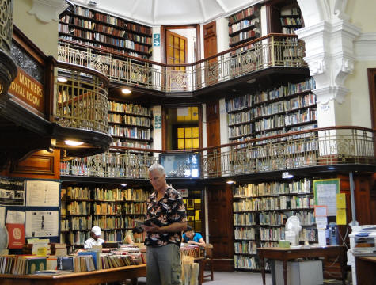

Joseph O. Gill,the author, at the Historical Port Elizabeth Public Library, South Africa 2011

Joseph Gill has talked for over 8 hours on national syndicated talk radio shows with 6 to 7 million listeners about symbolism and the simple origins of our different world religions.  After many personal requests Joseph has put together this simple picture documentary article for easy understanding and has supplied references for those people wanting more information details.  Go as far as you want.

This paper is given after 40 years of research in thousands of books, and 50 years of travel 1961-2011; personally visiting hundreds of churches and temples in over 100 countries.

**PLEASE FORWARD THIS ARTICLE TO ALL ON YOUR EMAIL LIST**

**The many forms of the universal Caduceus**

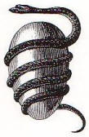                                          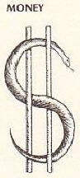             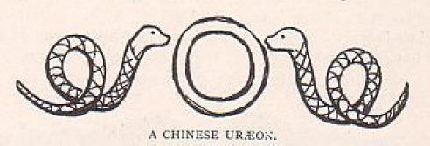

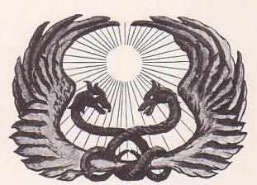      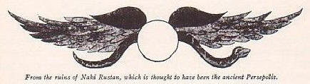    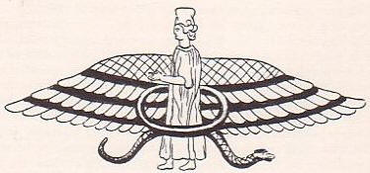    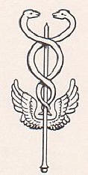

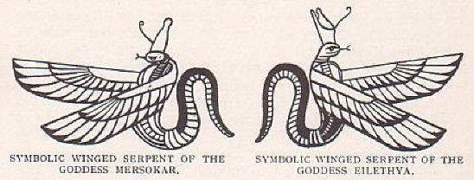        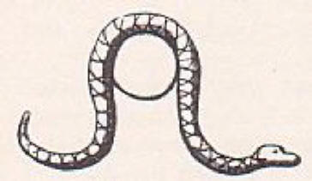

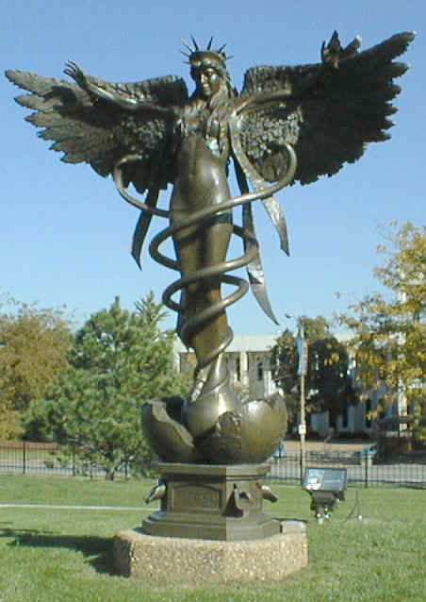

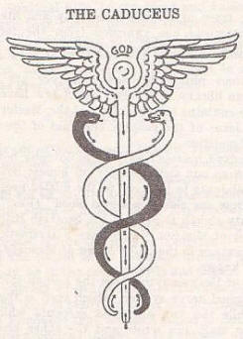    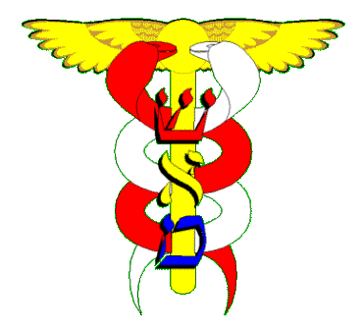    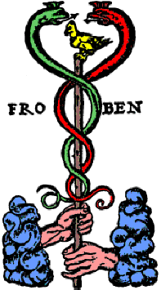  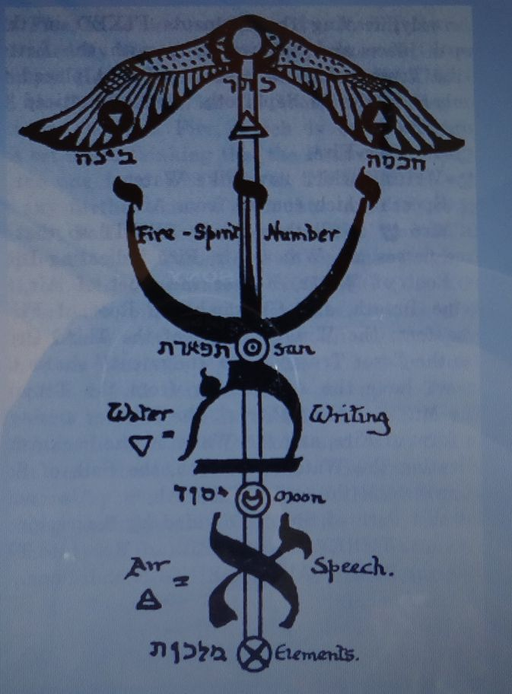   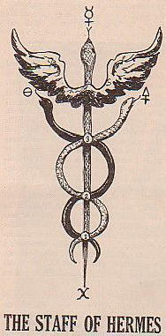

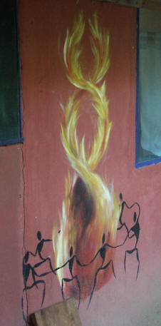   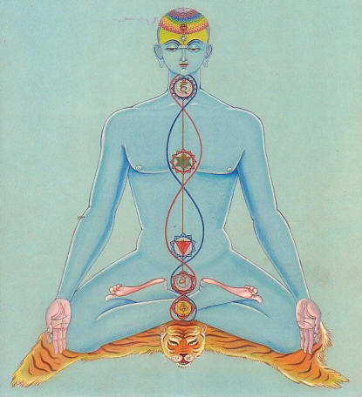    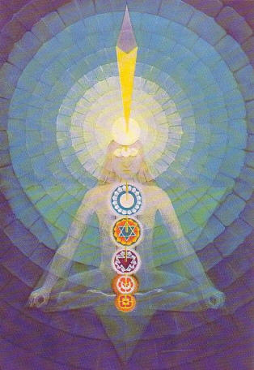

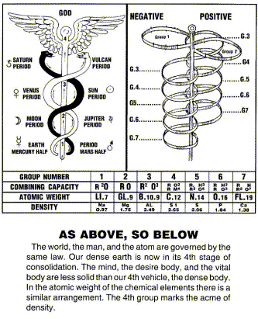                     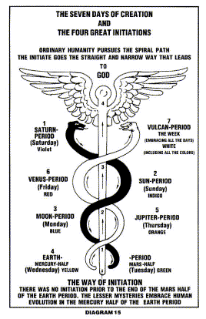                      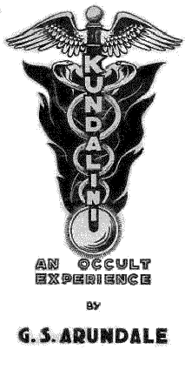

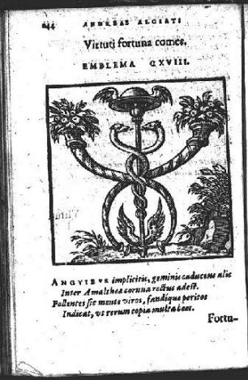       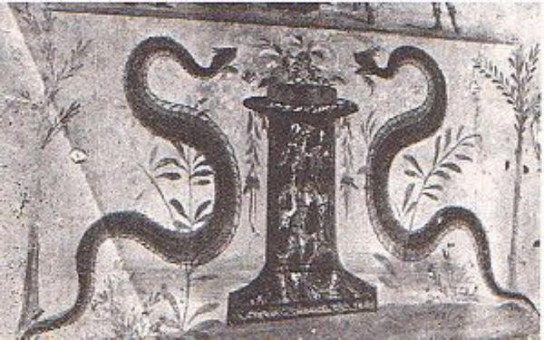    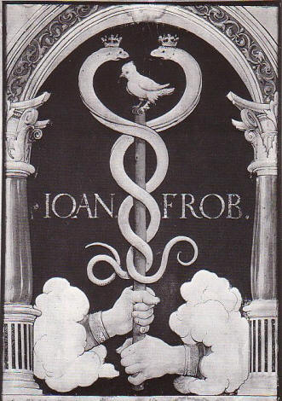

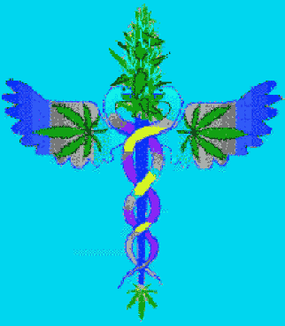   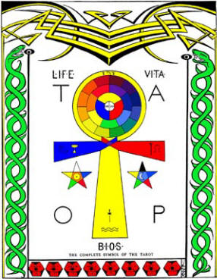    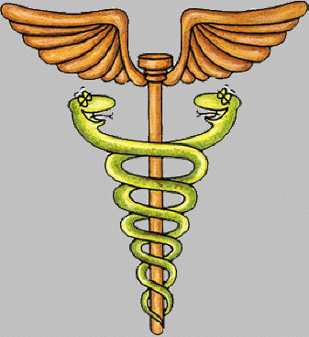    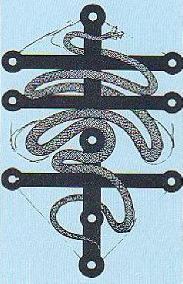

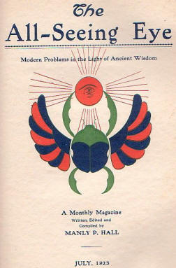     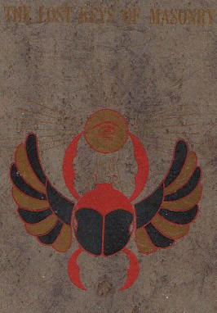     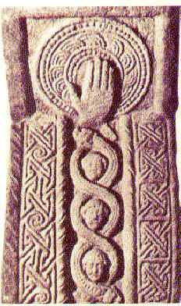      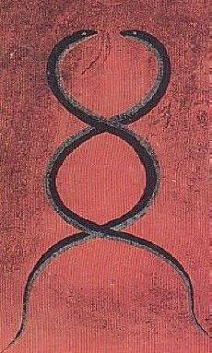

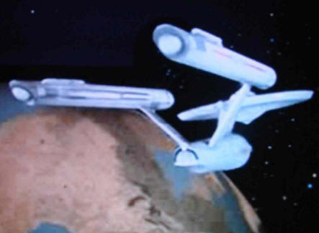    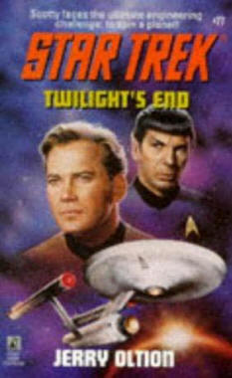    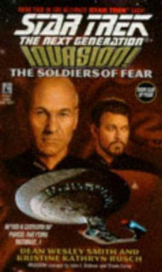    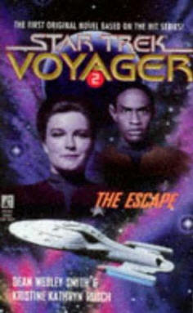

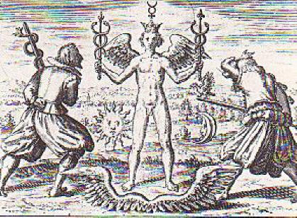                                             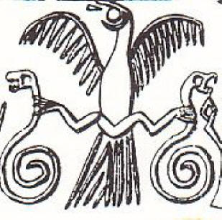

**The many forms of the universal Caduceus**

**Symbolism, as I have understood it over the years of my study, are basic images from our own natural environment, used to insight certain specific feelings in our subconscious. Symbols are repeated over and over through all the world religions and into every aspect of our daily lives.**

**Hermes Trismegistus brought us the message From the God’s, the Caduceus**

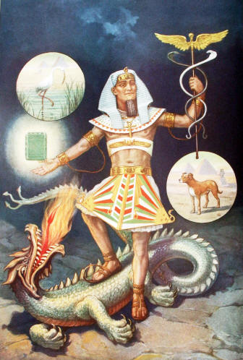                     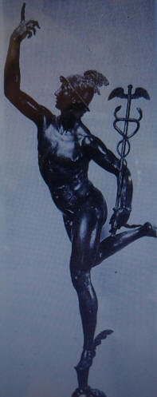

**Hermes Trismegistus& the Great Dragon                        Hermes as Mercury**

"The Word was Reason, and by the Reason of the Word, invisible things were made manifest."

 “To the ignorant the body is supreme and they are incapable of realizing the immortality that is within them. Knowing only the body which is subject to death, they believe in death because they worship that substance which is the cause and reality of death."

"That which the Word of God said, say I: 'Because the Father of all things consists of Life and Light, whereof man is made.' If, therefore, a man shall learn and understand the nature of Life and Light, then he shall pass into the eternity of Life and Light."

“The punishment of desire is the agony of unfulfillment."

Hermes was universal wisdom, standing on the head of ignorance, fear  & perversion the devourer of souls or the symbol of rebirth, a cycle without end.  In one hand Hermes carries the Caduceus, a winged rod with two serpents twisted about it & in the other hand the immortal Emerald Tablet.

Herodotus 484-425 BC (Father of History), Strabo 63?bc- ad24? (Father of Geography),  Hippocrates 460-377bc (Father of Medicine), Plato 428-347 bc (Father of Philosophy) & Pythagoras 580-500 bc a great sage, all have talked in their writings of Hermes Trismegistus.  He is described as coming to Ancient Egypt from the stars some 27,000 years BC, bringing the wisdom & knowledge of all the ages and holding in his hand the caduceus, symbol of medicine, man as a whole healthy being.

The great teacher of the ancient Egyptians was called Thoth or Hermes Trismegistus by the Egyptians and Hermes by the Greeks and later called Mercury by the Romans.  Investigators believe that it was Hermes who was known to the Jews as Enoch.  The name Hermes is derived from "Herm," a form of CHiram, the Personified Universal Life Principle, generally represented by fire. The Scandinavians worshiped Hermes under the name of Odin; the Teutons as Wotan, and certain of the Oriental peoples as Buddha, or Fo.  Master of all arts and sciences, perfect in all crafts, Ruler of the Three Worlds, Scribe of the Gods, and Keeper of the Books of Life, Thoth Hermes Trismegistus--the Three Times Greatest, the "First Intelligencer"--was regarded by the ancient Egyptians as the embodiment of the Universal Mind. He is generally depicted with the body of a man and the head of an ibis, because of its curious nature. He was revered through the form of the planet Mercury because this body is nearest to the SUN: Hermes of all creatures was nearest to God, and became known as the Messenger of the Gods. The Egyptians regarded him as the god of wisdom, letters, and the recording of time.  It is in consequence of the great respect entertained for Hermes by the old alchemists that chemical writings were called 'hermetic,' and that the phrase 'hermetically sealed' is still in use to designate the closing of a glass vessel by fusion, after the manner of chemical manipulators. We find the same root in the hermetic medicines of Paracelsus, and the hermetic freemasonry of the Middle Ages. Of the original forty-two books of Hermes he was said to have written six books on medicine, treating of the structure of the body, and of disease, and instruments, and medicines, and about the eyes, and the last about women.  There are thirty-six books containing the whole philosophy of the Egyptians, including four astrological books.  Among the fragmentary writings believed to have come from the stylus of Hermes are two famous works. The first is the Emerald Tablet, and the second is the Divine Pymander, or, as it is more commonly called, The Shepherd of Men. The famous books of Hermes were doubtless compiled at different periods.  He was reputed to be the first discoverer of the harmony and principle of voices or sounds, and the inventor of the musical instrument called the lyre. He taught men letters, astronomy, and the rites of religion, and who gave the instrument three tones; the treble, bass, and tenor ; the first to accord with summer, the second with winter, and the third with spring.  The Egyptians likened humanity to a flock of sheep. The Supreme and Inconceivable Father was the Shepherd, and Hermes was the shepherd dog. The origin of the shepherd's crook in religious symbolism, used by the Pope today, may be traced to the Egyptian rituals. The three scepters of Egypt include the shepherd's crook, symbolizing that by virtue of the power reposing in that symbolic staff the initiated Pharaohs guided the destiny of their people.

In the Egyptian drawings, Thoth carries a waxen writing tablet and serves as the recorder during the weighing of the souls of the dead in the judgment Hall of Osiris--a ritual of great significance. Hermes is of first importance to Masonic scholars, because he was the author of the Masonic initiatory rituals, which were borrowed from the Mysteries established by Hermes. Nearly all of the Christian, and other religions including Masonry symbols are Hermetic in character. Pythagoras studied mathematics with the Egyptians and from them gained his knowledge of the symbolic geometric solids. Hermes is also revered for his reformation of the calendar system. He increased the year from 360 to 365 days, thus establishing a precedent which still prevails. The appellation "Thrice Greatest" was given to Hermes because he was considered the greatest of all philosophers, the greatest of all priests, and the greatest of all kings. It is worthy of note that the last poem of America's beloved poet, Henry Wadsworth Longfellow, was a lyric ode to Hermes.

The caduceus as I have personally seen, in its original form, in many ancient texts and carvings, had a central golden colored rod called the Sushumna representing a balance in a scale as Virgo carries. The entwining serpent on the left going counterclockwise and colored red or black is called the Ida represented the female energy. The entwining serpent on the right going clockwise and colored white is called the Pingala represented the male energy.  Each of the serpents encircles the Sushumna three and a half times which adds up to seven, the number of energy centers called chakras in our human bodies.  The caduceus is three dimensional not two as it is usually seen drawn on a paper or carved on a flat surface.  When you look straight down on the caduceus the 2 serpents remind you of the 2 swastika’s.  The "Suavastika" which Max Müller named and believes was applied to the Swastika sign, has the ends bent to the left or counterclockwise (Female sign).  The Swastika, has the ends bent to the right or clockwise (Male sign).  For MUCH more see my third article on symbols, “Origins of the Suavastika& Swastika, Symbolism” - Joseph Gill 2011.

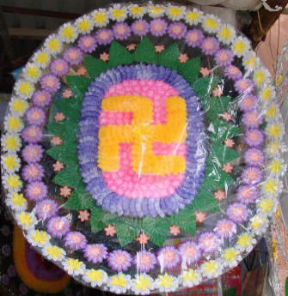                        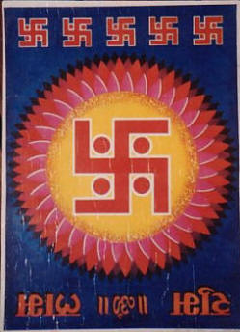

**Suavastika female                 &                   Swastika male**

See “The Swastika, the Earliest Known Symbol, and Its Migrations” - Thomas Wilson, Smithsonian Curator, 1894, page 767.

Download this and other books on the swastika at  
[www.archive.org](http://www.archive.org)

See Symbolism - Swastika

**FROM:**

**ENCYCLOPEDIC THEOSOPHICAL GLOSSARY , Gottfried de Purucker (1347 pages) Jan 2002  
Fountain-Source of Occultism – Gottfried de Purucker**

**Sushumna**sushumnâ, susumna [probably from su excellent, excellence, excelling + shumna musical hymn, happiness, joy] Perfect harmony; one of the three channels forming the spinal column of the body. These three channels are the main avenues not only for the psychovital economy of the body, but for spiritual and intellectual currents between the head and the body. In occultism the spinal column plays many physiological roles, but is especially threefold in its functions. The central channel or nadi, the sushumna-nadi, is the especial carrier of the “solar ray,” which comprises not merely physiological forces and attributes, but the spiritual and intellectual qualities and powers. The two other channels are the ida and pingala; exoteric Hindu works vary in regard to the positions of these, some place the pingala on the left and the ida on the right, and others the reverse. The sushumna connects the heart with the brahmarandhra and plays an important part in yoga practices.

**Ida (-nadi)** (Sanskrit) [from ida refreshment + nadi tubular vessel] One of the three channels forming the spinal column of the body, which are the main avenues for not only the psychovital economy of the body, but likewise for spiritual and intellectual currents between the head and the body proper. In occultism the spinal column plays many physiological roles, but is especially threefold in its functions. The central channel is called the sushumna-nadi, with a channel on either side: the pingala-nadi on the right, and the ida-nadi on the left, although sometimes these positions are given as reversed. All the chakras are connected with the spinal column and the nadis “by the nervous and sympathetic systems as well as by the blood vessels. In occultism the spinal column is not only an organ, but it is actually threefold in its functions, being the foundation of the pranic vitality of the body, driven by the kama of pingala and more or less controlled by the higher manasic or directing attributes of ida” (FSO – Fountain-Source of Occultism, by G. de Purucker 462).

**Pingala** (Sanskrit) Reddish brown, reddish tawny; one of the three nadis (channels) actually forming the spinal column of the body, which are the main avenues for not only the psychovital economy of the body, but likewise of spiritual and intellectual currents as between the head and the body proper. In occultism the spinal column plays many roles in the physiological economy of the living body, but is especially threefold in its functions. The central channel is called the sushumna-nadi, and the two mystical channels on either side of it are the pingala-nadi on the right (or left), and the ida-nadi on the left (or right).

**RED** or**BLACK** stripes (female life force)

with**WHITE** stripes (male life force) **EVERYWHERE!**

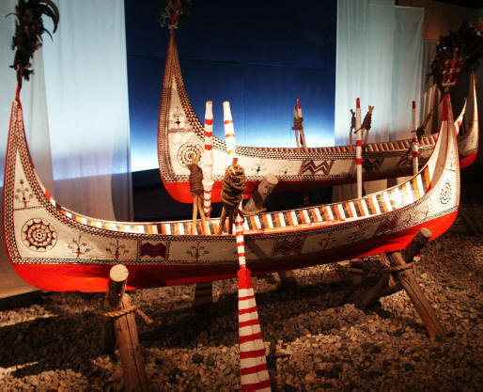

**Ancient Egyptian**

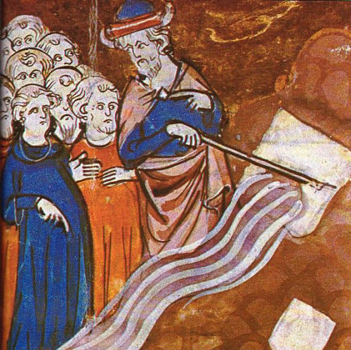

**Moses gets water from a rock**

Book 4 Numbers

020:011 And Moses lifted up his hand, and with his rod he smote the  
                rock twice: and the water came out abundantly, and the  
                congregation drank, and their beasts also.

The caduceus being the ultimate map of the human body both physical, electrical and spiritual can be seen all through our worlds cultures and societies and I picture only a few in this short picture article.  The caduceus shows itself in the candy canes hanging on the Christmas tree, in the Barber pole outside his shop and hanging down behind the US President as he gives his annual “State of the Union Speech”.  The caduceus shows throughout all the road system of the world to warn us all that we must take caution in the road ahead.  Did you ever notice while driving at night the red reflector on the left side on the road (danger) and the white reflector on the right side (caution)? What about the yellow or golden line down the middle of the road, like the yellow brick road in the old Wizard of Oz movie, or the middle yellow or golden pillar in the caduceus.



**The South Pole, British & American Flag**



             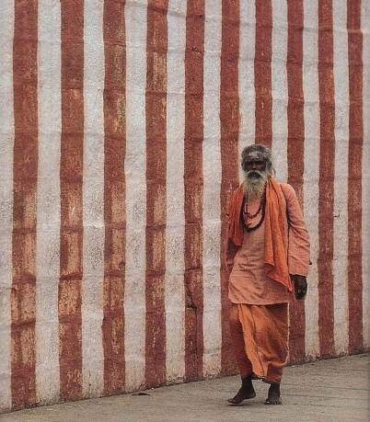

**The American Flag hanging down behind the US President “State of the Union Speech”                                                  Hindu Temple**

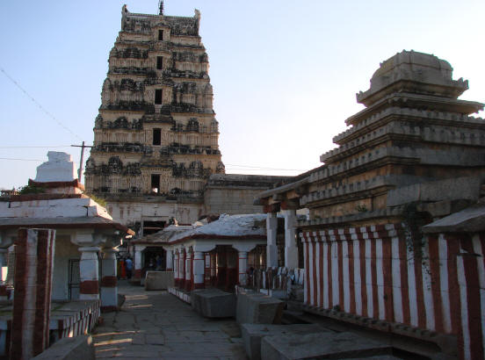          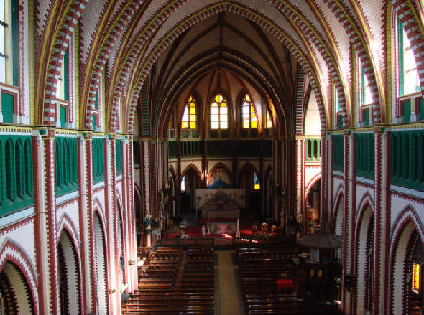

**Hindu Temple                                                                                                                                    Christian Church**

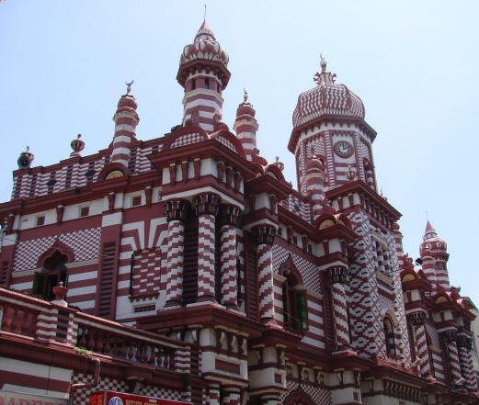          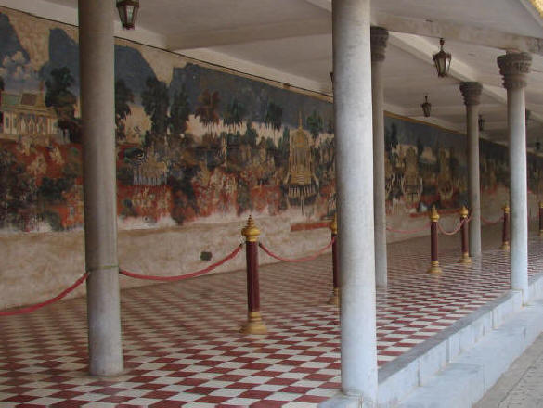

**Islamic Mosque                                                                                                                Sheik Temple**

                        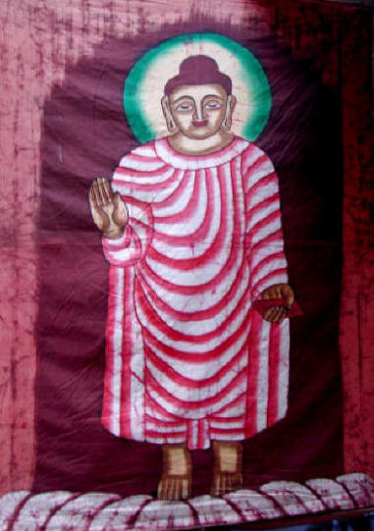

**Town Gate, Germany                                                 Buddhist image**

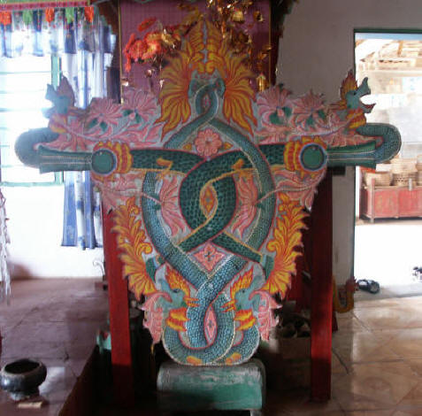         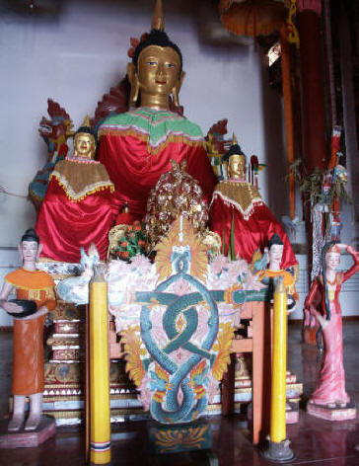

**Buddhist Temple**



**American jail work crew 1936**

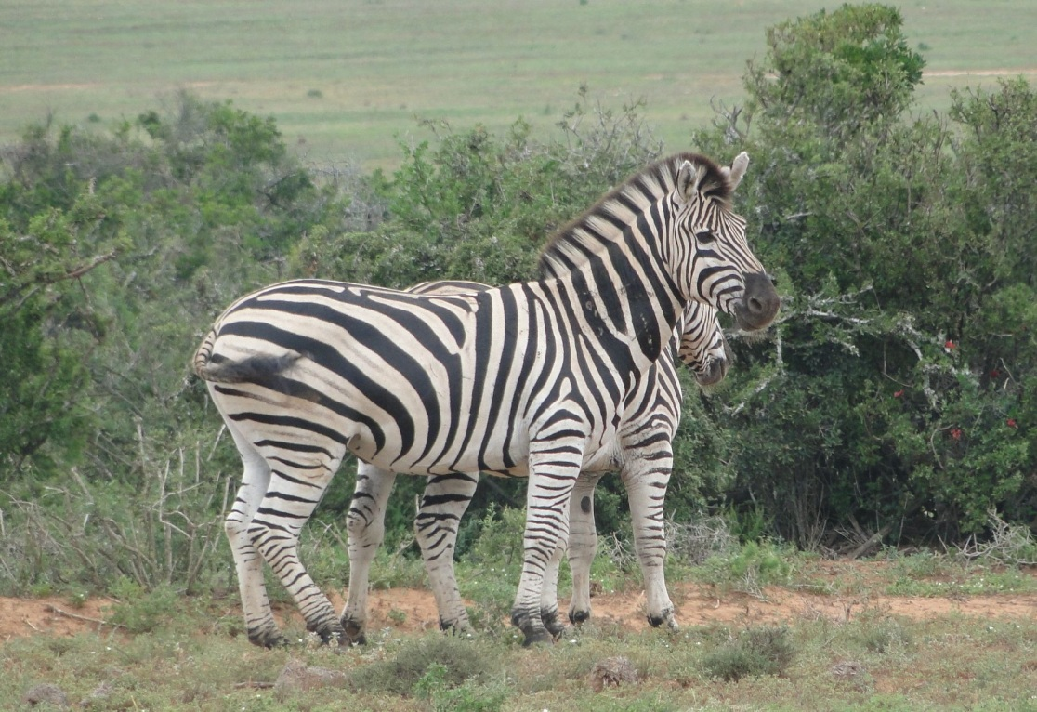 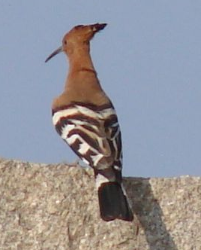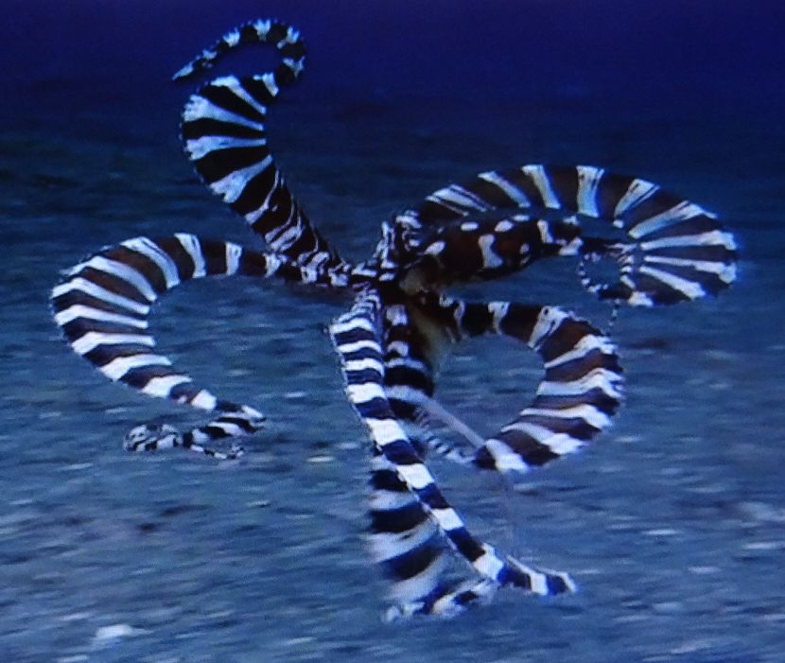

**Natures Stripes**

        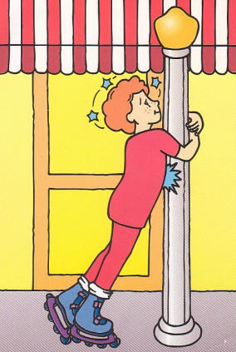    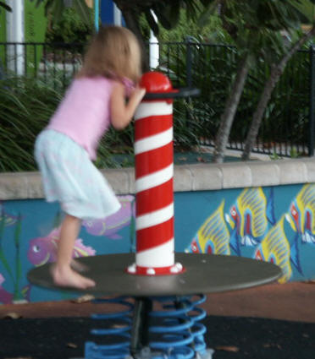

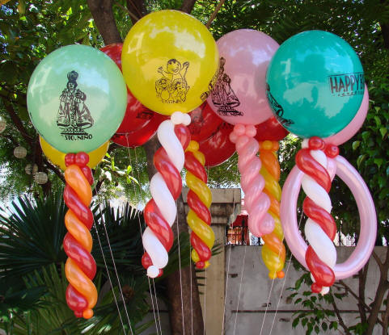

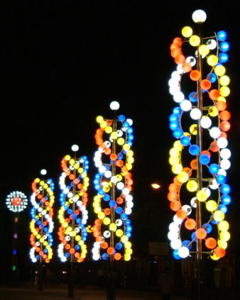                 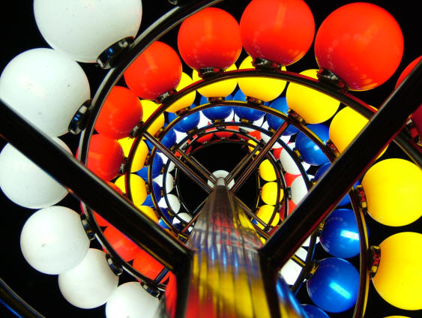

**Candy canes, EVERYWHERE**

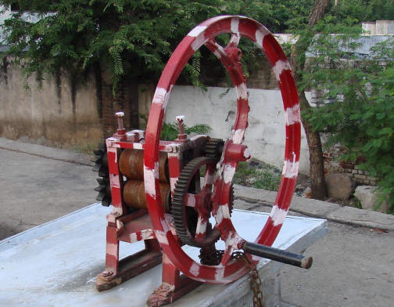

**Sugar cane juicer in India**

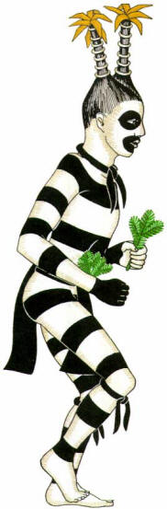

**“Chiffoneti” Zuni clown, American Indian, striped from neck to ankle**

**Road symbolism giving warning or caution**

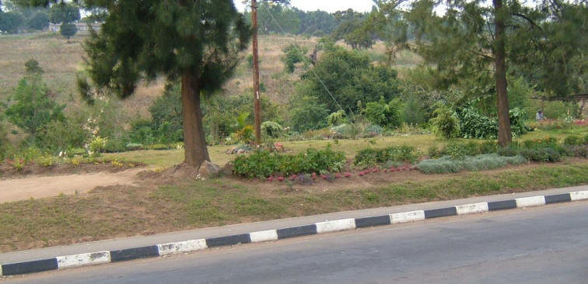

       

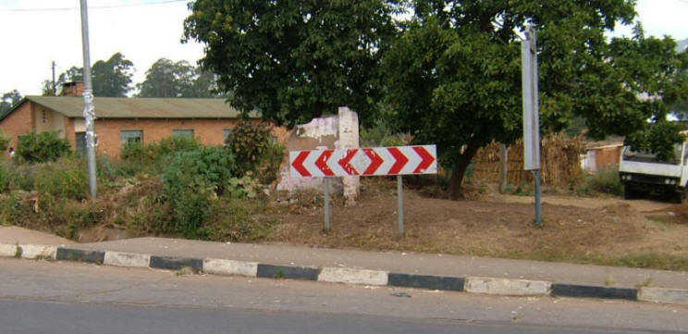       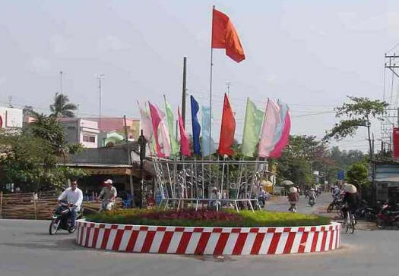

**Road symbolism giving warning or caution**

**The tree of life or the Kabbalah (Qabbalah)**

**The tree of life or the Kabbalah (Qabbalah)** gives a similar message to the caduceus with its left pillar of red or black of female powers, its right pillar white of male powers and it’s middle pillar of gold with balanced or neutral powers.

The author has collected a large library on the tree of life or kabbalah and has studied this for several years.  I feel the true meaning of the tree of life can be easily visualized by seeing a pregnant woman lying on her back and inside her womb is her baby laying on its back.  Out of the babies navel is growing the umbilical cord (or tree trunk) and out of the top of this unfolds the placenta or top of the tree, therein the tree of life is formed.  The esoteric study of the tree of life, like all religions, is basically a hidden symbolic philosophy that is more confusing than helpful.

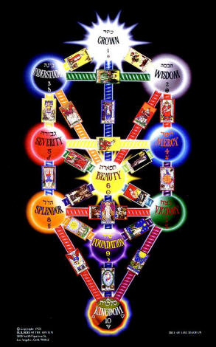  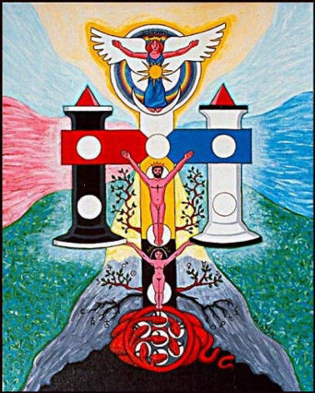  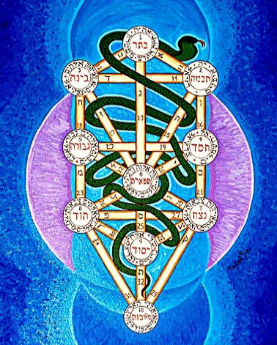

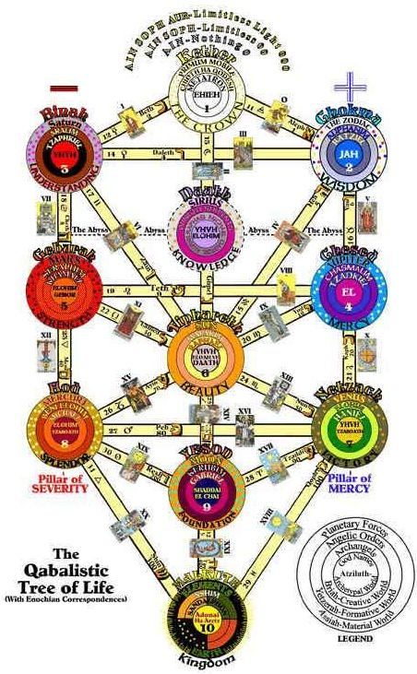                                    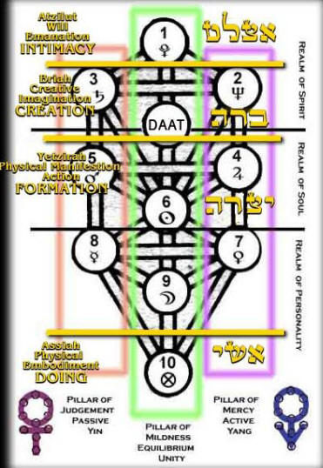

**FROM:**

**ENCYCLOPEDIC THEOSOPHICAL GLOSSARY , Gottfried de Purucker (1347 pages) Jan 2002  
Fountain-Source of Occultism – Gottfried de Purucker**

**Qabbalah** (Hebrew) [from *qabal* to receive, hand down] Also Cabala, Kabala, Kabbalah, etc.Tradition, that which is handed down; the theosophy of the Jews. Originally these truths were passed on orally by one initiate to chosen disciples, hence were referred to as the Tradition. The first one historically alleged to have reduced a large part of the secret Qabbalah of the Chaldees into systematic, and perhaps written, form was the Rabbi Shim`on ben Yohai, in the *Zohar*; but the work of this name that has come down to the present day -- through the medieval Qabbalists -- is but a compilation of the 13th century, presumably by Moses de Leon.

The principal doctrines of the Qabbalah deal with the nature of the divine incomprehensible All ('eynsoph); the divine emanations of the Sephiroth; cosmogony; the creation or emanation of angels and men, and of their destiny. The Jewish Qabbalah was derived from the Chaldean Qabbalah, and "mistaken is he who accepts the Kabalistic works of to-day, and the interpretations of the Zohar by the Rabbis, for the genuine Kabalistic lore of old! For no more to-day than in the day of Frederick von Schelling does the Kabala accessible to Europe and America, contain much more than 'ruins and fragments, much distorted remnants still of that *primitive system which is the key to all religious systems*' . . . The oldest system and the *Chaldean* Kabala were identical. The latest renderings of the *Zohar* are those of the Synagogue in the early centuries" (SD 2:461-2).

**Jachin& Boaz**

**The black female Boaz or left-hand pillar and the white male Jachin right-hand pillar also give a similar message to the caduceus.  They are the powerful pillars at the entrance to the temple.**

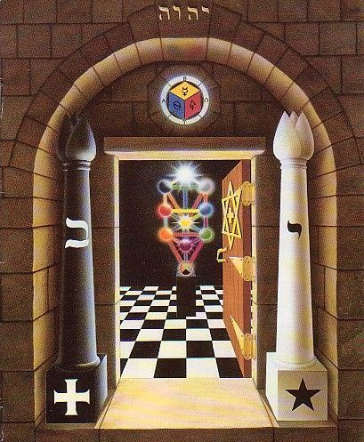

**FROM:**

**ENCYCLOPEDIC THEOSOPHICAL GLOSSARY , Gottfried de Purucker (1347 pages) Jan 2002  
Fountain-Source of Occultism – Gottfried de Purucker**

**Boaz**bo`az (Hebrew) [from be in + `oz might, strength, majesty] Strength, majesty; the name of an individual in the Old Testament, as well as of the left-hand pillar which was erected by the widow's son, Hiram, before the temple of Solomon (1 Kings 7:21). From the standpoint of the Qabbalah, Boaz stands for the third Sephirah, Binah (intelligence or mind).

**Jachin**yachin (Hebrew) The right-hand pillar set up before the temple of Solomon by Hiram (1 Kings 7:21). From the Qabbalistic standpoint, Jachin is the right pillar of the Sephirothal Tree composed of Hochmah (wisdom), Hesed (mercy), and Netsah (firmness).

I have seen thousands of examples of the caduceus both at ancient sights and in modern daily life, in my world travels since 1961, around the world over 30 times.

See our popular FREE web site where over 80,000 people from 120 countries come visit each month, to see our 25 year trip following the SUN.  Now we are in our 9th year of continuous travel.   [www.worldglobetrotters.com](http://www.worldglobetrotters.com)

Please send this article to all you know and please feel free to email me with your comments or pictures of any unusual caduceus that you see…………

My definition of life is LEARNING.    
So stay alive and listen, read & observe.    
Make your own mind up, only after looking at ALL possibilities.    
I am after 50 years of continuous study still studying the possibilities.

Blessings

Joseph O. Gill Traveler

Joseph Gill has talked for over 8 hours on national syndicated talk radio shows with 6 to 7 million listeners about symbolism and the simple origins of our different world religions.  After many personal requests Joseph has put together this simple picture documentary article for easy understanding and has supplied references for those people wanting more information details.  Go as far as you want.

This paper is given after 40 years of research in thousands of books and 50 years of travel 1961-2011; personally visiting hundreds of churches and temples in over 100 countries.

**PLEASE FORWARD THIS ARTICLE TO ALL ON YOUR EMAIL LIST**

**Bibliography (author’s favorites):**

Morals and Dogma - by Albert Pike 1871  
Indo Aryan Deities And Worship As Contained In The Rig Veda - by Albert Pike 1930  
The Secret Teachings of All Ages - Manly P Hall 1928  
Manners and Customs of the Ancient Egyptians, Vol. 1-3 -  John Gardner Wilkinson 1878  
A New System, Analysis of Ancient Mythology, Vol 1-3 - Jacob Bryant 1774  
An Encyclopedia of Freemasonry - by Albert Gallatin Mackey 1874  
Encyclopedia of Freemasonry, Vol. 1 1914 & Vol. 2 1916 - Albert G. Mackey  
THE SECRET DOCTRINE - H. P. Blavatsky 1888  
ISIS UNVEILED - H. P. Blavatsky 1877.  
The Theosophical Glossary - H. P. Blavatsky 1918  
Rivers of Life, Vol 1 - by James George Roche Forlong 1883 A.O  
Rivers of Life or Faiths of Man in all Lands - Synchronological Chart of the Religions of the World - by James George Roche Forlong 1883 A.O  
Faiths of Mankind - A Cyclopedia of Religions, Vol. 1 – 3  - by James George Roche Forlong 1906  
A History of Chemistry From the Earliest Times - James Campbell Brown 1920  
ENCYCLOPEDIC THEOSOPHICAL GLOSSARY , Gottfried de Purucker (1347 pages) Jan 2002  
Fountain-Source of Occultism - Gottfried de Purucker

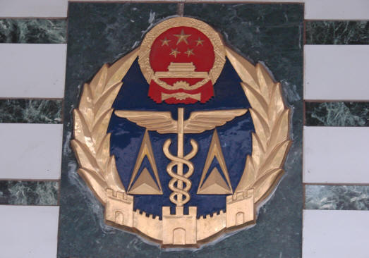

**The End**

**Personal Notes for the more deeply interested, from the Author**

**Morals and Dogma - by Albert Pike 1871**

The Caduceus, borne by Hermes or Mercury, and also by Cybele,

Minerva, Anubis, Hercules Ogmius the God of the Celts, and the

personified Constellation Virgo, was a winged wand, entwined by

two serpents. It was originally a simple Cross, symbolizing the

equator and equinoctial Colure, and the four elements proceeding

from a common centre. This Cross, surmounted by a circle, and

that by a crescent, became an emblem of the Supreme Deity

or of the active power of generation and the passive power of

production conjoined, and was appropriated to Thoth or Mercury.

It then assumed an improved form, the arms of the Cross

being changed into wings, and the circle and crescent being formed

by two snakes, springing from the wand, forming a circle by

crossing each other, and their heads making the horns of the

crescent ; in which form it is seen in the hands of Anubis.

Of HERMES, the Mercury of the Greeks, the Thoth of the

Egyptians, and the Taaut of the Phoenicians, we have heretofore

spoken sufficiently at length. He was the inventor of letters and

of Oratory, the winged messenger of the Gods, bearing the Caduceus

wreathed with serpents ; and in our Council he is represented

by the ORATOR.

Therein is the secret fire, living and philosophical, of which all

the Hermetic philosophers speak with the most mysterious reserve

: the Universal Seed, the secret whereof they kept, and which

they represented only under the figure of the Caduceus of Hermes.

Eusebius names as the principal Ministers in the Mysteries of

Eleusis, first, the Hierophant, clothed with the attributes of the

Grand Architect (Demiourgos) of the Universe. After him came

theDadoukos, or torch-bearer, representative of the Sun: then

the altar-bearer, representing the Moon : and last, the Hieroceryx,

bearing the caduceus, and representing Mercury.

--------------------------------------------------------------------------

**Indo Aryan Deities And Worship As Contained In The Rig Veda - by Albert Pike 1930**

Mercury was the messenger of the Gods, and especially of Jupiter, as

Pushan was of the sun. He was the patron of travelers, as Pushan was, and

of shepherds. He conducted the souls of the dead, another function ascribed

toPushan. He was the patron of orators and merchants, and also the

protector of thieves, pickpockets and other dishonest persons, and when just

born, stole and drove away the oxen of Admetus, which Apollo tended : and

was made not only the messenger, but the interpreter and cup-bearer of

Zeus, who presented him with a winged cap called petasus, and wings for the

feet, called talaria. He bore also a short sword called herpe. He invented

the lyre with seven strings, and gave it to Apollo, receiving in exchange the

celebrated caduceus, with which' the latter had driven the herds of Admetus.

The caduceus, originally something by which cattle were driven, became

at last a rod, entwined at one end by two serpents, in the form of two equal

semicircles. It is said to have been originally a herald's staff, an olive

stick, with garlands upon it, which were changed into serpents.

From the caduceus, a rod of gold (rabdos) he was called chrusorrapis

(xpu<r6j5powris) "having the rod of gold;" rdbdos meaning a stick, twig, rod,

staff, etc. This epithet is found in the Homeric hymn to Vesta and Hermes,

----------------------------------------------------------------------------------------------------

**The Secret Teachings of All Ages - Manly P Hall - 1928**

Mercury was typified as a youth with wings, often with two heads, carrying serpents or sometimes the caduceus.

Gemini is ruled by Mercury and the two children personify the serpents entwined around the caduceus.

The Caduceus of Hermes was an outgrowth of the TAU cross.

---------------------------------------------------------------------------------------------------

**An Encyclopaedia of Freemasonry - by Albert Gallatin Mackey 1874**

Caduceus. The Caduceus was the

magic wand of the god Hermes. It was

an olive staff" twined with fillets, which

were gradually converted to wings and serpents.

Hermes, or Mercury, was the messenger

of Jove. Among his numerous attributes,

one of the most important was that of

conducting disembodied spirits to the other

world, and, on necessary occasions, of bringing

them back. He was the guide of souls,

and the restorer of the dead to life. Thus,

Horace, in addressing him, says :

"

Unspotted spirits you consign

To blissful seats and joys divine,

And powerful with your golden wand

The Mght unburied crowd command."

Virgil also alludes to this attribute of

the magic wand when he is describing the

flight of Mercury on his way to bear Jove's

warning message to ^neas :

" His wand he takes; with this pale ghost he calls

From Pluto's realms, or sends to Tartarus

shore."

And Btatius, imitating this passage, makes

the same allusion in his Thebaid, (L 314,)

thus translated by Lewis.

" He grasps the wand which draws from hollow

graves,

Or drives the trembling shades to Stygian

waves ;

With magic power seals the watchful eye

In slumbers soft or causes sleep to fly."

The history of this Caduceus, or magic

wand, will lead us to its symbolism. Mercury,

who had invented the lyre, making it

out of the shell of the tortoise, exchanged

it with Apollo for the latter's magical wand.

This wand was simply an olive .branch

around which were placed two fillets of

ribbon. Afterwards, when Mercury was in

Arcadia, he encountered two serpents engaged

in deadly combat. These he separated

with his wand ; hence the olive wand

became the symbol of peace, and the two

fillets were replaced by the two serpents,

thus giving to the Caduceus its well-known

form of a staff*, around which two serpents

are entwined.

Such is the legend ; but we may readily

see that in the olive, as the symbol of immortality,

borne as the attribute of Mercury,

the giver of life to the dead, we

have a more ancient and profounder symbolism.

The serpents, symbols also of immortality,

are appropriately united with

the olive wand. The legend also accounts

for a later and secondary symbolism— that

of peace.

The Caduceus then — the original meaning

of which word is a herald's staff— as

the attribute of a life-restoring God, is in

its primary meaning the symbol of immortality

; so in Freemasonry the rod of the

Senior Deacon, or the Master of Ceremonies,

is but an analogue of the Hermean

Caduceus. This officer, as leading the aspirant

through the forms of initiation into

his new birth or Masonic regeneration, and

teaching him in the solemn ceremonies of

the third degree the lesson of eternal life,

may well use the magic wand as a representation

of it, which was the attribute of that

ancientdeity,who brought the dead into life.

---------------------------------------------------------------------

**Encyclopedia of Freemasonry, Vol 1 1914 &Vol 2 1916 - Albert G. Mackey**

Caduceus. The Caduceus was the magic

wand of the god Hermes . It was an olive staff

twined with fillets, which were gradually converted

to wings and serpents. Hermes, or Mercury,

was the messenger of Jove. Among his

numerous attributes, one of the most important

was that of conducting disembodied

spirits to the other world, and, on necessary

occasions, of bringing them back. He was

the guide of souls, and the restorer of the dead

to life. Thus, Horace, in addressing him, says :

"Unspotted spirits you consign

To blissful seats and joys divine,

And powerful with your golden wand

The light unburied crowd command ."

Virgil also alludes to this attribute of the

magic wand when he is describing the flight of

Mercury on his way to bear Jove's warning

message to e.:nws

"His wand he takes ; with this pale ghost he calls

From Pluto's realms, or sends to Tartarus'

shore."

And Statius, imitating this passage, makes

the same allusion in his Thebaid (i., 314), thus

translated by Lewis :

"He grasps the wand which draws from hollow

graves,

Or drives the trembling shades to Stygian

waves ;

With magic power seals the watchful eye

In slumbers soft or causes sleep to fly ."

The history of this Caduceus, or magic wand,

will lead us to its symbolism . Mercury, who

had invented the lyre, making it out of the

shell of the tortoise, exchanged it with Apollo

for the latter's magical wand . This wand was

simply an olive branch around which were

placed two fillets of ribbon . Afterward, when

Mercury was in Arcadia, he encountered two

serpents engaged in deadly combat . These he

separated with his wand ; hence the olive wand

became the symbol of peace, and the two fillets

were replaced by the two serpents, thus giving

to the Caduceus its well-known form of a staff,

around which two serpents are entwined .

Such is the legend ; but we may readily see

that in the olive, as the symbol of immortality,

borne as the attribute of Mercury, the giver of

life to the dead, we have a more ancient and

rofounder symbolism. The serpents, symls

also of immortality, are appropriately

united with the olive wand . The legend also

accounts for a later and secondary symbolism

-that of peace.

The Caduceus then-the original meaning

of which word is a herald's staff-as the attribute

of a life-restoring God, is in its primary

meaning the symbol of immortality ; so in

Freemasonry the rod of the Senior Deacon, or

the Master of Ceremonies, is but an analogue

of the Hermean Caduceus . This officer, as

leading the aspirant through the forms of initiation

into his new birth orMasonic regeneration,

and teaching him in the solemn ceremonies

of the Third Degree the lesson of eternal

life, may well use the magic wand as a representation

of it, which was the attribute of that

ancient deity who brought the dead into life .

**THE SECRET DOCTRINE - H. P. Blavatsky 1888**

###### [[Vol. 1, Page]] 550 THE SECRET DOCTRINE

Every one knows what the caduceus is, already modified by the Greeks. The original symbol -- with the triple head of the serpent -- became altered into a rod with a knob, and the two lower heads were separated, thus disfiguring somewhat the original meaning. Yet it is as good an illustration as can be for our purpose, this laya rod entwined by two serpents. Verily the wonderful powers of the magic caduceus were sung by all the ancient poets, with a very good reason for those who understood the secret meaning.

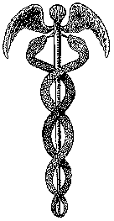

Now what says the learned President of the Chemical Society of Great Britain, in that same lecture, which has any reference to, or bearing upon, our above-mentioned doctrine. Very little; only this -- and nothing more: --

"In the Birmingham address already referred to I asked my audience to picture the action of two forces on the original protyle --- one being time, accompanied by a lowering of temperature; the other, swinging to and fro like a mighty pendulum, having periodic cycles of ebb and swell, rest and activity, being intimately connected with the imponderable matter, essence, or source of energy we call electricity. Now, a simile like this effects its object if it fixes in the mind the particular fact it is intended to emphasize, but it must not be expected necessarily to run parallel with all the facts. Besides the lowering of temperature with the periodic ebb and flow of electricity, positive or negative, requisite to confer on the newly-born elements their particular atomicity, it is evident that a third factor must be taken into account. Nature does not act on a flat plane; she demands space for her cosmogenic operations, and if we introduce space as the third factor, all appears clear. Instead of a pendulum, which, though to a certain extent a good illustration, is impossible as a fact, let us seek some more satisfactory way of representing what I conceive may have taken place. Let us suppose the zigzag diagram not drawn upon a plane, but projected in space of three dimensions. What figure can we best select to meet all the conditions involved? Many of the facts can be well explained by supposing the projection in space of Professor Emerson Reynolds' zigzag curve to be a spiral. This figure is, however, inadmissible, inasmuch as the curve has to pass through a point neutral as to electricity and chemical energy twice in each cycle. We must, therefore, adopt some other figure. A figure of eight (8), or lemniscate, will foreshorten into a zigzag just as well as a spiral, and it fulfils every condition of the problem."

Alemniscatefor the evolution downward, from Spirit into matter;

###### [[Vol. 1, Page]] 551 THE CADUCEUS OF LIFE.

another form of a spiral,perhaps, in its reinvolutionary path onward, from matter into Spirit, and the necessary gradual and final reabsorption into the laya state, that which Science calls in her own way "the point neutral as to electricity" etc., or the zero point. Such are the Occult facts and statement. They may be left with the greatest security and confidence to Science, to be justified some day. Let us hear some more, however, about this primordial genetic type of the symbolical caduceus.

"Such a figure will result from three very simple simultaneous motions. First, a simple oscillation backwards and forwards (suppose east and west); secondly, a simple oscillation at right angles to the former (suppose north and south) of half the periodic time -- *i.e.*, twice as fast; and thirdly, a motion at right angles to these two (suppose downwards), which, in its simplest form, would be with unvarying velocity. If we project this figure in space we find on examination that the points of the curves, where chlorine, bromine, and iodine are formed, come close under each other; so also will sulphur, selenium, and tellurium; again, phosphorus, arsenic, and antimony; and in like manner other series of analogous bodies. It may be asked whether this scheme explains how and why the elements appear in this order? Let us imagine a cyclical translation in space, each evolution witnessing the genesis of the group of elements which I previously represented as produced during one complete vibration of the pendulum. Let us suppose that one cycle has thus been completed, the centre of the unknown creative force in its mighty journey through space having scattered along its track the primitive atoms -- the seeds, if I may use the expression -- which presently are to coalesce and develop into the groupings now known as lithium, beryllium, boron, carbon, nitrogen, oxygen, fluorine, sodium, magnesium, aluminium, silicon, phosphorus, sulphur, and chlorine. What is most probably the form of track now pursued? Were it strictly confined to the same plane of temperature and time, the next elementary groupings to appear would again have been those of lithium, and the original cycle would have been eternally repeated, producing again and again the same 14 elements. The conditions, however, are not quite the same. Space and electricity are as at first, but temperature has altered, and thus, instead of the atoms of lithium being supplemented with atoms in all respects analogous with themselves, the atomic groupings which come into being when the second cycle commences form, not lithium, but its lineal descendant, potassium. Suppose, therefore, the *vis generatrix* travelling to and fro in cycles along a lemniscate path, as above suggested, while simultaneously temperature is declining and time is flowing on -- variations which I have endeavoured to represent by the downward sink -- each coil of the lemniscate track crosses the same vertical line at lower and lower points. Projected in space, the curve shows a central line neutral as far as electricity is concerned, and neutral in chemical properties -- positive electricity on the north, negative on the south. Dominant atomicities are governed by the distance east and west from the neutral centre line, monatomic elements being one remove from it, diatomic two removes, and so on. In every successive coil the same law holds good."

###### [[Vol. 2, Page]] 208 THE SECRET DOCTRINE.

Every scholar knows that both the heathen wand and the Jewish "serpent" are one and the same, namely, the Caduceus of Mercury, son of **A**POLLO-PYTHON. It is easy to comprehend why the Jews adopted the ophidian shape for their "seducer." With them it was purely physiological and phallic;and no amount of casuistical reasoning on the part of the Roman Catholic Church can give it another meaning, once that the mystery language is well studied, and that the Hebrew scrolls are read numerically. The Occultists know that the serpent, the Naga, and the dragon have each a septenary meaning; that the Sun, for instance, was the astronomical and cosmic emblem of the two contrasted lights, and the two serpents of the Gnostics, the good and the evil one; they also know that, when generalised, the conclusions of both science and theology present two most ridiculous extremes. For, when the former tells us that it is sufficient to trace the legends of the serpents to their primal source, the astrological legend, and to meditate seriously on the Sun, conqueror of Python, and the celestial virgin in the Zodiac forcing back the devouring dragon, if we would have the key of all the subsequent religious dogmas; it is easy to perceive that, instead of

###### [[Vol. 2, Page]] 209 COBRAS AS SYMBOLS.

generalising, the author simply has his eye on Christian religion and Revelation. We call this one extreme. The other we see in this: when, repeating the famous decision of the Council of Trent, theology seeks to convince the masses that "from the fall of man until the hour of his baptism the devil has full power over him, and possesses him by right (diabolum dominationem et potestatem super homines habere et jure cos possidere)."To this Occult philosophy answers: Prove first the existence of the devil as an entity, and then we may believe in such congenital possession. A very small amount of observation and knowledge of human nature may be sufficient to prove the fallacy of this theological dogma. Had **S**ATAN any reality, in the objective or even subjective world (in the ecclesiastical sense), it is the poor devil who would find himself chronically obsessed and even possessed by the wicked -- hence by the bulk of mankind. It is humanity itself, and especially the clergy, headed by the haughty, unscrupulous and intolerant Roman Church, which have begotten, given birth to, and reared in love the evil one; but this is a digression.

###### [[Vol. 2, Page]] 328 THE SECRET DOCTRINE.

That the Serpents were ever the emblems of wisdom and prudence is again shown by the caduceus of Mercury, one with Thot, the god of wisdom, with Hermes, and so on. The two serpents, entwined around the rod, are phallic symbols of Jupiter and other gods who transformed themselves into snakes for purposes of seducing goddesses -- but only in the unclean fancies of profane symbologists. The serpent has ever been the symbol of the adept, and of his powers of immortality and divine knowledge. Mercury in his psychopompic character, conducting and guiding with the caduceus the souls of the dead to Hades and even raising the dead to life with it, is simply a very transparent allegory. It shows the dual power of the Secret Wisdom: the black and the white magic. It shows this personified Wisdom guiding the Soul after death, and its power to call to life that which is dead -- a very deep metaphor if one thinks over its meaning. Every people of antiquity reverenced this symbol, with the exception of Christians, who chose to forget the brazen Serpent of Moses, and even the implied acknowledgment of the great wisdom and prudence of the Serpent by Jesus himself, "Be ye wise as serpents and harmless as doves." The Chinese, one of the oldest nations of our Fifth Race, made of it the emblem of their Emperors, who are thus the degenerate successors of the "Serpents" or Initiates, who ruled the early races of the Fifth Humanity. The Emperor's throne is the "Dragon's Seat," and his dresses of State are embroidered with the likeness of the

###### [[Vol. 2, Page]] 365 THE VARIOUS NOAHS.

Dragon. The aphorisms in the oldest books of China, moreover, say plainly that the "Dragon" is a human, albeit divine, Being. Speaking of the "Yellow Dragon," the chief of the others, the Twan-ying-t'u, says: "His wisdom and virtue are unfathomable . . . he does not go in company and does not live in herds (he is an ascetic). He wanders in the wilds beyond the heavens. He goes and comes, fulfilling the decree (Karma); at the proper seasons if there is perfection he comes forth, if not he remains (invisible).". . . And Kon-fu-tyu is made to say by Lu-lan, "The Dragon feeds in the pure water of Wisdom and sports in the clear waters of Life."

###### [[Vol. 2, Page]] 580 THE SECRET DOCTRINE.

The Ogdoad or 8 symbolizes the eternal and spiral motion of cycles, the 8, sd2-580, and is symbolized in its turn by the Caduceus. It shows the regular breathing of the Kosmos presided over by the eight great gods -- the seven from the primeval Mother, the One and the Triad.

--------------------------------------------------------------------------------------------------------------------------------

**ISIS UNVEILED - H. P. Blavatsky 1877.**

###### [[Vol. 1, Page]] 138 THE VEIL OF ISIS.

of a bull, a ram, or a dog. It is the double serpent of the caduceus, itis the Old Serpent of the Genesis, but it is also the brazen serpent of Moses entwined around the tau, that is to say, the generative lingha. It is also the goat of the witch-sabbath, and the Baphomet of the Templars; it is the Hyle of the Gnostics; it is the double-tail of serpent which forms the legs of the solar cock of the Abraxas; finally, it is the Devil of M. Eudes de Mirville. But in very fact it is the blind force which souls have to conquer to liberate themselves from the bonds of the earth; for if their will does not free "them from this fatal attraction, they will be absorbed in the current by the force which has produced them, and will return to the central and eternal fire."

###### [[Vol. 1, Page]] 556 THE VEIL OF ISIS.

As an induction, the narrative of the "brazen serpent" (the Caduceus of Mercury or Asclepios, the son of the sun-god Apollo-Python) becomes logical and natural.

----------------------------------------------------------------------------------------------------------------------------------

**The Theosophical Glossary - H. P. Blavatsky 1918**

Caduceus (Gg.). The Greek poets and mythologists took the idea of

the Caduceus of Mercury from the Egyptians. The Caduceus is found

as two serpents twisted round a rod, on Egyptian monuments built before

Osiris. The Greeks altered this. We find it again in the hands of

./Esculapius assuming a different form to the wand of ]\Iercurius or

Hermes. It is a cosmic, sidereal or astronomical, as well as a spiritual

and even physiological symbol, its significance changing with its application.

^Metaphysically, the Caduceus represents the fall of primeval

and primordial matter into gross terrestrial matter, the one Reality becoming

Illusion. (See Sect. Doct. I. 550.) Astronomically, the head

and tail represent the points of the ecliptic where the planets and even

the sun and moon meet in close embrace. Physiologically, it is the symbol

of the restoration of the equilibrium lost between Life, as a unit,

and the currents of life performing various functions in the human body.

Ether. Students are but too apt to confuse this with Akasa and

with Astral Light. It is neither, in the sense in which ether is described

by physical Science. Etiier is a material agent, though hitherto undetected

by any physical apparatus ; whereas Akasa is a distinctly spiritual

agent, identical, in one sense, with the Anima Mundi, while the Astral

Light is only the seventh and highest principle of the terrestrial atmosphere,

as undctectalile as Akasa and real Ether, because it is something

quite on anotlier i)lane. The seventh principle of the earth's atmosphere,

as said, the Astral Light, is only the second on the Cosmic scale. The

scale of Cosmic Forces, Principles and Planes, of Emanations—on the

metaphysical—and Evolutions—on the physical plane—is the Cosmic

Serpent biting its own tail, the Serpent reflecting the Higher, and reflected

in its turn by the lower Serpent. The Caduceus explains the

mystery, and the four-fold Dodecahedron on the model of which the

universe is said by Plato to have been built by the manifested Logos

—synthesized by the unmanifested First-Born—yields geometrically the

key to Cosmogony and its microcosmic reflection—our Earth.

Thoth (Eg.). The most mysterious and the least understood of ^rods.

whose personal character is entirely distinct from all other ancient

deities. While the permutations of Osiris, Isis, Horus, and the rest, are

so numberless that their individuality is all but lost, Thoth remains

chano:eless from the first to the last Dynasty. He is the ^rod of wisdom

and of authority over all other jrods. He is the recorder and the .iudge.

His ibis-head, the pen and tablet of the celestial scribe, who records the

thoughts, words and deeds of men and weighs them in the balance, liken

him to the type of the esoteric Lipikas. His name is one of the first that

appears on the oldest monuments. He is the lunar god of the first

dynasties, the master of Cynoeephalus—the dog-headed ape who stood

in Egypt as a living symbol and remembrance of the Third Root-Race.

(Secret Doetrine, II. pp. 184 and ISo). He is the "Lord of Hermopolis"

 —Jaiuis, Ilermes and Mercury combined. He is crowned with an a^/

and the lunar disk, and bears the "P]ye of Horus", the tliirel eye, in his

hand. He is the Greek Hermes, the god of learning, and Hermes

Trismegistus, the "Thrice-great Hermes", the patron of physical sciences

and the patron and very soul of the occult esoteric knowledge.

As Mr. J. Bonwick, F.R.G.S., beautifully expresses it: "Thoth . . .

has a powerful effect on the imagination ... in this intricate yet

beautiful phantasmagoria of thought and moral sentiment of that

shadowy past. It is in vain we ask ourselves however man, in the infancy

of this world of humanity, in the rudeness of supposed incipient civilization,

could have dreamed of such a heavenly being as Thoth. The lines

are so delicately drawn, so intimately and tastefully interwoven, that

we seem to regard a picture designed by the genius of a ^lilton, and

executed with the skill of a Raphael." Verily, there was some truth in

the old saying, "The wisdom of the Egyptians". . . . "When it is

shown that the wife of Cephren, builder of the second Pyramid, was a

priestess of Thoth, one sees that the ideas comprehended in him were Hxt'tl

 ti.OOO \tnvs a^'u"". Acfonliii^' 1<> ri;ito. •'rimtli Il.rnns was tlu*

iliscovnvi- ami invfiit(»r of mimlH'i-s, jri-oint'try. astnuiuniy and letters".

l*i*oclus, tilt- disciple (tf IMotimis. spcakintr of this inysterions deity, says:

"lie presides over evi-ry spicics of coiiditioii, leadirifr us to an intellitriltl"'

"ssence from this mortal abode, jjovernin^r the difTerent lierds of .souls".

In other words Thoth. as the Kefji.strar and Reeorder of Osiris in Anu'nti,

the JiKljrnuMif Hall of the Dead was a psychoponipic deity; while

lamhliehns hints that "thr cross with a handle (the thau or tan) which

Tot holds in his hand, was none other tlian the monoj^ram of his name".

Besiiles the Tau. as the ])rototype of Mercury. Thoth carries the serpent

rod. emblem of Wisdom, the rod that becomes the Caduceus. Says .Mr.

Monwick, ''Hermes was the serpent it.self in a mystical .sense. He j^lidcs

lik«' that creature, noiselessly, without ai)pan'nt exertion, along the

course of apres. He is ... a rei)rcsentative of the sjjanfrled lieavens.

Hut he is the foe of the bad serpent, for the ibis devoured the snakes of

Egypt ".

-------------------------------------------------------------------------------------------

**Rivers of Life, Vol 1 - by James George Roche Forlong 1883**

Wandering Arabs or

Edumean outcasts from Egypt were, however, but an insignificant part of the

mighty crowds which followed Python, or Ops, and called him incarnate power and

wisdom ; he was the power of the Lawgiver s Rod, Banner, or Caduceus, for this is a

true Phallic emblem, and one which in the case of Israel &quot;the Jhavh&quot; became

incarnate in, by turning it into that &quot;

holy thing,&quot; which Moses was desired in his

troubles to hold up in his hand, and to rear up on a pole for the salvation of the

1 Trans. You also Serpents which creep gleaming in golden splendour, harmless deities in all lands.

tribes. Then and there also was said of this deity what we still hear said of him

in India that &quot; if he stings, or even kills, he is also the healer of all evils.&quot;

The Caduceus idea of Fig. 1, Plate V., is again given as usually

worn by men of authority in Fig. 9, Plate IV., or else it is here to denote that this

Serpent on the right is the male, a fact often thus emphasized in Phallic lore.

Mr Marcus Keane tells us that although the Kelts of Ireland

rejected the phallic worship of their predecessors the Tuath-de-

Danaans, they yet retained their names and customs. May day

continued to be called La-Baal-Thinna, and was always con

nected with the worship of Baal as &quot; the green god

&quot; a very

ancient term for Mercury, whose hue was green ; and being so,

we &quot;here see him in dress of suitable shape and colour, and with

his Caduceus in hand. &quot;

Gad-el-glas or the Green-god-Snake,&quot; was an important Irish

deity, and the name seems to correspond with &quot; the green god,&quot; or &quot;Primeval Boodh,&quot;

-------------------------------------------------------------------------------------------------

WG **Pingala**, a particular current in the body: the right of three currents running from the *os coccyx* to the head, which, according to the anatomy of the Yoga system, are the chief passages of breath. (Literally, "yellowish.")

WGa **Pingala**, in addition to what is given it should be understood that the breath and its channels referred to are not the lungs and air passages but the inner psychic breath.

WG **Ida**, a magnetic current on the right side of the human body, between the heart and the Brahma-randhra.

--------------------------------------------------------------------------------------------------------------------------------------------------------

**ENCYCLOPEDIC THEOSOPHICAL GLOSSARY , Gottfried de Purucker (1347 pages) Jan 2002**

**Caduceus** (Latin) A herald's staff; specially, the wand of Mercury or Hermes, god of wisdom, corresponding to Thoth. It consists of a rod or tree with two serpents wound in opposite directions round it, their tails meeting below, and their heads approaching each other above.



At the top of the rod in the Greek version is a knob, in the earlier Egyptian form a serpent's head, from which spring a pair of wings. From the central head between the wings grew the heads of the entwined serpents (spirit and matter), which descended along the tree of life, crossing the neutral laya-centers between the different planes of being, to manifest where the two tails joined on earth (SD 1:549-50). The analogy is found in every known cosmogony, all of which begin with a circle, head, or egg surrounded by darkness. From this circle of infinity -- the unknown All -- comes forth the manifestations of spirit and matter. The emblem of the evolution of gods and atoms is shown by the two forces, positive and negative, ascending and descending and meeting. Its symbology is directly connected with the globes of the planetary chain and the circulations of the beings or life-waves on these globes, as well as with the human constitution and the afterdeath states. Significantly, in ancient Greek mythology, Hermes is the psychopomp, psychagog, or conductor of souls after death to the various inner spheres of the universe, such as the Elysian Plains or the Meads of Asphodel. The Caduceus also signifies the dual aspect of wisdom by its twin serpents, Agathodaimon and Kakodaimon, good and evil in a relative sense.

**Fountain-Source of Occultism - Gottfried de Purucker**

Now on each side of the central tube of the spinal cord are located respectively ida (called Ila in Vedic literature, the consort of Budha, god of wisdom) and pingala. Hindu writers are not unanimous with regard to the respective positions of ida and pingala, because many place pingala on the right of sushumna and others on the left. All three are called nadis, a Sanskrit word signifying tubular vessel. The meaning of pingala is reddish brown, and ida implies refreshment, the higher vital and stimulating spiritual essence; whereas the sushumna represents the solar vitality modified by lunar influences.

Hence the spinal column and the accompanying sushumna its tubular vessel with pingala and ida, are the main channels of the psychovital economy of the body, with which all the chakras are intimately connected by the nervous and sympathetic systems as well as by the blood vessels. In occultism the spinal column is not only an organ, but it is actually threefold in its functions, being the foundation of the pranic vitality of the body, driven by the kama of pingala and more or less controlled by the higher manasic or directing attributes of ida. This is why the adept at will and with his great knowledge can use these various nadis. It may be added that the 'soul' leaves the body at death through the brahmarandhra at the summit of the skull, which last is in intimate connection with the three tubular vessels of the spinal column, and therefore with the sahasrara and ajna, these two chakras being the pineal gland and the pituitary body respectively.

Due to the tremendous activity of these three nadis of the spinal column and the immense role they play in the economy of the physical body, they are destined to manifest as a double spinal column in the human beings of the far distant ages to come, for then ida and pingala will have developed into cartilaginous or semi-bony structures, i.e. two spinal columns connected by the central nadi or sushumna, which now is surrounded by the vertebrae of the spinal column.

Furthermore, the bodily chakras are the extensions or representatives of their respective principal foci or 'roots' in the brain and various appurtenances thereof contained in the skull, whether of the cerebrum or of the cerebellum. This is H.P.B.'s meaning when she says: "Our seven Chakras are all situated in the head, and it is these Master Chakras which govern and rule the seven (for there are seven) principal plexuses in the body, besides the forty-two minor ones to which Physiology refuses that name" (E.S.Instructions, III).

Every artery and every vein, as well as every tiny capillary, in the human body can technically be called nadis of the blood; and it is with reference to this that certain exoteric works of tantrika or hatha-yoga physiology speak of their number as being 72,000 -- which may or may not be accurate but which actually refers to every kind of 'tubular vessel' or nadi in the human body.

The blood of a man or of a beast, or indeed the sap of the plants, is a deposit of the pranic vitality suffusing throughout the physical body and emanating from the different sources of the seven (or ten or twelve) pranas in the auric egg. Thus blood really is the pranas condensed; whereas we may call the nervous fluids the condensed psychomental vital fluids of the higher portions of the auric egg expressing themselves on the astral and physical planes.

There is a constant and unceasing exchange and interchange of ethereal substances and forces between ida and pingala, and between these two and sushumna, and through these last again with all the other chakras and nadis, which is as much as saying with the sympathetic and/or nervous systems in the body and also its reticulated structure of blood vessels.

As by far the larger part of these Hindu writings are strongly influenced in one way or another by the tantrika thought, I again emphasize the warning to leave the chakras and their respective pranas alone, because very serious peril to both mental and physical health will almost certainly be incurred by foolish yoga experimentation with them, such as attempting to control the breath. No one was more keenly aware of the situation than was H.P.B., who wrote in her E.S. Instructions:

He who has studied both systems, the Hatha and Raja Yoga, finds an enormous difference between the two: one is purely psycho-physiological, the other purely psycho-spiritual. -- III

When we correlate all these physiological functions with the cosmic powers, we recognize that every human being is truly a miniature universe; and that every element and force in the solar system and therefore of the sun itself has its respective focus in man, in his auric egg, and hence in his astral-physical frame. This sublime truth can give spiritual dignity to our thoughts, and lead us to regard our bodies as temples of the god within us.

THE END