Swastika

http://en.wikipedia.org/wiki/Swastika

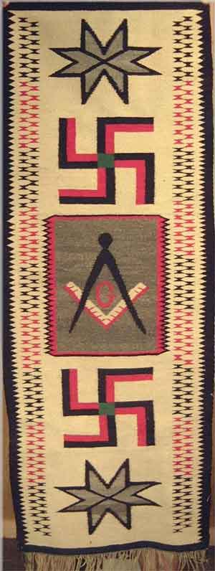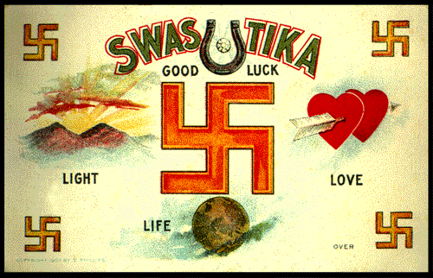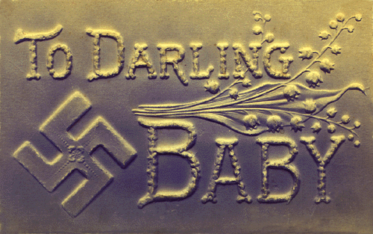

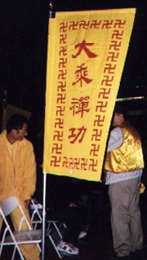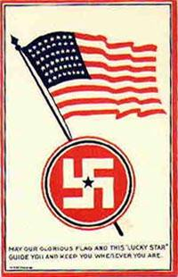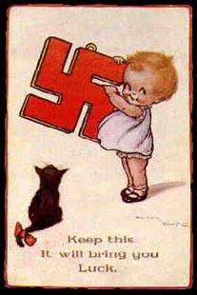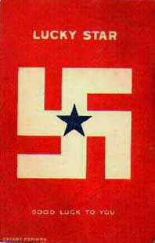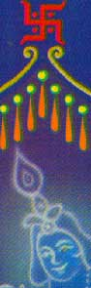
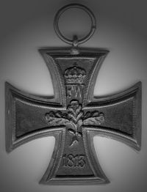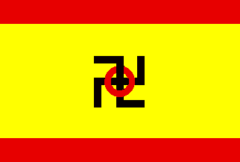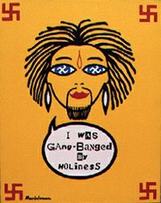
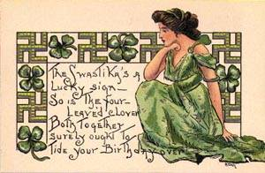
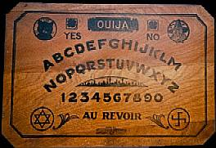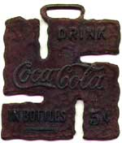
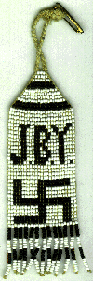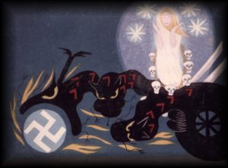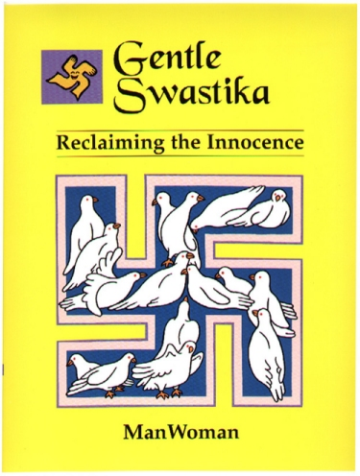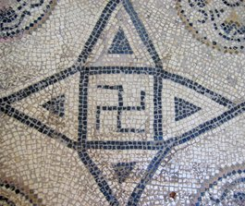
Iron Age Rock Carving near Ilkley in West Yorkshire

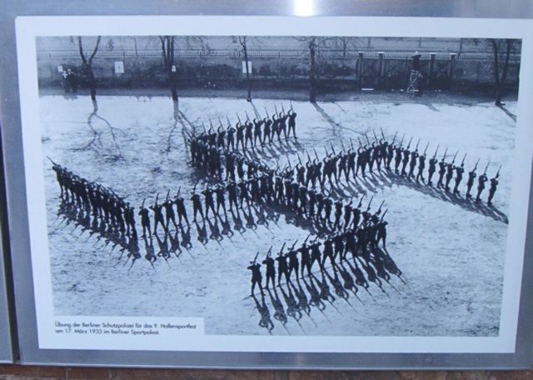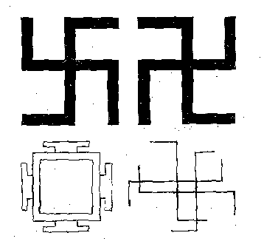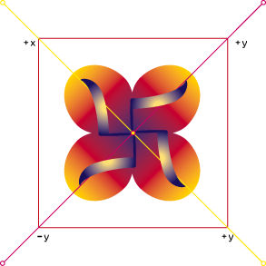
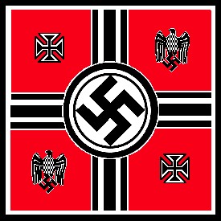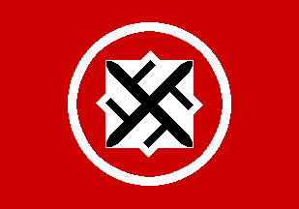
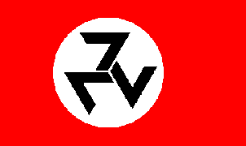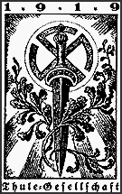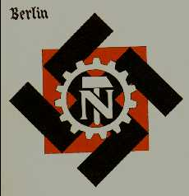
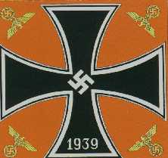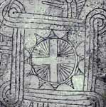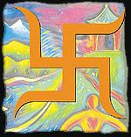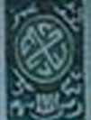

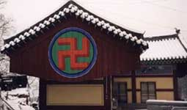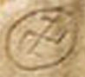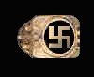



The swastika (from Sanskrit svástika स्वस्तिक ) is an equilateral cross with its arms bent at right angles in either left-facing (卍) or right-facing (卐) direction. In recent history, the Swastika was used in Nazi Germany flag, to emphasize the superiority of the supposedly Aryan/Indian German race [1] over other races, and became controversial symbol since then. In the Western world, it is most widely known and used as a symbol of Nazism (the Hakenkreuz, "hook-cross") and this political association has partly eclipsed its historical status.
On the other hand, traces of the use of swastika is known from 3000 years [2] , and is considered a sacred symbol in Dharmic religions (Hinduism, Buddhism and Jainism) and Germanic ones (Odinism^{[1]}.). The Hindu version is often decorated with a dot in each quadrant.
It is traditionally oriented so that a main line is horizontal, though it is occasionally rotated at forty-five degrees.
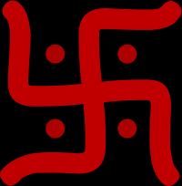
A "right-facing" Swastika in decorative Hindu form

Contents
- 1 Overview
- 2 Etymology and alternative names
- 3 History
  - 3.1 Origin hypotheses
  - 3.2 Archaeological record
  - 3.3 Historical use
  - 3.4 Reintroduction of the swastika in the West
- 4 Geometry and symbolism
- 5 Art and architecture
- 6 Religion and mythology
  - 6.1 Hinduism
  - 6.2 Buddhism
  - 6.3 Jainism
  - 6.4 Abrahamic religions
  - 6.5 Other Asian traditions
  - 6.6 Native American traditions
  - 6.7 Pre-Christian Europe
    - 6.7.1 Celtic
    - 6.7.2 Etruscan
    - 6.7.3 Germanic
    - 6.7.4 Greek
    - 6.7.5 Slavic
  - 6.8 Medieval Vehmic courts
- 7 Nazi Germany
- 8 Taboo in Western countries
  - 8.1 Germany
  - 8.2 Satirical use
  - 8.3 Bona-fide use causing controversy
- 9 Contemporary usage
  - 9.1 Finland
  - 9.2 South Asia
  - 9.3 Tajikistan
  - 9.4 Neopaganism
  - 9.5 Popular culture
- 10 See also
- 11 References
- 12 Notes
- 13 External links

Overview
The Swastika has an extensive history. The motif seems to have first been used in Neolithic Eurasia. The swastika is used in religious and civil ceremonies in India. Most Indian temples, entrance of houses, weddings, festivals and celebrations are decorated with swastikas. The symbol was introduced to Southeast Asia by Hindu kings and remains an integral part of Balinese Hinduism to this day, and it is a common sight in Indonesia. The symbol has an ancient history in Europe, appearing on artifacts from pre-Christian European cultures. It was also adopted independently by several Native American cultures.
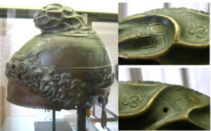
Greek helmet with swastika marks on the top part (details), 350-325 BCE from Taranto, found at Herculanum. Cabinet des Médailles, Paris.

In the Western world, the symbol experienced a resurgence following the archaeological work in the late nineteenth century of Heinrich Schliemann, who discovered the symbol in the site of ancient Troy and associated it with the ancient migrations of Proto-Indo-Europeans. He connected it with similar shapes found on ancient pots in Germany, and theorized that the swastika was a "significant religious symbol of our remote ancestors," linking Germanic, Greek and Indo-Iranian cultures.^{[2][3]} By the early 20th century it was widely used worldwide and was regarded as a symbol of good luck and auspiciousness.
The work of Schliemann soon became intertwined with the völkisch movements, for which the swastika was a symbol of "Aryan" identity, a concept that came to be equated by theorists like Alfred Rosenberg with a Nordic master race originating in northern Europe. Since its adoption by the Nazi Party of Adolf Hitler, the swastika has been associated with fascism, racism (white supremacy), World War II, and the Holocaust in much of the West. The swastika remains a core symbol of Neo-Nazi groups, and is also regularly used by activist groups to signify the supposed Nazi-like behavior of organizations and individuals they oppose.

Etymology and alternative names
The word swastika is derived from the Sanskrit svastika (in Devanagari, स्वस्तिक), meaning any lucky or auspicious object, and in particular a mark made on persons and things to denote good luck. It is composed of su- (cognate with Greek ευ-, "eu-"), meaning "good, well" and asti a verbal abstract to the root as "to be"; svasti thus means "well-being". The suffix -ka forms a diminutive, and svastika might thus (andre) be translated literally as "little thing associated with well-being", corresponding roughly to "lucky charm", or "thing that is auspicious".^{[4]} The suffix -tika also literally means mark; therefore a sometimes alternate name for swastika in India is shubhtika (literally good mark). The word first appears in the Classical Sanskrit (in the Ramayana and Mahabharata epics).
The Sanskrit term has been in use in English since 1871, replacing gammadion (from Greek γαμμάδιον).
Alternative historical English spellings of the Sanskrit word include suastika and svastica. Alternative names for the shape are:
- Black Spider, to various peoples in middle and western Europe.
- crooked cross.
- cross cramponned, ~nnée, or ~nny (in heraldry), as each arm resembles a crampon or angle-iron. (Compare Winkelmaßkreuz in German).
- cross gammadion, tetragammadion (Greek: τέτραγαμμάδιον) or just gammadion, as each arm resembles the Greek letter Γ (gamma). (Compare crux gammata in Latin, croiz gammée in Old French and croix gammée in French; cruz gamada or esvástica in Spanish); cruz gamada in Portuguese.
- double cross, by Bishop Fulton J. Sheen, on the April 6, 1941 ion of his radio program The Catholic Hour, not only comparing the Cross of Christ with the swastika, but also implying that siding with fascism was a "double-crossing" of Christianity.
- fylfot (possibly meaning "four feet", chiefly in heraldry and architecture). (See Fylfot for a discussion of the etymology).
- hooked cross (Dutch: hakenkruis; Serbian: kukasti krst; Icelandic: hakakross; German: Hakenkreuz; Finnish: hakaristi; Estonian: haakrist; Greek: αγκυλωτός σταυρός, agkylotos stavros; Norwegian: hakekors; Italian: croce uncinata; Romanian: Cruce încârligată; Swedish: hakkors; Danish: hagekors; Hungarian: horogkereszt; Czech: hákový kříž); Slovak: hákový kríž; Slovenian: kljukasti križ; Turkish: gamalı haç).
- sun wheel (German Sonnenrad), (Greek: ηλιοτροχός, iliotrokhos), a name also used as a synonym for the sun cross.
- tetraskelion, (Greek: τετρασκέλιον) "four legged", especially when composed of four conjoined legs (compare triskelion (Greek: τρισκέλιον)).
- Thor's hammer, from its supposed association with Thor, the Norse god of the weather, but this may be a misappropriation of a name that properly belongs to a Y-shaped or T-shaped symbol. (See Thomas Wilson, below.) The Swastika shape appears in Icelandic grimoires wherein it is named Þórshamar.
- thunder cross (Latvian: perkonkrusts).
- twisted cross.
- unexpected cross (Polish krzyżyk niespodziany) or highlander cross (Polish góralski krzyż), swarge, swarzyca.

[] History
In antiquity, the swastika was used extensively by the Indo-Aryans, Hittites, Celts and Greeks, among others. In particular, the swastika is a sacred symbol in Hinduism, Buddhism and Jainism. It occurs in other Asian, European, African and Native American cultures – sometimes as a geometrical motif, sometimes as a religious symbol.

[] Origin hypotheses
The ubiquity of the swastika symbol is easily explained by it being a very simple symbol that will arise independently in any basket- weaving society. The swastika is a repeating design, created by the edges of the reeds in a square basket-weave. Other theories attempt to establish a connection via cultural diffusion or an explanation along the lines of Carl Jung's collective unconscious.
While the existence of the swastika symbol in the Americas may be explained by the basket-weave theory, its American presence weakens the cultural diffusion theory. While some have proposed that the swastika was secretly transferred to North America by an early seafaring civilization on Eurasia, a separate but parallel development is considered the most likely explanation.
Yet another explanation is suggested by Carl Sagan in his book Comet. Sagan reproduces an ancient Chinese manuscript that shows comet tail varieties: most are variations on simple comet tails, but the last shows the comet nucleus with four bent arms extending from it, recalling a swastika. Sagan suggests that in antiquity a comet could have approached so close to Earth that the jets of gas streaming from it, bent by the comet's rotation, became visible, leading to the adoption of the swastika as a symbol across the world.

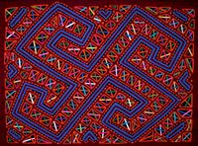
A mola showing a swastika, based on the Kuna flag.

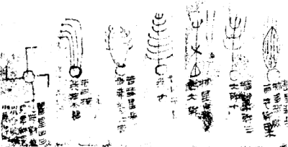
part of the Han Dynasty silk comet atlas

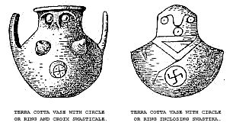

Bob Kobres in Comets and the Bronze Age Collapse (1992) contends that the swastika-like comet on the Han Dynasty silk comet atlas was labeled a "long tailed pheasant star" due to its resemblance to a bird's foot., and further suggests that many swastika and swastika-like motifs may have been representations of bird tracks, including many of those found by Schliemann.
Barbara G. Walker, author of The Woman's Dictionary of Symbols and Sacred Objects, claims that the crux dissimulata, an early swastika, represented the four winds. Concerning the short-armed version of this symbol, known as the gammadion because it is made up of four Greek gammas, Walker says this symbol was an emblem of the ancient goddess and probably represented "the solstices and equinoxes, or the four directions, four elements, and four divine guardians of the world."

Archaeological record
The earliest swastika symbols of the archaeological record date to the Neolithic. The symbol was found on a number of shards in the Khuzestan province of Iran and as part of the "Vinca script" of Neolithic Europe of the 5th millennium BC. In the Early Bronze Age, it appears as part of the Indus script used by the Indus Valley Civilization of Southeast Asia and on pottery found in Sintashta, Russia.[3]
Swastika-like symbols also appear in Bronze and Iron Age designs of the northern Caucasus (Koban culture), and Azerbaijan, as well as of Scythians and Sarmatians [4]. In all these cultures the swastika symbol does not appear to occupy any marked position or significance, but appears as just one form of a series of similar symbols of varying complexity.
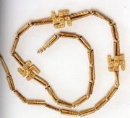
This Iranian necklace was excavated from Kaluraz, Guilan, first millennium BC, National Museum of Iran.

Historical use
In Zoroastrian Persia, the swastika symbolized the revolving sun (Garduneh-e Khorshid), Mithra's Wheel (Garduneh-e Mehr), fire, infinity, or continuing recreation. There is no reference to the swastika in the Vedas, the term svastika first appearing in Epic Sanskrit, but the symbol rose to importance in Hinduism and Buddhism in Maurya and Gupta India.
The use of the swastika by the indigenous Bön faith of Tibet, as well as syncretic religions, such as Cao Dai of Vietnam and Falun Gong of China, is thought to be borrowed from Buddhism as well. Similarly, the existence of the swastika as a solar symbol among the Akan civilization of southwest Africa may have been the result of cultural transfer along the African slave routes around AD 1500

Reintroduction of the swastika in the West
Main article: Western use of the Swastika in the early 20th century
The discovery of the Indo-European language group in the 1790s led to a great effort by archaeologists to link the pre-history of European peoples to the ancient "Aryans" (variously referring to the Indo-Iranians or the Proto-Indo-Europeans). Following his discovery of objects bearing the swastika in the ruins of Troy, Heinrich Schliemann consulted two leading Sanskrit scholars of the day, Emile Burnouf and Max Müller. Schliemann concluded that the Swastika was a specifically Indo-European symbol. Later discoveries of the motif among the remains of the Hittites and of ancient Iran seemed to confirm this theory. This idea was taken up by many other writers, and the swastika quickly became popular in the West, appearing in many designs from the 1880s to the 1920s.
These discoveries, and the new popularity of the swastika symbol, led to a widespread desire to ascribe symbolic significance to every example of the motif. In Germanic countries examples of identical shapes in ancient European artifacts and in folk art were interpreted as emblems of good-luck linked to the Indo-Iranian meaning.
Western use of the motif, along with the religious and cultural meanings attached to it, was subverted in the early twentieth century after it was adopted as the emblem of the Nazi Party (German: Nationalsozialistische Deutsche Arbeiterpartei). This association occurred because Nazism stated that the historical Aryans were the forefathers of modern Germans and then proposed that, because of this, the subjugation of the world by Germany was desirable, and even predestined. The swastika was used as a conveniently geometrical and eye-catching symbol to emphasize the so-called Aryan-German correspondence and instill racial pride. Since World War II, most Westerners know the swastika as solely a Nazi symbol, leading to incorrect assumptions about its pre-Nazi use in the West and confusion about its sacred religious and historical status in other cultures.

[] Geometry and symbolism

A right-facing swastika may be described as "clockwise"...


"counter-clockwise"


A swastika composed of 17 squares in a 5x5 grid


The left-facing swastika can be found in both Hindu and Buddhist tradition.

Geometrically , the swastika can be regarded as an irregular icosagon or 20-sided polygon. The arms are of varying width and are often rectilinear (but need not be). However, the proportions of the Nazi swastika were fixed: they were based on a 5x5 grid.^{[5]}
Characteristic is the 90° rotational symmetry (that is, the symmetry of the cyclic group C_{4h}) and chirality, hence the absence of reflectional symmetry, and the existence of two versions which are each other's mirror image.
The mirror-image forms are often described as:
- left-facing and, as depicted across, right-facing;
- left-hand and right-hand;
- clockwise and counterclockwise.
"Left-facing" and "right-facing" are used mostly consistently. Looking at an upright swastika, the upper arm clearly faces towards the viewer's left (卍) or right (卐). The other two descriptions are ambiguous as it is unclear if they refer to the direction of the bend in each arm or to the implied rotation of the symbol. If the latter, whether the arms lead or trail remains unclear. The terms are used inconsistently (sometimes even by the same writer) which is confusing and may obfuscate an important point, that the rotation of the swastika may have symbolic relevance.
The interpretation of rotational direction may be influenced by the viewer's own bias. Critics of the swastika may see a right-facing design as an active, even aggressive symbol, slicing like a circular saw in a clockwise manner. A viewer with a more positive bias may consider the right-facing arms to be a passive design, rotating like a waterwheel in the opposite direction.
Nazi ensigns had a through and through image, so each version was present on one side, but the Nazi flag on land was right-facing on both sides ([5], at the bottom).
Seen as a cross, the four lines emanating from the center point to the four cardinal directions. The most common association is with the Sun. Other proposed correspondences are to the visible rotation of the night sky in the Northern Hemisphere around Polaris.
The name "sauwastika" is sometimes given to the left-facing, form of the swastika (卍), based on D'Alviella (1894).^{[6]} Indians of all faiths sometimes use the symbol in both orientations mostly for symmetry. Buddhists, outside of India, generally use the left-facing swastika over the right-facing swastika although, again, both can be used. Claims to the effect that the left-facing swastika has inauspicious or "evil" connotations are without substance.

[] Art and architecture
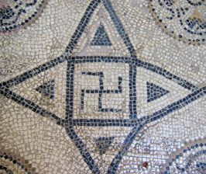
swastika on a Roman mosaic

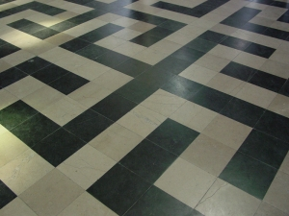
Interlocking swastika design in pavement of Amiens Cathedral.

The swastika is common as a design motif in current Hindu architecture and Indian artwork as well as in ancient Western architecture, frequently appearing in mosaics, friezes, and other works across the ancient world. Ancient Greek architectural designs are replete with interlinking swastika motifs. Related symbols in classical Western architecture include the cross, the three-legged triskele or triskelion and the rounded lauburu. The swastika symbol is also known in these contexts by a number of names, especially gammadion.
In Chinese, Korean, and Japanese art, the swastika is often found as part of a repeating pattern. One common pattern, called sayagata in Japanese, comprises left and right facing swastikas joined by lines.^{[7]} As the negative space between the lines has a distinctive shape, the sayagata pattern is sometimes called the "key fret" motif in English.
The swastika symbol was found extensively in the ruins of the ancient city of Troy and can also be found in some of the mosaics in the ruins of Pompeii.
In Greco-Roman art and architecture, and in Romanesque and Gothic art in the West, isolated swastikas are relatively rare, and the swastika is more commonly found as a repeated element in a border or tessellation. The swastika often represented perpetual motion, reflecting the design of a rotating windmill or watermill. A design of interlocking swastikas is one of several tessellations on the floor of the cathedral of Amiens, France.^{[8]} A border of linked swastikas was a common Roman architectural motif,^{[9]} and can be seen in more recent buildings as a neoclassical element. A swastika border is one form of meander, and the individual swastikas in such border are sometimes called Greek keys^{[10]}.
The Laguna Bridge in Yuma, Arizona was built in 1905 by the U.S. Reclamation Department and is decorated with a row of swastikas.^{[11][12]}.
Metal typeface Swastika borders were used by U.S. printers in the early 1900's.^{[13]} Controversy arose in 1937 when they appeared on Passaic, New Jersey sample election ballots. The printer responded "I've used the swastika emblems for ballot borders long before the world ever knew Hitler".^{[14]}
The Canadian artist ManWoman has attempted to rehabilitate the "gentle swastika".
Ceramic tiles with a swastika design have appeared in many parts of the world including the United States in the early part of the 20th century. When originally installed, the tiles are typically a minor decorative element. Some of the pre-World War II swastikas have become controversial after Jewish groups demanded they be removed. A number of the buildings are listed on the National Register of Historic Places or as Unesco World Heritage sites, and are considered worthy of historical preservation. See Western use of the Swastika in the early 20th century for specific examples.

[] Religion and mythology

[] Hinduism
In Hinduism, the two symbols represent the two forms of the creator god Brahma: facing right it represents the evolution of the universe (Pravritti), facing left it represents the involution of the universe (Nivritti). It is also seen as pointing in all four directions (North, East, South and West) and thus signifies stability and groundedness. Its use as a sun symbol can first be seen in its representation of the god Surya. The swastika is considered extremely holy and auspicious by all Hindus, and is regularly used to decorate all sorts of items to do with Hindu culture. It is used in all Hindu yantras and religious designs. Throughout the subcontinent of India it can be seen on the sides of temples, written on religious scriptures, on gift items, and on letterhead. The Hindu god Ganesh is often shown as sitting on a lotus flower on a bed of swastikas.<>
The swastika is found all over Hindu temples, signs, altars, pictures and iconography where it is sacred. It is used in all Hindu weddings, festivals, ceremonies, houses and doorways, clothing and jewelry, motor transport and even decorations on food items like cakes and pastries. Amongst the Hindus of Bengal, it is common to see the name "swastika" applied to a slightly different symbol, which has the same significance as the common swastika, and both symbols are used as auspicious signs. This symbol looks something like a stick figure of a human being.^{[15]} "Swastika" is a common given name amongst Bengalis and a prominent literary magazine in Calcutta is called the Swastika. The stick figure, however, is not mainstream usage in India.
The Aum symbol is also sacred in Hinduism. While Aum is representative of a single primordial tone of creation, the Swastika is a pure geometrical mark and has no syllabic tone associated with it. The Swastika is one of the 108 symbols of Lord Vishnu and represents the sun's rays without which there would be no life.

[] Buddhism


Swastika on a Buddhist temple in Korea.


On maps in the Taipei subway system a swastika symbol is employed to indicate a temple, next to a cross indicating a Christian church.

Buddhism originated in the Indian subcontinent in the 5th century BCE and inherited the swastika. These two symbols are included, at least since the Liao Dynasty, as part of the Chinese language, the symbolic sign for the character 萬 or 万 (wàn in Chinese, man in Korean/Japanese, vạn in Vietnamese) meaning "all", and "eternality" (lit. myriad) and as 卐 which is seldom used. A swastika marks the beginning of many Buddhist scriptures. The swastikas (in either orientation) appear on the chest of some statues of Gautama Buddha and is often incised on the soles of the feet of the Buddha in statuary. Because of the association with the right facing swastika with Nazism, Buddhist swastikas (outside India only) after the mid-20th century are almost universally left-facing: 卍. This form of the swastika is often found on Chinese food packaging to signify that the product is vegetarian and can be consumed by strict Buddhists. It is often sewn into the collars of Chinese children's clothing to protect them from evil spirits.
In 1922, the Chinese syncretist movement Daoyuan founded the philanthropic association Red Swastika Society in imitation of the Red Cross. The association was very active in China during the 1920s and the 1930s.
The swastika used in Buddhist art and scripture is known in Japanese as a manji (which literally just means "the Chinese character for eternality" 万字), and represents Dharma, universal harmony, and the balance of opposites. When facing left, it is the omote (front) manji, representing love and mercy. Facing right, it represents strength and intelligence, and is called the ura (rear) manji. Balanced manji are often found at the beginning and end of Buddhist scriptures (outside India).

[] Jainism
Jainism gives even more prominence to the swastika than Hinduism. It is a symbol of the seventh Jina (Saint), the Tirthankara Suparsva. It is considered to be one of the 24 auspicious marks and the emblem of the seventh arhat of the present age. All Jain temples and holy books must contain the swastika and ceremonies typically begin and end with creating a swastika mark several times with rice around the altar. Jains use rice to make a swastika (also known as "Sathiyo" in the state of Gujarat, India) in front of idols in a temple. Jains then put an offering on top of this swastika - this offering is usually a fruit, a sweet (mithai), a dried fruit or sometimes a coin or currency note.

[] Abrahamic religions
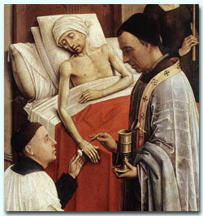
Detail of The Seven Sacraments (1445) by Roger van der Weyden. The crosses on the priest's stole are alternately in swastika and in "patent" form.

The swastika was not widely utilized by followers of the Abrahamic religions. Where it does exist, it is not always portrayed as an explicitly religious symbol, and is often purely decorative or, at most, a symbol of good luck. One example of scattered use is the floor of the synagogue at Ein Gedi, built during the Roman occupation of Judea, which was decorated with a swastika.^{[16]}
In Christianity, the swastika is sometimes seen as a hooked cross, and as symbolizing Christ's victory over death. Some Christian churches built in the Romanesque and Gothic eras are decorated with swastikas, carrying over earlier Roman designs. Swastikas are prominently displayed in a mosaic in the St. Sophia church of Kiev, Ukraine dating to the 12th century. They also appear as a repeating ornamental motif on a tomb in the Basilica of St. Ambrose in Milan. A proposed direct link between it and a swastika floor mosaic in the Cathedral of Our Lady of Amiens, which was built on top of a pagan site at Amiens, France in the 1200s, is considered unlikely. The stole worn by a priest in the 1445 painting of the Seven Sacraments by Roger van der Weyden presents the swastika form as simply one way of depicting the cross.
The Muslim "Friday" mosque of Isfahan, Iran and the Taynal Mosque in Tripoli, Libya both have swastika motifs.

[] Other Asian traditions
Some sources indicate that the Chinese Empress Wu (武則天)(684-704) of the Tang Dynasty decreed that the swastika would be used as an alternative symbol of the sun. As part of the Chinese script, the swastika has Unicode encodings U+534D 卍 (pronunciation following the Chinese character "萬": Cantonese: "man"; Mandarin: wan); (left-facing) and U+5350 卐 (right-facing).^{[17]}
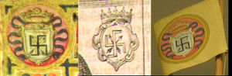
A swastika crossed by two arrows, within a shield and surmounted by a royal crown on an orange background was used as the coat of arms of the samurai Hasekura Tsunenaga in the early 17th century.

The Mandarin "Wan" is a homophone for "10,000" and is commonly used to represent the whole of creation, e.g. 'the myriad things' in the Dao De Jing.

In Japan, the swastika is called manji. Since the Middle Ages, it is used as a family coat of arms. On Japanese maps, a swastika (left-facing and horizontal) is used to mark the location of a Buddhist temple. The right-facing manji is often referred as the gyaku manji (逆卍, lit. "reverse manji"), and can also be called kagi jūji, literally "hook cross."
The left-facing Buddhist swastika also appears on the emblem of Falun Gong. This has generated considerable controversy, particularly in Germany, where the police have reportedly confiscated several banners featuring the emblem. A court ruling subsequently allowed Falun Gong followers in Germany to continue the use of the emblem.

[] Native American traditions
The swastika shape was used by some Native Americans. It has been found in excavations of Mississippian-era sites in the Ohio valley. It was widely used by many southwestern tribes, most notably the Navajo. Among different tribes the swastika carried various meanings. To the Hopi it represented the wandering Hopi clan; to the Navajo it was one symbol for a whirling winds (tsil no'oli'), a sacred image representing a legend that was used in healing rituals (after learning of the Nazi mimic "whirling winds" the Navajo rejected the symbol).^{[18]} A brightly colored Native American saddle featuring swastika designs is on display at a museum in Saskatchewan, Canada.^{[19]}
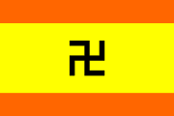
The Flag of Kuna Yala.

A swastika shape is an ancient symbol in the culture of the Kuna people of Kuna Yala, Panama. In Kuna tradition it symbolises the octopus, which created the world; its tentacles, pointing to the four cardinal points, gave rise to the rainbow, the sun, the moon and the stars.^{[20]}
In February, 1925, the Kuna revolted against Panamanian suppression of their culture, and were granted autonomy in 1930; the flag which they adopted at this time is based on the swastika shape, and remains the official flag of Kuna Yala. A number of variations on the flag have been used over the years; red top and bottom bands instead of orange were previously used, and in 1942 a ring (representing the traditional Kuna nose-ring) was added to the centre of the flag to distance it from the symbol of the Nazi party.^{[21]}

[] Pre-Christian Europe

[] Celtic
An Ogham stone found in Anglish, Co Kerry (CIIC 141) was modified into an early Christian gravestone, and was decorated with a cross pattée and two swastikas at this time.

[] Etruscan
The Vatican Museums contain examples of Etruscan pottery bearing the swastika.
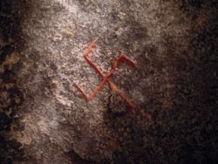
The sunwheel found on the Danish Snoldelev Stone, created ca. 800. Note angle and placement.

Germanic
The pre-Christian Norse regularly used the so-called Sun cross or Sun wheel one form of which is often interpreted as a variant of the swastika, and it appears regularly in Scandinavian folk art. Swastika shapes are found, among similar ornaments, on Germanic Migration period artifacts, such as the Gothic spearhead found at Brest-Litovsk, Russia, or the Younger Futhark Snoldelev Stone, in Ramsø, Denmark.
The swastika (also called a fylfot, a term coined in the 19th century from a 1500 reference to a figure used to fill empty space at the foot of stained-glass windows in medieval churches) appears as an ornament on many pre-Christian artefacts, drawn both left-facing and right-facing. Similar motifs, within a circle or in a swirling form have also been interpreted as "swastikas".
The pre-Christian Anglo-Saxon ship burial at Sutton Hoo, England, contains gold cups and shields adorned with swastika-like shapes.

[] Greek
The Greek goddess Athena was sometimes portrayed as wearing robes covered with swastikas.
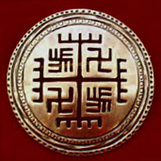
The "Hands of God" (Ręce Boga), allegedly an old (pre-Christian) Vandals and Slavic solar symbol.

Slavic
The swastika shape was also present in pre-Christian Slavic mythology. It was dedicated to the sun god Svarog and called kolovrat, (Polish kołowrót). In the Polish first Republic the symbol of the swastika was also popular with the nobility. According to chronicles, Varangians prince Oleg who in the 9th century with his Rus Vikings had captured Constantinople, had nailed his shield to the city's gates, which had a large red swastika painted on it. The several Polish noble houses, e.g. Boreyko, Borzym, and Radziechowski from Ruthenia also had Swastikas as their coat of arms. The family had reached its greatness in the 14-15th centuries and their crest can be seen in many heraldry books produced at that time.

[] Medieval Vehmic courts
Walker (A Woman's Dictionary of Symbols and Sacred Objects) states that the double swastika was associated with the Vehmic courts of the Middle Ages, a "secret sect" founded to persecute "heretics and Jews" before becoming associated with the Inquisition. These courts, she says, continued as "underground societies of summary justice" and "hotbeds of anti-Semitism" during the nineteenth century before being superseded by the Nazi party, the members of which substituted the single swastika for the doubled version.

[] Nazi Germany
In the wake of widespread popular usage, the Nazi Party (Nationalsozialistische Deutsche Arbeiterpartei or NSDAP) formally adopted the swastika or Hakenkreuz (hooked cross) in 1920. This was used on the party's flag (right), badge, and armband. It had also been used unofficially by the NSDAP and its predecessor, the German Workers Party, Deutsche Arbeiterpartei (DAP).


The flag of Nazi Germany and the NSDAP
Flag Ratio: 3:5
Flag Dimensions: 60 x 100
Disc Diameter: 45
Arm Width: 6


Plane of Ernst Udet used for acrobatic shows held during the 1936 Summer Olympics on display in the Polish Aviation Museum.

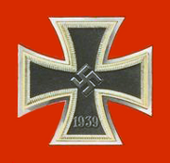
The Iron Cross featured a swastika during the Nazi period

In Mein Kampf, Adolf Hitler wrote:
"I myself, meanwhile, after innumerable attempts, had laid down a final form; a flag with a red background, a white disk, and a black swastika in the middle. After long trials I also found a definite proportion between the size of the flag and the size of the white disk, as well as the shape and thickness of the swastika."
(Red, white, and black were the colors of the flag of the old German Empire.)
The use of the swastika was associated by Nazi theorists with their conjecture of Aryan cultural descent of the German people. Following the Nordicist version of the Aryan invasion theory, the Nazis claimed that the early Aryans of India, from whose Vedic tradition the swastika sprang, were the prototypical white invaders. It was also widely believed that the Indian caste system had originated as a means to avoid racial mixing.^{[citation needed]} The concept of Racial purity was an ideology central to Nazism though it is now considered unscientific. For Rosenberg, the Aryans of India were both a model to be imitated and a warning of the dangers of the spiritual and racial "confusion" that, he believed, arose from the close proximity of races.
Thus, they saw fit to co-opt the sign as a symbol of the Aryan master race. The use of the swastika as a symbol of the Aryan race dates back to writings of Emile Burnouf. Following many other writers, the German nationalist poet Guido von List believed it to be a uniquely Aryan symbol. When Hitler created a flag for the Nazi party, he sought to incorporate both the swastika and "those revered colors expressive of our homage to the glorious past and which once brought so much honor to the German nation" (red, white and black). He also stated that "the red expressed the social thought underlying the movement. White the national thought. And the swastika signified the mission allotted to us – the struggle for the victory of Aryan mankind and at the same time the triumph of the ideal of creative work which is in itself and always will be anti-Semitic." (Mein Kampf).^{[22]}
In fact, the swastika was already in use as a symbol of German völkisch nationalists movements (Völkische Bewegung). In Deutschland Erwache (ISBN 0-912138-69-6), Ulric of England (sic) says —
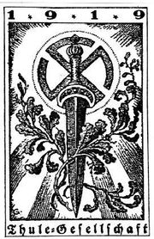
Thule Society Swastika

… what inspired Hitler to use the swastika as a symbol for the NSDAP was its use by the Thule Society (Ger. Thule-Gesellschaft) since there were many connections between them and the DAP … from 1919 until the summer of 1921 Hitler used the special Nationalsozialistische library of Dr. Friedrich Krohn, a very active member of the Thule-Gesellschaft, … Dr. Krohn was also the dentist from Sternberg who was named by Hitler in Mein Kampf as the designer of a flag very similar to one that Hitler designed in 1920 … during the summer of 1920, the first party flag was shown at Lake Tegernsee … these home-made … early flags were not preserved, the Ortsgruppe München flag was generally regarded as the first flag of the Party.
José Manuel Erbez says —
The first time the swastika was used with an "Aryan" meaning was on December 25, 1907, when the self-named Order of the New Templars, a secret society founded by [Adolf Joseph] Lanz von Liebenfels, hoisted at Werfenstein Castle (Austria) a yellow flag with a swastika and four fleurs-de-lys.^{[23]}
However, Liebenfels was drawing on an already established use of the symbol.
On 14 March 1933, shortly after Hitler's appointment as Chancellor of Germany, the NSDAP flag was hoisted alongside Germany's national colors. It was adopted as the sole national flag on 15 September 1935.
The swastika was used for badges and flags throughout Nazi Germany, particularly for government and military organizations, but also for "popular" organizations such as the Reichsbund Deutsche Jägerschaft.^{[24]}
While the DAP and the NSDAP had used both right-facing and left-facing swastikas, the right-facing swastika is used consistently from 1920 onwards. However, Ralf Stelter notes that the swastika flag used on land had a right-facing swastika on both sides, while the ensign (naval flag) had it printed through so that you would see a left-facing swastika when looking at the ensign with the flagpole to the right.^{[25]}
Several variants are found:
- a 45° black swastika on a white disc as in the NSDAP and national flags;
- a 45° black swastika on a white lozenge (e.g., Hitler Youth^{[26]});
- a 45° black swastika with a white outline was painted on the tail of aircraft of the Luftwaffe;
- a 45° black swastika outlined by thin white and black lines on a white disc (e.g., the German War Ensign^{[27]});
- an upright black swastika outlined by thin white and black lines on a white disc (e.g., Hitler's personal flag, in which a gold wreath encircles the swastika; the Schutzstaffel; and the Reichsdienstflagge, in which a black circle encircles the swastika);
- small gold, silver, black, or white 45° swastikas, often lying on or being held by an eagle, on many badges and flags.^{[28]}
- a swastika with curved outer arms forming a broken circle, as worn by the SS Nordland Division. (See photo at "[6]".)
There were attempts to amalgamate Nazi and Hindu use of the swastika. Notably by Savitri Devi Mukherji who declared Hitler an avatar of Vishnu (see Nazi mysticism).

[] Taboo in Western countries
Because of its use by Hitler and the Nazis and, in modern times, by neo-Nazis and other hate groups, for many people in the West, the swastika is associated primarily with Nazism, and white supremacy in general. Hence, outside historical contexts, it has become taboo in Western countries. The historical context of architectural decorations has sometimes been ignored in local efforts to remove swastikas from pre-World War II buildings.

[] Germany
The German postwar criminal code makes the public showing of the Hakenkreuz (the swastika) and other Nazi symbols illegal and punishable, except for scholarly reasons. It is even censored from the lithographs on boxes of model kits, and the decals that come in the box. The swastikas on Hindu and Jain temples are exempt, as religious symbols cannot be banned in Germany.
A German fashion company was investigated for using traditional British-made folded leather buttons after complaints that they resembled swastikas. In response, Esprit destroyed two hundred thousand catalogues^{[29]} ^{[30]}.
A controversy was stirred by the decision of several police departments to begin inquiries against anti-fascists.^{[31]} In late 2005 police raided the offices of the punklabel and mailorder "Nix Gut Records" and confiscated merchandise depicting crossed-out swastikas and fists smashing swastikas.^{[32]} In 2006 the Stade police department started an inquiry against anti-fascist youths using a placard, depicting a person dumping a swastika into a trashcan. The placard was displayed in opposition to the campaign of right-wing nationalist parties for local elections.^{[33]}
On Friday, March 17, 2006 member of the Bundestag Claudia Roth reported herself to the German police for displaying a crossed-out swastika on multiple demonstrations against Neo-Nazis, and subsequently got the Bundestag to suspend her immunity from prosecution. She intends to show the absurdity of charging anti-fascists with using fascist symbols: "We don't need prosecution of non-violent young people engaging against right-wing extremism."^{[32]}
The relevant excerpt^{[34]} of the German criminal code reads:
“ | § 86 StGB Dissemination of Means of Propaganda of Unconstitutional Organizations  (1) Whoever domestically disseminates or produces, stocks, imports or exports or makes publicly accessible through data storage media for dissemination domestically or abroad, means of propaganda:  1. of a party which has been declared to be unconstitutional by the Federal Constitutional Court or a party or organization, as to which it has been determined, no longer subject to appeal, that it is a substitute organization of such a party; [...]  4. means of propaganda, the contents of which are intended to further the aims of a former National Socialist organization, shall be punished with imprisonment for not more than three years or a fine. [...]  (3) Subsection (1) shall not be applicable if the means of propaganda or the act serves to further civil enlightenment, to avert unconstitutional aims, to promote art or science, research or teaching, reporting about current historical events or similar purposes. [...]  § 86a StGB Use of Symbols of Unconstitutional Organizations  (1) Whoever:  1. domestically distributes or publicly uses, in a meeting or in writings (§ 11 subsection (3)) disseminated by him, symbols of one of the parties or organizations indicated in § 86 subsection (1), nos. 1, 2 and 4; or  2. produces, stocks, imports or exports objects which depict or contain such symbols for distribution or use domestically or abroad, in the manner indicated in number 1,  shall be punished with imprisonment for not more than three years or a fine.  (2) Symbols, within the meaning of subsection (1), shall be, in particular, flags, insignia, uniforms, slogans and forms of greeting. Symbols which are so similar as to be mistaken for those named in sentence 1 shall be deemed to be equivalent thereto. [...] | ”

[] Satirical use
The powerful symbolism acquired by the swastika has often been used in graphic design and propaganda as a means of drawing Nazi comparisons; examples include the cover of Stuart Eizenstat's 2003 book Imperfect Justice,^{[35]} publicity materials for Costa-Gavras's 2002 film Amen,^{[36]} and a billboard that was erected opposite the U.S. Interests Section in Havana, Cuba, in 2004, which juxtaposed images of the Abu Ghraib torture and prisoner abuse pictures with a swastika. Also, in Australia, which has taken a considerable number of refugees who suffered under the Nazis, it is (legally) regarded as "racist".

[] Bona-fide use causing controversy
In recent years, controversy has erupted when consumer goods bearing the symbol have been exported (often unintentionally) to North America. In 2002, Christmas crackers containing plastic toy pandas sporting swastikas were pulled from shelves after complaints from consumers in Canada, although the China-based manufacturer claimed the symbol was presented in a traditional sense and not as a reference to the Nazis.^{[37]}
Founded in the 1970s, the Raëlian Movement, a religious sect believing in the possibility of immortality by scientific progress, used a symbol that was the source of considerable controversy: an interlaced Star of David and swastika. In 1991, the symbol was changed to remove the swastika and deflect public criticism.
The Society for Creative Anachronism, which aims to study and recreate Medieval and Renaissance history, imposes restrictions on its members' use of the swastika on their arms,^{[38]} although some arms dating to the early days of the group have the symbol.

[] Contemporary usage

[] Finland

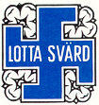
Finnish Air Force swastika.

Some decorations and flags of the Finnish Air Force use a blue swastika in a white circle.

[] South Asia


Samyukta Janamorcha Nepal electoral banner, 1994. The complete lack of any far-right connotations of the swastika in Asia is best illustrated by its use as a generic electoral symbol even by parties of the far-left.

In South Asia (excluding Pakistan), the swastika remains ubiquitous as a symbol of wealth and good fortune. Electoral ballot papers have been stamped with a round swastika, so that this variant of the symbol is connected with political elections. Many businesses and other organisations, like the Ahmedabad Stock Exchange, use the swastika in their logos. The Red Swastika was also suggested as an emblem of International Red Cross and Red Crescent Movement in India and Sri Lanka, but the idea was not put into practice [7]. Swastikas can be found practically everywhere in Indian cities, on buses, of buildings, on auto-rikshas, on clothes, etc.

Tajikistan
In 2005 authorities in Tajikistan called for the widespread adoption of the swastika as a national symbol. President Emomali Rahmonov declared the swastika an "Aryan" symbol and 2006 to be "the year of Aryan culture" a time to: “study and popularize Aryan contributions to the history of the world civilization; to raise a new generation (of Tajiks) with the spirit of national self-determination; and to develop deeper ties with other ethnicities and cultures.”[8]

[] Neopaganism
Odinic Rite claims the "fylfot" as a "holy symbol of Odinism", citing the pre-Christian Germanic use of the symbol.

[] Popular culture
Main article: Swastikas in popular culture
Swastikas or swastika-like shapes sometimes appear in modern popular culture.

[] See also
- Brigid's cross
- Celtic cross
- Fascist symbolism
- Fylfot
- Karl Haushofer
- Lauburu or Basque cross
- The Red Swastika Society (China)
- Rodło
- Sauwastika
- Sun cross, a traditional symbol also co-opted by many modern neo-Nazis
- Triskelion, including the three-legged badge of the Isle of Man
- Wolfsangel
- Afrikaner Weerstandsbeweging
- Forest swastika
- Western use of the Swastika in the early 20th century

[] References
- Aigner, Dennis J. (2000). The Swastika Symbol in Navajo Textiles. Laguna Beach, California: DAI Press. ISBN 0-9701898-0-X.
- Clube, V. and Napier, B. The Cosmic Serpent. Universe Books, 1982
- Enthoven, R.E. The Folklore of Bombay. London: Oxford University Press, 1924 (pp. 40-45).
- Lonsdale, Steven. Animals and the Origin of Dance, Thames and Hudson Inc., NY, 1982 (pp. 169-181).
- MacCulloch, C.J.A. Canon, John A. (Ed.) Mythology of all Races. vol. 8 ("Chinese Mythology" Ferguson, John C.) Marshall Jones Co. Boston, MA 1928 (p. 31).
- Morphy, Howard (Ed.). Animals into Art (ONE WORLD ARCHAEOLOGY; vol. 7) Unwin Gyman Ltd., London, 1989 (chapt. 11 Schaafsma, Polly).
- Roy, Pratap Chandra. The Mahabharata, Munshiram Manoharlal, New Delhi, 1973 (vol. 1 section 13-58, vol. 5 section 2-3)
- Sagan, Carl, and Ann Druyan (1985). Comet. New York: Random House. ISBN 0-394-54908-2. London: Joseph. ISBN 0-7181-2631-9.
- Schliemann, Henry. Ilios Harper & Brothers, Franklin Square, NY, 1881 (pp. 334-353).
- Tan Huay Peng. (1980-1983). Fun with Chinese Characters. Singapore: Federal Publications. ISBN 981-01-3005-8.
- Whipple, Fred L. The Mystery of Comets Smithsonian Inst. Press, Washington, DC 1985, (pp. 163-167).
- Wilson, Thomas (Curator, Department of Prehistoric Anthropology, U.S. National Museum) (1896). The Swastika: The Earliest Known Symbol, and Its Migrations; with Observations on the Migration of Certain Industries in Prehistoric Times. In Annual report of the Board of Regents of the Smithsonian Institution. Washington DC: Smithsonian Institution
- Norman Martin et al. "Standard of the Leader and National Chancellor 1935-1945". April 9, 2004. Hitler's personal flag;
- Marcus Wendel, Jaume Ollé, et al. "Schutzstaffel/SS" December 14, 2001;
- Jaume Ollé, Željko Heimer, and Norman Martin. "State Flag and Ensign 1935-1945" December 29, 2004. The "Reichsdienstflagge"
- "A critical update to remove unacceptable symbols from the Bookshelf Symbol 7 font". Microsoft Knowledge Base Article 833407. November 8, 2004
- "Clarence House issues apology for Prince Harry's Nazi costume". BBC News. January 13, 2005.

[] Notes
- ^ http://www.geocities.com/odinistlibrary/OLArticles/TruthSwastikaFylfot.htm
- ^ Schliemann, H, Troy and its remains, London: Murray, 1875, pp. 102, 119-20
- ^ Sarah Boxer. "One of the world's great symbols strives for a comeback". The New York Times, July 29, 2000.
- ^ "The Swastika". Northvegr Foundation. Notes on the etymology and meaning of Swastika
- ^ "Swastika Flag Specifications and Construction Sheet (Germany)". Flags of the World.
- ^ D'Alviella, The Migration of Symbols (1894)
- ^ "Sayagata 紗綾形". Japanese Architecture and Art Net Users System.
- ^ Robert Ferré. "Amiens Cathedral". Labyrinth Enterprises. Constructed from 1220 to 1402, Amiens Cathedral is the largest Gothic cathedral in France, a popular tourist attraction and since 1981 a UNESCO World Heritage Site. During World War I, Amiens was targeted by German forces but remained in Allied territory following the Battle of Amiens.
- ^ Gary Malkin. "Tockington Park Roman Villa". The Area of Bristol in Roman Times. December 9, 2002.
- ^ Lara Nagy, Jane Vadnal, "Glossary Medieval Art and Architecture", "Greek key or meander", University of Pittsburgh 1997-98.
- ^ Darin Fenger, "Symbol of luck, swastika adorn Yuma dam", Yuma Sun newspaper, Yuma, Arizona, Sep. 25, 2005.
- ^ Walter Smoter Frank, "Swastika on the Colorado", 2004
- ^ Steven Heller, Jeff Roth, The Swastika, Symbol Beyond Redemption?, Allworth Press, 2000, page 87.
- ^ The New York Times, September 16, 1937, quoted in Heller, page 80
- ^ Subhayu Banerjee. "Shubho Nabobarsho". Bengal on the Net. April 16, 2001
- ^ "Ein Gedi: An Ancient Oasis Settlement". Israel Ministry of Foreign Affairs. November 23, 1999.
- ^ "CJK Unified Ideographs", The Unicode Standard, Version 4.1. Unicode, Inc. 2005. (PDF file)
- ^ Dottie Indyke. "The History of an Ancient Human Symbol". April 4, 2005. originally from The Wingspread Collector’s Guide to Santa Fe, Taos and Albuquerque, Volume 15.
- ^ Photo and text,"Why is there a Swastika on the saddle in the First Nations Gallery?", Royal Saskatchewan Museum
- ^ Chants and Myths about Creation, from Rainforest Art. Retrieved February 25, 2006.
- ^ Panama - Native Peoples, from Flags of the World. Retrieved February 20, 2006.
- ^ "Chapter of Mein Kampf discussing the symbolism of the flag". April 03, 2006
- ^ José Manuel Erbez. "Order of the New Templars 1907". Flags of the World. January 21, 2001.
- ^ Santiago Dotor and Norman Martin. "German Hunting Society 1934-1945 (Third Reich, Germany)" Flags of the World. March 15, 2003. The flag of the Reichsbund Deutsche Jägerschaft
- ^ Mark Sensen, António Martins, Norman Martin, and Ralf Stelter. "Centred vs. Offset Disc and Swastika 1933-1945 (Germany)". Flags of the World. December 29, 2004.
- ^ Marcus Wendel et al. "Hitler Youth (NSDAP, Germany)". Flags of the World. January 17, 2004.
- ^ Norman Martin et al. "War Ensign 1938-1945 (Germany)". Flags of the World. The "Reichskriegsflagge"
- ^ Flags at Flags of the World:
- ^ "Fashion firm under investigation for swastika design", European Jewish Press, Oct 19,2006
- ^ "Prosecutors drop probe into swastika buttons", dpa Deutsche Presse-Agentur GmbH German News Service, October 19, 2006.
- ^ Le Journal Chrétien, "Stuttgart Seeks to Ban Anti-Fascist Symbols"
- ^ ª ^{b} (German) claudia-roth.de
- ^ (German) Tageblatt September 23, 2006
- ^ IUSCOMP The Comparative Law Society
- ^ Harry Kreisler. "Conversation with Stuart E. Eizenstat". Conversations with History. Institute of International Studies, UC Berkeley. April 30, 2003.
- ^ "Swastika film poster escapes ban". BBC News. February 21, 2002.
- ^ "Toy pandas bearing swastikas a cultural mix-up". CBC News. December 30, 2002.
- ^ "Glossary of Terms" of the Society for Creative Anachronism. December 23, 2003.

[] External links
- A very comprehensive source, by a Hindu scholar
- Shards Bearing the Swastika, dating back 5000bc
- The History of the Swastika (About.com)
- The Swastika in Heraldry (comments from the Heraldica mailing list)
- The Origins of the Swastika BBC News
- Reclaim The Swastika Movement to revive the spiritual use of the swastika
- Windsor's "Swastikas" Hockey Teams 1905-1916
- sites presenting versions of Wilson's The Swastika (above)
  - The Swastika
  - The Swastika (a scan of the original publication)
  - The Swastika, the Earliest Known Symbol (a searchable facsimile at the University of Georgia Libraries; DjVu & layered PDF format)
- Comets and the Bronze Age Collapse by Bob Kobres
- Positive Swastikas photo group View and submit photos of positive uses of swastikas
- Swastika in Indian Culture by Jyotsna Kamat
- Origins and its first appearance as a Nazi symbol
- The Swastika and the Nazis by Servando González
- From Flags of the World:
  - Origins of the Swastika Flag (Third Reich, Germany) (collection of links and comments)
  - Neonazi flags (links to other FOTW pages)
- "Which Way Am I Spinning?" Debunking the Nazi "Backwards Swastika" Myth
- Rehabilitating the Fylfot (notes from the Odinic Rite's website)
- Rehabilitating the Swastika Hindus in Britain launch campaign to revive the Swastika
- The Swastika, Lawrence Waldron, Chan Magazine, Summer 2000.
- "manwoman" - Canadian "pop artist" covered in Swastika tattoos
- Finnish uses of the swastika
- Swastika Gallery
- Swastika shaped building found on the US Naval Amphibious Base in Coronado, California
- The Swastika Stone on Ilkley Moor in England
- [9] US Army Air Corp (USAAC) Boeing P-12C with 55th Pursuit Squadrons swastika-insignia in 1930s. The USAAC became the United States Air Force in 1941.
- Legend of the SwastikaTruth and Legend of the Swastika
- [10]
- Reclaim the Swastika official website
- Pukka is a font based on the Swastika by Marcus McCallion. There is an interview, and explanation of the motives, with Steven Heller here.
- 1936 Council Bluffs, IA USA Wooden Bill with Swastika at corners
- Swastika History Poster - The True Legend of the Swastika (English download) from "Swastika - The Symbol of the Buddha" website.
=====================================================================================================================================
Symbolism of the Swastika

http://www.reclaimtheswastika.com/symbolism/

The swastika has been seen as a symbol for good luck by people in both ancient and modern times. A closer look at the etymology of this Sanskrit word, however, reveals a deeper meaning. When the Sanskrit scholar and spiritual teacher, P.R. Sarkar visited Germany in 1979 he gave the following interpretation of the word:



* su - means "good"

* asti - means "to be, to exist"

* ik - means "what is in existence, and will continue to exist"

* a - denotes feminine gender

So "Swastika" means a 'good existence' that is not to be destroyed and that remains in a good condition. He went on to say that its deeper meaning is permanent victory.
In the context of the cultural origins of the swastika, this means the victory of dharma - the fundamental spiritual nature of humanity.

Sarkar explained that the swastika has both a positive and a negative expression:

Positive and negative swastikas

He then went on to warn those present not to use the negative swastika, explaining that it brings total annihilation, while the positive swastika brings total victory.

HistoryoftheSwastika

Swastikas at a Hindu temple, India

Hindu temple, India.

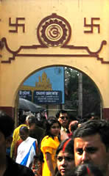

The swastika has held a place of great importance in India and Asia for thousands of years, and is widely used by Hindus, Jains and Buddhists.

The swastika is to be seen everywhere across the Indian sub-continent: sculptured into temples both ancient and modern, decorating buildings, houses, shops, painted onto public buses, in taxis - even decorating the dashboards of the three-wheeler motor rickshaws. Many religious and spiritual books display the symbol. It may well be the most prevalent symbol one will see in India.

However, the swastika is not limited to India and Asia. Evidence suggests that the swastika was in use in many other cultures too. For example:

* The ancient city of Troy, in the northwest of present-day Turkey

* The Iron Age Koban culture of the Caucasus in Asia minor

* On prehistoric Vinca artefacts from South-Eastern Europe

* Amongst the ancient Hittites who lived in the area of present day Syria

* In Ein Gedi, near Israel's Dead Sea

* In the Tang Dynasty of China

* In the 13th Century Amiens Cathedral in France

* In ancient Greek architectural designs

* On Native American Indian artefacts including those of the Navajo and Hopi

* On pre-Christian Anglo-Saxon and Druidic artefacts

The Edmonton Swastikas, a Canadian womens' ice hockey team, c.1916

The Edmonton Swastikas, a Canadian womens' ice hockey team, c.1916. (Credit)



The swastika was also used widely in the pre-Nazi twentieth century:

* Dust-covers of books by Rudyard Kipling and other authors

* Boy Scouts' badges in Britain from 1911 to 1922

* Bank notes printed by the 1917 Russian Provisional Government

* Emblem of the British National War Savings Committee

* Planes of the Finnish Air force and Army from 1918 until 1944

* Latvian Air Force, 1918 until 1934

* The Icelandic Steamship Company, Eimskip, from 1914

- The Theosophical Society, founded in New York in 1875

=====================================================================================================================

Nazi Swastika or
Ancient Symbol?
Time to Learn
the Difference
http://www.iearn.org/hgp/aeti/aeti-1997/swastika.html

By Chirag Badlani
During a religious holiday of mine, my mother and I went to the store, Staples, to make color copies of a few Gods to give to our temple. On one of the pictures, there was a very religious Hindu symbol, resembling a Nazi swastika, yet the arms faced the opposite direction.
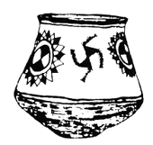

When we went on line to pay for the copies, the people behind us, not noticing the differentiation between the two signs, starting talking to each other, saying that my mother and I were Nazis. Quite appalled, my mother turned around and calmly explained to them that it was not a Nazi symbol, that the symbol first belonged to many different cultures before the Nazis adopted it. She explained the religious meaning and the people behind us said they were sorry and stated, "Oh, I never knew that."
I have realized that many people, not only in this country, but in the entire world, do not know about the meaning of the swastika and that it was not only the symbol of Nazi Germany.
The swastika is an equilateral cross with arms bent at right angles, all in the same direction, usually the right, or clockwise. The swastika is a symbol of prosperity and good fortune and is widely dispersed in both the ancient and modern world. It originally represented the revolving sun, fire, or life. The word swastika is derived from the Sanskrit swastika which means, "conducive to well- being". The swastika was widely utilized in ancient Mesopotamian coinage as well as appearing in early Christian and Byzantium art, where it was known as the gammadion cross. The swastika also appeared in South and Central America, widely used in Mayan art during that time period.
In North America, the swastika was a symbol used by the Navajos. The swastika still continues today to be an extensively used sign in Buddhism, Jainism, and Hinduism. In Buddhism, a swastika represents resignation. In Jainism, it delineates their seventh saint, and the four arms are also used to remind the worshiper of the four possible places of rebirth; the animal or plant world, in Hell, on Earth, or in the spirit world. To Hindus, the swastika with the arms bent to the left is called the sathio or sauvastika, which symbolizes night, magic, purity, and the destructive goddess Kali. In both Hinduism and Jainism, the swastika or sathio is used to mark the opening pages or their account books, thresholds, doors, and offerings.
The swastika was a symbol for the Aryan people, a name which, in Sanskrit means "noble". The Aryans were a group of people who settled in Iran and Northern India. They believed themselves to be a pure race, superior to the other surrounding cultures. When the Germans looked for a symbol, they looked for a symbol which represented the purity which they believed they contained. The Nazis regarded themselves as "Aryans" and tried to steal the accomplishments of these pre-historic people.
In Nazi Germany, the swastika with its arms turned clockwise became the national symbol. In 1910, a poet and nationalist Guido von List suggested that the swastika as a symbol for all anti-Semitic organizations. When the National Socialist Party was formed in 1919, it adopted the ancient symbol, the swastika, giving it the worst meaning possible, destroying the good symbolism which the swastika had held for thousands of years prior.
In 1935, the black swastika on a white circle with a crimson background became the national symbol of Germany. The major difference between the Nazi swastika and the ancient symbol of many different cultures, is that the Nazi swastika is at a slant, while the ancient swastika is rested flat.
Today, whenever the ancient symbol is used, it is automatically assumed by most people that it is a Nazi symbol and that the people who use it are Nazis. When the Nazis took the ancient symbol, they erased the good meaning of the swastika, the symbol of purity and of life. The racist people of today further degrade the meaning of the ancient symbol by spray painting the swastika on people houses, cars, and even schools.
In my eighth grade World of Difference class, we watched a video about a high school art student who painted the swastika and displayed it in his school's art gallery. We then had a debate on whether the painting should come down or not. Because most people are ignorant to the fact that the swastika was not only a Nazi symbol, symbolizing death and destruction, the class decided to take the painting down and in actuality, the boy was forced to take it down. This is a prime example of how the world delineates the swastika as a bad symbol, and how the Nazis destroyed the meaning of the symbol by adopting it as their own.
The swastika symbolizes so much more than what the Nazis planned. The swastika existed as a symbol of good fortune thousands of years before the Nazis even existed. The symbol is to many cultures an important one, representing their history and beliefs. The Nazis, by taking the swastika, annihilated the significance of the ancient symbol. Today, the swastika is to most people a symbol of evil, a symbol of demise, and a symbol of ruination. It is extremely depressing to find that although the swastika is a symbol of life, and symbol of joy, it has been made a symbol of evil, something the people of the ancient world never intended it to be.

======================================================================================================================
END

