Symbolism of the Mandala

http://www.buddhanet.net/mandalas.htm

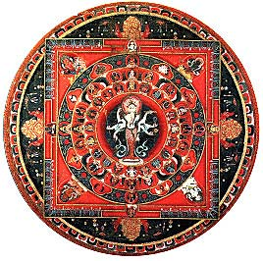
There are various forms of mandalas with distinct concepts and different purposes. The individual representations range from the so-called Cosmic Mandalas, which transmit the ancient knowledge of the development of the universe and the world-systems which represents a high point among Mandalas dedicated to meditation; to the Mandalas of the Medicine Buddha which demonstrates how the Buddha-power radiates in all directions, portraying the healing power of the Buddha.
The symbolism of meditation Mandalas has a rich tradition. The outer form of these so-called holy circles is a geometrical diagram, a Yantra, and each detail of its construction has symbolic meaning. The essence or purpose of the Mandala is concerned with the process of invocation, the calling in and realization of the spiritual force within the contemplator himself. All these different picture-tools have essentially the same inner meaning and purpose, but there are mandalas to suit all levels of consciousness: for the spiritually highly developed, for average people and for people not yet developed.
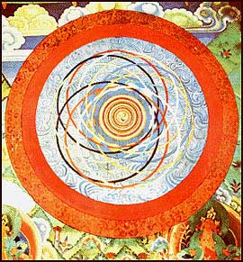
The Cosmic Mandala
The Cosmic Mandala is encompassed by a flaming circle. At the Centre is a three-footed spiral symbolizing a first movement, surrounded by rotating wind which condenses into so-called basic elements, representing the states of aggregation: Wind or Air stands for the gaseous state; Fire is usually depicted as a red triangle and stands for transformation; Water for liquid, represented by a half-circle or circle; Earth for solid matter, symbolized by a yellow square or cube. The emerging forms of the elements are painted in the blue ring surrounding the Centre, in the lower sphere intimating the world-continents to be. The blue Ether represents the all pervading condition, the source of all elements filling the space of the Mandala. On it circles are drawn; looking like ellipses in their dynamic intersection, they portray the orbits of celestial bodies, painted in all the colours of the rainbow plus black and white and indicating the directions. These twelve astrological circles of the upper sphere demonstrate the movements of sun, moon and stars in the seasons.
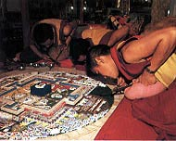
Tibetan monks constructing a festival mandala with sand and the dust of precious stones. After the festival the mandala will be destroyed, thus expressing the insubstantiality of visible forms.
See The Kalachakra Mandala - the Wheel of Time Sand Mandala and His Holiness the Dalai Lama's explanation of the practice in the Kalachakra Initiation.
Traditionally the Kalachakra Initiation has been a closely guarded secret and the viewing of the mandala forms the culmination of a twelve day initiation ritual for Tibetan Buddhist practitioners. However, the Dalai Lama, recognizing the many misconceptions surrounding Tibetan Buddhist practice, began presentations of the Kalachakra Sand Mandala to the general public as a cultural offering.

Kalachakra Sand Mandala
The Wheel of Time
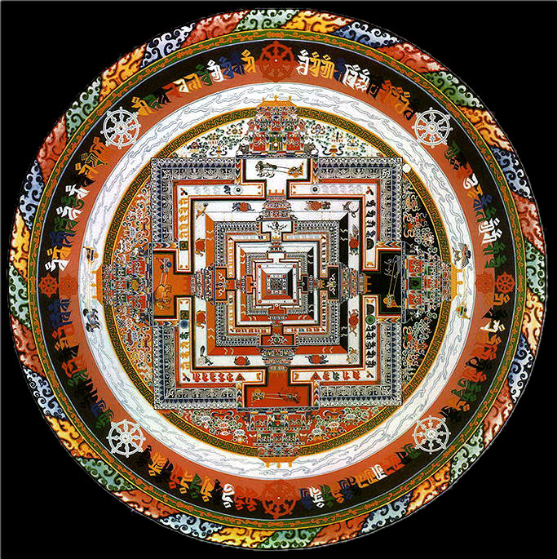

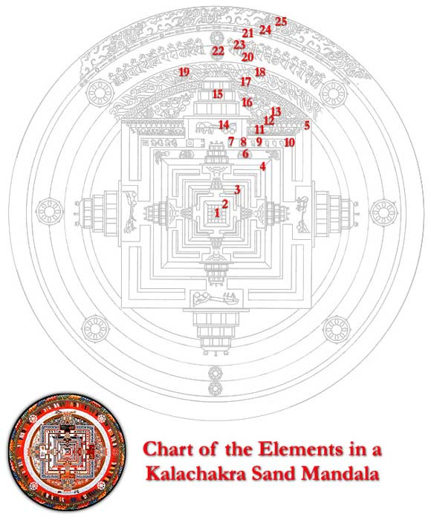
1. Mandala of Great Bliss with a lotus flower center housing six deities including Kalachakra and Vishvamata, Askshobhya and Prajnaparamita, Vajrasattva and Vajradhatvishvari surrounded by eight shaktis
2. Mandala of Enlightened Wisdom
3. Mandala of Enlightened Mind
4. Mandala of Enlightened Speech
5. Mandala of Enlightened Body
6. Animals representing the months of the year
7. Half vajras with half-moons, each adorned with a red jewel
8. Geometric shapes symbolizing the six elements, which are the five physical elements (fire, water, earth, air, space) plus the wisdom element (consciousness)
9. Thirty-six offering goddesses represented by Sanskrit seed-syllables
10. Double vajras which correspond to each of the four directions
11. Hanging garlands and half-garlands of white pearls surrounding the eight auspicious signs
12. Downspouts, which release rainwater from the palace roof
13. Half-lotus petal design symbolizing protection from afflictive emotion
14. Seven animals pulling a chariot that holds two protective deities; seven elephants are here in the western quadrant
15. Western gate of the Mandala of Enlightened Body
16. Offering garden
17. Earth element circle filled with interlocking crosses representing earth's stability
18. Water element circle containing wavelike ripples
19. Senge Kangpa Gyepa, an eight-legged lion pulling a cart containing two wrathful protective deities
20-21. This whole area is known as the cemetery grounds and is composed of the fire element circle (20) and the wind element circle(21)
22. Wheel of Dharma with a pair of protective deities in the center
23. Sanskrit seed-syllables
24. Space element circle containing an interlocking fence of golden vajras
25. Wisdom element circle, also known as the Great Protective Circle

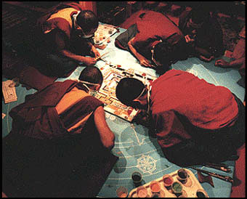
The multicoloured Kalachakra Mandala, made entirely from coloured sand, was painstakingly created over three weeks by monks from the Namgyal Monastery in Dharamsala, India. In a lesson about the impermanence of life, the completed mandala was destroyed and the sands were used as an offering for world peace.
'Kalachakra' means 'Wheel of Time' and is the name of one of the Buddhist deities which represent particular aspects of the Enlightened Mind. It forms a part of a system of teachings and practice conferred by the Buddha to his disciples. Traditionally this Kalachakra Initiation has been a closely guarded secret and the viewing of the mandala forms the culmination of a twelve day initiation ritual for the Buddhist practitioners. However, the Dalai Lama, recognizing the many misconceptions surrounding Tibetan Buddhist practice, began presentations of the Kalachakra Sand Mandala to the general public as a cultural offering.
Practitioners use the Mandala to visualize in meditation the steps along the Path to Enlightenment. In the Kalachakra Mandala, 722 deities, or manifestations of the supreme deity Kalachakra, are portrayed within a circle of some 2 metres in diameter in the form of miniature human, animal and flora forms, abstract pictographs and Sanskrit syllables. The sand is made from white stones ground and mixed with opaque water colors.

