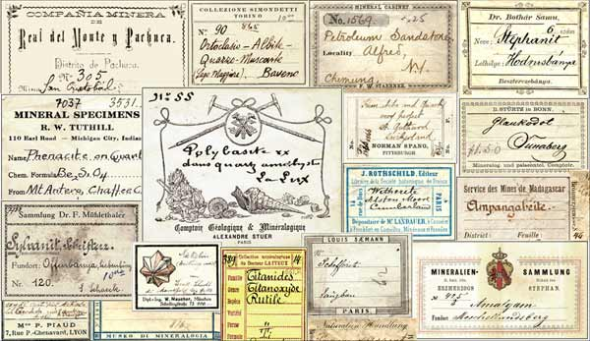

The Mineralogical Record Label Archive

The Mineralogical Record Label Archive is a collection of original, printed mineral specimen labels representing mineral collections from all countries during the last two centuries. With the possible exception of some of the great museums, it is the largest such collection in the world, with over 15,000 examples cataloged. The collection was initiated by the famous mineral collector and micromounter Neal Yedlin (1908-1977), in the 1960's. It was inherited upon his death by fellow label collector Ronald Bentley (1948-1995), who merged it with his own extensive holdings. Bentley bequeathed his and Yedlin's label collections (over 5,000 examples, counting duplicates) to the Mineralogical Record Library in 1995. The other major repository of mineral labels in the U.S. was assembled by Richard A. Bideaux (1935-2004), who in the 1990's also acquired the equally large collection of Lawrence H. Conklin and merged it with his own. The labels in Conklin's collection had all been salvaged from the effects of the late Peter Zodac (1894-1967) in 1967. Bideaux graciously bequeathed this combined collection of over 3,500 labels to the Mineralogical Record Library, in 2004. He believed that doing so was the only sensible choice for the ultimate disposition of such a collection. Since then the collections of Martin Zinn III (660 labels), Ulrich Burchard (450) and Günter Grundmann (2500 labels) have also been acquired, along with numerous relatively small donations.
The history of mineral collecting, especially by private individuals, is fragmented and scattered. These collections, taken together, constitute a unique historical documentation of mineral collecting over the last two centuries; in fact, some labels are the only surviving evidence that a particular person was a mineral collector or dealer, where they lived, or what kinds of specimens they had. We offer here images from this remarkable archive, for historical reference purposes, to aid in researching specimens, collections and biographies of early mineral collectors, mineral dealers and institutions. The images available here thus far represent only a small portion of the collection; more will be added periodically as time permits. We will be proceeding more or less in alphabetical order (with a few exceptions).
By the lower-right corner of the enlarged label images (which you can view by clicking on the small images) we have inserted initials to indicate the donor or collection from which the label was obtained.
LABEL DONORS & LABEL COLLECTIONS ACQUIRED:
AS = Andy Seibel
BAT = Robert Batik
BB = Bill Butkowski
BC = Bruce Cairncross
BG = Jennings "Beau" Gordon
C = Marc Wilson of the Carnegie Mineralogical Museum
CA = Claudio Albertini
DJ = Danny F. Jones
DV = Diederik Visser
ES = Ernest Schlichter
FG = Felix Garcia
GG = Günter Grundmann
GS = Gene Schlepp
GWR = George W. Robinson
H = Carl Francis (Harvard Mineralogical Museum)
JB = John Betts
JC = Juan M. Casanova Honrubia
JF = Jordi Fabre
JRM = J. Roger Mitchell
LACM = Los Angeles County Museum of Natural History
LHC = Lawrence H. Conklin
MD = Mel and Grace Dyck
MM = Marge Matula
MO = Marcus Origlieri
MZ = Martin Zinn III
PM = Roger Williams Park Museum
RAB = Richard A. Bideaux (and Lawrence Conklin/Peter Zodac) collection.
RB = Russell Behnke
REB = Ronald E. Bentley (and Neal Yedlin) collection
RL = Ross Lillie
SC = Steven C. Chamberlain
SW = Stuart Wilensky
TG = Thomas M. Gressman
UB = Ulrich Burchard
UMD = University of Minnesota, Duluth
V = Gerhard Niedermayr of the Vienna Natural History Museum
VUG = Steve Hardinger
WB = William Borden
WEW = Wendell E. Wilson
WU = Werner Wurster
We hope that in the future the Label Archive will continue to grow. First of all, we suggest that today's active label collectors consider following the lead of Ron Bentley, Dick Bideaux and others, and arrange to donate their label collections to the Mineralogical Record, to be added to the Label Archive. What better place for your collection to go? We also hope that collectors and dealers who have had personalized labels printed for their specimens will send us examples. And, if you have a deceased collector friend whom you would like to see remembered, and you have one or more of his personal labels, be sure to send them to us so that we can include them. We may even be interested in purchasing special labels or collections of labels, should they become available. The bottom line is that Mineralogical Record is the only institution in the world which is specializing specifically in preserving the history of mineral collecting. We invite all readers to help us in this important task.
Click on the drop-down menu above to select the desired collector, dealer or institution, then click on "Go to Gallery" to view one or more of their labels. Biographical information, where available, is also provided. Some of the biographical data has been contributed by Curtis Schuh and some by Michael P. Cooper, both of whom have extensive personal files of historical information.
NOTE: One important way in which readers can assist this project is by providing information they have on some of the collectors and dealers represented in the collection. In many cases we have almost nothing in the way of biographical notes. If you have information to contribute, just click on the e-mail link provided.
=====================================================================================================================================
END

