The Isometric Sephiroth: The Forgotten Correspondences
Being a study into, and graphical, isometrical, structural, physical and topological interpretation of the ancient Sefer Yetzirah (also called the Book of Formation or Creation) and the Sephirotic Tree of Life, with regard to the geometry of the circle, the equilateral triangle, the seed of life, the hexagon, isometric projection and the double cube.

Seven directors and their host
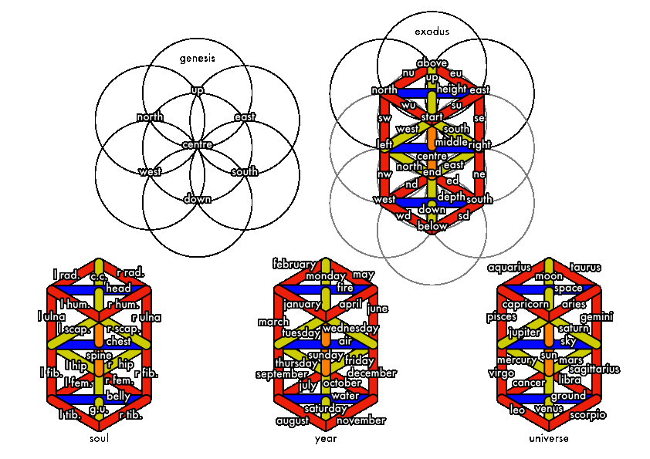

Faced forward
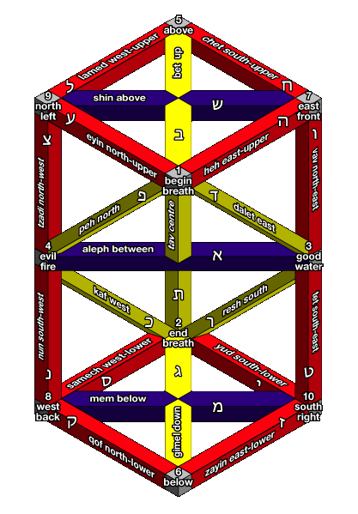

Their end is imbedded in their beginning
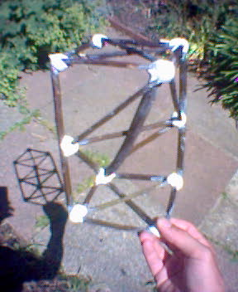

Twenty two objects in a single body
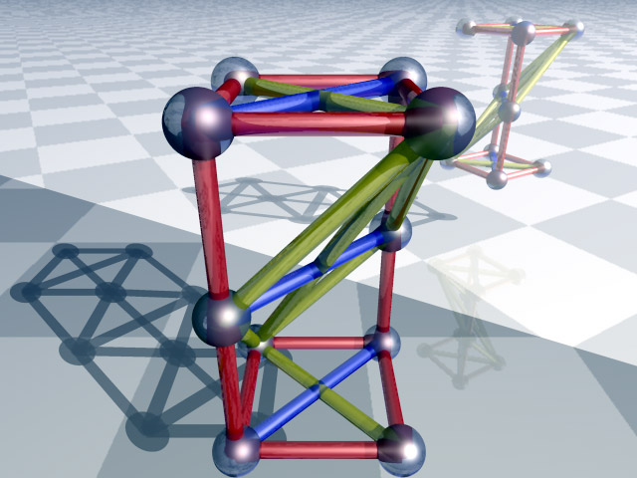

One opposite the other
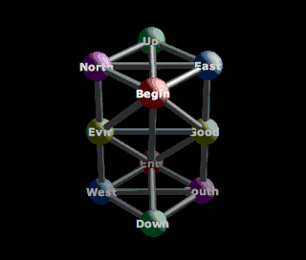

Stand a thing on its essence
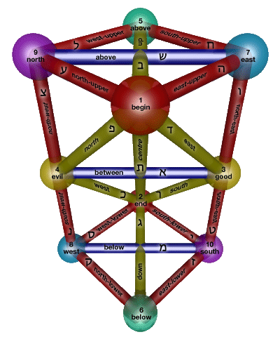

Pillars from air
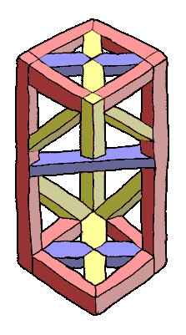

All of them depend on one
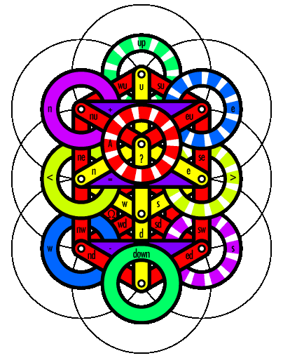

Table of Correspondences
# | Type | Hebrew |  | Character | Saadia |  |  |  |  | GRA |  |  |  |  | Westcott | Abbr. used | #
# | Type | Unicode | Img | Character | Attribute | Foundation | The Universe, The Dragon | The Year, The Wheel | The Soul, The Heart | Attribute | Foundation | The Universe, The Dragon | The Year, The Wheel | The Soul, The Heart | Attribute | Abbr. used | #
1 | Ten Ineffable Sephiroth, spheres, knots, depths or dimensions |  |  | 1 | Beginning |  |  |  |  | Beginning |  |  |  |  | Beginning | Begin or Α | 1
2 |  |  |  | 2 | End |  |  |  |  | End |  |  |  |  | End | End or Ω | 2
3 |  |  |  | 3 | Good |  |  |  |  | Good |  |  |  |  | Good | Good or < | 3
4 |  |  |  | 4 | Evil |  |  |  |  | Evil |  |  |  |  | Evil | Evil or > | 4
5 |  |  |  | 5 | Above |  |  |  |  | Above |  |  |  |  | Above | Up or Above | 5
6 |  |  |  | 6 | Below |  |  |  |  | Below |  |  |  |  | Below | Down or Below | 6
7 |  |  |  | 7 | East |  |  |  |  | East |  |  |  |  | East | E | 7
8 |  |  |  | 8 | West |  |  |  |  | West |  |  |  |  | West | W | 8
9 |  |  |  | 9 | South |  |  |  |  | South |  |  |  |  | South | S | 9
10 |  |  |  | 10 | North |  |  |  |  | North |  |  |  |  | North | N | 10
11 | Three Basic, Mother, Father or Parent pathways | א | 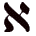 | Alef | Balance | Air | Air | Temperate (Spring & Autumn ) | Chest | Balance | Air | Air | Temperate (Spring & Autumn ) | Chest | Balance | Above or + | 11
12 | Three Basic, Mother, Father or Parent pathways | מ |  | Mem | Descend | Water | Earth | Cold (Winter) | Belly | Descend | Water | Earth | Cold (Winter) | Belly | Descend | Below or - | 12
13 | Three Basic, Mother, Father or Parent pathways | ש | 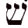 | Shin | Ascend | Fire | Heaven | Hot (Summer) | Head | Ascend | Fire | Heaven | Hot (Summer) | Head | Ascend | Between or = | 13
14 | Seven Double pathways | ב |  | Bet / Vayt | Above | Life / Death | Saturn | Saturday | Mouth | Above | Wisdom | Moon | Sunday | Right eye | Above | Up or U | 14
15 | Seven Double pathways | ג | 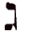 | Gimel / Ghimel | Below | Peace / War | Jupiter | Sunday | Right eye | Below | Wealth | Mars | Monday | Right ear | Below | Down or D | 15
16 | Seven Double pathways | ד | 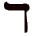 | Dalet / Dhalet | East | Wisdom / Folly | Mars | Monday | Left eye | East | Seed | Sun | Tuesday | Right nostril | East | E | 16
17 | Seven Double pathways | כ | 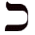 | Kaf / Khaf | West | Wealth / Poverty | Sun | Tuesday | Right nostril | West | Life | Venus | Wednesday | Left eye | West | W | 17
18 | Seven Double pathways | פ | 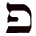 | Peh / Feh | North | Seed / Desolation | Venus | Wednesday | Left nostril | North | Dominance | Mercury | Thursday | Left ear | North | N | 18
19 | Seven Double pathways | ר |  | Resh / Rhesh | South | Grace / Ugliness | Mercury | Thursday | Right ear | South | Peace | Saturn | Friday | Left nostril | South | S | 19
20 | Seven Double pathways | ת |  | Tav / Thav | Middle | Dominance / Subjugation | Moon | Friday | Left ear | Middle | Grace | Jupiter | Saturday | Mouth | Middle | Centre or ? | 20
21 | Twelve Simple or Elemental pathways | ה | 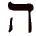 | He | North East | Sight | Aries | Nissan | Liver | East Height | Speech | Aries | Nissan | Right foot | North East | NE | 21
22 | Twelve Simple or Elemental pathways | ו | 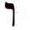 | Vav | East Height | Hearing | Taurus | Iyyar | Gall-bladder | North East | Thought | Taurus | Iyyar | Right kidney | South East | EU | 22
23 | Twelve Simple or Elemental pathways | ז | 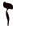 | Zayin | East Depth | Smell | Gemini | Sivan | Spleen | East Depth | Motion | Gemini | Sivan | Left foot | East Height | ED | 23
24 | Twelve Simple or Elemental pathways | ח | 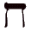 | Het | North West | Speech | Cancer | Tammuz | Intestine | South Height | Sight | Cancer | Tammuz | Right hand | East Depth | NW | 24
25 | Twelve Simple or Elemental pathways | ט | 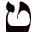 | Tet | North Height | Eating | Leo | Ab | Right kidney | South East | Hearing | Leo | Ab | Left kidney | North Height | NU | 25
26 | Twelve Simple or Elemental pathways | י | 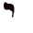 | Yod | North Depth | Coition | Virgo | Elul | Left kidney | South Depth | Action | Virgo | Elul | Left hand | North Depth | ND | 26
27 | Twelve Simple or Elemental pathways | ל | 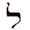 | Lamed | South West | Action | Libra | Tishri | Intestines | West Height | Coition | Libra | Tishri | Gall bladder | South West | SW | 27
28 | Twelve Simple or Elemental pathways | נ | 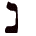 | Nun | West Height | Walking | Scorpio | Marheshevan | Stomach | South West | Smell | Scorpio | Marheshevan | Intestine | North West | WU | 28
29 | Twelve Simple or Elemental pathways | ס |  | Samech | West Depth | Anger | Sagitarius | Kislev | Right hand | West Depth | Sleep | Sagitarius | Kislev | Kivah | West Height | WD | 29
30 | Twelve Simple or Elemental pathways | ע | 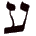 | Ayin | South East | Laughter | Capricorn | Tevet | Left hand | North Height | Anger | Capricorn | Tevet | Liver | West Depth | SE | 30
31 | Twelve Simple or Elemental pathways | צ | 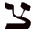 | Tsadeh | South Height | Thought | Aquarius | Shivat | Right foot | North West | Taste | Aquarius | Shivat | Korkeban | South Height | SU | 31
32 | Twelve Simple or Elemental pathways | ק | 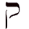 | Qof | South Depth | Sleep | Pisces | Adar | Left foot | North Depth | Laughter | Pisces | Adar | Spleen | South Depth | SD | 32
# | Type | Hebrew |  | Character | Saadia |  |  |  |  | GRA |  |  |  |  | Westcott | Abbr. used | #
 |  |  |  |  | Attribute | Foundation | The Universe, The Dragon | The Year, The Wheel | The Soul, The Heart | Attribute | Foundation | The Universe, The Dragon | The Year, The Wheel | The Soul, The Heart | Attribute | Abbr. used | #

