**Israel – A Nation Founded Upon a Monumental Lie**

Saturday, 2 May 2015

Graham Pick

http://www.maltanow.com.mt/?p=3663

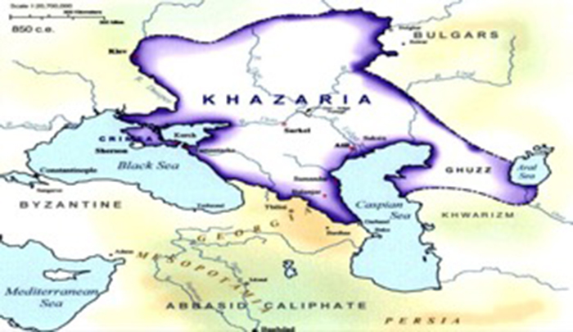

**An ancient map of Khazaria**

Once upon a time, hundreds of years ago, there was an extraordinarily evil kingdom. A land ruled by a wicked king who filled his court with practitioners of ancient Babylonian black arts, and occult oligarchs. A land inhabited by an aggressive demented race of thieves, murderers, and highwaymen, who would prey on travellers, steal from them, murder them, and then assume their identity. The citizens of neighbouring lands lived in constant fear and trepidation of this menacing realm, its criminal population, and its warlike tendencies.

Anyone could be forgiven for thinking that the above opening is the prologue to a mythical fable from times past, but such a sinister country, complete with its equally terrorizing inhabitants did exist. The country was called Khazaria, and its populace Khazars. A land to the north of Georgia and the south of Bulgaria, between the Black and Caspian seas.

The history of the Khazars, has been almost completely excised from history books and public records, and many hours of intense research were required to reconstruct this purposely hidden secret history of the Khazars. The following is the true history of Khazaria, its evolution, and its present day influences on our society.

The Khazars originally were an Asiatic Mongoloid nation. From time immemorial the homeland of the Khazars was in the heart of Asia. It was a very hostile nation, constantly at war with its neighbours. The Khazars were finally driven out of Asia by neighbouring countries in Asia with whom they were continually at war. The Khazars fled their Asian homeland and invaded eastern Europe to escape further defeats in Asia.

The very hostile Khazars did not find it difficult to subdue and conquer the 25 peaceful agricultural nations occupying approximately 1,000,000 square miles in eastern Europe. In a comparatively short period the Khazars established the largest and most powerful kingdom in Europe, and probably the wealthiest also.

Between 100 and 800AD an incredibly evil society evolved in Khazaria. During this time, Khazars become known to surrounding countries as thieves, murderers, road bandits, and for assuming the identities of those travellers they murdered as a normal occupational practice and way of life.

The Khazars were a pagan nation when they invaded eastern Europe. Their historical religious doctrines were a mixture of phallic worship and other forms of idolatrous reverence practiced in Asia by several pagan nations. The vile forms of sexual excess indulged in by the Khazars as their form of religious worship degenerated into a degree of debauched moral decadence unparalleled by any other nation of the time. This form of decadent worship continued until the 7th century until it could no longer be endured by the Khazarian king of the time.

King Bulan, ruler at that time of the Khazarian Kingdom, decided to abolish the practice of phallic worship and other forms of idolatrous worship and make one of the three monotheistic religions, about which he knew very little, the new state religion. After a documented historic session with representatives of the three monotheistic religions King Bulan eventually decided against Christianity and Islam and selected Judaism as the future state religion of the Khazarian nation. It was decreed that every man woman and child of Khazaria must convert to Judaism and practice its philosophy.

King Bulan and his 4000 feudal nobles were promptly converted by rabbis imported from Babylonia specifically for that event. Phallic worship and other forms of idolatry were thereafter forbidden. The Khazarian king then invited large numbers of rabbis to come and open synagogues and schools to instruct the population in the new form of religious worship. It was now the state religion. The converted Khazars were the first population of so-called or self-styled “Jews’ in eastern Europe.

After the conversion of King Bulan none other than a so-called or self-styled “Jew” could occupy the Khazar throne. The Khazar Kingdom became a virtual theocracy. The religious leaders were the civil administrators also. The religious leaders imposed the teachings of the Talmud upon the population as their guide to living. The ideologies of the Talmud became the axis of political, cultural, economic and social attitudes and activities throughout the Khazar kingdom. The Talmud provided both civil and religious law.

Despite this mass conversion by the king and his subjects there remained a select secret circle of oligarchs who continued practicing ancient Babylonian black magic, also known as Secret Satanism. This Secret Satanism involved occult ceremonies featuring child sacrifice, after “bleeding them out”, drinking their blood and eating their hearts.

The deep dark secret of those occult practices was that they were all based on ancient Baal Worship, also known as worship of the Owl. In order to deceive the Khazarian king this clandestine group melded these Luciferian black magic practices with Judaism and created a secret Satanic-hybrid religion, known as Babylonian Talmudism. This occult form of Judaism was surreptitiously practiced in Khazaria, and it nurtured the same evil that Khazaria was known for previously.

During the 10th, 11th, 12th, and 13th centuries the rapidly expanding new Russian empire gradually swallowed up the Khazar kingdom, its neighbour directly to the south. The conquest of the Khazar Kingdom by the Russians provides history with the explanation for the presence after the 13th century, of the large number of so-called “Jews” in Russia. This huge number of self-styled “Jews”, both in Russia and in many other eastern European nations after the destruction of the Khazar Kingdom, were thereafter no longer known as Khazars but as the “Yiddish” populations of these many countries. The term Yiddish is taken directly from the spoken and written language of the Khazarian “Jews”.

When the Khazars in the 1st century B.C. invaded eastern Europe their mother-tongue was an ancient Asiatic language. They spoke primitive Asiatic dialects without any alphabet or written form. When King Bulan was converted in the 7th century he decreed that the Hebrew characters he saw in the Talmud and other Hebrew documents was thereafter to become the official alphabet of the Khazar language. The Hebrew characters were adapted to the phonetics of the spoken Khazar language. The Khazars employed the characters of the ancient Hebrew language in order to provide a means of accomplishing a written account of their spoken words.

It is interesting to note that although the Yiddish and ancient Hebrew languages share the exact same characters in their alphabets, “Yiddish” must not be confused with “Hebrew”. There is not a single word of Yiddish in ancient Hebrew nor is there one word of ancient “Hebrew” in “Yiddish”. They are as totally different as spoken and written Swedish and Spanish, yet which both likewise share the same Latin based characters for their alphabets.

Whilst many textbooks and web-pages will attempt to assert that modern Hebrew and Yiddish both have roots in ancient biblical Hebrew, this claim can easily be debunked by both historians and linguists. The real reason that modern Hebrew has some similarities to Yiddish is because the inventors of modern Hebrew although attempting to revive and modernise ancient biblical Hebrew, couldn’t completely eradicate their Yiddish linguistic roots.

In the many wars with her neighbours in Europe since the 13th century, Russia was required to cede to her victors large areas which were originally part of the Khazar Kingdom. In this manner Poland, Lithuania, Galicia, Hungary, Rumania, and Austria were acquired from Russian territory which was originally a part of the Khazar Kingdom. Together with this territory these nations acquired a segment of the population of so-called or self-styled “Jews” descended from the Khazars who once occupied the territory. These frequent boundary changes by the nations in eastern Europe explains the presence today of many Jews in all of these countries, all whose ancestry can be traced back to the converted Khazars. Their common language, their common culture, their common religion, and their common racial characteristics classify them all beyond any question of doubt with the Khazars who invaded eastern Europe in the 1st century B.C. and who were converted to Judaism in the 7th century.

These so-called “Jews” of eastern European origin make up at least 90% of the world’s present total population of Jews. Judaism was given the greatest stimulus in all its history with the conversion of the large pagan Khazar population in the 7th century. Without the conversion of the Khazar population it is doubtful if Judaism could have survived. It would have disappeared with all of its contemporary creeds and cults but for the conversion of the Khazars in the 7th century. At that time Judaism was well on its way towards complete oblivion, but the conversion of the Khazarian empire gave it a new lease of life.

From the 13th to the beginning of the 20th century Khazarian Jews spread to the four corners of the globe, integrating into communities worldwide, having nowhere they could call their homeland. Khazaria no longer existed and Judea, the original homeland of the biblical Jews was long gone, following their expulsion from their native soil by the Romans some 2000 years previous. During this period Khazarian Jews either lost or abandoned their true heritage, instead preferring to falsely believe that they were actually native Jews of biblical origin who descended from Israelite–Canaanite tribes who left the Holy Land for Europe in the seventh century, following the Muslim conquest of Palestine. . They came to be known as Ashkenazi Jews.

Although Ashkenazi Jews are professed to be of Germanic/European origin, and descendants of native biblical Jews, there is very little evidence in support of this claim. In fact recent DNA analysis has concluded that Ashkenazi Jews are genetically descended from the Khazars.

In the late 19th century came the advent of the Zionist movement in Europe. Zionism is a political movement amongst Jews (although supported by many non Jews), which maintains that the Jewish people constitute a nation and are entitled to a national homeland. Formally founded in 1897, Zionism embraced a variety of opinions in its early years on where that homeland might be established. From 1917 it focused on the establishment of a Jewish national homeland or state in Palestine, the original location of the ancient Kingdom of Israel/Judea. However, even the claim that Palestine is the native home of the Jewish people is not totally supported by fact.

According to the bible, this land was first inhabited by Canaanites, known to be the descendents of Noah. The Nation of Israel appeared on this land centuries later when they were brought out of the land of Egypt. They remained here for a few centuries until their exile by Assyrians and then by Babylonians. Finding favour with the Persians, they returned to this land, only to be swept away once again by Romans and Greeks.

The principles of the Zionist movement began to permeate throughout Ashkenazi/Khazarian Jewish communities worldwide and many became enthralled by the notion of returning to their alleged historical, biblical homeland, even though in reality it was not.

Then, on 2nd November 1917 came the Balfour Declaration. The Balfour Declaration  was a formal statement of policy by the British government stating that:

*“His Majesty’s government view with favour the establishment in Palestine of a national home for the Jewish people, and will use their best endeavours to facilitate the achievement of this object, it being clearly understood that nothing shall be done which may prejudice the civil and religious rights of existing non-Jewish communities in Palestine, or the rights and political status enjoyed by Jews in any other country.”*

On 14th May 1948 the Balfour Declaration was realised and the modern state of Israel was founded.

[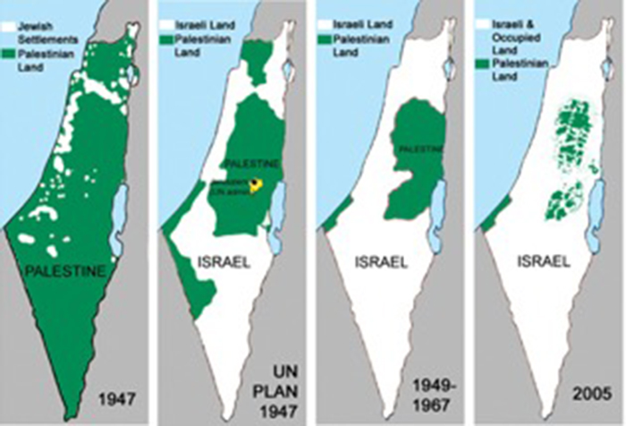](http://www.maltanow.com.mt/wp-content/uploads/2015/05/Israel.jpg)

Eradication of the People of Palestine…

Ashkenazi Jews flocked to their new found homeland in droves and rapidly expanded their borders beyond their intended limits. Since the inception of the state of Israel in 1948, and especially since 1967, Israel has relentlessly, brutally, and uncompromisingly expanded their borders into Palestinian land. These Jewish usurpers have seized land, stolen farms, and demolished Palestinian homes with unrelenting ruthlessness and unforgiving vindictiveness. They have reduced the Palestinian nation to nothing more than the wretched, pitiful strip of dessert – the Gaza strip, effectively making the Palestinians prisoners in their own land, and they will stop at nothing until they have either removed or annihilated all Palestinians.

These usurpers believe they have a right to this land as they are Gods chosen people. They profess to be of the lineage of Abraham so therefore have an ancestral entitlement to displace its present inhabitants, and replace them with their own. They claim the ancient land of Canaan (now Palestine) as their legacy because they are descendents of the 12 tribes. This is their God given birthright, based upon their ancestry.

Yet this is a monumental lie.

90% of the inhabitants of modern day Israel are not descendents of Abraham, or any other biblical predecessor. In fact they have next to no middle eastern blood in their veins. Ashkenazi Jews have no hereditary right whatsoever to the land they now inhabit. They have stolen this territory from its rightful inhabitants and are now obliterating them, just as the Khazars obliterated the former populace of Khazaria when they invaded from Asia.

They may have changed their religion in years gone by, but their decadent bloodthirsty conquests have remained!

**References**

**The Jewish Encyclopaedia**:

*“Khazars, a non-Semitic, Asiatic, Mongolian tribal nation who emigrated into Eastern Europe about the first century, who were converted as an entire nation to Judaism in the seventh century by the expanding Russian nation which absorbed the entire Khazar population, and who account for the presence in Eastern Europe of the great numbers of Yiddish-speaking Jews in Russia, Poland, Lithuania, Galatia, Besserabia and Rumania.”*

**The Universal Jewish Encyclopaedia**:

*“The primary meaning of Ashkenaz and Ashkenazim in Hebrew is Germany and Germans. This may be due to the fact that the home of the ancient ancestors of the Germans is Media, which is the Biblical Ashkenaz… in the early medieval ages the Khazars were sometimes referred to as Ashkenazim… About 92 percent of all Jews or approximately 14,500,000 are Ashkenazim.”*

**Encyclopaedia Americana**:

*“Ashkenazim, the Ashkenazim are the Jews whose ancestors lived in German lands…it was among Ashkenazi Jews that the idea of political Zionism emerged, leading ultimately to the establishment of the state of Israel… In the late 1960s, Ashkenazi Jews numbered some 11 million, about 84 percent of the world Jewish population.”*

**The American Peoples Encyclopaedia**:

*“In the year 740 A.D. the Khazars were officially converted to Judaism. A century later they were crushed by the incoming Slavic-speaking people and were scattered over central Europe* ***where they were known as Jews****.*

**The New Encyclopaedia Britannica**, Volume 6:

*“Khazar, member of a confederation of Turkic-speaking tribes that in the late 6th century A.D. established a major commercial empire covering the south-eastern section of modern European Russia…but the most striking characteristic of the Khazars was the adoption of Judaism by the Kagan and the greater part of the ruling class in about 740…The fact itself, however, is undisputed and unparalleled in the history of Central Eurasia. A few scholars have ascertained that the Judaized* ***Khazars were the remote ancestors of many of the Jews of Eastern Europe and Russia.****“*

============================================================================================================================