Monteverde Jubilee

Family Album
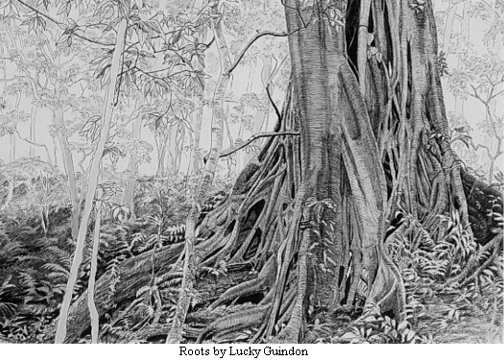
April 19, 1951
April 19, 2001
50 years growing and spreading our roots

Published by
Asociación de Amigos de Monteverde

Edited by the Album Committee
Lucille Guindon, Martha Moss, Marvin Rockwell,
John Trostle and Sue Trostle

