The International Jew- Henry Ford 1920,s
http://en.wikipedia.org/wiki/The_International_Jew
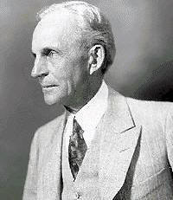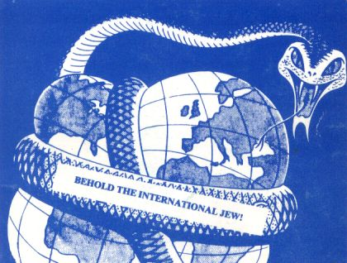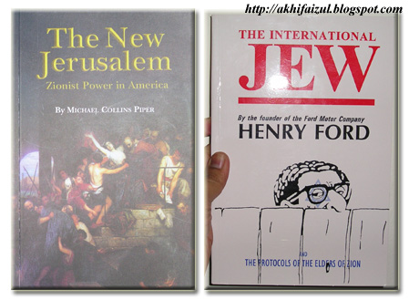
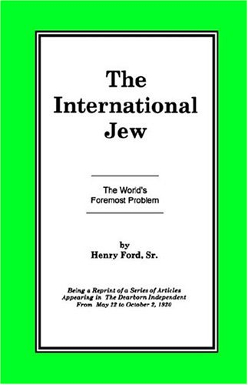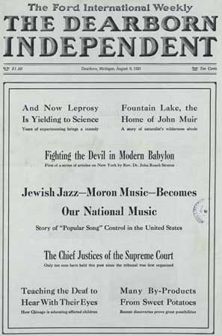

The International Jew: The World's Foremost Problem is a four (4) volume set of books originally published and distributed in the early 1920's by Henry Ford, an American industrialist, automobile developer and manufacturer. It consisted of a collection of articles serialized in The Dearborn Independent, a newspaper owned by Ford. Many of the texts were inspired by antisemitic plagiarism The Protocols of the Elders of Zion.^{[1]}
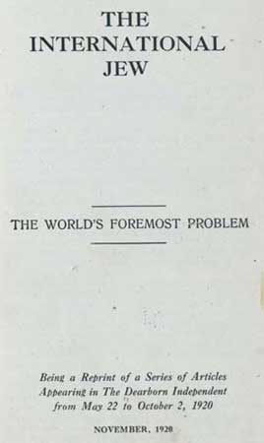
The International Jew, The World's Foremost Problem - November, 1920

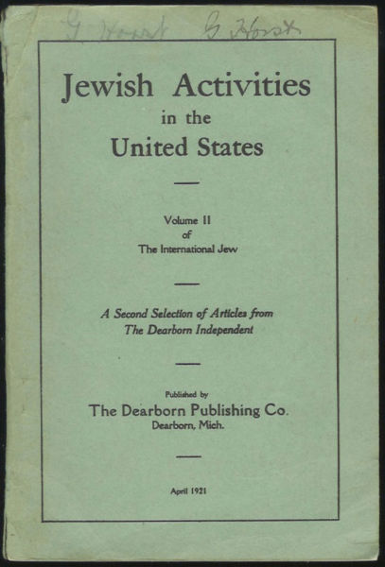
Jewish Activities in the United State (Volume II) - April, 1921

Book cover, The International Jew, November 1921 Ludvikus 07:38, 21 December 2006 (UTC)

Contents
- 1 Content
- 2 Influence on Hitler
- 3 Libel suit, 1927
- 4 Legacy
  - 4.1 The Patriotic Publishing Co.
  - 4.2 G. F. Green and the Chritian Nationalist Crusade
- 5 References
- 6 External link
- 7 Bibliography
  - 7.1 Primary Sources
  - 7.2 Secondary Sources

Content
After publication in the periodical, the articles were compiled into a four volume set as follows: ^{[2]}
- Volume 1: The International Jew
- Volume 2: Jewish Activities in the United States
- Volume 3: Jewish Influence in American Life
- Volume 4: Aspects of Jewish Power in the United States

[] Influence on Hitler
Vincent Curcio wrote that these publications "were widely distributed and had great influence, particularly in Nazi Germany, where no less a personage than Adolf Hitler read and admired them. Hitler based several sections of Mein Kampf on his writings: indeed, Ford is the only American mentioned in Hitler's book. It can probably be said, as Lacey does, that no American contributed as much to the evils of Nazism as Henry Ford."^{[3]}
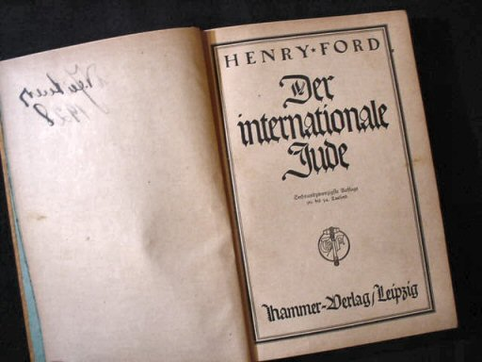
The Internationa Jew - German imprint

Libel suit, 1927
A libel lawsuit brought by San Francisco lawyer and Jewish farm cooperative organizer Aaron Sapiro in response to antisemitic remarks led Ford to close the Independent in December 1927. News reports at the time quoted him as being shocked by the content and having been unaware of its nature. During the trial, the or of Ford's "Own Page", William Cameron, testified that Ford had nothing to do with the orials even though they were under his byline. Cameron testified at the libel trial that he never discussed the content of the pages or sent them to Ford for his approval.^{[4]} Investigative journalist Max Wallace noted that "whatever credibility this absurd claim may have had was soon undermined when James M. Miller, a former Dearborn Independent employee, swore under oath that Ford had told him he intended to expose Sapiro.^{[5]} According to Michael Barkun, "That Cameron would have continued to publish such controversial material without Ford's explicit instructions seemed unthinkable to those who knew both men. Mrs. Stanley Ruddiman, a Ford family intimate, remarked that "I don't think Mr. Cameron ever wrote anything for publication without Mr. Ford's approval"".^{[6]}

[] Legacy

Book cover of The International Jew. Arabic ion. Egypt, 2001^{[7]}

The Dearborn Independent ceased publication in 1927 - Ford had a change of heart.

[] The Patriotic Publishing Co.
In 1934, The Patriotic Publishing Co., an unincorporated entity that operated out of a post office box ^{[8]} "Issued" and "Compiled and ed" the "The Protocols" as an expanded 300-page tome. The expansion from less than 100 pages to 300 pages was made possible by lifting substantial sections from The Dearborn Independent. Most of the later imprints of the Protocols are derived from this 1934 ion.
Distribution of The International Jew was halted in 1942^{[citation needed]}, but extremist groups often recycle the material; it still appears on anti-Semitic and neo-Nazi websites.

[] G. F. Green and the Chritian Nationalist Crusade
In June of 1949 there appeared a 174 page one volume abridgment of the text, entitled The International Jew, subtitled "The World's Foremost Problem", and ed by G. F. Green. It was published by G. F. Green, or of "The Independent Nationalist" with the address at 56 Gloucester Road, New Barnet, Herts, England.
The printer was H.L. Castle, Ltd., Victoria Printing Works; Watford, Herts, England. This ion sold for 9/- (British currency).
The book also sold in the United States. It was distributed by the Christian Nationalist Crusade with a sticker mounted on the front endpaper, recto side, bearing the following text:

Extra Copies Of This Book
The International Jew
May Be Had At $2.00 per Copy
Place Your Order With
CHRISTIAN NATIONALIST
CRUSADE
P.O. Box D-4 St. Louis 1, Mo.

This is the source of the version of the International Jew which currently circulates as an abridgment bearing the name of G. F. Green.

[] References
- ^ "Jewish World Plot": An Exposure. The Source of "The Protocols of Zion". Truth at LastPDF by Philip Graves published in The Times, August 16-18, 1921
- ^ The International Jew. The Worlds Foremost Problem. Being a Reprint of a Series of Articles Appearing in The Dearborn Independent from May 22 ... 1920 [to January 14, 1922] Dearborn, Mich.: Dearborn Publishing Co., 1920-1922
- ^ Curcio, Vincent (2001). Chrysler: The Life and Times of an Automotive Genius. New York, NY: Oxford University Press. ISBN 0-19-514705-7, p. 211.
- ^ Lewis, (1976) pp. 140-156; Baldwin p 220-221.
- ^ Wallace, p. 30.
- ^ Barkun, Michael (1996). Religion and the Racist Right: The Origins of the Christian Identity Movement. UNC Press. ISBN 0-8078-4638-4, p. 35.
- ^ The International Jew Arabic ion. Publisher: Dar al-Fadhilah, Cairo, Egypt. Translator: ‘Ali al-Gawhari. The International Jew: a commercial success in Egypt
- ^ P.O. Box 526, Chicago, IL

[] External link
- The New York Public Library, Catalog Record [1]

[] Bibliography

[] Primary Sources
- Call # *DA+ (Dearborn independent) Library has: Year 19, no.11-52-year 28, no.11 (Jan. 11-Dec. 31, 1927)
Title Dearborn independent (Dearborn, Mich. : 1901).
Dearborn independent.
Imprint Dearborn, Mich., Suburban Pub. Co.,
URL for this record
LOCATION CALL # STATUS
Humanities- General Research- Rm315 *DA+ (Dearborn independent) Library has: Year 19, no.11-52-year 28, no.11 (Jan. 11-Dec. 31, 1927)
Division Humanities- General Research- Rm315
Descript 28 v. ill. 40-51 cm.
Frequency Weekly
Note Began in 1901? Ceased with v.28, 1927; Cf. Ayer.
"The Ford international weekly" appears with title in masthead, <Jan 1919-Apr. 1925>.
Includes orial page by Henry Ford.
Description based on: Vol. 7, no. 27 (Jan 31, 1908).
Published as a weekly periodical <Nov. 1, 1919>-<Oct. 15, 1927>.
Numbering irregular.
Available on microfilm from the Auburn University Libraries.
Subject Dearborn (Mich.) -- Newspapers.
Wayne County (Mich.) -- Newspapers.
United States Michigan Wayne Dearborn.
Add'l name Ford, Henry, 1863-1947.
NYPL CATNYP: [2]

- LC Control No.: 21005671
Type of Material: Book (Print, Microform, Electronic, etc.)
Uniform Title: The Dearborn independent. [from old catalog]
Main Title: The international Jew, the world’s foremost problem, being a reprint of a series of articles appearing in The Dearborn independent from May 22 to October 2, 1920.
Published/Created: [Dearborn, Mich., The Dearborn publishing, co.] 1920.
Description: 1 p.l., [5]-235 p. 19cm.
Subjects: Protocols of the wise men of Zion. Jews.
LC Classification: DS145.D5 A3
CALL NUMBER: DS145.D5 A3
URL: [3]

- LC Control No.: 53049221
Type of Material: Book (Print, Microform, Electronic, etc.)
Uniform Title: The Dearborn independent. [from old catalog]
The International Jew. German. [from old catalog]
Main Title: Der internationale Jude.
Published/Created: Leipzig, Hammer-Verlag [192- ]
Description: 2 v. 22 cm.
Subjects: Jews--United States. [from old catalog]
LC Classification: DS145.D5 A4 1920z
CALL NUMBER: DS145.D5 A4 1920z

- LC Control No.: 76518610
Type of Material: Book (Print, Microform, Electronic, etc.)
Personal Name: Ford, Henry, 1863-1947.
Uniform Title: International Jew. Russian.
Main Title: Mezhdunarodnoe evreĭstvo / Genri Ford ; perevod s angliīskago.
Published/Created: [s.l. : s.n.], 192-]
Related Titles: Dearborn Independent.
Description: 237 p. ; 23 cm.
Notes: Translation of a collection of unsigned articles originally appearing in the Dearborn independent May 22-Oct. 2, 1920.
Subjects: Jews--United States.
LC Classification: DS141 .D45 1920z
Language Code: rus eng
Other System No.: (OCoLC)32521103

- Henry Ford; Egyptian Translator: ‘Ali al-Gawhari
The International Jew (Arabic
(Cairo: Dar al-Fadhilah, 2001)

[] Secondary Sources
- Ford R. Bryan
Henry's Lieutenants
(Detroit: Wayne State University Press, 1993)
ISBN 0-8143-2428-2 (paper)
- Albert Lee
Henry Ford and the Jews
(New York: Stein and Day, 1980)
ISBN 0-8128-2701-5
- Max Wallace
The American Axis: Henry Ford, Charles Lindbergh, and the Rise of the Third Reich
(New York: St. Martin's Press, 2003)
ISBN 0-312-29022-5

========================================================================================================================
END

http://en.wikipedia.org/wiki/Henry_Ford

Antisemitism and The Dearborn Independent
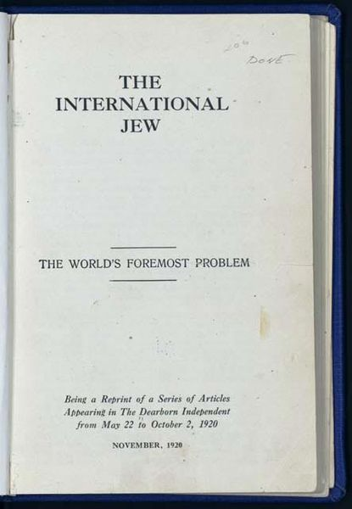
The International Jew, the World's Foremost Problem. Articles from The Dearborn Independent, 1920

In 1918, Ford's closest aide and private secretary, Ernest G. Liebold, purchased an obscure weekly newspaper, The Dearborn Independent, so that Ford could spread his views. By 1920 Ford had become virulently antisemitic and in March of that year began an anti-Jewish crusade in the pages of his newspaper.^{[9]} The Independent ran for eight years, from 1920 until 1927, during which Liebold was editor. The newspaper published "Protocols of the Learned Elders of Zion," which was discredited as a forgery during the Independent's publishing run by The Times of London. The American Jewish Historical Society describes the ideas presented in the magazine as "anti-immigrant, anti-labor, anti-liquor, and anti-Semitic". In February 1921, the New York World published an interview with Ford, in which he said "The only statement I care to make about the Protocols is that they fit in with what is going on". During this period Ford emerged as "a respected spokesman for right-wing extremism and religious prejudice," reaching around 700,000 readers through his newspaper.^{[10]}
Along with the Protocols, anti-Jewish articles published by The Dearborn Independent were also released, in the early 1920s, as a set of four bound volumes, cumulatively titled The International Jew, the World's Foremost Problem. Vincent Curcio writes of these publications that "they were widely distributed and had great influence, particularly in Nazi Germany, where no less a personage than Adolph Hitler read and admired them. Hitler, fascinated with automobiles, hung Ford's picture on the wall; Ford is the only American mentioned in Hitler's book. Steven Watts writes that Hitler "revered" Ford, proclaiming that "I shall do my best to put his theories into practice in Germany," and modelling the Volkswagen, the people's car, on the model T."^{[11]} In Mein Kampf (written in the mid-1920s) Hitler expressed the opinion that, "It is Jews who govern the stock exchange forces of the American Union. Every year makes them more and more the controlling masters of the producers in a nation of one hundred and twenty millions; only a single great man, Ford, to their fury, still maintains full independence."^{[12]}
Denounced by the Anti-Defamation League (ADL), the articles nevertheless explicitly condemned pogroms and violence against Jews (Volume 4, Chapter 80), preferring to blame incidents of mass violence on the Jews themselves.^{[13]} None of this work was actually written by Ford, who wrote almost nothing according to trial testimony. Friends and business associates say they warned Ford about the contents of the Independent, and that Ford probably never read them. (He claimed he only read headlines.)^{[14]} However, court testimony in a libel suit, brought by one of the targets of the newspaper, stated that Ford did indeed know about the contents of the Independent in advance of publication.^{[15]}
A libel lawsuit brought by San Francisco lawyer and Jewish farm cooperative organizer Aaron Sapiro in response to anti-Semitic remarks led Ford to close the Independent in December 1927. News reports at the time quoted him as being shocked by the content and having been unaware of its nature. During the trial, the editor of Ford's "Own Page", William Cameron, testified that Ford had nothing to do with the editorials even though they were under his byline. Cameron testified at the libel trial that he never discussed the content of the pages or sent them to Ford for his approval.^{[16]} Investigative journalist Max Wallace noted that "whatever credibility this absurd claim may have had was soon undermined when James M. Miller, a former Dearborn Independent employee, swore under oath that Ford had told him he intended to expose Sapiro.^{[17]}
Michael Barkun observed, 'That Cameron would have continued to publish such controversial material without Ford's explicit instructions seemed unthinkable to those who knew both men. Mrs. Stanley Ruddiman, a Ford family intimate, remarked that "I don't think Mr. Cameron ever wrote anything for publication without Mr. Ford's approval"'.^{[18]} According to Spencer Blakeslee,
The ADL mobilized prominent Jews and non-Jews to publicly oppose Ford's message. They formed a coalition of Jewish groups for the same purpose, and raised constant objections in the Detroit press. Before leaving his presidency early in 1921, Woodrow Wilson joined other leading Americans in a statement that rebuked Ford and others for their antisemitic campaign. A boycott against Ford products by Jews and liberal Christians also had an impact, and Ford shut down the paper in 1927, recanting his views in a public letter to Sigmund Livingston, ADL.^{[19]}


Grand Cross of the German Eagle

Ford subsequently became associated with the notorious anti-Semite Gerald L.K. Smith, who commented upon meeting Ford in the 1930s that he "was less anti-Semitic than Ford." Smith also remarked that, in 1940, Ford showed "no regret" for the Independent's anti-Semitic views, and "hoped to publish The International Jew again some time."^{[20]} In the same year Ford told The Manchester Guardian that "international Jewish bankers" were responsible for World War II.^{[21]}
In 1938, the German consul at Cleveland gave Ford the award of the Grand Cross of the German Eagle, the highest medal that Nazi Germany could bestow on a foreigner,^{[22]} while James D. Mooney, vice-president of overseas operations for General Motors, received a similar medal, the Merit Cross of the German Eagle, First Class.^{[23]}
Distribution of International Jew was halted in 1942, but extremist groups often recycle the material; it still appears on antisemitic and neo-Nazi websites.
================================================================================================================================
END

