COLIN ANDREWS

Best known for his research into the crop circle & UFO subjects since 1983. He provides the only   
continuity between the past crop circle research era and the present, along with his friend and colleague,   
Busty Taylor.  His long view of both the genuine phenomenon and the human-made phenomenon provides   
unique insight into the subject. His research results indicate the intelligence behind the phenomenon is   
interacting with both crop circle researchers and many of the people who make the hoaxes.    
  
He has publicly stated since the late 1980’s that the phenomenon indicates a future period of human chaos.   
The period indicated, supported by current trends, can be changed with human awareness and he believes   
there are serious eco-political implications and that the future direction of the planet is at the center of the   
phenomenon.   In the final analysis Andrews believes the phenomenon is challenging people to a higher   
level of consciousness.  Some native elders agree with Colin’s assessment which is supported by the   
2012 Mayan Prophecy, which his latest book, along with his wife, speaks: [*'The Complete Idiots   
Guide to 2012'.*](http://www.colinandrews.net/2012-book.html)  Colin’s twenty-eight year investigation continues with growing urgency for openness   
and honesty in government and private research, respect for divergent opinions and co-operation   
between investigators in all areas.

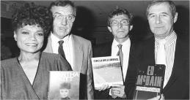

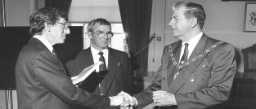

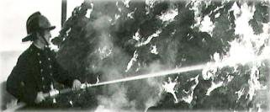

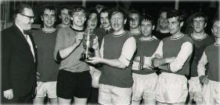

|  |
| --- |
|  |
|  |
|  |
|  |
|  |
|  |
|  |
|  |
|  |
|  |
|  |
|  |
|  |
|  |
|  |
|  |
|  |
|  |

He is an accomplished photographer, who has been invited to show his photographs in art galleries   
across the United States, including the Philadelphia Art Museum and the Cortland Jessup Art Gallery   
in Provincetown, Cape Cod. One spectacular photograph of [**Princess Diana and Prince Charles**](http://www.colinandrews.net/Photos-Misc.html)   
on their honeymoon was presented to the Queen and to this day also hangs in the Mayors Parlour at   
Romsey, England - the home town of Prince Charles uncle, Lord Louis Mountbatten of Burma.  
  
Colin Andrews, [electrical engineer](http://www.colinandrews.net/Biography-02.html) by profession, is the man who coined the term ‘Crop Circle’.   
Among his many accomplishments: he started the first research organization, Circles Phenomenon   
Research (CPR); designed [high-tech surveillance operations](http://www.colinandrews.net/Biography-03.html) attempting to film a circle being made;   
and advised Prime Minister Margaret Thatcher’s cabinet and Queen Elizabeth on the mysterious   
phenomenon. He compiled the largest data base in the world on the subject.  Colin has written   
numerous books including the classic [*Circular Evidence*](http://www.archivehousemedia.com) (1989) with co-author Pat Delgado, chosen   
by the Queen for her prestigious Summer Reading List. He is frequently highlighted in documentaries   
on the subject and was a consultant with the Mel Gibson movie Signs. His most recent books include   
[*The Complete Idiots Guide to 2012*](http://www.colinandrews.net/Store.html) and [*The Complete Idiots Guide to the Akashic Record*](http://www.colinandrews.net/Store.html)   
written with his wife, [Dr. Synthia Andrews](http://www.andrewshealingarts.com/). He is currently making his archives available to the public   
in books such as [*Government Circles, The Andrews Catalogue and The Assessment.*](http://www.archivehousemedia.com)[**Presentations**](http://www.colinandrews.net/Presentations.html)He has spent 29 years making [**presentations**](http://www.colinandrews.net/Presentations.html) at universities, schools and public venues as well as   
participate in government meetings and brainstorming sessions.  He has been a consultant to   
international institutes in many countries.

|  |
| --- |
| For fifteen years Colin was a retained (volunteer) fireman in the  Hampshire Fire and Rescue Service in his home town of Andover,  England. |
| He played soccer and represented Hampshire County in  several cup finals and continued to play for several teams  over a number of years. He lost just one fight as a light  heavy-weight boxer in the Army Cadet Force. |

|  |
| --- |
| Colin was engaged by Test Valley Borough Council in 1974,  initially as head of their Electrical operations. He went through  a series of rapid promotions into middle management, ending his  career with government service as a senior officer. Seen here  saying goodbye to the Mayor of the authority just before he  resigned to take up his research full-time in 1991. |

**Publications and cinema***Circular Evidence*, 1989.  Co-authored with Pat Delgado, this was the first book ever written on the   
subject.  It became an international best seller. It was also chosen by Queen Elizabeth for her   
prestigious "Summer Reading List", the first time a book of this kind has ever been selected.    
*Crop Circles: The Latest Evidence* , 1990, was also co-authored with Pat Delgado, this was the   
popular update to *Circular Evidence* and sold over 100,000 copies in Europe alone.  
[*Crop Circles – Signs of Contac*](http://www.colinandrewsarchives.com/STORE)*t*,  2003,  co-written with New York Times best selling author,   
[Steve Spignesi](http://www.stephenspignesi.com/) covering new aspects of the research. The book includes a full catalogue of crop   
patterns recorded by Colin between 1983 and 2003, which has also been self published separately   
and called *The Andrews Catalogue*. May 2009 his book [*Government Circles*](http://www.colinandrewsarchives.com/STORE) was published by   
Archive Publishing. *Undeniable Evidence*- 1990, the first crop circle video ever produced, which   
showed stunning aerial footage of the phenomenon, and links the mystery to eco-political changes.  
*The Truth About Crop Circles* – 1995, the live presentation made at Madison Square Garden, New   
York. Andrews was consultant for Mel Gibson’s [Disney block buster movie  *Signs*](http://today.msnbc.msn.com/id/3077371/); and Marcus   
Thompson’s British movie [*A Place to Stay*](http://www.bbc.co.uk/wiltshire/entertainment/films_and_tv/aplacetostay.shtml) which was shown at the Cannes Film Festival in 2002.  
Circular Evidence the Movie: [Renegade Pictures](http://www.renegadepictures.us/). This movie is under contract and tells a story based   
on the deeply moving experiences Colin has had while researching the mystery.  His research has   
profoundly affected all aspects of his personal life and career, as well as deeply impacting member’s of   
his family. Colin and his wife Dr. Synthia Andrews,  co-authored the new book ['The Complete Idiots   
Guide to 2012](http://www.colinandrews.net/2012-book.html) for  [Alpha books.](http://us.penguingroup.com/static/html/cig/index.html) It was published in various countries in October 2008. A second   
book in the famous series is due out in July 2010 called [The Complete Idiots Guide to The Akashic   
Record](http://www.amazon.com/Complete-Idiots-Guide-Akashic-Record/dp/1592579965/ref=sr_1_1?ie=UTF8&s=books&qid=1275963759&sr=1-1-spell).  
  
[**Media**](http://www.colinandrews.net/Media_Coverage.html)Andrews has appeared on numerous well known [television and radio](http://www.colinandrews.net/Media_Coverage.html) programs around the world   
including 60 Minutes, 20-20 with Barbara Walters, Good Morning America, Sightings, Unsolved   
Mysteries with Robert Stack, Coast To Coast with Art Bell, [Histories Mysteries](http://www.colinandrews.net/VideoPage02.html), The Shirley   
Maclaine Show, Dan Aykroyd’s Out There, The Sally Jessy Raphael Show, BBC's Daytime Live,   
The Ray Martin Show, National Geographic, Nippon TV’s Thursday Special, The Gloria Hunniford   
Show, History v Hollywood, American Movie Classics with Mel Gibson and M. Night Shyamalan,   
CNN Live Today, The Learning Channel's Looking for a Sign, Discovery one hour special, [CBS](http://www.colinandrews.net/VideoPage02.html)   
Gateway to the Unknown and many more.  He has [lectured extensively](http://www.colinandrews.net/Presentations.html) throughout the world to a   
wide range of audiences including the special interest group 'U.N.S.R.C..'  at the United Nations, and   
The Hakui Museum Project in Japan.

*"*[*The Toby Award*](http://www.colinandrews.net/Biography-TobyAward.html)*"* from New Heaven New Earth for his 'honesty and perseverance’ in the face of   
character assassination during his research of the Oliver's Castle video,.  The video showed a crop   
circle being made by UFO’s and was claimed by many to be genuine.  Colin’s investigation revealed   
it to be an elaborate hoax, intended to undermine the genuine crop circle mystery.  
  
*'EBE Film Award'* for the movie *"UFOs, Crop Formations and the Paranormal: The Secrets   
Unfold as Time Runs Out* at the IUFOC Film Awards in 1995: Producer, Reg Presley, featuring   
Colin Andrews, Reg Presley and Busty Taylor.  
  
September, 2002  *The* [*Maverick Award*](http://www.colinandrews.net/Presentations.html) from the Bay Area UFO Congress for pioneering scientific   
research into the Crop Circles.  
  
The 2009 Paradigm Research Group *'*[*Lifetime Achievement Award*](http://www.colinandrews.net/UFO-PRG-Awards2009.html)*' - Hall of Fame Inductee,*   
presented in Washington D.C.  
  
February 2012 at Scottsdale, Arizona, *' The Lifetime Achievement Award'* by Open Minds TV at   
the International UFO Congress, one of the largest of its kind in the world.

|  |
| --- |
|  |
|  |

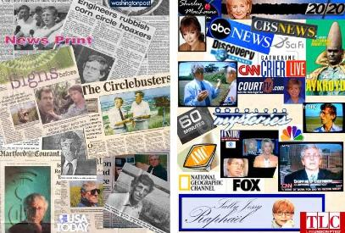

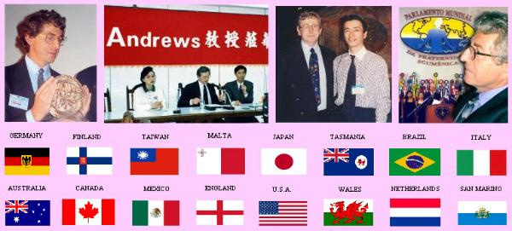

|  |
| --- |
|  |
|  |

Colin and Synthia have been invited to work with The World Genesis Foundation in corporation with   
The United Nations Educational, Scientific and Cultural Organization - [To Support UNESCO Youth   
Project in Romania](http://www.worldgenesis.org/press-2010-05-24.html).  
  
Colin is writing two new books, one of which is a novel and has taken part in several recent   
television interviews, both of which will be transmitted on International networks  - details soon.  
  
Colin is also a professional photographer, having shown in art galleries across the United States. His   
photographs have appeared in numerous television programs, magazines, newspapers, etc.   He uses   
his photography to highlight the importance of nature and the dire need for preservation and   
conservation on our planet.  
  
Synthia his wife, has just completed writing another book which she and many others, including Colin   
are very excited about. Called [*The Path of Energy*](http://andrewshealingarts.com/Path-Of-Energy.html) encompasses much of her life's work and has   
arrived at a unique time in history when science is now able to relate and support it.  The book will   
be published in June 2011 and has received powerful endorsements by well known and highly   
respected pioneers such as Astronaut [Dr. Edgar Mitchell](http://www.jsc.nasa.gov/Bios/htmlbios/mitchell-ed.html), [Dr. James Hurtak, Dr. Desiree Hurtak](http://www.youtube.com/watch?v=j715EL5IWz0),   
[Gregg Braden](http://www.greggbraden.com/about/) and [Dannion Brinkley](http://www.dannion.com/). The forward is written by [Barbara Marciniak.](http://www.youtube.com/watch?v=QmwarZQnVEA)Colin and his wife Synthia reside on a small farm in rural Connecticut.

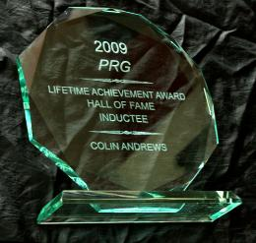

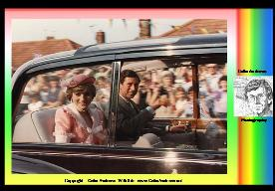

|  |
| --- |
| **Photographer** |
| One of Colin's favourite photographs, taken of Princess  Diana and Prince Charles arriving on their honeymoon in  Romsey, Hampshire, England. |

|  |
| --- |
| [**Media**](http://www.colinandrews.net/Media_Coverage.html) **Appearances** |
| [**Presentations**](http://www.colinandrews.net/Presentations.html) **throughout the world** |

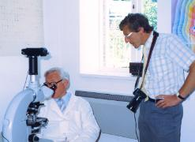

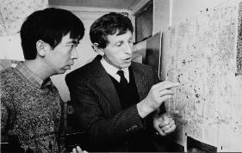

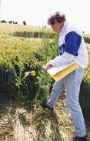

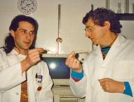

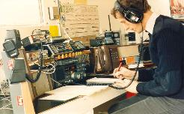

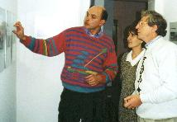

|  |
| --- |
| **Principal Websites and Bloggs** |

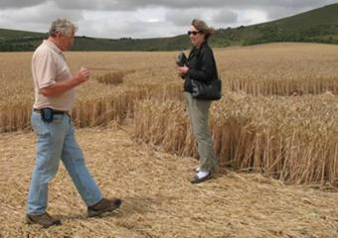

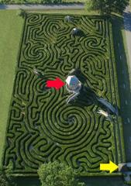

Without prior knowledge of why he had been invited to Longleat Adventure Park in   
England, he was lead to the center (red arrow) of the worlds longest maze which is one   
and three quarters mile long, handed his copper dowsing rods and asked to dowse his   
way to the exit (yellow arrow).  Without a single error his rods took him directly via   
many twists and turns to the exit.  With just one bend to go, he was told he was in the   
wrong place to test his confidence which he ignored and continued directly as the rods   
lead him to the exit. Colin worked with elders in the Australian outback and impressed   
them with his ability to confirm traditional routes taken by the Aborigine peoples   
hundreds of years ago. He has also successfully dowsed human involvement in crop   
circles.

One of many highly successful results of his   
remote viewing skills was when he identified a   
murderer in Washington DC before the police   
knew who they were looking for.  
  
The murderer became known as the *Beltway   
sniper*, who randomly killed ten people over a   
period of three weeks during October 2002,   
creating near panic along the I95 near the city.   
Apart from those he shot and killed he also   
critically injured three. On the night of October   
14th, 2002 while watching reports on TV of   
another shooting, Colin Remotely Viewed a   
young black man, 17years old, and sketched   
him near the edge of a parking lot, some   
distant from the victim.  When the police   
finally got their man, Colin's Sketch closely   
resembled that of the young 17 year old black   
man, Lee Boyd Malvo.  The incident Colin   
accessed was in the parking lot of Home   
Depot, in Fairfax County, Virginia where FBI   
intelligence analyst was shot dead as she left   
the store - killed by Lee Boyd Malvo *(watch   
video above)*. Colin has interacted with many of   
the best known Remote Viewers in the world,   
and was invited to participate in programs at   
the famous Monroe Institute in the United   
States.

|  |
| --- |
| **Experienced Dowser** |
| **Remote Viewer** |

|  |
| --- |
|  |

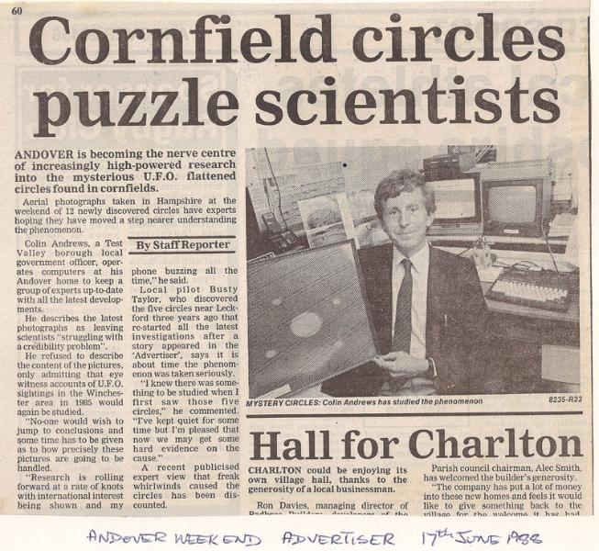

|  |
| --- |
| **Life Changing Experience** |

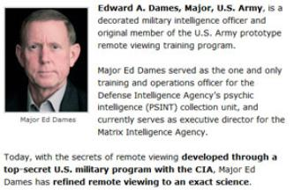

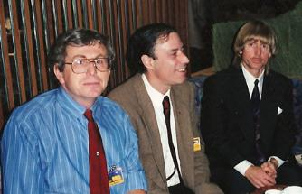

Left: Colin Andrews, Antonio Huneeus and Edward Dames in   
Dusseldorf, Germany where they spoke at an International Conference

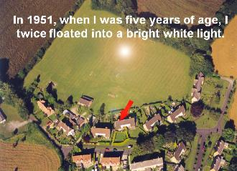

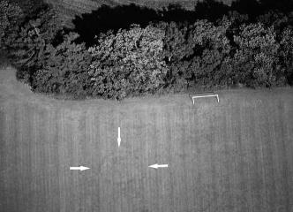

|  |
| --- |
| I was Five Years Old When A Bright White Light Appeared in the Field Behind my  House and Following a Strange Experience Blisters Appeared Over My Body. The  First Circle To Appear in my life Is Still There in the Field Today - [HERE](http://www.colinandrews.net/Dedication-MumDad-TheWhiteLightEnham.html) |

..........................................................

|  |
| --- |
| **PERSONAL MISSION** To expose truths in Politics,  Government and Business /  Promote [Environmental Awareness](http://www.colinandrews.net/2012-ClimateChange.html)  and Education / Illuminate the [Crop Circle](http://www.colinandrews.net/Crop_Circle_Research.html) & [UFO Phenomenon](http://www.colinandrews.net/UFO.html)./  Investigate [Consciousness](http://www.colinandrews.net/Consciousness.html) as an  energy field / Increase awareness  about the mistreatment of Animals  and to  [**Give our Children Hope.**](http://www.colinandrews.net/QuotationOfTheDay01.html) |

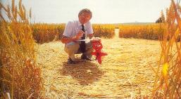

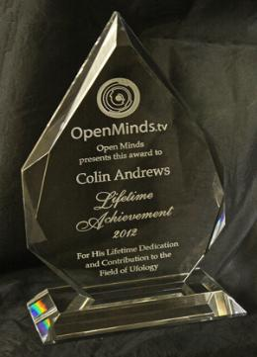

|  |
| --- |
| The award [ceremony](http://www.youtube.com/watch?v=b2gwFE61nfE) |
| ***Lifetime Achievement  Award 2012*** *Presented to COLIN ANDREWS By Open Minds  Lifetime Dedication and  Contribution to the Field  of Ufology* [***World's Largest UFO  Congress, Scottsdale,  Arizona, USA***](http://www.colinandrews.net/QuotationOfTheDay01.html) |

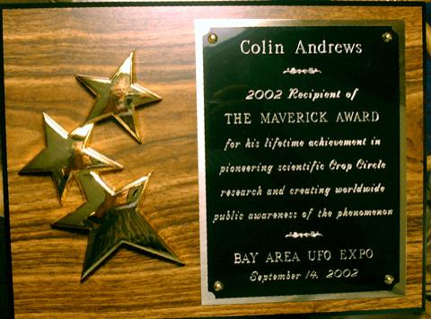

|  |
| --- |
|  |
|  |

|  |
| --- |
| COLIN ANDREWS  2002 Recipient of  THE MAVERICK  AWARD  for his liftetime  achievement in pioneering scientific Crop Circle research and creating worldwide public awareness of the phenomenon. - - - BAY AREA UFO  EXPO September 14, 2002 |
| Lifetime Achievement Award Presented following the short movie above |

|  |
| --- |
| SIDE NOTE  The two incidence that Colin  experienced when he was five  years old, and referred to in  this film can be seen [HERE](http://www.colinandrews.net/Dedication-MumDad-TheWhiteLightEnham.html) |

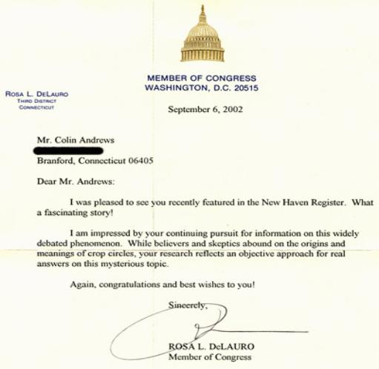

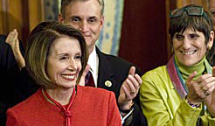

Nancy Pelosi and Rosa L. DeLauro - Congress 2009.

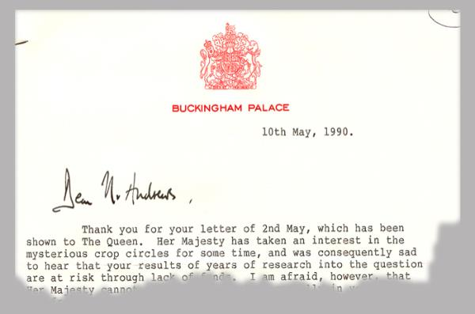

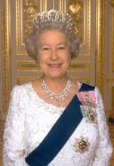

Her Majesty Queen Elizabeth.

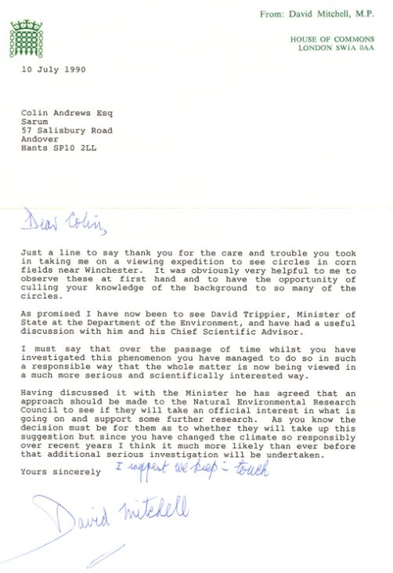

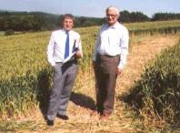

|  |
| --- |
| Colin Andrews with Sir David Mitchell  M.P.(member of the British Government)  in a  crop circle. |

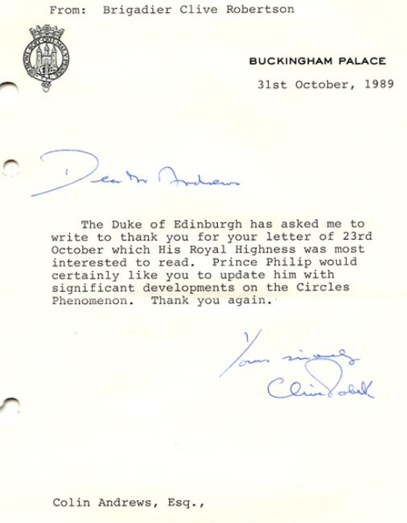

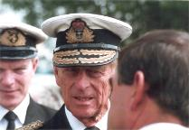

Duke of Edinburgh: Fascinated with the crop circles.

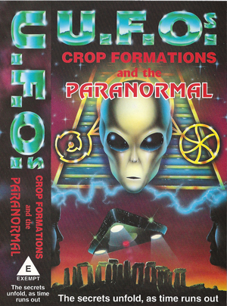

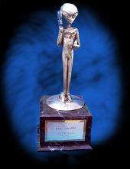

|  |
| --- |
| EBE Film Award - 1995 |
| EBE Film Award 1995 - Reg Presley, Colin Andrews and Busty Taylor |
|  |

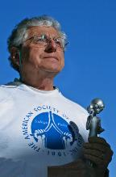

==========================================================================================

END