**John Alva Keel** (born **Alva John Kiehle)** 1930 – 2009

<http://en.wikipedia.org/wiki/John_Keel>

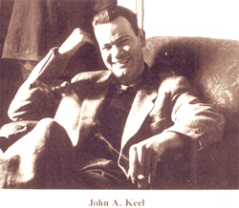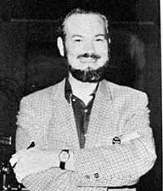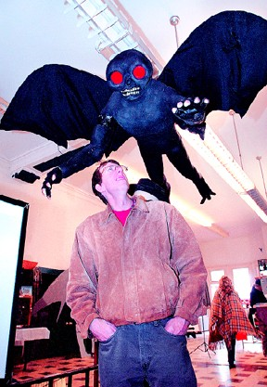

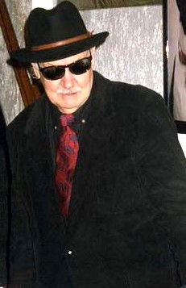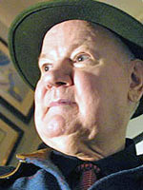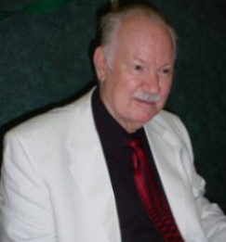

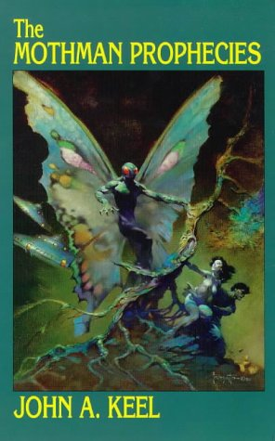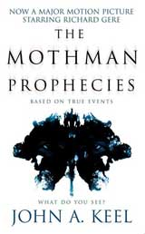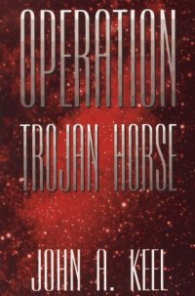

**John Alva Keel** (born **Alva John Kiehle** March 25, 1930 - July 3, 2009)[[1]](http://en.wikipedia.org/wiki/John_Keel" \l "cite_note-John_A._Keel_has_died-0) was a [Fortean](http://en.wikipedia.org/wiki/Fortean) author and professional [journalist](http://en.wikipedia.org/wiki/Journalist).

Keel wrote professionally from the age of 12, and was best known for his writings on [unidentified flying objects](http://en.wikipedia.org/wiki/Unidentified_flying_object), the "[Mothman](http://en.wikipedia.org/wiki/Mothman" \o "Mothman)" of [West Virginia](http://en.wikipedia.org/wiki/West_Virginia), and other [paranormal](http://en.wikipedia.org/wiki/Paranormal) subjects. Keel was arguably one of the most widely read and influential [ufologists](http://en.wikipedia.org/wiki/Ufology) since the early 1970s.[[2]](http://en.wikipedia.org/wiki/John_Keel#cite_note-JAHYNEK-1) Although his own thoughts about [UFOs](http://en.wikipedia.org/wiki/UFOs) and associated anomalous phenomena gradually evolved since the mid 1960s, Keel remained one of ufology's most original and controversial researchers. It was Keel's second book, *UFOs: Operation Trojan Horse* (1970), that popularized the idea that many aspects of contemporary UFO reports, including humanoid encounters, often paralleled ancient folklore and religious encounters. Keel coined the term "[men in black](http://en.wikipedia.org/wiki/Men_in_black)" to describe the mysterious figures alleged to harass UFO witnesses[[3]](http://en.wikipedia.org/wiki/John_Keel" \l "cite_note-2) and he also argued that there is a direct relationship between UFOs and [psychic phenomena](http://en.wikipedia.org/wiki/Psychic_phenomena). He did not call himself a ufologist and preferred the term [Fortean](http://en.wikipedia.org/wiki/Fortean), which encompasses a wide range of paranormal subjects.

|  |
| --- |
| **Contents**   * [1 Biography](http://en.wikipedia.org/wiki/John_Keel#Biography)   + [1.1 Early life and career](http://en.wikipedia.org/wiki/John_Keel#Early_life_and_career)   + [1.2 Initial UFO Investigations (1960s)](http://en.wikipedia.org/wiki/John_Keel#Initial_UFO_Investigations_.281960s.29)   + [1.3 Rejection of Extraterrestrial hypothesis](http://en.wikipedia.org/wiki/John_Keel#Rejection_of_Extraterrestrial_hypothesis)   + [1.4 The Mothman Prophecies](http://en.wikipedia.org/wiki/John_Keel#The_Mothman_Prophecies)   + [1.5 Health](http://en.wikipedia.org/wiki/John_Keel#Health) * [2 Bibliography](http://en.wikipedia.org/wiki/John_Keel#Bibliography) * [3 Notes](http://en.wikipedia.org/wiki/John_Keel#Notes) * [4 External links](http://en.wikipedia.org/wiki/John_Keel#External_links) |

**Biography**

**Early life and career**

Keel's first published story was in a magician's magazine at the age of 12. He later moved to [Greenwich Village](http://en.wikipedia.org/wiki/Greenwich_Village) and wrote for various magazines.[[4]](http://en.wikipedia.org/wiki/John_Keel#cite_note-3). He was [drafted](http://en.wikipedia.org/wiki/Conscription) into the [United States Army](http://en.wikipedia.org/wiki/United_States_Army) during the [Korean War](http://en.wikipedia.org/wiki/Korean_War), but served in [Frankfurt, Germany](http://en.wikipedia.org/wiki/Frankfurt,_Germany) on the staff of the [Armed Forces Network](http://en.wikipedia.org/wiki/Armed_Forces_Network). He was then employed as a press correspondent for several years, before resigning to tour [Egypt](http://en.wikipedia.org/wiki/Egypt) and the [Middle East](http://en.wikipedia.org/wiki/Middle_East). His first published book, *Jadoo* (1957), was serialised in a [men's adventure magazine](http://en.wikipedia.org/wiki/Men%27s_adventure_magazine). *Jadoo* details Keel's travels to [India](http://en.wikipedia.org/wiki/India) to investigate the alleged activities of [fakirs](http://en.wikipedia.org/wiki/Fakir) and holy men who perform the [Indian rope trick](http://en.wikipedia.org/wiki/Indian_rope_trick) and who survive being [buried alive](http://en.wikipedia.org/wiki/Buried_alive).

**Initial UFO Investigations (1960s)**

Influenced by writers such as [Charles Fort](http://en.wikipedia.org/wiki/Charles_Fort), [Ivan Sanderson](http://en.wikipedia.org/wiki/Ivan_Sanderson), and [Aimé Michel](http://en.wikipedia.org/w/index.php?title=Aim%C3%A9_Michel&action=edit&redlink=1), in early 1966, John Keel commenced a full-time investigation of UFOs and paranormal phenomena. Over a four-year period, Keel interviewed thousands of people in over twenty U.S. states. He read over 2,000 books in the course of this investigation, in addition to thousands of magazines, newsletters, and newspapers. Keel also subscribed to several newspaper-clipping services, which often generated up to 150 clippings for a single day during the 1966 and 1967 UFO "wave". Keel wrote for several magazines including [*Saga*](http://en.wikipedia.org/w/index.php?title=Saga_%28magazine%29&action=edit&redlink=1) with one 1967 article *UFO Agents of Terror* referring to the [Men in Black](http://en.wikipedia.org/wiki/Men_in_Black).[[5]](http://en.wikipedia.org/wiki/John_Keel#cite_note-4)

**Rejection of Extraterrestrial hypothesis**

Like contemporary 1960s researchers such as [J. Allen Hynek](http://en.wikipedia.org/wiki/J._Allen_Hynek) and [Jacques Vallée](http://en.wikipedia.org/wiki/Jacques_Vall%C3%A9e), Keel was initially hopeful that he could somehow validate the prevailing extraterrestrial visitation hypothesis. However, after one year of investigations, Keel concluded that the extraterrestrial hypothesis was untenable. Indeed, both Hynek and Vallée eventually arrived at a similar conclusion. As Keel himself wrote:

I abandoned the [extraterrestrial hypothesis](http://en.wikipedia.org/wiki/Extraterrestrial_hypothesis) in 1967 when my own field investigations disclosed an astonishing overlap between [psychic](http://en.wikipedia.org/wiki/Psychic) phenomena and UFOs... The objects and apparitions do not necessarily originate on another planet and may not even exist as permanent constructions of matter. It is more likely that we see what we want to see and interpret such visions according to our contemporary beliefs.[[6]](http://en.wikipedia.org/wiki/John_Keel#cite_note-5)

In *UFOs: Operation Trojan Horse* Keel argues that a non-human or spiritual intelligence source has staged whole events over a long period of time in order to propagate and reinforce certain erroneous belief systems. For example, the [fairy](http://en.wikipedia.org/wiki/Fairy) faith in Middle Europe, [vampire](http://en.wikipedia.org/wiki/Vampire) legends, [mystery airships](http://en.wikipedia.org/wiki/Mystery_airship) in 1897, mystery aeroplanes of the 1930s, mystery helicopters, anomalous creature sightings, [poltergeist](http://en.wikipedia.org/wiki/Poltergeist) phenomena, balls of light, and [UFOs](http://en.wikipedia.org/wiki/Unidentified_flying_object). Keel conjectured that ultimately all of these anomalies are a cover for the real phenomenon.

In *Our Haunted Planet,* Keel coined the term "Ultraterrestrials" to describe the UFO occupants. He discussed the seldom-considered possibility that the alien "visitors" to Earth are not visitors at all, but an advanced Earth civilization, which may or may not be human.

Keel took no position on the ultimate purpose of the phenomenon other than that the UFO intelligence seems to have a long-standing interest in interacting with the human race.

**The Mothman Prophecies**

In 1975, Keel published [*The Mothman Prophecies*](http://en.wikipedia.org/wiki/The_Mothman_Prophecies), an account of his 1966-1967 investigation of sightings of the [Mothman](http://en.wikipedia.org/wiki/Mothman), a strange winged creature reported in and around [Point Pleasant](http://en.wikipedia.org/wiki/Point_Pleasant,_West_Virginia), [West Virginia](http://en.wikipedia.org/wiki/West_Virginia).

The book was loosely adapted into a [2002 movie](http://en.wikipedia.org/wiki/The_Mothman_Prophecies_%28film%29), starring [Richard Gere](http://en.wikipedia.org/wiki/Richard_Gere), [Laura Linney](http://en.wikipedia.org/wiki/Laura_Linney) and [Alan Bates](http://en.wikipedia.org/wiki/Alan_Bates). Those two actors played two parts of Keel's personality. Bates's character was "Leek," which was "Keel" spelled backwards, and Gere's character worked for a newspaper, "John Klein," also a play on Keel's name.

In the May/June 2002 issue of [Skeptical Inquirer](http://en.wikipedia.org/wiki/Skeptical_Inquirer), journalist John C. Sherwood, a former business associate of UFO researcher [Gray Barker](http://en.wikipedia.org/wiki/Gray_Barker), published an analysis of private letters between Keel and Barker during the period of Keel's investigation. In the article, "Gray Barker's Book of Bunk," Sherwood reported finding significant differences between what Keel wrote at the time of his investigation and what he wrote in his first book about the Mothman reports, raising questions about the book's accuracy. Sherwood also reported that Keel, who was well known for writing humorous and outrageous letters to friends and associates, would not assist him in clarifying the differences thus raising doubts about Sherwood's supposition.

**Health**

On Friday October 13, 2006, Keel admitted himself to [New York City](http://en.wikipedia.org/wiki/New_York_City)'s Lenox Hill Hospital, having suffered a heart attack, and underwent successful heart surgery on October 16. Keel then was moved from the hospital to a rehabilitation center on October 26, according to his friend [Doug Skinner](http://en.wikipedia.org/wiki/Doug_Skinner) who remained in contact with him and who requested that well wishers contact Keel by mail in order to give him time to recover. Although annoyed by postings of his premature death, Keel continued to improve for some time. In early 2009, Keel moved into a nursing home near his apartment on the Upper West Side.

He died on July 3, 2009, at Mount Sinai Hospital in New York City, at the age of 79.[[1]](http://en.wikipedia.org/wiki/John_Keel#cite_note-John_A._Keel_has_died-0)

**Bibliography**

* *Jadoo* (1957)
* *UFOs: Operation Trojan Horse* (1970)
* *Strange Creatures From Time and Space* (1970)
* *Our Haunted Planet* (1971)
* *The Flying Saucer Subculture* (1973)
* [*The Mothman Prophecies*](http://en.wikipedia.org/wiki/The_Mothman_Prophecies) (1975)
* *The Eighth Tower* (1975)
* *Disneyland of the Gods* (1988)
* *The Complete Guide to Mysterious Beings* (1994) (revised version of *Strange Creatures from Time and Space*)
* *The Best of John Keel* (Paperback 2006) (Collection of Keel's Fate Magazine articles)

**Biography for John A. Keel**

Born Alva John Kiehle, John A Keel's fascinating life began on march 23, 1930, in Hornell NY. His parents divorced when he was very young and he was sent to live with his grandparents. When he was 10, he joined his mother and her new husband on a farm nearby Perry, NY.

Keels voracious curiosity manifested early, he read everything, particularly science, travel, humour and magic. When he was 12, he had one of his first brushes with the paranormal - an attic poltergeist that responded to his knocking. By the time he was 14, he was renting office space, writing a columns for the *Perry Herald*, publishing the school paper, and contributing to the magazines, all while working on the family farm. The 16, he was publishing a SF Fanzine, *The* *Lunarite*; and had sold a piece to *The New Yorker*.

In 1947, Keel packed a bag and hitch-hicked to Manhattan. He was soon active in the Greenwich Village scene, editing the magazine *Poets of American*, and writing fir the arts weekly *Limelight*. He also turned out comic books for superman creator Jerri Siegel, scripts for pioneer TV station WEBD, and countless magazine articles and shorts stories. In the 1950, John Keel worked for the department of the army as chief of continuity and production for the American Forces Network (AFN) in Frankfurt, Germany - the world's largest radio network.

In 1952 he wrote and produces the radio program *Things in the Sky*, about unidentified flying objects, which was heard by millions throughout Europe. His broadcast locations ranged from Frankenstein's Castle in Germany to the Great Pyramid of Giza in Egypt. For the next few ears, Keel travelled through the middle East, supporting himself by articles sent back to the U. S. . he spotted a UFO in Egypt and, possibly, Yeti in Sikkim. Interviewed snake charmers, filmed street magicians, and learned the indian ripe trick. He was finally deported as an adventurer in Singapore, he moved to Barcelona and wrote up his experiences in his autobiography, *Jadoo* (Hindi word for Magic).

Keel then re-entered the worlds of television and radio. He provided ad-libs for Merv Griffin, wrote for game shows, and completed 200 episodes of the slapstick series *Mack and Meyer for Hire*. He was head writer for a station WPIX in New York, and he worked in Hollywood, contributing scripts to *Get Smart*, *The Monkeys*, *Lost in Space*; and other shows. In 1965, and editor at *Playboy* asked for the "definitive" UFO article. For the next few years, Keel pursued the subject, interviewing witnesses and investigating reports across the country. The phenomenon, he learned, was not a passive one. He entered a shadowy world where black cars disappeared on country roads, meaningless messages turned up in hotel rooms, and his phone and mail suffered increasingly strange interception.

In 1966, he repeatedly visited Point Pleasant, WV, then the site of a particularly lively UFO and monster flap; the result of was one of his most popular books, *The Mothman Prophecies* (1975). **Tor Books**is produced to be bringing this cult classic back into print in February 2002, to coincide with the Screen Gems movie production starring Richard Gere. For many years, John Keel wrote a syndicated newspaper columns that appeared in major dailies throughout the world, and countless magazine articles that appeared in nearly every leading periodical. His monthly column "Modern Mysteries" ran in *Saga magazine* for ten years. He was editor and publisher of *Anomaly*, a newsletter devoted to scientific mysteries, and served on the Board of Directors of the Society for the Investigations of the Unexplained (S.I.T.U.), founded by Ivan T. Sanderson. He was also the editor of the Society's journal, *Pursuit*.

In 1970s, John A Keel lived in Woodstock and then New York City, and received his private pilot license. He was recently the subject of *Secrets of the Shadow World*, a feature-length documentary film by director George Kuchar that premiered at the 2000 New York Video Festival at Lincoln Center'sWalter Reade Theater.

His extensive television appearances include Johnny Carson, Jack Paar, Hugh Downs and David Letterman. Currently, John A. Keel contributes to many major publications. He is looking forward to the January 25th, 2002 release of the "Mothman Prophecies" movie based on his book and starring Richard Gere as "John Klein". He lives in Manhattan.

**Keel's Bookshelf selection**

Arguably he world's foremost researcher into the paranormal, John A Keel has travelled extensively to over forty countries investigating the unknown for almost fifty years. He is the author of thirty groundbreaking books that have bee published in over twenty countries and include many of ufologist's most acclaimed titles:

*Jadoo*. 1957, Julian Messner, NY, NY. "The Astounding Story of One Man's Search into the Mysteries of Black Magic in the Orient." UK edition by W.H. Allen, 1958;

*The Fickle Finger of Fate*. 1966, Fawcet Publications, Greenwich, CT. "A Camp Classic-For Adults only" The adventure of the Satyr-Man, with illustrations by MAD's Al Jafee.

*Strange Creatures from Time and Space*. 1970, FAWCETT Publications. A round-up of monsters, aliens and other "ambling nightmares". Reprinted by Global Communications, NY, NY1984, as Strange Mutants; by Illuminet Press, Lilburn, GA, 1994, as The Complete Guide to Mysterious Beings.

*UFOs: Operation Trojan Horse*. 1970, Putnam's NY, NY. A detailed study of UFOs; suggests they are "material apparitions" controlled by "cosmic jokers." UK edition by Abacus, 1973; reprinted by Iluminet Press, 1996. Reprinted by Manor, 1976, as Why UFOs.

*Our Haunted Planet*. 1971, Fawcett Publications. On a variety of Fortean topics, with an emphasis to the "Revolution of the Mind."

*How to Build and Atom Bomb in Your Basement and Become the First Kid on Your Block to Take Over the World*. 1073, Lancer Books. A satire on the arms race.

*The Mothman Prophecies*. 1975, Saturday Review Press, NY, NY. What was happening in Point Pleasant, anyway? UK edition by Panther, 1976, as Visitors from Space.

*The Eight Tower*. 1975, Saturday Review Press. "The Cosmic Force Behind All Religious Occult and UFO Phenomena." UK edition by Panther, 1978, as The Cosmic Question.

*Disneyland of the Gods*. 1988, Amok Press, NY, NY. "An Investigation into Psychic Phenomena and the Outer Limits of Human Perception." Drawn mostly from Saga columns.