**Zecharia Sitchin 1922-2010**

[**http://en.wikipedia.org/wiki/Zecharia_Sitchin**](http://en.wikipedia.org/wiki/Zecharia_Sitchin)

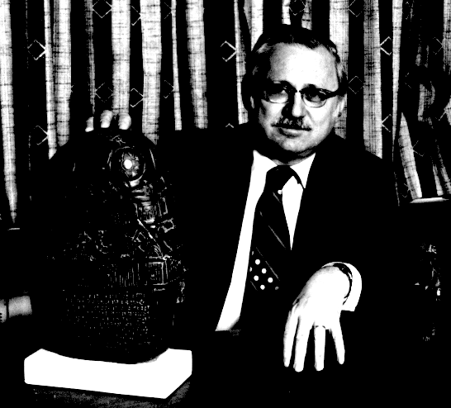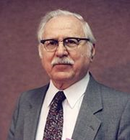

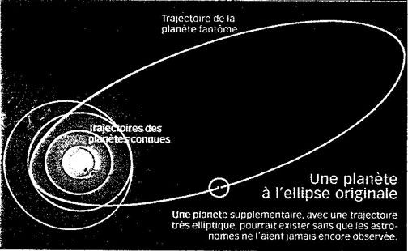 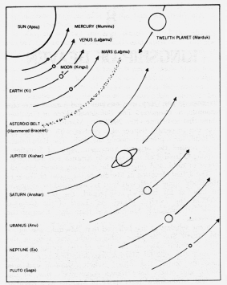

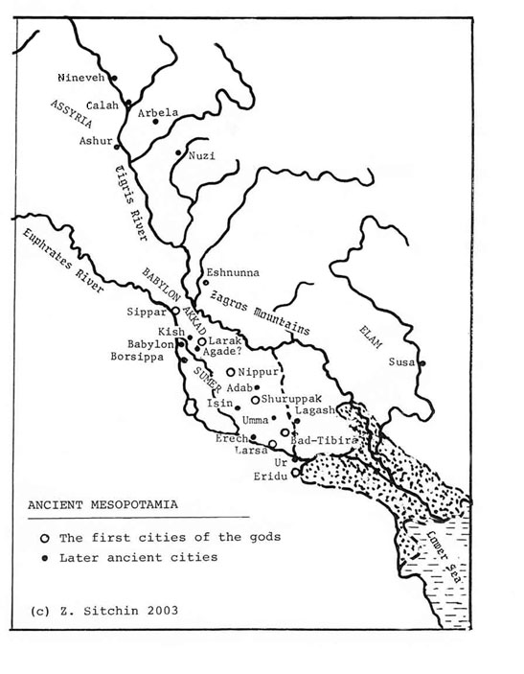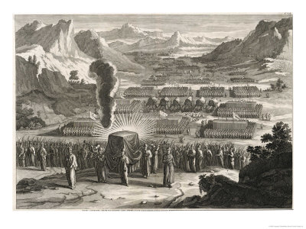

**Zecharia Sitchin** (July 11, 1920 – October 9, 2010)[[1]](http://en.wikipedia.org/wiki/Zecharia_Sitchin#cite_note-0) is an author of books promoting an explanation for human origins involving [ancient astronauts](http://en.wikipedia.org/wiki/Ancient_astronauts), amidst other aspects of [pseudoscience](http://en.wikipedia.org/wiki/Pseudoscience).

Sitchin attributes the creation of the ancient [Sumerian](http://en.wikipedia.org/wiki/Sumeria) culture to the "[Anunnaki](http://en.wikipedia.org/wiki/Anunnaki)" (or "[Nephilim](http://en.wikipedia.org/wiki/Nephilim)"), a race of aliens from a [planet](http://en.wikipedia.org/wiki/Planet) he calls [*Nibiru*](http://en.wikipedia.org/wiki/Nibiru_%28hypothetical_planet%29), which he believes to be in an elongated, elliptical orbit in the [Earth](http://en.wikipedia.org/wiki/Earth)'s own [Solar System](http://en.wikipedia.org/wiki/Solar_System) and asserts that [Sumerian mythology](http://en.wikipedia.org/wiki/Sumerian_mythology) reflects this view.

His speculations are entirely discounted by professional [scientists](http://en.wikipedia.org/wiki/Scientist), [historians](http://en.wikipedia.org/wiki/Historian), and [archaeologists](http://en.wikipedia.org/wiki/Archaeologist), who note many problems with his translations of ancient texts and with his understanding of physics.[[2]](http://en.wikipedia.org/wiki/Zecharia_Sitchin#cite_note-1)

|  |
| --- |
| **Contents**   * [1 Life](http://en.wikipedia.org/wiki/Zecharia_Sitchin#Life) * [2 Ideas](http://en.wikipedia.org/wiki/Zecharia_Sitchin#Ideas) * [3 Criticisms](http://en.wikipedia.org/wiki/Zecharia_Sitchin#Criticisms) * [4 Influence](http://en.wikipedia.org/wiki/Zecharia_Sitchin#Influence) * [5 See also](http://en.wikipedia.org/wiki/Zecharia_Sitchin#See_also) * [6 Bibliography](http://en.wikipedia.org/wiki/Zecharia_Sitchin#Bibliography)   + [6.1 DVDs](http://en.wikipedia.org/wiki/Zecharia_Sitchin#DVDs) * [7 References](http://en.wikipedia.org/wiki/Zecharia_Sitchin#References) * [8 External links](http://en.wikipedia.org/wiki/Zecharia_Sitchin#External_links)   + [8.1 Criticisms](http://en.wikipedia.org/wiki/Zecharia_Sitchin#Criticisms_2) |

**Life**

Sitchin was born in [Baku](http://en.wikipedia.org/wiki/Baku), [Azerbaijan](http://en.wikipedia.org/wiki/Azerbaijan), and was raised in [Palestine](http://en.wikipedia.org/wiki/Palestine). He acquired some knowledge of modern and ancient [Hebrew](http://en.wikipedia.org/wiki/Hebrew), other [Semitic](http://en.wikipedia.org/wiki/Semitic) and European languages, the [Old Testament](http://en.wikipedia.org/wiki/Old_Testament), and the history and archeology of the [Near East](http://en.wikipedia.org/wiki/Near_East). Sitchin graduated from the [London School of Economics](http://en.wikipedia.org/wiki/London_School_of_Economics), [University of London](http://en.wikipedia.org/wiki/University_of_London), majoring in [economic history](http://en.wikipedia.org/wiki/Economic_history). A [journalist](http://en.wikipedia.org/wiki/Journalist) and editor in [Israel](http://en.wikipedia.org/wiki/Israel) for many years, he now lives and writes in [New York City](http://en.wikipedia.org/wiki/New_York_City). His books have been widely translated, converted to [braille](http://en.wikipedia.org/wiki/Braille) for the blind, and featured on radio and television.

**Ideas**

According to Sitchin's interpretation of Sumerian [cosmology](http://en.wikipedia.org/wiki/Cosmology), there is an [undiscovered planet](http://en.wikipedia.org/wiki/Hypothetical_planet) which follows a long, elliptical orbit, reaching the inner solar system roughly every 3,600 years. This planet is called [Nibiru](http://en.wikipedia.org/wiki/Nibiru) (the planet associated with the god [Marduk](http://en.wikipedia.org/wiki/Marduk) in [Babylonian](http://en.wikipedia.org/wiki/Babylonian) cosmology). According to Sitchin, Nibiru collided [catastrophically](http://en.wikipedia.org/wiki/Catastrophism) with Tiamat, another supposed planet located by Sitchin between [Mars](http://en.wikipedia.org/wiki/Mars) and [Jupiter](http://en.wikipedia.org/wiki/Jupiter). This collision supposedly formed the planet Earth, the [asteroid belt](http://en.wikipedia.org/wiki/Asteroid_belt), and the [comets](http://en.wikipedia.org/wiki/Comet). [Tiamat](http://en.wikipedia.org/wiki/Tiamat), as outlined in the [Enûma Elish](http://en.wikipedia.org/wiki/En%C3%BBma_Elish), is a goddess. According to Sitchin, however, Tiamat was what is now known as Earth. When struck by one of planet Nibiru's moons, Tiamat split in two. On a second pass Nibiru itself struck the broken fragments and one half of Tiamat became the asteroid belt. The second half, struck again by one of Nibiru's moons, was pushed into a new orbit and became today's planet Earth.

According to Sitchin, Nibiru was the home of a technologically advanced human-like [extraterrestrial](http://en.wikipedia.org/wiki/Extraterrestrial_life) race called the [Anunnaki](http://en.wikipedia.org/wiki/Anunnaki) in Sumerian myth, who Sitchin states are called the [Nephilim](http://en.wikipedia.org/wiki/Nephilim) in [Genesis](http://en.wikipedia.org/wiki/Book_of_Genesis). He claims they first arrived on Earth probably 450,000 years ago, looking for minerals, especially [gold](http://en.wikipedia.org/wiki/Gold), which they found and mined in [Africa](http://en.wikipedia.org/wiki/Africa). These "gods" were the rank and file workers of the colonial expedition to Earth from planet Nibiru. Sitchin believes the Anunnaki genetically engineered [*Homo sapiens*](http://en.wikipedia.org/wiki/Homo_sapiens) as slave creatures to work their gold mines by crossing extraterrestrial genes with those of [*Homo erectus*](http://en.wikipedia.org/wiki/Homo_erectus). Sitchin claims ancient inscriptions report that human civilization in [Sumer](http://en.wikipedia.org/wiki/Sumer) of [Mesopotamia](http://en.wikipedia.org/wiki/Mesopotamia) was set up under the guidance of these "gods", and human [kingship](http://en.wikipedia.org/wiki/Monarchy) was inaugurated to provide intermediaries between mankind and the Anunnaki. Sitchin believes that [fallout](http://en.wikipedia.org/wiki/Nuclear_fallout) from [nuclear weapons](http://en.wikipedia.org/wiki/Nuclear_weapon), used during a war between factions of the extraterrestrials, is the "evil wind" that destroyed [Ur](http://en.wikipedia.org/wiki/Ur) around [2000 BC](http://en.wikipedia.org/wiki/2000_BC). Sitchin claims the exact year is 2024 BC. This event is described in the [Lament for Ur](http://en.wikipedia.org/wiki/Lament_for_Ur).[[3]](http://en.wikipedia.org/wiki/Zecharia_Sitchin#cite_note-2) Sitchin claims that his research coincides with many biblical texts, and that biblical texts come originally from Sumerian writings.

**Criticisms**

When Sitchin wrote his books, only specialists could read the Sumerian language, but now anyone can check his translations by utilizing the 2006 book *Sumerian Lexicon*.[[4]](http://en.wikipedia.org/wiki/Zecharia_Sitchin#cite_note-3) Sitchin's translations of both individual words and of larger portions of ancient texts are generally found to be incorrect.[[5]](http://en.wikipedia.org/wiki/Zecharia_Sitchin#cite_note-4)[[6]](http://en.wikipedia.org/wiki/Zecharia_Sitchin#cite_note-5)

Sitchin's "planetary collision" view does superficially resemble a theory which is seriously entertained by modern [astronomers](http://en.wikipedia.org/wiki/Astronomer) — the [giant impact theory](http://en.wikipedia.org/wiki/Giant_impact_theory) of the [Moon](http://en.wikipedia.org/wiki/Moon)'s formation about 4.5 billion years ago by a body impacting with the newly-formed Earth. However, Sitchin's proposed series of rogue planetary collisions differ in both details and timing. As with [Immanuel Velikovsky](http://en.wikipedia.org/wiki/Immanuel_Velikovsky)'s earlier *Worlds in Collision* thesis, Sitchin claims to have found evidence of ancient human knowledge of rogue celestial motions in a variety of mythological accounts. In Velikovsky's case, these interplanetary collisions were supposed to have taken place within the span of human existence, whereas for Sitchin these occurred during the early stages of planetary formation, but entered the mythological account passed down via the alien race which purportedly evolved on Nibiru after these encounters.

Sitchin's scenario for the creation of the Solar System is hard to reconcile with the Earth's current small [orbital eccentricity](http://en.wikipedia.org/wiki/Orbital_eccentricity) of only 0.0167. Sitchin's supporters maintain that it would explain Earth's peculiar early geography due to cleaving from the celestial collision, i.e., solid continents on one side and a giant ocean on the other.

The scenario outlined by Sitchin, with Nibiru returning to the inner solar system regularly every 3,600 years, implies an orbit with a semi-major axis of 235 Astronomical Units, extending from the asteroid belt to twelve times farther beyond the sun than Pluto. "Elementary perturbation theory indicates that, under the most favorable circumstances of avoiding close encounters with other planets, no body with such an eccentric orbit would keep the same period for two consecutive passages. Within twelve orbits the object would be either ejected or converted to a short period object. Thus, the failed search for a trans-Plutonian planet by [T.C. Van Flandern](http://en.wikipedia.org/wiki/Tom_Van_Flandern), then with the U.S. Naval Observatory, which Sitchin uses to bolster his thesis, is no support at all."[[7]](http://en.wikipedia.org/wiki/Zecharia_Sitchin#cite_note-Ellenberger.2C_C_1981._pp._3-4-6)[[8]](http://en.wikipedia.org/wiki/Zecharia_Sitchin#cite_note-7)

Sitchin claims that "from an equal start, the Nefilim evolved on Nibiru 45 million years ahead of comparable development on Earth with its decidedly more favorable environment. Such an outcome is unlikely, to say the least, since Nibiru would spend over 99% of its time beyond Pluto. Sitchin's explanation that heat from radioactive decay and a thick atmosphere keep Nibiru warm is absurd and does not address the problem of darkness in deep space. Also unexplained is how the Nefilim, who evolved long after Nibiru arrived, knew what happened when Nibiru first entered the solar system."[[7]](http://en.wikipedia.org/wiki/Zecharia_Sitchin#cite_note-Ellenberger.2C_C_1981._pp._3-4-6)

Sitchin bases his arguments on his personal interpretations of Pre-Nubian and Sumerian texts, and the seal VA 243. Sitchin claims these ancient civilizations knew of a 12th planet, when in fact they only knew five.[[9]](http://en.wikipedia.org/wiki/Zecharia_Sitchin#cite_note-autogenerated1-8) Hundreds of Sumerian astronomical seals and calendars have been decoded and recorded, and the total count of planets on each seal has been five. Seal VA 243 has 12 dots that Sitchin identifies as planets. When translated, seal VA 243 reads "You're his Servant" which is now thought to be a message from a nobleman to a servant. According to semitologist [Michael S. Heiser](http://en.wikipedia.org/wiki/Michael_S._Heiser), the so-called sun on Seal VA 243 is not the Sumerian symbol for the sun but is a star, and the dots are also stars.[[9]](http://en.wikipedia.org/wiki/Zecharia_Sitchin#cite_note-autogenerated1-8)[[10]](http://en.wikipedia.org/wiki/Zecharia_Sitchin#cite_note-9) The symbol on seal VA 243 has no resemblance to the hundreds of documented Sumerian sun symbols.

[Peter James](http://en.wikipedia.org/wiki/Peter_James_%28historian%29) has criticised him both for ignoring the world outside of Mesopotamia and more specifically for misunderstanding Babylonian literature:

|  |  |  |
| --- | --- | --- |
| **“** | He uses the Epic of Creation [Enuma Elish](http://en.wikipedia.org/wiki/Enuma_Elish) as the foundation for his [cosmogony](http://en.wikipedia.org/wiki/Cosmogony), identifying the young god [Marduk](http://en.wikipedia.org/wiki/Marduk), who overthrows the older regime of gods and creates the Earth, as the unknown "Twelfth Planet". In order to do as he interprets the Babylonian [theogony](http://en.wikipedia.org/wiki/Theogony) as a factual account of the birth of the other "eleven" planets. The Babylonian names for the planets are established beyond a shadow of a doubt--[Ishtar](http://en.wikipedia.org/wiki/Ishtar) was the deity of Venus, [Nergal](http://en.wikipedia.org/wiki/Nergal) of Mars, and Marduk of Jupiter -- and confirmed by hundreds of astronomical/astrological tables and treatises on clay tablets and papyri from the Hellenistic period. Sitchin merrily ignores all this and assigns unwarranted planetary identities to the gods mentioned in the theogony. For example, [Apsu](http://en.wikipedia.org/wiki/Abzu), attested as god of the primeval waters becomes, of all things, the Sun! [Ea](http://en.wikipedia.org/wiki/Enki), as it suits Sitchin, is sometimes planet Neptune and sometimes a spaceman. And the identity of Ishtar as the planet Venus, a central feature of Mesopotamian religion, is nowhere mentioned in the book--instead Sitchin arbitrarily assigns to Venus another deity from *Enuma Elish*, and reserves Ishtar for a role as a female astronaut.[[11]](http://en.wikipedia.org/wiki/Zecharia_Sitchin#cite_note-10) | **”** |

Similar ideas have been advanced by authors such as [Immanuel Velikovsky](http://en.wikipedia.org/wiki/Immanuel_Velikovsky), [Erich von Däniken](http://en.wikipedia.org/wiki/Erich_von_D%C3%A4niken), [Alan F. Alford](http://en.wikipedia.org/wiki/Alan_F._Alford) and [Laurence Gardner](http://en.wikipedia.org/wiki/Laurence_Gardner). Alford later recanted his views and became a critic of Sitchin's interpretation of myth.

Sitchin in “the case of Adam’s alien genes” [[12]](http://en.wikipedia.org/wiki/Zecharia_Sitchin#cite_note-11) claims that 223 unique genes found by the Human Genome Sequencing Consortium are without the required predecessors on the genomic evolutionary tree. Later researchers have argued that the conclusion from the Human Genome Sequencing Consortium can not be drawn due to a lack of a comprehensive gene database for comparison. An analysis by Salzberg identified 40 potential genes laterally transferred into the genome from prokaryotic organisms. Salzberg also argues that gene loss combined with sample size effects and evolutionary rate variation provide an alternative, more biologically plausible explanation.[[13]](http://en.wikipedia.org/wiki/Zecharia_Sitchin#cite_note-12)

**Influence**

[Raëlism](http://en.wikipedia.org/wiki/Ra%C3%ABlism), the [UFO religion](http://en.wikipedia.org/wiki/UFO_religion) founded by [Claude Vorilhon](http://en.wikipedia.org/wiki/Claude_Vorilhon), appropriated some of its beliefs from Sitchin's work,[[14]](http://en.wikipedia.org/wiki/Zecharia_Sitchin#cite_note-13) as does the [Nuwaubian](http://en.wikipedia.org/wiki/Nuwaubian) religion founded by [Dwight York](http://en.wikipedia.org/wiki/Dwight_York).[[*citation needed*](http://en.wikipedia.org/wiki/Wikipedia:Citation_needed)] [Zetatalk](http://en.wikipedia.org/wiki/Zetatalk), the internet cult founded by self-proclaimed [contactee](http://en.wikipedia.org/wiki/Contactee) Nancy Leider, describes "[Planet X](http://en.wikipedia.org/wiki/Planets_beyond_Neptune)", a large object they claim is about to hit Earth, as "Nibiru" in reference to Sitchin's claims. [David Icke](http://en.wikipedia.org/wiki/David_Icke) also draws on Sitchin's work in his [conspiracy theories](http://en.wikipedia.org/wiki/Conspiracy_theories).

**See also**

* [Panbabylonism](http://en.wikipedia.org/wiki/Panbabylonism)
* [Planet V](http://en.wikipedia.org/wiki/Planet_V)

**Bibliography**

* *The 12th Planet* (Earth Chronicles, No. 1), New York: [Harper](http://en.wikipedia.org/wiki/HarperCollins), 1976, [ISBN 038039362X](http://en.wikipedia.org/wiki/Special:BookSources/038039362X)
* *The Stairway to Heaven* (Earth Chronicles, No. 2), 1980, [Avon Books](http://en.wikipedia.org/wiki/Avon_Books) ([Bear & Company](http://en.wikipedia.org/wiki/Bear_%26_Company), 1992, [ISBN 0939680890](http://en.wikipedia.org/wiki/Special:BookSources/0939680890); Harper, 2007, [ISBN 0061379204](http://en.wikipedia.org/wiki/Special:BookSources/0061379204))
* *The Wars of Gods and Men* (Earth Chronicles, No. 3), 1985, Avon Books (Bear & Company, 1992, [ISBN 0939680904](http://en.wikipedia.org/wiki/Special:BookSources/0939680904))
* *The Lost Realms* (Earth Chronicles, No. 4), AVON BOOKS, 1990, [ISBN 0-380-75890-3](http://en.wikipedia.org/wiki/Special:BookSources/0380758903)
* *Genesis Revisited: Is Modern Science Catching Up With Ancient Knowledge?*, (AVON BOOKS, 1990, [ISBN 0-380-76159-9](http://en.wikipedia.org/wiki/Special:BookSources/0380761599))
* *When Time Began* (Earth Chronicles, No. 5), 1993), (HARPER, 2007, [ISBN 006137928X](http://en.wikipedia.org/wiki/Special:BookSources/006137928X), [ISBN 978-0061379284](http://en.wikipedia.org/wiki/Special:BookSources/9780061379284))
* *Divine Encounters: A Guide to Visions, Angels and Other Emissaries*, AVON BOOKS, 1995, [ISBN 0-380-78076-3](http://en.wikipedia.org/wiki/Special:BookSources/0380780763))
* *The Cosmic Code* (Earth Chronicles, No. 6), AVON BOOKS, 1998, [ISBN 0-380-80157-4](http://en.wikipedia.org/wiki/Special:BookSources/0380801574))
* *The Lost Book of Enki: Memoirs and Prophecies of an Extraterrestrial god*, Bear & Company, 2002, [ISBN 1591430372](http://en.wikipedia.org/wiki/Special:BookSources/1591430372)
* *The Earth Chronicles Expeditions*, Bear & Company, 2004, [ISBN 978-1591430766](http://en.wikipedia.org/wiki/Special:BookSources/9781591430766)
* *The End of Days: Armageddon and Prophecies of the Return (Earth Chronicles, No 7),* [*William Morrow*](http://en.wikipedia.org/wiki/William_Morrow_and_Company)*, 2007,* [*ISBN 978-0-06-123823-9*](http://en.wikipedia.org/wiki/Special:BookSources/9780061238239)
* *Journeys to the Mythical Past* (Earth Chronicles Expedition) Bear and Company, 2007 [ISBN 978-1591430803](http://en.wikipedia.org/wiki/Special:BookSources/9781591430803)

**DVDs**

* *Are We Alone in the Universe?* (based on *Genesis Revisited*), documentary, 1978 (2003 DVD release)[[15]](http://en.wikipedia.org/wiki/Zecharia_Sitchin#cite_note-14)

**References**

1. [**^**](http://en.wikipedia.org/wiki/Zecharia_Sitchin#cite_ref-0) Ronald Story, ed., *The Encyclopedia of Extraterrestrial Encounters*, (New York New American Library, 2001), s.v. "Zecharia Sitchin," pp. 552.
2. [**^**](http://en.wikipedia.org/wiki/Zecharia_Sitchin#cite_ref-1) "[Sitchin Zecharia Sitchin](http://skepdic.com/sitchin.html)". The Skeptic's Dictionary. <http://skepdic.com/sitchin.html> Sitchin. Retrieved 2009-09-18.
3. [**^**](http://en.wikipedia.org/wiki/Zecharia_Sitchin#cite_ref-2) [Evil Wind web page](http://www.sitchin.com/evilwind.htm)
4. [**^**](http://en.wikipedia.org/wiki/Zecharia_Sitchin#cite_ref-3) Halloran, John A. (2006). Sumerian Lexicon: A Dictionary Guide to the Ancient Sumerian Language. The David Brown Book Company.
5. [**^**](http://en.wikipedia.org/wiki/Zecharia_Sitchin#cite_ref-4) <http://www.sitchiniswrong.com/sitchinerrors.htm>
6. [**^**](http://en.wikipedia.org/wiki/Zecharia_Sitchin#cite_ref-5) <http://www.ianlawton.com/mes6c.htm> What's in a Shem?
7. ^ [***a***](http://en.wikipedia.org/wiki/Zecharia_Sitchin#cite_ref-Ellenberger.2C_C_1981._pp._3-4_6-0) [***b***](http://en.wikipedia.org/wiki/Zecharia_Sitchin#cite_ref-Ellenberger.2C_C_1981._pp._3-4_6-1) [Ellenberger, C. Leroy](http://en.wikipedia.org/wiki/C._Leroy_Ellenberger) 1981. Marduk Unmasked. *Frontiers of Science*, May-June, pp. 3-4.
8. [**^**](http://en.wikipedia.org/wiki/Zecharia_Sitchin#cite_ref-7) [Tom Van Flandern](http://en.wikipedia.org/wiki/Tom_Van_Flandern) on Coast to Coast a.m. radio program, June 25, 2008, in reply to question from host [George Noory](http://en.wikipedia.org/wiki/George_Noory).
9. ^ [***a***](http://en.wikipedia.org/wiki/Zecharia_Sitchin#cite_ref-autogenerated1_8-0) [***b***](http://en.wikipedia.org/wiki/Zecharia_Sitchin#cite_ref-autogenerated1_8-1) <http://www.michaelsheiser.com/va_243%20page.htm> The Myth of a 12th Planet in Sumero-Mesopotamian Astronomy: A Study of Cylinder Seal VA 243 by Dr. [Michael S. Heiser](http://en.wikipedia.org/wiki/Michael_S._Heiser)
10. [**^**](http://en.wikipedia.org/wiki/Zecharia_Sitchin#cite_ref-9) <http://www.michaelsheiser.com/VA243seal.pdf> The Myth of a 12th Planet: A Brief Analysis of Cylinder Seal VA 243 by [Michael S. Heiser](http://en.wikipedia.org/wiki/Michael_S._Heiser)
11. [**^**](http://en.wikipedia.org/wiki/Zecharia_Sitchin#cite_ref-10) James, Peter *SIS Workshop* no. 7, vol. 2, no. 2 (Nov. 1979), reprinted from *Fortean Times* no. 27 (Nov. 1978).
12. [**^**](http://en.wikipedia.org/wiki/Zecharia_Sitchin#cite_ref-11) [the case of Adam's alien genes](http://www.sitchin.com/adam.htm)
13. [**^**](http://en.wikipedia.org/wiki/Zecharia_Sitchin#cite_ref-12) Salzberg, Steven L. , Owen White, et al. “Microbial Genes in the Human Genome: Lateral Transfer or Gene Loss?”. Science 292.5523 (2001): 1903 – 3.
14. [**^**](http://en.wikipedia.org/wiki/Zecharia_Sitchin#cite_ref-13) [Carroll, RT](http://en.wikipedia.org/wiki/Robert_Todd_Carroll) (2008-05-11). "[Zecharia Sitchin and The Earth Chronicles](http://www.skepdic.com/sitchin.html)". [The Skeptic's Dictionary](http://en.wikipedia.org/wiki/The_Skeptic%27s_Dictionary). <http://www.skepdic.com/sitchin.html>. Retrieved 2008-12-31.
15. [**^**](http://en.wikipedia.org/wiki/Zecharia_Sitchin#cite_ref-14) [*Are We Alone in the Universe?*](http://www.imdb.com/title/tt0179649/) at the [Internet Movie Database](http://en.wikipedia.org/wiki/Internet_Movie_Database)

**External links**

|  |  |
| --- | --- |
|  | Wikiversity has learning materials about [***Zecharia Sitchin***](http://en.wikiversity.org/wiki/Special:Search/Zecharia_Sitchin) |

* [Official Website](http://www.sitchin.com/)

**Criticisms**

* [Zecharia Sitchin's Ancient Astronaut Theories - A Skeptical Archive](http://www.geocities.com/Area51/Corridor/8148/zindex.html)
* [Zecharia Sitchin's Errors: An Overview](http://www.sitchiniswrong.com/sitchinerrors.htm)
* [Zecharia Sitchin's World](http://jcolavito.tripod.com/lostcivilizations/id14.html)
* [Ian Lawton's Mesopotamia Papers](http://www.ianlawton.com/mesindex.htm)
* [An Astronomer's View of the Akkadian Seal by Tom van Flandern](http://www.lauralee.com/vanflan.htm)
* [Sitchin's Sumerian Astronomy Challenged](http://www.ramtops.co.uk/siren.html)