**Erich Anton Paul von Däniken 1935 –**

<http://en.wikipedia.org/wiki/Erich_von_D%C3%A4niken>

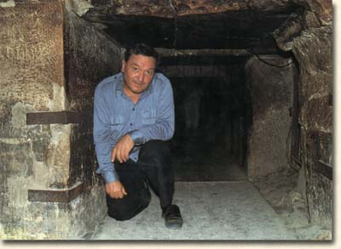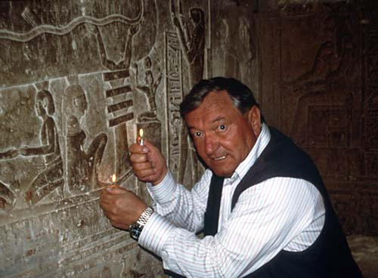

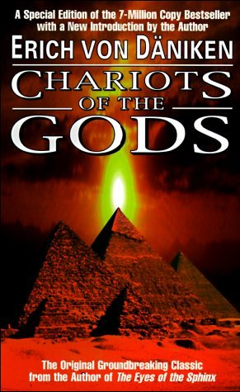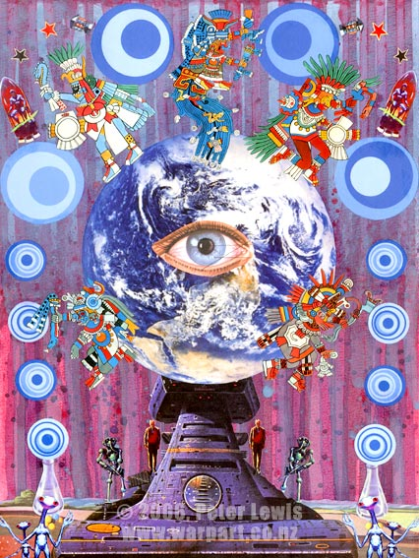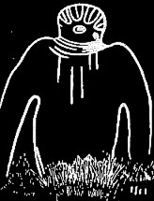

**Erich Anton Paul von Däniken** (b. [Zofingen](http://en.wikipedia.org/wiki/Zofingen), [Aargau](http://en.wikipedia.org/wiki/Aargau), [Switzerland](http://en.wikipedia.org/wiki/Switzerland), [April 14](http://en.wikipedia.org/wiki/April_14), [1935](http://en.wikipedia.org/wiki/1935)) is a controversial Swiss author best known for his books which examine possible evidence for [extraterrestrial](http://en.wikipedia.org/wiki/Extraterrestrial_life) influences on early human culture. Von Däniken is one of the key figures responsible for popularizing the [paleocontact](http://en.wikipedia.org/wiki/Paleocontact) and [ancient astronaut](http://en.wikipedia.org/wiki/Ancient_astronaut_theory) hypotheses.

Von Däniken is a co-founder of the [Archaeology, Astronautics and SETI Research Association](http://en.wikipedia.org/w/index.php?title=Archaeology%2C_Astronautics_and_SETI_Research_Association&action=edit&redlink=1) (AAS RA). He developed a [theme park](http://en.wikipedia.org/wiki/Theme_park) called [Mystery Park](http://en.wikipedia.org/wiki/Mystery_Park) in [Interlaken](http://en.wikipedia.org/wiki/Interlaken), [Switzerland](http://en.wikipedia.org/wiki/Switzerland), which opened on [May 23](http://en.wikipedia.org/wiki/May_23), [2003](http://en.wikipedia.org/wiki/2003) and closed on [November 19](http://en.wikipedia.org/wiki/November_19), [2006](http://en.wikipedia.org/wiki/2006).

His 26 books have been translated into more than 20 languages, selling more than 60 million copies worldwide, and his documentary TV shows have been viewed around the world. His influence can also be seen in [science fiction](http://en.wikipedia.org/wiki/Science_fiction), the [New Age](http://en.wikipedia.org/wiki/New_Age) culture and some modern religions [[1]](http://en.wikipedia.org/wiki/Erich_von_D%C3%A4niken#cite_note-Penny-0).

|  |
| --- |
| **Contents**  [1 Claims of alien influence on Earth](http://en.wikipedia.org/wiki/Erich_von_D%C3%A4niken#Claims_of_alien_influence_on_Earth)   * [2 Criticism](http://en.wikipedia.org/wiki/Erich_von_D%C3%A4niken#Criticism) * [3 Popularity](http://en.wikipedia.org/wiki/Erich_von_D%C3%A4niken#Popularity) * [4 Bibliography](http://en.wikipedia.org/wiki/Erich_von_D%C3%A4niken#Bibliography) * [5 Documentaries](http://en.wikipedia.org/wiki/Erich_von_D%C3%A4niken#Documentaries) * [6 See also](http://en.wikipedia.org/wiki/Erich_von_D%C3%A4niken#See_also) * [7 References](http://en.wikipedia.org/wiki/Erich_von_D%C3%A4niken#References) * [8 External links](http://en.wikipedia.org/wiki/Erich_von_D%C3%A4niken#External_links) |

**Claims of alien influence on Earth**

Building on previous works by other authors (including Italian [Peter Kolosimo](http://en.wikipedia.org/wiki/Peter_Kolosimo), who was later critical of von Däniken), von Däniken claimed that if intelligent extraterrestrial life exists and has entered the local Solar System in the past, then there is the possibility of finding traces of their visits on Earth, on neighboring planets, or elsewhere in space. He also supports the hypothesis that [human evolution](http://en.wikipedia.org/wiki/Human_evolution) may have been manipulated through means of [genetic engineering](http://en.wikipedia.org/wiki/Genetic_engineering) by extraterrestrial beings.

The evidence that von Däniken has put forward to support the paleo-contact hypotheses can be categorized as follows:

* Artifacts have been found which are alleged to represent a higher technological [knowledge](http://www.book-of-thoth.com/thebook/index.php/Image:Mynplane2.jpg) than is presumed to have existed at the times when they were manufactured. Von Däniken maintains that these artifacts have been manufactured either by extraterrestrial visitors, or by humans who obtained the necessary knowledge from them. Such artifacts include [Stonehenge](http://en.wikipedia.org/wiki/Stonehenge), the statues of [Easter Island](http://en.wikipedia.org/wiki/Easter_Island), the [Antikythera mechanism](http://en.wikipedia.org/wiki/Antikythera_mechanism), and the [Piri Reis map](http://en.wikipedia.org/wiki/Piri_Reis_map).
* In ancient art throughout the world, themes are observed which can be interpreted to illustrate astronauts, air and space vehicles, non-human but intelligent creatures, and artifacts of a high technology. Von Däniken also points out details that are similar in the art of unrelated cultures.
* Origins of religions might be a reaction to contact with an alien race by primitive humans. The humans considered the technology of the aliens to be [supernatural](http://en.wikipedia.org/wiki/Supernatural) and the aliens themselves to be [gods](http://en.wikipedia.org/wiki/God). According to von Däniken, the oral and literal traditions of most religions contain references to visitors from “stars” and vehicles traveling through air and space. These, he says, should be interpreted as literal descriptions which have changed during the passage of time and have become more obscure, rather than as symbolic or mythical fiction. One such is [Ezekiel](http://en.wikipedia.org/wiki/Ezekiel)’s revelation in the [Old Testament](http://en.wikipedia.org/wiki/Old_Testament), which he interprets as a detailed description of a landing spacecraft.

**Criticism**

Most in the scientific community have ignored or dismissed von Däniken’s hypotheses. A few scientists, such as [Carl Sagan](http://en.wikipedia.org/wiki/Carl_Sagan) and [I. S. Shklovskii](http://en.wikipedia.org/wiki/Iosif_Samuilovich_Shklovskii), have written about von Däniken’s [paleocontact](http://en.wikipedia.org/wiki/Paleocontact) and [extraterrestrial](http://en.wikipedia.org/wiki/Extraterrestrial_life) visitation claims. Although Sagan did not rule out the possibility of visitation, he insisted that such extraordinary assertions as von Däniken’s demand extraordinary proof without which it would be inappropriate to believe the claims.

Von Däniken claimed that a non-rusting [iron pillar](http://en.wikipedia.org/wiki/Iron_pillar_of_Delhi) in India was evidence of extraterrestrial influence.[[2]](http://en.wikipedia.org/wiki/Erich_von_D%C3%A4niken#cite_note-1) However, he admitted in a [*Playboy*](http://en.wikipedia.org/wiki/Playboy) interview[[3]](http://en.wikipedia.org/wiki/Erich_von_D%C3%A4niken#cite_note-2) that the pillar was actually rusty and man-made, and that as far as supporting his hypotheses goes “we can forget about this iron thing.” (Von Däniken did not invent the tale of the rust-free iron pillar in India: in 1935 [Will Durant](http://en.wikipedia.org/wiki/Will_Durant) inserted the same mistake in [*Our Oriental Heritage*](http://en.wikipedia.org/wiki/Our_Oriental_Heritage), p. 478) Neither von Däniken nor his publishers have removed this, or any other, discredited evidence from subsequent reprints of his books.

Ronald Story published [*The Space Gods Revealed*](http://en.wikipedia.org/wiki/The_Space_Gods_Revealed) in 1976, providing an almost page-by-page refutation of the hypotheses and evidence in von Däniken’s *Chariots of the Gods?*, although Story's book itself was deconstructed by a number of critics, including [Rocky Wood](http://en.wikipedia.org/wiki/Rocky_Wood).

**Popularity**

Von Däniken became popular in [India](http://en.wikipedia.org/wiki/India) during the 1970s, as a result of his books being translated into the [Bengali language](http://en.wikipedia.org/wiki/Bengali_language) by translator [Ajit Dutta](http://en.wikipedia.org/w/index.php?title=Ajit_Dutta&action=edit&redlink=1). School level students were the first major group of his believers in India. Von Däniken subsequently visited the [Kashmir](http://en.wikipedia.org/wiki/Kashmir) region of India to check for the presence of [radioactivity](http://en.wikipedia.org/wiki/Radioactivity) in an ancient temple, where he believed that a “spacecraft” had once landed. This was mostly covered by the Indian media in a critical manner. Major media houses in India referred to von Däniken’s trip as a “failure,” due to his inability to state the nature of the radioactivity found in the temple.

An exhibit, *Un Monde Insolite*, largely based on Däniken's [Chariots of the gods](http://en.wikipedia.org/wiki/Chariots_of_the_gods) book was opened in [Montreal](http://en.wikipedia.org/wiki/Montreal), Canada for several summers in the 1970s. The exhibit was located in a former theme pavilion on the [Expo-67](http://en.wikipedia.org/w/index.php?title=Expo-67&action=edit&redlink=1) universal exhibition. It featured replicas of various historical artefacts that Däniken claimed were proof of past alien visitation.

**Bibliography**

* [*Chariots of the Gods?*](http://en.wikipedia.org/wiki/Chariots_of_the_Gods) (*Erinnerungen an die Zukunft*, 1968)
* [*Gods from Outer Space*](http://en.wikipedia.org/w/index.php?title=Gods_from_Outer_Space&action=edit&redlink=1) (1970), formerly available as *Return to the Stars*
* [*The Gold of the Gods*](http://en.wikipedia.org/wiki/Cueva_de_los_Tayos) (1972)
* [*In Search of Ancient Gods*](http://en.wikipedia.org/w/index.php?title=In_Search_of_Ancient_Gods&action=edit&redlink=1) (1973)
* [*Miracles of the Gods*](http://en.wikipedia.org/w/index.php?title=Miracles_of_the_Gods&action=edit&redlink=1) (1974)
* [*According to the Evidence*](http://en.wikipedia.org/w/index.php?title=According_to_the_Evidence&action=edit&redlink=1) (1977)
* [*Signs of the Gods*](http://en.wikipedia.org/w/index.php?title=Signs_of_the_Gods&action=edit&redlink=1) (1979)
* [*Pathways to the Gods*](http://en.wikipedia.org/w/index.php?title=Pathways_to_the_Gods&action=edit&redlink=1) (1981)
* [*The Gods and Their Grand Design*](http://en.wikipedia.org/w/index.php?title=The_Gods_and_Their_Grand_Design&action=edit&redlink=1) (1982)
* [*The Eyes of the Sphinx*](http://en.wikipedia.org/w/index.php?title=The_Eyes_of_the_Sphinx&action=edit&redlink=1) (1996)
* [*The Return of the Gods—Evidence of Extraterrestrial Visitations*](http://en.wikipedia.org/w/index.php?title=The_Return_of_the_Gods%E2%80%94Evidence_of_Extraterrestrial_Visitations&action=edit&redlink=1) (1997)
* [*Odyssey of the Gods—An Alien History of Ancient Greece*](http://en.wikipedia.org/w/index.php?title=Odyssey_of_the_Gods%E2%80%94An_Alien_History_of_Ancient_Greece&action=edit&redlink=1) (2000)

**Documentaries**

* *Erich von Däniken—Die Videobiographie* (English title: *Erich von Däniken—30 Years Chariots of the Gods*) is a German 2005 documentary written and directed by Torsten Sasse. The documentary tells the story of Däniken’s life and tries to explain his worldwide popularity.

**See also**

* [Astroarcheology](http://en.wikipedia.org/wiki/Astroarcheology)
* [Frauds, Myths, and Mysteries: Science and Pseudoscience in Archaeology](http://en.wikipedia.org/wiki/Frauds%2C_Myths%2C_and_Mysteries:_Science_and_Pseudoscience_in_Archaeology) (book)

**References**

1. [**^**](http://en.wikipedia.org/wiki/Erich_von_D%C3%A4niken#cite_ref-Penny_0-0) [The Past, Present and Future of Falun Gong.](http://www.nla.gov.au/grants/haroldwhite/papers/bpenny.html) ([Webpage](http://en.wikipedia.org/wiki/Webpage)). [National Library of Australia](http://en.wikipedia.org/wiki/National_Library_of_Australia) ([2001](http://en.wikipedia.org/wiki/2001)). Retrieved on [2008](http://en.wikipedia.org/wiki/2008)-[03-04](http://en.wikipedia.org/wiki/March_4).
2. [**^**](http://en.wikipedia.org/wiki/Erich_von_D%C3%A4niken#cite_ref-1) von Däniken, Erich: [*Chariots of the Gods?*](http://en.wikipedia.org/wiki/Chariots_of_the_Gods%3F), p.94
3. [**^**](http://en.wikipedia.org/wiki/Erich_von_D%C3%A4niken#cite_ref-2) [*Playboy magazine*](http://en.wikipedia.org/wiki/Playboy_magazine), Volume 21 Number 8, 1974

**External links**

* [Erich von Däniken’s official homepage](http://www.daniken.com/)
* [Skeptic’s Dictionary entry](http://skepdic.com/vondanik.html)
* [AAS RA homepage](http://www.legendarytimes.com/)
* [Annual World Mysteries Forum](http://www.worldmysteryforum.ch/)
* [Mystery Park Interlaken](http://www.mysterypark.ch/)
* [SwissInfo.org story about theme park](http://www.swissinfo.org/sen/Swissinfo.html?siteSect=105&sid=1918331)
* [The Prophet of the Space Gods](http://www.skepticreport.com/pseudohistory/daniken.htm)
* [UK Channel 4 biographical research](http://www.channel4.com/history/microsites/R/real_lives/daniken.html)
* [Mysteries Book page](http://www.mystery.com.sg/)
* [Daniken entry from the Encyclopedia of Astrobiology, Astronomy and Spaceflight](http://www.daviddarling.info/encyclopedia/D/Daniken.html)

<http://www.daniken.com/e/index.html>

For over 45 years, Erich von Däniken has pursued the theory which postulates that Earth might have been visited by extraterrestrials in the remote past. Erich von Däniken, the world's most successful non-fiction writer of all time, has written 26 books on the topic and has sold over 63 million copies worldwide. His books have been translated into 32 languages. In the United States Erich von Däniken won instant fame as a result of the television special "In Search of Ancient Astronauts," based upon his first book Chariots of the Gods. In addition, Erich von Däniken has participated and contributed in numerous film and TV productions, has written countless articles and compilations, and produced a CDRom. Fluent in four languages, Erich von Däniken is an avid researcher and an energetic traveler, averaging 100'000 miles per year to visit remote places of the Earth. This enables him to closely examine the phenomena about which he writes. Erich von Däniken initialized the interdisciplinary "[World Mysteries Forum](http://www.worldmysteryforum.ch)" which once in a year welcomes international scientists to present and discuss important discoveries and theories. His research organization, the [A.A.S. R.A. / legendarytimes.com](http://www.legendarytimes.com) (Archaeology, Astronautics & SETI Research Association), comprises laymen and academics from all walks of life. Internationally, there are about 10,000 members.

<http://www.daniken.com/e/index.html>

# Erich von Däniken

**Mail address:**  
P.O. Box  
CH-3803 [Beatenberg](http://www.aas-fg.org/cgi/redirect.pl?url=http://www.beatenberg.ch/)  
SWITZERLAND

Fax: ++41(0)33-8412081  
 e-Mail: [daniken@daniken.com](mailto:daniken@daniken.com)

Born on April 14th, 1935, in Zofingen, Switzerland, Erich von Däniken was educated at the College St-Michel in Fribourg, where already as a student he occupied his time with the study of the ancient holy writings. While managing director of a Swiss 5-Star Hotel, he wrote his first book, [Chariots of the Gods](http://www.legendarytimes.com/chariotsofthegods#_blank)**,** which was an immediate bestseller in the United States, Germany, and later in 38 other countries.

In the United States, Erich von Däniken won instant fame as a result of the television special "In Search of Ancient Astronauts," based upon his first book. In 1993, the German television station SAT-1 started a twenty-five part TV series with and by Erich von Däniken, entitled "Auf den Spuren der All-Mächtigen" (Pathways of the Gods). In 1996**,** the American TV company ABC/Kane produced a one-hour special, filmed all over the world, entitled **Chariots of the Gods - The Mysteries Continue**. This film was broadcast on the ABC network on September 26th 1996. In 1996/97 ABC/Kane produced another documentary with Erich von Däniken (seen on the Discovery Channel). In Germany, the biggest TV network, RTL, showed the film on November 26th, 1996. **7,7 million viewers** in Germany alone watched the program. Today, Erich von Däniken continues his filming with ABC and RTL.

Erich von Däniken's latest book just translated and now published is [The Gods Were Astronauts](http://www.legendarytimesbooks.com/product.php?productid=1&cat=3&page=1#_blank): Evidence of the True Identities of the Old 'Gods". In this book Erich von Däniken investigates a mystery that has fascinated humankind for millennia: who, or what, were the Gods described in ancient stories? Von Däniken has exhaustively researched and analyzed the great world religions, their myths and belief structures, in an effort to find an answer to this question. His extraordinary conclusion? The Gods were not metaphysical beings born of humanity's overactive imagination, but extraterrestrials who left traces of their presence everywhere on Earth. An overview on all publications of Erich von Däniken including a link to the Swiss Natrial Library collecting all translation is listed on the [bibliography page](http://www.daniken.com/e/bibliography.shtml).

**Erich von Däniken's publications are available from** [**legendarytimesbooks.com**](http://www.legendarytimesbooks.com#_blank)**, the online bookstore of his international research association A.A.S. R.A. / legendarytimes.com.**

Erich von Däniken's books have been translated into 32 languages, and have sold 63 million copies worldwide. From his books two full-length documentary films have been produced: *Chariots of the Gods* and *Messages of the Gods.* Of the more than 3,000 lectures which Erich von Däniken has given in 25 countries, over 500 were presented at universities. Fluent in four languages, Erich von Däniken is an avid researcher and a compulsive traveller, averaging 100'000 miles each year to remote spots of the Earth. This enables him to closely examine the phenomena about which he writes.

Erich von Däniken is a member of the Swiss writers association, the German writers association, and the International PEN-Club. He was awarded with an Honorary Doctorate degree by the State University of Bolivia. He received the "Huesped Illustre" award from the cities of **Ica** and **Nazca** in Peru. In Brasil he received the "Lourenço Filho" award in Gold and Platin, and in Germany he was awarded with the "Order of Gordon Bleu du Saint Esprit" (together with the German astronaut Ulf Merbold). 2003: Ideas Oscar for Mysteries of the World Theme Park founder Erich von Däniken.

Today, Erich von Däniken lives in the small mountain-village of Beatenberg in Switzerland (40 miles from Berne, above the city of Interlaken). In 2003 the "Mysteries of the World Theme Park", the Mystery Park, initialized by Erich von Däniken opened in Interlaken, Switzerland. A platform for the presentation and research of the mysteries of the world, including Paleo-SETI, the so called Ancient Astronaut Theory. Unfortunately the theme park closed November 19th 2006.

Erich von Däniken participated also at the "[**World Mysteries Forum**](http://www.worldmysteryforum.ch#_blank)", an international conference and public congress for interdisciplinary research.

And, airing about Summer 2003 - the [new TV series](http://www.chariotsofthegods.com#_blank): Based on Erich von Däniken's best-selling books, "Chariots of the Gods" is a 22 one hour sci-fi adventure series that combines the suspenseful investigative techniques of the hit show CSI, melds it with the exotic adventures of Alias, and then throws in a dash of Tomb Raider for good measure. The series combines the style and intrigue of the popular forensic investigation and mysterious place/raranormal documentary programs.

In 1998, Erich von Däniken co-founded the [Archaeology, Astronautics and SETI Research Association , A.A.S. R.A.](http://www.legendarytimes.com/index.php?adv=4#_blank) which publishes the English journal [*Legendary Times*](http://www.legendarytimes.com/index.php?menu=journal&op=page&id=6&adv=4#_blank)™ reporting about the latest research in the [Paleo-SETI](http://www.legendarytimes.com/index.php?adv=4#_blank) field.

Erich von Däniken has been married to Elisabeth Skaja since 1960. He has one daughter, Cornelia (born 1963), and two grandchildren. Von Däniken is a hobby-chef and a lover of Bordeaux wines.

*http://www.daniken.com/pics/linie.gif*

### Erich von Däniken has published the following books:

|  |  |
| --- | --- |
| **Year of publication** | **Title** |
| 1968 | [Chariots of the Gods?](http://www.legendarytimesbooks.com/product.php?productid=178&cat=0&page=1) (Putnam and Bantam Books) [DVD: [Chariots of the Gods - The Movie](http://www.legendarytimesbooks.com/product.php?productid=140&cat=0&page=1) ] |
| 1970 | Gods from Outer Space (Putnam and Bantam Books) |
| 1972 | The Gold of the Gods (Putnam and Bantam Books) |
| 1973 | In Search of Ancient Gods (Putnam and Bantam Books) |
| 1974 | Miracles of the Gods (Putnam and Bantam Books) |
| 1977 | [According to the Evidence](http://www.legendarytimesbooks.com/product.php?productid=179&cat=0&page=1) (Putnam and Bantam Books) |
| 1978 | Im Kreuzverhör (not available in English) |
| 1979 | [Signs of the Gods?](http://www.legendarytimesbooks.com/product.php?productid=186&cat=0&page=1) (Putnam and Bantam Books) |
| 1981 | Pathways to the Gods (Putnam and Bantam Books) |
| 1982 | The Gods and Their Grand Design (Putnam and Bantam Books) |
| 1983 | Ich liebe die ganze Welt (not available in English) |
| 1984 | Der Tag an dem die Götter kamen (not available in English) |
| 1985 | Habe ich mich geirrt? (not available in English) |
| 1987 | Wir alle sind Kinder der Götter (not available in English) |
| 1990 | Die Spuren der Ausserirdischen (not available in English) |
| 1991 | Die Steinzeit war ganz anders (not available in English) |
| 1991 | Die Rätsel im alten Europa (not available in English) |
| 1992 | Der Götterschock (not available in English) |
| 1993 | Raumfahrt im Altertum (not available in English) |
| 1993 | Das Erbe von Kukulkan (not available in English) |
| 1994 | Auf den Spuren der All-Mächtigen (not available in English) |
| 1996 | [The Eyes of the Sphinx](http://www.legendarytimesbooks.com/product.php?productid=5&cat=0&page=1) (BERKELEY BOOKS, New York) |
| 1997 | [The Return of the Gods - Evidence of Extraterrestrial Visitations](http://www.legendarytimesbooks.com/product.php?productid=4&cat=0&page=1). (ELEMENT BOOKS, London and New York) |
| 1998 | [The Arrival of the Gods - Revealing the Alien Landing Sites of Nazca](http://www.legendarytimesbooks.com/product.php?productid=3&cat=0&page=1). (ELEMENT BOOKS, New York and London) |
| 2000 | [Odyssey of the Gods - An Alien History of Ancient Greece](http://www.legendarytimesbooks.com/product.php?productid=2&cat=0&page=1). (ELEMENT BOOKS, New York, London) |
| 2002 | [The Gods Were Astronauts:](http://www.legendarytimesbooks.com/product.php?productid=1&cat=0&page=1) Evidence of the True Identities of the Old 'Gods". (Vega Books, London) |
| 2005 | [Astropolis feat Erich von Däniken](http://www.citydisc.ch/music/detail.cfm?lang=d&art_nr=9360131#_blank) Music CD |
| 2005 | [Mysteries](http://www.mystery.com.sg/#_blank) |
| 2005 | Tomy und der Planet der Lüge (not available in English) |
| 2007 | Falsch informiert! (not available in English) |

***Supplement:***

Overview of all published translations of Erich von Däniken's books in different languages: [State of the art online catalog of the Swiss National Library, Berne (just typ in at "Quick Search" the subject terms "Erich von Daeniken")](http://topaz.nb.admin.ch/cgi-bin/gw/chameleon?skin=helveticat&lng=en)

http://www.daniken.com/pics/linie.gif

<http://skepdic.com/vondanik.html>

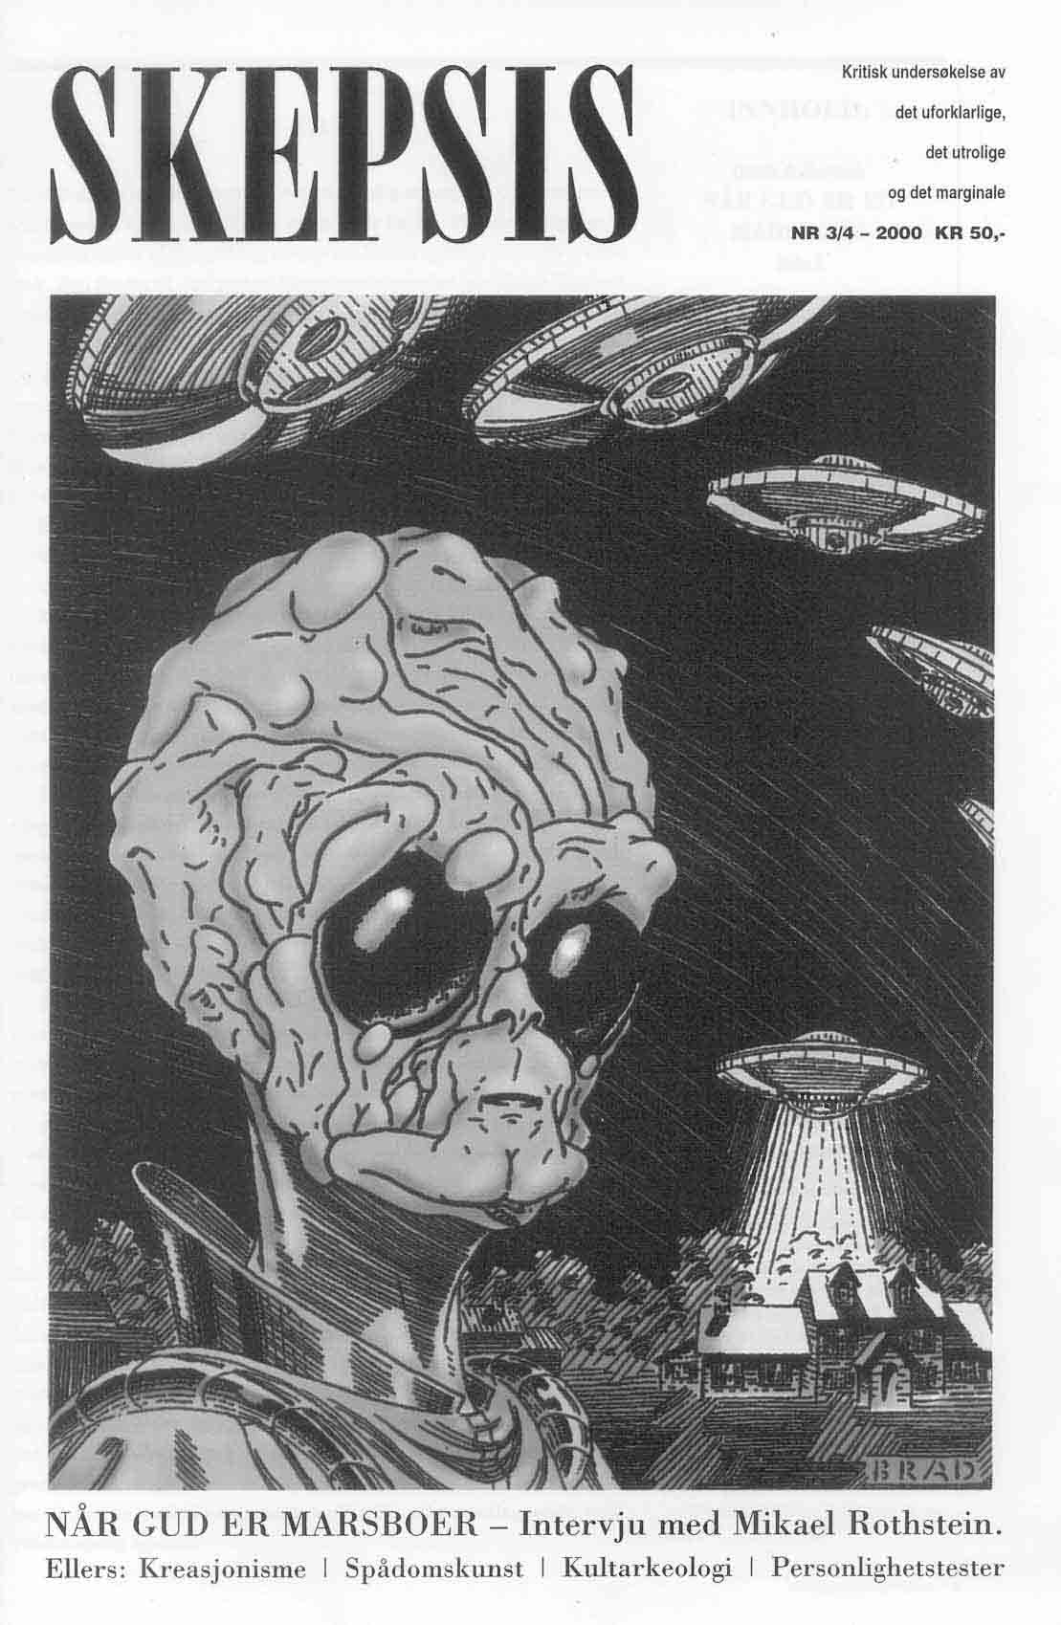

**ancient astronauts**

The term 'ancient astronauts' designates the speculative notion that aliens are responsible for the most ancient civilizations on earth. The most notorious proponent of this idea is Erich von Däniken, author of several popular books on the subject. His *Chariots of the Gods? Unsolved Mysteries of the Past*, for example, is a sweeping attack on the memories and abilities of ancient peoples. Von Däniken claims that the myths, arts, social organizations, etc., of ancient cultures were introduced by astronauts from another world. He questions not just the capacity for memory, but the capacity for culture and civilization itself, in ancient peoples. Prehistoric humans did not develop their own arts and technologies, but rather were taught art and science by visitors from outer space.

Where is the proof for von Däniken's claims? Some of it was fraudulent. For example, he produced photographs of pottery that  he claimed had been found in an archaeological dig. The pottery depicts flying saucers and was said to have been dated from Biblical times. However, investigators from *Nova* (the fine public-television science program) found the potter who had made the allegedly ancient pots. They confronted von Däniken with evidence of his fraud. His reply was that his deception was justified because some people would only believe if they saw proof ("The Case of the Ancient Astronauts," first aired 3/8/78, done in conjunction with BBC's *Horizon* and Peter Spry-Leverton)!

However, most of von Däniken's evidence is in the form of specious and fallacious arguments. His data consists mainly of archaeological sites and ancient myths. He begins with the ancient astronaut assumption and then forces all data to fit the idea. For example, in [Nazca](http://skepdic.com/nazca.html), Peru, he explains giant animal drawings in the desert as an ancient alien airport. The likelihood that these drawings related to the natives' religion or science is not considered. He also frequently reverts to false dilemma reasoning of the following type: "*Either* this data is to be explained by assuming these primitive idiots did this themselves *or* we must accept the more plausible notion that they got help from extremely advanced peoples who must have come from other planets where such technologies as anti-gravity devices had been invented." His devotion to this theory has not dwindled, despite contrary evidence, as is evidenced by still another book on the subject, *Arrival of the Gods : Revealing the Alien Landing Sites at Nazca* (1998)*.*

There have been many critics of von Däniken's notions, but Ronald Story stands out as the most thorough. Most critics of von Däniken's theory point out that prehistoric peoples were not the helpless, incompetent, forgetful savages he makes them out to be. (They must have at least been intelligent enough to understand the language and teachings of their celestial instructors--no small feat!) It is true that we still do not know how the ancients accomplished some of their more astounding physical and technological feats. We still wonder how the ancient Egyptians raised giant obelisks in the desert and how stone age men and women moved huge cut stones and placed them in position in dolmens and passage graves. We are amazed by the giant carved heads on Easter Island and wonder why they were done, who did them, and why they abandoned the place. We may someday have the answers to our questions, but they are most likely to come from scientific investigation not pseudoscientific speculation. For example, observing contemporary stone age peoples in Papua New Guinea, where huge stones are still found on top of tombs, has taught us how the ancients may have accomplished the same thing with little more than ropes of organic material, wooden levers and shovels, a little ingenuity and a good deal of human strength. [*Nova's* "Secrets of Lost Empires"](http://www.pbs.org/wgbh/nova/lostempires/) made no appeal to alien teachers in the attempt to figure out how the ancient Egyptians might have raised a giant [obelisk](http://www.pbs.org/wgbh/nova/lostempires/obelisk/), how the medieval warriors built their [catapults](http://www.pbs.org/wgbh/nova/lostempires/trebuchet/) and how & why the sculptors of [Easter Island](http://www.pbs.org/wgbh/nova/lostempires/easter/) did what they did.

We have no reason to believe our ancient ancestors' memories were so much worse than our own that they could not remember these alien visitations well enough to preserve an accurate account of them. There is little evidence to support the notion that ancient myths and religious stories are the distorted and imperfect recollection of ancient astronauts recorded by ancient priests. The evidence to the contrary--that prehistoric or 'primitive' peoples were (and *are*) quite intelligent and resourceful--is overwhelming.

Of course, it is possible that visitors from outer space did land on earth a few thousand years ago and communicate with our ancestors. But it seems more likely that prehistoric peoples themselves were responsible for their own art, technology and culture. Why concoct such an explanation as von Däniken's?  To do so may increase the mystery and romance of one's theory, but it also makes it less reasonable, especially when one's theory seems inconsistent with what we already know about the world. And why restrict one's examples to Egypt, Mexico, and other non-European countries? What about the builders of Newgrange or Stonehenge? The ancient astronaut hypothesis is unnecessary. [Occam's razor](http://skepdic.com/occam.html) should be applied and the hypothesis rejected.

**See also** [alien abduction](http://skepdic.com/aliens.html), [the face on Mars](http://skepdic.com/faceonmars.html), [the Nazca lines](http://skepdic.com/nazca.html), [Sirius](http://skepdic.com/dogon.html), [Zecharia Sitchin](http://skepdic.com/sitchin.html), [UFO,](http://skepdic.com/ufos_ets.html) and [Velikovsky](http://skepdic.com/velikov.html).

**further reading**

[**reader comments**](http://skepdic.com/comments/vondancom.html)

* [Erich von Daniken's "Chariots of the Gods?": Science or Charlatanism?](http://www.debunker.com/texts/vondanik.html) by Robert Sheaffer
* [Who Were the Ancient Engineers of Egypt? James Trefil](http://csicop.org/sb/2007-03/egypt.html)
* [The Maya "Astronaut"](http://members.shaw.ca/mjfinley/vondaniken.html) by Michael Finley
* [Nova - Hot Science](http://www.pbs.org/wgbh/nova/alienactivity/nazca3a.html)
* [Chariots of Lies](http://www.abc.net.au/science/correx/archives/lies.htm): the CorreX files by Paul Willis (The site is now known as the **Correx Archives** due to legal threats from 20th Century Fox Alien Network for breach of copyright)
* [Sitchin's Twelfth Planet](http://www.skepdic.com/essays/sitchin.htm) by Rob Hafernik

[Bullard, Thomas E. "Ancient Astronauts," in *The Encyclopedia of the Paranormal* edited by Gordon Stein (Buffalo, N.Y.: Prometheus Books, 1996), pp. 25-32.](http://www.amazon.com/exec/obidos/ISBN=1573920215/roberttoddcarrolA/)

[Colavito, Jason. (2005). *The Cult of Alien Gods - H. P. Lovecraft and Extraterrestrial Pop Culture*. Prometheus.](http://www.amazon.com/exec/obidos/ISBN=1591023521/roberttoddcarrolA/)

[De Camp, L. Sprague. *The Ancient Engineers* (New York: Ballantine Books, 1977).](http://www.amazon.com/exec/obidos/ISBN=0345320298/roberttoddcarrolA/)

[Fagan, Garrett G. *2006. Archaeological Fantasies: How Pseudoarchaeology Misrepresents the Past and Misleads the Public.* Routledge.](http://www.amazon.com/exec/obidos/ISBN=0415305934/roberttoddcarrolA/)

[Feder, Kenneth L. *Frauds, Mysteries and Myths*, 4th ed. (McGraw Hill Co., 2001).](http://www.amazon.com/exec/obidos/ISBN=076742722X/roberttoddcarrolA/)

Story, Ronald. *Guardians of the Universe* (New York: St. Martin's Press, 1980).

Story, Ronald. *The Space-gods Revealed: a Close Look at the Theories of Erich von Däniken*, 2nd ed. (New York: Barnes & Noble, 1976).

[**www.badarchaeology.net/.../daniken.php**](http://www.badarchaeology.net/extraterrestrial/daniken.php)

## Erich von Däniken



Erich von Däniken  
the most successful of  
Bad Archaeologists

One of the most successful and influential of all Bad Archaeologists is the Swiss hotelier, Erich von Däniken (born 1935). He caused controversy in the late 1960s with his popularisation of what has become known as the ‘ancient astronaut hypothesis’, although he was by no means the first to propose it. His first book, Chariots of the Gods?, published in 1967 after no fewer than twenty-two rejections, became a worldwide bestseller, thanks in no small part to its tone: a strident attack on hide-bound academia by one who dared to speak his mind. He was not the first fringe writer to adopt this stance and he has not been the last: expert bashing has become an important cultural cliché over the past half century or so. The ups and downs of his career have seen him arrested for fraud, become a global media personality and, ultimately, made him wealthy through the sale of over sixty million copies of his books.



he ‘Great Martian God’,  
a rock painting discovered in the  
Tassilli mountains by Henri Lhote  
and said by von Däniken to be  
a representation of an alien  
wearing a spacesuit

During an early career as a waiter, he was able to save for extensive travels in which he hoped to find evidence for an idea he had developed through reading the Bible (and, although he does not admit as much, through his reading of the works of speculative writes such as Louis Pauwels and Jacques Bergier): that extraterrestrials had meddled in human history. The most convincing piece of evidence he has ever produced is the cover slab of the tomb of the Lord Pacal in the Pyramid of the Inscriptions at Palenque, weak stuff though it is. He saw it as a representation of a humanoid being in a space capsule and it became the cover image for the hardback publication of the English edition of Chariots of the Gods?. Subsequent books took his search for evidence farther afield and he even dabbled in analyses of religious visions (Miracles of the Gods) and Greek mythology.

END