AMEX PREKNOWLEDGE VISIT

>As you sit at the towers you may notice that the Amex Building is

>across the street from the hole where the towers used to exist.

>

>I worked at Amex on 9/11. in SLC UT.

>

>Imagine my surprise when I arrived at the SLC office on 9/11 2001 to

>find our Beloved CEO Ken Chennault in our SLC office for a surprise visit.

>This was unannounced and not normal. SLC usually spent months prepping

>for any visit from our loved CEO - Everything would be painted, and

>cleaned- even obscure things....

>

>Why on this day - did he show up unannounced. Then- he had an

>impromptu Town hall... Where he mentioned my project. Surprise to my team.

>

>The event was eerily like the classroom where George Bush sat- reading

>stories as the events unfolded.... I was with company 28 years.  1990-2018  Over the years I  worked  in multiple locations in Phoenix AZ,  and in Salt Lake City, Utah  offices.  I visited NY offices on multiple occasions for project meetings.   I left this year. shortly after Ken's departure. (so many company reorgs and layoffs)  Ken retired this year. He announced his retirement in Oct 2017- and left in Feb 2018-

Ken's retirement announcement came shortly after he announced we would shut down our big new Plenti Business.  Which was a Very expensive Endeavor that I worked on.  We purchased Payback- a Munich based business- for 800$ million. Spent another 100$ million or so- trying to launch this business in US and other various countries- Ran it for a little over a year- then shut it down....-announced in fall 2017.

**AMEX- Core US Locations:**

* Headquarters- NY- World financial Center. Across from Trade Center.  You can see the hole in the ground from the Amex office windows....

* Phoenix- has several large locations- mostly technologies and service centers.

* Fort Lauderdale FL- Business groups. service centers, and few tech groups.

* Salt Lake City UTAH-  SLC is a small location.  Travelers cheques, stored Value, New accounts... One building.. Ken doesn't go there too much.

* Many other locations around the world...

9/11- NY Towers- Amex building was used as a morgue- damage was done to our building.... due to dust and debris. A handful of Amex employees died- from our travel office- located in the Trade Center.  Many other employees were in the office that day of course- Some folks walked home for miles that day.  I have chatted with many folks from this office hearing about their days.  nobody I talked to saw the planes. All projects went on hold after this attack for several months....office was closed- all employees worked remotely for several months post this event.

Amex loved Ken.  **Regardless- where he goes- it is always a big deal.**   The planning is wide spread- the mandates to organize, clean carpets, paint, organize areas- even clean areas that Ken would never go were obsessively planned and organized ... but not on 9/11.

I worked in SLC office on 9/11- and when I arrived at work, it was while all hell was breaking loose.  Everyone walked around and watched TV from Conference rooms .

However, Ken Chenault was i**n the SLC office when we showed up for work.  Not just there, but walking around and setting up a video in our Cafe..   My initial thought was - WHAT? How did he get here, and why?  nobody knew he was coming.  What was the purpose?**

He conducted a town hall.  He had his video equipment there- and the cafeteria was set up for him to speak...

Of course he discussed the horror that was taking place at the moment, and then mentioned a few key company efforts that were currently the top priorities-  funny- one of the projects was mine- ExpressPay. This was our test of a new RFID - contact-less pay chip in fobs-

My leaders- and project team - had no idea he would mention or would be here to discuss anything related to our work...  If you know leaders and how they act when they are to be highlighted- then you know this is odd.....  VERY Odd...

I don't think he had any real business reason to be in SLC that day.   The purpose was to create the company video to be strong...... blah blah blah. When I watched George Bush in FL school- it reminded me of how Ken was acting...

Like everyone- I watched 9/11 and my instinct felt this was too good - like a Hollywood version of the event. not like a bumbling terrorist org...

I was in the elevator with Ken. and specifically said.... I bet this is so hard for you- to be trapped in this crazy little town while your family and colleagues are so far away- (airports were shut down)

I do not recall how long he stayed in UT..   I did not see too much of him after that first day.... I assume he had the company private jet.

2nd odd thing- Ed Gilligan- next in line for CEO- dies in the company plane in May 2015... Heart attack???

[Edward P. Gilligan, American Express Executive, Dies at 55](https://www.nytimes.com/2015/05/30/business/edward-p-gilligan-american-express-executive-dies-at-55.html)

|  |  |  |  |  |  |  |  |
| --- | --- | --- | --- | --- | --- | --- | --- |
| |  |  |  |  | | --- | --- | --- | --- | | |  |  |  | | --- | --- | --- | | |  |  | | --- | --- | |  |  | | | | |  |  | | --- | --- | | https://s.yimg.com/nq/storm/assets/enhancrV2/23/logos/nytimes.png | Edward P. Gilligan, American Express Executive, Dies at 55 Mr. Gilligan was largely seen as the likely successor to Kenneth Chenault, the chief executive. | | |

**Note-**Every year our company does an internal performance review- **Ken** gives a score- based on our achievement of the goals.  A company score- plus score by organization- how they contributed to the score.  Well, (in my opinion- as his departing "gift") he gave our company an internal rating of "1"- in 2017-   All company raises are based on our internal score- this score is supposed to measure how well we did as a company.  1- is the best.  2017 was NOT the best year.  I could not believe that the one rating was touted.... When I mentioned this to my VP, he scoffed...

We shut down so many business groups in 2017- Serve, Plenti, recovered from the loss of Costco and some of our other ventures....  so many lay offs....

But hell- our bonuses/raises are based on the rating- plus I assume the stocks are as well...   Most years we are in 2's- but there were bad years with 3 or 4 was our own internal rating for achieving goals. This "1" was obviously a "gift"  - See my first paragraph on Plenti - my project- in normal years- shutting down a business unit like this would not garner a "1" rating....

This info although it does not seem like to much, it is enough  for "Me" to solidify that Top Executives knew 9/11 would occur... they were informed and did nothing to stop it. Thus making them responsible for the death and destruction to the lives of our colleagues that perished.

Thanks for your great work.  It feels good to see some folks that question the narrative, and I appreciate your letting me speak.  As you know, others don't like to discuss.

__________________________

Kristin VonWald- Ex Amex Employee of 28 years.

480-272-3315

# *Edward P. Gilligan, American Express Executive, Dies at 55*

**By**[**David Segal**](http://www.nytimes.com/by/david-segal)

* May 29, 2015

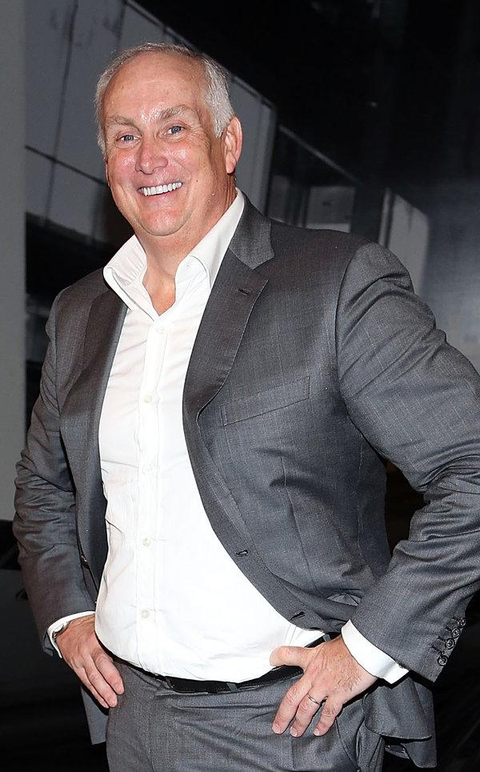

Edward GilliganCreditCreditMonica Schipper/Getty Images

Edward Gilligan, the president of American Express and heir apparent to the company’s chief executive, Kenneth Chenault, died on Friday after falling ill during a flight to New York. He was 55.

The cause was believed to be a heart attack, a company spokesman said. Mr. Gilligan was aboard a corporate jet with several colleagues returning from a business trip to Tokyo. CPR was performed during the flight, which was diverted to Green Bay, Wis., the spokesman said. Mr. Gilligan was pronounced dead at a hospital in the area.

Mr. Gilligan was appointed president of American Express, the world’s largest issuer of credit cards, in 2013, establishing him as the likely future chief executive. He oversaw the company’s small business, merchant, global consumer, network, merchant, risk and banking groups.

He started at American Express 35 years ago as an intern while earning an undergraduate degree in economics and management from New York University. He rose steadily through the company’s ranks, becoming vice president for business travel and later senior vice president for commercial card and business travel for the Eastern United States.

In 2002 he moved to London, where he headed the company’s international consumer card division. He returned to the United States in 2009 and led efforts to integrate American Express into social media, helping to embed the company’s offerings on Facebook as well as through tech companies like Uber.

“Ed loved to talk tech; he loved to talk sports; he was a great storyteller,” said Michael O’Neill, American Express’s executive vice president for corporate affairs. “He was the guy at dinner you wanted to be seated next to.”

Mr. Gilligan’s death comes during a challenging period for American Express. In February, the company and the big-box retailer Costco announced that they were unable to agree on terms to extend a 16-year relationship in which American Express was the only card Costco accepted. Mr. Chenault said at the time that the news would affect one-tenth of all American Express cards, describing it as a financial blow that would hurt the company’s results for two years.

That same month, a Federal District Court judge in Brooklyn ruled that American Express had violated antitrust law by prohibiting retailers from directing consumers to lower-cost cards. The judge, Nicholas Garaufis, ruled that the company’s actions “imposed actual, concrete harms on competition.” The company said it would appeal.

American Express’s statement on Friday did not say how Mr. Gilligan’s death would affect succession plans at the company.

Mr. Gilligan, who lived on the Upper West Side of Manhattan, was born on July 13, 1959, in Brooklyn and attended Xaverian, a Roman Catholic high school there, before enrolling at N.Y.U.

He is survived by his wife, Lisa; their four children, Katie, Meaghan, Kevin and Shane; and a brother, Michael.