**The Status of the World Trade Center Complex, 13 Years Later**

[29 comments](http://ny.curbed.com/2014/9/11/10048974/the-status-of-the-world-trade-center-complex-13-years-later#comments)

by [Evan Bindelglass](http://ny.curbed.com/authors/evan-bindelglass) [@evabin](http://www.twitter.com/evabin) Sep 11, 2014, 11:15a

* [tweet](https://twitter.com/intent/tweet?counturl=http%3A%2F%2Fny.curbed.com%2F2014%2F9%2F11%2F10048974%2Fthe-status-of-the-world-trade-center-complex-13-years-later&text=The+Status+of+the+World+Trade+Center+Complex%2C+13+Years+Later&url=http%3A%2F%2Fny.curbed.com%2F2014%2F9%2F11%2F10048974%2Fthe-status-of-the-world-trade-center-complex-13-years-later&via=CurbedNY)
* [share](https://www.facebook.com/sharer/sharer.php?text=The+Status+of+the+World+Trade+Center+Complex%2C+13+Years+Later&u=http%3A%2F%2Fny.curbed.com%2F2014%2F9%2F11%2F10048974%2Fthe-status-of-the-world-trade-center-complex-13-years-later)
* [pin](http://www.pinterest.com/pin/create/button/?description=The+Status+of+the+World+Trade+Center+Complex%2C+13+Years+Later&media=https%3A%2F%2Fcdn0.vox-cdn.com%2Fthumbor%2FuHNzJrxXZYShVvysBrMFeopvErE%3D%2F0x64%3A737x479%2F1000x563%2Fcdn0.vox-cdn.com%2Fuploads%2Fchorus_image%2Fimage%2F47991855%2Fsite_panynj.0.jpeg&url=http%3A%2F%2Fny.curbed.com%2F2014%2F9%2F11%2F10048974%2Fthe-status-of-the-world-trade-center-complex-13-years-later)
* [Rec](http://ny.curbed.com/2014/9/11/10048974/the-status-of-the-world-trade-center-complex-13-years-later)

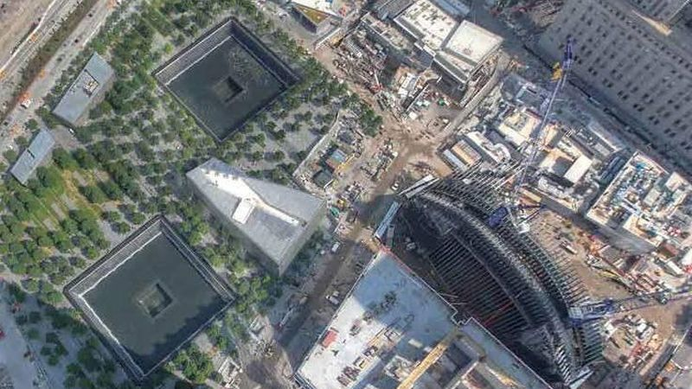*World Trade Center site. Photo: Port Authority*

Today marks the **13th anniversary** of the September 11 terrorist attacks, and although the 16-acre **World Trade Center** complex is far from complete, a [substantial amount has been rebuilt](http://fieldcondition.com/blog/2014/9/11/wtc), filling a long-empty piece of Downtown. "We all wish we could have gotten it done faster," [said World Trade Center developer Larry Silverstein this week](http://www.dnainfo.com/new-york/20140911/financial-district/interactive-see-whats-opening-when-at-world-trade-center), "but that does not diminish the **pride** we all should feel." The [9/11 Memorial](http://ny.curbed.com/tags/911-memorial) has now welcomed visitors for three years, the first tenants will soon move into [4 World Trade Center](http://ny.curbed.com/tags/4-world-trade-center), and the crown jewel of it all, the 1,776-foot One World Trade Center will finally open its this fall.

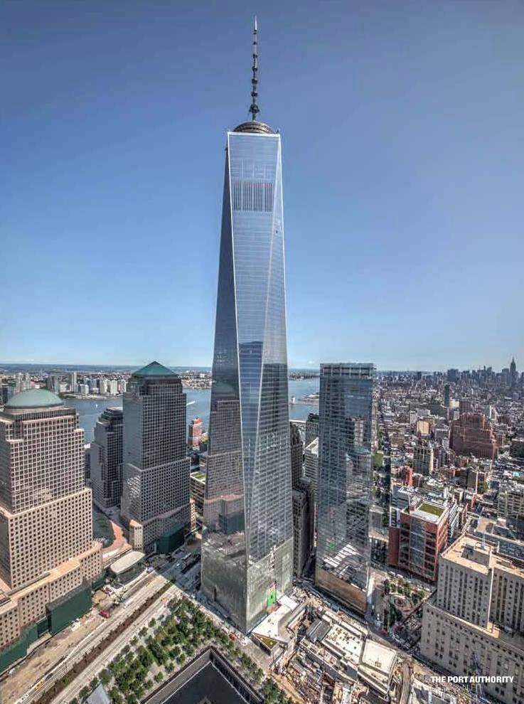<img src="https://cdn1.vox-cdn.com/uploads/chorus\_asset/file/4802093/1wtc-wtcprogress.0.jpg" alt=" "> [One World Trade Center. Photo: Port Authority]

**One World Trade Center**  
Located on the site of what was 6 World Trade Center, this [$3.9 billion tower](http://ny.curbed.com/places/1-world-trade-center) is the centerpiece of the new World Trade Center. The 104-story, three-million-square-foot skyscraper, designed by David Childs of Skidmore, Owings & Merrill, officially rises to 1,776 feet (roof is 1,368 feet), and it was [declared](http://ny.curbed.com/archives/2013/11/12/at_last_its_official_one_world_trade_center_is_1776_feet_tall.php) the tallest building in the U.S. by the Council on Tall Buildings and Urban Habitat, topping Chicago's ~~Sears~~ Willis Tower. Port Authority Vice Chairman Scott Rechler said Tuesday that it will open this November [with a 60 percent occupancy](http://abcnews.go.com/US/wireStory/world-trade-center-completion-25391719). Conde Nast is the anchor tenant with 1.1 million square feet, and other tenants include [Servcorp](http://ny.curbed.com/tags/one-world-trade-center), KiDS Creative, BMB Group, and Legends Hospitality. A three-level [public observation deck](http://www.panynj.gov/wtcprogress/wtc-observation-deck.cfm) on floors 100 to 102, approximately 1,250 feet up, will open sometime next year.

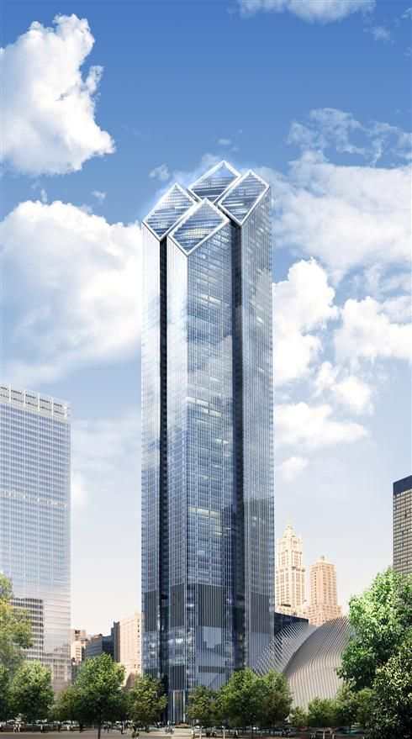<img src="https://cdn1.vox-cdn.com/uploads/chorus\_asset/file/4802095/32\_01\_Tower2\_Rendering.0.jpg" alt=" "> [Rendering of 2 World Trade Center. Via Silverstein Properties]

**2 World Trade Center**  
Also known as 200 Greenwich Street, this office tower, designed by **Norman Foster** of London-based [Foster + Partners](http://www.fosterandpartners.com/), is slated to be 88 stories and 1,349-feet-tall, which will make it [the second tallest of the World Trade Center buildings](http://ny.curbed.com/tags/2-world-trade-center). While foundation work was completed back in 2013, it is unclear when the building proper will be finished as [developer Larry Silverstein is still seeking tenants](http://abcnews.go.com/US/wireStory/world-trade-center-completion-25391719).

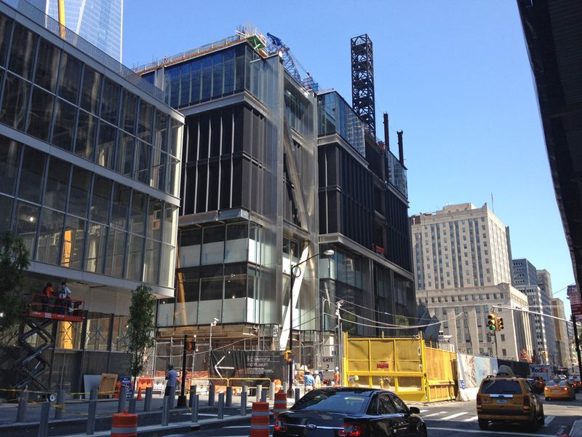<img src="https://cdn0.vox-cdn.com/uploads/chorus\_asset/file/4802097/3WTC-curbed-1.0.jpg" alt=" ">

**3 World Trade Center**  
The Richard Rogers-designed [3 World Trade Center](http://ny.curbed.com/tags/3-world-trade-center) has been stuck at seven stories for several years, but eventually the tower will rise to 80 stories. Silverstein said Tuesday that [he **has financing to complete the building** by early **2018**](http://newyork.cbslocal.com/2014/09/09/less-construction-on-911-memorial-plaza-marks-another-year-of-progress/), which is welcome news. Currently, the tower only has one future tenant; GroupM signed on awhile ago for 20 percent of the building. The original 3 World Trade Center was the Marriott hotel that was angled in between the Twin Towers on the southwest corner of the site.

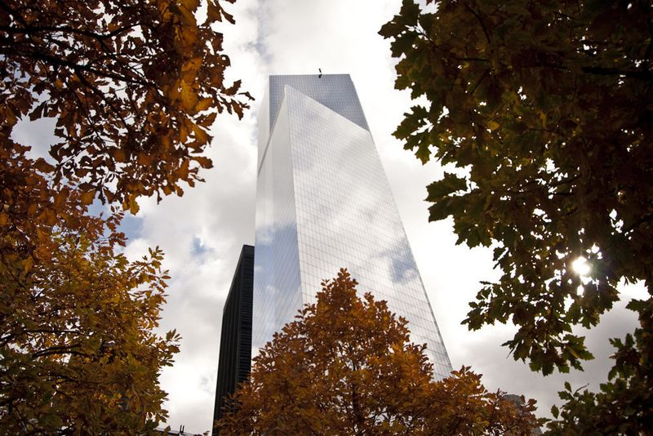<img src="https://cdn3.vox-cdn.com/uploads/chorus\_asset/file/4802099/4wtc-willfemia.0.jpg" alt=" "> [4 World Trade Center. Photo: Will Femia]

**4 World Trade Center**  
Designed by Fumihiko Maki of the Tokyo-based architectural firm Maki & Associates, 4 World Trade Center (150 Greenwich Street) was [the first building to open](http://ny.curbed.com/archives/2013/11/12/go_inside_the_first_complete_world_trade_center_tower.php) in the new WTC complex. It tops out at 977 feet and 72 stories, and the architecture world absolutely loves the design. One critic called it "[shimmering perfection](http://ny.curbed.com/archives/2014/04/18/archicritics.php)," and the American Institute of Architects honored it in its annual awards. Tenants, which include the Port Authority, will move next month (they had to build out their spaces themselves).

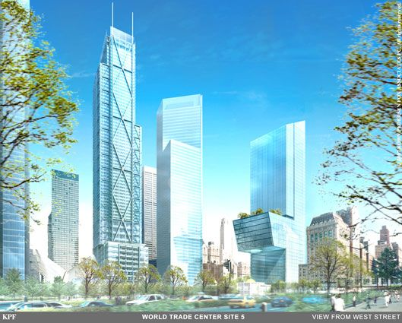<img src="https://cdn3.vox-cdn.com/uploads/chorus\_asset/file/4438403/5WTC-KPF.0.jpg" alt=" "> [Old rendering for 5 World Trade Center (right).]

**5 World Trade Center**  
Also known as 130 Liberty Street, this is one of the less talked about pieces of the World Trade Center. It was to have been the 42-story headquarters of JPMorgan Chase, but [that fell through](http://therealdeal.com/blog/2008/03/20/jpmorgan-might-flip-wtc-site/) and construction of the Kohn Pederson Fox-designed building is currently on hold. KPF might not even end up being the architect behind whatever eventually is built there as the Port Authority has not made a final decision. There is no date for the future of the project. The site originally had the [Deutsche Bank Building](http://en.wikipedia.org/wiki/Deutsche_Bank_Building), which was heavily damaged and contaminated on 9/11 and is now gone. A **temporary plaza** currently exists on the site.

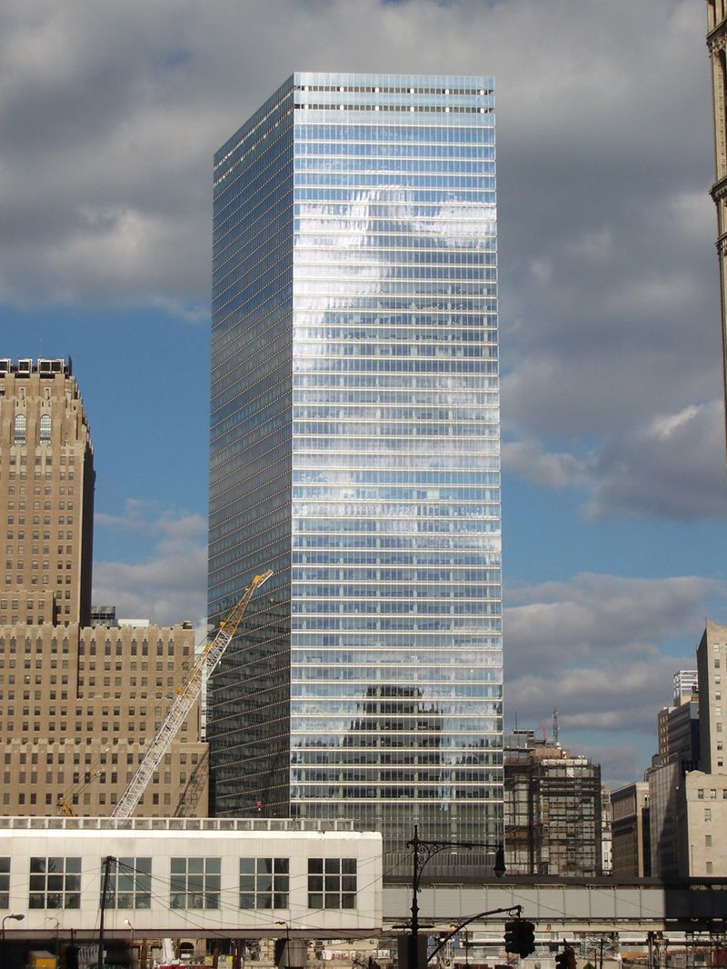<img src="https://cdn2.vox-cdn.com/uploads/chorus\_asset/file/4438405/7\_World\_Trade\_Center.0.jpg" alt=" "> [7 World Trade Center. Photo by [Sweenyr via Wikipedia](http://en.wikipedia.org/wiki/7_World_Trade_Center#mediaviewer/File:7_World_Trade_Center.jpg)]

**7 World Trade Center**  
Located just north of the World Trade Center, 7 WTC shares the complex's name, but is technically separate from the 16-acre development. Having opened in May **2006**, it was the first tower rebuilt after the attacks. Standing 741 feet and 52-stories-tall and designed by a team from Skidmore, Owings & Merrill, it sits on the same site as the old 7 World Trade Center. It [was fully leased](http://ny.curbed.com/archives/2011/09/19/wtc_redevelopment_watch.php) as of 2011.

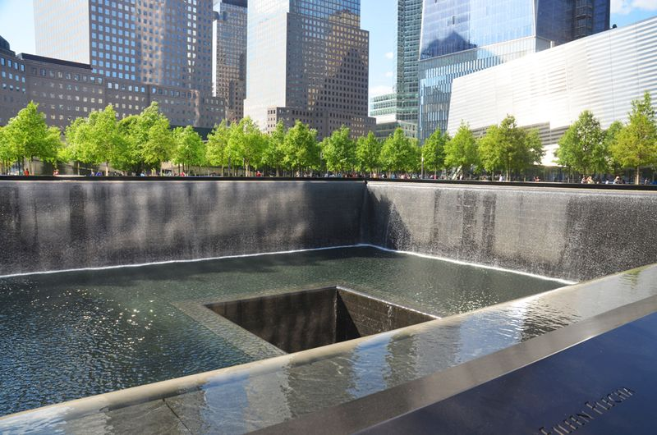<img src="https://cdn2.vox-cdn.com/uploads/chorus\_asset/file/4802101/911memorial\_evanbindelglass.0.JPG" alt=" "> [9/11 Memorial plaza. Photo: Evan Bindelglass]

**9/11 Memorial**  
The 9/11 Memorial is a large public plaza officially called "Reflecting Absence." It features rows of trees and benches around two recessed pools, which sit in the footprints of the Twin Towers. Water cascades down the sides and disappears into a second recessed area, the bottoms of which cannot be seen from the plaza. The memorial opened to victims' families on September 11, 2011 and to the public the day after. Tickets were previously needed to visit the memorial, but after the surrounding **barriers were removed** this spring, the public can now just walk in off the street. This 9/11 [will mark the first anniversary it will be open at night](http://ny.curbed.com/archives/2014/08/29/remembrances.php) and completely open to the public.

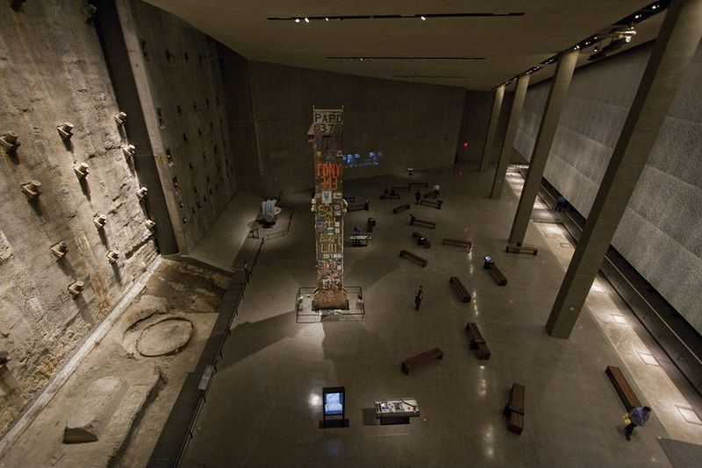 [The "Last Column" inside the 9/11 Museum.]

**9/11 Museum**  
Almost entirely underground, the 9/11 Museum [holds a number of artifacts and exhibits](http://www.911memorial.org/memorial-museum-faq) connected to the site's history and the 2001 terrorist attacks. Artifacts in the haunting, hallowed space include the Survivors' Staircase, FDNY fire trucks, an ambulance, and the "last column." After some delay, it [was dedicated on May 16 of this year](http://ny.curbed.com/archives/2014/05/23/123_photos_inside_the_911_museum_on_somber_opening_day.php) and opened to the public on May 21.

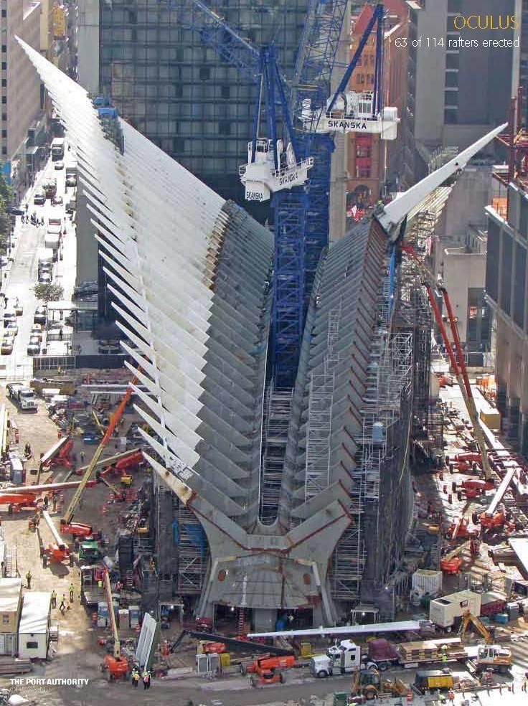<img src="https://cdn1.vox-cdn.com/uploads/chorus\_asset/file/4802105/oculus\_panynj.0.jpeg" alt=" "> [World Trade Center Transportation Hub. Photo: Port Authority]

**WTC Transportation Hub**  
Also known as the Oculus, the 150-foot-tall winged structure is currently under construction and was designed by Spanish architect **Santiago Calatrava**. The Port Authority said it will be third largest transportation center in the city. It [will connect](http://www.panynj.gov/wtcprogress/transportation-hub.html) the PATH trains, 11 subway lines, World Trade Center towers 1-4, the memorial plaza, Brookfield Place (formerly the World Financial Center), and the Battery Park City ferry terminal. It will also hold 225,000 square feet of retail space. The Port Authority currently lists a **2015** completion date, but that [is reportedly eight years behind schedule and **$2 billion** over budget](http://online.wsj.com/articles/complex-design-political-fights-send-world-trade-center-rail-hubs-cost-soaring-1409788832).

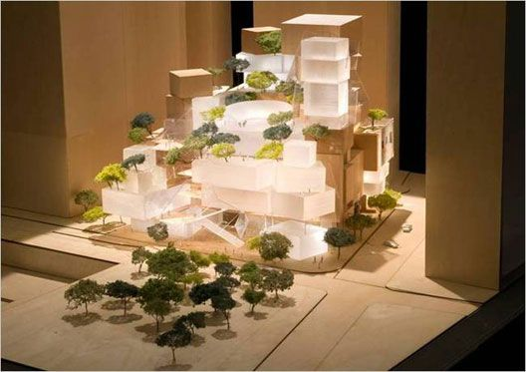<img src="https://cdn0.vox-cdn.com/uploads/chorus\_asset/file/4438413/wtcperforming\_gehrypartners.0.jpg" alt=" "> [The former design of the World Trade Center Performing Arts Center. Photo: Gehry Partners]

**WTC Performing Arts Center**  
There were grand Frank Gehry-designed plans for the complex's performing arts center, but [his design was scrapped last week](http://ny.curbed.com/archives/2014/09/04/wtc_arts_center_execs_officially_scrap_frank_gehrys_design.php). Located between One World Trade Center and 7 World Trade Center, this structure is supposed to house the Joyce Theater, but without a design and with fundraising efforts largely stalled, it's anyone's bet when this project will actually move forward. Plus, the site is currently occupied by the temporary PATH station, which won't be eliminated until the transportation hub opens.

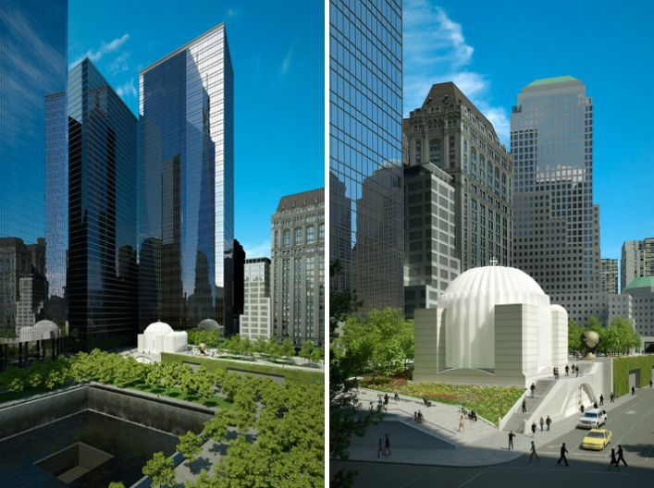<img src="https://cdn2.vox-cdn.com/uploads/chorus\_asset/file/4552983/stnicholas1.0.jpg" alt=" "> [Renderings of the new St. Nicholas Greek Orthodox Church. Credit: Santiago Calatrava]

**St. Nicholas Greek Orthodox Church**  
Commercial buildings weren't the only structures to fall during the attacks; St. Nicholas Greek Orthodox Church was also destroyed. [Built in 1916, it was located at 155 Cedar Street](http://www.goarch.org/special/september11/archival/stnicholaschurch/stnicholas), across Liberty Street from the old hotel and 2 World Trade Center. Calatrava was selected to design the new church at 130 Liberty Street, just east of its original location. There was hope that the new church [would be completed in 2016](http://newyork.cbslocal.com/2012/04/25/rebuilding-of-st-nicholas-greek-orthodox-church-moves-forward/), but as far as we can tell, construction, which was to have commenced this year, [has not started](http://www.nydailynews.com/new-york/struggle-rebuild-st-nicholas-church-ten-years-9-11-article-1.1791816).

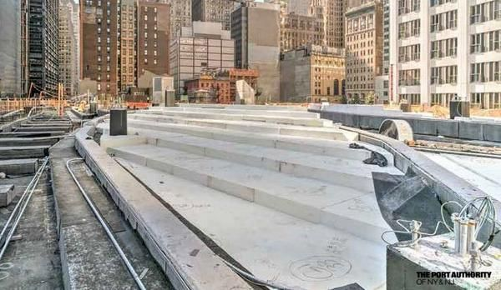<img src="https://cdn2.vox-cdn.com/uploads/chorus\_asset/file/4802107/libertypark-panynj.0.jpg" alt=" "> [Construction at Liberty Park. Photo: Port Authority]

**Liberty Park**  
This [brand new park](http://ny.curbed.com/archives/2014/02/03/new_renderings_reveal_what_liberty_park_will_look_like.php) will sit between Greenwich Street and the West Side Highway and between Liberty Street and Cedar Street in front of the new St. Nicholas church. It will be built on top of the World Trade Center Vehicle Security Center and feature an overlook for a unique view of the WTC site. It's hoped that the park will be open in **2015**.  
· [All World Trade Center coverage](http://ny.curbed.com/tags/world-trade-center) [Curbed]  
· [World Trade Center](http://www.wtc.com/) [official]

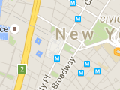

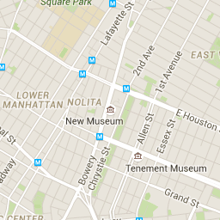

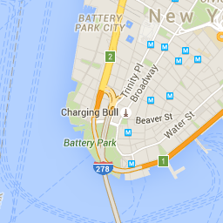

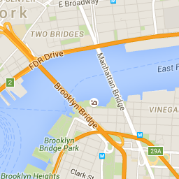

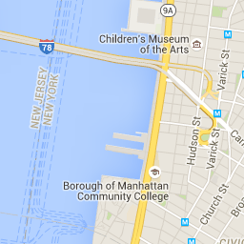

Map Data

Map data ©2016 Google

http://maps.gstatic.com/mapfiles/api-3/images/mapcnt6.png

Map DataMap data ©2016 Google

Map data ©2016 Google

[Terms of Use](https://www.google.com/intl/en-US_US/help/terms_maps.html)

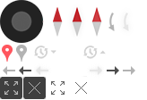

[Report a map error](https://www.google.com/maps/@40.7118252,-74.0107298,14z/data=!10m1!1e1!12b1?source=apiv3&rapsrc=apiv3)

http://maps.gstatic.com/mapfiles/api-3/images/tmapctrl.png

http://maps.gstatic.com/mapfiles/api-3/images/tmapctrl.png

http://maps.gstatic.com/mapfiles/api-3/images/tmapctrl4.png

http://maps.gstatic.com/mapfiles/api-3/images/tmapctrl4.png

[[http://maps.gstatic.com/mapfiles/api-3/images/google4.png](https://maps.google.com/maps?ll=40.711825,-74.01073&z=14&t=m&hl=en-US&gl=US&mapclient=apiv3)](https://maps.google.com/maps?ll=40.711825,-74.01073&z=14&t=m&hl=en-US&gl=US&mapclient=apiv3" \o "Click to see this area on Google Maps" \t "_blank)

[Foursquare](https://www.foursquare.com/v/4dee2b062271e7b4462ef353)

[**2 World Trade Center**](http://ny.curbed.com/building/3315/2-world-trade-center)

200 Greenwich St, New York, NY 10007

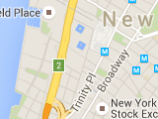





Map Data

Map data ©2016 Google

http://maps.gstatic.com/mapfiles/api-3/images/mapcnt6.png

Map DataMap data ©2016 Google

Map data ©2016 Google

[Terms of Use](https://www.google.com/intl/en-US_US/help/terms_maps.html)



[Report a map error](https://www.google.com/maps/@40.7101464,-74.0132295,14z/data=!10m1!1e1!12b1?source=apiv3&rapsrc=apiv3)

http://maps.gstatic.com/mapfiles/api-3/images/tmapctrl4.png

http://maps.gstatic.com/mapfiles/api-3/images/tmapctrl4.png

[**St. Nicholas National Shrine**](http://ny.curbed.com/building/3370/st-nicholas-church)

130 Liberty Street, New York, NY 10006