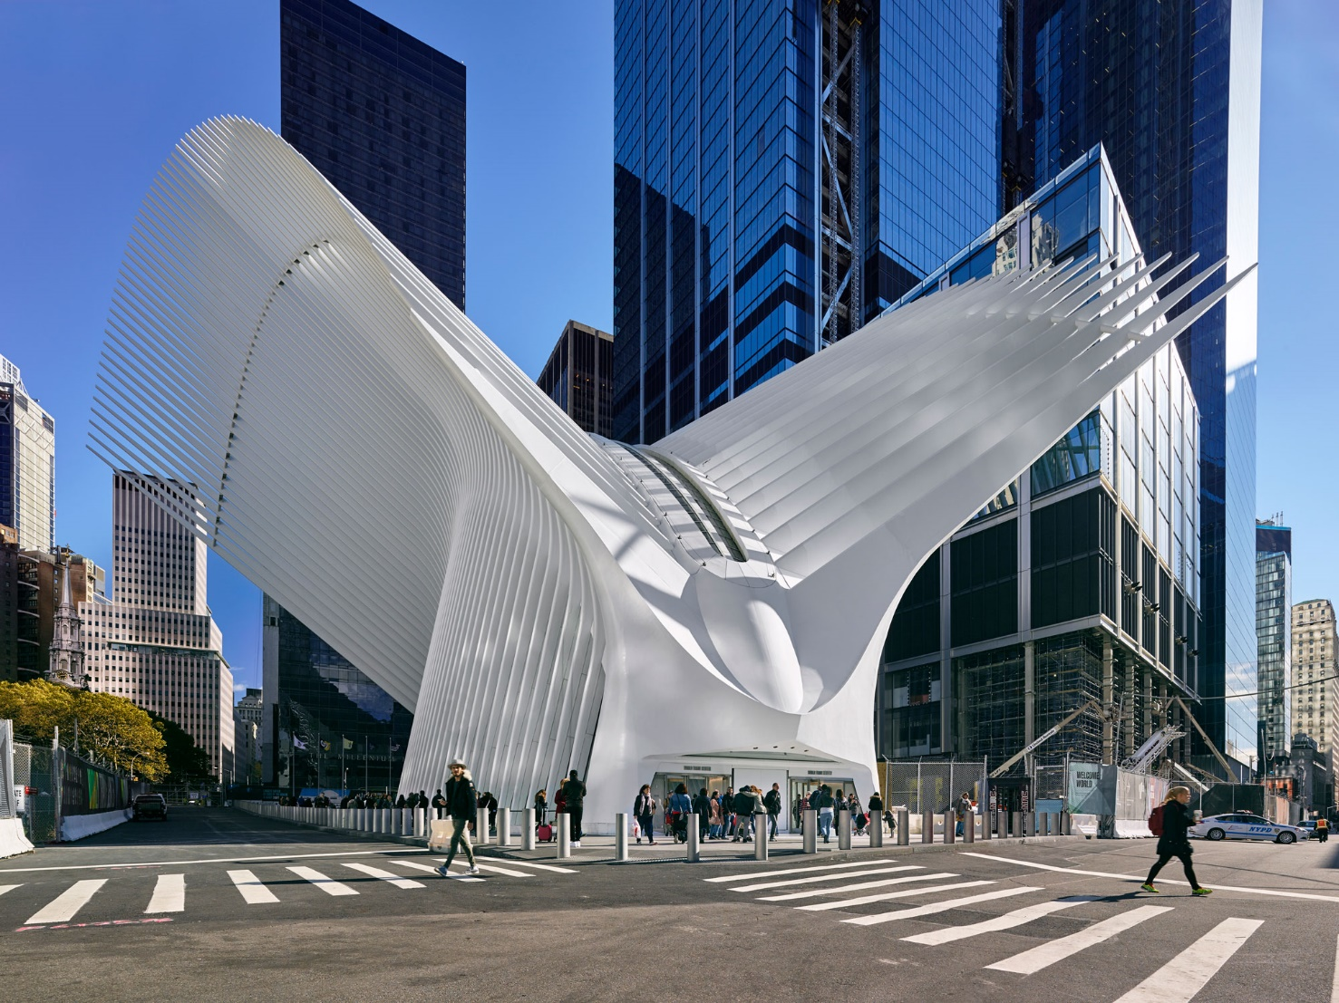

**WORLD TRADE CENTER TRANSPORTATION HUB**

CITY[New York, NY](https://heintges.com/location/new-york-ny/)

REGION[United States (Northeast)](https://heintges.com/region/united-states-northeast/)

CLADDING AREA108 000 sf

ARCHITECTSantiago CalatravaDowntown Design Partnership

OWNERPort Authority of NY and NJ

PROJECT TYPE[Transportation](https://heintges.com/type/transportation/)

PHASE OF INVOLVEMENTDesign  
Construction

TYPE OF CONSTRUCTION[New](https://heintges.com/construction/new/)

YEAR OF COMPLETION2016

<https://www.google.com/url?sa=i&rct=j&q=&esrc=s&source=images&cd=&cad=rja&uact=8&ved=2ahUKEwjE_Y3wvrPdAhXOCuwKHbjDBzAQjRx6BAgBEAU&url=https%3A%2F%2Fheintges.com%2Fwtc-transportation-hub%2F&psig=AOvVaw08BwQvWBdZZ-5e33kU6OqH&ust=1536773844379453>

hej Ole take a look at this monster ,when you come out of the subway you end in the stomach of this monster is the belly of the beast, ribbons,the spine this kind of fishy "espinas" even the eye where is suppose to be the head is called occulus or something like that ,that means something with the eyes, I was shocked is so spooky, and to get to the two empty basins you need to get out of the mouth of this beast, you are being throw up to the street by the beast , take a look...

The World Trade Center Transportation Hub, designed by Santiago Calatrava, has become a new icon for New York City. Delicate-yet-powerful, the structure provides a grand welcome to travelers arriving by subway or PATH commuter train. The terminal, located on the former ground-zero site, serves as a regional transportation hub as well as a significant cultural and retail destination.

The main hall, known as the Oculus, is a soaring sculptural steel-and-glass shell enclosing a cathedral-like space and flooding it with natural light. This freestanding lens-shaped structure appears to have wings formed by steel ribs that extend upward beyond the main enclosure. Where the “wings” meet along a curved ridge, a 330-foot operable skylight allows for ventilation and passive conditioning of the space below and is opened ceremonially on September 11th. The sunlight that enters through the ribbed enclosure also suffuses the train platforms, 60 feet below ground, with natural light.

The complex geometry of the skeletal structure dictates that nearly every steel rib and lite of glass is a slightly different shape. Atypical construction sequences were employed during installation. The curtain wall and skylight systems are designed to accommodate a complex set of performance criteria, with special attention paid to security, energy efficiency and dynamic movement of the structure.

Heintges provided consulting services for the exterior enclosure and interior glazing for all phases of design and construction.

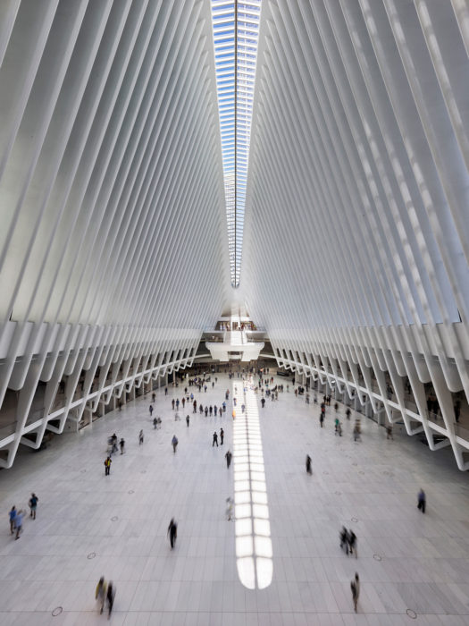

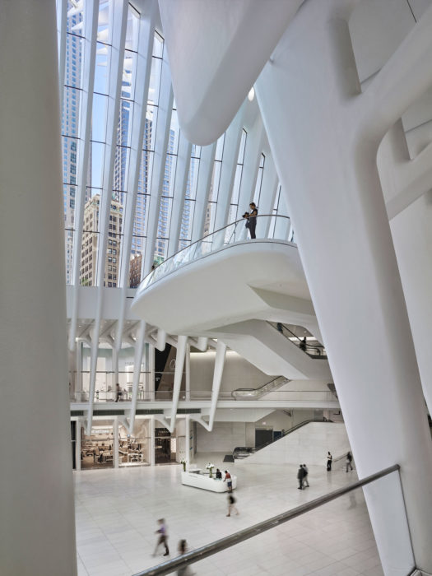

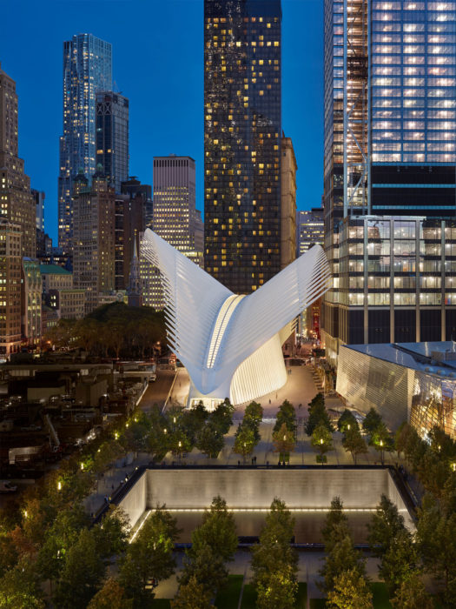

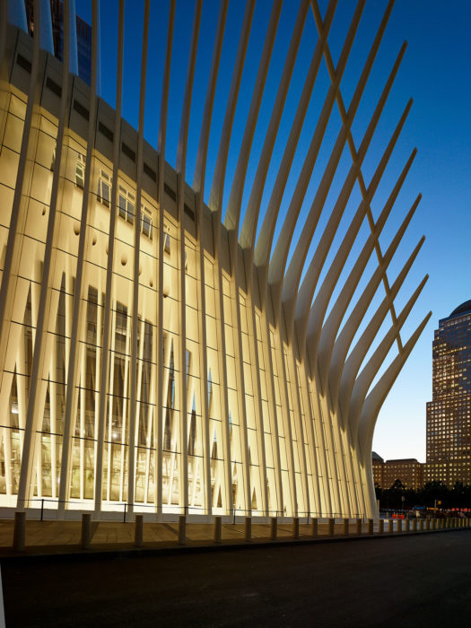

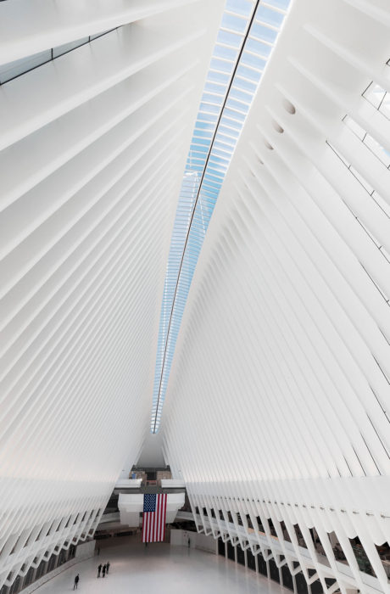

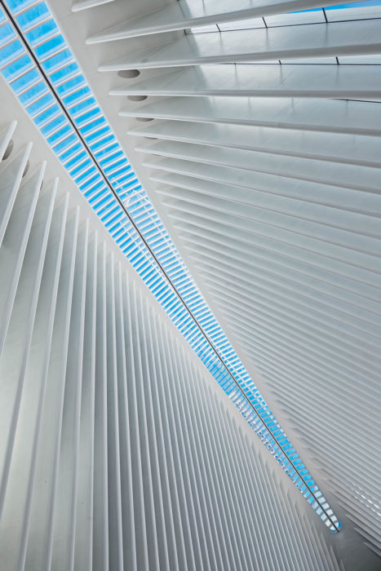

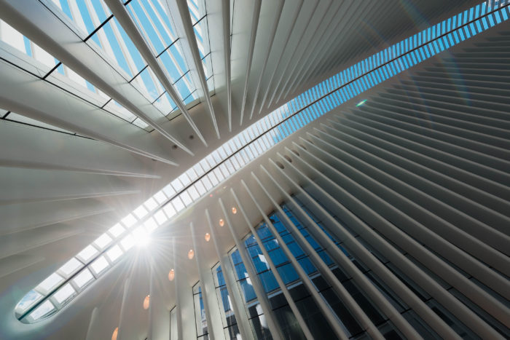

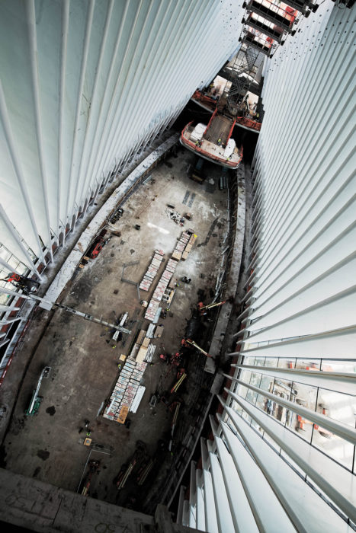

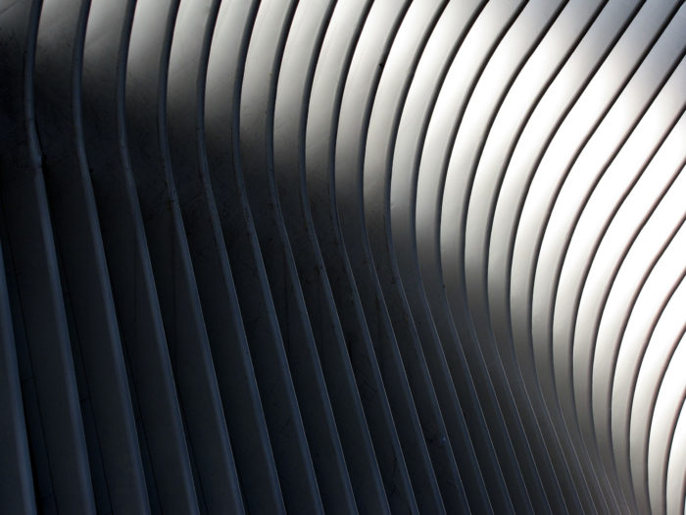

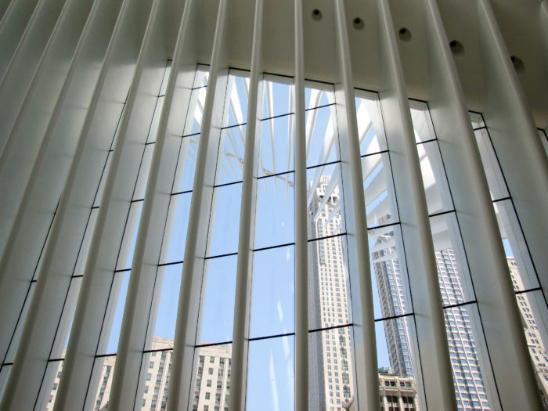

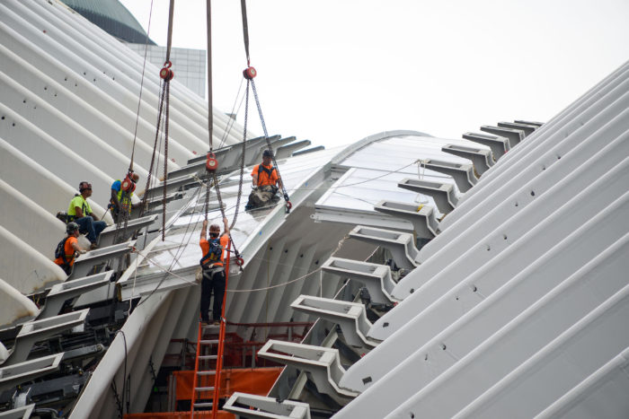

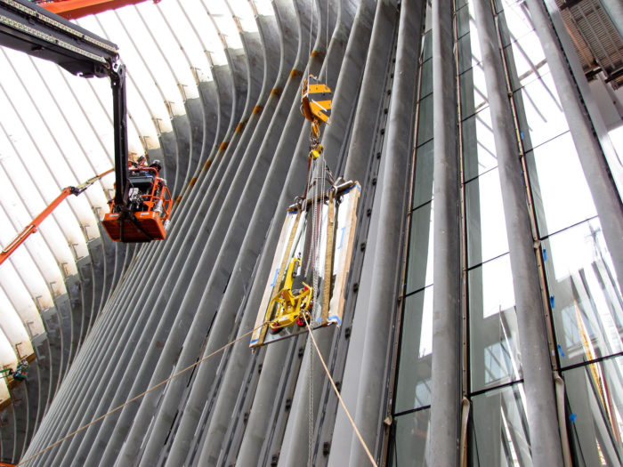

Photographs 1-5 by Alan Karchmer; photographs 6-9 by Whitney Starbuck Boykin; photographs 10-13 by Heintges.