***My Letter to America.***

***PDF available***[***here***](https://9af0ab83-7bde-48b7-80f9-33c34020b2dd.filesusr.com/ugd/f5ff08_6efcc41287794e49ae155642495da5b4.pdf?index=true)

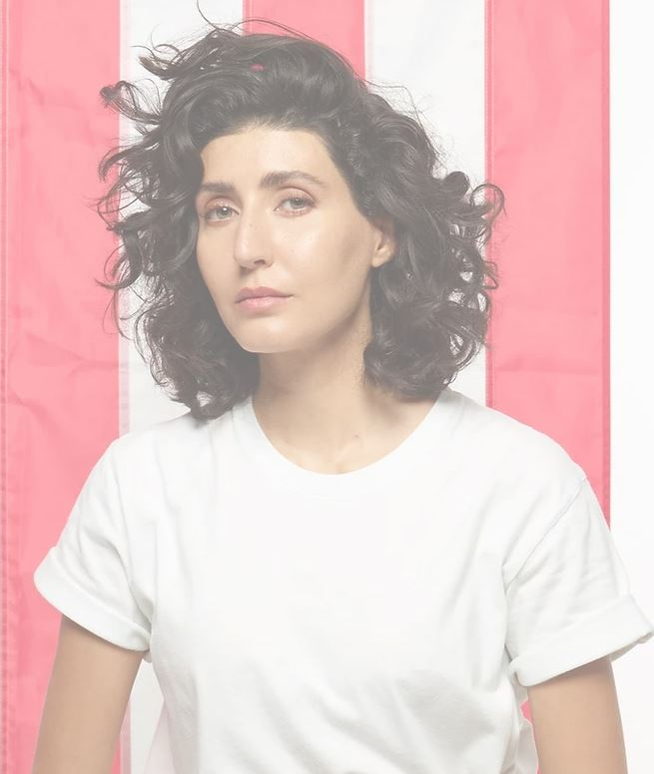

America

Two hundred and fourty-four years ago, the resolve, courage, and wisdom of your Founding Fathers forever changed the course of history. For the first time, with the ratification of your Declaration of Independence, mankind was offered an unmatched societal ideal and dignified way of life. Human beings were recognized for what we truly are by nature: all created free and equal, endowed with unalienable rights which do not derive from any government, but from our Creator. With your Constitution, your Founders sealed these God given rights, and protected them by instituting a limited form of self-government along with a robust justice system. This combination keeps the promise of freedom for future generations alive and allows for human injustices to be rectified.

This, America, is what makes your nation exceptional. It is why you have stood as a beacon of democracy and hope for all subjugated peoples over the past two centuries. During some of our darkest hours, we remember how you fought for those who couldn’t defend themselves from tyranny, at the cost of your own brave men. The world is forever in debt for your sacrifice, and we are grateful for the refuge you provide those who can flee persecution.

This, America, is your heritage and the reason we still look to you as our champion of liberty to this day. Those currently fighting for their freedoms across the world value the plight of your brave Founding Fathers who forever inked the model to which we can hold our governments accountable. From the peaceful Hong Kong protesters who proudly brandish the American flag in the streets, to the Iranian students who refused to walk over a painted version of it on the ground of a Tehran university, people who live under oppressive regimes know first hand that being free has no price. And they know that America is the ultimate shelter for the downtrodden.

Watching the gratuitous violence, streets burn, buildings and statues being defaced in America over these past months, I am heartbroken to see how an entire generation was successfully brainwashed into hating the very nation that has yielded the most freedom, justice and equality anywhere in the world.

I am also highly distressed by the blatant erosion at various levels of your most basic individual rights and freedoms as guaranteed by your Bill of Rights, from arbitrary censorship of speech to unlawful, politically motivated abuses of justice.

America, this is why I feel compelled to address you. Though I am an unlikely messenger at first glance, rest assured that the name that I carry is antithetical to the values I hold, and that my heart is in the right place: with you. The level of urgency coupled with the available platform granted by my circumstance bound me to speak up and warn you before it is too late.

The question is, how did we get to this point? They want you to believe that this is a recent phenomenon. The truth is that the undoing of America has been decades in the making. The globalists, Deep State, swamp, whichever name you call them, have been hard at work to weaken America’s sovereignty and standing as world leader. Intent on erecting a new system of world governance where they would be in total control, they are seeking to undermine the fundamental principle of your country, “a government for the people by the people”, replacing it instead with a world order of international institutions ultimately puppeteered by a caste of technocrats, oligarchs and international bankers.

Though your Constitution stands firmly in their way, it never deterred them. Like a trojan horse, they infiltrated governmental and intelligence agencies, and all realms of society - education, media, entertainment, culture. At their disposal, tools of mass population influence: propaganda, fake news and censorship. By pushing their marxist-socialist progressive agenda for years, they set out to destroy your fundamental values and divide you. They negated God, dissolved the family unit and dissevered us from moral objectivity, effectively leaving a vacuum of degeneracy, cognitive dissonance and absurdity in its wake. Yuri Bezmenov tried to warn us. This social engineering operation took place as we were lulled into a sense of comfort and complacency due to modernity’s technological progress and liberalism’s appeal. In reality we were being driven further down a path of enslavement while they solidified their plans for a covert power grab.

However, they didn’t count on a great awakening of people tired of being crushed by their self-serving economic policies. Nor did they foresee that COVID-19 would highlight their system’s gross failings, from an over dependence on a global supply chain to corruption in major institutions like the World Health Organization. They didn’t anticipate that we would all rally online to share information and real news, bypassing their controlled mainstream media outlets. Above all, they never thought Hillary Clinton would lose.

Since President Trump’s victory, these nefarious forces have done everything in their power to stop him from reversing past administrations’ destructive policies. They have failed, hoax after hoax. Despite their relentless attacks on all fronts, President Trump has demonstrated he is the only leader who can save us from a bleak future. As evidenced by his first term, results of his America First policy speak for themselves.

Domestically, he removed handicapping regulations to American economic growth; rebuilt a depleted military; brought back manufacturing and revamped dying industries by renegotiating trade deals and cutting taxes; achieved energy independence; curbed immigration - all of which contributed to setting record unemployment rates. He also saved your tax payer dollars by withdrawing from corrupt international organizations and agreements. Remarkably, he tackled neglected issues such as human trafficking and unjust incarceration; defunded Planned Parenthood; took care of your disregarded veterans; lowered prescription drug prices. All these undertakings prove just how much he values the lives and wellbeing of ALL Americans.

By strengthening America from within, President Trump bolstered his plans when it comes to foreign policy, and thanks to his vision and tactical use of diplomatic avenues, has made the world a much safer place since taking office. To name a few achievements: he stood up to China, kept us out of new wars, made Europe comply with their NATO requirements, solidified ties with Israel, overturned the disastrous Iran deal, obliterated ISIS, took down other key terrorists, and facilitated a historic peace deal between Israel and the UAE. His administration has also made Christian persecution worldwide a top priority with the State Department instituting the Ministerial to Advance Religious Freedom, the first of its kind.

With President Trump at her helm, America stands a chance at restoring her principles, pride, independence and true place in the world as beacon of liberty and hope for all. This to me, is what “Make America Great Again” means. Looking back at your country’s foundation, and preserving what makes it truly GREAT. But also knowing that the best is yet to come.

All the above achievements will be torpedoed with a Biden/Harris presidency, and the dream of America’s enemies to see her weak and on her knees would be fulfilled. Make no mistake America, you are under attack. Supported by the fake news propaganda machine and violent marxists groups such as Antifa with their ISIS-type tactics, they have pushed their agenda through fearmongering, hypocrisy, lies and destruction onto you, the American people, and for one motive only: power. The escalation of the past four years is your preview of what to expect should we lose: an abject repudiation of our Judeo-Christian values and utter disregard for your individual rights. This insurrection if successful, would sign the unravelling of law and order and the end of your Republic as we know it. Tyranny would inevitably ensue.

America, you are at the very edge of the precipice. Please wake up! Take hold! Fight for your country, and be proud of your roots! Uphold your values. Stand for your flag and your anthem. Defend your history. Don’t relent in the face of those who seek to re-write it to serve their narrative and justify the destruction of your nation. You have much to cherish and protect for your sake, and ours.

We need you to stay the course, America. You are our last safeguard from an imminent civilisational collapse and if you lose, all humanity loses.

Be assured, we are with you in this decisive hour in your history. All of us freedom-seeking and loving people across the globe pray for you to succeed.

We are rooting for you and watching closely America, “for with |your] fate will the destiny of unborn Millions be involved.”

​

Your fellow patriot,

​

Noor Bin Ladin