**[Are The Jews God’s Chosen People?](http://www.ziopedia.org/articles/editorial/are_the_jews_god%27s_chosen_people?/)**

Friday, 27 February 2009 08:12 Andrew Winkler, The Rebel Media Group

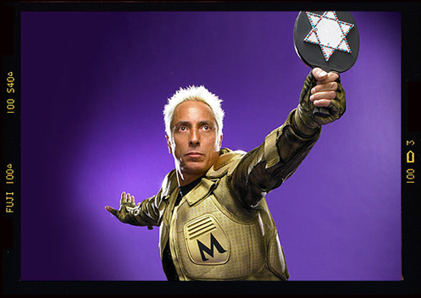

One misunderstanding that often confuses pious Christians and Judaics alike is the Judaic claim to be God’s ‘Chosen People’. The implied meaning is that the God Christians and Judaics share favours Judaics over all other human beings, giving them a privileged position.

The question I always ask, when confronted with that claim, is how that alleged favouritism is transferred from Biblical times’ Judaics to modern days Jews. Is it race or religion? This distinction is important because only a very small minority of modern days Jews, the so-called Oriental Jews, are the direct descendants of Biblical times’ Judaics. The majority of the descendants are today’s Palestinians. So if the ‘Chosen People’ status is transmitted genetically, then it is the Palestinians and not the Jews who are the chosen ones.

No, no, that’s impossible, is usually the shocked response to such ‘heretic’ thoughts. Imagine the consequences! It is, of course, the ‘Covenant’ between God and the Judaics, that makes them his ‘Chosen People’. In this religious contract the Judaics have undertaken to follow God’s law as layed down in what Christians call the Old Testament (OT).

My next question then is how God would feel if his Chosen People introduced thousands of new rules and exemptions to an extent that God’s original rules are no longer followed. Wouldn’t that break the ‘Covenant’ and make the Judaics loose their favourite status?

Of course, it would. Judaism has rejected the covenant by introducing the so-called oral tradition which was codified in form of the Babylonian Talmud after the destruction of the Jerusalem Temple. Anyone who has studied Judaism is aware of the fact that

* the Talmud has absolute priority over the OT,
* the Talmud is the most perverted and racist piece of hate literature ever written in human history,
* the Talmud systematically reinterprets the OT to an extent that what the OT ‘really means’, according to the rabbis’ teachings, and what Christians and Muslims believe have no resemblance what so ever, and
* that rabbis during their training spend more than 90% of their time studying the Talmud, and the rest is reserved for things like the sex-crazy black magic classic of the Cabala. The OT is only studied through the angle of what the Talmud teaches how to understand the OT.

According to traditional Christian teachings, the Judaics have lost their status as the Chosen People by rejecting God’s word in form of the OT in favour of the oral teachings of the rabbis which - most of the time - are in complete contradiction to what the OT says. Jesus got killed by the Judaics - either, as the Talmud describes in most gruesome detail, by the rabbis themselves, or by bullying the Romans into killing him - for rejecting the oral teachings of the rabbis.

If we follow the theory that the Chosen People is transferred via adherence to the Covenant, God’s law, Biblical times’ Judaics have lost the favourite status. By rejecting the oral tradition and refocusing on God’s law, the Christians have taken the place of the Judaics as the Chosen People. If modern days’ Jews want to regain God’s good-will, they have to reject the racist and pornographic oral traditions codified in the rabbinic concoctions of the Talmud and Cabala.

*Andrew Winkler is the founder and editor/publisher of dissident blog ZioPedia.org and independent news site RebelNews.org. You can read more of his writings in the editorial section of ZioPedia.org. Andrew can be contacted on*[*andrew@therebel.org*](mailto:andrew@therebel.org)

*This e-mail address is being protected from spambots. You need JavaScript enabled to view it  
<!–  
document.write( ‘</’ );  
document.write( ’span>’ );  
//–>*

Source: [ZioPedia.org](http://www.ziopedia.org/articles/editorial/are_the_jews_god%27s_chosen_people?/)