This Note’s for You

Neil Young & The Bluenotes
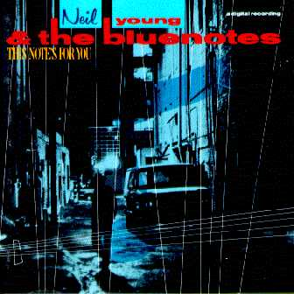
This Note's For You was released in April 1988 by Neil Young & The Blue Notes. Primary musicians on this album were:
- Neil Young: Vocals, guitar
- Chad Cromwell: Drums
- Rick Rosas: Bass
- Frank Sampedro: Keyboards
- Steve Lawrence: Lead tenor saxophone
- Ben Keith: Alto saxophone
- Larry Cragg: Baritone saxophone
- Claude Cailliet: Trombone
- John Fumo: Trumpet
- Tom Bray: Trumpet
Secondary musicians were:
- Ralph Molina: Drums on "One Thing"
- George Whitsell: Bass on "One Thing"
- Steve Onsuka: Harmonica
During the period Neil worked with the Blue Notes, they also recorded live material for a planned live album called Blue Note Cafe. Two songs were released on Lucky Thirteen. Neil wrote and performed several songs that have remained unreleased to this day during the Blue Notes period, Most notable are the unreleased 12 minute epic "Ordinary People" and the 20 minute, 12 verse "Sixty To Zero" (a seven minute snippet of which was released as "Crime In The City" on Freedom).

