Unplugged 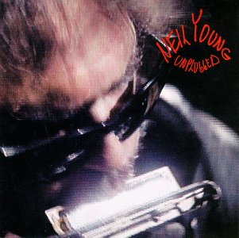
The official release of Neil Young's MTV Unplugged was in June 1993. He performed 5 more songs which never made it onto the recording. They were : "Tonight's The Night", "Dreamin' Man", "Sample & Hold", "War Of Man", & "Winterlong". Providing additional vocals were Neil's sister Astrid Young, Nicolette Larson & Nils Lofgren. There was a first attempt at an Unplugged concert in December 1992 at the Ed Sullivan Theatre in New York. Neil was by himself & did false starts & several versions of almost every song before walking out, scrapping the concert.

