Road Rock (Friends & relatives)
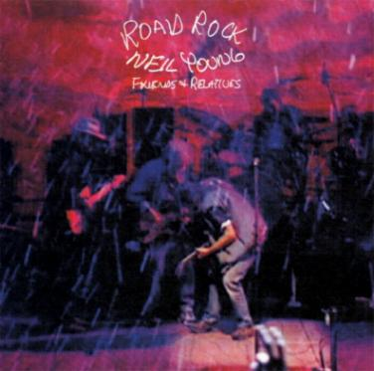
Road Rock (Friends & Relatives) was released on December 5, 2000 by Neil Young & the "Friends & Relatives Band".
Primary musicians on this effort include:
- Neil Young: Vocals, Guitars & Piano
- Ben Keith: Guitar, Lap Slide Guitar, Pedal Steel Guitar & Vocals
- Spooner Oldham: Piano, Electric Piano & Organ
- Donald Dunn: Bass
- Jim Keltner: Drums & Percussion
- Pegi Young: Vocals
- Astrid Young: Vocals
* Chrissie Hynde played guitar & vocals on "All Along The Watchtower"
Road Rock is a culmination of Neil Young's 2000 U.S Summer gigs with the "Friends & Relatives Band".
Pegi Young is Neil's wife, Astrid Young is Neil's half-sister.
The Pretenders & Chrissie Hynde's band, were the opening act on the tour, explaining her appearance on this album.
“Fool For Your Love" was last performed on the 1988 Bluenotes tour.
"Walk On" and "Peace Of Mind" were last performed in the 1970's. Neil has never before performed "Words" live yet played it on every show on this tour.

Songs:
- Cowgirl In The Sand [18:00]
- Walk On [4:30]
- Fool For Your Love [4:02]
- Peace of Mind [5:00]
- Words [11:00]
- Motorcycle Mama [5:30]
- Tonight's The Night [10:00]
- All Along The Watchtower [7:50]

