<http://www.flatearthdoctrine.com/gov-admits-flat-earth/>

FLAT EARTH Government Doc #1

This document, CIA-RDP86-00513R001343720008-3, from the CIA contains information from the Soviet Union, perhaps, stolen. There are several different documents within this particular document, however, please pay close attention to the document on PDF pages 14 - 34.

Author: Kirillov, F.A.

Title: Dissertations Defended in the Scientific Council of the Institute of Physics of the Earth, Institute of Physics of the Atmosphere and Institute of Applied Geophysics, Ac.Sc USSR during the First Semester of 1957

Periodical: Izvestiya Akademim Nauk SSSR, Seriye Geofizicheskaya, 1957, No.12, pp. 1532 - 1536 (USSR).

The noteworthy items you will find in that particular section of that document include:

* Page #19: "firmament"
* Page #20: "near-sun," "flat earth," and "firmament"
* Page #32: Correlation established between earthquakes and light effects

To be fair, page 20 states "...derived on an assumption of a "flat" earth..." The reason the word "assumption" has to be used is because there does NOT exist any evidence that the earth is anything but FLAT. Thus, the earth HAS TO BE FLAT!

In another document, within this document, it is interesting to see how some scientists were already brainwashed into thinking they were living on a spinning ball and believed "Mars" to be a place that is habitable. Again, what was written on PDF page 60 is from a different author than what is written on PDF pages 14-34.

Page #60: "hypothese [hypotheses] on plant life on Mars"

[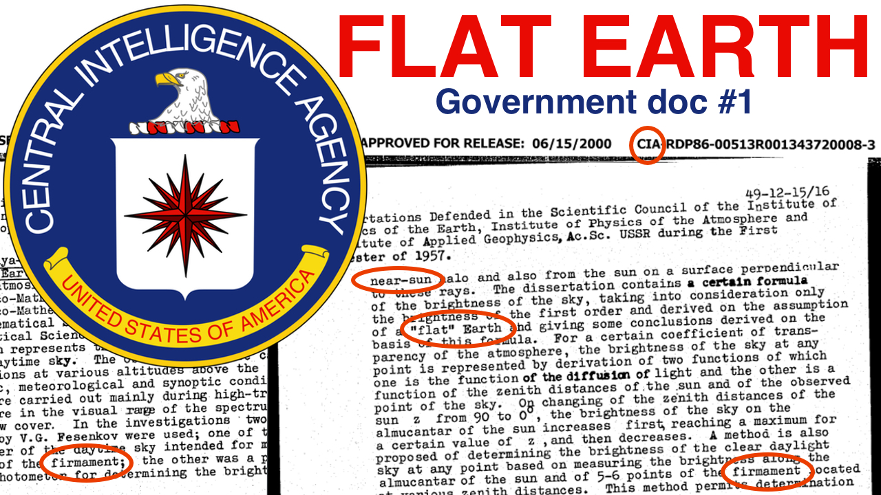](https://www.cia.gov/library/readingroom/document/cia-rdp86-00513r001343720008-3)

Click the graphic above to be taken directly to the source of information. The document is also available by [clicking here](https://drive.google.com/open?id=1KPgWYfrFc-A73CsfUPc2mfTeX59e1Obb).

## FLAT EARTH Government Doc #2

The title, Propagation of Electromagnetic Fields Over ***Flat Earth***, of this document, ARL-TR-2352, from the Army Research Laboratory speaks for itself. Enjoy!

Performing and Sponsoring Agency: U.S. Army Research Laboratory

Document Title: Propagation of Electromagnetic Fields Over Flat Earth

Performing Organization Report Number: ARL-TR-2352

Report Date: February 2001

Author: Joseph R. Miletta

"FLAT EARTH" is written 6 different times on the following pages of the doc:

* Page 1
* Page 7
* Page 14
* Page 17
* Page 18
* Page 28

[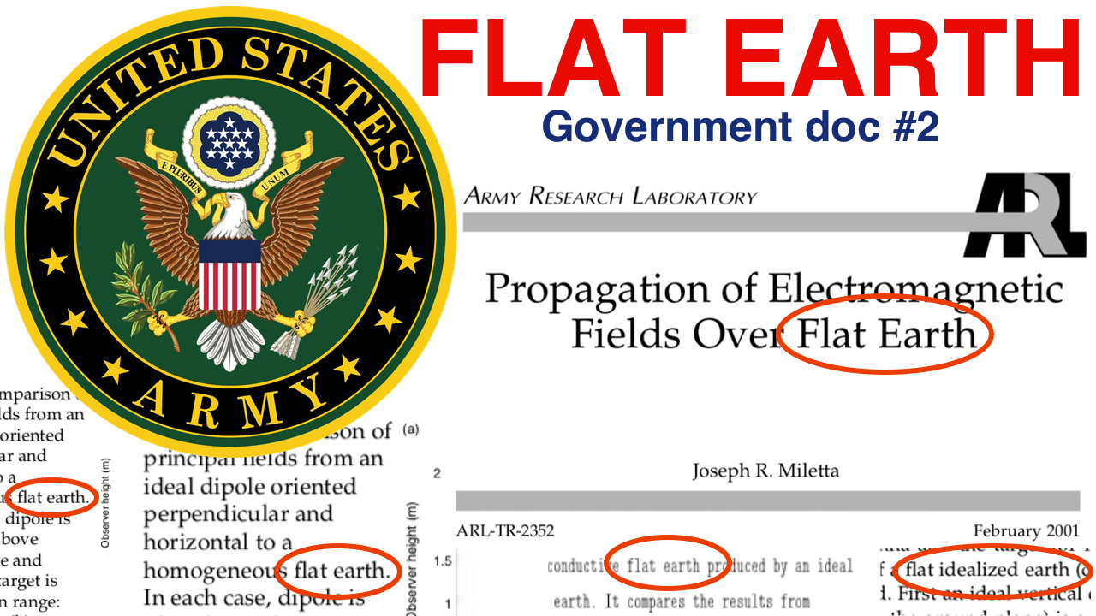](http://www.arl.army.mil/arlreports/2001/ARL-TR-2352.pdf)

Click the graphic above to be taken directly to the source of information. The document is also available by [clicking here](https://drive.google.com/open?id=1jQAYnNYl6-BsGxSofz7hlp4O41_UrrgI).

## FLAT EARTH Government Doc #3

Performing and Sponsoring Agency: U.S. Army Research Laboratory

Document Title: An Energy Budget Model to Calculate the Low Atmosphere  
Profiles of Effective Sound Speed at Night

Performing Organization Report Number: ARL-MR-563

Report Date: May 2003

Author: Arnold Tunick

While the phrase "flat earth" is used once in the document (PDF page 16), that is not the most interesting aspect to the document. The most interesting aspect to the document is found on PDF page 3 in the diagram illustrated by F.V. Hansen. The diagram reveals three key aspects to the reality of earth, of which, NONE work within a Heliocentric Universe model. Rather, they work only within a Flat Earth Universe model:

1. Near-sun
2. Crepuscular rays
3. Flat (level) earth

[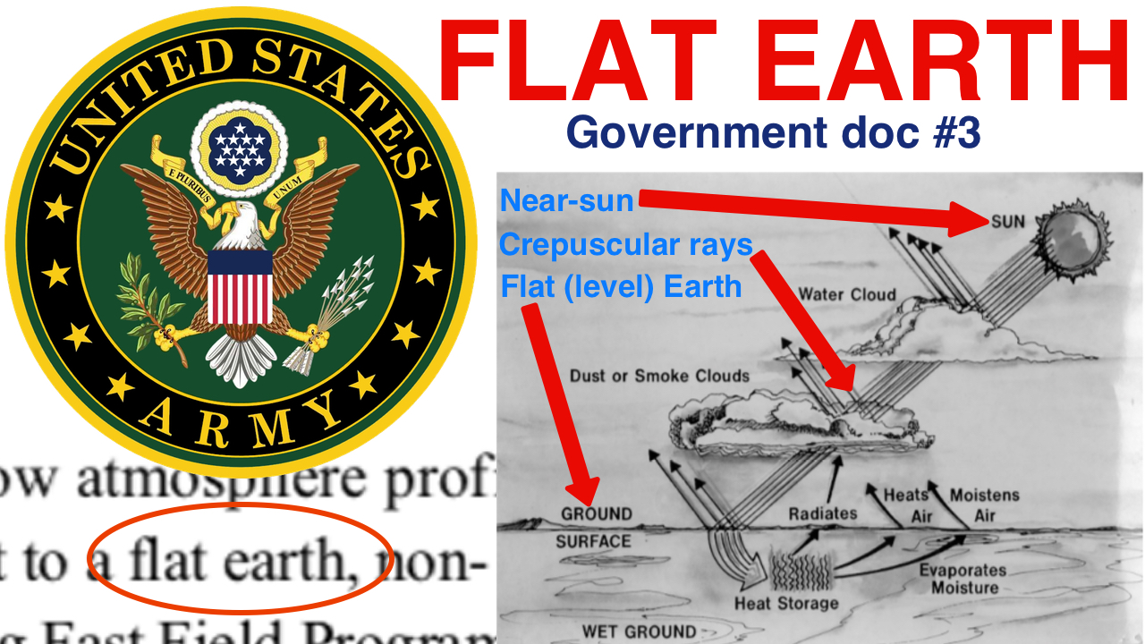](http://www.arl.army.mil/arlreports/2003/ARL-MR-563.pdf)

Click the graphic above to be taken directly to the source of information. The document is also available by [clicking here](https://drive.google.com/open?id=1X8dy9uoyEBqAYIVS7gnQM3vUl_1tPQxc).

## FLAT EARTH Government Doc #4

Performing and Sponsoring Agency: U.S. Army Research Laboratory

Document Title: Computationally Efficient Algorithms for Estimating the Angle of Arrival of Helicopters Using Acoustic Arrays

Performing Organization Report Number: ARL-TR-4998

Report Date: September 2009

Author: Geoffrey Goldman

The term "flat earth" is on the following PDF page numbers within the document:

* Page #17
* Page #30
* Page #31
* Page #35

[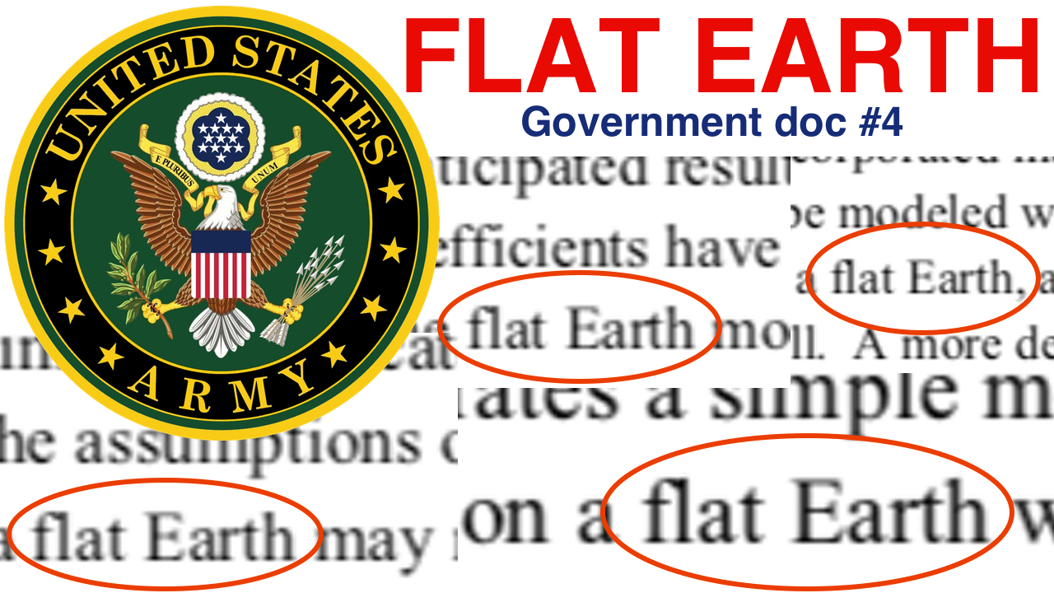](http://www.arl.army.mil/arlreports/2009/ARL-TR-4998.pdf)

Click the graphic above to be taken directly to the source of information. The document is also available by [clicking here](https://drive.google.com/file/d/1fbq-6zTfzRFUyPyXyEI_3MCXK5a1YbaQ/view?usp=sharing).

## FLAT EARTH Government Doc #5

Performing and Sponsoring Agency: U.S. Army Research Laboratory

Document Title: Adding Liquid Payloads Effects to the 6-DOF Trajectory of Spinning Projectiles

Performing Organization Report Number: ARL-TR-5118

Report Date: March 2010

Author: Gene R. Cooper

Many will scoff at the notion, minimize, or even completely dismiss the phrase "flat earth" in this document because the entirety of the statement includes the word "assume."

*"These equations assume a****flat earth****."* (PDF page #7)

Dismissing the term "flat earth" because the word "assume" precedes it would be a grave error in one's logic and discernment. For the equations to falsely assume a "flat earth" would nullify the entire document. Either the Army has yet to figure-out how to determine "Adding Liquid Payloads Effects to the 6-DOF Trajectory of Spinning Projectiles" or they have figured it out within this document, given an assumed FLAT EARTH.

The reason the word "assume" has to be used is because there does NOT exist any evidence that the earth is anything but FLAT. Thus, the earth HAS TO BE FLAT!

A miss in this document, which should have been notated though was not, is to also assume a "non-rotating" earth. If there were a rotation to the earth, the equations within the document would have included it...though do NOT.

[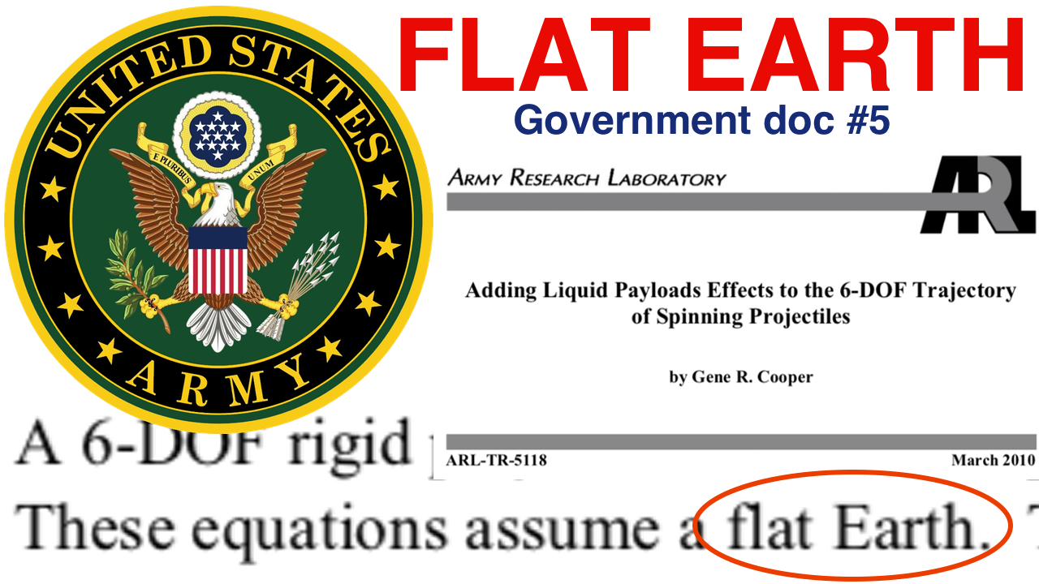](http://www.arl.army.mil/arlreports/2010/ARL-TR-5118.pdf)

Click the graphic above to be taken directly to the source of information. The document is also available by [clicking here](https://drive.google.com/open?id=1lR8XGn_zEL6OqYKck0HkUWD1znWk-7pg).

## FLAT EARTH Government Doc #6

Performing and Sponsoring Agency: U.S. Army Research Laboratory

Document Title: Trajectory Prediction of Spin-Stabilized Projectiles With a Steady Liquid Payload

Performing Organization Report Number: ARL-TR-5810

Report Date: November 2011

Author: Gene R. Cooper

Many will scoff at the notion, minimize, or even completely dismiss the phrase "flat earth" in this document because the entirety of the statement includes the word "assume."

*"These equations assume a****flat earth****."* (PDF page #10)

Dismissing the term "flat earth" because the word "assume" precedes it would be a grave error in one's logic and discernment. For the equations to falsely assume a "flat earth" would nullify the entire document. Either the Army has yet to figure-out how to determine the "Trajectory Prediction of Spin-Stablized Projectiles With a Steady Liquid Payload" or they have figured it out within this document, given an assumed FLAT EARTH.

The reason the word "assume" has to be used is because there does NOT exist any evidence that the earth is anything but FLAT. Thus, the earth HAS TO BE FLAT!

A miss in this document, which should have been notated though was not, is to also assume a "non-rotating" earth. If there were a rotation to the earth, the equations within the document would have included it...though do NOT.

[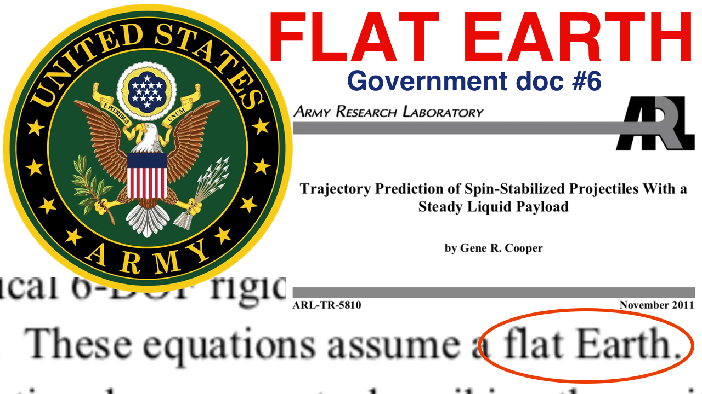](http://www.arl.army.mil/arlreports/2011/ARL-TR-5810.pdf)

Click the graphic above to be taken directly to the source of information. The document is also available by [clicking here](https://drive.google.com/open?id=1LITm2IwznMAmpHA9gggWGJRcCiL4MwiL).

Thank you to [Pastor Dean Odle](http://www.deanodle.org/) for doing the initial research and passing it along to me!