Bates method

Brief introduction
The Bates method is a system of natural vision improvement invented by William H. Bates, M. D. in the early part of this century. From his observations of patients who wear glasses, he came to a few conclusions. Eyesight can change, for either the better or the worse. Poor eyesight is caused by the strain to see. The way to better eyesight is through relaxation of both mind and body. Below, I shall detail the principal exercises of the Bates method. Practise them and you will be doing yourself a big favour.

Scientific validity
Despite its long history (and critics over the decades), no one has yet proven nor disproven the Bates method. To the best of my knowledge, there has been no long-term clinical trials on the Bates method. It may all sound very unsubstantiated and "alternative", but there has been thousands of anecdotal accounts of success. We must explore every possible weapon in the fight against the epidemic that is myopia. If there is a vision scientist or psychologist out there reading this, please propose a clinical study of the Bates method. The possible benefits are too big for us to ignore.

Palming

Background and rationale
"Palming" was originally a yoga technique. After Bates noticed its beneficial effects on the visual system, he "borrowed" it and incorporated into his system of vision improvement.
Palming works by calming the visual system. Our eyes see by receiving light signals. If there were no light entering the eyes, one should expect to see nothing. Instead, in eyes with defective eyesight, there appears swirling patches of colours, creating pictures where there should be none. This is a symptom of the eyestrain causing defective vision.
The act of palming makes people aware of the strain. The warmth from the hands helps relaxes the tense eyeballs. Some people claim to be able to the "inner energy" or "chi" emanating from the palms. I think we can safely dismiss those claims.

How to do
Place your palms over your closed eyes, letting the fingers cross over at the forehead. Slightly cup your palms such that you are not pressingon the eyeballs. Feel the warmth of the hands ra diate and diffuse gently into your eyeballs. Think of the most peaceful scene that you can imagine. Relax...

A few things to note
- Do not press against the eyeballs with your palms. This will put pressure on the blood vessels in the eyeballs and reduce circulation of blood and nutrients.
- Make sure that as much light as possible is blocked out by the palms. The exact position of the palms is up to the individual. Crossing the fingers at the forehead usually helps.
- Put yourself in a comfortable and proper posture e.g. don't slouch
- Remember to keep your eyes closed, behind the palms.
- And keep your hands clean, otherwise there will be the attack of the pimples!
The most important thing is to relax. Of course, one can't try to relax. The harder you try, the more tense you become. The trick is to imagine pleasant scenery such as floating clouds in a blue sky, a peaceful sunrise at the top of the mountains.

Advantages of palming
- Physical and mental relaxation
- Relief of eye strain
- Can be used in conjunction with imagery

Physical and mental relaxation
At the beginning, you may see swirling colours or grey patches. As you relax, you will notice the visual field becoming blacker and blacker. This is a sign that both your mind and body have relaxed, and your visual system is working harmoniously. Once you are able to achieve perfect blackness, clarity returns.

Relieves eye strain
Do it as often as you can, whenever you feel that your eyes are tired. Palming helps a lot in refreshing bleary eyes.

Promotes visual imagery
While you are palming, you can visualise anything, as long as it doesn't cause stress. For example, you can visualise your plans for the today when you are lying in bed. Make the images as vivid and real as possible. Feel yourself getting drawn into the images that you conjure up in your mind.
This use of visual imagery activates your right-hemisphere and may increase creativity and promote imagination. ( By the way, a left-right dichotomy of the brain is too simplistic as there are many overlapping areas of functions i.e. the left can take over for the right and vice-versa. )
Palming | Centralisation | Sunning | Swinging | Test card practice

Centralisation
This is an exercise to promote correct use of the eye. More accurately, it should be named "vision habit" for the simple reason that you do this "exercise" throughout the day, not just during the session.
According to the structure of the eye, there is a small point known as the fovea centralis . This is where vision is sharpest: in the middle of the visual field straight in front of you. By centralisation, one should focus one's visual attention at a single point in front of you. When looking at an object for example, look at it part by part; bit by bit. Trying to see the entire scene clearly simultaneously is going beyond the limitations of the physical eye, thus creating strain, which is suposedly the root cause of bad eyesight.
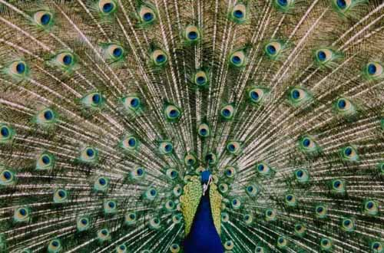
Focus at a single "eye", seeing only that one very clear and bright. Let all the other "eyes" become dull and soft. Move your gaze gently around the bright shining "eye".
When you have accomplished this, focus on a different "eye". Now, this will become bright and colourful while others become dull (including the first eye you looked at initially).
Have you tried the exercise? The experience of seeing only the central part of the visual field clearly is called "centralisation". Apply what you have learnt here to all waking hours. Make it a habit and encourage correct use of the eyes: an important part of vision improvement.
Palming | Centralisation | Sunning | Swinging | Test card practice

Sunning

Rationale
The Sun is important for our health. Sunshine enables us to manufacture the Vitamin D that we need. Eyes that have been deprived of sunshine are pale and lifeless. Extreme sensitivity to sunshine is called photophobia. People who are sensitive to light and glare usually solve their problem by wearing sunglasses. But is that a long-term solution or just a stop-gap measure?
Sunglasses prevent our eyes from getting adequate sunlight and causes even greater light sensitivity. The more we wear them, the more we are sensitive to light. Hence a vicious cycle develops.

Benefits of sunning
Bates recommend that we sun our eyes. We can reduce our sensitivity to light and sharpen our eyesight. Many people have reported that their vision improve after sunning. If you are worried about the effects of ultraviolet radiation causing skin cancer or cataracts, you don't have to worry if you go by the following guidelines :
- Only do sunning in the morning or evening, never during the hot afternoon sun.
- Do a moderate amount for each session. There is no need to sun your eyes until you are sun-burnt.

How to do sunning
Close your eyes and face the sun directly. Slowly move your head left and right to let the sunshine reach every part of your retina. Notice the sun moving in the opposite direction. Breathe deeply and slowly.
After this, you can do a variation. Imagine that your eyes shoot laser beams. Using your "eye lasers", trace around the edge of the sun. First do in a clockwise direction, then change direction.
After sunning, finish up the session by palming for about 2 minutes.
Palming | Centralisation | Sunning | Swinging | Test card practice

Swinging

Rationale
Bates postulated that one of the main culprits of bad eyesight is rigidity of the eyes. Staring is harmful for the eyes. The eye usually vibrates very quickly. This allows images formed on the retina of the eye to be sustained. If the retina is made motionless, either by injection of drugs or hard staring (try it for yourself if you are not convinced) , then visual images will fade and you will see an empty grey field instead. To break this habit of rigid staring, Bates used the technique of swinging to make the eyes mobile once again. There are a few variations of swinging:
- short swing ( move the head alone )
- long swing ( move the entire body )
In both techniques, the aim is the same. Try out the long swing to experience the feeling. Then you will understand.

How to do
Stand wth your feet shoulder-width apart. Face the front and do not move the head nor the eyes throughout the exercise. Gently swing your entire body towards the left, lifting your right heel as you do so. Once you have turned 90 degrees, stop. Did you notice that the room seems to be moving? As you move left, it appears to swing in the opposite direction, in this case right.
Now, gently swing towards the right, this time lifting the left heel but still keeping the foot on the ground. Stop once you turn 90 degrees. I know this can be a bit confusing (get your lefts and rights sorted out first!), but this is definitely worth the trouble to learn.

Benefits
- Relax your body, especially the spine and the eyes
- Teach your eyes to work properly
The swinging motion in the long swing loosens up the spine. The spine can store a lot of stress and tension after a hard day's work at the office. Do the long swing to un-creak those bones!
But the main benefit comes from seeing the scenery move in the opposite direction. If you don't do it correctly, the view will appear to swing in the same direction! Properly done, this will encourage relaxation of the eye, enabling to vibrate in a smooth and relaxed fashion.

Tips for doing the swing
Do not glaze your eyes nor look hard at the surroundings while doing the swing. Instead feel the illusion of the swing, let the world pass you by. When I first started doing the swing, I made the error of glazing my eyes, and focussed on nothing. I first realised this when I noticed double images during the swing, which meant that I was unconsciously crossing my eyes. So, do take note of this!
Palming | Centralisation | Sunning | Swinging | Test card practice

Eye exercises
Presented here are a series of eye exercises that promote relaxation of the eye, or strengthens and conditions them. There are some who claim that vision is "90% mental and 10% physical", but doing these exercises can provide relief for tired eyes.
The most notable example of eye exercises on a wide scale is that of China. Every morning, the schoolchildren and factory workers massage their eyes for a short while. And they do have a low incidence of myopia. But so many other factors come into play as well. Just consider the following questions: Can we compare China with industrialised countries? How about the undergraduate population? Does nutrition and lifestyle play a role? So eye exercises are no miracle cure, but may produce some results.
Call them what you will, exercises or games, come on! Stop staring at your computer screen and start doing them right now!
Note: The exercises stated below have no copyrights (expired long ago). They are common knowledge and should be treated as such. Free feel to tell all your friends and family about them! What may be a little bit more contentious are the names given to them by various authors of eyesight improvement books.

General tips when doing eye exercises
- Please take off your glasses or contact lenses, you will then feel more comfortable and relaxed.
- When doing the exercises, intensely concentrate on your eyes. Feel them working and coming to life again!
- Do them on a regular basis, e.g. ideally 3 times a day. The results will be better.
clock rotation | eye rolls | near / far focusing | blinking | palming

Clock rotation
Research has shown that the extraocular muscles play a role in the accommodation of the eye. The theory goes as follows: strengthen the muscles = clearer vision. You can try it for yourself, the results are usually quite noticeable even only after a minute.
Pretend that y ou are looking at the center a giant clockface straight ahead. Keeping your head still all the while, look up as far as possible towards the 12th O'clock position, hold for 2 seconds, then return to the original position. You must really feel the stretch in your eyeballs!
1st step (look at the vertical red arrow):
Look straight ahead - go to 12th O'clock - hold for 2 seconds - back to center
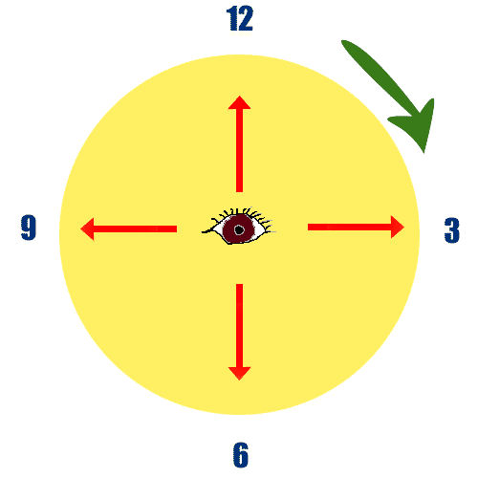
Next, do it for the 1 O'clock position, then 2 O'clock and so on. Always return to the center before moving on to the next hour. When you have finished one clockwise cycle (as indicated by the green arrow), do an anticlockwise cycle next.
This exercise will stretch your extraocular muscles, and will make them stronger and more flexible.
clock rotation | eye rolls | near / far focusing | blinking | palming

Eye rolls
This vision exercise is similar to the "clock rotation" exercise. Start from the 12 O'clock position, and slowly roll to the 1 O'clock place (without returning to the centre), then 2 o'clock and so on, until one whole cycle is completed.
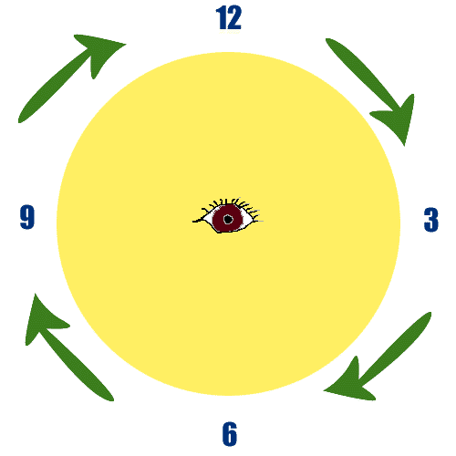
Remember to stretch as far out as possible all the time. Go slow, and do it properly. No prizes for the fastest roll in the West.
Again, this exercise puts your extraocular muscles through a good workout.
clock rotation | eye rolls | near / far focusing | blinking | palming

Near / far focusing
If you have read books on vision improvement before, you will know that they have been called many fanciful names before. But I will stick to one that conveys the essence of this exercise.
Near point stress has been quoted as a cause of myopia. It refers to the fact that people do too much near work, e.g. reading and computer. Near work causes the eyeballs to strain as they try to focus. As a result, the eyeballs adapts by changing its shape, becoming fatter and more circular.
This exercise will teach the eyeballs to return to its original shape, by simply by focusing near and far. Hold up a finger or a pencil in front of you, about 6 inches away. Choose a sailent object, e.g. a chimney, tree, flag etc. at least 20 feet (6 metres) away. These will be your near and far points respectively. Alternate between the near and far objects, looking at each for about 2 seconds at a time. Repeat until you feel your eyes really working, then persevere some more.
Simple?
clock rotation | eye rolls | near / far focusing | blinking | palming
The next 2 are not really exercises, more like relaxation techniques. Use them whenever you feel tired, have dry eyes, suffer from blurred vision.

Blinking
This one is a real help if you have dry eyes. Solution: produce more tears to moisten the eyes.
You can stimulate the tear ducts by squeezing your eyes shut really tightly. Then blink normally a few times, and squeeze again. Repeat a few times, and your eyes will feel more relaxed and comfortable.
clock rotation | eye rolls | near / far focusing | blinking | palming

Palming
This is when you cover your eyes with your palms. A few things to take note:
- Do not rest on the eyeballs directly. Only put pressure around the eye socket.
- Please make sure that your hands are clean. Introducing germs and bacteria to your eyes does not help matters much.
Gently cover your eyes so that you can see no light. In the darkness, you may see brief flashes of light. This is normal, and simply indicates the spontaneous firing of the neurones in your eyes. But if the light flashes are too intense, they may indicate that you are too tense. Loosen up a bit! Nobody's watching you.

