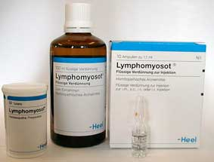
Complex homeopathy:
Complex or compound (antihomotoxic) homœopathy differs from classical homœopathy in so far that the latter will only prescribe one single remedy for one complaint. Complex homœopathy on the other hand takes the view that nowadays any complaint is based on several, concurring dysfunctions and consequently its prescriptions include several homœopathic remedies, phytotherapy remedies etcetera in any one tablet or dilution. Reportedly 80% of all homœopathic prescribing in Germany at this moment concerns complex (compound) homœopathy. The Heel® remedies used at Integrated Medicine Practice are manufactured in Germany and are fully licensed in Germany, Belgium, Spain and the USA. Heel preparations are distributed to physicians and pharmacists in over 55 countries.

Complex homœopathy can be used successfully for every age group and for many clinical conditions. Clinical trials on the most commonly used Heel remedies have been published in Biomedical Therapy, International Journal of Integrated Medicine; randomised trials on Traumeel® for instance have been published in The Lancet and other peer reviewed medical journals.

In chronic degenerative conditions patients are advised to have a Biological Terrain Screening first as this provides a solid platform for the use of antihomotoxic treatment. Because an often overlooked point is that Prof.Dr. Reckeweg MD stated that homœopathic remedies, either single or complex, are at its most effective only when applied to well nourished patients. A patient with a Pantothenic Acid, Pyridoxine, Magnesium and Zinc deficiency is unlikely to respond as well as a patient with a full deck of nutrients. For simple clinical cases a detailed interview & clinical examination usually provides sufficient information to prescribe along the principles of Prof.Dr. Reckeweg's Homotoxicology.

It is particularly wonderful to see how well children respond to (complex) homœopathy. When Han van de Braak's daughter developed febris e causa ignota and this did not subside 'quickly' enough, he gave her some allopathic antipyreticum because of fear of dehydration. Sure enough the fever subsided but within a week she developed otitis media with purulent otorrhœa. Homotoxicologists eat your hearts out! Swiftly she was given Lymphomyosot® orally, topically applied Traumeel® and Viburcol® suppositories. What we should have done in the first place of course, was to give her Belladonna-Homaccord®. That is called 20/20 hindsight as well as cobler's shoes...
Complex, antihomotoxic homœopathy truly is a remedy for all ages and for almost all clinical situations, recently an elderly lady was helped greatly in a grieving process by homœsinensis of Ignatia-Homaccord® + Tonico-Injeel®.

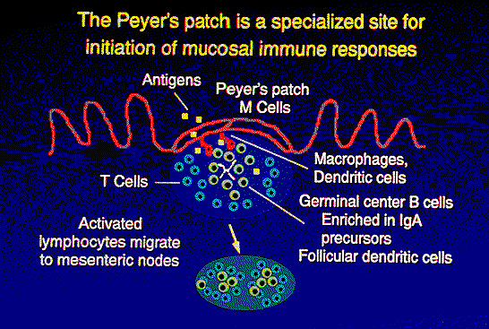
The immunity of children under the age of five largely depends on their Peyer's Patches. These are large aggregates of confluent lymphoid nodules present in the wall of the ileum; each patch is composed of approximately 10-200 nodules; there are roughly 30 patches in the adult; they are covered with epithelium composed of M (microfold) cells; these cells have numerous membrane invaginations that form pits and contain lymphocytes; the M cells take up microorganisms and foreign antigens and transport them to the underlying lymphocytes which then migrate to the lymph nodes where an immune response can be initiated; the Gut-Associated Lymphoid Tissue [GALT] also produces secretory IgA as a first line of defense. Prolonged or repeated prescriptions of antibiotics cause an imbalance of intestinal microbial flora which in turn diminishes the function of these Peyer's Patches. In conditions which are not immediately life threatening, one can afford to wait with the prescription of antibiotics and use antihomotoxic treatment first.
To facilitate the use of his homotoxicological system, Prof.Dr. Hans-Heinrich Reckeweg MD used familiar medical nomenclature to describe diseases which was a departure from classical homœopathy. This is why it is much easier to use for clinicians not trained as classical homœopaths. A central pillar of his formulas are the potency chords (standard = 12X, 30X, 200X) due to which the incidence of healing crises is greatly reduced; also the body makes use of the best suited potency within the chord. Special types of homœopathic medications are nosodes, suis-organ preparations, catalysts and homœopathically adjusted allopathic medications.
Antihomotoxic, complex homœopathic medications frequently contain active constituents in addition to the classical homœopathic remedies -i.e. besides the traditional homœopathic preparations from the plant, animal and mineral kingdoms. These additional agents serve the purpose of achieving more intensive therapeutic action. Antihomotoxic Biotherapeutic Preparations from Heel GmbH consists of:
Injeel® has a potency chord (12X, 30X, 200X) of a single remedy and offers a healing stimulus for a wide range of disorders. Injeel forte® is also a single remedy in multiple attenuations but has the lower potency 4X added to a normal Injeel which makes it better suited for acute conditions.
Nosode Preparations are homœopathic attenuations of pathogenic materials from humans or animals including tissues, serums, metabolic products or secretions, plus viruses, bacteria, fungi and parasites. Nosodes are sterilised to ensure safety from infection and are often used where a previous illness is suspected of being the cause of a current illness. In such cases the clinician attempts to reproduce a weak version of the original illness which the patient's defences will be able to overcome. Nosodes are particularly appropriate for application during the cellular phases. (see Homotoxicology)
Suis-Organ Preparations are homœopathic attenuations of healthy animal organs. Dr. Reckeweg preferred the use of suis-organs, derived from pigs, because of the biological similarity to human tissue. Homœopathic suis-organs improve the functioning of the corresponding human organ.
Intermediary Catalysts are generated during processes of cellular respiration (citric acid-acid cycle, redox systems) as well as in the course of other fermental-conversion processes in which they catalytically participate. In homœopathic attenuations they are important to homotoxicology since many impregnation phases begin with disturbances to cell respiration. Treatment using homœopathically attenuated catalysts provides a therapeutic stimulus aimed at specific functions in the cellular respiratory process. The result with all homœopathic catalysts is an unblocking of stalled metabolic pathways.
Homœopathically Adjusted Allopathic Remedies are used for the purpose of rectifying iatrogenic damage. All conventional drugs produce side effects. When the conventional drugs themselves are prepared in homœopathic dilutions, they become capable of counteracting the very side effects they originally caused.
Homaccord® combines the potency chords of two or three different single remedies, all mixed together. The standard potency chord for each Homaccord is 10X, 30X, 200X, 1000X a mixture which has effect on different levels of the patient's condition (low potency 2X-11X for physical level; middle potency 12X-30X for mental level; high potency >30X for emotional level). Due to their composition Homaccords® are especially suited for the treatment of chronic conditions.
Composita Preparations are complex formulas in which each ingredient appears only once, i.e. there are no potency chords. Composite preparations contain 10-15 or more individual ingredients, generally in low to middle potencies which makes them well suited for treating acute conditions.
Specialities are those complex medicines which fit in no other group.

