**9 in every 10 COVID Deaths over the last year have been among the Fully/Triple Vaccinated**

[**https://expose-news.com/2023/09/16/9-in-every-10-covid-deaths-over-the-last-year-have-been-among-the-fully-triple-vaccinated/**](https://expose-news.com/2023/09/16/9-in-every-10-covid-deaths-over-the-last-year-have-been-among-the-fully-triple-vaccinated/)

By [The Exposé](https://expose-news.com/author/the-expose/) on [September 16, 2023](https://expose-news.com/2023/09/16/9-in-every-10-covid-deaths-over-the-last-year-have-been-among-the-fully-triple-vaccinated/)

|  |
| --- |
|  |

**Official figures published by the UK Government reveal the fully/triple vaccinated population have accounted for over 9 in every 10 Covid-19 deaths in England over the past year, 91% of all Covid-19 deaths since the beginning of 2022, and 94% of all Covid-19 deaths since the beginning of April 2022.**

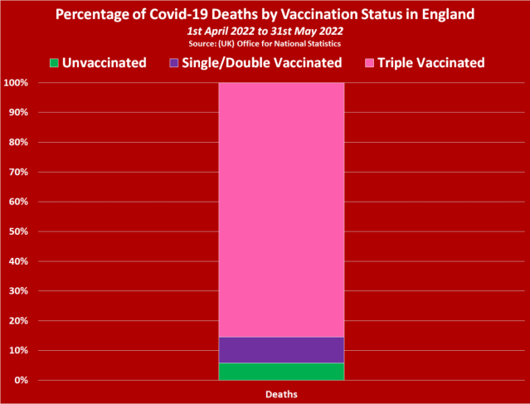

***Let’s not lose touch…Your Government and Big Tech are actively trying to censor the information reported by The Exposé to serve their own needs. Subscribe now to make sure you receive the latest uncensored news in your inbox…***

Top of Form

Type your email…

Bottom of Form

On the 6th July, a UK Government agency, known as the Office for National Statistics (ONS), published data on deaths by vaccination status in England up to 31st May 2022.

The latest dataset from the ONS is titled ‘[*Deaths by Vaccination Status, England, 1 January 2021 to 31 May 2022*](https://www.ons.gov.uk/file?uri=/peoplepopulationandcommunity/birthsdeathsandmarriages/deaths/datasets/deathsbyvaccinationstatusengland/deathsoccurringbetween1january2021and31may2022/referencetable06072022accessible.xlsx)‘, and it can be accessed on the ONS site [**here**](https://www.ons.gov.uk/peoplepopulationandcommunity/birthsdeathsandmarriages/deaths/datasets/deathsbyvaccinationstatusengland), and downloaded [**here**](https://www.ons.gov.uk/file?uri=/peoplepopulationandcommunity/birthsdeathsandmarriages/deaths/datasets/deathsbyvaccinationstatusengland/deathsoccurringbetween1january2021and31may2022/referencetable06072022accessible.xlsx).

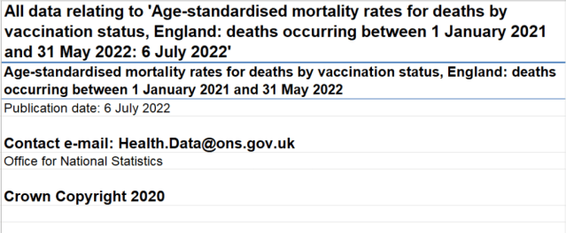[*Source*](https://www.ons.gov.uk/file?uri=/peoplepopulationandcommunity/birthsdeathsandmarriages/deaths/datasets/deathsbyvaccinationstatusengland/deathsoccurringbetween1january2021and31may2022/referencetable06072022accessible.xlsx)

Table 1 of the latest dataset contains figures on the mortality rates by vaccination status for all-cause deaths, deaths involving Covid-19, and deaths not involving Covid-19. And it is here that we are able to ascertain the vaccination status of everyone who has died of Covid-19 since the beginning of 2022.

Here’s how the ONS presents the figures for the month of January 2022 –

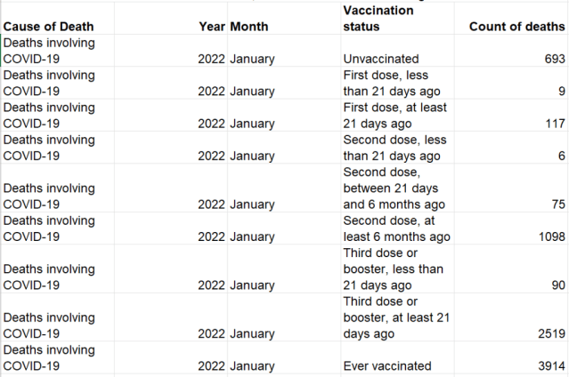

We’ve taken the figures provided by the ONS for an entire year, and have produced the following chart showing Covid-19 deaths per month by vaccination status in England between 1st June 2021 and 31st May 2022 –

[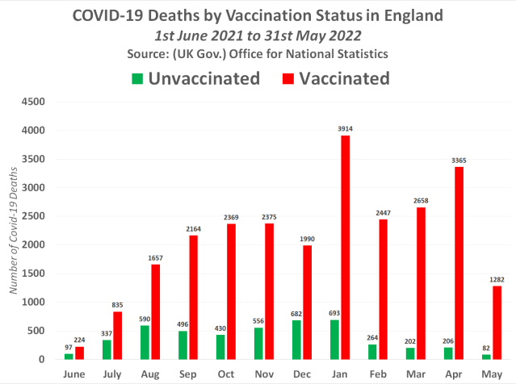](https://i0.wp.com/expose-news.com/wp-content/uploads/2022/08/image-18.png?ssl=1)*Click to enlarge*

January 2022 saw the most deaths among the vaccinated population and unvaccinated population with 3,914 deaths among the vaccinated and just 693 deaths among the unvaccinated. Whereas June 2021 saw the lowest number of deaths among the vaccinated population with 224 deaths.

However, the lowest number of deaths among the unvaccinated population occurred in May 2022, with 82 deaths. For context, the vaccinated population recorded 1,282 deaths during the same month. This means the vaccinated accounted for 94% of all Covid-19 deaths during the most recent month.

[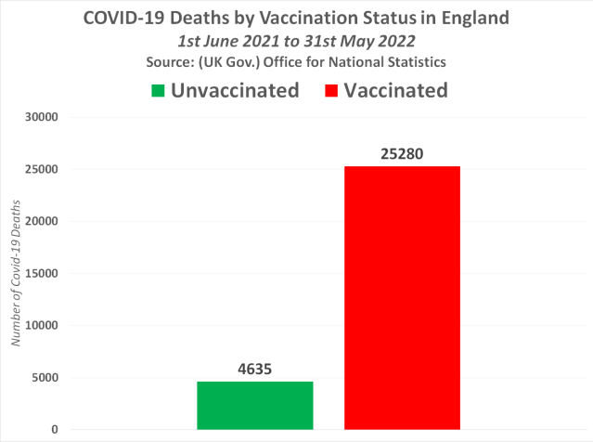](https://i0.wp.com/expose-news.com/wp-content/uploads/2022/08/image-20.png?ssl=1)

In all, there were 29,915 Covid-19 deaths in England between 1st June 2021 and 31st May 2022, and 25,280 of those deaths were among the vaccinated population, while just 4,635 deaths were among the unvaccinated population. This means the fully vaccinated population have accounted for 85% / 9 in every 10 Covid-19 deaths over the past twelve months.

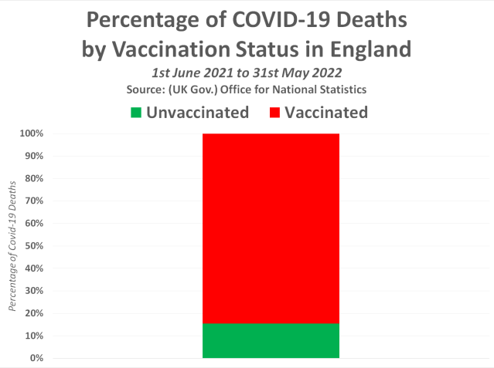

Unfortunately, the mass Booster campaign in winter 2022 has done absolutely nothing to alleviate the huge number of deaths among the vaccinated population. In all honesty, the data suggests that the booster campaign actually made things worse.

The following chart shows Covid-19 deaths by vaccination status in England between 1st January and 31st May 2022 –

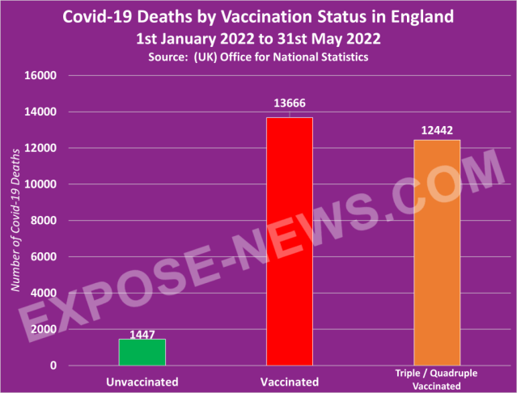

Overall, there were 15,113 Covid-19 deaths by 31st May 2022, and a shocking 13,666 of those deaths were among the vaccinated population. But what’s even more shocking than this is that 12,442 of those deaths were among the triple/quadruple vaccinated population.

This means the triple/quadruple vaccinated population have accounted for a frightening 91% of all Covid-19 deaths among the vaccinated since the beginning of 2022.

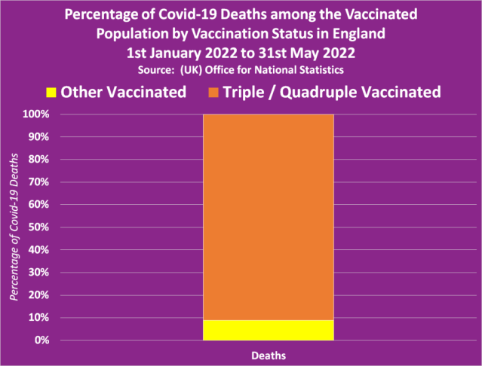

Unfortunately, the fourth dose that has been quietly rolled out since Spring shows no signs of having improved the terrible situation either.

The following chart shows Covid-19 deaths by vaccination status in England between 1st April and 31st May 2022 –

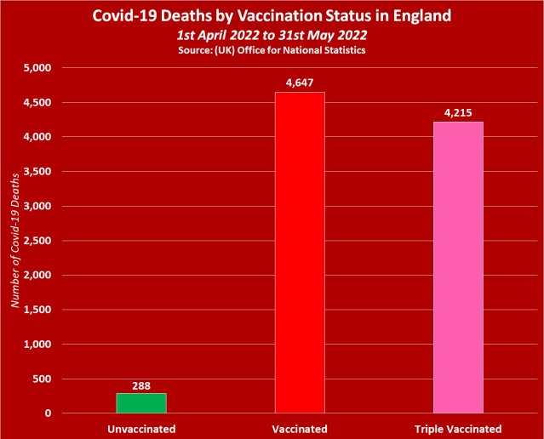

In all, according to the ONS, there were 4,935 Covid-19 deaths over these two months, and the vaccinated population accounted for a shocking 4,647 of those deaths. But what’s even more shocking is that the triple vaccinated accounted for 4,216 of those deaths, with just 288 deaths recorded among the unvaccinated population.

The following chart shows the percentage of Covid-19 deaths by vaccination status in England between 1st April and 31st May 2022, according to the latest ONS dataset published just hours before Boris Johnson’s resignation –

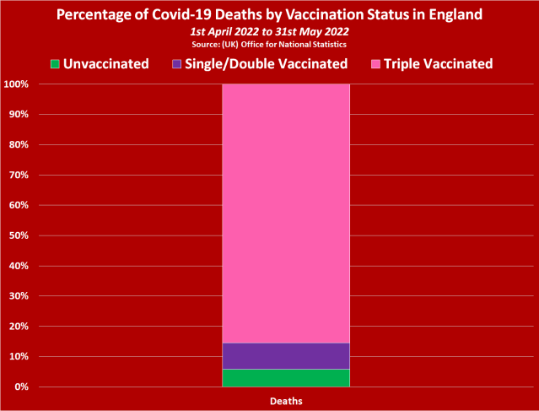

The quietly published figures reveal that the vaccinated population as a whole accounted for a shocking 94% of all Covid-19 deaths in April and May 2022, with the unvaccinated accounting for just 6% of all Covid-19 deaths. But the most horrific statistic here is that 90% of the deaths among the vaccinated were among people who had been given at least three doses of a Covid-19 injection.

These aren’t the kind of figures you would expect to see if the Covid-19 injections really are up to 95% effective at preventing death, are they?

With news like this being swept under the rug by the mainstream media, it makes you wonder what else you are not being told…