**After 440,000 Americans are Dead – Facebook and American Journal of Medicine Admit Their Stand on HCQ was Wrong — These People Should be Prosecuted!**

<https://www.thegatewaypundit.com/2021/01/440000-americans-dead-facebook-american-journal-medicine-admit-stand-hcq-wrong-people-prosecuted/>

Back in August 2020 [we wrote this](https://www.thegatewaypundit.com/2020/08/stunning-proof-hcq-saved-tens-thousands-lives-us-coronavirus-land-dr-fauci-prison/) on treating the coronavirus–

**The liberal mainstream media can’t hide this truth from the American public forever.**

**The** [**latest international testing**](https://c19study.com/) **of hydroxychloroquine treatment of coronavirus shows countries that had early use of the drug had a 79% lower mortality rate than countries that banned the use of the safe malaria drug.**

Advertisement - story continues below

**This means that Dr. Fauci, Dr. Birx, the CDC, the liberal fake news media and the tech giants have been pushing a lie that has had deadly consequences!**

America had lost (reportedly) over 150,000 lives at that time.

**TRENDING:** [DC Officials Announce Plans to Erect Permanent Security Fence Around US Capitol - In Same Week Democrats Ended Construction of Border Security Fence](https://www.thegatewaypundit.com/2021/01/pelosis-house-dc-officials-announce-plans-erect-permanent-security-fence-around-us-capitol-week-democrats-ended-construction-border-security-fence/)

Today [that number](https://www.worldometers.info/coronavirus/) is at 440,000.

**We now know that that number could have been lowered significantly if HCQ use would have been promoted in the US!**

Advertisement - story continues below

A new study posted in the [American Journal of Medicine](https://www.amjmed.com/article/S0002-9343(20)30673-2/fulltext) in January found that early treatment of coronavirus patients with hydroxychloroquine lowered the mortality rate for the disease.

The study found that immediate use of HCQ, while the patient was still at home, showed significant benefits.

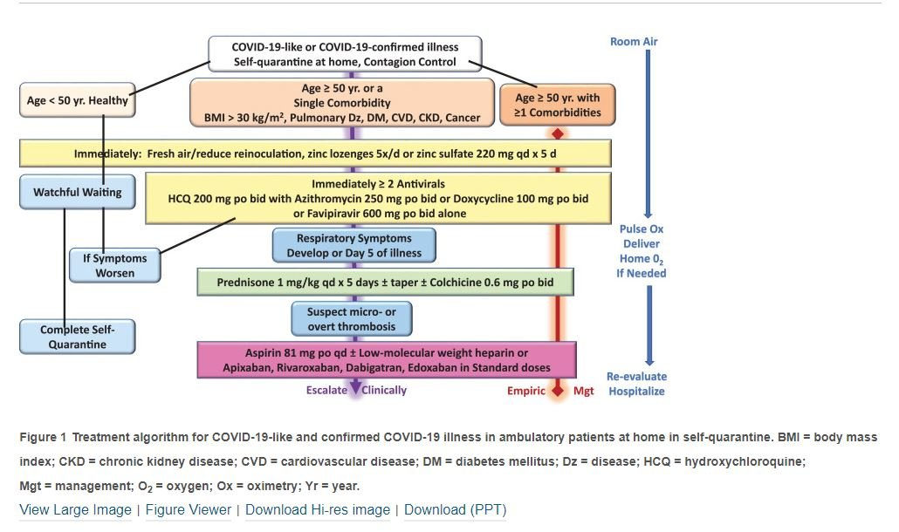

This is just the latest study that shows the effectiveness of HCQ in treating the coronavirus.

For the past several months the website [c19study.com](https://c19study.com/) has been tracking the HCQ-coronavirus studies.

Advertisement - story continues below

According to [c19study.com](https://c19study.com/) there have been 237 studies, 171 of which were peer reviewed that show 67% of patients improved in early treatment trials.

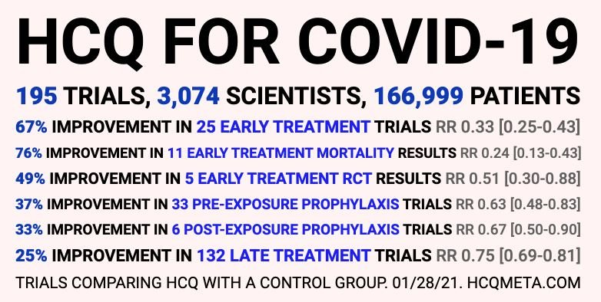

Also today the [Facebook Oversight Board](https://oversightboard.com/news/325131635492891-oversight-board-overturns-facebook-decision-case-2020-006-fb-fbr/) announced it was overturning a previous case on the effectiveness of HCQ.

Facebook’s previously removed a post on the use of hydroxychloroquine in France which it claimed, “contributes to the risk of imminent… physical harm.”

Advertisement - story continues below

Today Facebook announced this was a mistake.

### ****How many hundreds of thousands of victims were killed due to Dr. Fauci, the CDC and the tech giants’ false claims on hydroxychloroquine?****

### ****The jihad against HCQ was to get back at Trump. Hundreds of thousands of Americans are dead today!****

### ****When will these people face justice?****

====================================================================================================================================