**Attorney Reiner Fuellmich - The COVID Criminals Run Free While he is 10 Months In Prison Aug 14 2024**

[**https://mail.yahoo.com/d/folders/1/messages/ADDwN145EtVuZruZ8wx_OMvBMt8?reason=invalid_crumb**](https://mail.yahoo.com/d/folders/1/messages/ADDwN145EtVuZruZ8wx_OMvBMt8?reason=invalid_crumb)

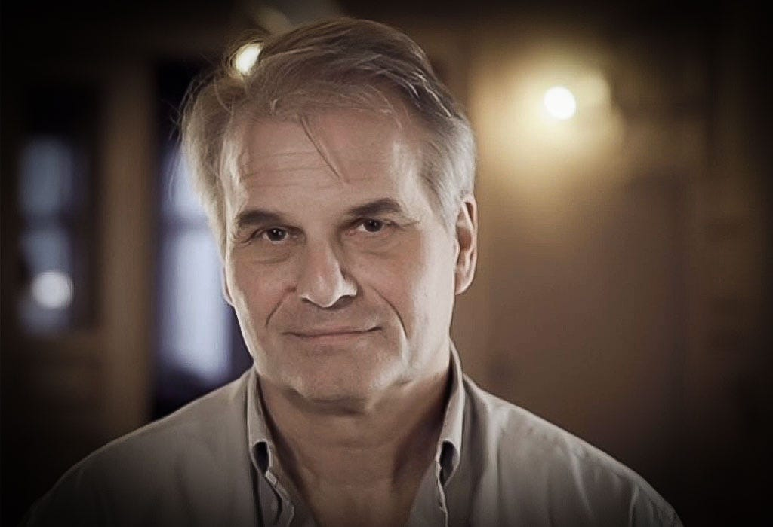

**Reiner Fuellmich**is a German attorney who has licenses to practice law in both Germany and the United States. He has been a champion of the people in Germany where he took on corporate giants such as Deutsche Bank for mortgage fraud and Volkswagen for emissions scandal and bested them in court trials. Today, he still languishes in prison on what appears to be fabricated charges.

Reiner set up a Corona Investigative Committee where he interviewed over 150 professionals including doctors and experts on the Covid-19 pandemic. He was preparing for a Nuremberg II hearing on Crimes Against Humanity similar to hearings held after WW II to hold Nazi criminals accountable.  Problem, the global fascists are presently in control and did not like that possibility of being investigated, indicted and arrested. The Truth is their enemy.

**Hear from Reiner himself,** [https://rumble.com/v5accd1-new-world-order-justice-system.html](https://substack.com/redirect/bd8dae4b-cce0-4a9b-bb5b-249559dfed99?j=eyJ1IjoiMTlqNTBzIn0.2UMHzUv2Iu1BLIkr_FHgbMu4c5Wa8op2Xe8hGq-NZsg)

Reiner had a property in California were he had moved and was licensed to practice law there.  He and his wife were on a speaking engagement in England and upon returning via Mexico, he was not allowed by the Biden administration to re-enter the United States, as he was considered anathema and a threat to the established Covid-19 narrative.  While in Mexico, he and his wife lost their passports.  Receiving assurances in Mexico at the German Embassy that new pass ports would be generated, he was arrested upon returning for the passport and whisked out of Mexico by German authorities who brought him back to Germany on arrest warrants that he had no idea about. This  government action appears to be an illegal international kidnapping. He was put in prison on October 12, 2023 and still languishes there 10 months later.

Apparently, members of the Corona Committee turned on him and created a scandal concerning missing money.  However, there appears to be no money missing on account of Reiner and serious questions of integrity involving the accusers of Reiner.

While public attention has been re-focused from the Covid-19 scam and deadly plot of global gangsters to Reiner's alleged misdeeds, Reiner faces a hostile judiciary and prosecution in Germany with-holding evidence supporting Reiner's innocents and is confined to prison without a bail.

Reiner has been a friend to both the National American Renaissance Movement and the Lawyers' Committee for 9/11 Inquiry, where he has given talks.  His kidnapping and  incarceration without a bail is an outrage while real Covid-19 criminals remain protected by a corrupted and inept judicial and law enforcement system world-wide.

The National American Renaissance Movement has worked diligently sending 25 custom-made Grand Jury petitions to the Governors and Attorney Generals of 25 states requesting a criminal investigation and an immediate ban of the Coivid-19 vaccinations. Until someone is investigated and indicted for the Covid-19 crimes the world's population is in grave danger because these crimes will be repeated with impunity and innocent and courageous freedom-fighters like Reiner will be imprisoned while global gangsters laugh at the inept public and count their money.

The substack, "Truth Summit" written by Elsa seems like a reputable reporting outlet for Reiner's trial.

Here is the address to write to Reiner:

**LETTERS;**  
JVA Rosdorf  
Dr. Reiner Fuellmich  
Am Grossen Sieke 8  
37124 Rosdorf  
Germany

* postcards and cards allowed,
* no glitter on the envelops,
* no stamps or money in the envelops,
* no books or other objects - not permitted,
* nothing to be mentioned about the case - though now, according to the latest information, his mail is no longer scanned,
* put your name of each page of the letter, just in case - though at present letters are no longer taken out of the envelops.

Here is a link where you can send a donation for his legal assistance.

[https://www.givesendgo.com/GBBX2](https://substack.com/redirect/173c6524-821a-4de8-aba6-0443e079ae6e?j=eyJ1IjoiMTlqNTBzIn0.2UMHzUv2Iu1BLIkr_FHgbMu4c5Wa8op2Xe8hGq-NZsg)

Help the National ARM push for a state Covid-19 criminal investigation.[https://nationalarm.org/donate/](https://substack.com/redirect/42df2f2b-d8c5-4662-955d-06a20a293475?j=eyJ1IjoiMTlqNTBzIn0.2UMHzUv2Iu1BLIkr_FHgbMu4c5Wa8op2Xe8hGq-NZsg)

=======================================================================================================