<https://www.republicanmandate.com/news-articles/blank-covid-vaccine-card>

**Blank Covid Vaccine Card : How to Download and Complete**

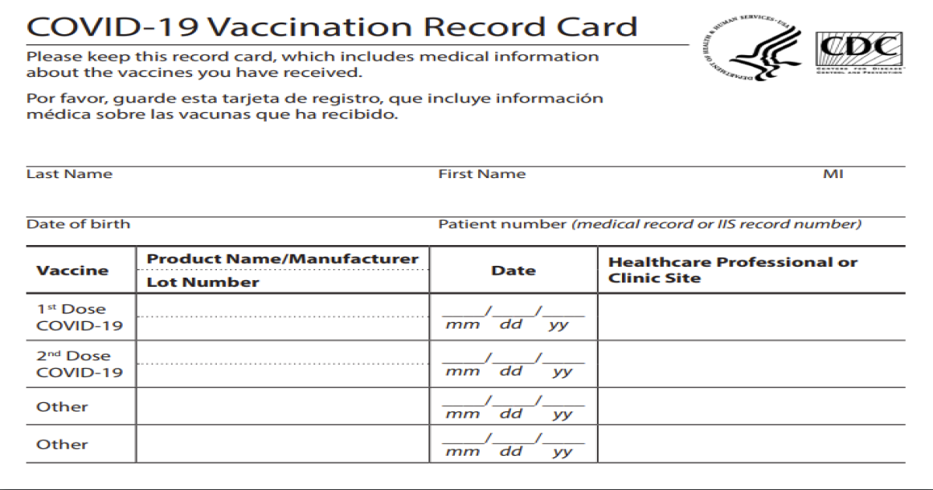

## The official CDC Vaccine Card

### For Patriots that will not give in to the Medical Tyranny

Published December 20th, 2020

In the full on authoritarian system that we find ourselves in today we must stand strong for our principles. This article is not to discuss the vaccine itself. If you found this page you most likely already know enough about the "vaccine" to know to avoid it. But what if a day comes where refusal to take it could put your livelihood in jeopardy? It may come sooner than we think. Here is how to make a counterfeit vaccination record for you and your family.

## how to download:

[COVID VACCINE CARD PDF DIRECT DOWNLOAD](https://uploads-ssl.webflow.com/5fcbf617fdca3ed7ada98d52/5fdf91bc9758a56656e10dd1_2020-COVID-19-shot-card-2b.pdf)[HOW TO PRINT CORRECTLY](https://www.republicanmandate.com/news-articles/blank-covid-vaccine-card#print)

### Click the button above to download the .PDF file.

Once you have this pdf saved to your computer you can either print the card and fill the information in by hand or you can edit it with a pdf editor to add your information. The more effort you put in at this point will make the card look more legitimate. I would recommend buying card stock type paper instead of using regular printer paper.

## Step 1 : Fill out your personal information

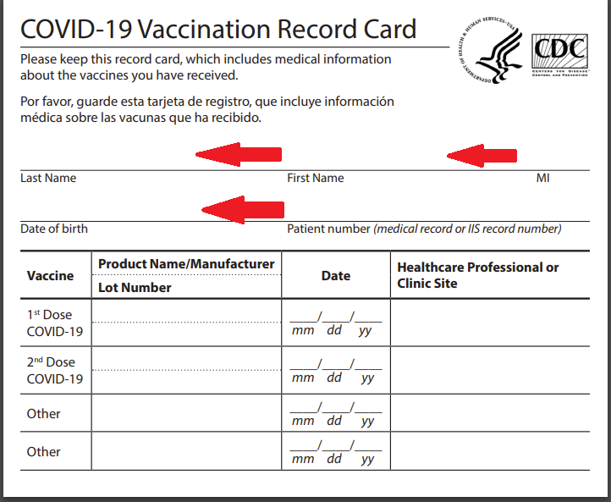

## Step 2 : Patient Number (medical record or IIS number)

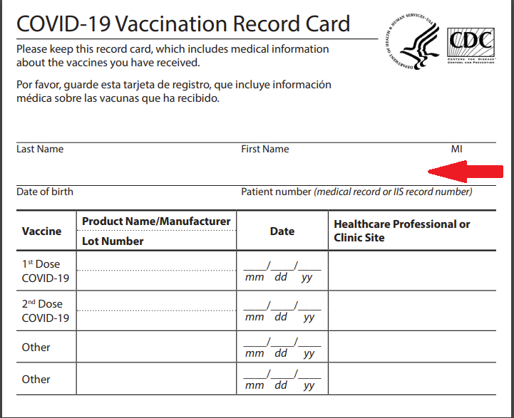

### Lets look at some examples.

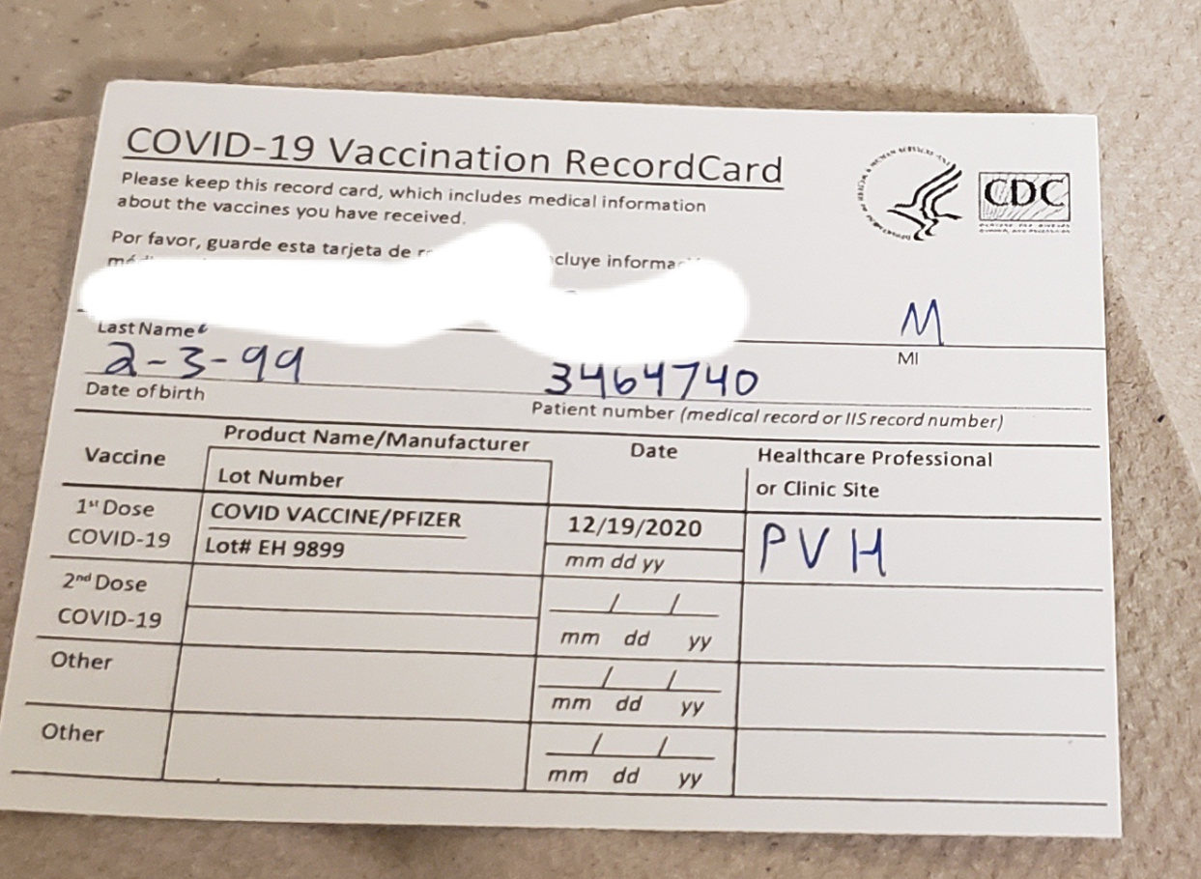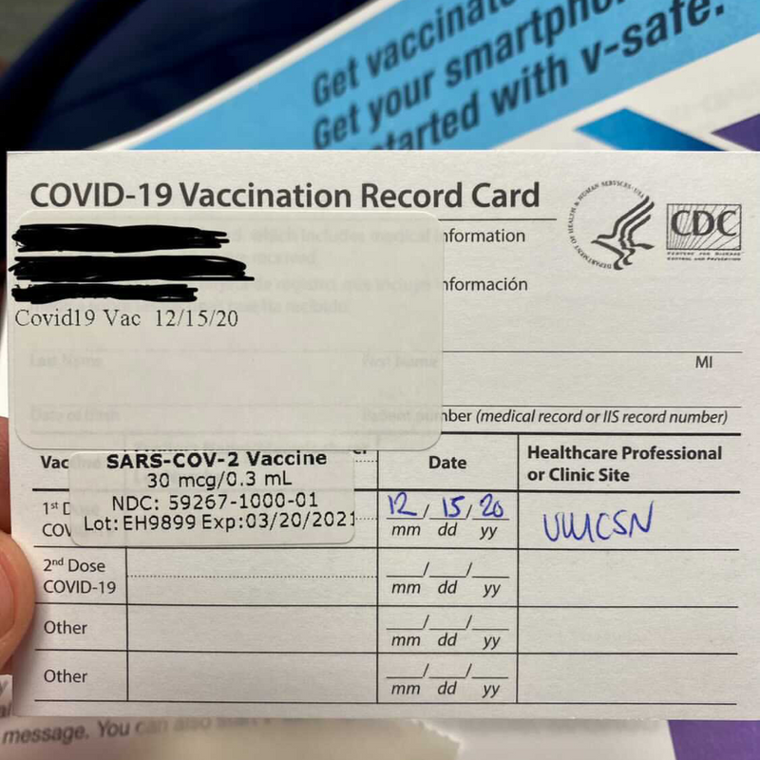

We have an advantage here because the format is not consistent. In the first example we see a seven digit number and on the second it is blank. This is because there is no guidance for clinics on what kind of information they need to put on the card. Your job will not be able to actually verify any of this information and will not try because medical records are private. We just need it to pass a smell test. If you can make the card look legitimate then you will be good to go.

### Add a random seven digit number in this spot.