**BREAKING NEWS - URGENT - Connecticut Publishes Moderna COVID Vax Ingredients: DEADLY POISON "SM-102 - Not for Human or Veterinary Use"**

[World](https://halturnerradioshow.com/index.php/en/news-page/world) [NewsDesk](https://halturnerradioshow.com/index.php/en/authors/author/Newsdesk) 17 May 2021 Hits: 37638

https://halturnerradioshow.com/index.php/en/news-page/world/breaking-news-urgent-connecticut-publishes-moderna-covid-vax-ingredients-deadly-poison-sm-102-not-for-human-or-veterinary-use

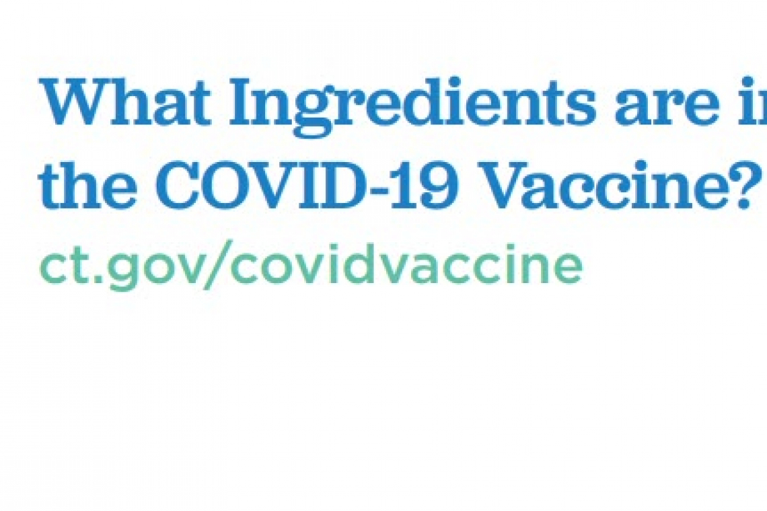

The Connecticut Department of Public Health has published the Ingredients list for the Moderna COVID "Vaccine" and that data sheet confirms it contains a chemical "SM-102."

The SM-102 Material Safety Data Sheet describes this chemical as **"NOT FOR HUMAN OR VETERINARY USE"**

Here is the information published by the Connecticut Department of Health about the Moderna COVID Vaccine, which lists its INGREDIENTS:

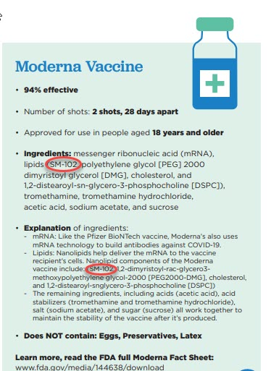

**More:**

According to the manufacturer, Cayman Chemical Company in their filing with the Occupational Safety and Health Administration (OSHA), this chemical causes "Acute Toxicity **"Fatal in contact with skin."**

In that same OSHA filing, the manufacturer declares SM-102  **"Causes damage to the central nervous system, the kidneys, the liver and the respiratory system through prolonged or repeated exposure."**

Here is a section from the manufacturer's OSHA filing:

[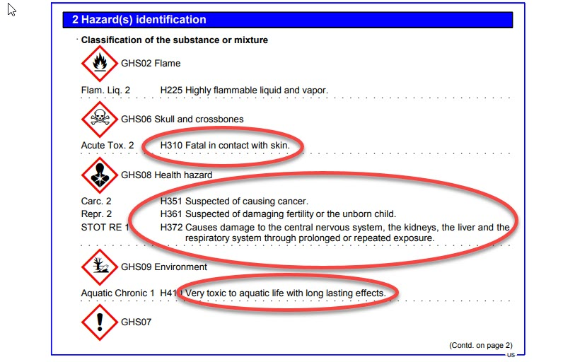](https://halturnerradioshow.com/images/2021/05/17/OSHAFiling-1.jpg)

This appears to be what they are injecting into YOUR arm when you take the Moderna COVID Vax.  **You are APPARENTLY being POISONED!**

**Perhaps this is why so many people are having "adverse reactions" to the so-called "vaccine?"**

Yet Health departments all over this country are running TV and Radio ads telling the general public this vaccine is "safe."  **That seems to be FALSE ADVERTISING.**

The full information release from the Connecticut Department of health, listing the ingredients, can be downloaded directly from the Connecticut State Government web site [HERE](https://portal.ct.gov/-/media/Coronavirus/Community_Resources/Vaccinations/Print-Materials/Fact-Sheets/Ingredients_English.pdf)   (Archived [HERE](https://web.archive.org/web/20210223181027/https:/portal.ct.gov/-/media/Coronavirus/Community_Resources/Vaccinations/Print-Materials/Fact-Sheets/Ingredients_English.pdf))

The full Material Data Safety Sheet on Chemical "SM-102" can be downloaded from the Cayman Chemical Company web site [HERE](https://www.caymanchem.com/msdss/33474m.pdf)   (Archived [HERE](https://web.archive.org/web/20210513181822/https:/www.caymanchem.com/msdss/33474m.pdf))

Now that this information is out, YOU may wish to carefully re-think whether or not you want someone injecting this into YOU.

For those who made the decision to get this vaccine, you may want to get in touch with a good personal injury lawyer and present this information to that attorney.   (While you're still alive.)

**HAL TURNER EDITORIAL OPINION**

Clearly very many of you made the decision to receive this vaccine based on deliberately false claims by politicians, celebrities, public health officials,  TV and Radio Stations, the print and electronic NEWS MEDIA (ABC, NBC, CBS, CNN, MSNBC, CNBS, etc.) and perhaps others, that told YOU these vaccines were "safe."

Why were they out there telling people this was "safe" when the ingredients list clearly shows a chemical "not for human ... use" that is known to "cause cancer" and "damage to central nervous system . . ."

Maybe **THOSE PEOPLE SHOULD BE SUED** for what their false information has done to you. Where was their Due Diligence?  Did they even bother to look up the ingredients before they went out and told the public this was "safe?"

Oh, and how about social media giants (with deep pockets) like Facebook, Twitter, Reddit, Google/Youtube? They not only pushed false information, but also **actively and aggressively BLOCKED truthful information about the bad reactions taking place**, and **CENSORED or SHUT OFF accounts trying to get facts to the public**. What price should they pay for what they've done?

Their CENSORSHIP seems to have been an effort to aid and abet the flow of false safety information which ultimately may have damaged YOU!  Maybe the social media companies need to get sued too?

I can't help but feel that if the big mouth, holier-than-thou celebrities, actors, left-wing media pundits, and politicians, all find themselves getting sued for what they've publicly told people to do, maybe these folks will (finally) shut up . . . or go out of business.

How about state Governors?  Guys like New York's Andrew Cuomo and my home state of New Jersey Governor Phil Murphy, or the wretched woman, Gretchen Whitmer, out in Michigan; out there almost every day for MONTHS telling people "Get vaccinated, it's safe."  What should happen with folks like that who pushed this toxic and deadly chemical on residents of entire states?

Those of you who work or attend school at places where the bosses or school administration REQUIRED you to get the vaccine as a condition of continued employment or condition of attending school, maybe THEY SHOULD GET SUED AS WELL.

OSHA has made clear that when an employer REQUIRES people to take an experimental vaccine, the employer is responsible under Workman's Compensation Laws for any injuries or deaths caused by their requirement!

A lot of these people seem to think they're so much smarter than everyone else, and they somehow needed to tell all us "little people" what was best for us.

Let them explain how injecting a cancer-causing chemical clearly labelled NOT FOR HUMAN USE, was "good" for us. Let's see what a jury thinks of that.

Let their vast personal intellect, that they seem to think makes them so much smarter than the rest of us, **hit their pocketbook**; maybe they'll start minding their own business . . . if they have a business left after all these lawsuits!

Given the information above, it seems to me that people who took the Moderna "jab" are likely to get sicker and sicker until they die.  Maybe I'm wrong.   Yet the Material Safety Data Sheet clearly states **"Causes damage to the central nervous system, the kidneys, the liver and the respiratory system through prolonged or repeated exposure"**  so to me, that means every time your heart beats and your blood flows, that chemical is REPEATEDLY hitting the cells in your body.  To me, that makes it "prolonged and repeated exposure."

Those of you who are suffering from "the jab" should ask a lawyer.

Of course, the lawyer may tell you the vaccine companies were granted immunity as a condition of releasing their experimental vaccine.  But the US Supreme Court has held in the past that "fraud vitiates everything" (See ["UNITED STATES v. THROCKMORTON" 98 U.S. 61](https://www.law.cornell.edu/supremecourt/text/98/61)) and if these vaccine companies told the government their vaccine was "safe" when their own ingredients list says otherwise, then it may be that those companies committed fraud . . . and . . .  fraud vitiates everything.  Thus, maybe a court holds those vaccine companies have NO immunity?

Of course, proving fraud is a tough legal thing to do.  But maybe this will help; Pharmaceutical Companies are required to put an INSERT into their products that list ingredients and all known side effects.   But as the images below will show, those inserts boxed with the "vaccines" . . . .  ARE BLANK!

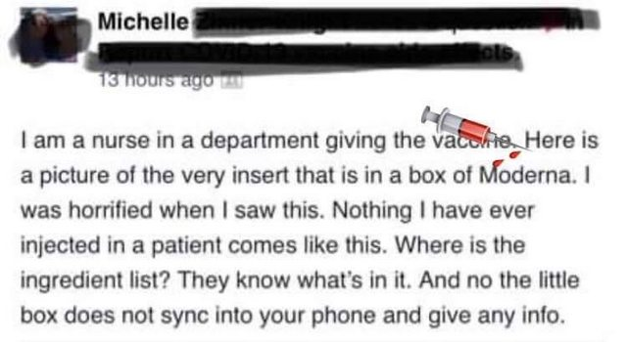

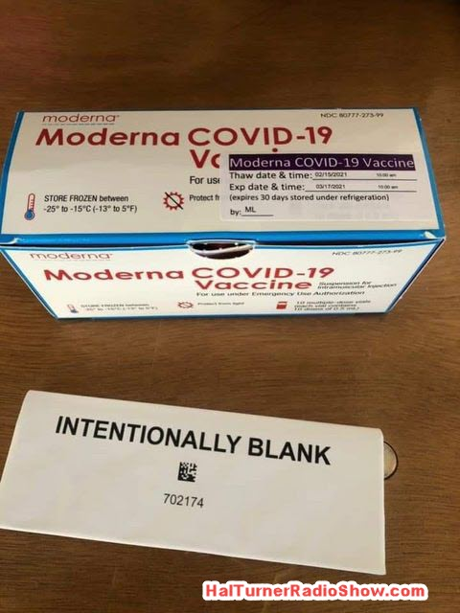

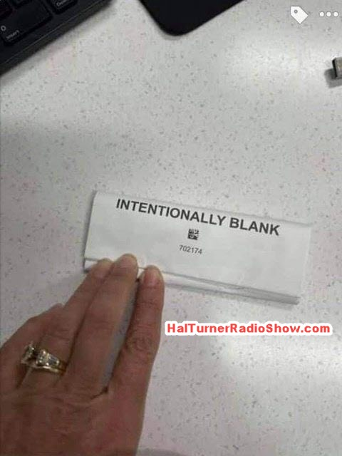

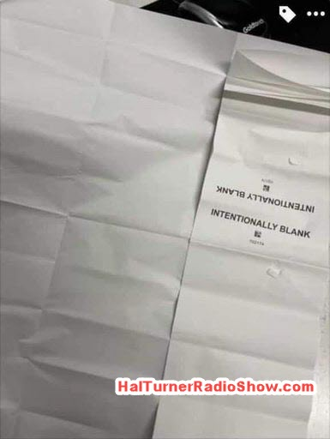

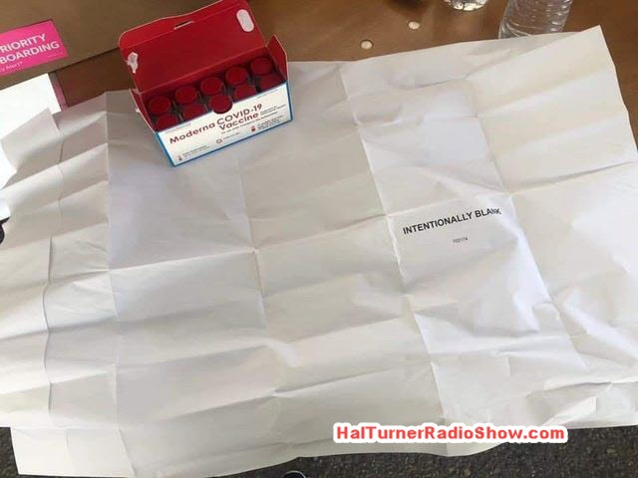

Now, I'm no pharmaceutical expert, so I don't know why the companies left this insert blank.  Someone I know worked for a big pharmaceutical MANUFACTURER,  and he told me that these inserts are called "Ancillary labels" and when he worked in the industry, he was instructed by the company that these are an FDA requirement; they could not ship product without them.

Yet, Moderna (and some others) shipped product with blank inserts.  Why?

Were they worried people would look up the ingredients, find out they're not for human or veterinary use, and go bonkers?  In criminal law, might the decision to use blank inserts be **"consciousness of guilt?"**  I'm not an attorney, so I don't have the answers.

Those of you who have NOT taken the vaccine, should maybe think an awful lot longer before you do.