**Curves Tell a Story: Lockdowns Had No Effect on COVID-19 Spread**

**<https://www.anti-empire.com/curves-tell-a-story-lockdowns-had-no-effect-on-covid-19-spread/>**

**https://www.nationalreview.com/2020/10/stats-hold-a-surprise-lockdowns-may-have-had-little-effect-on-covid-19-spread/**

**"If we showed people these curves without any markings, they would not be able to discern when or even if lockdowns went into effect"**

[Jay W. Richards](https://www.anti-empire.com/guest-author/jay_w__richards/) 1 day ago 869

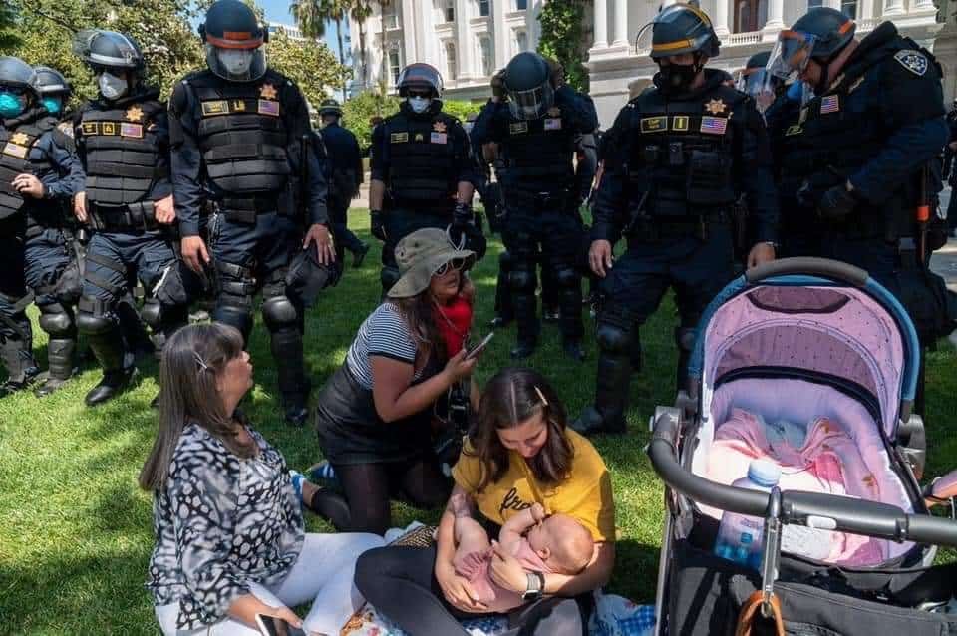

In 1932, Supreme Court justice Louis Brandeis famously called the states “laboratories of democracy.” Different states can test out different policies, and they can learn from each other. That proved true in 2020. Governors in different states responded to the COVID-19 pandemic at different times and in different ways. Some states, such as California, ordered sweeping shutdowns. Others, such as Florida, took a more targeted approach. Still others, such as South Dakota, dispensed information but had no lockdowns at all.

As a result, we can now compare outcomes in different states, to test the question no one wants to ask: Did the lockdowns make a difference?

**If lockdowns really altered the course of this pandemic, then coronavirus case counts should have clearly dropped whenever and wherever lockdowns took place.** The effect should have been obvious, though with a time lag. It takes time for new coronavirus infections to be officially counted, so we would expect the numbers to plummet as soon as the waiting time was over.

How long? **New infections should drop on day one and be noticed about ten or eleven days from the beginning of the lockdown.** **By day six, the number of people with first symptoms of infection should plummet** (six days is the average time for symptoms to appear). By day nine or ten, far fewer people would be heading to doctors with worsening symptoms. If COVID-19 tests were performed right away, we would expect the positives to drop clearly on day ten or eleven (assuming quick turnarounds on tests).

**To judge from the evidence, the answer is clear: Mandated lockdowns had little effect on the spread of the coronavirus.** The charts below show the daily case curves for the United States as a whole and for thirteen U.S. states. As in almost every country, we consistently see a steep climb as the virus spreads, followed by a transition (marked by the gray circles) to a flatter curve. At some point, the curves always slope downward, though this wasn’t obvious for all states until the summer.

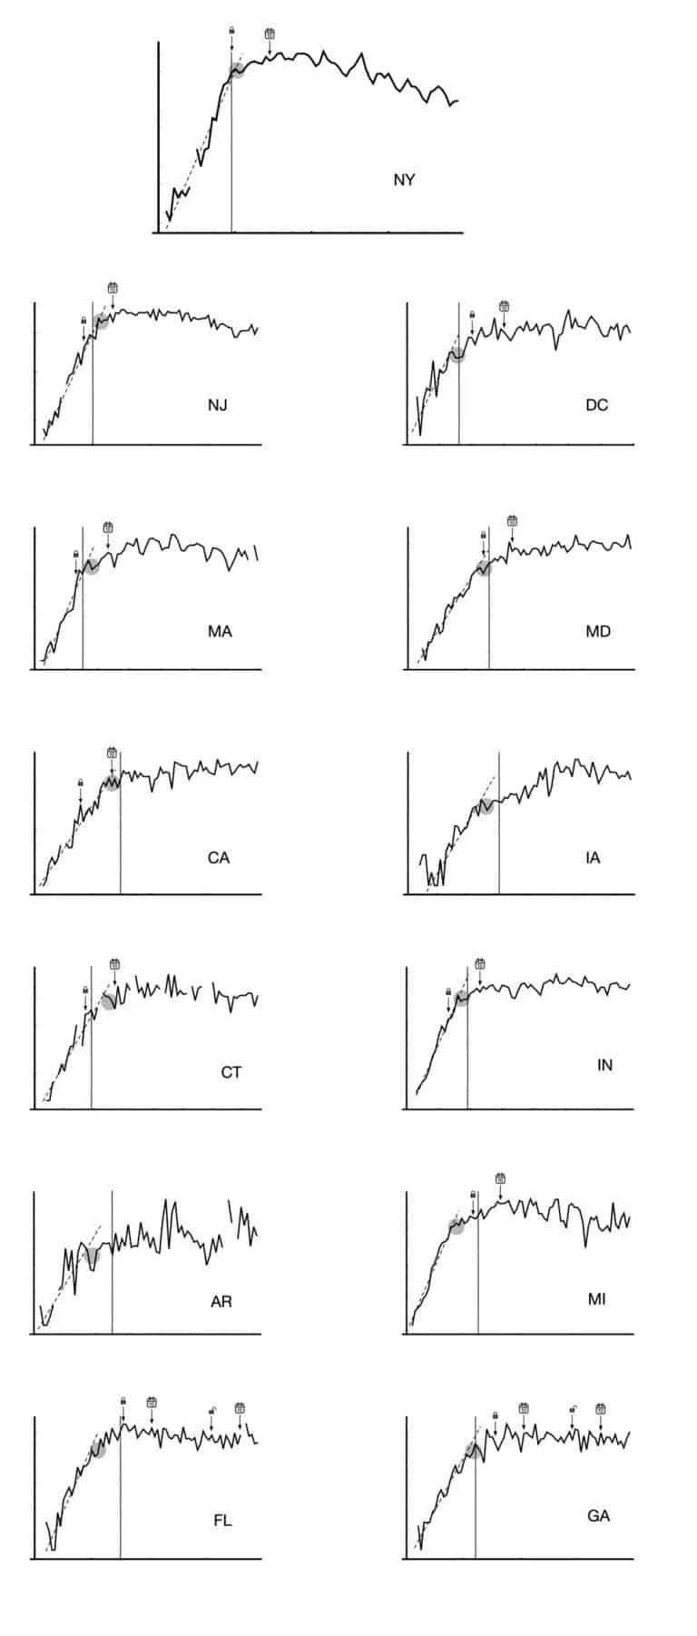

**Lockdowns Not the Cause**

**The lockdowns can’t be the cause of these transitions.** In the first place, the transition happened even in places without lockdown orders (see Iowa and Arkansas). And where there were lockdowns, the transitions tended to occur well before the lockdowns could have had any serious effect. The only possible exceptions are California, which on March 19 became the first state to officially [lock down](https://archive.is/o/7blRc/https:/covid19.ca.gov/img/Executive-Order-N-33-20.pdf), and Connecticut, which followed four days later.

Even in these places, though, the downward transitions probably started before the lockdowns could have altered the curves. The reason is that a one-day turnaround for COVID-19 test results probably wasn’t met in either state. On March 30, the Los Angeles Times [reported](https://archive.is/o/7blRc/https:/www.latimes.com/business/story/2020-03-30/its-taking-up-to-eight-days-to-get-coronavirus-tests-results-heres-why) the turnaround time to be eight days. That would make the delay from infection to confirmation not the 10 we assumed, but more like 17 days (6 for symptoms to appear, 3 for them to develop, and 8 for test processing). In early April, the Hartford Courant [reported](https://archive.is/o/7blRc/https:/www.courant.com/coronavirus/hc-news-coronavirus-covid-19-testing-drive-through-numbers-0402-20200406-yi7fymio3bejfo66i3h2nr4ksq-story.html) similar problems with delayed test results in Connecticut.

What’s more, there’s no decisive drop on the dates when lockdowns should have changed the course of the curves. **Instead, the curves gradually bend downward for reasons that predate the lockdowns, with no clear changes ten days later.**

Lockdown partisans might say that the curves would have been higher after the ten-day mark without the lockdown. While we can’t redo history to prove them wrong, the point is that **the sudden and dramatic changes we should see if they were right aren’t there.**

**If we showed people these curves without any markings, they would not be able to discern when or even if lockdowns went into effect.**

The vertical lines mark the date when the number of deaths attributed to the coronavirus reached five per million people in the population. This is probably the best way to mark similar extents of viral progress in each state, since we don’t know how many total cases there were. **The curves usually start to bend somewhere around the same death toll (roughly five per million people), which suggests that the approach of herd immunity caused the bends.** In other words, we see in this data not only a lack of evidence that lockdowns caused the curves to bend, but also evidence of the very early stages of herd immunity.

In fact, a May 18 [column](https://archive.is/o/7blRc/https:/www.nytimes.com/2020/05/18/briefing/coronavirus-world-health-organization-mike-pompeo-monday-briefing.html) in the New York Times argued that coronavirus cases in New York City probably peaked before the state lockdown began on March 22. Though that newspaper is not known for taking a critical stance on lockdowns, this point implies that **the spread was slowing before the mayor and governor even ordered the lockdown.**

**Something caused this overall decline. It couldn’t have been lockdowns,** which weren’t maintained (or heeded) in full force through June. **At the moment, we can only speculate. But if this virus is like others, its decline is likely attributable to some mix of changing seasons and the gradual onset of herd immunity.** Another factor, of course, could be the widespread use of masks as the year progressed.

**The evidence suggests, then, that the sweeping, mandated lockdowns that followed voluntary responses exacted a great cost, with little effect on transmission.** We can’t change the past, but we should avoid making the same mistake again.

Source: [**National Review**](https://www.nationalreview.com/2020/10/stats-hold-a-surprise-lockdowns-may-have-had-little-effect-on-covid-19-spread/)