Graphene Is Transmitted From Vaccinated To The Unvaccinated!

It Destroys Red Blood Cells And Causes Blood Clots**!**

[**https://thetruereporter.com/graphene-is-transmitted-from-vaccinated-to-the-unvaccinated-it-destroys-red-blood-cells-and-causes-blood-clots/**](https://thetruereporter.com/graphene-is-transmitted-from-vaccinated-to-the-unvaccinated-it-destroys-red-blood-cells-and-causes-blood-clots/)

[Brenda Brown](https://thetruereporter.com/author/admin_brenda/) [Send an email](mailto:bobotips@yahoo.com) 4 weeks ago

0 5,520 1 minute read

[Facebook](https://www.facebook.com/sharer.php?u=https://thetruereporter.com/graphene-is-transmitted-from-vaccinated-to-the-unvaccinated-it-destroys-red-blood-cells-and-causes-blood-clots/) [Twitter](https://twitter.com/intent/tweet?text=Graphene%20Is%20Transmitted%20From%20Vaccinated%20To%20The%20Unvaccinated%21%20It%20Destroys%20Red%20Blood%20Cells%20And%20Causes%20Blood%20Clots%21&url=https://thetruereporter.com/graphene-is-transmitted-from-vaccinated-to-the-unvaccinated-it-destroys-red-blood-cells-and-causes-blood-clots/) [LinkedIn](https://www.linkedin.com/shareArticle?mini=true&url=https://thetruereporter.com/graphene-is-transmitted-from-vaccinated-to-the-unvaccinated-it-destroys-red-blood-cells-and-causes-blood-clots/&title=Graphene%20Is%20Transmitted%20From%20Vaccinated%20To%20The%20Unvaccinated%21%20It%20Destroys%20Red%20Blood%20Cells%20And%20Causes%20Blood%20Clots%21) [Tumblr](https://www.tumblr.com/share/link?url=https://thetruereporter.com/graphene-is-transmitted-from-vaccinated-to-the-unvaccinated-it-destroys-red-blood-cells-and-causes-blood-clots/&name=Graphene%20Is%20Transmitted%20From%20Vaccinated%20To%20The%20Unvaccinated%21%20It%20Destroys%20Red%20Blood%20Cells%20And%20Causes%20Blood%20Clots%21) [Pinterest](https://pinterest.com/pin/create/button/?url=https://thetruereporter.com/graphene-is-transmitted-from-vaccinated-to-the-unvaccinated-it-destroys-red-blood-cells-and-causes-blood-clots/&description=Graphene%20Is%20Transmitted%20From%20Vaccinated%20To%20The%20Unvaccinated%21%20It%20Destroys%20Red%20Blood%20Cells%20And%20Causes%20Blood%20Clots%21&media=https://thetruereporter.com/wp-content/uploads/2022/04/Capture-32.png) [Reddit](https://reddit.com/submit?url=https://thetruereporter.com/graphene-is-transmitted-from-vaccinated-to-the-unvaccinated-it-destroys-red-blood-cells-and-causes-blood-clots/&title=Graphene%20Is%20Transmitted%20From%20Vaccinated%20To%20The%20Unvaccinated%21%20It%20Destroys%20Red%20Blood%20Cells%20And%20Causes%20Blood%20Clots%21) [VKontakte](https://vk.com/share.php?url=https://thetruereporter.com/graphene-is-transmitted-from-vaccinated-to-the-unvaccinated-it-destroys-red-blood-cells-and-causes-blood-clots/) [Odnoklassniki](https://connect.ok.ru/dk?st.cmd=WidgetSharePreview&st.shareUrl=https://thetruereporter.com/graphene-is-transmitted-from-vaccinated-to-the-unvaccinated-it-destroys-red-blood-cells-and-causes-blood-clots/&description=Graphene%20Is%20Transmitted%20From%20Vaccinated%20To%20The%20Unvaccinated%21%20It%20Destroys%20Red%20Blood%20Cells%20And%20Causes%20Blood%20Clots%21&media=https://thetruereporter.com/wp-content/uploads/2022/04/Capture-32.png) [Pocket](https://getpocket.com/save?title=Graphene%20Is%20Transmitted%20From%20Vaccinated%20To%20The%20Unvaccinated%21%20It%20Destroys%20Red%20Blood%20Cells%20And%20Causes%20Blood%20Clots%21&url=https://thetruereporter.com/graphene-is-transmitted-from-vaccinated-to-the-unvaccinated-it-destroys-red-blood-cells-and-causes-blood-clots/)



In a set of slides of blood samples taken from the vaccinated and unvaccinated, we can conclude that graphene in the people grows into larger fibers and structures, which causes magnetic characteristics and electrical charge.

Join Our Telegram channel here:<https://t.me/TheTrueReporter>

Dr. Philippe van Welbergen said that shards of graphene were spread from vaccinated to the unvaccinated population. It will destroy the red blood cells and causes blood clots in the unvaccinated.

Dr. Philippe is a Medical Director of Biomedical Clinics, and he is among the first doctors who warned the population not to take the vaccines against C-19 due to its adverse reactions.

Since the start of 2021, he was a guest on a South African community channel, where he shared that when his patients started complaining about chronic fatigue, and dizziness, he immediately took blood samples for analysis.

He noticed unusual tube-like structures, and some particles lit up. Also, he saw many damaged cells.

Since then, he was constantly a guest on Loving Life TV, speaking about the shots’ cause to people.

On February 12, 2022, Dr. Philippe shared images of his latest blood samples.

His discussion was shared in two separate parts. In the first part, there was a discussion answering the audience’s questions.

In the second part, he shared images of the latest blood slides and explained what the images showed.

Watch the video below:

Check the video below:

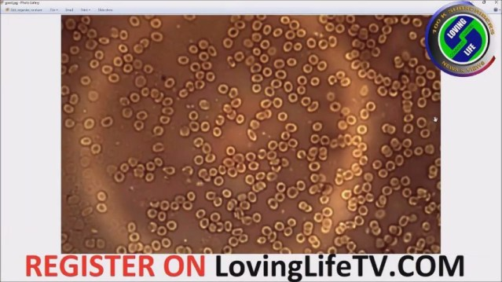

ad

The image below is from a vaccinated person. You can see that the blood is coagulated, and misshapen red blood cells are clumped together.

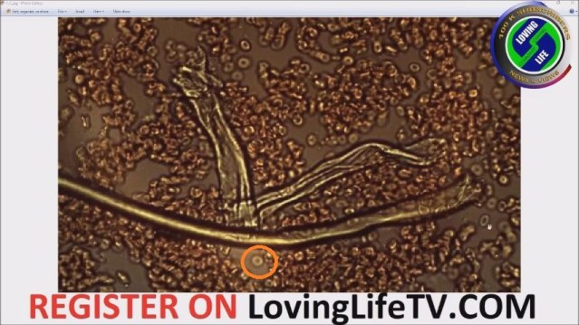

A couple of weeks before the video was created, Dr. Philippe noticed magnetic or electrical polarity effects on different sides of the graphene fibers.

ad

In the image below,” to the right of the fiber, the cells are coagulated and on the left-hand side is what looks like a gap or roughly backward “C” shaped spacing. ”



From the image below, we can see a blood sample of an unvaccinated person.

ad

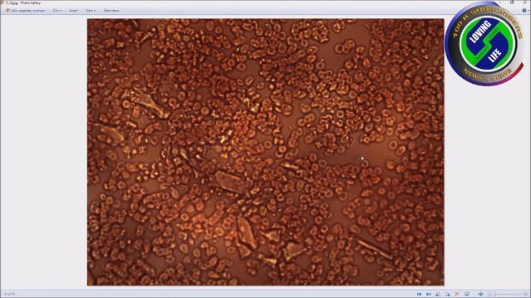

Check this out:



=======================================================================================================================