**How can killer snails improve the state of the world?**

[**https://www.weforum.org/agenda/2015/09/how-can-killer-snails-improve-the-state-of-the-world/**](https://www.weforum.org/agenda/2015/09/how-can-killer-snails-improve-the-state-of-the-world/)

[Fourth Industrial Revolution](https://www.weforum.org/agenda/archive/fourth-industrial-revolution)

© 2023 World Economic Forum

Sep 11, 2015



[**Mandë Holford**](https://www.weforum.org/agenda/authors/mande-holford)

Associate Professor of Chemical Biology, Hunter College, City University of New York (CUNY)

**Share:**

•

•

•

[Our Impact](https://www.weforum.org/impact/world-s-first-space-sustainability-rating-launched/)

[What's the World Economic Forum doing to](https://www.weforum.org/impact/world-s-first-space-sustainability-rating-launched/) *[accelerate action on Fourth Industrial Revolution?](https://www.weforum.org/impact/world-s-first-space-sustainability-rating-launched/)*

[[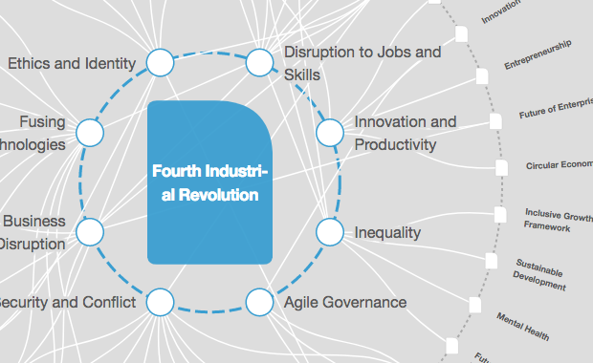](https://intelligence.weforum.org/topics/a1Gb0000001RIhBEAW?tab=publications)](https://intelligence.weforum.org/topics/a1Gb0000001RIhBEAW?tab=publications)

[The Big Picture](https://intelligence.weforum.org/topics/a1Gb0000001RIhBEAW?tab=publications)

**[Explore and monitor how Fourth Industrial Revolution is affecting economies, industries and global issues](https://intelligence.weforum.org/topics/a1Gb0000001RIhBEAW?tab=publications)**

[[](https://uplink.weforum.org/uplink/s?utm_source=Weforum&utm_medium=AgendaTout&utm_campaign=Weforum_AgendaTout_UpLink_to_Homepage)](https://uplink.weforum.org/uplink/s?utm_source=Weforum&utm_medium=AgendaTout&utm_campaign=Weforum_AgendaTout_UpLink_to_Homepage)

[Crowdsource Innovation](https://uplink.weforum.org/uplink/s?utm_source=Weforum&utm_medium=AgendaTout&utm_campaign=Weforum_AgendaTout_UpLink_to_Homepage)

**[Get involved with our crowdsourced digital platform to deliver impact at scale](https://uplink.weforum.org/uplink/s?utm_source=Weforum&utm_medium=AgendaTout&utm_campaign=Weforum_AgendaTout_UpLink_to_Homepage)**

**Stay up to date:**

**Fourth Industrial Revolution**

This post is part of a [blog series](https://agenda.weforum.org/topic/agenda-in-focus-inside-science/) with Young Scientists, who attended the [Annual Meeting of the New Champions 2015](http://www.weforum.org/events/annual-meeting-new-champions-2015), which took place in Dalian, China, from 9-11 September. In this blog, Mande Holford, Assistant Professor of Chemical Biology at Hunter College in New York, discusses using venomous marine snails as tools for manipulating cell signalling in the nervous system.

**How can killer snails help improve the state of the world?**

Most people wouldn’t think of snails as venomous creatures, but just like snakes, scorpions and spiders they have an extraordinary potential to contribute to medical science.

Venom is potent, fast-acting and extremely efficient. In short, it has all the makings of a successful drug. The venom of conoidean snails – or killer snails, as I lovingly refer to them – allows these slow-moving predators to feed on an agile prey by shutting down a fish’s normal functions, preventing them from escaping. The same venomous peptides that switch off cellular function can be used to stop cancerous cells from multiplying and forming malignant tumours, or turn off neuronal impulses such as chronic pain.

**What other secrets of nature have you uncovered during your time as a scientist?**

I’ve discovered that nature has many secrets and we’ve just begun to understand them. The venom of conoidean snails is similar to that of snakes and scorpions. They’re not from a common ancestor, but the compounds found in their venom are similar. Nature found a formula that worked and has repeated it again and again. How that occurs is a complete mystery and a fascinating challenge to figure out.

**What other areas of science are exciting you most right now?**

Pluto! How can anyone not be fascinated with it after the New Horizon’s flyby? There are mountains in the form of brass knuckles, an atmosphere we didn’t think was there, surface haze due to wind erosion – all kinds of fascinating findings. Also, the areas of synthetic biology and stem-cell regeneration are really exciting. We’re creating life-like entities, whether organs or whole organisms in the form of bacteria. We’re also doing it three-dimensionally. 3D printing, both for mechanical gadgets and biological tissue, is really revolutionary. From the stars to the seas, we’re doing future science and it’s a great time to be scientist.

**You recently wrote about the need for** [**young scientists to become involved in diplomacy**](http://m.sciencemag.org/content/349/6247/455.full.pdf)**. Why?**

From Einstein to Moniz, scientists have had a long history of participating in international affairs. Two recent events – the normalization of relations between the United States and Cuba, and America’s nuclear arms deal with Iran – have convinced me that young scientists need to be at the negotiating table. Not only can they play a role in establishing successful cooperation between nations, but they will also be needed to work alongside diplomats to solve global challenges. Early career scientists are particularly suited to this role, not only because they have inherited the challenge of developing vaccines, conducting ecological and seismological surveys, and designing new technologies for societal benefit – but also because, as a creative, highly mobile and energetic workforce, they are most at home with the forces of globalization and innovation that are increasingly defining scientific enterprise.

**This will be your second AMNC: what was the main take-away from last year?**

The drivers of the current knowledge-based society are talented individuals at the intersection of research, education and business. This is referred to as the Knowledge Triangle, and I believe the Annual Meeting of the New Champions is a great forum for showcasing models that enhance this. It is incredibly important at a time when early career scientists are being asked to think about their research in terms of commercial and global impacts. In my own efforts, for example, I’ve used my research into killer snails to co-found a STEM-focused [learning games company](http://www.killersnails.com). Our mission is to create science-learning games that achieve knowledge proficiency while having broad commercial appeal. I like to think this entrepreneurship is aligned with the meeting’s goals of highlighting creativity and innovation to address global issues.

**Given the negative news at the moment concerning the gender gap in science, what have been your personal experiences of being a young, successful woman scientist?**

The lack of gender parity in science is troubling, if only for the reason that 50% of the population can be excluded from making society better. I have not consciously experienced the same problems as other women in the fields of science and technology, but sexism in science is real. Whether it’s deliberate or an unconscious bias practised by both sexes, being a woman in that arena can be challenging. What’s empowering at the moment is that this “sexism” is no longer hidden or silent; it gets exposed very quickly. Women are more able to take control of the issue, as we saw recently with the outrage over [scientist Tim Hunt’s ill-fated comments](http://www.bbc.co.uk/news/uk-33090022). While his words may not have been malicious in intent, when many women are being denied access to a career in science, it is important to denounce disparaging behaviour.

**If you could make one thing happen at AMNC, what would it be?**

The meeting is geared towards addressing a new challenge, in which a “future of slow and unbalanced growth” is predicted. Slow and unbalanced usually translates as low-income communities suffering more than they already are. Intelligence, creativity and curiosity should not be exclusive to high-income communities. Similar to the gender gap, an income gap is preventing several people from reaching their potential. If I could make one thing happen at the meeting, it would be for the New Champion scientists, Young Global Leaders and Global Shapers to spend four hours brainstorming on two topics that severely jeopardize the future of low-income children. What can we do now to make it better for the next generation?

**Have you read?**  
[Why scientists need to think like entrepreneurs](https://agenda.weforum.org/2015/09/why-scientists-need-to-think-like-entrepreneurs/)  
[What the quantum revolution means for us](https://agenda.weforum.org/2015/09/what-the-quantum-revolution-means-for-us/)  
[Can a computer tell what you’re thinking?](https://agenda.weforum.org/2015/09/can-a-computer-tell-what-youre-thinking/)

Author: Mande Holdford, Associate Professor, Chemical Biology, Hunter College, City University of New York (CUNY), USA and is a World Economic Forum Young Scientist. She will be participating at the Forum’s [Annual Meeting of the New Champions](http://www.weforum.org/events/annual-meeting-new-champions-2015), which is taking place in Dalian, China, 9-11 September.

**Don't miss any update on this topic**

Create a free account and access your personalized content collection with our latest publications and analyses.

License and Republishing

World Economic Forum articles may be republished in accordance with the Creative Commons Attribution-NonCommercial-NoDerivatives 4.0 International Public License, and in accordance with our Terms of Use.

The views expressed in this article are those of the author alone and not the World Economic Forum.

**Related topics:**

**Share:**

Global Agenda

**The Agenda Weekly**

A weekly update of the most important issues driving the global agenda

You can unsubscribe at any time using the link in our emails. For more details, review our [privacy policy](https://www.weforum.org/about/privacy-and-terms-of-use).

**More on Fourth Industrial Revolution**

[**See all**](https://www.weforum.org/agenda/archive/fourth-industrial-revolution)

[[](https://www.weforum.org/agenda/2023/05/the-power-of-collective-action-institutionalizing-4ir-technologies/)](https://www.weforum.org/agenda/2023/05/the-power-of-collective-action-institutionalizing-4ir-technologies/)

[From innovation to integration: the role of collective action in institutionalising 4IR technologies](https://www.weforum.org/agenda/2023/05/the-power-of-collective-action-institutionalizing-4ir-technologies/)

Vignesh Santhanam, Piyush Gupta and Vivek HP

May 8, 2023

[[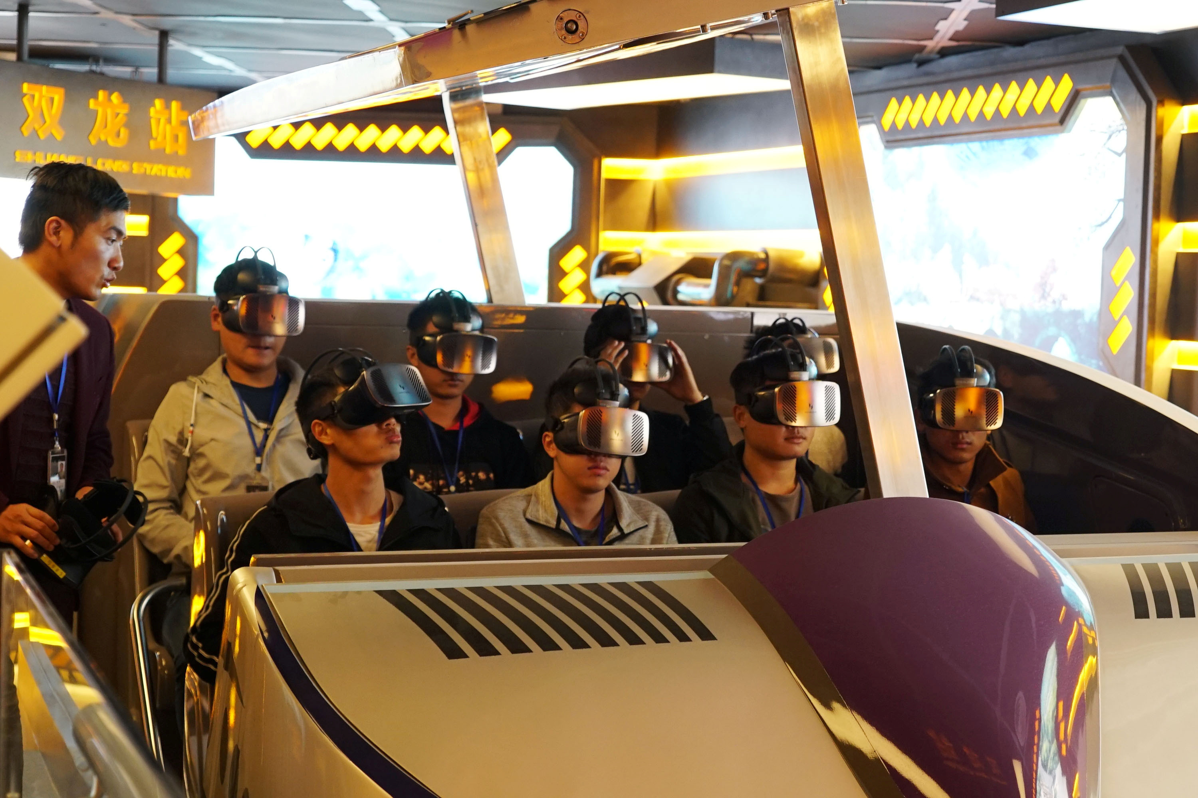](https://www.weforum.org/agenda/2023/04/disney-shuts-metaverse-division-and-other-metaverse-stories-april-2023/)](https://www.weforum.org/agenda/2023/04/disney-shuts-metaverse-division-and-other-metaverse-stories-april-2023/)

[Disney drops metaverse division, EU seeks rules for virtual worlds, and other metaverse stories you need to read this month](https://www.weforum.org/agenda/2023/04/disney-shuts-metaverse-division-and-other-metaverse-stories-april-2023/)

Cathy Li

April 12, 2023

[[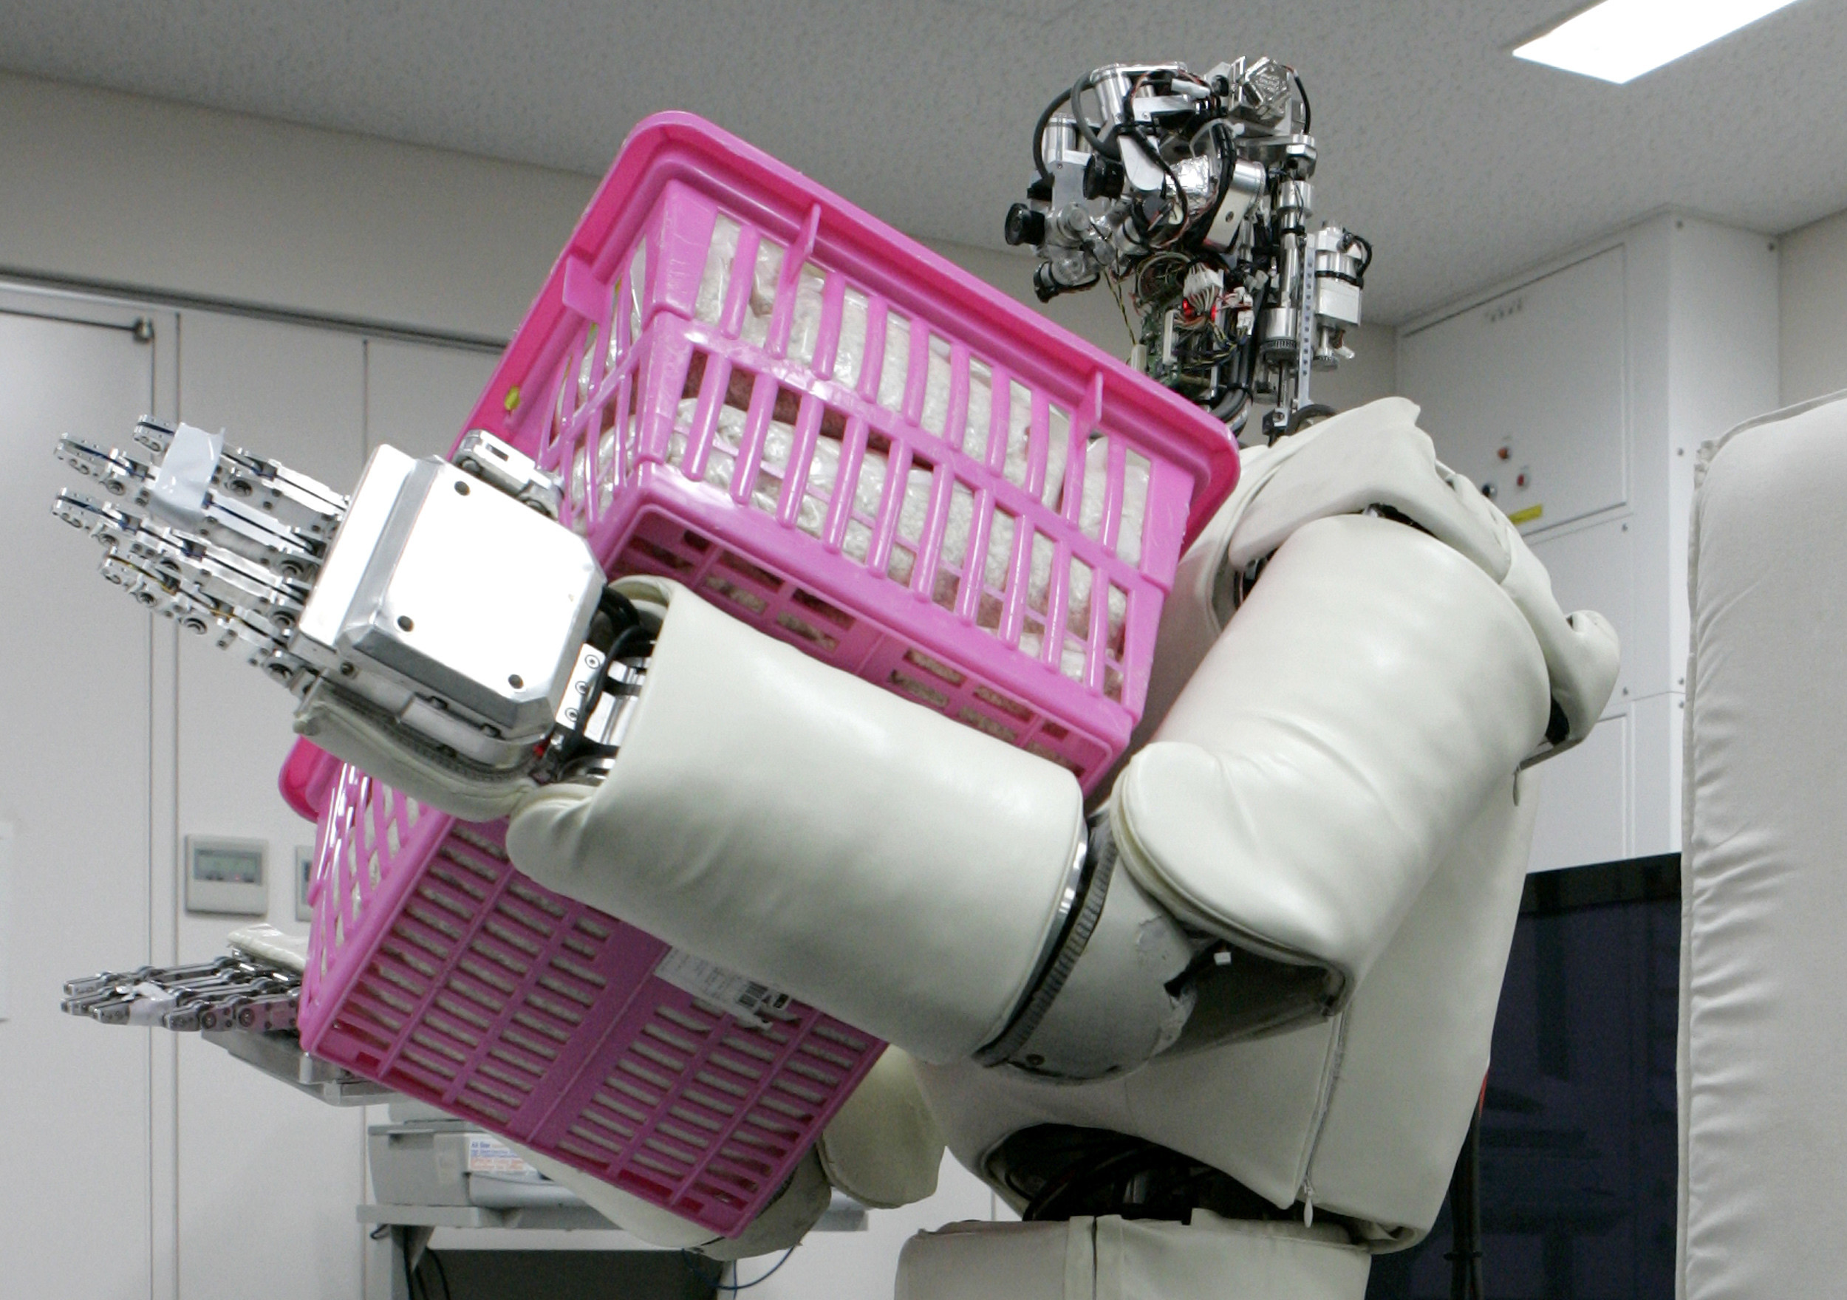](https://www.weforum.org/agenda/2023/04/ai-housework-gender-gap-robots/)](https://www.weforum.org/agenda/2023/04/ai-housework-gender-gap-robots/)

[Domestic chores could be done by robots 40% of the time within a decade - new study](https://www.weforum.org/agenda/2023/04/ai-housework-gender-gap-robots/)

[Here's why education systems need to start taking a 'skills-first' approach](https://www.weforum.org/agenda/2023/03/heres-why-educations-systems-need-to-start-taking-a-skills-first-approach/)

The Lego Foundation

March 30, 2023

[The world's first sustainability rating system for space exploration](https://www.weforum.org/impact/world-s-first-space-sustainability-rating-launched/)

March 2, 2023

[[](https://www.weforum.org/agenda/2023/02/blockchain-has-high-potential-but-beware-of-cyber-threats-8642651f20/)](https://www.weforum.org/agenda/2023/02/blockchain-has-high-potential-but-beware-of-cyber-threats-8642651f20/)

[Is blockchain really secure? Here are four pressing cyber threats you must consider](https://www.weforum.org/agenda/2023/02/blockchain-has-high-potential-but-beware-of-cyber-threats-8642651f20/)

Yazeed Alabdulkarim

February 21, 2023

About Us

* [Our Mission](https://www.weforum.org/about/world-economic-forum)
* [Our Impact](https://www.weforum.org/our-impact)
* [Leadership and Governance](https://www.weforum.org/about/leadership-and-governance)
* [Our Partners](https://www.weforum.org/partners)
* [Sustainability](https://www.weforum.org/sustainability-world-economic-forum)
* [History](https://www.weforum.org/about/history)
* [Careers](https://www.weforum.org/forum-careers)
* [Contact Us](https://www.weforum.org/contact-us)

Events

* [Events](https://www.weforum.org/events)
* [Open Forum](https://www.weforum.org/open-forum)

Media

* [Press](https://www.weforum.org/press)
* [Subscribe to our press releases](https://weforum.us3.list-manage.com/subscribe/?u=6308fe51b420dc9ff3834abc8&id=bf3fa00e64)
* [Pictures](https://www.flickr.com/photos/worldeconomicforum/)

More from the Forum

* [Strategic Intelligence](https://intelligence.weforum.org)
* [UpLink](https://uplink.weforum.org/uplink/s?utm_source=Weforum&utm_medium=Footer&utm_campaign=Weforum_Footer_UpLink_to_Homepage)
* [Global Shapers](https://www.globalshapers.org)
* [Young Global Leaders](https://www.younggloballeaders.org)
* [Schwab Foundation for Social Entrepreneurship](https://www.schwabfound.org)
* [Centre for the Fourth Industrial Revolution](https://www.weforum.org/centre-for-the-fourth-industrial-revolution)
* [New Champions](https://www.weforum.org/about/new-champions)

[Privacy Policy & Terms of Service](https://www.weforum.org/about/privacy-and-terms-of-use)

© 2023 World Economic Forum