**Johns Hopkins University Confirms (see study below) That ‘Self-Spreading’ Vaccines Are Real**

[**https://humansarefree.com/2021/05/johns-hopkins-university-self-spreading-vaccines-real.html**](https://humansarefree.com/2021/05/johns-hopkins-university-self-spreading-vaccines-real.html)

[HAF](https://humansarefree.com/author/ascanu)May 8, 2021

*by* [*Ethan Huff*](https://www.afinalwarning.com/516895.html)

**Most Americans are saying no to** [**Wuhan coronavirus**](https://humansarefree.com/category/coronavirus) **(Covid-19)** [**vaccines**](https://humansarefree.com/2021/05/european-database-of-adverse-drug-reactions-for-covid-19-vaccines.html) **despite the deep state’s best efforts to sway them. It may not matter, though, because the jabs** [**could be self-spreading**](https://rense.com/general96/self-spreading-vaccines.php)**, meaning the vaccinated could be effectively vaccinating the unvaccinated simply by “shedding” it onto them.**

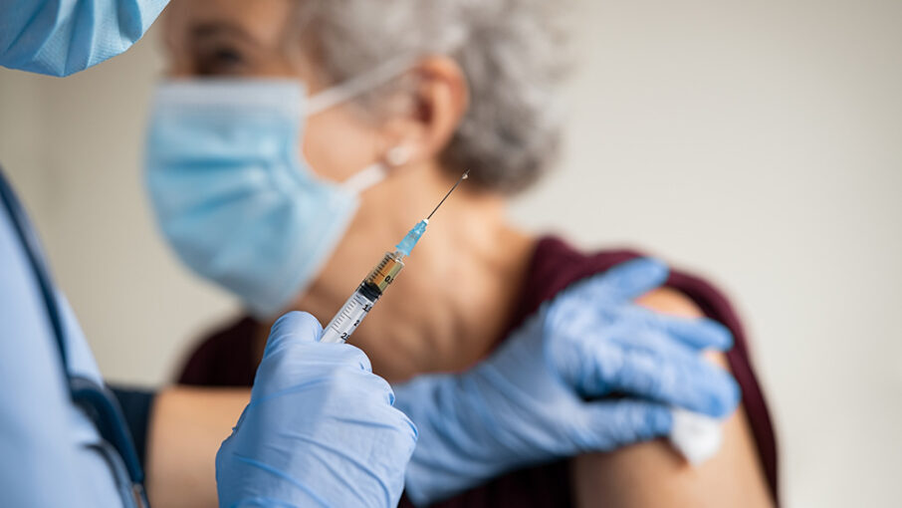

A [Johns Hopkins University](https://www.jhu.edu/) (JHU) paper explains how self-spreading vaccines work to spread through both vaccinated and unvaccinated populations by design.

Even if you forego the jab, in other words, you could still end up becoming vaccinated if someone you come into contact with was recently injected.

Ironically, this makes vaccinated people the true “superspreaders” who are putting society at risk.

Since there is still no real proof that viruses even spread through the air at all, who is actually responsible for spreading disease throughout society? The answer is the vaccinated.

*“Self-spreading vaccines – also known as transmissible or self-propagating vaccines – are genetically engineered to move through populations in the same way as communicable diseases, but rather than causing disease, they confer protection,” the JHU paper explains.*

*“The vision is that a small number of individuals in the target population could be vaccinated, and the vaccine strain would then circulate in the population much like a pathogenic virus. These vaccines could dramatically increase vaccine coverage in human or animal populations without requiring each individual to be inoculated.”*

The paper goes on to explain the two different types of self-spreading vaccines: recombinant vector vaccines and live viral vaccines. It would appear as though Wuhan coronavirus (Covid-19) injections constitute the former.

*“Recombinant vector vaccines combine the elements of a pathogenic virus that induce immunity (removing the portion that causes disease),” the paper explains.*

*“Cytomegalovirus is one candidate vector for recombinant vaccines because it is highly species-specific and moderately transmissible.”*

The full paper is available for viewing at [this link](https://rense.com/general96/self-spreading-vaccines.php).

**You could already be “vaccinated” without even knowing it**

As for the Chinese Virus, scientists were [already brainstorming](https://thebulletin.org/2020/09/scientists-are-working-on-vaccines-that-spread-like-a-disease-what-could-possibly-go-wrong) last summer how to make self-spreading vaccines for it.

The Bulletin reported that because of vaccine “hesitancy,” eugenicists are trying to figure out how to maximize the self-propagating properties of injections.

*“For at least 20 years, scientists have been experimenting with such self-spreading vaccines, work that continues to this day, and which has gained the attention of the US military,” The Bulletin reported, admitting that the risks of such technology are high.*

*“Once released, scientists will no longer be in control of the virus. It could mutate, as viruses naturally do. It may jump species. It will cross borders. There will be unexpected outcomes and unintended consequences. There always are.”*

Like everything else that comes out of Big Pharma, self-spreading vaccines are fake.

Genetic engineering is required to make them “work,” and they function like a virus, which suggests that vaccines are the true virus that threatens us all.

*“The idea, essentially, is to vaccinate a small proportion of a population through direct inoculation,” The Bulletin further explained.*

*“These so-called founders will then passively spread the vaccine to other animals they encounter either by touch, sex, nursing, or breathing the same air. Gradually, these interactions could build up population-level immunity.”*

**Self-spreading vaccines were invented for “pest control”**

Ironically, the idea for self-spreading vaccines was birthed out of a desire among scientists to develop a new way to control pest populations.

In other words, self-spreading vaccines exist for the purpose of *pest control*.

Some of the earliest self-spreading vaccines used in animals effectively sterilized them.

This form of “immunocontraception” hijacked the immune systems of injected mice and prevented them from fertilizing offspring.

This is eerily similar to what is now happening to men and women who are suffering reproductive problems after getting injected.

The official story is that self-spreading vaccines have not yet been “tested” on humans, but we know better than that.

By the time the media has reported that something like this exists, chances are it has already been in use for quite some time. This is how the establishment plays the game.

Mike Adams, the Health Ranger, [calls this](https://www.naturalnews.com/infographic-sos-stop-out-of-control-science.html) “out-of-control” science. It is an existential threat to humanity itself because once the cat is out of the bag, there is no way to ever again contain it.

“If an action or policy has a suspected risk of causing harm to the public or to the environment, the burden of proof that it is NOT harmful falls on those taking the action,” Adams warned back in 2012.

“In other words, scientists must PROVE their experiments are NOT dangerous before being allowed to unleash them upon the world!”

The only problem is that today’s scientists seem to want their experiments to be dangerous – that is the whole point.

In this case, the [Wuhan coronavirus (Covid-19) plandemic](https://humansarefree.com/?s=plandemic), including the mass vaccination component, is all about exterminating most of humanity and leaving behind only a very small remnant of survivors.

It will come as no surprise that billionaire eugenicist [Bill Gates](https://humansarefree.com/category/bill-gates) has long played a role in this agenda.

Every single vaccine and other “medical” intervention he has concocted has had one purpose, and one purpose alone: **mass genocide**.

**“We are watching a genocidal transgenerational plan unfolding. Bill Gates is executing it on behalf of dead men and others who shared their goals**,” writes Vince Morreno.

**“This is diabolical. Satanic. Civilization in facing a hugely clear and present danger.”**

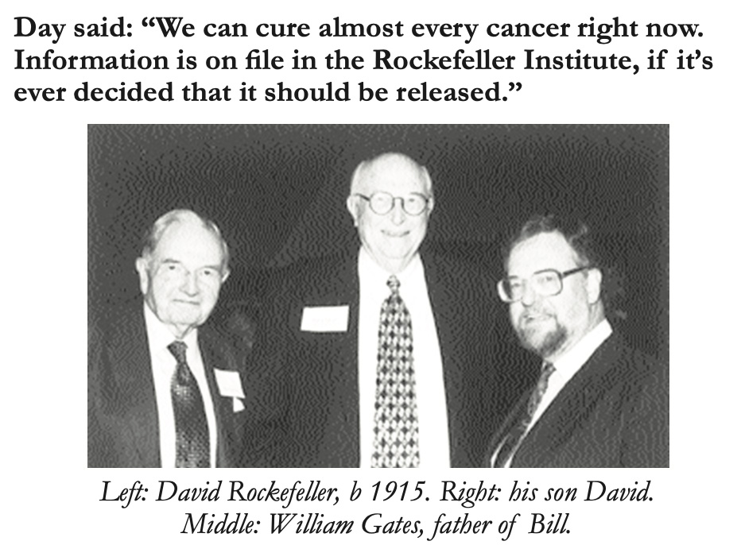

ORIGINAL STUDY

|  |  |
| --- | --- |
| **Self-Spreading Vaccines Are No Myth...It's Hard Science  Johns Hopkins Confirmed Them - Covid Genocide Is Here**  https://rense.com/general96/self-spreading-vaccines.php |  |
| By Vince Morreno  5-1-21 |  |
| Jeff,   Self spreading vaccines are no myth. Johns Hopkins University confirms it. See attached page down below. I have their original document.   You'll get the vaccine whether you like it or not.   Self propagating vaccines were conceived by Australian Nobel Virologist Sir Macfarlane Burnet. You know about him. As you know, my interest arose when I bought his former house in 2013 and strange things happened. I looked into his life. I was so shocked, I proposed getting a priest in to do an exorcism the house. No joke.   Burnet with his protégé Sir Gustav Nossal, and the CSIRO, developed the Myxomatosis virus. First used in Australia on rabbit plagues. It was the world's first self-propagating virus that recognized - self, and acted as a vaccine which caused immune suppression. AIDS for rabbits!   Australia is ground zero for the unfolding Covid genocide.   Burnet and William Gates were friends.   William Gates started the William Gates foundation, later renamed the Bill & Melinda Gates Foundation. Burnet's protégé, Gustav Nossal went on to work for the foundation and WHO after Burnet died in 1985. He carried forth the Burnet-Gates Senior plan for genocide.   Gates, Sr. and Burnet conceived and financed the genocidal message on the Georgia Guide stones. Think about that.   The two were friends with the eugenists William Shockley who engaged a friend Dr Herman Kermet to undertake the works incognito. I trust you watched the doco, Dark Clouds over Elberton.   The US bio weapons lab at Fort Detrick commissioned Burnet who proposed unleashing an Influenza Carona Virus on China in 1947. The technology of the time couldn't guarantee no virus blowback, so it was shelved. He was also working for the British equivalent. Burnet was seriously connected   In the late 1970s, the Australian government CSIRO developed CRISPR gene editing for Myrtleford, Victoria tobacco farmers. They originally called it Gene Shears. The science minister of the time, Barry Jones, stated the technology would change the world. It has. We've seen none of the full horrors yet of chimera humans and ethic DNA targets bioweapons which was Burnet's dream.   The CRISPR biotech is being used for the Covid Myxoma self-spreading 'vaccine' bioweapon.   Melbourne, Australia is ground zero for Covid technology and the Gates family plan. It was also ground zero for curfews, lockdowns, freedom of movement denial and mask wearing. The techniques spread around the globe.   Both Burnet and Gates were eugenists connected to the London Eugenics society (rebranded the Gaulton institute to drop the term 'eugenics'). Bill Gates has been marinated in this stuff from his childhood. He is executing the plans of his father and the maniacal Sir Macfarlane Burnet.   In 1967, Burnet wrote 'Endurance of Life' (1978). It received a critical reception for his eugenicist and sociobiological views. It provoked great controversy. Those views included, capital punishment to rid society of undesirables and mentally unfit, abortion for population selection and euthanasia for the unworthy. This particularly included killing the disabled and elderly when they were no longer productive. This is despite he, himself, being 79 when he wrote that book. Burnet's other 13 books he wrote in retirement include almost word for word what we read on the Georgia Guidestones. He wrote the Guidestones tenets with lawyer pal William Gates, who was a close friend of David Rockefeller - see attached photo.   Do you get the picture, Jeff? We are watching a genocidal transgenerational plan unfolding. Bill Gates is executing it on behalf of dead men and others who shared their goals.   This is diabolical. Satanic. Civilization in facing a hugely clear and present danger.   - Vince  https://rense.com/general96/self-spreading-vaccines.jpg |  |