# White House turns up heat on Big Tech's Covid 'disinformation dozen'

https://edition.cnn.com/2021/07/16/tech/misinformation-covid-facebook-twitter-white-house/index.html

[[](https://edition.cnn.com/profiles/donie-osullivan)](https://edition.cnn.com/profiles/donie-osullivan)

By [Donie O'Sullivan](https://edition.cnn.com/profiles/donie-osullivan), CNN Business

Updated 1858 GMT (0258 HKT) July 16, 2021



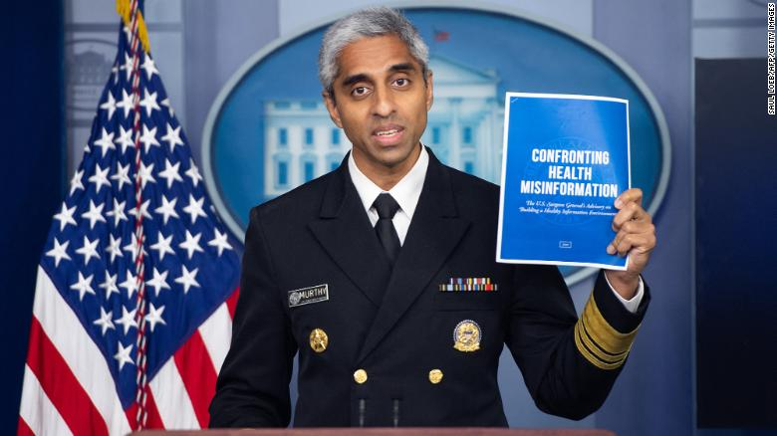

NOW PLAYING

Surgeon general issues warning over vaccine misinformation as White House turns up the heat on Facebook

[CNN](https://edition.cnn.com/2021/07/16/tech/misinformation-covid-facebook-twitter-white-house/index.html)

00:28 / 04:31

Now Playing Surgeon general issues...

### Robot manicure really 'nails it'

### Disney unveils one of its most innovative attractions

### Novogratz: Sports will make NFTs broadly accessible

### Delta Air Lines prepares 'connected cabins' for post-pandemic flights

### Florida governor signs bill targeting social media platforms

### This company is making drone delivery a reality

### Watch self-driving car struggle to understand traffic cones

### It's a boat? It's a plane? No, it's a 'seaglider.' And it goes fast...really fast

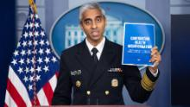

Now Playing

### Surgeon general issues warning over vaccine misinformation as White House turns up the heat on Facebook



### This is what the future of mobility looks like

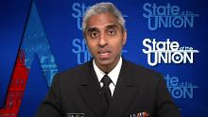

### Surgeon general issues warning about sharing health information on social media

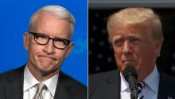

### Cooper: Ignoring Trump, as tempting as it may be, isn't option



### Microsoft urges Windows users to install update

### Kaseya: The massive ransomware attack compromised up to 1,500 businesses

### Websites and apps go down during massive outage

### FaceTime. IDs. Do Not Disturb. See Apple's latest updates

### Robot manicure really 'nails it'

### Disney unveils one of its most innovative attractions

### Novogratz: Sports will make NFTs broadly accessible

### Delta Air Lines prepares 'connected cabins' for post-pandemic flights

### Florida governor signs bill targeting social media platforms

### This company is making drone delivery a reality

### Watch self-driving car struggle to understand traffic cones

### It's a boat? It's a plane? No, it's a 'seaglider.' And it goes fast...really fast



### Surgeon general issues warning over vaccine misinformation as White House turns up the heat on Facebook



### This is what the future of mobility looks like



### Surgeon general issues warning about sharing health information on social media



### Cooper: Ignoring Trump, as tempting as it may be, isn't option



### Microsoft urges Windows users to install update

### Kaseya: The massive ransomware attack compromised up to 1,500 businesses

### Websites and apps go down during massive outage

### FaceTime. IDs. Do Not Disturb. See Apple's latest updates

(CNN Business)The White House turned up the pressure on Silicon Valley to get a handle on vaccine misinformation Thursday, specifically singling out 12 people one group dubbed the "disinformation dozen," saying they were responsible for a great deal of misinformation about Covid-19.

"There's about 12 people who are producing 65% of anti-vaccine misinformation on social media platforms," [White House Press Secretary Jen Psaki said](https://twitter.com/CCDHate/status/1416010577554587655) Thursday.

That statistic is from the nonprofit Center for Countering Digital Hate (CCDH) which [identified in a report published in March](https://www.counterhate.com/disinformationdozen) about a dozen people it said were super-spreaders of anti-vaccine misinformation.

The CCDH had at the time called on Facebook and Twitter to shut down all pages run by those people.

Robert F. Kennedy Jr., a prominent figure in the anti-vaccine movement, is among the people whom the CCDH said should be kicked off social media.

Kennedy's page on Facebook-owned Instagram was [shut down earlier this year](https://www.cnn.com/2021/02/10/tech/robert-kennedy-jr-instagram-ban/index.html) for sharing Covid-19 misinformation, Facebook said. However, Kennedy is still allowed on Facebook ([FB](https://money.cnn.com/quote/quote.html?symb=FB&source=story_quote_link)) itself, and he has more than 300,000 followers on the platform.

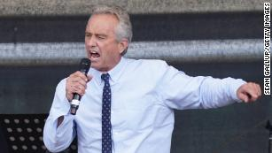

Robert F. Kennedy Jr., nephew of former U.S. President John F. Kennedy and a prominent figure in the anti-vaccination movement, in 2020.

Explaining why Kennedy was kicked off one of its platforms but not the other, a Facebook spokesperson told CNN Thursday, "We don't automatically disable accounts across our apps, because the accounts may post about different things on our different services."

At the time the CCDH's report was released in March, [Kennedy told NPR](https://www.npr.org/2021/05/13/996570855/disinformation-dozen-test-facebooks-twitters-ability-to-curb-vaccine-hoaxes) that he had become more cautious on Facebook, which according to NPR he also accused of censorship. "I have to post, like, unicorns and kitty cat pictures on there," he said.

The CCDH said Friday that 35 social media accounts tied to the people it identified have now been shut down, losing them 5.8 million followers, but 62 accounts with a total of 8.4 million followers are still active.

CNN reported Thursday that meetings between the Biden administration and Facebook have grown "tense," according to a person familiar with the conversations.

The person pointed specifically to Kennedy's still-active Facebook account as an example of what some White House officials view as Facebook's inaction regarding Covid-19 misinformation.

A Facebook spokesperson told CNN Friday the company had shut down some pages and groups belonging to the dozen or so people identified by the CCDH but would not say what pages.

A spokesperson for Twitter ([TWTR](https://money.cnn.com/quote/quote.html?symb=TWTR&source=story_quote_link)) did not immediately respond to a request for comment.

# Tracking Viral Misinformation

Published Sept. 15, 2020Updated Aug. 5, 2021

https://www.nytimes.com/live/2020/2020-election-misinformation-distortions/joseph-mercola-disinformation

© 2021 The New York Times Company

Times reporters will chronicle and debunk false and misleading information that is going viral online.

[](https://www.nytimes.com/by/davey-alba)

**Aug. 4, 2021, 1:36 p.m. ET**

**Aug. 4, 2021, 1:36 p.m. ET**

By [Davey Alba](https://www.nytimes.com/by/davey-alba)

## [A top spreader of coronavirus misinformation says he will delete his posts after 48 hours.](file:///C:\Users\gilljoseph1949\Desktop\More%20Updates\Health\COVID%2019\joseph-mercola-disinformation.html#joseph-mercola-disinformation)

Joseph Mercola, who researchers say is [a chief spreader of coronavirus misinformation](https://www.nytimes.com/2021/07/24/technology/joseph-mercola-coronavirus-misinformation-online.html) online, said on Wednesday that he would delete posts on his site 48 hours after publishing them.

In a post on his website, Dr. Mercola, an osteopathic physician in Cape Coral, Fla., said he was deleting his writings because President Biden had “targeted me as his primary obstacle that must be removed” and because “blatant censorship” was being tolerated.

Last month, the White House, while criticizing tech companies for allowing misinformation about the coronavirus and vaccines to spread widely, pointed to research showing that a [group of 12 people](https://www.counterhate.com/disinformationdozen) were responsible for sharing 65 percent of all anti-vaccine messaging on social media. The nonprofit behind the research, the Center for Countering Digital Hate, called the group the “Disinformation Dozen” and listed Dr. Mercola in the top spot.

Dr. Mercola has built a vast operation to disseminate anti-vaccination and natural health content and to profit from it, according to researchers. He employs teams of people in places like Florida and the Philippines, who swing into action when news moments touch on health issues, rapidly publishing blog posts and translating them into nearly a dozen languages, then pushing them to a network of websites and to social media.

[An analysis by The New York Times](https://www.nytimes.com/2021/07/24/technology/joseph-mercola-coronavirus-misinformation-online.html) found that he had published more than 600 articles on Facebook that cast doubt on Covid-19 vaccines since the pandemic began, reaching a far larger audience than other vaccine skeptics. Dr. Mercola criticized The Times’s reporting in his post on Wednesday, saying it was “loaded with false statements,” (not “false facts” as was previously reported here).

Dr. Mercola said in his blog post that he would remove 15,000 past posts from his website. He will continue to write daily articles, he said, but they will only be available for 48 hours before being removed. He said it was up to his followers to help spread his work.

Rachel E. Moran, a researcher at the University of Washington who studies online conspiracy theories, said the announcement by Dr. Mercola was “him trying to come up with his own strategies of avoiding his content being taken down, while also playing up this martyrdom of being an influential figure in the movement who keeps being targeted.”

Aaron Simpson, a Facebook spokesman, said, “This is exactly what happens when you are enforcing policies against Covid misinformation — people try extreme ways to work around your restrictions.”

Facebook, he said, “will continue to enforce against any account or group that violates our rules.”

YouTube said that it had clear [community guidelines for Covid-19 medical misinformation](https://support.google.com/youtube/answer/9891785), that it had removed a number of Dr. Mercola’s videos from the platform and that it had issued “strikes” on his channel. The company also said it would terminate Dr. Mercola’s channel if it violated its [three strikes policy](https://support.google.com/youtube/answer/2802032?hl=en).

Twitter said that it had taken enforcement action on Dr. Mercola’s account in early July for violations of its Covid-19 misinformation policy, putting his account for in read-only mode for seven days.

“Since the introduction of our Covid-19 misinformation policy, we’ve taken enforcement action on the account you referenced for violating these rules,” said Trenton Kennedy, a Twitter spokesman. “We’ve required the removal of tweets and applied Covid-19 misleading information labels to numerous others.”

***Correction:****Aug. 5, 2021*

*Because of an editing error, an earlier version of this article misstated a portion of the post from Joseph Mercola. He said a previous article in The New York Times was full of false "statements," not false "facts."*

[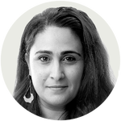](https://www.nytimes.com/by/sheera-frenkel)

* © 2021 The New York Times Company

**Report: Here are the 12 people most responsible for spreading COVID misinformation**

by [**Cecilia Lenzen**](https://coronavirus.nautil.us/author/cecilialenzen/) 17 days ago

<https://coronavirus.nautil.us/covid-misinformation-disinformation-dozen/?utm_source=DailyDot&utm_medium=ReusableBlock&utm_campaign=Coronavirus_must_reads>

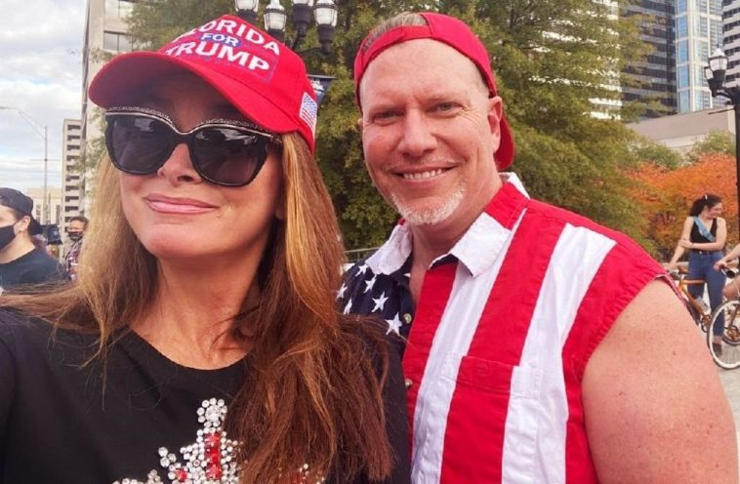

Photo via Ty Charlene Bollinger/Facebook

On social media, misinformation often runs rampant, especially during conflicting times such as the COVID pandemic. Many people believe whatever they see on the web, so long as it aligns with what they want to believe. Or who they want to believe.

Amid the ongoing COVID-19 pandemic, consumers are receiving information on various important topics such as case rates and vaccine safety from all kinds of sources, and sometimes it can be hard to tell what’s factual and what’s fake.

A report shows that the majority of COVID misinformation was spread by 12 people, dubbed “The Disinformation Dozen.”

Compiled by the Center for Countering Digital Hate (CCDH), a U.K./U.S. nonprofit, the report suggests that almost two-thirds of anti-vaccine content circulating on social media stemmed from 12 anti-vaxxers. The Disinformation Dozen were selected because they have large followings on social media, produce high volumes of anti-vaccine content, or saw rapid growth of their social media accounts from February-March 2021.

Here is who the CCDH deemed the Disinformation Dozen.

1. Joseph Mercola, an osteopathic physician and major proponent of “natural health”
2. Robert F. Kennedy, Jr., the son of Robert F. Kennedy and an environmental lawyer and the founder of Children’s Health Defense
3. Ty and Charlene Bollinger, self-acclaimed filmmakers and founders of the docuseries *The Truth about Cancer*
4. Sherri Tenpenny, an osteopathic physician who believes vaccines cause autism
5. Rizza Islam, an antisemitic and anti-LGBTQ social media influencer who targets his anti-vaccine messaging to the Black community
6. Rashid Buttar, an osteopathic physician known for using [chelation therapy](https://www.webmd.com/balance/guide/what-is-chelation-therapy) for numerous conditions, including autism and cancer
7. Erin Elizabeth, runs an alternative health site called “Health Nut News” who has also shared antisemitic posts
8. Sayer Ji, the founder of GreenMedInfo, a popular alternative medicine portal
9. Kelly Brogan, an author of books on alternative medicine, such as *Mind of Your Own*
10. Christiane Northrup, an obstetrics and gynecology physician and author who has embraced pseudoscientific alternative medicine theories
11. Ben Tapper, who works as a chiropractor and founded The Wellness Pointe
12. Kevin Jenkins, a social epidemiologist focused on inequities in healthcare

An analysis of anti-vaccine content shared or posted on Facebook and Twitter a total of 812,000 times between February 1-March 16 shows that 65% of that content was attributable to the Dozen, according to the report. Up to 73% of the 689,000 times that anti-vaccine content was posted to Facebook and up to 17% of more than 120,000 anti-vaccine tweets during that time frame originated from the Dozen.

Despite reportedly violating Facebook, Instagram, and Twitter’s terms of service agreements multiple times, nine of the Dozen still have accounts on all three platforms. The other three have been removed from just one platform each.

According to a [Vice report](https://www.vice.com/en/article/m7evpn/bill-gates-anti-vax-covid-lies-facebook-banned), many of the dozen are intertwined with each, and the Bollingers “have been making huge profits from selling anti-vax disinformation videos. … Part of their scheme was to pay affiliates, including renowned anti-vaxxer Robert Kennedy Jr., to promote the videos to their online followings in exchange for.a cut of the profits. [An archived version of a site](https://web.archive.org/web/20200507154810/https:/partners.thetruthaboutcancer.com/ttav2020/) tracking the success of the affiliate marketers shows that [Erin] Elizabeth was one of the top earners.”

Research from CCDH in 2020 indicates that social media platforms don’t act on up to 95% of reported COVID misinformation.

Misinformation is only growing, as 425 anti-vaxxer accounts had a cumulative 59.2 million followers as of December 2020; this was an increase of 877,000 since June of the same year.

The dozen have also caught the attention of President Joe Biden, who [said](https://www.cnbc.com/2021/07/19/facebook-isnt-killing-people-biden-says-as-he-walks-back-attack-over-vaccine-lies.html), “These 12 people are out there giving misinformation. Anyone listening to it is getting hurt by it. It’s killing people. It’s bad information.”

**Read more on the coronavirus vaccines:**

* [Even some Republicans are calling the politicization of vaccines ‘moronic’](https://coronavirus.nautil.us/vaccine-politics-mitt-romney/)
* [U.S. military troops might be forced to get a COVID vaccine](https://coronavirus.nautil.us/military-forced-vaccinations/)
* [Does the Johnson & Johnson vaccine protect against the delta variant of COVID?](https://coronavirus.nautil.us/johnson-and-johnson-vaccine-against-delta-variant/)
* [Does the Pfizer vaccine protect against the delta variant of COVID?](https://coronavirus.nautil.us/pfizer-vaccine-against-delta-variant/)
* [Does the Moderna vaccine protect against the delta variant of COVID?](https://coronavirus.nautil.us/modern-vaccine-against-delta-variant/)
* [Why did the Johnson & Johnson vaccine fail, as compared to Pfizer and Moderna?](https://coronavirus.nautil.us/johnson-and-johnson-vaccine-fail/)
* [Does the COVID vaccine make your breasts bigger?](https://coronavirus.nautil.us/covid-vaccine-larger-breasts/)
* [How long will the COVID-19 vaccines keep you safe from the coronavirus?](https://coronavirus.nautil.us/how-long-does-the-covid-vaccine-last/)

**Sources:** [CCDH](https://www.counterhate.com/disinformationdozen), [Vice](https://www.vice.com/en/article/m7evpn/bill-gates-anti-vax-covid-lies-facebook-banned), [CNBC](https://www.cnbc.com/2021/07/19/facebook-isnt-killing-people-biden-says-as-he-walks-back-attack-over-vaccine-lies.html)

# Just 12 People Are Behind Most Vaccine Hoaxes On Social Media, Research Shows

<https://www.npr.org/2021/05/13/996570855/disinformation-dozen-test-facebooks-twitters-ability-to-curb-vaccine-hoaxes>

• • • Updated May 14, 202111:48 AM ET

Heard on [All Things Considered](https://www.npr.org/programs/all-things-considered/2021/05/13/996463354)

[](https://www.npr.org/people/763523701/shannon-bond)

[Shannon Bond](https://www.npr.org/people/763523701/shannon-bond)

[Twitter](https://www.twitter.com/shannonpareil)

4-Minute Listen

* [**Download**](https://ondemand.npr.org/anon.npr-mp3/npr/atc/2021/05/20210513_atc_disinformation_dozen_just_12_people_behind_bulk_of_vaccine_falsities_onl.mp3?orgId=1&topicId=1019&aggIds=973275370&d=257&p=2&story=996570855&dl=1&sc=siteplayer&siteplayer=true&size=4118614&dl=1)



* [**Transcript**](https://www.npr.org/transcripts/996570855)

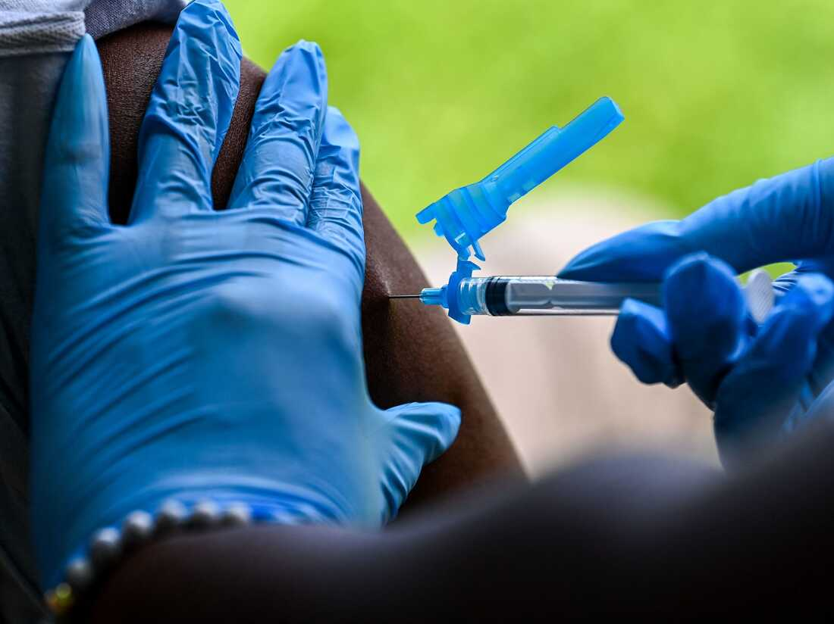

The majority of anti-vaccine claims on social media trace back to a small number of influential figures, according to researchers.

Chandan Khanna/AFP via Getty Images

Researchers have found just 12 people are responsible for the bulk of the misleading claims and outright lies about COVID-19 vaccines that proliferate on Facebook, Instagram and Twitter.

"The 'Disinformation Dozen' produce 65% of the shares of anti-vaccine misinformation on social media platforms," said Imran Ahmed, chief executive officer of the Center for Countering Digital Hate, which [identified](https://252f2edd-1c8b-49f5-9bb2-cb57bb47e4ba.filesusr.com/ugd/f4d9b9_b7cedc0553604720b7137f8663366ee5.pdf) the accounts.

[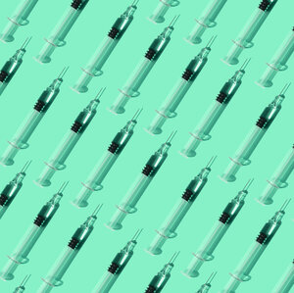](https://www.npr.org/sections/health-shots/2021/05/12/993615185/for-some-anti-vaccine-advocates-misinformation-is-part-of-a-business)

### [Shots - Health News](https://www.npr.org/sections/health-shots/)

### [For Some Anti-Vaccine Advocates, Misinformation Is Part Of A Business](https://www.npr.org/sections/health-shots/2021/05/12/993615185/for-some-anti-vaccine-advocates-misinformation-is-part-of-a-business)

Now the vaccine rollout is reaching a critical stage in which most adults who want the vaccine have gotten it, but many others are holding out, these 12 influential social media users stand to have an outsize impact on the outcome.

After this story published on Thursday, Facebook said it had taken down more of the accounts run by these 12 individuals.

These figures are well-known to both researchers and the social networks. They include anti-vaccine activists, alternative health entrepreneurs and physicians. Some of them run multiple accounts across the different platforms. They often promote "natural health." Some even [sell supplements and books](https://www.npr.org/sections/health-shots/2021/05/12/993615185/for-some-anti-vaccine-advocates-misinformation-is-part-of-a-business).

Many of the messages about the COVID-19 vaccines being widely spread online mirror what's been said in the past about other vaccines by peddlers of [health misinformation](https://www.npr.org/2020/12/10/944408988/the-perfect-storm-how-coronavirus-spread-vaccine-misinformation-to-the-mainstrea).

"It's almost like conspiracy theory Mad Libs. They just inserted the new claims," said John Gregory, deputy health editor at NewsGuard, which rates the credibility of news sites and has done its own tracking of COVID-19 and vaccine misinformation ["superspreaders."](https://www.newsguardtech.com/special-report-covid-19-vaccine-misinformation/)

The claims from the "Disinformation Dozen" range from "denying that COVID exists, claiming that false cures are in fact the way to solve COVID and not vaccination, decrying vaccines and decrying doctors as being in some way venal or motivated by other factors when they recommend vaccines," Ahmed said.

[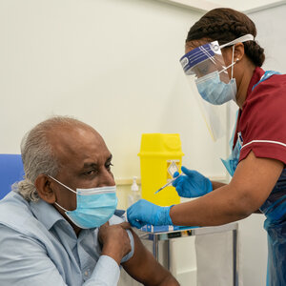](https://www.npr.org/2020/12/10/944408988/the-perfect-storm-how-coronavirus-spread-vaccine-misinformation-to-the-mainstrea)

### [The Coronavirus Crisis](https://www.npr.org/series/812054919/the-coronavirus-crisis)

### ['The Perfect Storm': How Vaccine Misinformation Spread To The Mainstream](https://www.npr.org/2020/12/10/944408988/the-perfect-storm-how-coronavirus-spread-vaccine-misinformation-to-the-mainstrea)

Many of the 12, he said, have been spreading scientifically disproven medical claims and conspiracies for years.

Which provokes the question: Why have social media platforms only recently begun cracking down on their falsehoods?

Both members of Congress and state attorneys general have urged Facebook and Twitter to ban the "Disinformation Dozen."

"Getting Americans vaccinated is critical to putting this pandemic behind us. Vaccine disinformation spread online has deadly consequences, which is why I have called on social media platforms to take action against the accounts propagating the majority of these lies," Sen. Amy Klobuchar, D-Minn., told NPR.

**Social networks crack down on COVID-19 vaccine claims**

The companies have stopped short of taking all 12 figures offline entirely, but they have [stepped up their fight](https://www.npr.org/2021/02/08/965390755/facebook-widens-ban-on-covid-19-vaccine-misinformation-in-push-to-boost-confiden): They've labeled misleading posts. They've removed falsehoods. In some cases, they've banned people who repeatedly share debunked claims.

[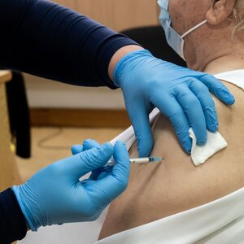](https://www.npr.org/2021/02/08/965390755/facebook-widens-ban-on-covid-19-vaccine-misinformation-in-push-to-boost-confiden)

### [The Coronavirus Crisis](https://www.npr.org/series/812054919/the-coronavirus-crisis)

### [Facebook Widens Ban On COVID-19 Vaccine Misinformation In Push To Boost Confidence](https://www.npr.org/2021/02/08/965390755/facebook-widens-ban-on-covid-19-vaccine-misinformation-in-push-to-boost-confiden)

After NPR's reporting, Facebook said it had taken additional action against some of the figures identified by the Center for Countering Digital Hate, several of which operate multiple accounts on the social network's apps. The company said on Thursday it had found new posts violating its rules.

Facebook has now removed 16 accounts from Facebook or Instagram and placed restrictions on 22 others, such as preventing them from being recommended to other users, reducing the reach of their posts and blocking them from promoting themselves through paid ads.

"We reacted early and aggressively to the COVID-19 pandemic by working with health experts to update our misinformation policy to target harmful claims about COVID-19 and vaccines, including taking action against some of the accounts in the CCDH report," spokesperson Kevin McAlister said in a statement. "In total, we've removed more than 16 million pieces of content which violate our policies and we continue to work with health experts to regularly update these policies as new facts and trends emerge."

However, Facebook also disputed the methodology of the center's report, saying it was not clear what criteria the group used to choose the set of social media posts at which it looked.

Twitter said it permanently suspended two of the "Disinformation Dozen" accounts for repeatedly breaking its rules, required other accounts to delete some tweets and applied labels that link to credible information about vaccines and don't allow the tweets to be shared or replied to. Overall, it's removed more than 22,400 tweets for violating its COVID-19 policies.

However, spokesperson Elizabeth Busby said Twitter distinguishes between "harmful vaccine misinformation that contradicts credible public health information, which is prohibited under our policy, and negative vaccine sentiment that is a matter of opinion."

And so the "Disinformation Dozen" are still easy to find on social media.

**"Tried and true" tactics**

Sometimes they skirt the platforms' rules by using codes.

"Instead of saying 'vaccine,' they may, in a video, hold up the V sign with their fingers and say, 'If you're around someone who has been' — hold up V sign — 'you know, X might happen to you,' " Ahmed said.

Or they take something true and [distort it](https://www.npr.org/2021/03/25/980035707/lying-through-truth-misleading-facts-fuel-vaccine-misinformation), such as falsely linking a famous person's death to the fact that the celebrity got a vaccine days or weeks earlier.

[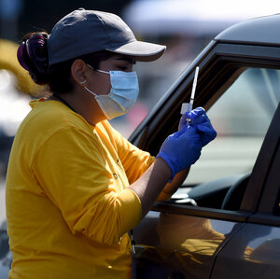](https://www.npr.org/2021/03/25/980035707/lying-through-truth-misleading-facts-fuel-vaccine-misinformation)

### [Untangling Disinformation](https://www.npr.org/series/973275370/untangling-disinformation)

### [Few Facts, Millions Of Clicks: Fearmongering Vaccine Stories Go Viral Online](https://www.npr.org/2021/03/25/980035707/lying-through-truth-misleading-facts-fuel-vaccine-misinformation)

NewsGuard's Gregory said a "tried and true" tactic of vaccine opponents is "grossly misrepresenting some sort of research, some sort of data to promote whatever narrative they've chosen."

Facebook said it now limits the reach of posts that could discourage people from getting vaccinated, even if the messages don't explicitly break its rules.

But the cat-and-mouse game continues.

**Anti-vaccine activists claim censorship**

As the social networks have cracked down, some previously prolific spreaders of vaccine misinformation have toned down their posts and have told their followers they are being censored.

[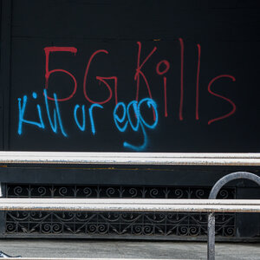](https://www.npr.org/2020/07/10/889037310/anatomy-of-a-covid-19-conspiracy-theory)

### [The Coronavirus Crisis](https://www.npr.org/series/812054919/the-coronavirus-crisis)

### [Anatomy Of A COVID-19 Conspiracy Theory](https://www.npr.org/2020/07/10/889037310/anatomy-of-a-covid-19-conspiracy-theory)

Take anti-vaccine activist Robert F. Kennedy Jr., one of the "Disinformation Dozen" identified by the center, who has promoted the long discredited idea that vaccines are linked to autism. During the pandemic, he has shared baseless conspiracy theories linking [5G cellular networks](https://www.npr.org/2020/07/10/889037310/anatomy-of-a-covid-19-conspiracy-theory) to the coronavirus, and suggested, without evidence, that the death of [baseball great Hank Aaron](https://www.npr.org/2021/01/22/959600201/hank-aaron-baseballs-legendary-slugger-dies-at-86) was "part of a wave of suspicious deaths" tied to vaccines.

None of that is true.

Kennedy was [kicked off Instagram](https://www.npr.org/sections/coronavirus-live-updates/2021/02/11/966902737/instagram-bars-robert-f-kennedy-jr-for-spreading-vaccine-misinformation), which Facebook owns, in February over repeatedly sharing debunked claims.

Yet Facebook did not remove him from its namesake platform. He told NPR the company has flagged some of his posts, however, so he has become more cautious.

"I have to post, like, unicorns and kitty cat pictures on there," he said. "I don't want to give them an excuse."

He also uses it to promote his website and newsletter, where he makes claims he cannot on the social network.

Kennedy said he's never posted misinformation and accused Facebook of censorship. He said the crackdown has cost "hundreds of thousands of dollars" in donations to his organization.

**A battle of persuasion**

Even as the social media companies have gotten tougher recently on misinformation, researchers worry the persistence of vaccine-related hoaxes will further erode confidence among people who hesitate to get the shot.

That's especially concerning as vaccines roll out for [children 12 and up](https://www.npr.org/sections/coronavirus-live-updates/2021/05/12/996185305/federal-panel-recommends-coronavirus-vaccines-for-adolescents-aged-12-15).

[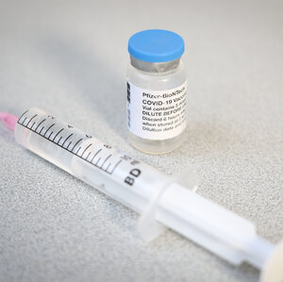](https://www.npr.org/sections/coronavirus-live-updates/2021/05/12/996185305/federal-panel-recommends-coronavirus-vaccines-for-adolescents-aged-12-15)

### [Coronavirus Updates](https://www.npr.org/sections/coronavirus-live-updates/)

### [CDC Says Kids As Young As 12 Should Get The Pfizer COVID-19 Vaccine](https://www.npr.org/sections/coronavirus-live-updates/2021/05/12/996185305/federal-panel-recommends-coronavirus-vaccines-for-adolescents-aged-12-15)

In a survey of U.S parents, Indiana University sociologist Jessica Calarco found more than a quarter don't plan to vaccinate their kids.

"So many of these moms are turning to Facebook, are turning to Twitter, are turning to other social media platforms" for news and information, she said. "And they're saying, 'Every time I open my phone, I see something different.' "

Even some parents whose kids have had routine childhood vaccines told Calarco they're unsure about COVID-19 jabs.

Facebook this week [released survey data](https://about.fb.com/news/2021/05/supporting-vaccination-efforts-on-our-apps/) showing vaccine acceptance among adults in the U.S. has increased by 10% since January. However, its survey also shows that the top reasons people said they don't want to get vaccinated are worries about side effects and lack of trust in the vaccines or the government — exactly the kind of fears anti-vaccination accounts promote.

The social networks said amplifying credible information from authoritative sources, such as the Centers for Disease Control and Prevention, is just as important as reducing the spread of harmful posts. Both Facebook and Twitter link to public health information in their apps and in the labels they put on misleading posts.

But they now face an uphill battle of persuading the skeptics.

Calarco said many of the parents she spoke with weigh the posts they see on social media "equally against the kinds of expert medical recommendations, expert medical information coming out of things like the CDC."

***Editor's note:*** Facebook is among NPR's financial supporters.

Jul 19, 2021,07:30am EDT|27,051 views

# De-platform The Disinformation Dozen – Forbes

# <https://www.forbes.com/sites/stevensalzberg/2021/07/19/de-platform-the-disinformation-dozen/?sh=696dfa1e7378>

[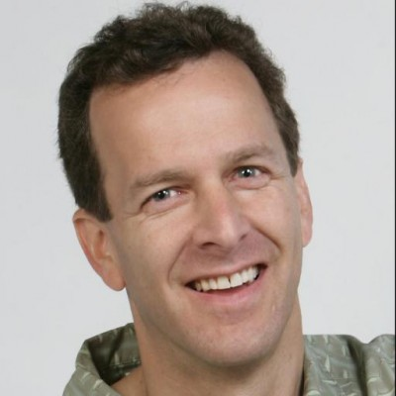](https://www.forbes.com/sites/stevensalzberg/)

[Steven Salzberg](https://www.forbes.com/sites/stevensalzberg/)

Contributor

[Healthcare](https://www.forbes.com/healthcare)

• • 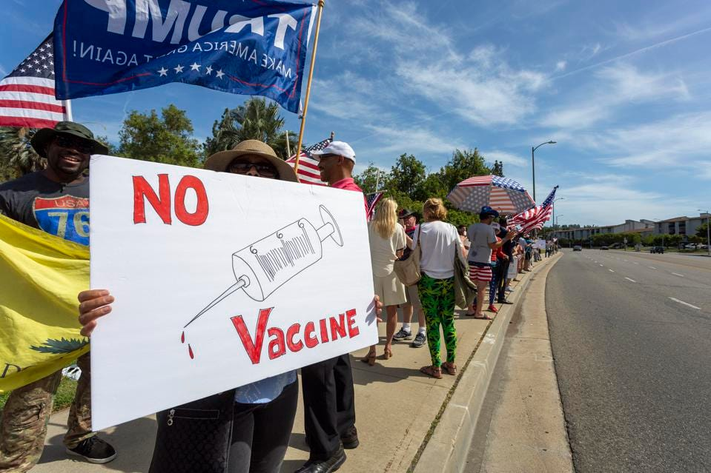

WOODLAND HILLS, CA - MAY 16: A protester holds an anti-vaccination sign as supporters of President ... [+]

Getty Images

I’ve been writing about anti-vaxxers for a dozen years now, warning of the threat to public health that they represent. Today, though, the threat is far greater than it was in the past, because now we’re in the midst of a deadly pandemic, and vaccines are our only tool out of it. Merely educating the public on the benefits of vaccines isn’t working in the face of a deluge of misinformation from anti-vaxxers. It’s time to take away their platforms.

[A new report from the nonprofit Center for Countering Digital Hate](https://www.counterhate.com/disinformationdozen) (CCDH) reveals that 65% of the anti-vaccine disinformation online can be traced to just twelve people. This offers hope that we can actually do something: by removing a tiny number of accounts, millions of lives can be saved. The social media platforms have the power to do this, and they could do it virtually overnight.

(No, I’m not calling for censorship, and no, they don’t have any 1st amendment rights to spread their lies. I’ll get to that below.)

A bit of background: the modern anti-vax movement started in the late 1990s, focusing primarily on childhood vaccines, especially the vaccines against measles, mumps, and rubella, and using (initially) a fraudulent study published in The Lancet to scare people about a non-existent link between vaccines and autism. That study was eventually retracted, and the lead author, Andrew Wakefield, lost his medical license after his fraud came to light.

But the damage was done. Anti-vaxxers and the misinformation they spread on social media caused vaccination rates to drop in the US and the UK, and in other countries, and diseases such as measles, which we had essentially eliminated in the US, started to re-emerge. Tragically, some people died of completely preventable diseases. One thing we’ve learned from the past 20 years is that once anti-vaxxers start spreading their misinformation, it’s incredibly difficult to correct the falsehoods.

Anti-vaxxers today have turned their social media efforts towards attacking the Covid-19 vaccines. (They actually started attacking the vaccines before the vaccines even existed, a kind of reality-twisting that would be funny if it weren’t so tragic.)

MORE FOR YOU

### [UnitedHealth Escalates Partnerships To Address Health Inequity](https://www.forbes.com/sites/brucejapsen/2021/07/19/unitedhealth-escalates-partnerships-to-address-health-equity/)

### [This Startup Raised $30 Million To Create Brain Maps To Aid Surgeries And Therapeutics](https://www.forbes.com/sites/aayushipratap/2021/07/19/this-startup-raised-30-million-to-create-brain-maps-to-aid-surgeries-and-therapeutics/)

Covid-19 has already killed millions, and millions more may die before we get it under control. The only realistic way to end the pandemic is through vaccination. Fortunately, we now have multiple highly effective vaccines, as I’ve written about several times in the past year. Unfortunately, a large segment of the population has been grievously misled, and many people say they will never get vaccinated. The pandemic might persist for years, hurting all of us, if these people continue to refuse vaccines.

The anti-vax movement constantly spreads lies, rumors, and misinformation in an effort to scare people away from vaccination. I won’t repeat the lies here, because merely stating them gives them more credibility than they deserve. But the anti-vaxxers and the social media platforms that spread their messages must be stopped. [As President Biden said this past Friday, “they’re killing people.”](https://www.latimes.com/politics/story/2021-07-16/delta-variant-sets-back-bidens-progress-against-covid-19-risks-economic-revival)

One particularly unfortunate development in the US is that the anti-vax position has become hyper-political. Even though Trump has claimed credit for developing the vaccines, and even though he and his family were vaccinated as soon as the vaccines became available, many leaders of the Republican party and on right-wing media [such as Fox News have embraced anti-vaccine positions](https://www.nytimes.com/2021/07/11/business/media/vaccines-fox-news-hosts.html), and have told their millions of followers to refuse vaccination. Logically, it makes no sense that vaccine refusal has become a political issue, [but it has](https://www.vanityfair.com/news/2021/07/biden-administration-vs-covid-anti-vaxxers).

The good news is that we might actually be able to stop the anti-vaxxers. The[CCDH report on the Disinformation Dozen](https://www.counterhate.com/disinformationdozen) shows that these 12 people, who collectively have [59 million followers](https://www.theguardian.com/world/2021/jul/17/covid-misinformation-conspiracy-theories-ccdh-report), are responsible for 73% of the anti-vax content on Facebook and 65% of anti-vaccine messages on other major platforms, including Twitter, Instagram, and YouTube. This in turn means that if the social media platforms will simply shut down their accounts (and other sites that they control, such as the misleadingly-named Children’s Health Defense and National Vaccine Information Center), we will see a dramatic reduction in false vaccine information, virtually overnight.

So who are the Disinformation Dozen? Here they are:

1. Joseph Mercola
2. Robert F. Kennedy, Jr.
3. Ty and Charlene Bollinger
4. Sherri Tenpenny
5. Rizza Islam
6. Rashid Buttar
7. Erin Elizabeth
8. Sayer Ji
9. Kelly Brogan
10. Christiane Northrup
11. Ben Tapper
12. Kevin Jenkins

I’ve written about Mercola and RFK Jr. before, multiple times, but not the others. I’m intentionally not providing links to their anti-vax accounts, which include Facebook, Instagram, Twitter, YouTube, and dedicated websites, because any links simply add to their influence. Mercola, for example, has become wealthy by selling dietary supplements with unproven and often bogus health claims, and by pushing anti-vaccine myths, [as I wrote all the way back in 2010](https://www.forbes.com/sites/sciencebiz/2010/04/27/making-money-promoting-anti-vaccine-myths/). Perhaps if people realized this, they wouldn’t be so quick to believe him.

It’s time to de-platform the anti-vaccine Disinformation Dozen. In our current world, this can only happen if the companies themselves–Facebook, Instagram, Twitter, and Google–delete their accounts. One might expect that these companies would have already done this, based on their own policies, but as [the CCDH report states](https://www.counterhate.com/disinformationdozen):

“Despite repeatedly violating Facebook, Instagram and Twitter’s terms of service agreements, nine of the Disinformation Dozen remain on all three platforms, while just three have been comprehensively removed from just one platform.”

This isn’t a free speech or First Amendment issue; private companies aren’t required to provide a platform for anyone. And I’m not calling for the Disinformation Dozen to be arrested or legally punished for spreading misinformation, even though it is harmful, and even though they are indirectly killing people by their actions. But private companies can kick anyone off their platforms, whenever they want, and if these companies care at all about public health, and about the health of their own customers, they’ll delete all the accounts associated with these 12 people.

Finally, let me get a bit philosophical. It’s astonishing that we’ve created a society where we appear to be powerless to stop the spread of lies and distortions that are actually killing people. Our technology allows anti-vaxxers to reach millions of people and to convince those people to take actions that harm not only themselves, but all of us, because they’re allowing the virus to spread and mutate. It appears that our governments simply don’t have the power to force Facebook, Twitter, YouTube, Google, and Instagram to shut down these accounts, so instead we rely on the whims of a tiny number of people who run those companies.

Should governments step in here and force the companies to take action? I don’t know, but so far the companies themselves have failed to take action on their own. Germany and France seem to have the best solution so far: [by requiring vaccines in order to eat at restaurants and travel on planes and trains](https://www.washingtonpost.com/world/europe/vaccine-mandate-france-germany/2021/07/17/c36b0e74-e634-11eb-88c5-4fd6382c47cb_story.html), they’ve convinced large swaths of their populations, including formerly vaccine-hesitant people, to get vaccinated. The US, by contrast, has 50 different policies for 50 states, including some policies that are straight-up anti-vaccine. There must be a better way.

Follow me on [Twitter](https://www.twitter.com/StevenSalzberg1). Check out my [website](http://salzberg-lab.org).

[Steven Salzberg](https://www.forbes.com/sites/stevensalzberg/)

I'm the Bloomberg Distinguished Professor of Biomedical Engineering, Computer Science, and Biostatistics at Johns Hopkins University. From 2005-2011 I was the Horvitz

# A dozen anti-vaccine accounts are responsible for 65% of disinformation shared online, new report finds

<https://www.cbsnews.com/news/vaccine-disinformation-social-media-center-for-countering-digital-hate-report/>

By Audrey McNamara

March 25, 2021 / 10:09 PM / CBS News

A new report by the Center for Countering Digital Hate finds that "just 12 anti-vaxxers are responsible for almost two-thirds of anti-vaccine content circulating on social media platforms." The so-called "Disinformation Dozen" remain prominent figures on platforms like Facebook and Twitter, despite repeatedly violating their terms of service, according to the center.

"Living in full view of the public on the internet are a small group of individuals who do not have relevant medical expertise and have their own pockets to line, who are abusing social media platforms to misrepresent the threat of COVID and spread misinformation about the safety of vaccines," reads the [report](https://252f2edd-1c8b-49f5-9bb2-cb57bb47e4ba.filesusr.com/ugd/f4d9b9_b7cedc0553604720b7137f8663366ee5.pdf) from the nonprofit organization, which works to disrupt "the spread of digital hate and misinformation."

The center identified the dozen "because they have large numbers of followers, produce high volumes of anti-vaccine content or have seen rapid growth of their social media accounts in the last two months." Among them are [Robert F. Kennedy Jr.](https://www.cbsnews.com/news/robert-kennedy-jr-instagram-ban-false-covid-19-claims/), who leads an anti-vaccine group; Dr. Joseph Mercola, who has made a fortune selling dietary supplements as alternatives to vaccines; and Ty and Charlene Bollinger, founders of "The Truth About Cancer."

"They're not just individuals... these are individuals who have behind them large companies that they themselves run, which pump our misinformation with the aim of persuading people not to follow the clinical guidance, and to instead buy their false cures, or to buy access to the information they claim is the truth about coronavirus and about vaccines," Imran Ahmed, founder and CEO of the Center for Countering Digital Hate, told CBSN on Wednesday.

The center analyzed over 812,000 Facebook and Twitter vaccine-related posts shared between February 1 and March 16 of this year. Sixty-five percent percent of anti-vaccine posts came from one of the 12 "Disinformation Dozen."

"Anti-vaccine activists on Facebook, YouTube, Instagram and Twitter reach more than 59 million followers, making these the largest and most important social media platforms for anti-vaxxers," according to the report. The center also found that these accounts specifically target Black Americans, who've been [less likely to get vaccinated](https://www.cbsnews.com/news/covid-vaccine-hesitancy-opinion-poll/) so far.

### Trending News

[](https://www.cbsnews.com/news/mendocino-california-drought-running-out-of-water/?intcid=CNI-00-10aaa3b)

[California tourist town running out of water amid drought](https://www.cbsnews.com/news/mendocino-california-drought-running-out-of-water/?intcid=CNI-00-10aaa3b)

[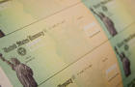](https://www.cbsnews.com/news/fourth-stimulus-check-update-2021-08-05/?intcid=CNI-00-10aaa3b)

[What's behind the push for a fourth stimulus check](https://www.cbsnews.com/news/fourth-stimulus-check-update-2021-08-05/?intcid=CNI-00-10aaa3b)

[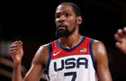](https://www.cbsnews.com/news/team-usa-mens-basketball-olympics-gold-medal-game-how-to-watch/?intcid=CNI-00-10aaa3b)

[How to watch Team USA men's basketball compete for gold medal](https://www.cbsnews.com/news/team-usa-mens-basketball-olympics-gold-medal-game-how-to-watch/?intcid=CNI-00-10aaa3b)

[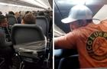](https://www.cbsnews.com/news/frontier-airlines-flight-attendants-passenger-maxwell-wilkinson-berry/?intcid=CNI-00-10aaa3b)

[Passenger taped to seat after allegedly groping flight attendants](https://www.cbsnews.com/news/frontier-airlines-flight-attendants-passenger-maxwell-wilkinson-berry/?intcid=CNI-00-10aaa3b)

The organization has called for Facebook, Instagram, YouTube and Twitter to deplatform the "Disinformation Dozen" as well as the organizations they are linked to. Three of the 12 have been comprehensively removed from at least one platform, but none have been removed from all.

"Facebook, Google and Twitter have put policies into place to prevent the spread of vaccine misinformation; yet to date, all have failed to satisfactorily enforce those policies," reads the report. "All have been particularly ineffective at removing harmful and dangerous misinformation about coronavirus vaccines, though the scale of misinformation on Facebook, and thus the impact of their failure, is larger."

A spokesman for Twitter told CBS News it had removed 22,400 tweets under its COVID-19 "misleading information policy" and "challenged" nearly 12 million accounts. Dani Lever, a spokesperson for Facebook, said the company has removed more than 2 million pieces of content since February.

Facebook's Mark Zuckerberg told lawmakers on the House Energy and Commerce Committee [at a hearing Thursday](https://www.cbsnews.com/news/misinformation-extremism-hearing-google-facebook-twitter-watch-live-stream-today-2021-03-25/) that his platform separates misinformation into categories, the most serious being what could cause "imminent physical harm." False claims about the coronavirus, or its vaccines, he said, could lead to someone getting sick, and therefore [would be removed](https://www.cbsnews.com/news/facebook-widens-ban-on-vaccine-misinformation-to-include-anti-vaccination-conspiracy-theories/).

"That's the broad approach that we have … that sort of explains some of the differences between some of the different issues and how we approach them," Zuckerberg said.

That "broad approach" has been criticized by a group of [12 state attorneys general](https://www.cbsnews.com/news/covid-vaccine-disinformation-twitter-facebook-state-attorneys-general/) who have urged Facebook and Twitter to "take immediate steps" to crack down on online "anti-vaxxer" falsehoods amid the ongoing effort to vaccinate the public against [COVID-19](https://www.cbsnews.com/feature/coronavirus/).

In a [letter](https://drive.google.com/file/d/19g9jEHU6wm_an37TVPpTsO9txh9zztdY/view?usp=sharing) to Zuckerberg and Twitter CEO Jack Dorsey on Wednesday, the attorneys general pressed the social media giants to fully "identify and enforce" the companies' terms of service to combat against vaccine disinformation and misinformation.

"A small group of individuals use your platforms to downplay the dangers of COVID-19 and spread misinformation about the safety of vaccines," the group said, citing CCDH's report. "These individuals lack medical expertise and are often motivated by financial interests."

In addition to deplatforming the dozen, the center also recommends platforms establish a clear threshold for enforcement action, display corrective posts to users exposed to disinformation, add warning screens when users click links to misinformation sites, institute an Accountability API (application programming interface), and ban private and secret anti-vaccine Facebook Groups.

"(Their) content has the potential of harming human life," Ahmed told CBSN. "Not just the individuals themselves, but more cruelly, the people they love and our communities as a whole."

First published on March 25, 2021 / 10:09 PM

© 2021 CBS Interactive Inc. All Rights Reserved.

Health

March 29, 2021

Related Condition Centers

* [COVID-19 (Coronavirus)](https://www.self.com/health-conditions/covid-19-coronavirus)

**These 12 Sources Are Apparently Responsible for 65% of Vaccine Disinformation on Social Media**

Watch out for the “disinformation dozen.”

<https://www.self.com/story/vaccine-disinformation-on-social-media>

By [Sarah Jacoby](https://www.self.com/contributor/sarah-jacoby)

Westend61/Adobe Stock

As [COVID-19 vaccines](https://www.self.com/story/which-covid-19-vaccine) have become more available, so has vaccine disinformation. But according to a new report, just 12 sources are responsible for the majority of the [anti-vaccine information](https://www.self.com/story/from-anti-to-pro-vaccine) circulating on social media.

For the [report](https://252f2edd-1c8b-49f5-9bb2-cb57bb47e4ba.filesusr.com/ugd/f4d9b9_b7cedc0553604720b7137f8663366ee5.pdf), published by the nonprofit Center for Countering Digital Hate, researchers analyzed anti-vaccine posts from 10 private and 20 public Facebook groups as well as a sample of about 123,000 anti-vaccine tweets from February 1 to mid-March of this year. Their results showed that 73% of vaccine disinformation posts on Facebook and 17% of those on Twitter (about 65% overall) originate from the same 12 sources. (While *mis*information is false information that people spread perhaps without realizing that it's wrong, *dis*information is typically defined as false information that people spread deliberately.)

Those 12 sources, which the report calls the “disinformation dozen," are: Joseph Mercola, Robert F. Kennedy Jr., Ty and Charlene Bollinger, Sherri Tenpenny, Rizza Islam, Rashid Buttar, Erin Elizabeth, Sayer Ji, Kelly Brogan, Christiane Northrup, Ben Tapper, and Kevin Jenkins. “The majority of the disinformation dozen remain on major social media platforms, despite repeated violations of their terms of service,” the report says.

Of course, it's crucial to identify the places where the majority of this bad information starts. But it's also important to recognize how easily false claims like these can spread on a small scale—especially between friends and family, whom we may be inherently more likely to trust. When deciding whether or not to share something on social media, the [News Literacy Project](https://newslit.org/tips-tools/information-hygiene-sanitize-before-you-share/) first recommends pausing to take a breath and look at the comments to see whether someone has replied with a fact-check of the post. From there, you can search for the claims in the post online for the claims to see whether reputable news organizations or other reliable sources confirm the information. And you can ask the person who originally posted the claim for their source too, the News Literacy Project suggests.

It's always important to make sure you're getting health information from reliable sources. And it's even more important to be careful about that during a global pandemic because all of us will need to do our part—wearing masks, staying socially distanced, getting vaccinated when eligible—to contain COVID-19. Those [reliable sources](https://www.self.com/story/accurate-coronavirus-news) could include official organizations (like the Centers for Disease Control and Prevention or the World Health Organization), major scientific news outlets (such as [*Science*](https://www.sciencemag.org/) and [*Nature*](https://www.nature.com/)), and qualified experts (like those [on this Twitter list](https://twitter.com/i/lists/1220869298631200769) created by an epidemiologist).

To sort through ongoing coronavirus news, try using the [News Literacy Project](https://newslit.org/wp-content/uploads/2020/09/How-to-know-what-to-trust-DIGITAL_092320.pdf)'s seven-step guide for avoiding misinformation depending on whether the information is user-generated (like on social media), from a source or organization you're not familiar with, or from a recognizable source that follows journalistic best practices. In general, it's also a good idea to get your news from multiple trusted sources, such as longtime newspapers with large national circulation and public radio, so that you can cross-check their claims, science and health journalist Tara Haelle [told SELF previously](https://www.self.com/story/accurate-coronavirus-news).

But you as an individual can only do so much, which is why the Center for Countering Digital Hate recommends that major social media sites deplatform (ban) the worst disinformation offenders to limit their reach. The report also recommends that platforms [display corrections on posts](https://www.self.com/story/trump-facebook-removed-covid) containing misinformation, warn users when they click on sites known for disinformation, and ultimately ban public and private groups that exist mainly for the purpose of spreading vaccine disinformation. Considering just how crucial the current vaccine rollout is, it's worth the effort to make sure we're getting our information from reliable sources.

**Related:**

* [I Used to Be An Anti-Vaxxer. Here’s What Changed My Mind.](https://www.self.com/story/from-anti-to-pro-vaccine)
* [Dr. Fauci Says His Biggest COVID-19 Vaccine Worry Is That People Won't Get It](https://www.self.com/story/dr-fauci-covid-19-vaccine-hesitancy)
* [6 Health-Care Providers on How They Talk to Vaccine-Hesitant Patients](https://www.self.com/story/vaccine-hesitant-patients)

[](https://www.self.com/contributor/sarah-jacoby)

[Sarah Jacoby](https://www.self.com/contributor/sarah-jacoby) is the Associate News Director at [SELF](https://www.self.com/contributor/sarah-jacoby). She's an experienced health and science journalist who is particularly interested in the science of skin care, sexual and reproductive health, drugs and drug policy, and mental health. Sarah is a graduate of NYU's Science, Health, and Environmental Reporting Program

[International](https://businessinsider.mx/12-anti-vaxxers-responsible-for-most-disinformation-online-study-says-2021-7/?r=US&IR=T) 18/07/2021 a las 06:11am

**Just 12 people are responsible for the majority of COVID-19 conspiracy theories online, study finds. JFK’s anti-vaxxer nephew is one of the ‘disinformation dozen.’**

<https://businessinsider.mx/12-anti-vaxxers-responsible-for-most-disinformation-online-study-says-2021-7/?r=US&IR=T>

[Business Insider International](https://www.businessinsider.com/international/?IR=C)

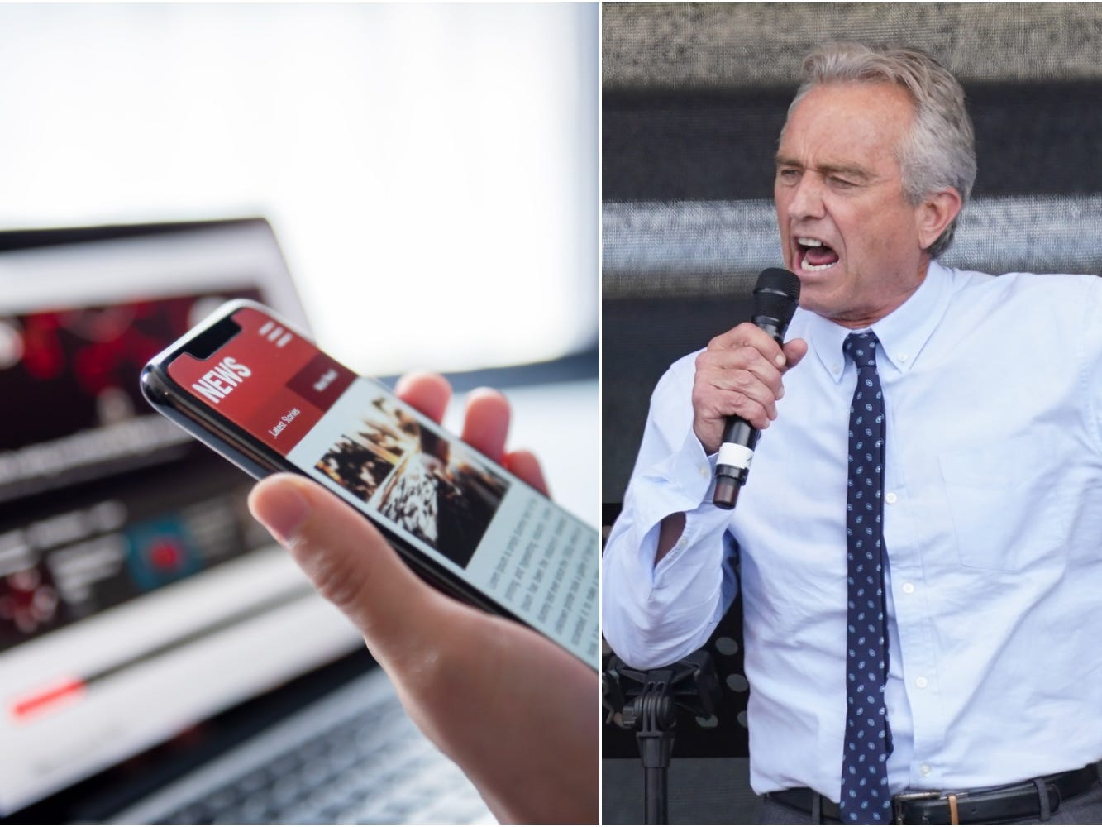The disinformation dozen, which includes Robert F. Kennedy Jr, are twelve anti-vaxxers who play leading roles in spreading digital misinformation about COVID-19 vaccines.  
Getty Images

* 12 people are responsible for the majority of COVID-19 disinformation shared online, according to a new study.
* The CCDH found that 65% of anti-vaccine posts on Facebook and Twitter could be attributed to the "disinformation dozen."
* The disinformation dozen includes a bodybuilder, a wellness blogger, and JFK's nephew.
* [See more stories on Insider's business page](https://www.businessinsider.com/?hprecirc-bullet).

The majority of COVID-19 disinformation shared online comes from just 12 people, according to a [new report](https://252f2edd-1c8b-49f5-9bb2-cb57bb47e4ba.filesusr.com/ugd/f4d9b9_b7cedc0553604720b7137f8663366ee5.pdf) by the [Center for Countering Digital Hate (CCDH)](https://www.counterhate.com/).

The CCDH analyzed 812,000 anti-vaccine posts shared on Facebook and Twitter between February 1 and March 16, 2021. It found that 65 percent of this content could be attributed to what is being dubbed the "disinformation dozen."

On Facebook alone, the CCDH found that those 12 people were responsible for 73 percent of the anti-vaccine content on the platform.

***Read more:*** [*Anti-maskers are using fake medical cards to avoid scrutiny for not wearing coverings in public*](https://www.businessinsider.com/mask-exemption-lanyards-anti-mask-movement-2021-7)

The disinformation dozen is made up of a bodybuilder, a wellness blogger, and a religious zealot, [The Guardian](https://www.theguardian.com/world/2021/jul/17/covid-misinformation-conspiracy-theories-ccdh-report) reported.

Also, most notably, it includes the nephew of former President John F Kennedy. Robert F Kennedy Jr is a prominent anti-vaxxer who has proliferated disinformation [connecting vaccines to autism](http://www.sacbee.com/news/politics-government/capitol-alert/article17814440.html) and the [COVID-19 shots to 5G phone technology.](https://www.theglobeandmail.com/world/article-robert-f-kennedy-jr-medical-misinformation/)

His account was part removed by Instagram, the CCDH said, but he remains active on Facebook and Twitter.

Fewer than half of the members of the disinformation dozen – Kennedy, Sherri Tenpenny, Rizza Islam, Sayer Ji, and Kelly Brogan – have had one of their social media accounts removed or partially removed, the study said.

The CCDH is now calling on Facebook, Instagram, Twitter, and YouTube to de-platform every member of the disinformation dozen with haste.

"The most effective and efficient way to stop the dissemination of harmful information is to de-platform the most highly visible repeat offenders, who we term the disinformation dozen," the study said. "This should also include the organizations these individuals control or fund, as well as any backup accounts they have established to evade removal."

**Majority of Covid misinformation came from 12 people, report finds**

<https://www.theguardian.com/world/2021/jul/17/covid-misinformation-conspiracy-theories-ccdh-report>

CCDH finds ‘disinformation dozen’ have combined following of 59 million people across multiple social media platforms



On Facebook alone, the dozen are responsible for 73% of all anti-vaccine content, though the vaccines have been deemed safe and effective by the US government and its regulatory agencies. Photograph: Science Photo Library/Alamy Stock Photo

[*Erum Salam*](https://www.theguardian.com/profile/erum-salam)

Sat 17 Jul 2021 19.34 BST

Last modified on Sat 17 Jul 2021 19.36 BST

The vast majority of Covid-19 anti-vaccine misinformation and conspiracy theories originated from just 12 people, a report by the Center for Countering Digital Hate (CCDH) cited by the White House this week found.

[[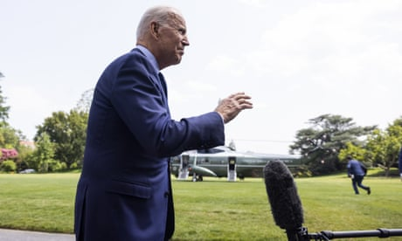](https://www.theguardian.com/media/2021/jul/17/theyre-killing-people-biden-slams-facebook-for-covid-misinformation)](https://www.theguardian.com/media/2021/jul/17/theyre-killing-people-biden-slams-facebook-for-covid-misinformation)

[‘They’re killing people’: Biden slams Facebook for Covid disinformation](https://www.theguardian.com/media/2021/jul/17/theyre-killing-people-biden-slams-facebook-for-covid-misinformation)

[Read more](https://www.theguardian.com/media/2021/jul/17/theyre-killing-people-biden-slams-facebook-for-covid-misinformation)

CCDH, a UK/US non-profit and non-governmental organization, found in March that these 12 online personalities they dubbed the “disinformation dozen” have a combined following of 59 million people across multiple social media platforms, with Facebook having the largest impact. CCDH analyzed 812,000 Facebook posts and tweets and found 65% came from the disinformation dozen. Vivek Murthy, US surgeon general, and Joe Biden focused on misinformation around vaccines [this week](https://www.nytimes.com/2021/07/15/us/politics/surgeon-general-vaccine-misinformation.html) as a driving force of the virus spreading.

On [Facebook](https://www.theguardian.com/technology/facebook) alone, the dozen are responsible for 73% of all anti-vaccine content, though the vaccines have been deemed safe and effective by the US government and its regulatory agencies. And 95% of the Covid misinformation reported on these platforms were not removed.

Among the dozen are physicians that have embraced pseudoscience, a bodybuilder, a wellness blogger, a religious zealot, and, most notably Robert F Kennedy Jr, the nephew of John F Kennedy who has also linked vaccines to autism and 5G broadband cellular networks to the coronavirus pandemic.

Kennedy was since removed from Instagram, which Facebook owns, but not from Facebook itself.

“Facebook, Google and [Twitter](https://www.theguardian.com/technology/twitter) have put policies into place to prevent the spread of vaccine misinformation; yet to date, all have failed to satisfactorily enforce those policies,” wrote CCDH’s CEO, Imran Ahmed, in the report.“All have been particularly ineffective at removing harmful and dangerous misinformation about coronavirus vaccines.”

Although platforms have since taken measures to remove many posts and even remove three of the 12 from one platform, the CCDH is calling on Facebook and Instagram, Twitter and YouTube to completely deplatform the disinformation dozen they believe are dangerous and instrumental in creating vaccine hesitancy at a crucial moment in the pandemic.

“Updated policies and statements hold little value unless they are strongly and consistently enforced,” the report said. “With the vast majority of harmful content being spread by a select number of accounts, removing those few most dangerous individuals and groups can significantly reduce the amount of disinformation being spread across platforms.”

… as you're joining us from Mexico, we have a small favour to ask. Tens of millions have placed their trust in the Guardian’s high-impact journalism since we started publishing 200 years ago, turning to us in moments of crisis, uncertainty, solidarity and hope. More than 1.5 million readers, from 180 countries, have recently taken the step to support us financially – keeping us open to all, and fiercely independent.

With no shareholders or billionaire owner, we can set our own agenda and provide trustworthy journalism that’s free from commercial and political influence, offering a counterweight to the spread of misinformation. When it’s never mattered more, we can investigate and challenge without fear or favour.

Unlike many others, Guardian journalism is available for everyone to read, regardless of what they can afford to pay. We do this because we believe in information equality. Greater numbers of people can keep track of global events, understand their impact on people and communities, and become inspired to take meaningful action.

We aim to offer readers a comprehensive, international perspective on critical events shaping our world – from the Black Lives Matter movement, to the new American administration, Brexit, and the world's slow emergence from a global pandemic. We are committed to upholding our reputation for urgent, powerful reporting on the climate emergency, and made the decision to reject advertising from fossil fuel companies, divest from the oil and gas industries, and set a course to achieve net zero emissions by 2030.

If there were ever a time to join us, it is now. Every contribution, however big or small, powers our journalism and sustains our future. **Support the Guardian from as little as $1 – it only takes a minute. If you can, please consider supporting us with a regular amount each month. Thank you.**

[Support the Guardian](https://support.theguardian.com/int/contribute?REFPVID=krzypz1wtbnyw6sdlbb5&INTCMP=gdnwb_copts_memco_2021-07-06_FALLBACK_JULY__EU_ROW_CONTROL&acquisitionData=%7B%22source%22%3A%22GUARDIAN_WEB%22%2C%22componentId%22%3A%22gdnwb_copts_memco_2021-07-06_FALLBACK_JULY__EU_ROW_CONTROL%22%2C%22componentType%22%3A%22ACQUISITIONS_EPIC%22%2C%22campaignCode%22%3A%22gdnwb_copts_memco_2021-07-06_FALLBACK_JULY__EU_ROW_CONTROL%22%2C%22abTest%22%3A%7B%22name%22%3A%222021-07-06_FALLBACK_JULY__EU_ROW%22%2C%22variant%22%3A%22CONTROL%22%7D%2C%22referrerPageviewId%22%3A%22krzypz1wtbnyw6sdlbb5%22%2C%22referrerUrl%22%3A%22https%3A%2F%2Fwww.theguardian.com%2Fworld%2F2021%2Fjul%2F17%2Fcovid-misinformation-conspiracy-theories-ccdh-report%22%2C%22isRemote%22%3Atrue%7D" \t "_blank)

 The Disinformation Dozen

###### Why platforms must act on twelve leading online anti-vaxxers

​ https://www.counterhate.com/disinformationdozen

Just twelve anti-vaxxers are responsible for almost two-thirds of anti-vaccine content circulating on social media platforms. This new analysis of content posted or shared to social media over 812,000 times between February and March uncovers how a tiny group of determined anti-vaxxers is responsible for a tidal wave of disinformation - and shows how platforms can fix it by enforcing their standards.

[Read the Report](https://252f2edd-1c8b-49f5-9bb2-cb57bb47e4ba.filesusr.com/ugd/f4d9b9_b7cedc0553604720b7137f8663366ee5.pdf)

[Executive Summary](https://252f2edd-1c8b-49f5-9bb2-cb57bb47e4ba.filesusr.com/ugd/f4d9b9_750e5af82aea4920a270b1c5a8b094c2.pdf)

Center for Countering Digital Hate Ltd (UK)

Center for Countering Digital Hate Inc (US)

UK Company Number: 11633127  
Registered Address *(Please note this is not the location of our physical office):*  
Langley House, Park Road, East Finchley, London, United Kingdom, N2 8EY©2020 Center for Countering Digital Hate

# A top spreader of coronavirus misinformation says he will delete his posts after 48 hours

<https://www.seattletimes.com/nation-world/a-top-spreader-of-coronavirus-misinformation-says-he-will-delete-his-posts-after-48-hours/>

Aug. 4, 2021 at 9:30 pm Updated Aug. 4, 2021 at 9:30 pm

By

[Davey Alba](https://www.seattletimes.com/author/davey-alba/)

The New York Times

Joseph Mercola, who researchers say is a chief spreader of coronavirus misinformation online, said Wednesday that he would delete posts on his site 48 hours after publishing them.

In a post on his website, Mercola, an osteopathic physician in Cape Coral, Florida, said he was deleting his writings because President Joe Biden had “targeted me as his primary obstacle that must be removed” and because “blatant censorship” was being tolerated.

Last month, the White House, while criticizing tech companies for allowing misinformation about the coronavirus and vaccines to spread widely, pointed to research showing that a group of 12 people were responsible for sharing 65% of all anti-vaccine messaging on social media. The nonprofit behind the research, the Center for Countering Digital Hate, called the group the “Disinformation Dozen” and listed Mercola in the top spot.

## More on the COVID-19 pandemic

* [Coronavirus live updates for Thursday, Aug. 5](https://www.seattletimes.com/seattle-news/health/coronavirus-daily-news-updates-august-5-what-to-know-today-about-covid-19-in-the-seattle-area-washington-state-and-the-world-2/)
* [Should I mask? Can I travel? How delta is changing advice for the vaccinated](https://www.seattletimes.com/nation-world/should-i-mask-can-i-travel-what-about-hugs-how-delta-is-changing-advice-for-the-vaccinated/)
* [COVID hospitalizations rise sharply in state, worrying health officials](https://www.seattletimes.com/seattle-news/health/health-officials-concerned-with-uptick-in-coronavirus-cases-hospitalizations-in-washington-due-to-delta-variant/)
* [Fauci fears that a COVID variant worse than delta is coming, says cases may double](https://www.seattletimes.com/nation-world/nation-politics/fauci-fears-that-a-covid-variant-worse-than-delta-is-coming-says-cases-may-double/)
* [Moderna says its vaccine is strongly effective 6 months after full vaccination](https://www.seattletimes.com/nation-world/moderna-says-its-covid-vaccine-is-strongly-effective-6-months-after-full-vaccination/)
* [Full coverage of the coronavirus here and around the world](https://www.seattletimes.com/tag/coronavirus/)

Mercola has built a vast operation to disseminate anti-vaccination and natural health content and to profit from it, according to researchers. He employs teams of people in places like Florida and the Philippines, who swing into action when news moments touch on health issues, rapidly publishing blog posts and translating them into nearly a dozen languages, then pushing them to a network of websites and to social media.

An analysis by The New York Times found that he had published more than 600 articles on Facebook that cast doubt on COVID-19 vaccines since the pandemic began, reaching a far larger audience than other vaccine skeptics. Mercola criticized the Times’ reporting in his post Wednesday, saying it was “loaded with false facts.”

Advertising

[Skip Ad](https://www.seattletimes.com/nation-world/a-top-spreader-of-coronavirus-misinformation-says-he-will-delete-his-posts-after-48-hours/#skip-2)[Skip Ad](https://www.seattletimes.com/nation-world/a-top-spreader-of-coronavirus-misinformation-says-he-will-delete-his-posts-after-48-hours/#skip-3)[Skip Ad](https://www.seattletimes.com/nation-world/a-top-spreader-of-coronavirus-misinformation-says-he-will-delete-his-posts-after-48-hours/#skip-4)

Mercola said in his blog post that he would remove 15,000 past posts from his website. He will continue to write daily articles, he said, but they will only be available for 48 hours before being removed. He said it was up to his followers to help spread his work.

Rachel Moran, a researcher at the University of Washington who studies online conspiracy theories, said the announcement by Mercola was “him trying to come up with his own strategies of avoiding his content being taken down while also playing up this martyrdom of being an influential figure in the movement who keeps being targeted.”

Aaron Simpson, a Facebook spokesperson, said, “This is exactly what happens when you are enforcing policies against COVID misinformation — people try extreme ways to work around your restrictions.”

Facebook, he said, “will continue to enforce against any account or group that violates our rules.”

YouTube said that it had clear community guidelines for COVID-19 medical misinformation, that it had removed a number of Mercola’s videos from the platform and that it had issued “strikes” on his channel. The company also said it would terminate Mercola’s channel if it violated its three-strikes policy.

Twitter said that it had taken enforcement action on Mercola’s account in early July for violations of its COVID-19 misinformation policy, putting his account in read-only mode for seven days.

“Since the introduction of our COVID-19 misinformation policy, we’ve taken enforcement action on the account you referenced for violating these rules,” said Trenton Kennedy, a Twitter spokesperson. “We’ve required the removal of tweets and applied COVID-19 misleading information labels to numerous others.”

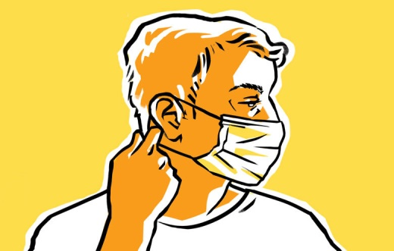

* [Charts, tips and resources to help you understand the pandemic and get through it safely](https://www.seattletimes.com/seattle-news/health/resources-to-help-you-understand-and-navigate-the-coronavirus-pandemic/)
* [How to improve your mask’s protection against COVID-19: Do’s and don’ts](https://www.seattletimes.com/seattle-news/how-to-improve-your-masks-protection-against-covid-19-dos-and-donts/)
* [How to get a vaccine in Seattle and across Washington state](https://www.seattletimes.com/seattle-news/health/how-to-get-a-covid-19-vaccine-in-seattle-king-county-and-washington-state/)

More

This story was originally published at nytimes.com. [Read it here.](https://www.nytimes.com/live/2020/2020-election-misinformation-distortions/joseph-mercola-disinformation)

## Most Read Nation & World Stories

* [Here's what we know about the 'delta-plus' variant, already detected in U.S. and elsewhere](https://www.seattletimes.com/nation-world/heres-what-we-know-about-the-delta-plus-variant/)
* [Should I mask? Can I travel? What about hugs? How delta is changing advice for the vaccinated](https://www.seattletimes.com/nation-world/should-i-mask-can-i-travel-what-about-hugs-how-delta-is-changing-advice-for-the-vaccinated/)
* [Passenger arrives taped to his seat after assault of 3 flight attendants](https://www.seattletimes.com/nation-world/passenger-arrives-taped-to-his-seat-after-assault-of-3-flight-attendants/)
* [Bill Gates says Epstein relationship was ‘a huge mistake’](https://www.seattletimes.com/nation-world/bill-gates-says-epstein-relationship-was-a-huge-mistake/)
* [A top spreader of coronavirus misinformation says he will delete his posts after 48 hours](https://www.seattletimes.com/nation-world/a-top-spreader-of-coronavirus-misinformation-says-he-will-delete-his-posts-after-48-hours/)

The Seattle Times does not append comment threads to stories from wire services such as the Associated Press, The New York Times, The Washington Post or Bloomberg News. Rather, we focus on discussions related to local stories by our own staff. You can read more about our [community policies here](https://www.seattletimes.com/help/#commenting-on-articles-on-seattletimes-com).

Advertising