Large groups of Medical doctors from several different countries are declaring that the pandemic was “planned":

https://stateofthenation.co/?p=40106

1. A group of over 500 medical doctors in Germany called ‘Doctors for Information’ made a shocking statement during a national press conference: (1)
‘The Corona panic is a ‘play'. It’s a ‘scam'. A swindle. It’s high time we understood that we’re in the midst of a global crime.’
This large group of medical experts publishes a medical newspaper (500,000 copies every week), to inform the public about the massive misinformation in the mainstream media.
They also organize mass protests in Europe, like this one on August 29, 2020 where 12 million people signed up and several million actually showed up.
Why do these 500+ medical doctors say the pandemic is a global crime? What do they know, that we don’t? That’s only the beginning!!

One of the many protests against the “plandemic” that you will not see in the "mainstream media”!

2. Hundreds of Spanish medical doctors are saying the pandemic is "planned”:
In Spain a group of 600 medical doctors called ‘Doctors for Truth’, have made a similar statement during a press conference.

"Doctors for Truth” in Spain
‘Covid-19 is a false pandemic created for political purposes. This is a world dictatorship with a sanitary excuse. We urge doctors, the media and political authorities to stop this criminal operation, by spreading the truth.’ (2)
Germany and Spain are just two examples. Similar large groups of hundreds of medical experts exist in countries across the world.
In the USA a documentary called PLANDEMIC, which exposes COVID-19 as a criminal operation, is supported by over 27,000 medical doctors!
Why are these thousands of medical professionals “worldwide" saying the pandemic is a crime? What information do they have access to, that we are not getting from the mainstream media, ESPECIALLY in America?

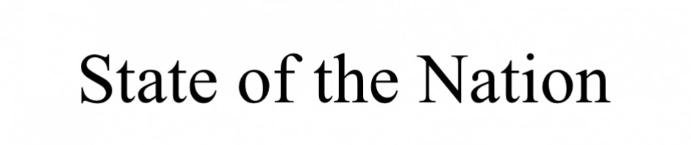
Skip to content
- Home
- 3 CRITICAL COVID VIDEOS
- About SOTN
- Contact Us
- JOE BIDEN DISQUALIFIED
- OPERATION COVID-19
- SOTN Library
- Twitter
← Urgent listen. ER Physician warns the public that the bait & switch is coming. (Video)
See how WHO Director Tedros Adhanom has been deliberately lying about herd immunity to promote a global Covid vaccination regime! →

Ultimate Proof: Covid-19 Was Planned to Usher in the New World Order
Posted on December 6, 2020 by State of the Nation
FacebookTwitterPinterestRedditEmail
Share
Humans Are Free

1. Medical doctors declare that the pandemic was planned
A group of over 500 medical doctors in Germany called ‘Doctors for Information’ made a shocking statement during a national press conference: (1)
‘The Corona panic is a play. It’s a scam. A swindle. It’s high time we understood that we’re in the midst of a global crime.’

This large group of medical experts publishes a medical newspaper on 500,000 copies every week, to inform the public about the massive misinformation in the mainstream media.
They also organize mass protests in Europe, like the one on August 29, 2020 where 12 million people signed up and several millions actually showed up.
Why do these 500+ medical doctors say the pandemic is a global crime? What do they know, that we don’t?
One of the many protests against the “plandemic” that you will not see in the mainstream media

2. Hundreds of Spanish medical doctors say the pandemic is planned
In Spain a group of 600 medical doctors called ‘Doctors for Truth’, made a similar statement during a press conference.
Doctors for Truth, Spain
‘Covid-19 is a false pandemic created for political purposes. This is a world dictatorship with a sanitary excuse. We urge doctors, the media and political authorities to stop this criminal operation, by spreading the truth.’ (2)
Germany and Spain are just two examples. Similar large groups of hundreds of medical experts exist in countries across the world.
In the USA a documentary called PLANDEMIC, which exposes COVID-19 as a criminal operation, is supported by over 27,000 medical doctors!
Why are these thousands of medical professionals worldwide saying the pandemic is a crime? What information do they have access to, that we are not getting from the mainstream media?
I invite you to look at the following facts with an open mind and then come to your own conclusions…

3. In 2015 a testing method was patented for… COVID-19
In 2015 a ‘System and Method for Testing for COVID-19′ was patented by Richard Rothschild, with a Dutch government organisation.
Did you catch that? In 2015 – four years before the disease even existed – a testing method for COVID-19 was developed. (2B) You can read the article here.

Take a deep breath and let that sink in for a while…

4. Millions of COVID-19 test kits sold in 2017 and 2018
As we know the new COVID-19 disease appeared in China towards the end of 2019. Therefore it was named COVID-19 which is an acronym for Corona Virus Disease 2019.
Data from the World Integrated Trade Solution, however, shows something astonishing:
“in 2017 and 2018 – two years before COVID-19 – hundreds of millions of test kits for COVID-19 were distributed worldwide.”
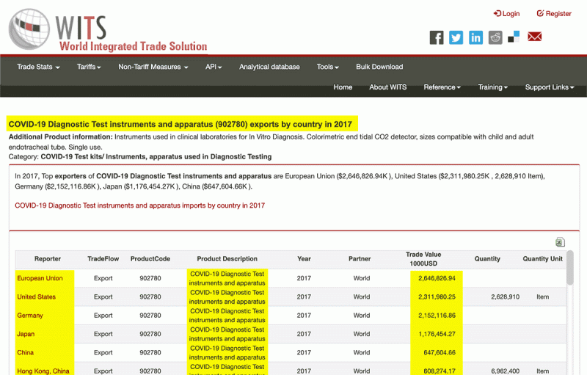

‘Quick! Hide it!!’
This baffling data was discovered by someone on September 5, 2020, who posted it on social media. The next day it went viral all over the world.
On September 6 the WITS suddenly changed the original designation ‘COVID-19’ into the vague ‘Medical Test Kits’.
This is not allowed in trade, because you always have to be specific. There are many types of test kits for different diseases.
The fact that they removed the specification ‘COVID-19’, after this data became known worldwide, proves that they don’t want anyone to know about it.
They however forgot to delete one detail: the product code for these ‘Medical Test Kits’ is 300215 which means: ‘COVID-19 Test Kits’.
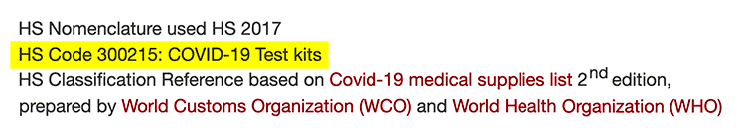
Their cover up came too late: this critical information was uncovered and is being revealed by millions worldwide. You can download a PDF that shows the original data of this website.
Two years before the outbreak of COVID-19 the USA, the EU, China and nations around the world started exporting millions of diagnostic test instruments for… COVID-19, a disease that supposedly didn’t even exist back then.

6. The COVID-19 ‘project’ is planned until 2025
The World Bank shows that COVID-19 is a project that is planned to continue until… end of March 2025! So the intention is to continue it for another FIVE YEARS. (2C)


7. Anthony Fauci guaranteed a pandemic within the next two years
In 2017 Anthony Fauci made a very strange prediction, with an even stranger certainty.
With complete confidence Fauci announced that during the first term of President Trump a surprise outbreak of an infectious disease would surely happen.
Here’s what he said: (3)
“There is NO QUESTION there is going to be a challenge for the coming administration in the arena of infectious diseases.
“There will be a SURPRISE OUTBREAK. There’s NO DOUBT in anyones mind about this.”
How could Fauci guarantee a surprise outbreak to happen during the first term of the Trump administration? What did he know, that we don’t?


8. Bill and Melinda Gates guaranteed an imminent global pandemic
In 2018 Bill Gates publicly announced that a global pandemic was on it’s way that could wipe out 30 million people. He said this would probably happen during the next decade. (4)
Melinda Gates added that an engineered virus is humanities greatest threat and also assured this would hit humanity in the coming years. (5)
‘A global pandemic is ON IT’S WAY. An ENGINEERED VIRUS is humanities greatest threat. This will happen in the NEXT DECADE.’ – BILL GATES, in 2018

Let their choice of words resound into your mind for a moment…
They claim that the dense population of the world guarantees this imminent global pandemic.
But let’s be honest: most of the earth is uninhabited. Just fly over America in an airplane and look out the window. You see empty space most of the time, with a few cities here and there. Most of the United States is still wide open and empty.
The same goes for the rest of the world.
Australia, Russia, India, China, America, Africa… it’s wilderness for the most part. Our planet isn’t nearly as populated as Bill Gates wants us to believe. This world map shows it clearly…

Most of the earth is totally void of any human presence. So the idea that the world is vastly overpopulated and is therefor bound to give rise to an imminent global pandemic is a lie.
[The powers that shouldn’t be also use this excuse to justify a reduction in the world’s population – i.e. depopulation.]
The Gates also claimed that air travel was sure to create a global pandemic. But countless people have been traveling in airplanes the past century.
Did that give rise to constant outbreaks of global pandemics? Of course not!
Their arguments why they guaranteed a global pandemic in the next few years are lies. So what is their real basis to make such guaranteed predictions?

9. Practicing for a pandemic
A few months before the outbreak, Bill Gates – the world’s nr 1 vaccine dealer – organized an event in New York City. Guess what the event was all about? It was a ‘coronavirus pandemic exercise’.
Yes, you read that right:
Bill Gates organized a coronavirus pandemic exercise, right before it happened!

On the large display in the auditorium, you see the text printed: ‘We need to prepare for the event that becomes a pandemic.’ This pandemic exercise was called Event201 and took place in October 2019, literally right before the outbreak.

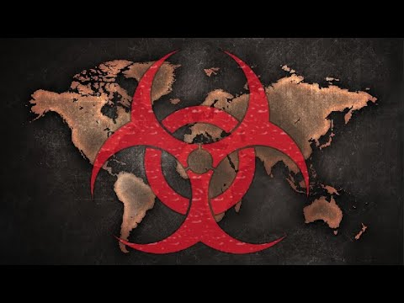

Their conclusion was that all of humanity must be vaccinated…
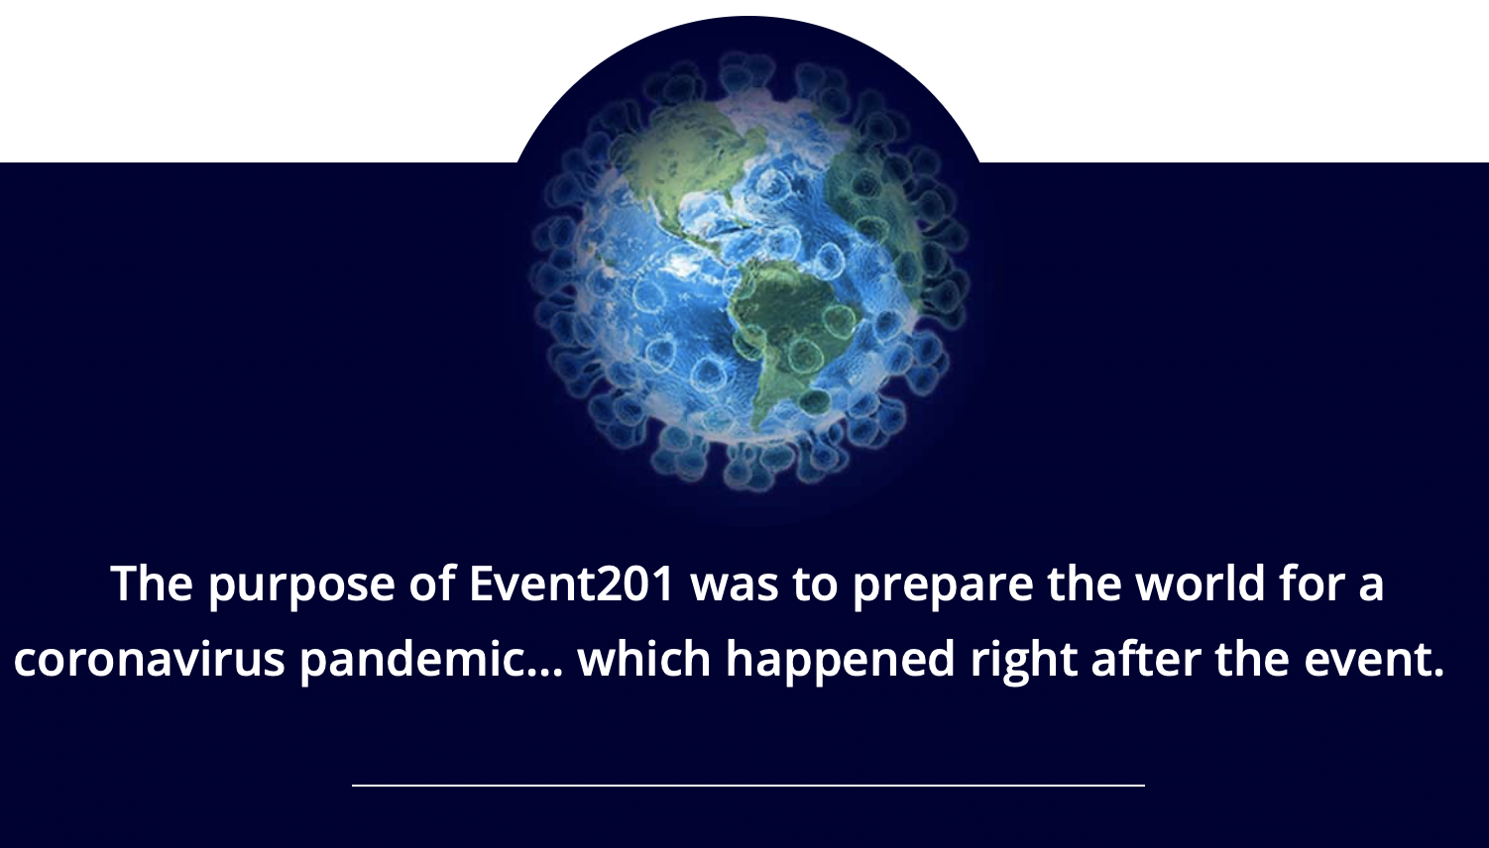

10. Excitement about selling vaccines in the next year
Shortly after this ‘exercise for a coronavirus pandemic’ Bill Gates tweeted:
“I’m particularly excited about what the next year could mean for one of the best buys in global health: vaccines.” – Bill Gates, Dec. 19, 2019
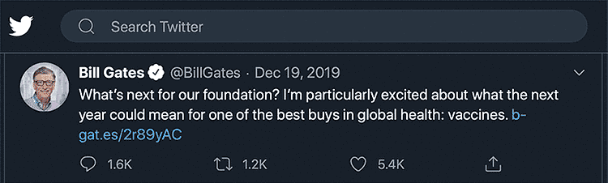
Think about this: the world’s nr 1 vaccine dealer guarantees a global pandemic to occur in the next few years, and his wife said we should all fear an engineered virus that is ‘on its way’. Then they organize an exercise for an imminent global pandemic and say vaccines will be the only solution. Next Bill Gates tweets how excited he is about selling vaccines in the next year. Immediately after that, the announced pandemic breaks out.
Indeed, right away Bill Gates proclaims that the only solution for humanity is to buy his vaccines…

11. 2020 coronavirus pandemic predicted in 2013
Back in 2013 a musician wrote a song called PANDEMIC. In his lyrics he described a global pandemic that kills millions, shuts down economies and gives rise to riots.
His song literally described in great detail what we are seeing in our world today, seven years later.
He even mentioned the exact year of the pandemic: 2020, and the specific type of virus: a coronavirus. (6)
This is a line in his lyrics from 2013:
‘2020 combined with CoronaVirus, bodies stacking.’
This song also predicted the riots that are now raging throughout America:
‘The State is rioting, using the street outside. It’s coming to your windows.’
How could this musician have known in 2013 that a coronavirus pandemic would break out in 2020, and that during this pandemic riots would erupt? He explains:
‘I did research back in 2012, and read the so called “conspiracy theories”. You know, those investigations the media doesn’t want us to look into. According to those theories pandemics were bound to happen in the decade of 2020 – 2030. So I wrote the song Pandemic about it.’

12. Global Preparedness Monitoring Board in Sept. 2019: ‘Get ready for a global coronavirus pandemic’
In September 2019 – also right before the outbreak – the Global Preparedness Monitoring Board released a report titled ‘A World At Risk’.
It stressed the need to be prepared for… a coronavirus outbreak!

On the cover of the report is the picture of a coronavirus and people wearing face masks.
In the report we read the following interesting paragraph:
‘The United Nations (including WHO) conducts at least two system-wide training and simulation exercises, including one for covering the deliberate release of a lethal respiratory pathogen.’
Did you catch that?
They have been practicing for a deliberate release of a lethal respiratory pathogen.

13. Outbreak from China announced
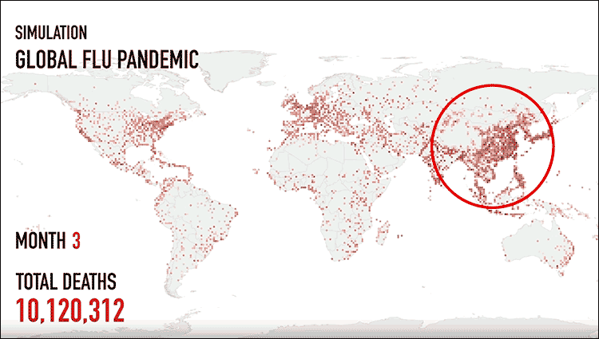
In 2018 The Institute for Disease Modeling made a video in which they show a flu virus originating in China, from the area of Wuhan, and spreading all over the world, killing millions. They called it ‘A Simulation For A Global Flu Pandemic.’ That is exactly what happened, two years later.
Why did they say it would come from China? Why not Africa, where far more diseases are present? Or why not South America? Or India? How could they know there would be a flu virus coming from China and even show Wuhan as the originating area, that would infect the whole world?

Was this coronavirus engineered?
Where did the virus come from? One of the world’s leading experts in bioweapons is Dr. Francis Boyle. He is convinced it originated from a bioweapon lab in Wuhan, the Bio Safety Lab Level 4.
This facility is specialized in the development of… coronaviruses!
They take existing viruses and ‘weaponize’ them, meaning they make them far more dangerous, to be used as a biological weapon.
In the following two minute video clip you see a spokesperson for the Trump administration, bioweapon expert Dr. Francis Boyle and president Trump talk about how this virus came from the lab in Wuhan.
Dr. Li-Meng Yan, a Chinese virologist (MD, PhD) fled the country, left her job at a prestigious Hong Kong university and became a whistleblower. She appeared on British television where she claimed SARS-CoV-2, the virus which causes COVID-19, was created by Chinese scientists in a lab – and she offered evidence to support her claims. You can read more on the subject HERE.
Now comes the most interesting part:

14. In 2015 Anthony Fauci gave this very lab 3,7 million dollars.
Figure this: the same man who guaranteed a surprise outbreak of a virus in the next two years, gave almost 4 million dollars to a lab that develops coronaviruses.
In the short clip below you can see a journalist ask president Trump about this grant given by Fauci to the Wuhan lab.
There are however more options in Wuhan where this virus could have originated from. Some believe it came from the Wuhan Virology Institute, where they also work on weaponizing coronaviruses.

15. Chinese biological experiments to infect humans with Coronavirus exposed in 2015 by Italian state media
Five years ago, Italian state owned media Company, RAI – Radiotelevisione Italiana, – exposed dark efforts by China on viruses.
The video, which was broadcast in November, 2015, showed how Chinese scientists were doing biological experiments on a SARS connected virus believed to be Coronavirus, derived from bats and mice, asking whether it was worth the risk in order to be able to modify the virus for compatibility with human organisms.
Below is a transcription of the Italian broadcast translated in English:
Chinese Biological Experiments
Chinese scientists have created a pulmonary supervirus from bats and mice only for study reasons but there are many questionable aspects to this. Is it worth the risk? It’s an experiment, of course, but it is worrisome.
It worries many scientists: It is a group of Chinese researchers attaching a protein taken from bats to the SARS virus, Acute Pneumonia, derived from mice.
The output is a super coronavirus that could affect humans. – (Source here, were you can read more)



16. Movies predicted the coronavirus pandemic
Predictive programming is the process of informing the population about events that are soon to occur.
The past years several movies and television series were produced, about… a global coronavirus pandemic!
The film ‘Dead Plague’ depicts a global pandemic with a coronavirus and even mentions hydroxychloroquine as the cure.
Another film called ’Contagion’ shows how a coronavirus spreads globally with social distancing, face masks, lock-downs, washing of hands etc. as a result.
Literally everything we see now, is predicted in detail in these movies.

17. Pandemic depicted during Olympics summergames in 2012
Talking about predictive programming: during the opening show of the Summer Olympics in 2012, a coronavirus pandemic was played out for the eyes of the whole world.
Dozens of hospital beds, large numbers of nurses becoming puppets of a controlling system, death lurking about, a demonic giant rising up over the world, and the whole theatre was lit up in such a way that seen from the sky it looked like a coronavirus.
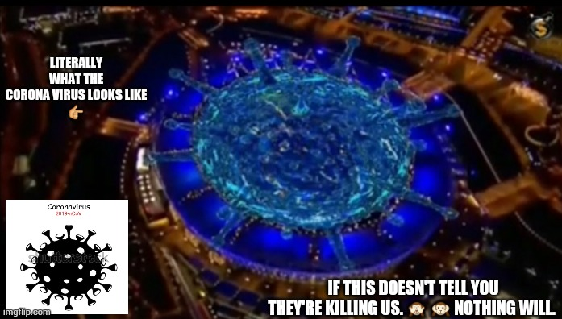


Why did the Olympic Games show a coronavirus pandemic, in their opening show?

18. Worldwide lockdown predicted in 2008

The author and investigator Robin de Ruiter predicted in 2008 that there would come a global lockdown.
He said the purpose of this would be to create a new world of authoritarian control.
Because much of what he wrote back in 2008 is now happening right in front of our eyes, this book has been republished.

19. Journalists predicted planned pandemic
In 2014 the investigative journalist Harry Vox predicted a planned global pandemic and said why the ‘ruling class’ would do such thing:
‘They will stop at nothing to complete their toolkit of control. One of the things that had been missing from their toolkit is quarantines and curfews. The plan is to get hundreds of thousands of people infected with it and create the next phase of control.’ (7)


20. ‘Scenario for the Future’
This renown researcher refers to a famous document by the Rockefeller Foundation in which everything we see happening now is literally predicted in great detail: the global pandemic, the lock-downs, the collapse of the economy and the imposing of authoritarian control.
It’s all described with terrifying accuracy… ten years before it happened!
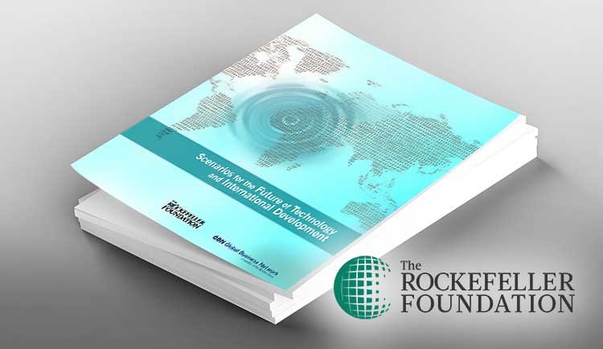
The document is titled ‘Scenario for the Future of Technology and International Development’. (9)
That says it all: a scenario for the future. It has a chapter called ‘LockStep’ in which a global pandemic is reported as if it happened in the past, but which is clearly intended as a rehearsal for the future.
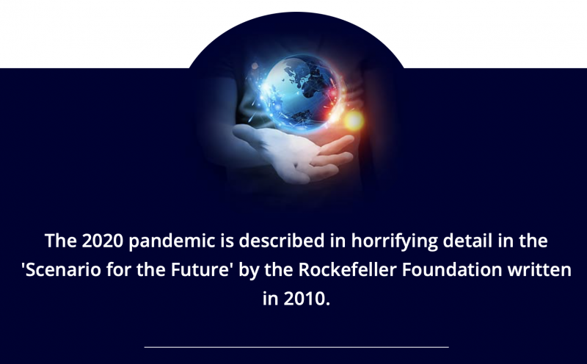
Rockefeller Foundation’s Operation Lockstep: ‘Under The Guise Of A Pandemic, We Will Create A Prison State’



The ‘Scenario for the Future’ continues with comparing two different responses to their predicted pandemic: the USA only ‘strongly discouraged’ people from flying, while China enforced mandatory quarantine for all citizens.
The first response is accused of spreading the virus even more, while the imposing of a suffocating lock-down is praised. Then it goes on to describe the implementation of totalitarian control:
“During the pandemic, national leaders around the world flexed their authority and imposed airtight rules and restrictions, from the mandatory wearing of face masks to body-temperature checks at the entries to communal spaces like train stations and supermarkets.”
Clearly the flexing of authority is the desired response. But it gets worse, according to this ‘Scenario of the Future’:
‘Even after the pandemic faded, this more authoritarian control and oversight of citizens and their activities stuck and even intensified.’
‘In developed countries, this heightened oversight took many forms: biometric IDs for all citizens, for example, and tighter regulation of key industries whose stability was deemed vital to national interests.’
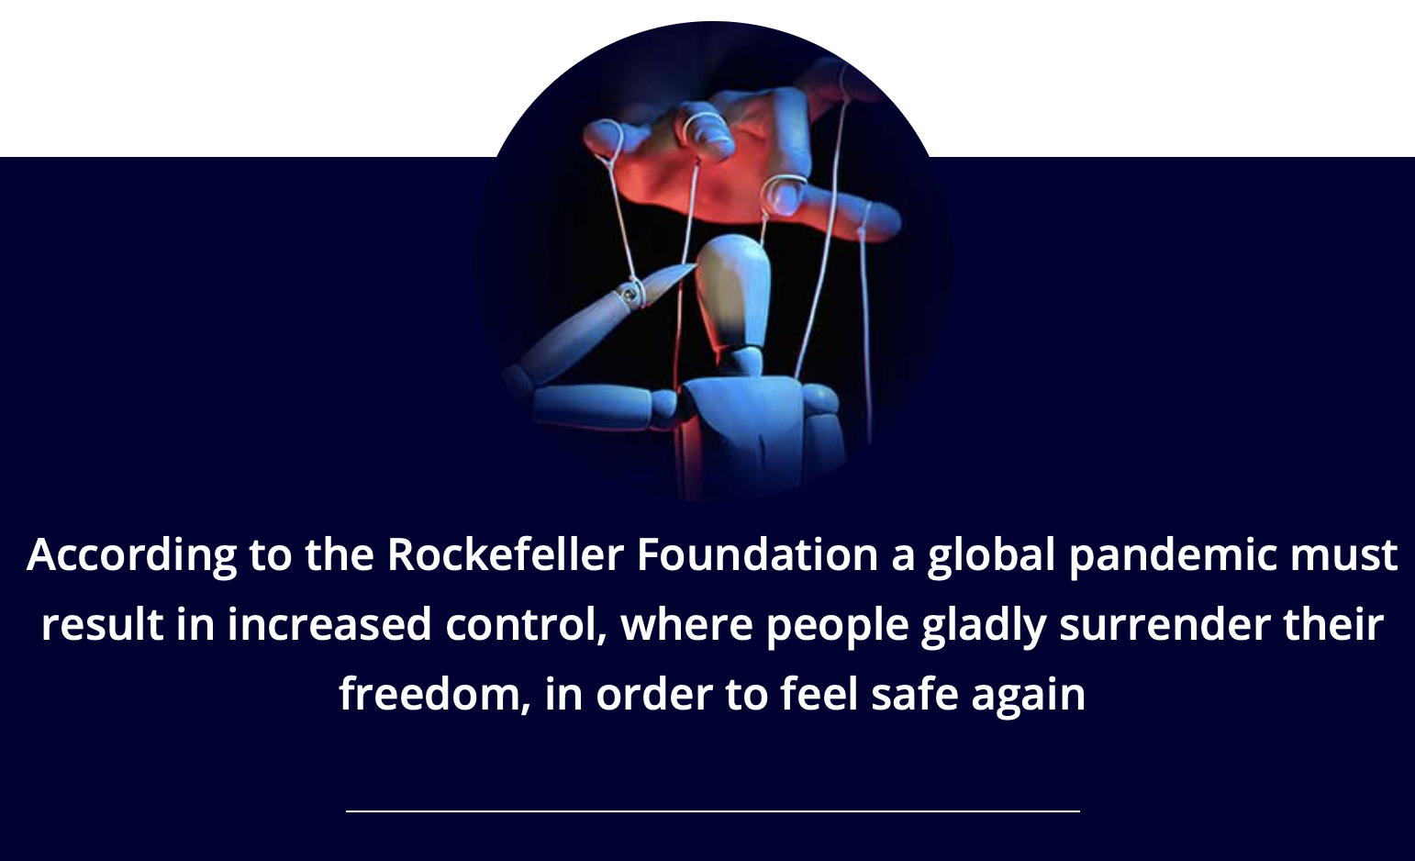

Handbook for global control
Now that the announced pandemic is indeed here, the same Rockefeller Foundation came forward with step two: a handbook on how to implement new control systems during this pandemic. Only when all the required control networks are in place, can the world open up again.

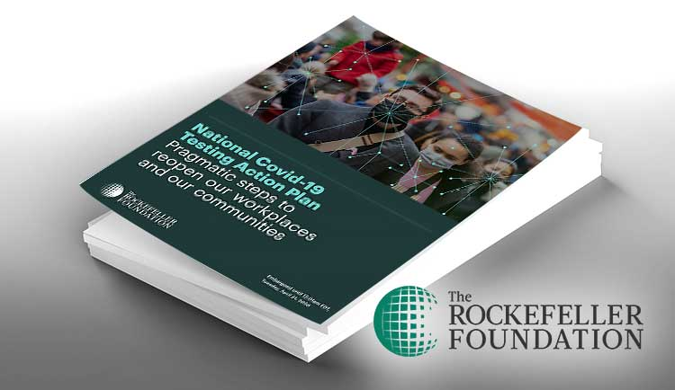
When you combine the two Rockefeller documents, you see the plan:
1) First they announce a global pandemic with a coronavirus and say what it should lead to: a whole new level of authoritarian control.
2) Secondly they give practical steps on how to apply this control system.
These are illustrations and quotes from their guide:

‘Digital apps and privacy-protected tracking software should be widely used to enable more complete contact tracking.’
‘In order to fully control the Covid-19 epidemic, we need to test the majority of the population on a weekly basis.’

According to their ‘Scenario of the future’ the entire world population should get a digital ID that indicates who has received all the vaccines. Without sufficient vaccinations, access to schools, concerts, churches, public transport etc. will be denied.
Now in 2020 that is exactly what Bill Gates and many governments are calling for.

21. Bill Gates negotiated $100 Billion contact tracing deal with Democratic Congressman sponsor of bill six months BEFORE Coronavirus pandemic
The shocking revelations were unveiled on the Thomas Paine Podcast and the Moore Paine Show on Patreon by the two investigators.
nine months after the meetings with the Gates Foundation in Rwanda — Bobby L. Rush, a Democrat from Illinois, introduced the $100 BILLION H.R. 6666, the COVID-19 Testing, Reaching and Contacting Everyone (TRACE) Act.

Everyone’s contacts must be checked
In a leaked government video (10) we see a conversation between former American president Bill Clinton and Andrew Cuomo, the governor of the state of New York.
They discuss how to set up a large control system to test the entire population and check all their contacts. They discuss how to build an army to carry out this control system.
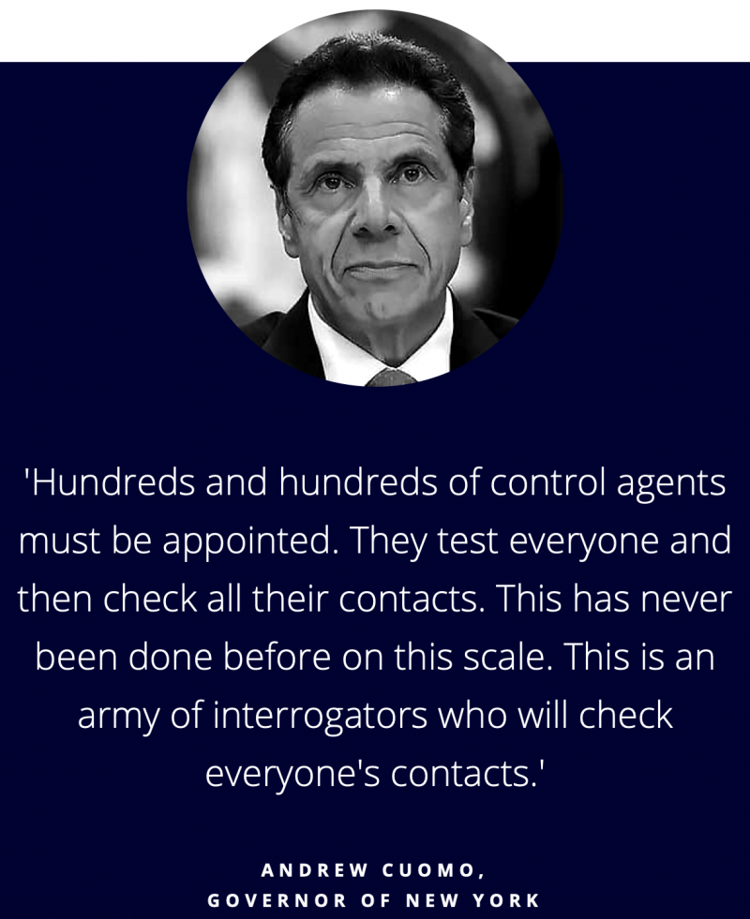

A whole new level of global control
Bill Gates also made it clear that only people who have been vaccinated against Covid-19 should be allowed to travel, go to school, attend meetings and work. (11)
Digital vaccine ID’s are already being developed (12) and Gates has a patent on the technology that makes it possible to trace an individual’s body anywhere. This technology is called WO2020-060606 (13).
Also very interesting to note: An Enzyme Called LUCIFERASE Is What Makes Bill Gates Implantable Vaccine Work
In addition, Gates wants to set up a global monitoring network, which will track everyone who came into contact with Covid-19 (14).

The plan: inject mankind with DNA altering vaccine
The famous investigative journalist Anthony Patch did years of research concerning the plans to control the world, by means of created pandemics and mandatory vaccines. During an interview in 2014 this researcher predicted the following:
‘They will release a man-made coronavirus. As a result the people will demand a vaccine to protect them. This vaccine will add a third strain of DNA to a persons body, essentially making them a hybrid.
‘Once a person is injected, almost immediately their DNA undergoes a transformation. This genetic change will cause people to loose the ability to think for themselves, without them even being aware this happened. Thus they can be controlled easier, to become slaves for the elite.’
Of course that sounds insane and it is insane indeed. Yet we have to be aware that this professional investigator is no fool. He has done years of research and this is what he discovered over the years.
We must be careful not to reject sound knowledge, based on years of research, simply because of our own lack of insight in these topics.

20 years of research say: the vaccine will change our DNA
Doctor Carrie Madej directed two large clinics in Georgia, before she went to the Dominican Republic to do humanitarian work. She studied DNA and vaccines for the past twenty years and made an urgent video in which she warns that there is a plan to inject humanity with very dangerous vaccines for Covid-19.
The purpose of these new vaccines will be twofold:
1) reprogram our DNA and make us hybrids that are easier to control.
2) connect us to artificial intelligence through a digital vaccine ID, which will also open a whole new realm of control.
This medical expert says she has observed multiple times how diseases were spread over populations by air craft. Because of satefy reasons she is not able to share more details about this in public.

Depopulate the earth by means of organized epidemics
Dr. John Coleman is a famous Intelligence Officer from the CIA who wrote a book titled ‘The Committee of 300‘.
In it he explains how secret societies manipulate governments, health care, food industries, the media and so on. This book can be found on the website of the CIA. (15)
One of the primary goals of the many secret societies, that control governments and the media, is to depopulate the earth.
You can find a list of 32 ‘elites’ who support and promote (according to their own claims) depopulation HERE.

Dr. Coleman says the following about their strategy:
‘At least 4 billion useless eaters shall be eliminated by the year 2050 by means of limited wars and organized epidemics of fatal rapid acting diseases…’ – DR. JOHN COLEMAN, CIA INTELLIGENCE OFFICER

Maintain humanity under 500,000,000
In 1980 a granite monument was erected in Georgia, called the Guidestones. A set of 10 guidelines is inscribed on the structure in eight modern languages and a shorter message is inscribed at the top of the structure in four ancient language scripts.

The first guideline goes as follows:
1. Maintain humanity under 500,000,000 in perpetual balance with nature.
The CIA officer Dr. Coleman revealed that one of their methods to ‘maintain humanity’ is to cause ‘organized epidemics of fatal rapid acting diseases’.

Using vaccines to reduce humanity
During a TED talk Bill Gates echoed this goal, when he literally said that new vaccines can be used to reduce the world’s population with 10 – 15%! (16)
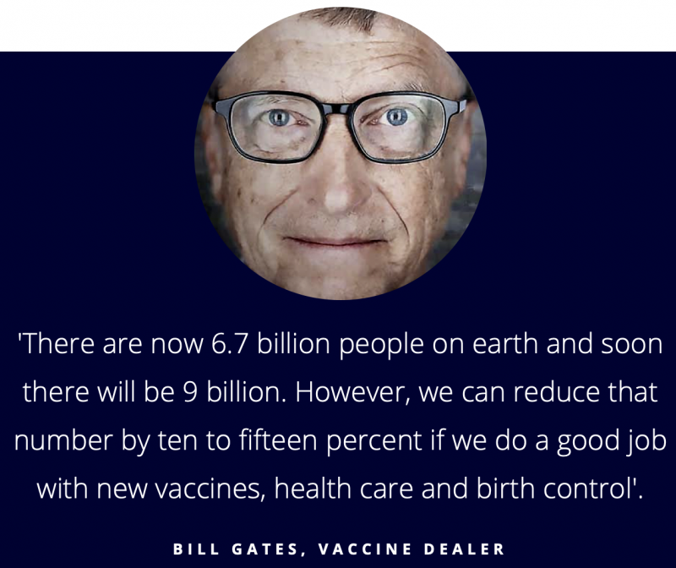
‘There are now 6.7 billion people on earth and soon there will be 9 billion. However, we can reduce that number by ten to fifteen percent if we do a good job with new vaccines, health care and birth control’. – BILL GATES, VACCINE DEALER

Covid19 vaccine for population control?
Mike Adams is a published food scientist, author of the popular science book Food Forensics and founder of ISO-accredited CWC Labs.
Years ago he said the following:
“An engineered bioweapon will be released in population centers. There will be calls for massive government funding for the vaccine industry to come up with a vaccine. Miraculously, they will have a vaccine developed in record time. Everyone will be required to line up and take this vaccine shot.”
There is indeed a release of an engineered bioweapon, followed by a vaccine mandate, massive government funding for the vaccine industry and a vaccine that is being developed in record time.
The rest of his message is that this vaccine will slowly begin to kill millions – if not billions – of people over the course of a few years. It will be a kill-switch vaccine, designed to reduce the world’s population.

SUMMARY: WAS THE PANDEMIC PLANNED?
Thousands of medical doctors call the pandemic a global crime, and a world dictatorship with a sanitary excuse.
Two years before Covid-19 came to the global scene, the European Union, the USA, China and other nations suddenly started exporting tens of millions of test kits for Covid-19.
In 2013 a musician predicts a global pandemic with a coronavirus and says this will happen in 2020. He knew this because of personal investigation of so called ‘conspiracy theories’.
In 2017 Anthony Fauci guaranteed a surprise outbreak of an infectious disease during the first term of the Trump administration.
Right before the outbreak of a coronavirus pandemic, Bill Gates organized a global coronavirus pandemic exercise: Event201.
Right before the outbreak the Global Preparedness Monitoring Board told the world to be ready for a coronavirus pandemic.
In 2018 the Institute for Disease Modeling announced a global pandemic with a flu virus, originating in China in the area of Wuhan.
In 2018 Bill and Melinda Gates announced that in the coming years there would be a global pandemic of an engineered virus.
The coronavirus SARS-CoV-2 was created in the Bio Safety Lab Level 4 in Wuhan, which received millions of dollars from Anthony Fauci.
Several movies depicted the coronavirus pandemic with great detail, and even mention hydroxychloroquine as the cure.
The Summer Olympics in 2012 played a pandemic of a coronavirus during their opening show.
The investigative journalist Harry Vox predicted in 2014 that a global pandemic would be caused, so the ‘ruling class’ could implement a higher level of authoritarian control.
The investigative journalist Anthony Patch predicted a global pandemic with a man made virus, that would be used to force a DNA altering vaccine on humanity.
Dr. Carrie Madej studied DNA and vaccines for decades and says the plan is to use the Covid-19 vaccine to start the process of transhumanism: reprogramming the human DNA.
The CIA officer Dr. John Coleman studied secret societies and says their goal is to depopulate the earth by means of organized pandemics of fatal rapid acting diseases.
In the state of Georgia a huge monument was erected in 1980 with ten guidelines for humanity, in eight languages. The first of these ‘Ten Commandments’ is that humanity needs to be reduced to half a billion people.
Bill Gates said during a TED talk that new vaccines can be used to reduce the world’s population with 10-15%.
The ‘health ranger’ Mike Adams predicted years ago what we see happening now: the release of an engineered bioweapon, followed by a vaccine mandate, massive government funding for the vaccine industry and a vaccine that is being developed in record time. He also predicted that this vaccine will kill innumerable people over the course of a couple of years.
In 2010 the Rockefeller Foundation published the ‘Scenario for the future…’ in which they describe a coming global pandemic, that should result in the implementation of authoritarian control over the people, which will then intensify after the pandemic.
In 2020 they publish a handbook on how to create this world of control, with a step by step guide. They say life cannot return back to normal, until the world has become ‘Locked Down’ with this top down control from authoritarian governments.
We indeed see that Bill Gates and many others worldwide are right away seizing control in unprecedented ways, with enforcing vaccine ID’s, microchips that will be implanted into people, mandating the wearing of face masks, social distancing, forced lock-downs, extreme contact tracing, and so on.
Part of this top down control is extreme censoring of every single voice from doctors, scientists or other experts that criticize what is going on.

All predictions were done shortly before it happened
Note that every single prediction of this pandemic was announced a few years or even months before it happened. That is significant.
Gates and Fauci lie to their audience when they say ‘history tells us this will happen’, but there is no historic basis for guaranteeing a global coronavirus pandemic to occur within a few months or years.
Never in history did anything like this occur, on such a global scale.
The fact that such a historically unique event was predicted in great detail – by movies, shows, investigators, medical doctors, those who finance labs that develop these viruses, those who earn billions from these pandemics, those who want to create a whole new level of control in our world, etc. – shows it was planned.

Are there signs that the pandemic is being manipulated?
So far we have looked at indications that the pandemic was planned beforehand. If it is indeed orchestrated, then that should also be obvious during the pandemic. A planned pandemic is also a controlled pandemic.

The plan to control the world
You may have heard the word ‘globalists’ before, but for those who aren’t familiar with it: these are people around the world who plan to create one global government, so they can have total global control over health, religion, finances – everything.
Main players in this are the United Nations, the World Economic Forum, the World Health Organization, the European Union, the International Monetary Fund, and many others.
They recently came together in an event called DAVOS, where they expressed how the pandemic will be used to deploy their plans.
Here are some of the statements they made: (18)
‘Now is the historic moment in time, not only to fight the virus, but TO SHAPE THE SYSTEM.
The pandemic represents a window of opportunity to RESET OUR WORLD.
The world must act jointly and swiftly to REVAMP ALL ASPECTS of our societies and economies, from educational to social contacts and working conditions.
EVERY COUNTRY, from the United States to China, must participate, and every industry, from oil and gas to tech, must be TRANSFORMED.’ – Klaus Schwab, Funder of the World Economic Forum
A major leader of gobalism, is the World Economic Forum, founded by Klaus Schwab. He created a ‘spinning wheel’ with all their objectives. On it we can see the following three ‘projects’: Covid19 followed by Global Governance, and Internet Governance.
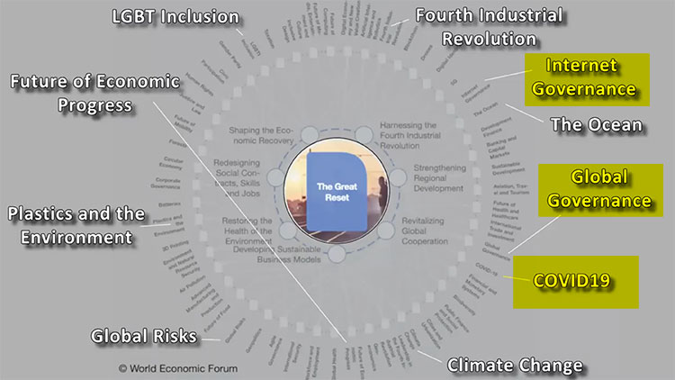

Good read: The Response To Coronavirus Is The New World Order / Agenda 2030

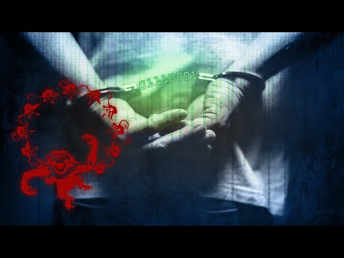

Nobody wants these organizations
Not a single human on the earth has voted for these organizations to even exist, let alone take full control of our lives, families, communities, jobs, health, industries, etc. Yet they present themselves as our ‘world leaders’ who are planning our entire future.
The World Health Organization presents itself as the global boss over our health, without anyone of us having chosen for them.
They apply a tyranny in mainstream media and social media, where no expression of medical or scientific expertise is allowed, unless it is in line with the guidelines of this ‘World’ organization.
Tens of thousands of medical doctors and scientists have been censored all over the world, by Facebook, Youtube and Twitter. Why? Because these social media giants state that ONLY what the World health Organization says, is true.
All of humanity must submit to these people who have positioned themselves over all of us, without ever asking our opinion or even consulting with other medical experts.
In fact, every single medical expert speaking out against their decisions is censored.
This means complete loss of medical freedom, loss of freedom of speech, loss of true science, loss of true journalism and an imposing of dictatorships by organizations that nobody voted for, lead by people nobody wanted and yet they simply seize ownership of our world.
They are the big fat mean bully on the playground, that plays boss over everyone.

World Health Organization is run by a terrorist
The head of the Word Health Organization, Tedros Adhanom Ghebreyesus, is a member of a violent revolutionary communist party in Ethiopia, Tigray People’s Liberation Front. (19)
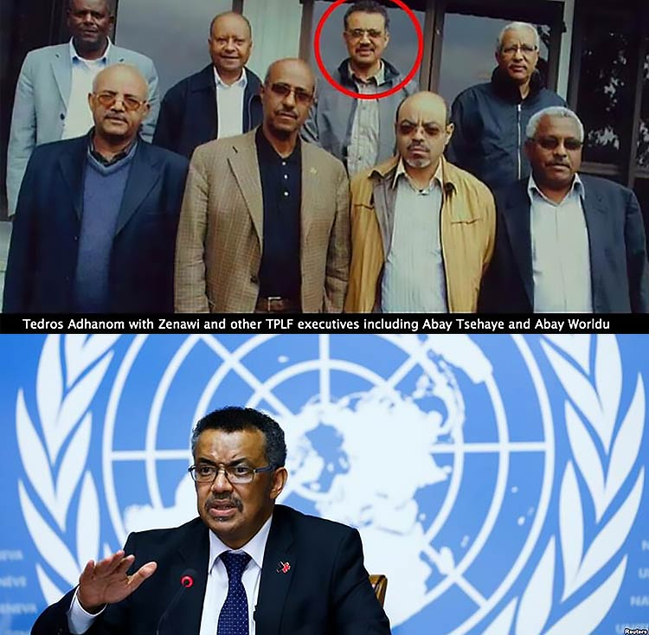
The Department of Homeland Security clearly states:
“The TPLF qualifies as a Tier III terrorist organization… on the basis of its violent activities…”
Let this get through to you: the man directing the World Health Organization is literally a communist terrorist, who has been involved in murdering thousands of innocent people, trying to impose communism on Ethiopia.
And this man is bullying the entire world, telling all of us what we can and cannot do, censoring every medical professional who has a different opinion, demanding blind obedience from all of humanity, while imposing mandates to be vaccinated by their number one financial sponsor: Bill Gates.
Is this the world you want to live in, from now on?

More and more pandemics, untill mankind submits
These globalists even threaten humanity with more suffering, if we don’t submit to their total control. Prince Charles recently joined DAVOS and publicly stated:
“There will be more and more pandemics, if we don’t do ‘the great reset’ now.” (18)
Bill Gates already calls this ‘pandemic one’ and is talking about ‘pandemic two and three’.
The investigator who back in 2013 predicted a coronavirus pandemic to occur in 2020, followed by riots, said the plan is to create series of pandemics during 2020-2030.
This decade is the selected timeframe to turn the world into one big banana republic, run by mad powerhungry men, who depopulate the earth, and enslave the rest of humanity.
They are planning to cause as many pandemics as needed, in order to break the back of humanity, until everybody submits to their global control.
Are you beginning to understand why more than 500 medical doctors from Germany, 600 doctors from Spain, thousands of medical experts from the USA and many more all over the world are calling this pandemic a ‘global’ crime’?

Leaders of Catholic Church Warn Humanity
An archbishop and several cardinals of the Roman Catholic Church wrote a letter to humanity, to warn us for gloval tyranny under the guise of Covid-19.
This is an excert of this historic message, that has been translated in many languages and was sent to leaders all over the world. (20)
“We have reason to believe, on the basis of official data on the incidence of the epidemic as related to the number of deaths, that there are powers interested in creating panic among the world’s population with the sole aim of permanently imposing unacceptable forms of restriction on freedoms, of controlling people and of tracking their movements. The imposition of these illiberal measures is a disturbing prelude to the realization of a world government beyond all control.”

Is there hope? What can we do?
Is there any hope for our future, or are we surrendered to the merciless hands of these wicked mega-billionaires who want to depopulate the earth and seize total control over humanity?

Yes, there is hope. The future is brighter than we can even imagine!
This is not a doom and gloom scenario, but a wake up call for humanity to stop blindly believing the mafia-media and perverse politicians, and rise up as one for a future of freedom.
I invite you to join a unique and historic movement of Global Freedom Fighters, who will lead humanity into a new era of hope, restoration and more freedom than we have ever known.
Source: StopWorldControl.com / References:
1: German group of Doctors For Information
2: Spanish group of Doctors For Truth
2B: Richard Rothshild patented a testing method for COVID-19 in 2015
2C: World Bank shows planned end date of project COVID-19
3: Fauci guarantees an outbreak with the next two years.
4: Bill Gates announced a global pandemic
5: Melinda Gates says humanities greatest threat is an engineered virus
6: Lyrics of 2013 song that predicted coronavirus pandemic in 2020
7: Harry Vox predicted the global pandemic
8: Robin de Ruiter predicted lockdowns
9: Scenario for the future described global pandemic
10: Andrew Cuomo talks with Bill Clinton about authoritarian control
11: Bill Gates talks about a digital ID to control people
12: Linking vaccines to a digital ID
13: Gates has pattent on technology to trace a body anywhere
14: Gates wants a global monitoring system
15: Download the book of CIA officer Coleman
16: Gates talks about reducing world population using vaccines
17: Tens of millions of Covid-19 test kist were exported by the EU, USA, China etc in 2017 and 2018
18: DAVOS and the gathering of the globalists
19: The head of the World Health Organization is member of violent terorrist group
20: Letter from archbishop and cardinals to humanity
___
https://humansarefree.com/2020/09/proof-covid-19-planned-new-world-order.html
This entry was posted in SOTN Special. Bookmark the permalink.
← Urgent listen. ER Physician warns the public that the bait & switch is coming. (Video)
See how WHO Director Tedros Adhanom has been deliberately lying about herd immunity to promote a global Covid vaccination regime! →

Top of Form
Bottom of Form

Recent Posts
  - Communist Coercive Methods Being Stealthily Employed Throughout THE GREAT SCAMDEMIC
  - Who do Governor Gavin Newsom and the Blue Whale have in common?
  - OPERATION COVID-19 & Communist Coercive Methods for Eliciting Individual Compliance
  - Bad Actors Cuomo & Fauci Admit They’re Just Acting! (MUST VIEW Video)
  - Election ‘Issues’ Must Be Resolved Before Winner Declared — Director of National Intelligence
  - Wisconsin Secretary of State Doug J. La Follette & Dominion Voting System: The Election Theft Conspiracy
  - CDC data show COVID-19 has NO effect on percentage of death in older people
  - There are several statistical reasons why Trump won and Biden stole the election.
  - Yes, Bill Gates’ invention really is an injectable, permanent, under-the-skin, biochip sensor?
  - Deep State Threat? Gov. Kemp Daughter’s Boyfriend Killed In Fiery, Explosive Wreck
  - Would a Biden justice department arrest Trump as a national security threat? Who would stop them?
  - The Never-Ending List of Hypocrisy (Video)
  - The COVID-19 Vaccine is a Genocidal Bioweapon
  - The Devastating Hannibal Trap!
  - The Australian Government Is Being Sued for Gross Misuse of the COVID-19 Test
  - The Covid-19 Vaccine: Is the Goal Immunity or Depopulation?
  - THIS IS HUGE!!! A (+) PCR test with Ct value of 37 or higher (level set by most labs) means the test is a FALSE POSITIVE.
  - A Patriot Writes to TIME Magazine About Their Covid Mask “VOTE” Issue
  - Here’s how these AntiFa bolsheviks will react when they are on the defensive.
  - “There’s No Science Claim On This”
  - The Federalist Destroys Attempted Debunking Of Late-Night Ballot Malarkey In Georgia
  - Biden so-called election win is statistically implausible — Pollster
  - How did Black Lives Matter become ‘the most dominant force in the art world’?
  - Trump Slams Georgia Gov. Kemp: ‘What Is He Hiding?’
  - A Forensic Analysis of the 2020 POTUS Vote Proves the Election Stolen, Every Major Voting Metric Indicated a Trump Win (MUST VIEW Video)
  - “I Drove ‘Thousands of Ballots’ From New York to Pennsylvania” — Whistleblower
  - ‘No Vaccine, No Work’ — WOW!
  - Barr ‘so deep in the swamp’ he can’t ‘see his fellow reptiles’
  - Michigan Poll Worker with Sheafs of Affidavits Proving Massive Fraud and Election Criminality
  - Taking America Back!
  - Experts warn mRNA vaccines could cause irreversible genetic damage
  - Why is Brian Kemp standing right in front of the Chinese Communist flag?
  - Election Outcome Now Bending Toward National Defense Scenario
  - COVID-19 Vaccine Bombshell: FDA Documents Reveal DEATH + 21 Serious Conditions As Possible Adverse Outcomes
  - COVITEERS BEWARE! Don’t mess with the residents of Durango, CO!
  - URGENT ADVICE for President Trump! Please, everyone, backchannel this to the Prez!
  - President Trump MUST Invoke the Insurrection Act
  - “The Entire FBI & Dept. of Justice need to be Hosed Out with Clorox and Firehoses!”
  - International Tribunal Formed to Issue Emergency Injunctions Stopping COVID Vaccines
  - Police Group Rightly Calls Black Live Matter a “Terrorist Group”, See how the MSM reported it below
  - “President Trump Must Take Out ALL Traitors With One Strike”
  - “THERE WILL BE NO SECOND CHANCE!”
  - “To sin by silence, when we should protest, makes cowards out of men.”
  - Dr. Andrew Wakefield warns humanity about the coming wave of coronavirus vaccines (Video)
  - Arizona lawmakers call for audit of Dominion machines (Video)
  - Even the FDA revealed that Covid vaccines may cause death and 21 other life-threatening conditions!
  - This Charlie Daniels video is both hysterical and totally true! (Mustr Watch)
  - This is what treacherous American traitors look like when they’re caught in the act.
  - This is what YouTube, Twitter & Facebook will look like when they surely merge.
  - Now we know why de Blasio is shutting down so many businesses in New York City.
  - Check out this little Corona story that’s repeating itself all over America today.
  - WANTED FOR TREASON
  - Oh, really?! Let’s talk about this little coronavirus!
  - Badass Dutch girl speaks out against modern-day feminism and mass migration (Video)
  - Genocidal Technologies-Pandemic Treaty Conference
  - Operation Warp Speed Designed to Inflict Mass Vaccine Casualties Across the United States Military
  - COVID-19 Vaccine Proves To Be Extremely Dangerous
  - Americans Are Finally Resisting the Insidious Draconian Covid Regime
  - Horrible and Lethal Deep State Objectives in Injecting You
  - Western Australia to Make COVID-19 Vaccine Compulsory for Schoolchildren
  - COVID-19 Vaccine Intended to Completely Destroy the Human Genome
  - Everyone needs to know about the illegal domestic war now terrorizing countless U.S. citizens!
  - Here’s how the Patriot Movement can subvert any serious gun control during a Biden presidency (God forbid!!!)
  - Cashless Society and the End of Freedom (Video)
  - What took the globalists so long to infect Rudy G. with Covid? This is how they neutralize every enemy of the NWO agenda!
  - Rejected Georgia Appeal Going to Supreme Court
  - Now this is serious—VERY SERIOUS INDEED!
  - Take a look at how California is literally cancelling Christmas!
  - Ex-Pfizer Exec Demands EU Halt COVID-19 Vaccine Studies
  - Dominion Voting Machines in Michigan Will Be Subjected to an Forensic Audit — Judge
  - PA Case Deadline Moved Up by SCOTUS in the Nick of Time
  - Florida Governor Ron DeSantis Bravely Blows Up the PCR Test Data
  - Get a look at Biden in his latest tryst with the press!
  - EPIC MAGA MOMENT — Crowd chants ‘fight for Trump!’ (Video)
  - Missing trailer of ballots, illegally backdated ballots, pre-filled ballots shipped in from out of state, and secretly adding in bulk Biden votes after lying and sending observers home. (Video)
  - Biden trying to Swing a deal as the wheels come off the stealection. Big troop movement in the U.S. (Video)
  - Fascism Under the Guise of Public Safety Looks Just Like This….
  - Here’s how the Democrat Party is now viewed by millions of former Democrats.
  - “The President laid a trap and the Deep State is toast.”
  - This is how the MSM and Big Social Media are criminally covering up the Democrat’s transparent election theft.
  - A Quick and Sober Reality Check to Set Things Straight
  - Every Militia Member Needs to Read This
  - Corona Vax is YOUR DOOM! (Video)
  - See how WHO Director Tedros Adhanom has been deliberately lying about herd immunity to promote a global Covid vaccination regime!
  - Ultimate Proof: Covid-19 Was Planned to Usher in the New World Order
  - Urgent listen. ER Physician warns the public that the bait & switch is coming. (Video)
  - Here’s how Putin got rid of the Western-aligned oligarchs who plundered Russia.
  - Trump Orders Withdrawal Of Nearly All US Troops From Somalia
  - Michigan Secretary of State ORDERS Election Data Destroyed!
  - Trump listed several records that he set in the 2020 POTUS election all of which means he really won the race—BY FAR! (Video)
  - Whoever wins both Florida and Ohio wins the POTUS election, Trump won both in 2020
  - Here’s why they call it the Plandemic.
  - 222 GOP Congressmen Do Not Accept a President-Elect Biden
  - Paris Explodes Again! Macron Needs to Go—Now!
  - Did You Test Positive for COVID-19? Then Be Sure To Ask This Question.
  - California Sheriffs Refusing to Enforce Newsom’s Tyrannical Orders
  - ELECTIONgate: GOP Poll Observers Told To Go Home
  - These are the bogus ballot templates from the printing house in China.
  - 1.5 Million Bogus Ballots Unaccounted for according to Chinese whistleblower
  - Do you really think this Georgia car accident before Pence’s rally was an accident?!?!
  - BOMBSHELL! Soros Appoints Mark Malloch Brown to Lead Open Society Foundation
  - PENTAGON BRIEFING ON REMOVING THE GOD GENE VIA FUNVAX (Video)
  - Election Update 2020: An Important December 5th Update
  - “This election-stealing business has such a blatant ‘in your face’ feel to it”.
  - Why did Joe Biden joke that he would ‘fake illness and resign’ over disagreement? Freudian slip?!
  - COVID-19 VACCINE: A Biological Weapon of Mass Destruction
  - Take a close look at this extremely DANGEROUS medicine delivery technology!
  - “ANY VOTE THAT CAME IN AFTER ELECTION DAY WILL NOT BE COUNTED!”
  - Election Attorney Says Plenty of Time for President Trump to Overturn 2020 Result
  - Michigan Activists Launch No-Nonsense Investigation into MI Dem Sec of State
  - Here’s how the NWO globalists are coercing every nation on Earth to impose draconian Covid measures.
  - Chief Medical Officer Says Canadians Who Refuse Vaccine Won’t Have “Freedom to Move Around”
  - To keep silent when we should protest, makes cowards of men.”
  - Federal workers caught in Zoom call plotting White House coup
  - Every American Needs to Take This Warning Very Seriously
  - CCTV Shows Ballot-Stuffed Suitcases Emerging After Poll Watchers Left Count
  - CORONAVIRUS LITIGATION: Class Action Lawsuit Filed by German Attorneys for Covid Crimes Against Humanity
  - Why suddenly all the Covid blood clots?
  - SOTN, THERE WILL BE NO SECOND CHANCE
  - RARE DOUBLE PLANET APPEARANCE: The Great Conjunction of 2020
  - Aerosolized FunVax & The God Gene
  - Does THE GREAT RESET foreshadow the deindustrialization winter?
  - Operation Warp Speed all about getting Americans to receive a COVID-19 vaccine
  - How convenient! Soros and Gates are partners in crime with the Remdesivir scheme
  - Canadian Enlisting Military for Aggressive Vaccine Roll-out
  - Huge Rally TODAY — DEC 5 — IN PHILLY. Be There If You Can!
  - The Most Deadly Medical Scandal of the Third Millennium
  - As far as the stolen election is concerned, this commentator knows the real deal. (Video)
  - It’s all about exerting absolute CONTROL! Because of TPTB are full of FEAR!
  - Video from GA shows suitcases filled with ballots pulled from under a table AFTER poll workers left (Video)
  - Operation Disclosure: LOTs of things going on in the background right now
  - Retired Top Judge Slams UK Govt Over Pandemic ‘Vandalism’
  - The Medical and Pharmaceutical Horrors Are Beyond Belief
  - How is it that COVID-19 was present in the USA before it was confirmed in Wuhan?
  - Trump To Invoke Insurrection Act
  - Covid Vaccine is Female Sterilization
  - THE PSYCHOSIS OF HEGEMONY
  - Trump urged to suspend the Constitution and hold a re-vote
  - The Eugenicist Mindset Propelling Operation Warp Speed (Video)
  - The Coming “Cyber Pandemic” & ‘Virus Mimicking’ Nanotech & COVID Vaccine Manipulation (Video)
  - US War Department Vaccination Cards
  - Here’s What Happened to Fox News…. Please pass on.
  - Here’s how you can avoid masks and vaccine mandates
  - NASDAQ Threatens to Delist 75% of Corporations Until Minorities Are Appointed to Board
  - Governments are now working overtime to vaccinate every citizens
  - Democrats Going Crazy with QAnon Mania—WOW!
  - Archbishop Calls Out the Satanic “Great Reset” Agenda
  - Here’s how they are vaccinating us without our approval … and targeting the brain.
  - COVID-911: From Homeland Security to Biosecurity (Video)
  - Rick Santelli Absolutely Excoriates the Covidiots, Coviteers and Covidians at CNBC (Video)the
  - Fauce Admits the British Vaccine Approval Process Is Downright Dangerous to Human Health
  - Fauci Proves To Be A Highly Dangerous Menace to Society
  - Gov Kemp only flipped because he got caught with his pants down—BIG TIME!
  - Orwell described the Democrat communists trying to take over America perfectly. (Must Read)
  - Meet the new “Theragripper”! Brought to your intestines by Johns Hopkins .
  - COVID HIGH ALERT! EVERYBODY NEEDS to SEE THIS! (Video)
  - Here’s another huge reason why President-elect imposter Joe Biden Must NOT be Inaugurated!
  - USB Drives in Nevada Voting Machines Had Tallies Altered Overnight — Eyewitness
  - British Government Puts COVID-1984 on Super Steroids, Face Masks to be Worn For Years
  - Bill Clinton ‘Couldn’t Stay Away’ From Jeffrey Epstein
  - Priest Who Volunteered for COVID Vaccine Is Dead
  - THE GREAT RESET Can’t Happen Until the Sovereignty of the USA is Destroyed
  - WORLD LEADERS AGREE: THE VACCINE DOES NOT WORK!
  - TOTALITARIANISM: Using “Total Terror” to Stampede Humanity into a Pen of Fearful Compliance
  - Busted: Dominion Technician Caught Uploading (Biden) Votes With A USB Flash Drive in Corrupt Georgia (Video)
  - President Trump Won by Default because “FRAUD VITIATES EVERYTHING”
  - A Manifesto against COVID-19 Vaccines
  - Video literally shows poll workers pulling ballots out suitcases!
  - People, please post this election fraud video everywhere before it’s removed by YouTube!
  - GA Vote Fraud Confirmed, Election Felony Crime Caught ON VIDEO!
  - Every lie will be revealed’ (Video)
  - Trump’s Final Word on this Transparently Stolen Election (Video)
  - “Shut Up and Move On” — Oh really?!
  - ELECTION THEFT: Georgia Video Shows Ballots Being Counted After Poll Watchers Ousted
  - Lawsuit Filed Over Israel Loyalty Oath Mandate in USA (Video)
  - Key Election Fraud Data Points That Need To Br Disseminated
  - 233,000 Yemenis Killed After 6 Years of Nonstop Bombing by US-Saudi Coalition
  - ‘Biden can’t be president’
  - Authoritative Witness Says Thousands of Ballots Were Scanned Numerous
  - Look at this outrageous MSM fearmongering around the so-called Covid second wave that’s really just the regular flu season.
  - Is Lin Wood really playing hardball with the RINOs?
  - IMMUNITY CARDS, Here They Come — Why is the DoD issuing a trackable COVID-19 vaccine status card to every America?!
  - Take a close look at this fake MSM report that quite deliberately covers up the greatest election theft in world history
  - Obama totally ridiculed for promise to take COVID-19 vaccine. Oh, really, Barack, you and Big Mike will get a Covid jab?!?!
  - THIS IS TOO IMPORTANT (Video)
  - Soviet Communism = Bolshevism = Zionism
  - “Bolshevism was the greatest human slaughter of all time.”
  - AG Barr Will Not Be at DoJ Very Long If Trump Wins
  - State Legislators Can Choose the Electors They Want and Ignore Obviously Fraudulent Vote Results
  - Don’t even consider the COVID-19 vaccine until you read this!
  - Is COVID-19 the cover story for the 5G global roll-out and planet lockdown?
  - Project Veritas Exposes CNN Boss Demanding Fake Trump Stories (Video)
  - Joe Biden Loses His Mask, Handlers Escort Him on Walking Boot — Looks Like He’s in a Nursing Home! (Videdo)
  - COVID-1984: Welch Govt Demanding ID Card with Proof of Covid Vaccination
  - DOMINION EXPOSED: This Video Should Terrify Every American
  - Vote Fraud: The Cheaters Are Being Exposed
  - The Most Scathing Election Theft Indictment in World History
  - Transcript of Trump’s Election Fraud Speech—Send this out everywhere!
  - “They committed all of this vote and election fraud for naught!”
  - Attention all you anti-Trumper Secretaries of State, TDS-afflicted election officials and your copy-cat traitorous minions!
  - BEST. ELECTION. FRAUD. SPEECH. EVER.
  - POTUS NAILS IT! Line ’em up for brazen treason and a naked coup! (Video)
  - The Extent of Voter Fraud and Ballot Theft During the 2020 Election Cycle is Shocking by Any Standard
  - Mainstream Media Must Be Prosecuted and Shut Down After Covering Up this Election Fraud
  - The Total Globalist Control Over the USA Proven by Media Blackout of this Presidential Address
  - That this election fraud presentation was not reported by the CIA’s Mockingbird Media is an unrivaled disgrace.
  - How is this momentous POTUS speech not cover by the mainstream media?!
  - The Can Be No Official POTUS Election Result Until This Fraud Is Explained to the American People (Video)
  - Ten Major Scientific Flaws of the PCR Test to Detect SARS-CoV-2
  - Is THE GREAT RESET really designed to advance Transhumanism at warp speed?!
  - “Vaccines Can Be FORCED On People”
  - Covert op: “the virus” as cover story
  - Coronavirus Hysteria Is Simply Too Ridiculous to Continue
  - ‘Stop the Steal’ rally in Georgia (Video)
  - What is now happening in the US mirrors the 1917 Bolshevik Revolution.
  - This May Be the Most Important Speech I’ve Ever Made! (Video)
  - Watch: President Trump Delivers His “Most Important Speech Ever” (Video)
  - Major Detroit Voting Precinct Worker Witnessed a “Complete Fraud”
  - 3-Star General McInerney Calls For Martial Law, Tribunals & Investigation of Treason (Video)
  - Communist Subversion | A Plan For Total World-Wide Control | Part 1 (Video)
  - The Raging War Between the White House and CIA? (Video)
  - ELECTION FRAUD: Of a batch of 575,000 PA votes, Biden allegedly received 99.4%, Trump got 0.6%
  - SOTN challenges any reader to verify any of the key statements in this “Obama, Biden & Haspel arrested” report.
  - New York City Becomes the Epicenter for Illegal Covid Business Closures and Unlawful Arrests
  - Oh, really, AG Barr?! What has the DoJ done since the 2020 POTUS election was outright stolen?!?!?!?!
  - Why was the Zappos Founder and CEO so clumsily assassinated?!
  - BRITISH PRIVY COUNCIL Is Hugely Responsible for the 2020 POTUS Foreign Interference
  - Sidney Powell, Lin Wood attend ‘Stop the Steal’ rally in Georgia (Video)
  - Did Putin join the NWO globalist cabal? Has Russia become a beta test site for COVID-1984?
  - Now we know for sure that FBI Director Wray is a Deep State operative and traitor to the Republic
  - Fearmonger-in-Chief Fauci Flip Flops Yet Again to CYA
  - Florida Governor Will NOT Follow Biden’s Lockdown Order
  - Is this why Deep Stater AG Barr elevated Durham to a Special Counsel?!
  - Here’s how the USPS was used to steal the POTUS election in the swing states
  - Over 250 Ongoing Vote Fraud Investigations in Georgia Alone!
  - It was an anti-Trump RINO who approved Dominion software for Michigan.
  - Were GA Election Officials Actually Filmed Destroying Evidence?
  - Michigan Was a Hot Mess of Voter Fraud
  - The United States Is At A Grave Tipping Point—FOR REAL!
  - Legal SOLUTIONS to fight corruption are here!
  - “President Trump Must Take Out ALL Traitors With One Strike”
  - Is Treasonous CIA Director Gina Haspel singing like a canary or as seditious as ever?! (Video)
  - Explosive Developments in the President’s Countercoup
  - British Gov’t Goes Full Bore with COVID-1984 by Mandating Coronavirus Vaccine
  - DON’T let anyone stick anything (test swab) up your nose or in your mouth (Video)
  - 1918 Spanish Flu Pandemic was blueprint for the 2020 Coronavirus Pandemic
  - RAW ELECTION FRAUD TRUTH is banned from Twitter yet again
  - Here’s how the Democrats stole each battleground state via massive vote fraud in the largest Democrat-controlled cities. (MUST VIEW Video)
  - Here’s how the “Regime of International Terrorism” is run in one graphic.
  - ALWAYS REMEMBER: “Rothschild owns Reuters News Service, which bought the Associated Press.”
  - Did a Chinese professor just reveal Biden’s plot to destroy the USA?
  - They always use the same playbook for world domination
  - How MI SoS Jocelyn Benson Colluded with Foreign Enemies to Conduct Vote Fraud Statewide
  - All Military Ballots Looked Like “Xerox Copies” of Each Other and Were 100% Biden Votes — MI Eyewitness
  - AG Barr Comes Out as Just Another Swamp Creature and “Enemy of the People”
  - Pelosi continues to betray the American people by thwarting desperately needed Covid relief
  - This is why the Mainstream Media MUST be Shut Down!
  - Maricopa GOP Chairwoman Says Trump Ballots Defaulted And Switched To Biden On Dominion System
  - Gov. DeSantis Perceptively Describes Lockdown Advocates as Today’s “Flat Earthers”
  - California Churches to Defy Newsom After SCOTUS Ruling
  - BOMBSHELL USPS TESTIMONY! Driver Delivered Hundreds of Thousands of Completed Ballots Across Three State Lines
  - Are the US & UK Intel Communities preparing to take down all anti-vax truth-telling websites?
  - ‘I Witnessed Fraud All Night Long’ — Dominion Contractor exposes massive fraud by which MI Vote was stolen from Trump
  - CUOMO SUBPOENAED FOR ELECTION FRAUD INVESTIGATION (Video)
  - DEAR MR. PRESIDENT: Please Invoke Insurrection Act — We the People
  - It’s time for the Insurrection Act with Habeas Corpus! — Lt. Gen. McInerney
  - Agent of Deep State William Barr Proves to be yet Another Globalist Traitor
  - “President Trump Should Declare Martial Law” to Hold New Election — Attorney Lin Wood
  - How the ELECTION STEAL was was done (Video)
  - Why is Joe Biden so quickly forming a Cabinet when my investigators have found hundreds of thousands of fraudulent votes, enough to “flip” at least four States, which in turn is more than enough to win the Election?
  - Who were those off-the-book contractors attempting to wipe the servers at the CIA hub in Frankfort, Germany?
  - Trump Must Take ‘Drastic Action’
  - Here’s the law Trump can invoke to seriously challenge the bogus election results
  - President Trump Demands a ‘Signature Match Recount’ in Georgia
  - The FBI is Collecting Data on Vote Fraud………But What Will They Do With It?!
  - Look at how the “Bloody Brits” are spying on ‘anti-vax’ folks with a “British Elite Army Unit”!
  - Check out this totally deceptive MSM new report that misleads its readers about FOX News Bartiromo’s comment ‘This is Disgusting!’
  - Now the UK High Court Rules Minors Must Understand Gender Transition Before Being Transgendered by Parents
  - Biden’s OMB Choice Wanted to Make Libya Pay for the Western Bombing Campaign to Fund Leftist Social Programs
  - “That guy is a class A moron. He should be drawn and quartered.”
  - 220,000 Votes Were Affected by Absentee Ballot Abuses in Wisconsin
  - Ex-Cybersecurity Chief Christopher Krebs Needs to be ‘Taken Out at Dawn and Shot’
  - THE COVID-19 VIDEO THAT BROKE THE AUSTRALIAN INTERNET
  - “The Entire FBI and Dept. of Justice need to be Cleaned Out with Clorox and Firehoses!”
  - French Protests Tear Up Paris, Violence Compels Gov’t to Suspend Controversial Security Bill (Video)
  - RINO Rick Snyder not only endorsed Biden, the former MI Governor covered up Flint’s toxic water disaster
  - Why is Georgia’s Gov. Raffensperger suddenly concerned about illegal out-of-state votes?!
  - COVER-UP ALERT! Why was the Dominion server removed from Fulton County while lawyers sought restraining order?!
  - An Interesting Contemplation for Every Patriot
  - Bloodlines of Illuminati (MUST READ)
  - A Franciscan Speaks the Truth (Video)
  - 3-STAR GENERAL MCINERNEY CALLS FOR MARTIAL LAW, TRIBUNALS & INVESTIGATION OF TREASON (Video)
  - Hard Data Presented at Arizona Hearing that Demolishes Biden ‘Win’
  - Former FBI Special Agent Finds 17,514 Georgia Voters with Out-of-State Forwarded Mail Addresses
  - Democrats used mail-in ballots as a backup for when they fell too far behind in the battleground states (Video)
  - BOMBSHELLS Dropping as Arizona State Legislature Holds Public Hearing on 2020 Election (Video)
  - Maricopa County officials in Arizona allegedly didn’t validate the signatures on 1.9 million mail-in ballots.
  - “The Great Reveal is Coming”
  - General McInerney Talks Insurrection Act (Video)
  - 5G, COVID AND THE GREAT RESET (Video)
  - See how the World Health Organization is aggressively pushing their COVID-1984 agenda.
  - Oregon Nurse Suspended Over TikTok Video Dismissing COVID-19 Precautions — ZeroHedge.com
  - Iran Nuclear Scientist Was Shot With Mounted Remote-Controlled Machine Gun
  - All of the MSM Election ‘Facts’ are Transparently False
  - Election Update 2020 (Video)
  - 353 U.S. Counties Had Voter Registration Rates Exceeding 100%
  - “MY LIFE NOW IN DANGER HERE IN SWITZERLAND BY HAVING EXPOSED MASSIVE, IRREFUTABLE SWITZERLAND-2020 ELECTION CONNECTIONS”
  - Biden’s days are numbered!? Right sprained ankle has SIGNIFICANT meaning. (Video)
  - Will the PA GOP really press to withdraw the election certification?
  - COVID DERANGEMENT COMPLEX: Do you have it?
  - Bill Gates Is a Stone-cold Eugenicist
  - Deep State Showdown — Trump Uses JFK National Security Memo 57! (Video)
  - Here’s the ‘far-right’ strategy to suppress voters?
  - COVID-19 Death Hoax Blown Wide Open
  - Why is the British MSM Featuring False Info from Fauci the Fearmonger?!
  - LISTEN to the 4.5 min video to learn what’s in the COVID-19 vaccine!
  - FOX News Would Rather Commit Media Suicide Than Report Truth
  - Why did the Johns Hopkins study mysteriously disappear after it stated there were no more deaths in 2020 than prior years?!
  - Over 2.7 Million Votes Deleted Nationwide, At Least 500,000 Switched from Trump to Biden
  - “President Trump received more votes than any previous incumbent seeking reelection.”
  - 10 MILLION votes went to Biden via illegal ballot harvesting (Video)
  - All Drop-Box Ballots Illegal in Wisconsin? — Supreme Court Petitioned
  - Judge Issues Restraining Order for 10 Days Preventing Defendants from Destroying or Erasing Dominion Voting Machines
  - Rothschild Bank Burning in Paris France (Video)
  - REPORTS: Truckers Strike Actually BEGINNING
  - THE SHUT DOWN BEGINS (Video)
  - The 2020 POTUS election is not the first to be outright stolen; consider these others where nationalists lost even though the polls indicated victory
  - ¡¿FUE ASESINADO EL SUPER ESTRELLA DEL FÚTBOL DIEGO MARADONA ?! ¿Por qué y por quién?
  - Trump is right: By their criminal failure to investigate the FBI and DoJ helped rig the POTUS election
  - PA State Senator: The legislature must assert its constitutional authority on presidential electors (Video)
  - The Faulty PCR Test & Flawed Covid Vaccine Approval Process
  - Armenian Genocide of 2020: The Role of NATO, USA, Israel & Turkey
  - OPERATION COVID-19 & the Nanotech Agenda
  - A “Delusional Psychosis” is Descending Upon the American People
  - A Psychiatrist Exposes Naked Covid Scare-mongering
  - TIME-SENSITIVE OPEN LETTER: A Trump Patriot Speaks For And To All Of US!
  - Looks like Kamala Harris is getting ready for the Junior Prom with Joe Biden. (Video)
  - Coup Against Trump Still In Progress — Former National Security Advisor
  - A COVID-19 Special Report and National Alert
  - THE BIDERMAN REPORT: The American people are now being subjected to communist coercive methods for eliciting individual compliance
  - Coronavirus Pandemic Has NOT Increased U.S. Death Rate! Why ?
  - Trump’s Wild Card Is the US Military, Tribunals Coming!
  - Who exactly placed the bulk order for fake US 2020 ballots?
  - How did the 47 USB drives go missing that uploaded up to 120,000 illegal votes?!
  - MUST. VIEW. VIDEO.
  - Trump won MI, PA, NV, MI, GA and WI according to evidence submitted thus far. (Video)
  - Every Patriot Needs to Watch this Video: Trump Won and the Fraud Will Be Proven
  - The ‘smartest man in the room’ has joined Sidney Powell’s team
  - 2020 POTUS Election the Biggest Theft in 200 Years
  - This is by far the the most important video ever done!
  - Lt Gen McInerney Reports US Special Forces Attacked CIA Server Farm In Germany In Seizure Operation
  - Why is MI Secretary of State Jocelyn Benson the second state leader to visit Israel this month?
  - Massive Lawsuit in Georgia in Opening Legal Salvo
  - PA GOP To Seat Pro-Trump ELECTORS (Video)
  - How Trump won the election BEFORE Nov. 3rd (Video)
  - Is the COVID-19 vaccine really the “Mark Of The Beast”?
  - Dominion On The Run: Dominion VP is Missing … Offices Closing! (Video)
  - WARNING: All Vaccines Tested Contaminated With Cancer-Causing (Video)
  - Why Are Parents Enrolling Their Kids in Experimental COVID Vaccine Trials?
  - CORONAhoax: A Must Watch Video
  - The Whole World Bashes the Brits for Their Despicable Treatment of Maradona’s Tragic Death
  - Maradona’s Death Demands an Investigation — His Personal Attorney
  - Watch the very funny and likable Diego Maradona make mincemeat of the Bloody Brit reporter (Video)
  - WAS SOCCER SUPERSTAR DIEGO MARADONA JUST ASSASSINATED?! Why and By Whom?
  - Was Maradona’s death by ‘criminal idiocy’ made to happen ON PURPOSE?
  - Was football great Diego Maradona murdered by medical incompetence or his hidden enemies?
  - Diego Armando Maradona: Watch the GOAT perform his magic on the pitch (Video)
  - The Deep State Planned Out An Election Coup And They Got Caught
  - How the Election Steal Was Done (Video)
  - BLOCKBUSTER INTERVIEW! LT. Gen. Mike Flynn Gives First Interview Since Trump’s Pardon
  - Take a close look at these ‘Young Global Leaders’ associated with the World Economic Forum.
  - High Altitude Atmospheric Testing Conducted by Geoengineering Watch (video)
  - Let’s remember the passing of legendary soccer star—Diego Armando Maradona.
  - Facebook fact-checkers forced to remove ‘correction’ to Biden “NOT PRESIDENT-ELECT” post
  - Watch as 20K PA votes for Trump disappear in real time on CNN on Election Night … from 1,690K to 1,670K.
  - #StopTheSteal: Clarion Call for Patriots Needed in Arizona for Public Hearing With President Trump’s Legal Team
  - President Trump Legal Team To Do Public Hearing On Election 2020 (Video)
  - Here’s how easy it was to hack the 2020 election. (Video)
  - Pennsylvania Judge Backs Trump Claims Over Mail-In Ballots, Says ‘Unlikely Constitutional’
  - Here’s how the cultural marxists are trying to erase American history. AntiFa is a highly organized communist criminal organization
  - BLOCKBUSTER: ‘Biden can only enter the White House as President if he can prove that his ridiculous “80,000,000 votes” were not fraudulently or illegally obtained.’
  - ‘Biden must prove votes were cast legally’ — President Donald J. Trump
  - Now you know where the real power that runs the USA secretly resides.
  - American FlashPoint 2020 (Video)
  - What’s really going on with the Digital Dollar?
  - Everyone needs to listen to this vaccine expert—EVERYONE! (Video)
  - These are the biggest Democrat hypocrites pushing the CORONAhoax
  - Look, 97 police officers stationed here to prevent folks from getting a steak sandwich with a mask on (Video)
  - The Hidden Agenda Behind the Democrat’s Attempted Election Coup
  - Biden Praised Worldwide For His Miraculous Powers!
  - HUGE War Rages Under the Radar for the CIA-run Servers (Discretion advised)
  - PA GOP To Seat Pro-Trump Electors (Video)
  - COVID-19 Lockdowns Over 10 Times More Deadly Than Pandemic Itself
  - Hundreds of Thousands of Votes Transferred from Trump to Biden IN ALL BATTLEGROUND STATES
  - Well over 150,000 potentially fraudulent ballots in WI
  - The Definitive Case Proving Donald Trump Won the Election
  - The Biden Vote FRAUD Is About to IMPLODE! (Video)
  - PA State Legislators Given Power To Choose Electors
  - Pennsylvania State Legislature Files Resolution to Dispute Statewide 2020 Election Results…
  - Massive Voter Fraud Proven In PA
  - A Prophetic Perspective on Donald Trump (Video)
  - Is something very big about to go down in DC?! (Discretion advised)
  - Pope Francis Criticizes Anti-Lockdown Protesters In New Book — ZH Title
  - COVID FRAUD: “the reclassification of expected deaths from all causes into Covid deaths”
  - How To Be More Obedient (Video)
  - COVID-1984 and the Vaccine from Hell
  - Are Hospitals Really Over-Crowded due to COVID Sick Patients?
  - The Right Must Not Quit In This Fight
  - Is America becoming a nation of rats and snitches?
  - The Liberal Hypocrisy Only Gets Worse
  - Read these 9 articles documenting the 2020 election theft
  - Brave New World Unfolding
  - OPERATION COVID-19 & THE GREAT RESET
  - THE GREAT RESET: Political Globalism and Fascism on Steroids
  - COVID-19 RT-PCR Test Misleads by Intentional Design to Lock Down Humanity
  - Our Canadian Friends ‘File’ a Petition to Terminate THE GREAT RESET
  - Here are some major legal initiatives taken against COVID-19 measures.
  - Was Mayor de Blasio really installed to destroy New York City?
  - Who knew that the COVID-19 test is really about unlawful collecting and surveilling!
  - PENTAGON PURGE? The Whole Place Is Being Taken Out
  - This is how the lockdowns are destroying humanity.
  - Who’s really trying to push Iran into a full-blown regional war?
  - It’s going to the Supreme Court where it has to go.
  - Joe Biden Is Already an Abject Failure! (Video)
  - PEDOVORES BEWARE! No More Gag Order For Gen. Mike Flynn
  - The People Have Had Enough!
  - Globalists Put Lipstick on the NWO Conspiracy Pig
  - COVID-19 Tests Not Even Fit to Determine Coronavirus Infections
  - Here’s a Russian warship stalking a U.S. Destroyer before stopping it dead in its track
  - “PANDEMIC IS OVER!”
  - 5G Wireless Technology Seriously Questioned Berkeley Ph.D.
  - YouTube Greatly Advances Their Devastating Cultural Marxist Agenda
  - Canadians Launch Epic Vaccine Petition: THE PEOPLE DO NOT CONSENT
  - The COVID Cult Unmasked, Part 2
  - Joe Biden Belongs in Prison, Not the White House
  - No one is even talking about the 6,000,000 votes shifted by Google.
  - Joe Biden’s Career of Plagiarism and Bald-faced Lies
  - No wonder why the Georgia election is so compromised!
  - The Best Is Yet To Come! (Video)
  - Pelosi Meant It: “Democrats will use every arrow in our quiver.”
  - This video is a bombshell…..any normal person can see this is absolute fraud of 800K votes — CAT Report
  - VICTORY for PATRIOTS (Victory)
  - THERE IS ONLY ONE RESPONSE TO THE GREAT STEALECTION
  - Have you noticed how almost every Democrat has this response to THE GREAT STEALECTION?
  - All laws which are repugnant to the U.S. Constitution are null and void—PERIOD!
  - Main MSM Organ of Propaganda DRUDGE REPORT Piles It Up High on President Trump
  - Supreme Court Disallows Statistical Anomalous States, Trump Wins in House (Video)
  - Profoundly Disrespectful NYS Gov. Cuomo Childishly Calls SCOTUS Ruling ‘Irrelevant’
  - Democrats Perpetrated Election Fraud By Any Means Necessary!
  - Mainstream Media Morphs Into Deadly Superspreader of the Fear Virus
  - This is how the NWO globalists reward their American political puppets when they are in grave danger because of their crime sprees
  - Twitter Continues to Collude with Coup Plotters, Censors Sydney Powell’s 104-page Criminal Complaint Alleging Election Fraud
  - Attorney Sidney Powell files a 104-Page complaint on massive voter fraud in the 2020 Georgia election
  - “If we perish, we perish.” — An Open Letter to President Trump
  - PA Hearing Elicits Gasps from Audience Because of Transparently Fraudulent Vote Tallies
  - Are they really going to deliver an unproven and toxic COVID-19 vaccine through the food supply?!
  - Donald Trump Will Not Concede (Video)
  - ELECTION THEFT CONFIRMED: Watch this Pennsylvania Republican Hearing on the 2020 Election to Find Out How They Did It
  - Everyone Needs to Understand These 10 Stages of Genocide—they’re happening right now across the planet
  - GOP Poll Watcher Who Witnessed 35K Ballot Dump in Detroit Threatened with Violence
  - Devout Catholic Joe Biden doesn’t know the “P” in “Psalmist” is silent, not the “s”.
  - MPLS Residents Can Now Sue for Police Reduction Judge Rules
  - Killer Cuomo Gets Whacked in Court
  - Sydney Powell Releases the Kraken
  - Awfully odd that Kamala Harris has yet to resign her CA senate seat?!?!
  - President Trump Grants General Mike Flynn a Full Pardon
  - PA Lawmaker: Democrat Governor Wolf MANDATED Dominion Voting Systems — It was NOT Voted on by Lawmakers
  - The Insane Tyrant Who Head Up the World Economic Forum’s “Great Reset” Says It Means the End of Human Autonomy
  - FLASHBACK: Democrats Stole Every Election Sight During 2018 Midterms
  - Only 1.8 Million Mail-In Ballots Were Sent Out in PA Yet 2.5 Million Were Counted
  - Jon Voight Offers a Special and Urgent Message to America (Video)
  - Model Demand Letter for Californians to Send to Reps Requesting an Election Audit
  - Sixty-six Percent of American Voters Will Not Receive COVID-19 Vaccine
  - Even Doctors Are Warning About Serious Side Effects From COVID-19 Vaccine
  - The Great Reset for Dummies
  - 35,000 Votes Given to Every Democrat Candidate in Arizona Just to Start the Voting Off
  - WE ARE AT WAR!
  - Fauci the Fearmonger & the Remarkable Parallels Between the AIDS and COVID Scares
  - “When tyranny becomes law, rebellion becomes duty.”
  - Buffalo, New York Business Owners Stand Up to Cuomo Lockdown Orders; Chase Out Sheriff & Health Dept (Video)
  - SHOCKING VIDEO: A Melbourne pub security guard holds a patron in a headlock, drops him to the floor, then drags him out the door
  - Expert Testimony Confirms PA Spike Frauds Indicated 570,000 Votes to Biden, 3,200 to Trump
  - Trump Pardons Flynn, Liberates Him from the Globalist-run D.C. Injustice System
  - Transcript of Covid DEFAMATION LAWSUIT Video
  - Crimes Against Humanity DEFAMATION LAWSUIT Filed by Dr. Reiner Fullmich (Video)
  - Gretchen the Grinch Steals Thanksgiving before Christmas
  - Antifa Warning to President Trump
  - Eric Coomer Explains How To Alter Votes In The Dominion Voting System (Video)
  - BREXIT BUSTED UP WITH NO DEAL
  - Wisconsin Vote Certification Process Under Legitimate Legal Assault
  - Biden Wants To Tax You To Tune Of $34 Billion
  - Look at the naked criminal COVID conduct by the New Mexico governor—WOW!
  - SIDNEY POWELL JUST REVEALED WHY SHE’S NOT YET PUBLICLY RELEASING HER EVIDENCE (Video)
  - There is Plenty of Hard Evidence of Massive Voter Fraud in 17 States
  - WE HAVE TO OPEN UP THE ECONOMY OURSELVES
  - Meet the Judicial Fixer for the Deep State.
  - NIH AND MODERNA RELEASE DATA IN RESPONSE TO ICAN LAWSUIT
  - Brave Nurse Speaks Out About The Real Struggle The Human Race Is Facing (Video)
  - What NO ONE is Saying About The Lockdowns (Video)
  - GRAND THEFT ELECTION !
  - 1000s of Georgia Voters Don’t Even Reside at Their Addresses
  - This is the profound disrespect that globalist leaders have for service members!
  - Patriots, no matter what you read or hear, there really is a PLAN. Pay attention to these key bullet points!
  - The Kraken & Panic In The D.C. (Video)
  - COVIDIOCRACY Put On Super Steroids
  - How this career criminal Covidiot even still in charge of the WHO?!
  - DEEP STATE WILL BE DEFEATED — Attorney Lin Wood (Video)
  - “This Election Was Hacked” — Intel by Tech Giant Insider BLOWS THE LID OFF the Entire Election Narrative! (Video)
  - Maryland Governor Imposes Insane Mask Mandate
  - Tucker takes on how the election was really stolen
  - YouTube Continues Violating the 2nd Amendment, Suspends OANN for Covid Cure Video
  - The only way out of this is HERD IMMUNITY!
  - Why Trump wins WITH or WITHOUT the courts (Video)
  - NYC Sets Up Covid Checkpoints to Catch and Fine Travelers
  - A British Doctor Speaks Candidly About the Dangers and Risks Associated with the COVID-19 Vaccine
  - We the People Must Resist the Lockdowns, the Face Masks and Mandatory Vaccinations!
  - Nancy Pelosi’s Chief of Staff Is Chief Executive and Feinstein’s Husband a Shareholder at Dominion (Video)
  - You mean the UK is considering a freedom pass to work proving COVID-19 vaccinations.
  - ‘Whoever Threatens the Most Wins’ — Lone Michigan Canvasser Holdout
  - GA Gov. Kemp and CA Gov. Newsom bought off by communist China
  - THE GREAT RESET will abolish the U.S. Constitution and Bill of Rights
  - Will most of US become willing slaves of a Covidian state?
  - We are now up against “an abusive and unaccountable police state”.
  - BANNED VIDEO: Former Pfizer Chief Science Officer Dr. Michael Yeadon Reveals COVID Second Wave Based on False Positives
  - Bitcoin.com Executive Chairman Roger Ver Discusses Being Tortured in Federal Prison (Video(
  - The Thick Red Line (Video)
  - A Resolution Supporting the Impeachment of Gov. Whitmer Approved by Michigan County Commission
  - Trump Launches Two-Pronged Legal Attack on Election Theft and Vote Fraud
  - The 2020 POTUS Election Vote Was Totally DOMINIONized!
  - Why did Georgia’s Secretary of State fake testing on the Dominion voting machines?
  - Here’s one small piece from the Sidney Powell back story!
  - Sidney Powell is a registered as a military lawyer and authorized to prosecute treason at a military tribunal!
  - ‘Whoever Threatens the Most Wins’ — Lone Michigan Canvasser Holdout
  - All the 2020 POTUS election statistics irrefutablly prove ballot stuffing!
  - MEET SIDNEY POWELL’S EXPERT THAT TUCKER WOULDN’T INTERVIEW (Video)
  - WE CAUGHT THEM! Forensic Evidence Will Prove 2020 Election Was 100% Rigged (Video)
  - The Connections between Lord Mark Malloch-Brown, George Soros, World Economic Forum, World Bank, United Nations and the Open Society Foundation
  - Trump voters can take this action to #StopTheSteal
  - Everyone, Please Sign This Election Petition ASAP!

THE GREAT STEALECTION: Trump got 80 MILLION votes, not Biden

  - There’s only one reason why international criminal and election thief George Soros is not behind bars!
  - Soros Indictment Proves to be a Fake Document
  - Just remember that all these people and their entities are intimately connected for decades.
  - “The three conspirators in this attempt to steal this Election are the democrat party, big tech, and big media. The facts are coming out.”
  - The Freedom Rally in NYC on November 22, 2020 (Video)
  - Why did the Supreme Court just reject Trump’s lawsuit disqualifying the PA mail-in votes?
  - The NWO globalist know that the USA cannot weather another lockdown which is why they are pushing it so hard.
  - This is the RINO Chris Christie who is trying to convince President Trump to concede in the face of massive vote fraud.
  - Here’s Sidney Powell in her own words
  - The Final Death of Journalism
  - As for Sidney Powell’s recent transition, there’s much more to the story.
  - The Hidden British Hand Behind THE GREAT STEALECTION
  - Twitter Becomes a Stone-cold Co-Conspirator in the Coup Against Trump
  - Classified US Embassy Cable Proves Smartmatic’s Connection to Venezuela
  - FLASHBACK: Prosecutor Andrew Weissmann Indicted Arthur Andersen for a Crime They Never Committed (Video)
  - Here’s an excellent Covid truth video to send to family and friends infected by the MSM’s fear virus.
  - CIA & NSA Can Target Anyone, Anytime, Anywhere on Earth with DARPA Mind Control Assassin Programs
  - This is what the NWO globalists planned for US until Trump entered the Oval Office.
  - The Great Reset Is Not A Conspiracy Theory! (Video)
  - US Military Election Sting Will Ensure A Trump Second Term
  - How is Lin Wood’s radioactive tweet not taken down from Twitter already?!?!
  - BOMBSHELL VOTER FRAUD REVEALED!!! ((Video)
  - People will soon be shocked at the level of pedophilia and satan worship that’s been going on — Trump attorney
  - Take a look at all of the globalist NGOs that give millions to the Soros-backed Tides Foundation!
  - Pro-Trump Attorney Urges Republicans Not to Vote in Georgia Runoff
  - INSTITUTIONALIZED INSANITY! Twitter Says It Will Make Biden @POTUS, Regardless Of Election Outcome
  - The “Sidney Powell Story” is a little complicated unless you know what the PLAN is
  - “Pandemic is Over” — Former Pfizer Chief Science Officer
  - Intel Sources Say President Trump Will Remain in Office (Video)
  - Dominion Voting Systems shares office with extreme left-wing and George Soros-linked group (Video)
  - FREEDOM RALLY: Video Footage taken on November 22nd 2020 in New York City
  - The Greatest Fraud Ever Perpetrated Against Humanity
  - Is the Arizona Secretary of State guilty of approving fraudulent Dominion testing by foreign actors?!
  - Please, Patriot legal eagles, confirm the legitimacy of this indictment document for defendant George Soros.
  - GEORGE SOROS ARRESTED? Originating news report contains an apparently official indictment document # 20-316 filed by the U.S. District Court of Western PA (Discretion advised)
  - Whoever controls the Five Eyes effectively controls the whole world.
  - The “Global Reset” Scam
  - Biden didn’t get 80 MILLION votes, Trump did!
  - Trump: Enough Fraud “To Flip At Least Four States”
  - Pfizer COVID-19 Vaccine Volunteer ‘Develops Grievous Sores On Both Her Feet’
  - New Jersey Governor Murphy Gets Caught in Restaurant, Quickly Puts On Face Mask After Being Excoriated By Other Patrons (MUST VIEW Video)
  - Here’s how George Soros is stealthily taking over the American law enforcement system
  - This is how they endlessly manipulate US! Leaked document discloses raw details of banskster’s control matrix.
  - “Must Watch”: DEMOCRAT Affidavits Detailing Significant Problems In Georgia Recount (Video)
  - Special JFK assassination anniversary live stream (Video)
  - Corona, False Alarm? Facts and Figures by Prof. Sucharit Bhakdi (Video)
  - Prince Charles is now selling his ‘eco-fascist fantasy of the Great Reset’ (Video)
  - Look at how FOX News is going out of its way to cover up the Dominion vote-switching scam!
  - Why are only first-world nations with first-class health care systems affected by COVID-19?!?
  - Let me get this straight about the COVID-19 vaccine!
  - Georgia Bombshell Analysis: BIDEN takes Minimum 98% of a 23,487 vote batch at 12:18AM (Video)
  - Not only did the Democrats outright steal the election, they stole Trump’s overwhelming mandate!
  - ‘GO GET A WARRANT!’ New York gym owner berates sheriff (VIDEO)
  - Crazy Cultural Marxists Totally Take Over British Society
  - PCR Tests “Unreliable” and Quarantines “Unlawful” — Portuguese Appeals Court
  - If Putin won’t recognize Biden, there’s a very good reason for his serious reluctance.
  - “Burn That Mask! Burn That Mask!” – Huntington Beach Protesters March In Defiance Of California’s New Curfew
  - 10 MILLION ILLEGAL VOTES CAST FOR BIDEN (Video)
  - The Evidence of Global COVID-19 Fraud is Now Overwhelming
  - FCC Chair says Trump has extremely solid case with ‘legitimate accusations’ of election fraud
  - Even Al Franken Probably Won His Last Election Through Voter Fraud
  - Yes, Ex-Kemp Staffer Lobbies For DOMINION!
  - SCOTUS TO CERTIFY TRUMP RE-ELECTION (Video)
  - Leftists Want All Conservatives Punished And/Or Dead (Videos)
  - If there are mass arrests, this is how they will go down! (Video)
  - The Stages of the Ongoing Color Revolution in the USA are Following the Soros Serbian Playbook (MUST READ!)
  - WE WILL NOT COMPLY
  - 35,000 Votes Were Added to Every Democrat Candidate (Video)
  - Georgia Was Stolen – Tally Shows MASSIVE Biden Vote Dumps
  - “Georgia Is the First State I’m Going to Blow Up and Mr. Kemp and the Secretary of State Need to Go With It!”
  - HUGE! Buffalo, New York Business Owners Stand Up to Cuomo Lockdown Orders (Video)
  - These Extremely Dangerous Political Bolsheviks Have No Place in American Government
  - Best Comeback Ever by WHPS to Ridiculous MSM Questions (Video)
  - The Right has a very serious problem: The Left only receives totally fake news — 24/7 — and believes every word of it because of their serious TDS!
  - What everyone needs to know about “False Flag Bioterrorism” (Video)
  - TRUMP SILENT RUNNING 2020 (Video)
  - Some great election humor from our friends in Asia (Must View Video)
  - A new study is raising serious questions about the #Covid19 timeline. (Video)
  - WORLD DOCTORS ALLIANCE Publishes Powerful Open Letter to World Community of Nations
  - Rudy Giuliani Explains the Nationwide Ballot Fraud and Election Theft
  - Lockdown Goals (Video)
  - THE END GAME (Video)
  - The Election Theft Explained In 4 Minutes (Video)
  - Judge Jeanine slams the patently false MSM narrative about President Trump, Exposes a highly organized criminal enterprise that fixed the POTUS election outcome (Video)
  - Now let’s get this straight: Who empowered the AP to declare Joe Biden the winner of the 2020 POTUS election?!?!
  - Steven R. Swartz, President & Chief Executive Officer of Hearst is Chairman of the Associated Press
  - Who the hell runs the AP? Who owns the Associated Press?
  - Isn’t it suspicious that so many Republicans are somehow stricken with COVID-19 and not Democrats?
  - ELECTIONgate: ‘Biblical’ Lawsuit Coming
  - Retired Air Force General blows whistle on CIA vote hacking (Video)
  - Shocking server raw data from Frankfurt to be revealed! (Video)
  - Trump votes crushed cheating system (Video)
  - Why did Facebook ban Kyle Rittenhouse? Has truth-telling now banished from all social media?!
  - “The servers was confiscated the other day and she’s hearing it was our forces that got them.”
  - CA Congressman Shreds Governor Newsom’s Illegal Edicts (Video)
  - “There’s a person in the DOD who has been on the internet with Bernie Sanders and AOC instructing people how to commit sabotage in their respective offices within the government” (Video)
  - How Kamala Harris is linked to SGO Smartmatic with Lord George Mark Malloch-Brown
  - Why Did Gov. Gavin Newsom Exempt Entertainment Industry Workers From New Coronavirus Restrictions?
  - DRUDGE REPORT has gone so dark it’s quite unbelievable!
  - This is how the NWO globalists rewards their utterly fake leaders and fraudulent politicians
  - The Pentagon and the CIA Are in Charge of Foreign Policy
  - The Coming Georgia Lawsuit is a Real Shocker
  - The Power Elite is at War with the American Republic
  - The Secret Agenda of the World Bank and IMF
  - Biden’s Deep State
  - Pennsylvania Secretary of State Kathy Boockvar Loses Her Law Firm Representation in Suit Brought by Trump
  - Snitch Society Being Encouraged by Oregon Governor
  - ‘Multiple People’ Were Watching the Fraud Happen in Real-Time
  - Now we know why they abruptly stopped the counting on election night.
  - How did ‘remote access to Dominion’ for the 2020 election ever get illegally approved?
  - BOMBSHELL! Over 23K PA Ballots Were Filled Out and Returned Before They Were Ever Mailed To Voters
  - What in the world happened to Tucker Carlson? Or, is he really part of the sting op?!
  - Democrat logic gets more twisted and tortuous by the day!
  - ELECTIONgate: These are just a few of the bombshells recently dropped by Sidney Powell.
  - Facebook now blocking factual scientific studies when they bump up against any part of the official Covid narrative!
  - If Biden is successful at stealing the election, look at how he will conduct press conferences! (Video)
  - THE GREAT STEALECTION Summed Up In One Visual
  - Why Did Dominion Voting Systems Refuse to Testify Before the House Committee?
  - What just happened to Armenia(ns) can happen anywhere and it ain’t good.
  - This is the level of depravity that Joe Biden stooped to in 1991. (Video)
  - It was Joe Biden who lynched Clarence Thomas in the nation’s capital in 1991!

THE PARTY IS OVER ! ! !

  - HUGE counterattack against Democrats occurring below the radar!
  - Four Conservative SCOTUS Justices Just Reassigned to Oversee MI, PA, WI and GA Where Election Theft Is Evident
  - Kamala Harris’ Husband is Power Behind the Throne, British Crown Is the Real Power Behind Douglas Emhoff
  - “Don’t worry about the election, Trump’s not gonna win. I made f*cking sure of that!” — Eric Coomer (Dominion VP & Software Engineer)
  - Look at what YouTube just did to the LIFESITE News channel for posting Covid truth!
  - Why has book burning become acceptable on college campuses?
  - Dominion Running Scared—VERY SCARED!
  - German Physician is Arrested Live on Camera for Covid Truth-telling (Video)
  - It’s over for the Democrats and the Democrat Party! Here’s why—
  - Sidney Powell Releases the Voter Fraud Kraken On Media to Their Faces (Video & Transcript)
  - Sidney Powell Provides Shocking Vote Fraud Evidence (Video)
  - Tucker’s not stupid — He must be a part of the Alt Media sting designed to explode the media buzz around the obvious vote-switching fraud
  - Here’s how Governor “Geriatric Genocide” will forever be known!
  - Not only did they outright steal the election, the Democrats also stole this from President Trump!
  - You know Obama is scared when he makes recklessly cavalier statements like this.
  - Eliminate the fraudulent ballots and Trump has 400+ electoral votes
  - It’s not Russia or China behind the election coup, it’s the Brits.
  - Canadian Prime Minister Justin Trudeau Exposes the Connection Between COVID-19 and The Great Reset
  - This is how the banksters really think!
  - The Great Reset vs. the Great Awakening
  - COVID-19 PUT ON TRIAL—LITERALLY (Video)
  - Why did THE GREAT SCAMDEMIC, THE GREAT RESET & THE GREAT STEALECTION all occur in 2020?
  - ‘The Covid tests are magnetically tagging you and the vaccine is designed for mass depopulation and the synthetic transformation of the human body’ (Video)
  - It’s critical for every Patriot to understand the realities of Team Trump’s litigation strategy and stolen election response!
  - Sidney Powell, where is the hard evidence of election theft? Are the courts hearing and seeing it?
  - This Covid data point is crucial to understand.
  - Are Armenia’s enemies waging war because it’s a devoutly Christian nation?
  - The Election Deception Laid Bare
  - Did Tucker Carlson’s FOX News master sick him on the single most important attorney on Team Trump?
  - Arizona Governor Won’t Accept False Election Result
  - Cincinnati Democrat Arrested For Accepting Bribes in Exchange For Votes
  - Three Large CA Counties Refuse to Enforce Gov. Newsom’s Unlawful Curfew Order
  - Why are the US and UK Intelligence Communities waging cyber-war on the Alt Media?
  - Really, Governor “Killer Cuomo” expects NYS sheriffs to enforce his unlawful Thanksgiving orders!
  - This is the Dr. Strangelove who’s leading THE GREAT RESET!
  - ELECTIONgate: “The Single Greatest Crime in American History!” & “Democracy Destroy!” (Video)
  - “The entire election, frankly, in all the swing states should be overturned and the legislatures should make sure that the electors are selected for Trump.” — Trump attorney
  - Globalist John Kerry Reveals Hidden Agenda of “The Great Reset” and “The Great Scamdemic”

Recent Comments

Archives
  - December 2020
  - November 2020
  - October 2020
  - September 2020
  - August 2020
  - July 2020
  - June 2020
  - May 2020
  - April 2020
  - March 2020
  - February 2020
  - January 2020
  - December 2019
  - November 2019
  - July 2019

Categories
  - SOTN Special
  - Uncategorized

Meta
  - Log in
  - Entries feed
  - Comments feed
  - WordPress.org

============================================================================================================================================================================

