[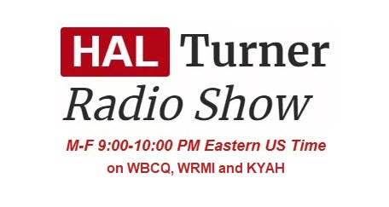](https://halturnerradioshow.com/)

Moderna COVID-19 Vax Ingredients Insert "BLANK"

https://halturnerradioshow.com/index.php/en/news-page/world/moderna-covid-19-vax-ingredients-insert-blank

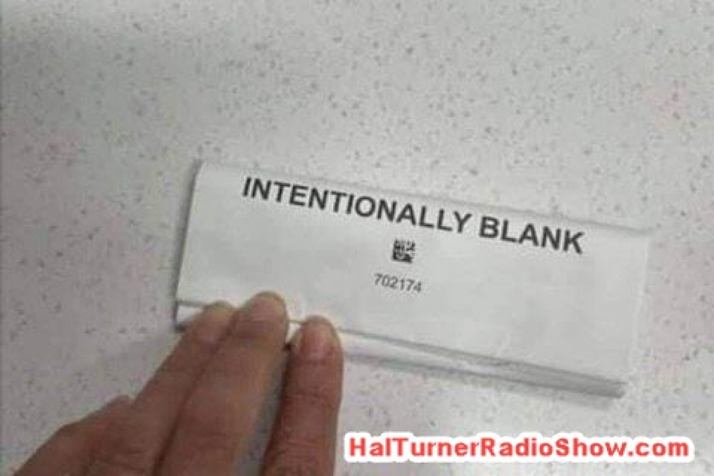

A Nurse has forwarded to me photos of a Moderna COVID-19 "vaccine" box along with the medical information insert that accompanies ALL Medications.  The Moderna insert is "Intentionally Left Blank."

The Nurse relates that she has "never seen anything like this in her life:"

[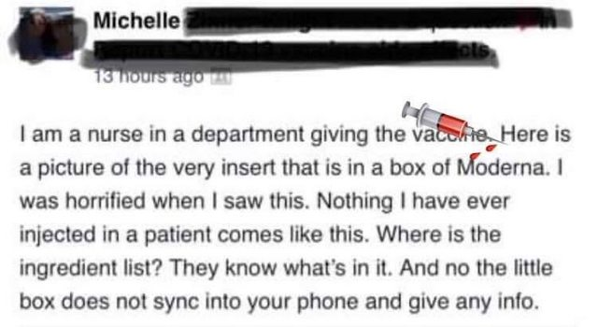](https://halturnerradioshow.com/images/2021/05/01/BlankInserMODERNA-1.jpg)

Here are the images she took directly from the Moderna Vaccine Box:

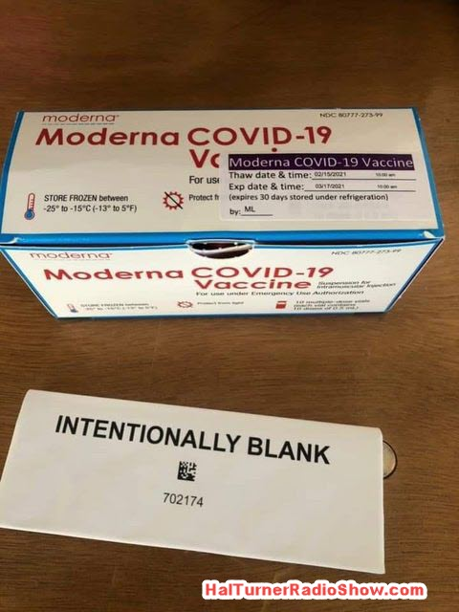

Focusing on the Vaccine Medical Information Insert, we see the entire thing is blank!

[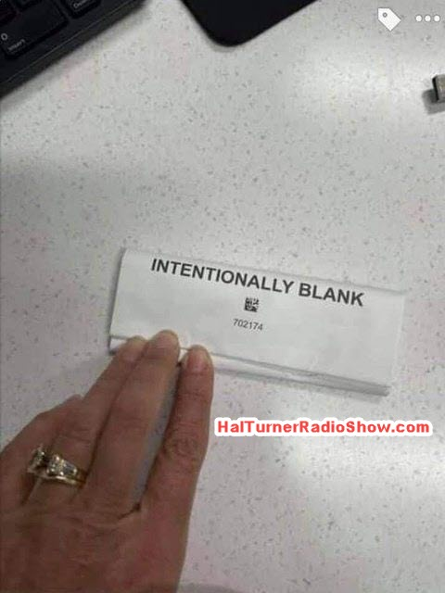](https://halturnerradioshow.com/images/2021/05/01/BlankInsertMODERNA-2.jpg)

Including the inside:

[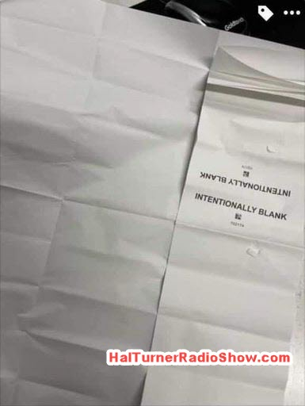](https://halturnerradioshow.com/images/2021/05/01/BlankInsertMODERNA-3.jpg)

In fact, BOTH sides of the insert are blank:

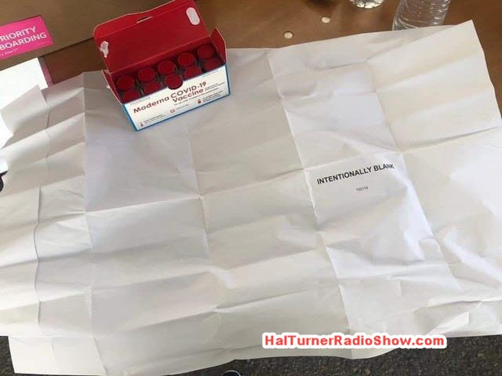

Here's a closer look at the box and insert:



So there you have it; people getting this vaccine are getting something that the manufacturer is NOT DISCLOSING what's actually in it!

Would you take a substance by injection when you didn't know what's in it?

Yet hundreds-of-thousands of people are taking this "jab" all over the world.   The old saying "the masses are asses" comes to mind.

*Now that you have read this story, please COVER THE COST for what your visit cost this site by clicking one or more of the ads* ***below*** *which generates Advertiser revenue of two to three cents per click -* ***no purchase necessary by you*** *-- and helps offset operating costs for this web site.*

*When YOU read a story here, the web hosting company charges us for "data transfer / Bandwidth" to convey the material to you.  Without your help by clicking an ad below, this web site would be in danger of shut down from the data transfer charges.  Please click any ad below to offset the cost of bringing this news to you,*