**Most Who Took COVID Vax will be dead by the year 2025. We now know the following facts . . .**

[World](https://halturnerradioshow.com/index.php/en/news-page/world) [NewsDesk](https://halturnerradioshow.com/index.php/en/authors/author/Newsdesk) 14 June 2021 Hits: 24268

<https://halturnerradioshow.com/index.php/en/news-page/world/most-who-took-covid-vax-will-be-dead-by-the-year-2025-we-now-know-the-following-facts>

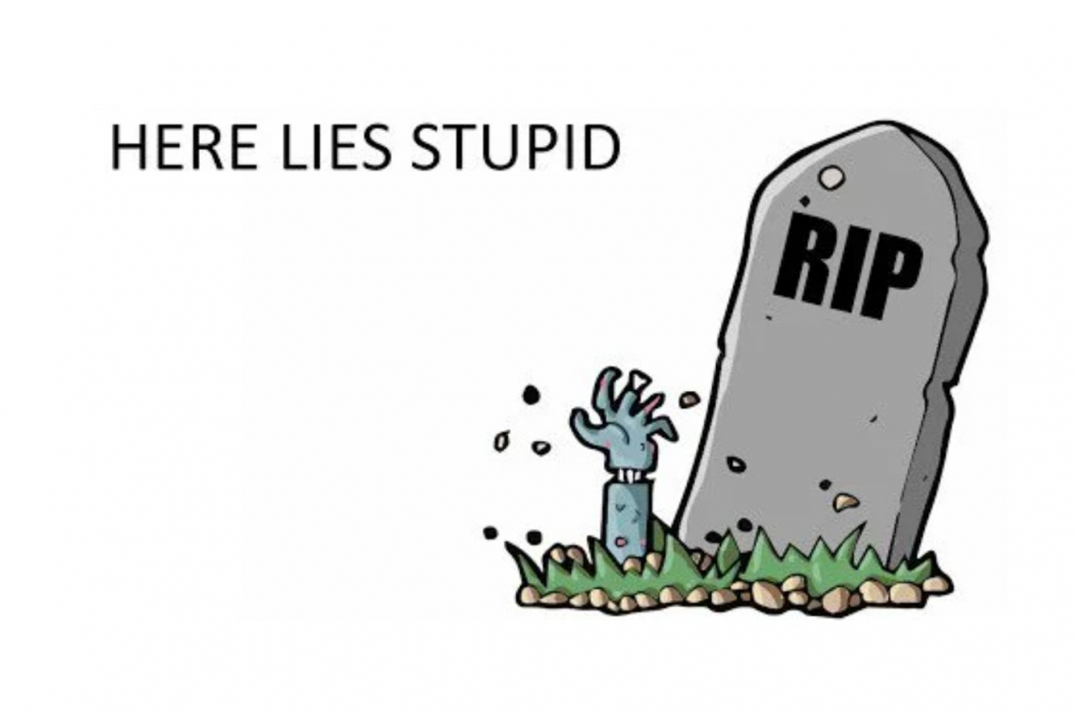

Most of the people who took a COVID "vaccine" will be dead by the year 2025.  The proof is now available for all to see.

Thanks to the people who participated in this first ever human experiment with a mRNA gene-therapy, fooled into thinking it was a "vaccine" for a phony "pandemic" allegedly caused by the never-isolated "COVID-19," we now know the following based on fact-based, post-vaccine research:

1.) It's not a vaccine. The COVID-19 mRNA vaccine does not provide immunity to Covid or it's variants so you can still catch Covid and transmit it to others making you asymptomatic. You will likely need a booster shot every 6 months, so get ready to roll up that sleeve every six months once that system rolls out.  
[[link to www.bustle.com](https://www.bustle.com/wellness/how-long-will-covid-vaccine-immunity-last-doctors)]  
  
2.) The 95% efficacy is the RRR (Relative Reduction Risk) where the real reduction rate **ARR (Absolute Reduction Risk) is less than 2%** as per this scientific Lancet study.  
[[link to www.thelancet.com](https://www.thelancet.com/action/showPdf?pii=S2666-5247(21)00069-0)]  
  
This means you are really not protected much at all, as the architects of this phony pandemic would like you to 'believe.'  
  
3.) The lipid nanoparticles in the vaccines do not remain in the intramuscular region of the deltoid muscle.  They seep out into the cardiovascular system infecting the entire body with spike-protein. **Something the manufacturers claimed would never happen**, yet it does and is why the adverse-side effects are so bad with this shot.  
[[link to www.sciencedirect.com](https://www.sciencedirect.com/science/article/pii/S1201971221003647)]  
  
4.) The spike-protein itself is toxic and a part of the disease pathology being the cause of inflammation, ACE2 deregulation, and opens up immunity pathways. This means Myocarditis (heart inflammation), Encephalitis (brain inflammation ) and hepatomegaly (liver inflammation) are huge risks and confirmed by many adverse-reactions reported to VAERS and EuroVigilance.  
[[link to www.ahajournals.org](https://www.ahajournals.org/doi/10.1161/CIRCRESAHA.121.318902)]  
[[link to www.salk.edu](https://www.salk.edu/news-release/the-novel-coronavirus-spike-protein-plays-additional-key-role-in-illness/)]  
[[link to www.news-medical.net](https://www.news-medical.net/news/20210503/SARS-CoV-2e28099s-distinctive-spike-protein-plays-a-key-role-in-the-disease-itself-shows-study.aspx)]  
[[link to pubmed.ncbi.nlm.nih.gov](https://pubmed.ncbi.nlm.nih.gov/33758854/)]  
[[link to www.jimmunol.org](https://www.jimmunol.org/content/173/12/7602)]  
  
This means the spike-protein itself is enough to damage the cardiovascular system and organs.  Some of that damage will kill them within a short time (weeks-to-0months) while some can have harmful events farther in the future.  Think of it like injecting someone with Covid-19 damaging the inside of the body, rather than the lungs.  
  
5.) The synthetic spike-protein itself has coding errors and a 5 GxxxG motif placing it in the category of a prion which could pose a long-term risk of neural degenerative diseases.  
[[link to www.longdom.org](https://www.longdom.org/open-access/bnt162b2-vaccine-possible-codons-misreading-errors-in-protein-synthesis-and-alternative-splicings-anomalies-61718.html)]  
[[link to ijvtpr.com](https://ijvtpr.com/index.php/IJVTPR/article/view/23)]  
[[link to www.newstarget.com](https://www.newstarget.com/2021-05-19-covid-vaccines-prion-brain-degeneration-mad-cow.html)]  
[[link to www.nature.com]](https://www.nature.com/articles/s41593-020-00771-8)  
[[link to www.preprints.org](https://www.preprints.org/manuscript/202003.0422/v1)]  
[[link to www.nature.com](https://www.nature.com/articles/s41421-020-00240-3)]  
[[link to www.biorxiv.org](https://www.biorxiv.org/content/10.1101/2021.02.23.432474v1)]  
  
6.) The lipid nanoparticles after injection bulk-accumulate in Ovaries in women followed by bone-marrow. Research is also showing the spike proteins accumulate in the testes of men.  The implications for infertility are obvious. Dr. Robert Malone the inventor of mRNA covers these findings in lay terms for stupid people who can't process scientific data easily.  
[[link to www.bitchute.com](https://www.bitchute.com/video/dO7qGs8Bww0i/)]

**Hal Turner Editorial Opinion**

If it wasn't for the gullible and naïve idiots who jumped on an experimental gene-therapy shot which skipped any real, meaningful, trials that would have presented the above findings, we now have this data and evidence from the human lab-rats running around gleefully and ignorantly celebrating their Eugenics shot, completely blind to the short-term and long term consequences that this data all points to:  **MOST of them will die from one or more of the conditions outlined in the reports above, and MOST of those deaths will take place by the year 2025.**  
  
Enjoy your harmful spike-protein that you will never get out of your body, and the neural degenerative, long-term risks, which ultimately could lead to untreatable deadly neurological illnesses as your brain slowly rots and deteriorates from the prion causing misfolded proteins that damage your neurons slowly over time.  
  
Your sacrifice for the safety of others, which will likely kill most of you, was based on your ignorance, your failure to research things for yourself, and your willingness to simply accept what other (ignorant) people - like politicians - told you.

World population of 500 million coming; just as the Georgia Guide Stones suggested, and the psychotic maniacs who believe humans need to be culled from the planet, took literally.

How about we blame the real culprits who created this in the first place:

Fauci with his gain-of-function research that was banned in the US so he moved it the lab in Wuhan where this took place.

Bill Gates with his depopulation agenda and ties to pedophile Jeffery Epstein.   
  
The CDC/WHO/Rockefeller Foundation and John Hopkins, who ran [Event 201](https://www.centerforhealthsecurity.org/event201/), [Spars](https://stars.library.ucf.edu/cgi/viewcontent.cgi?article=1029&context=jicrcr), [Lockstep](https://www.rockefellerfoundation.org/blog/innovating-for-a-bold-future/),  planning all of this for their globalist new world order.

Have a nice day!

The End