[**Mysterious Pilot Deaths Are Increasing Globally, Large Numbers of Flights Cancelled**](https://tapnewswire.com/2021/06/mysterious-pilot-deaths-are-increasing-globally-large-numbers-of-flights-cancelled/)

[**https://tapnewswire.com/2021/06/mysterious-pilot-deaths-are-increasing-globally-large-numbers-of-flights-cancelled/**](https://tapnewswire.com/2021/06/mysterious-pilot-deaths-are-increasing-globally-large-numbers-of-flights-cancelled/)

[Mon 8:30 am +00:00, 28 Jun 2021](https://tapnewswire.com/2021/06/mysterious-pilot-deaths-are-increasing-globally-large-numbers-of-flights-cancelled/)

posted by Weaver

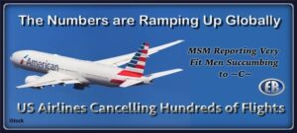

**ER Editor:** A shout out to one of our readers for having alerted us to this story, via Google translate. The publication date is June 22, 2021, from the German site [*Report24.news*](https://report24.news/) in English translation. The second article below that, from*The Colorado Herald*, reports on **several US airlines having recently cancelled more than the usual number of flights**.

We recommend clicking on the MSM Indian media links below. Airline employees are being vaccinated with an initial dose at the rate of 96-99%(!); 17 pilots at the time of reporting died ***of ‘Covid’***.  In summer. At relatively young ages (37 in one case). We remind readers, as the reports below do, that pilots are some of the fittest people around, and must necessarily be so. *The Colorado Herald* rightly sounds the alarm on **OUR risks as vaccinated passengers flying**. We face precisely the same ones as the pilots themselves, yet we may not be so healthy.

**And we highly recommend the site, new to us,**[***The Colorado Herald***](https://thecoloradoherald.com/)***.* They are**[**not afraid**](https://thecoloradoherald.com/about/)**to report on what MSM steers us away from.**

See this article we published recently, titled [**4 British Airways Pilots Dead Following COVID-19 Injections While Spain, Russia Concerned About Clots During Air Travel.**](https://www.europereloaded.com/4-british-airways-pilots-dead-following-covid-19-injections-while-spain-and-russia-concerned-about-clots-during-air-travel/)



********

**Mysterious deaths among pilots are increasing: Vaccinations are suspected**

**Report24.News**

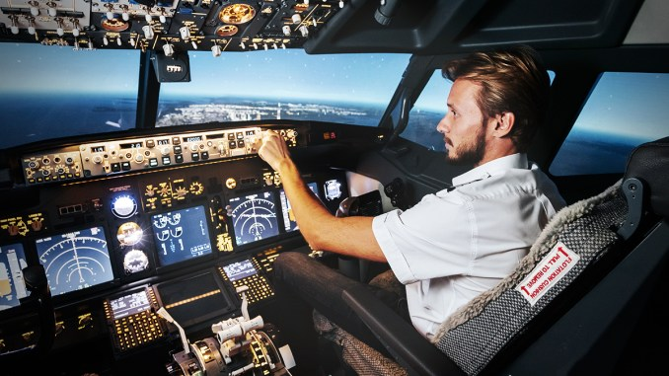Image: freepik / maximdenisenko

**Reports of dead pilots are currently causing a stir.**[**Four pilots of**](https://translate.google.com/website?sl=auto&tl=en&ajax=1&elem=1&se=1&u=https://de.rt.com/europa/119447-vier-todesfalle-unter-britischen-piloten/)**the British airline British Airways have recently died within a very short time. There are also reports of this kind from India. This gives food for thought insofar as this professional group has to undergo regular meticulous examinations of the state of health: Only those who are in the best of health are allowed to fly an airplane. So what happened? Many fear that the Covid vaccinations could play a role in the deaths.**

British Airways itself is keeping a low profile on the causes of pilot death. Only a connection between the cases (e.g. by receiving the vaccination?) is denied via Twitter.

That doesn’t stop the rumors – on the contrary. The fact that pilots have to undergo health checks at annual to 6-month intervals is not unknown to Twitter users either:

Pilots undergo medical examinations every year. This exam includes the heart, eyesight, hearing, brain, and so on. From a certain age, the health check must be carried out every 6 months. **It is very unlikely that these pilots had any previous illness.**Incidentally, many Indian pilots also died recently!

**Pilot deaths also in India**

With his reference to India, the user is right: In May alone, [five pilots](https://translate.google.com/website?sl=auto&tl=en&ajax=1&elem=1&se=1&u=https://www.hindustantimes.com/cities/others/air-india-loses-5th-pilot-to-covid-19-in-a-month-101622399862205.html) died there , other sources even report [17 deaths](https://translate.google.com/website?sl=auto&tl=en&ajax=1&elem=1&se=1&u=https://www.telegraphindia.com/india/covid-claims-17-pilots-in-may/cid/1817677) . Allegedly, the people died of Covid-19, it is said. However, the vaccination of pilots in India was supposed to start in May – **and one of the airlines affected said it had already vaccinated a large part of its employees.**

It remains unclear whether the respective pilots received a Covid vaccination shortly before their death. **In view of the risk of thrombosis as a result of vaccinations and the increased risk of thrombosis when flying, many people feel uncomfortable.**In a “[fact check](https://translate.google.com/website?sl=auto&tl=en&ajax=1&elem=1&se=1&u=https://www.reuters.com/article/factcheck-coronavirus-aviation/fact-check-british-airways-is-not-in-crisis-talks-with-the-government-over-vaccinated-pilots-idUSL2N2NZ1ZO)” via Reuters it was said that deaths among vaccinated pilots were “not known” at least to the British Medicines Agency MHRA – unfortunately, that doesn’t mean anything.

[**Source**](https://translate.google.com/translate?hl=en&sl=auto&tl=en&u=https%3A%2F%2Freport24.news%2Fraetselhafte-todesfaelle-unter-piloten-haeufen-sich-verdacht-faellt-auf-impfung%2F%3Ffeed_id%3D3189)

********

**Thousands of flights cancelled as vaccinated pilots fall ill or die**

**DARCY SCHOENING**

According to a [2014 study published in the Journal of Thrombosis and Haemostasis](https://onlinelibrary.wiley.com/doi/full/10.1111/jth.12627), **pilots suffer an increased risk of clotting issues due to frequent and prolonged air travel**. Pilots are encouraged to be aware of the signs of deep venous thrombosis and clotting issues and take preventative measures such as compression stockings and stretching of their legs during long flights.

[Medical News Today](https://www.medicalnewstoday.com/articles/oxford-astrazeneca-vaccine-slight-increase-in-blood-clot-risk) published a study on June 15th, 2021 that showed an increased risk of blood clotting and low platelets in AstraZeneca COVID-19 vaccine recipients. Some scientists hypothesize that since the ethylenediaminetetraacetic acid (EDTA) in the shot causes a full body reaction, once the vaccine comes into contact with platelets inside the human body, the vaccine [activates those platelets](https://www.livescience.com/amp/greinacher-theory-coronavirus-vaccine-clots.html), causing them to change shape and transmit chemical signals to the immune system. Those platelets send out [platelet factor 4](https://www.genecards.org/cgi-bin/carddisp.pl?gene=PF4) (PF4), which regulates blood clotting.

However, in some people, after some undetermined amount of time, at random, PF4 latches onto the vaccine, and large “complexes” form. Since those complexes are “unknown,” the human body interprets those clusters as threats. Thus, [immune cells](https://www.cancer.gov/publications/dictionaries/cancer-terms/def/immune-cell) in the body mistakenly attack PF4’s, prohibiting them from preventing the problematic clots seen in some COVID-19 vaccine recipients.

**Pilots have an increased risk of blood clots. COVID-19 vaccine recipients have an increased risk of blood clots.** [Reuter’s](https://mobile.reuters.com/article/amp/idUSL2N2NX252) and Fact Checkers cannot hide the fact that an increased risk on top of an increased risk is potentially a disaster, but neither has any regard for human life or the truth, as evidenced by the propaganda they’re currently creating by the minute.

**Delta Airlines now**[**requires the COVID-19 vaccine**](https://amp.usatoday.com/amp/5126620001)**for all new employees, potentially putting Delta employees at risk of blood clots and death.** American Airlines doesn’t require the vaccine but gives its employees [one day off of work and $50](https://loyaltylobby.com/2021/03/06/american-airlines-offers-one-extra-day-off-50-to-employees-who-receive-vaccinations/) for getting the vaccine. **No mention of the inherent risk for non-air employees, let alone those who spend ample time in the clouds, is ever made by Delta or American.**

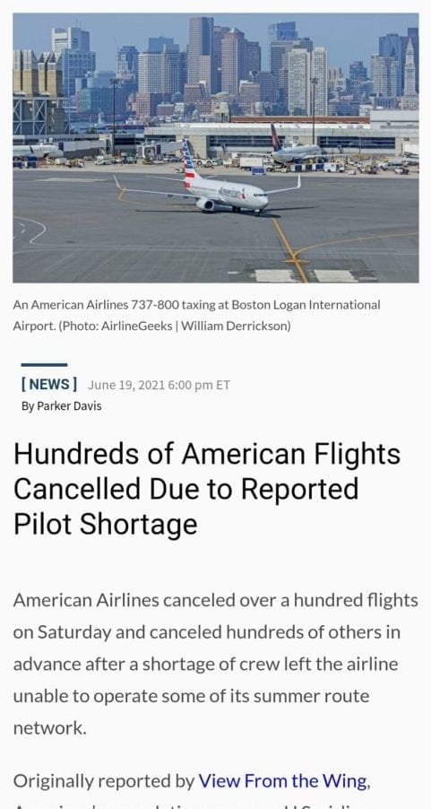

At British Airways, at least four pilots have died this week, but the airline wants you to know that their deaths are totally unrelated; [Reuter’s and Fact Checkers](https://fullfact.org/online/british-airways-pilot-vaccine/) are working hard to dispel any rumors that the pilots could have died from the COVID-19 vaccine. British Airways boasts that [85% of its employees are vaccinated](https://sicem365.com/forums/7/topics/88580). **Airlines are so quick to obey the COVID-19 vaccine narrative that they forget the welfare of their own employees is at stake.**

According to [flightaware.com](https://flightaware.com/live/cancelled/today),**120,000 cancellations per year is the average for global flights**. An average day would see **329** cancellations. A 2 day average would see 658 cancellations. But between Friday and Saturday *(ER: the 18th to 19th),***3,533** cancellations occurred. **That’s a 580% increase in cancellations globally in the past 2 days.**

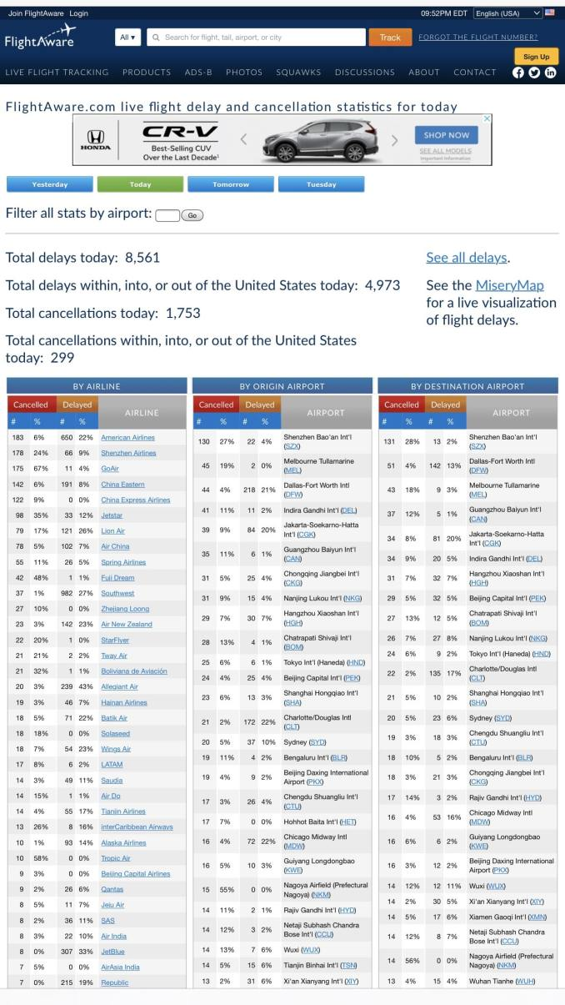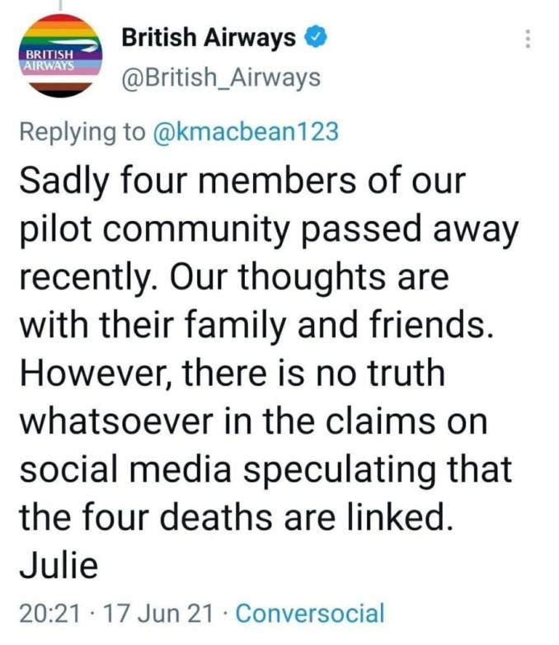

**Southwest delayed or**[**cancelled hundreds of flights last week**](https://www.nytimes.com/2021/06/16/business/southwest-delays-cancellations.amp.html) and blamed a host of issues such as technical difficulties and weather on the cancellations and delays. **American Airlines announced Sunday that it would**[**cancel hundreds of flights through mid-July**](https://amp.cnn.com/cnn/2021/06/20/business/american-airlines-flights-canceled-labor-shortages/index.html)**.** American blames weather issues and labor shortages on its preemptively cancelled flights. British Airways, which has seen at least 4 pilots die recently, [cancelled hundreds of flights](https://www.thelocal.it/20210615/travel-why-are-airlines-cancelling-flights-between-the-uk-and-italy/?amp)but then **furloughed thousands of its employees with**[**85% pay**](https://amp.rte.ie/amp/1227505/)**this week.**

Not to worry: the same agencies (mainstream media, Reuters, and Fact Checkers) tasked with exploring the safety and efficacy of a vaccine for the general public and for pilots who transport [6 million people per day](https://www.gaytravel.com/gay-blog/airline-and-flight-statistics) also ruled out a Wuhan lab leak and any conceivable voter fraud in the 2020 elections. Those agencies have [reversed their stance](https://www.wsj.com/amp/articles/the-science-suggests-a-wuhan-lab-leak-11622995184) on one of those issues, the Wuhan lab leak, only after it became impossible not to do so. One day, it’s conceivable that the media may reverse its stance on the COVID-19 vaccine…when it becomes impossible not to do so…

***Pilots are already at increased risk of blood clots; categorizing them as high risk for a vaccine with a known side effect of blood clots isn’t misinformation. It’s science.***

**For now, pilots should exercise their right to medical freedom and refuse to become vaccinated. Clearly, the truth isn’t coming anytime soon.**

************

[**Source**](https://thecoloradoherald.com/2021/thousands-of-flights-cancelled-as-vaccinated-pilots-fall-ill-or-die/)

***Published to The Liberty Beacon from***[***EuropeReloaded.com***](http://www.europereloaded.com/)

https://www.thelibertybeacon.com/mysterious-pilot-deaths-are-increasing-globally-large-numbers-of-flights-cancelled/