**New CDC report shows 94% of COVID-19 deaths in US had contributing conditions**

<https://www.abc27.com/news/new-cdc-report-shows-94-of-covid-19-deaths-in-us-had-underlying-medical-conditions/>

by: Natasha Anderson and Nexstar Media Wire

Posted: Aug 30, 2020 / 03:10 PM EDT / Updated: Aug 30, 2020 / 01:11 PM EDT



AddThis Sharing Buttons

Share to Facebook

Share to TwitterShare to WhatsAppShare to SMSShare to EmailShare to More

ATLANTA, Ga. (WJW) — The [Centers for Disease Control and Prevention](https://fox8.com/tag/cdc/) released new data last week that depicts how many Americans who have died from [COVID-19](https://fox8.com/news/coronavirus/) also had contributing conditions.

[According to the report,](https://fox8.com/news/coronavirus/) only 6% of deaths have COVID-19 as the only cause mentioned, revealing that 94% of patients who died from coronavirus also had other “health conditions and contributing causes.”

The [report](https://www.cdc.gov/nchs/nvss/vsrr/covid_weekly/index.htm?fbclid=IwAR3-wrg3tTKK5-9tOHPGAHWFVO3DfslkJ0KsDEPQpWmPbKtp6EsoVV2Qs1Q) reads in part:

Table 3 shows the types of health conditions and contributing causes mentioned in conjunction with deaths involving coronavirus disease 2019 (COVID-19). For 6% of the deaths, COVID-19 was the only cause mentioned. For deaths with conditions or causes in addition to COVID-19, on average, there were 2.6 additional conditions or causes per death.

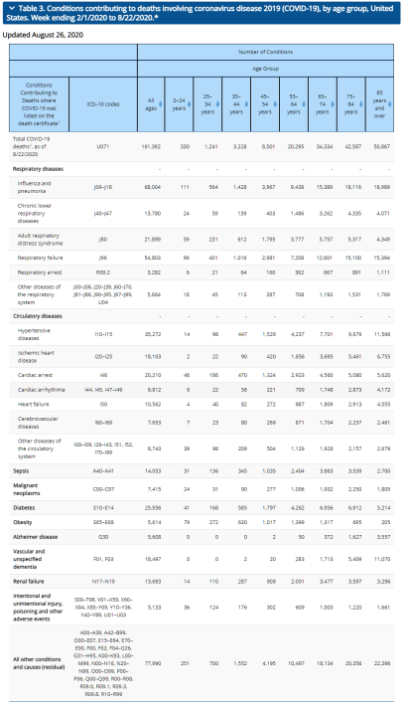

Table 3. Conditions contributing to deaths involving coronavirus disease 2019 (COVID-19), by age group, United States. Week ending 2/1/2020 to 8/22/2020.* (Courtesy: CDC)

[Study: These are the six COVID-19 symptom clusters to watch for](https://www.wric.com/health/coronavirus/study-these-are-the-six-covid-19-symptom-clusters-to-watch-for/)

The CDC listed the following as the top underlying medical conditions linked to coronavirus deaths:

* Influenza and pneumonia
* Respiratory failure
* Hypertensive disease
* Diabetes
* Vascular and unspecified dementia
* Cardiac arrest
* Heart failure
* Renal failure
* Intentional and unintentional injury, poisoning and other adverse events
* Other medical conditions
* [Global coronavirus cases now top 25 million, with US leading the count](https://fox8.com/news/coronavirus/global-coronavirus-cases-now-top-25-million/)
* The CDC explains that their data uses provisional death counts to “deliver the most complete and accurate picture of lives lost to COVID-19.”
* These numbers are based on death certificates, which the organization says are the most reliable source of data. Death certificates reportedly contain information that is not available anywhere else and includes comorbid conditions, race and ethnicity and place of death.
* [Nevada man may be first documented COVID-19 reinfection case in US](https://fox8.com/news/nevada-man-may-be-first-documented-covid-19-reinfection-case-in-us/)
* The CDC says provisional death counts may not match counts from other sources, such as numbers from county health departments, because death certificates take time to be completed, states report at different rates, it takes officials extra time to code COVID-19 deaths, and because other reporting systems use different definitions or methods for counting deaths.
* The organization adds that provisional data is not yet complete, provisional counts are not final and are subject to change, and that death counts should not be compared across states.
* Editor’s note: We’ve updated the language of this article to read “contributing conditions” when noting COVID-19 death percentages. In a previous version, those contributing conditions were labeled “underlying health conditions.”
* Copyright 2020 Nexstar Broadcasting, Inc. All rights reserved. This material may not be published, broadcast, rewritten, or redistributed.

## Share this story

* AddThis Sharing Buttons
* Share to Facebook
* Share to TwitterShare to WhatsAppShare to SMSShare to Email

# 94% of Americans who died from COVID-19 had contributing conditions: CDC

<https://nypost.com/2020/08/31/94-of-americans-who-died-from-covid-19-had-contributing-conditions/>



Christopher Sadowski

#### More On:

### [Coronavirus](https://nypost.com/coronavirus/)

## [Parents locked up kids for months to protect them from COVID-19](https://nypost.com/2020/09/03/paranoid-parents-locked-up-kids-to-protect-them-from-covid-19/)

## [US workers file 881,000 more jobless claims](https://nypost.com/2020/09/03/us-workers-file-881000-jobless-claims-as-feds-adjust-data/)

## [Stylist comes to Pelosi's defense after salon owner's 'setup'](https://nypost.com/2020/09/03/nancy-pelosis-stylist-says-she-was-set-up-by-salon-owner/)

## [Salon owner denies Nancy Pelosi hair appointment was a setup](https://nypost.com/2020/09/03/salon-owner-denies-that-nancy-pelosi-hair-appointment-was-a-setup/)

Ninety-four percent of Americans who died from COVID-19 had other “types of health conditions and contributing causes” in addition to the virus, according to [a new CDC report](https://www.cdc.gov/nchs/nvss/vsrr/covid_weekly/index.htm?fbclid=IwAR3-wrg3tTKK5-9tOHPGAHWFVO3DfslkJ0KsDEPQpWmPbKtp6EsoVV2Qs1Q).

Using provisional data on coronavirus-related deaths from the week ending Feb. 1 through Aug. 22, the Centers for Disease Control and Prevention concluded last week that “for 6 percent of the deaths, COVID-19 was the only cause mentioned.”

“For deaths with conditions or causes in addition to COVID-19, on average, there were 2.6 additional conditions or causes per death,” the report said.

Respiratory conditions such as influenza and pneumonia, respiratory failure and respiratory arrest, as well as circulatory conditions such as hypertensive diseases, cardiac arrest and heart failure are on the list.

Other conditions included sepsis, diabetes, renal failure and Alzheimer’s disease.

The counts are based on death certificates, which the agency called “the most reliable source of data.”

However, the provisional data is not yet complete, the counts are not final, and they should not be compared across states, the agency warned.

As of Monday, the US has surpassed 6 million coronavirus cases and 183,000 deaths, Johns Hopkins University statistics show.