**Obedience is a killer: 91% of Biden voters took the DEATH jab… huge demographic and ELECTORAL changes coming for America as vax clots kill Democrats and liberal women the most**

[**https://www.naturalnews.com/2022-09-06-obedience-is-a-killer-91-of-biden-voters-took-the-death-jab.html**](https://www.naturalnews.com/2022-09-06-obedience-is-a-killer-91-of-biden-voters-took-the-death-jab.html)

Tuesday, September 06, 2022 by: [Mike Adams](https://www.naturalnews.com/author/healthranger)   
*Tags:* [*badhealth*](https://www.naturalnews.com/tag/badhealth)*,* [*badmedicine*](https://www.naturalnews.com/tag/badmedicine)*,* [*COVID*](https://www.naturalnews.com/tag/covid)*,* [*demographics*](https://www.naturalnews.com/tag/demographics)*,* [*depopulation*](https://www.naturalnews.com/tag/depopulation)*,* [*elections*](https://www.naturalnews.com/tag/elections)*,* [*Electoral College*](https://www.naturalnews.com/tag/electoral-college)*,* [*genocide*](https://www.naturalnews.com/tag/genocide)*,* [*gullible*](https://www.naturalnews.com/tag/gullible)*,* [*Joe Biden*](https://www.naturalnews.com/tag/joe-biden)*,* [*liberals*](https://www.naturalnews.com/tag/liberals)*,* [*medical fascism*](https://www.naturalnews.com/tag/medical-fascism)*,* [*Medical Tyranny*](https://www.naturalnews.com/tag/medical-tyranny)*,* [*obey*](https://www.naturalnews.com/tag/obey)*,* [*pandemic*](https://www.naturalnews.com/tag/pandemic)*,* [*President Trump*](https://www.naturalnews.com/tag/president-trump)*,* [*vaccine compliance*](https://www.naturalnews.com/tag/vaccine-compliance)*,* [*Vaccine deaths*](https://www.naturalnews.com/tag/vaccine-deaths)*,* [*vaccines*](https://www.naturalnews.com/tag/vaccines-tag)*,* [*voting*](https://www.naturalnews.com/tag/voting)*,* [*whites*](https://www.naturalnews.com/tag/whites)*,* [*women*](https://www.naturalnews.com/tag/women)  
  
**This article may contain statements that reflect the opinion of the author**

Bypass censorship by sharing this link:



[Copy URL](javascript:%20CNWCopytoClipboard();)

28KViews

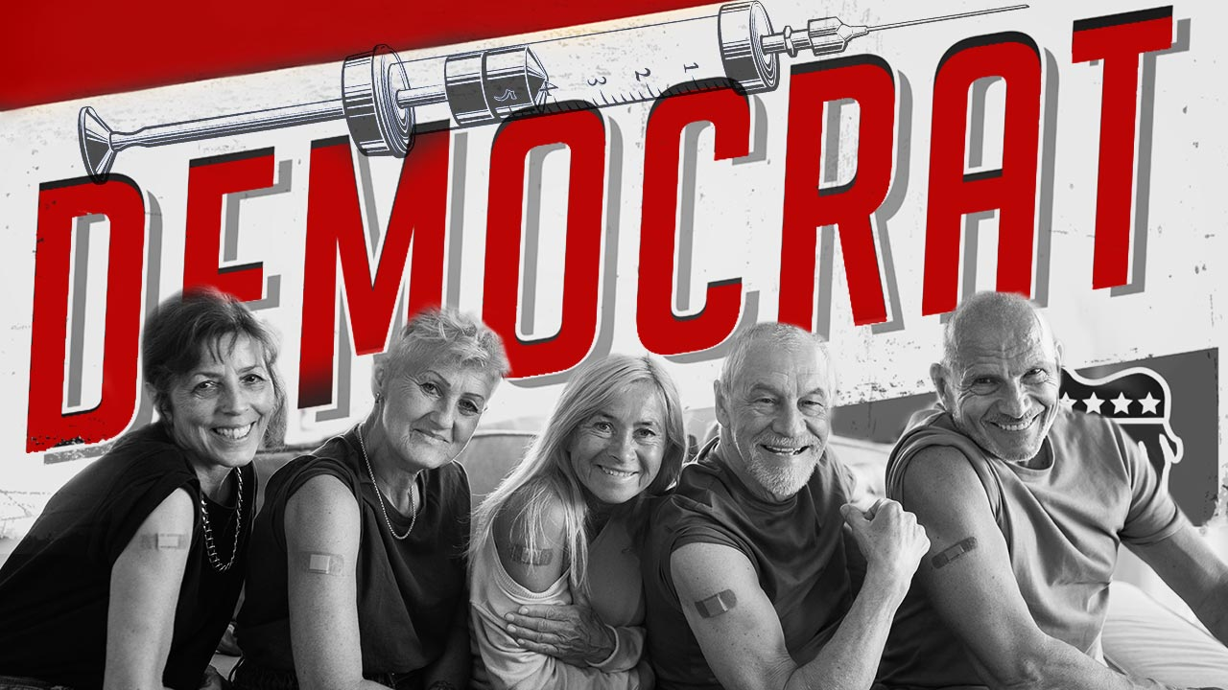

([Natural News](https://www.naturalnews.com)) A new poll from *The Economist* and [covered by Breitbart News](https://www.breitbart.com/politics/2022/09/05/three-ten-americans-did-not-get-coronavirus-vaccine/) has found that the vast majority of both Biden and Trump voters were easily tricked into taking a suicide shot falsely labeled the “covid-19 vaccine.”

According to the poll, 91% of Biden voters took at least one of the jabs, most likely because those who support Biden are obedient, oblivious NPCs who blindly trust government and corporations with their lives, even when those governments and corporations are quite literally trying to exterminate them.

*Orange Man Bad, but Orange Man’s vaccine GOOD…*

Interestingly, 66% of Trump voters also took the jabs, no doubt stemming from the fact that Trump fraudulently promoted the vaccines as safe and effective after launching *Operation Warp Speed* to rush untested, unsafe vaccines into widespread adoption.

[See the results of the survey here (PDF)](https://docs.cdn.yougov.com/kqp1ntoj7v/econTabReport.pdf). (Go to page 67 for vaccine results.)

The upshot of this survey? **Both Biden and Trump supporters are remarkably gullible when it comes to vaccines, with Biden supporters proving to be far more gullible than Trump supporters**.

The lesson here? Just because your “leader” tells you to go jump off a cliff doesn’t mean you should do it.

*Independents* achieved the highest rejection of covid-19 vaccines, with 39% saying they took no shots whatsoever. This confirms that political independents are, indeed, true to their philosophy of thinking for themselves some of the time (although 61% actually took the jab, which means they aren’t as independent as they would like to believe).

[Brighteon.TV](https://www.brighteon.tv/)

**College-educated liberal white women shown to be the most gullible and compliant with vaccine propaganda**

The survey reveals something quite fascinating. While men, Blacks and Hispanics all caught on and largely stopped taking the fraudulent covid-19 vaccine after the first or second dose, White liberal women (college-educated / indoctrinated) continued to remain shockingly obedient to the covid-19 propaganda and demanded three or more doses.

From the study, while only 42% of Hispanics took three jabs, and 55% of Blacks took three jabs, and even White college-educated men only had 58% compliance with three jabs, **White women with college degrees (i.e. liberal women) showed 70% compliance with triple jabs**.

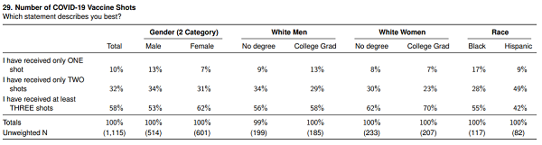

This shocking finding reveals that White women are heavily indoctrinated in today’s colleges and are incredibly obedient to socially-engineered demands for mass extermination. While a larger number of Blacks, Hispanics and even White men came to their senses and stopped taking the clot shots, liberal White women doubled, tripled, and even quadrupled down and demanded more injections (most likely while screaming at everybody around them to put on more masks and keep their distance).

This finding is consistent with another study [covered by Information Liberation](http://www.informationliberation.com/?id=63315) that has found the following shocking beliefs among White liberals (mostly women):

* The now believe that Whites are more violent than Blacks
* They believe that Whites are more lazy compared to Blacks
* They believe that Whites are less intelligent than Blacks

These beliefs have been hammered into White liberals via the fake news media and pop culture programming (movies, TV, advertising, etc.). White liberal women soaked it up like a mindless sponge.

White liberal women, it seems, are practically incapable of independent, non-racist thinking and have been largely brainwashed with false beliefs about culture, race, medicine and science. As they are taking their fourth shot, a White liberal woman is likely to scream, “I trust the science!” even though they are being slowly genocided by the jab.

The rise of modern tyranny across Western Civilization, by the way, is supported — if not outright spearheaded — by insane, angry White liberal women. These are the same women who tend to support child mutilations, transgenderism, grooming, abortions and who despise God. No surprise there. They hate men and they also hate women (feminists). They of course hate Trump, America and the American flag. But they love to run school boards and city councils, and they want to control your life and wield political power over everything you’re allowed to do.

**Covid-19 vaccines have been proven to be a complete fraud**

The entire premise behind the so-called covid vaccine has been proven to be a total fraud, of course. As Breitbart reports:

*The survey was taken August 28-30, 2022, among 1,500 U.S. adult citizens and comes as some across the country are on their fourth shot.*

*After months of controversy, it is a well-established fact now that the vaccines themselves do not actually stop the transmission of the virus — a claim President Joe Biden made over the course of the pandemic.*

It turns out that **both Biden and Trump lied about the vaccines**, and by doing so, they both caused millions of their followers to line up for injections that will, in many cases, kill them.

Whether you are a Biden or Trump supporter, there’s no getting around the fact that your “leader” marched people right into the death shots. And even when the evidence became clear that excess mortality was exploding among the vaccinated, your “leader” did nothing to stop the massacre.

By embracing deadly, quack science “vaccines” that are killing people by the millions worldwide, both Joe Biden and Donald Trump disqualify themselves from ever representing We the People on anything related to health, medicine or science.

**Huge demographic changes coming as vaccine-obedient democrats and liberal women die off during the Vaccine Holocaust**

Now that we know 70% of college-educated liberal White women have taken three or more covid shots, we also know that these women are going to die in unprecedented numbers. The deaths will be explained away as strokes, heart attacks, neurological disorders, blood clots and the like, but the truth is that **these are all vaccine deaths**.

By taking three or more clot shots, White, liberal women have already killed themselves. Between now and 2030, millions of them are going to prematurely die. There will also be millions of deaths of White men, Blacks, Hispanics and other ethnic groups that took the jab — Asians and Native Americans also show high obedience uptake of the jab — but the most pronounced deaths will occur among White liberal women (since they had the highest compliance).

We wonder at what point White liberal “journalists” will discover how many of their colleagues are dying after taking multiple covid jabs. Then again, White liberal women are capable of incredible feats of denialism and self-delusion, so they will probably never make the connection.

But the fact is clear that **there will be fewer liberals and Democrats around for each coming election over the next decade** (and thereafter).

**Millions of Americans who took the jab will be dead by the 2024 election**

Based on available excess mortality figures already available today (see the 2021 excess mortality numbers from [SOA Research Institute](https://www.soa.org/48ff80/globalassets/assets/files/resources/research-report/2022/group-life-covid-19-mortality.pdf), shown below), we know that **more than twice the number of “normal” deaths are being seen in some groups following covid vaccinations**.

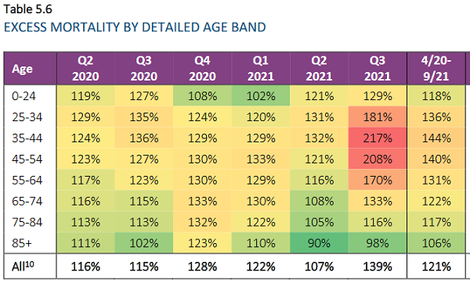

According to conservative estimates based on industry numbers, at least 600,000 Americans have already died from covid-19 vaccines. A [recent Epoch Times news report](https://www.theepochtimes.com/embalmers-have-been-finding-numerous-long-fibrous-clots-that-lack-post-mortem-characteristics_4696015.html?utm_source=ref_share&utm_campaign=navigator&rs=SHRNBSWT&) (which cites my lab’s ICP-MS analysis of the post-vaccine clots) documents the existence of fibrous clots that are being pulled from the bodies of dead people who took covid-19 vaccines.

I have interviewed several experts about these clots, including Dr. Jane Ruby, Dr. Judy Mikovitz and others, and the best conclusion from the data so far is that **these clots are aggregate proteins being constructed by the body in response to mRNA instructions**. These are not “blood” clots, they are fibrous, protein clumps that are self-assembling (growing) inside blood vessels and arteries.

As they grow larger, they block blood flow, leading to stroke, heart attacks, embolisms, etc. Many of these end in death.

Because these clots / biostructures are getting larger (i.e. “growing”) inside people’s bodies, they are like ticking time bombs of inevitable death. With each passing month, those who took multiple vaccine jabs are inching closer to instant death due to the clots.

Between now and the 2024 elections, it seems likely that millions of Americans will be dead from these clots. Democrats will be disproportionately killed by this phenomenon, as will White liberal women who were the most obedient in taking the jabs.

This means **the demographics of America will be substantially changed by 2024**. Ultimately, both the US Census and even Electoral College votes will have to be recalibrated over the next decade to account for the mass die-off of those who took the clot shots and died as a result.

White liberal women probably never considered that by obeying vaccine mandates, they would not merely remove themselves from the human gene pool, they would also remove their votes from all future elections.

**Why did White liberal women allow themselves to be medically violated by the Trump vaccine?**

I have even heard the outrageous argument — and for the record I do not espouse this argument, nor agree with it — that supposes Trump pushed the vaccine for this very reason, to exterminate more liberals than conservatives. Despite the outrageous nature of such an evil plot, there are people who believe this is exactly what’s going on, claiming that America cannot survive as a free nation with so many White liberal women voters who are deranged, socialist-minded commies / lunatics. You can draw your own conclusions, but I do not think Trump is capable of carrying out genocide for political purposes. I do think he is capable of being hoodwinked by Fauci and other evil demons, however, and my assessment is that’s exactly what happened.

Ironically, the very people who might believe Trump is capable of such evil acts are in fact White liberal women. These same women who take great pride is screaming at Trump and directed unrelenting hatred toward “Orange Man” ended up **taking Trump vaccines** and injecting them into their bodies, apparently oblivious to the fact that these vaccines were rushed into production by Trump’s directives to Pfizer and the FDA. Thus, these very women who despise Trump ended up injecting themselves with genetic-altering material that was spearheaded into production by Trump himself. In essence, from one perspective, they allowed themselves to be medically violated by Trump. And over the next decade, millions of them will die.

For the record, we have tried to warn everyone about these vaccines — Democrats, conservatives and independents alike. We wish no vaccine harm upon anyone and have worked tirelessly to help save the lives of anyone who would listen to reason. But White liberal women are largely incapable of reason. **They make choices based almost entirely on emotion**, and they reject reason outright. They are driven by feelings, not facts, and they “believed” in the “science” of vaccines, so they took the Trump jabs and now they are dying in droves.

As you can see, this is not a simple left/right political story. This is not a pro-Trump analysis. It is a reality-based analysis. Trump and Biden both pushed the “vaccines,” and now millions of Americans will die as a result. Most likely at least a million have *already* died, with more millions yet to come. Business is booming for funeral homes, it turns out, which is something I predicted in this 2006 *Counterthink* cartoon that showed a society based on mass Big Pharma deaths, where the mayor declared, “Business is booming” among the hospitals, cancer centers and funeral homes. (Yes, I called it over a decade ago…)

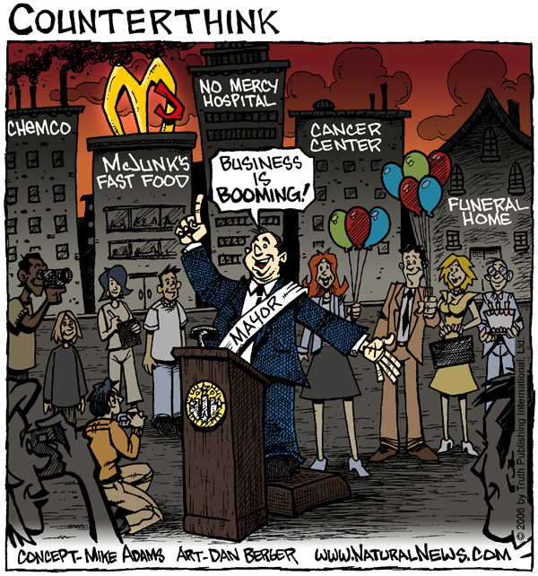

One of the very best sites analyzing all this, by the way, is [The Covid Blog, founded by Brian Wilkins](https://thecovidblog.com). Read the site’s [outstanding analysis of crazed vaccine pusher (and White liberal woman) Brandy Zadrozny](https://thecovidblog.com/2022/05/10/brandy-zadrozny-case-study-on-nbc-news-vaxx-zealot-tiffany-dover-reporter-and-how-mainstream-media-curate-and-create-these-on-air-performers/), a vax-propagandist journo-terrorist working for NBC News.

A more recent story from Wilkins is entitled, “[Trump loyalists jumping ship due to his vaxx zealotry, one of worst “vaccine” adverse reactions to date, and 13 more sudden deaths](https://thecovidblog.com/2022/09/06/tuesday-tidings-v-trump-loyalists-defecting-one-of-worst-vaccine-adverse-reactions-to-date-and-13-more-sudden-deaths/).”

Wilkins does outstanding research for each of his stories and is a fact-based reporter that mainstream media has been relentlessly attacking and trying to shut down. His headlines are indexed in real time, by the way, at [Censored.news](http://Censored.news).