[](https://ambassadorlove.wordpress.com/)

[**Ariyana Love**](https://ambassadorlove.wordpress.com/)

Goodwill Ambassador

[May 2, 2021](https://ambassadorlove.wordpress.com/2021/05/02/the-covid-vaxxed-must-be-quarantined-expert-consensus/) by [Ariyana Love](https://ambassadorlove.wordpress.com/author/ambassadorlove/)

**THE COVID VAXXED MUST BE QUARANTINED! Expert Consensus**

**<https://ambassadorlove.wordpress.com/2021/05/02/the-covid-vaxxed-must-be-quarantined-expert-consensus/>**

**and the Video:**

[**https://www.brighteon.com/92d8294a-a5c0-43c0-beda-dd39ff2c77f1**](https://www.brighteon.com/92d8294a-a5c0-43c0-beda-dd39ff2c77f1)

By Dr. Ariyana Love

A vitally important panel discussion was held on April 22nd with a group of leading medical experts who are deeply concerned for the continued existence of the human species. There is now an official consensus among the experts that Covid-19 shots are *bioweapons*, something I’ve been reporting on from the beginning.

In the latest episode of Critical Thinking, Dr. Sherri Tenpenny, Dr. Carrie Madej, Dr. Larry Palevsky, Dr. Christiane Northrop, Dr. Lee Merritt and Paediatrician Maurine McDonald, expose the hard core truths about Big Pharma’s Covid-19 *extermination* by genetic experimentation.

Due to the severity of the situation, I transcribed all of the key points made during this discussion so that medical professionals, international bodies, journalists and researchers worldwide can study the material carefully and share it more widely.

The terrifying focus of the discussion was on medical reports which demonstrate that *transmission* of the Covid bioweapons is taking place from the vaxxed to the unvaxxed. Those who did not subject themselves to Big Pharma’s experiment are getting infected anyway. Even though men and women did not take the deadly jab, they are being *sterilized* without direct physical contact to a vaxxed person.

Self spreading vaccines is no myth. [**Page number 45 from this PDF**](https://www.centerforhealthsecurity.org/our-work/pubs_archive/pubs-pdfs/2018/181009-gcbr-tech-report.pdf) produced by Johns Hopkins University demonstrates that self-spreading vaccines do already exist.

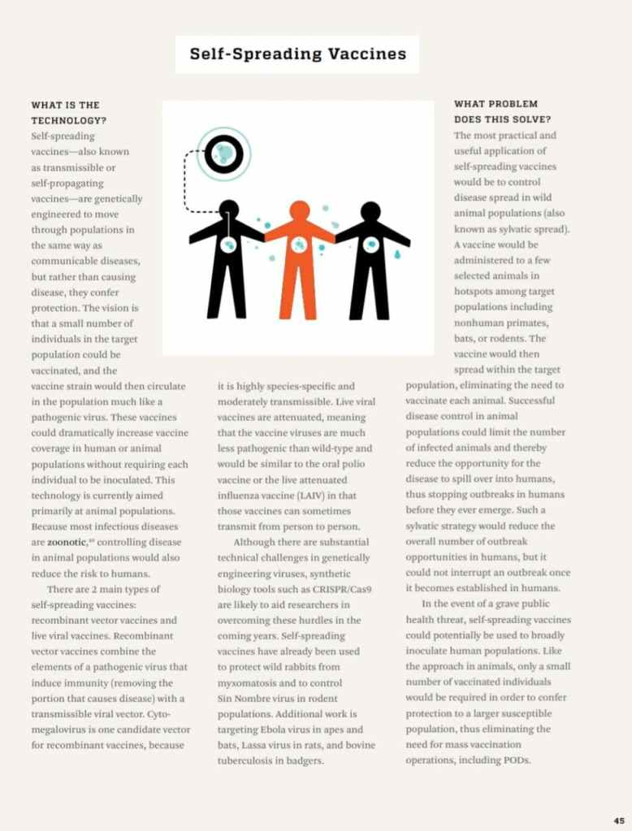

Self-disseminating vaccines for emerging infectious diseases has existed since 2016, [**according to this study**](https://www.ncbi.nlm.nih.gov/pmc/articles/PMC4732410/) by the US National Library of Medicine National health Institute.

[**Pfizer officially admits**](https://www.humorousmathematics.com/post/the-adverse-effects-of-experimental-messenger-rna-mrna-vaccines-a-k-a-injections-for-covid-19) in their own documents that the experimental mRNA trial subjects are *Super Spreaders* who transmit disease to the unvaxxed. During Pfizer’s clinical trials it’s cleverly termed “occupational exposure”.

Please also read: [**“World Medical Doctors Warning: Stay Away From The Vaxxed!”**](https://ambassadorlove.wordpress.com/2021/04/28/world-doctors-warning-stay-away-from-the-vaxxed/)

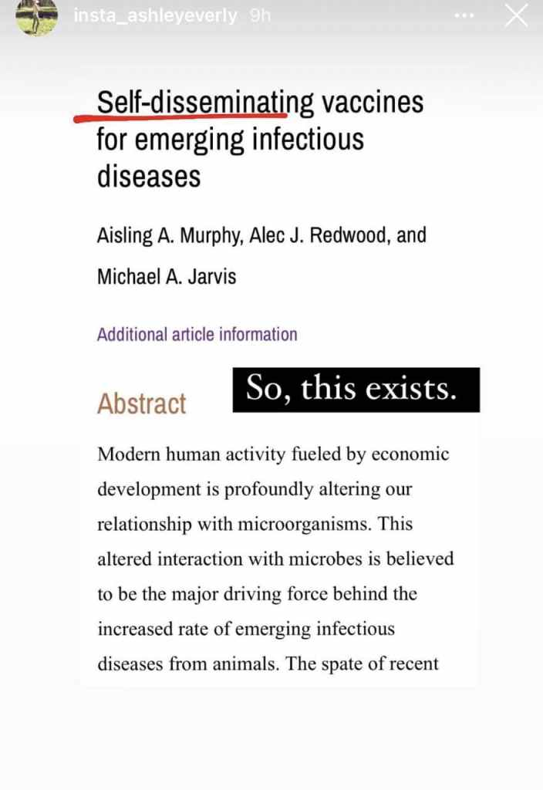

This technology is immorally infecting the unknowing unvaxxed population who have unintentional contact with the mRNA vaxxed. This is a blatant violation of the Nuremberg Code from 1947 and is further evidence that experimental mRNA injections for Covid-19 are in fact *genetic biowarfare*. This comes straight out of the Pfizer BioNTech study (PF-07302048) titled “A Phase 1/2/3 Study to Evaluate the Safety, Tolerability, Immunogenicity, and Efficacy of RNA Vaccine Candidates Against Covid in Healthy Individuals.”

So now the “vaxxed” mRNA injected individuals are the true super spreaders. Pfizer had complete prior knowledge that transmission occurs from the vaxxed to the unvaxxed and therefore this genocide was intentionally planned.

People need to understand that the masks, swab “tests” and injections all [**contain lethal bioweapons**](https://ambassadorlove.wordpress.com/2021/04/07/masks-and-covid-tests-contain-nanotech-vaccines-without-informed-consent/) without your Informed Consent. These weapons cut your life short by causing Prion Disease and blood coagulation which is leading to clotting. The Covid-19 injection from Pfizer has been [**confirmed to cause brain damage**](https://www.naturalnews.com/2021-04-27-covid19-vaccine-pfizer-brain-damage-neurodegenerative-disease.html) and neurodegenerative disease. These are weapons of war for depopulation.

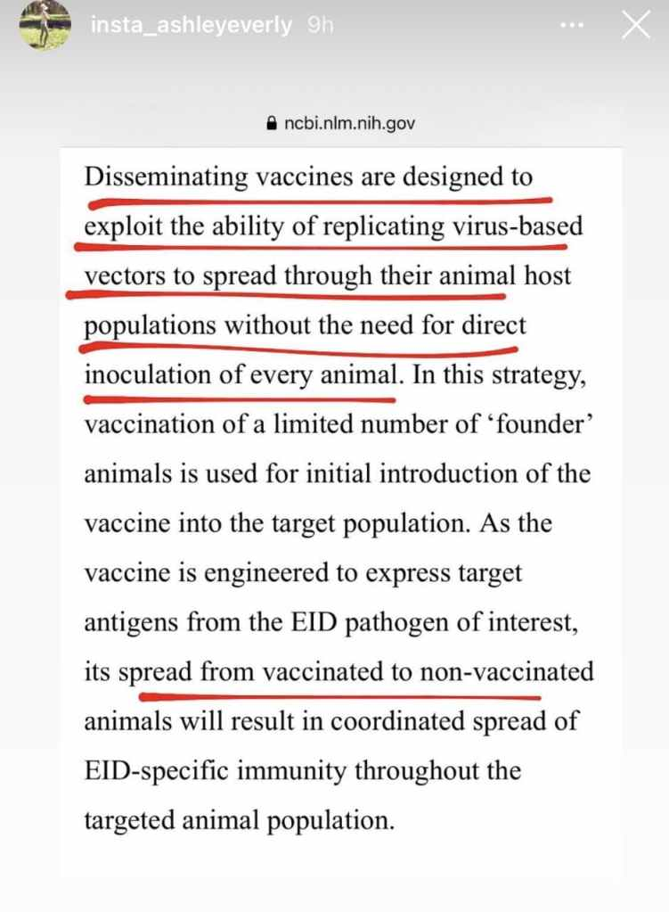

Experts believe that transmission from the vaxxed to the unvaxxed is *airborn*e. Doctors are seeing sterilization, miscarriages and other strange bleeding and clotting in women, men and children exposed to the Covid vaxxed. Transmission is occurring without direct physical contact, therefore the expert consensus now is that the vaxxed should be *quarantined* immediately. They should at least be wearing a yellow badge out in public so the unvaxxed can identify them and steer clear.

Another important point made by the medical panel is that the vaxxed are *not* “shedding” as we earlier thought. Shedding is a phenomenon which happens after vaccination but these are *not* vaccines. Covid shots are a form of gene therapy however the “therapy” part has been inverted because the messenger RNA technology is not programmed for healing but for cell destruction. Therefore, we are dealing not with “shedding” but with bioweapons *transmission*, the panel makes clear.

Pfizer whistleblower Dr. Michael Yeadon [**has warned us about**](https://en-volve.com/2021/03/29/former-pfizer-vp-sounds-alarm-covid-19-vaccine-is-madness-that-will-be-used-for-massive-scale-depopulation/) the looming extermination of the human race. He estimates those who were injected in Big Pharma’s Biotech experiment have one or maybe two years maximum, to live. He informs us that each additional Covid shot reduces the life expectancy even more. I pointed this out in a previous article after industry insider Dr. Geert Vaden Bossche issued a [**world public health emergency**](https://ambassadorlove.wordpress.com/2021/03/21/world-public-health-emergency-stop-big-pharmas-dna-vaccine-experiment/) warning and called for an immediate halt to the Biotech experiment.

You have only to look at the [**latest Adverse Events and Deaths**](https://childrenshealthdefense.org/defender/vaers-significant-jump-reported-injuries-deaths-after-covid-vaccine/) reported to VAERS to know that death and injury from the Covid shots are far worse than the Corona virus, which is no more deadly than the seasonal Influenza flu.

**Vaccination vs Transfection**

A normal vaccine injects a pathogen into your blood stream to evoke an immune response whereby your body produces antibodies to the disease. Never has a vaccine inserted anything directly into human cells before.

The Covid shots are raping the human being by a process known as *biohacking*. Messenger RNA (mRNA) and adenoviruses are being directly deposited into your cells for *genetic reprogramming* using a lipid-nanotechnology delivery system. None of these Biotechnologies have ever been tested on humans before and now they are being used worldwide without Informed Consent of the ingredients or Adverse Reactions.

Learn more about biohacking here: [**The Corona Jab Serum & It’s Effects On Human DNA & Brain Hacking! Are You Ready To Blow Your Mind?**](https://www.bitchute.com/video/6BN7ostWeWzq/?fbclid=IwAR3qQdgIFzrCbF4IbbBvgfVaw-IW_C2bcyCty6jwqRWgLnnoVvC9_JOfnGc)

Synthetic and foreign RNA is being fused to your tissue through the use of semiconducting Hydrogels and literally changing forever what it means to be human. This process of genetically modifying the human race and creating a new species of hybrid humans, is called *transfection* not vaccination. Big Pharma, mainstream media, government and leading health authorities are lying to us because this is *not* vaccination.

Worse yet is that the cells of the Covid vaxxed are being programmed to produce the synthetic spike protein of the pathogen they were injected with. So their bodies are now *pathogen creators* and they are transmitting the disease to others. It’s unclear whether this pathogen production ever stops. Production of this disease by your own cells, causes the immune system to produce antibodies to the spike protein. This triggers the body of the vaxxed to *attack itself*.

Do you understand what you have an immune system for? Your immune system is there to identify pathogens and attack them so they don’t harm you. How on God’s green Earth could injecting a pathogen into your cells and *programming your cells* through genetic engineering, to produce that synthetic pathogen in the form of a spike protein, be a good thing?

We are just discovering that Big Pharma only needed to inject part of the population with their bioweapons experiment in order to sterilize the rest of the population and exterminate the majority, potentially.

These doctors on the front lines are now sharing testimony of *transmission* from the vaxxed to the unvaxxed. The Biotech infected person can *now* infect anyone. They are a danger to us all and must be quarantined at once.

The billionaire predators like Bill Gates, Klaus Schwab, Anthony Fauci and those who perpetrated this genocide on mankind must be restrained by their necks and stand trial.

Please note that the nanotechnology medical devices being used in the Covid shots have a shelf life of *two years*. This is most likely why the Biotech industry want to inject the population year after year.

**Panel Discussion**

**Critically Thinking with Dr. T and Dr. P – Episode 44**

**Panel Discussion Transcription:**

**Dr. Larry** **Palvesky** points out that a vaccine is supposed to protect us against a bacterial or viral infection. There is nothing in any of these shots that is designed to protect us against a viral infection. The authorities say this and the patents describe it too that these shots were never designed to protect us against a virus. As soon as we realize that these are not vaccines, we realize that everything after that is a complete and utter lie. The Covid-19 shots were not designed to protect us against a SARS-CoV-2 infection and therefore it cannot stop the transmission from a SARS-CoV-2.

Dr. Larry continues, by saying when we look at the literature from 2020, we see people are getting illnesses of blood disorders, lack of oxygen, hypoxia, lung disease, clotting disease, strokes, hypertension, hypotention, loss of taste, loss of smell and neurological issues. These are not symptoms of a virus illness. This was a clinical presentation of the *poisoning of the blood*, he says. All the literature shows that the *spike protein* of this virus was responsible for causing all of these symptoms; brain and neurological problems, heart disease, clotting factors, loss of oxygen, loss of taste and smell, hypertension and hypotension. The *spike protein* was responsible for causing the diseases that we saw. This spike protein is not a naturally occurring thing, it is a man made *weapon*. It is not a virus. It is a part maybe attached to the virus and god knows what else, that started the ball rolling in getting people sick. This was never an Influenza-like or flu-like disease. It was straight up a *poisoning of the blood*. This spike protein could attach to receptors in all parts of the body; brain, heart, lungs, kidneys, intestines, sperm and female reproductive system.

So why in God’s name are we all *ok* with injecting something into the body that’s going to cause all of us to make spike protein? The very part of the so called weapon that was creating the illness and the group of symptoms in the first place! *This is not a vaccine!* Now, if your body is being given the genetic material to make a synthetic spike protein, we have absolutely no idea what the body does when the genetic instructions get into the cells and start making spike protein.

Dr. Tenpenny has found the real possibility that there is other foreign RNA inside these Covid shots. We really have no idea what’s in these shots. *We think* it’s spike protein Dr. Larry continues but we generally have no idea. If we go on the fact that it’s a spike protein that is being manufactured in the factory by the cells of the human body and that we know that maybe if our own Messenger RNA is in our cells we would turn it off ourselves. But we have no experience using an injected synthetic messenger RNA genetic instructions as to whether or not our bodies are going to turn that on or turn it off after our bodies start the factory production of spike proteins. So there’s zero evidence or scientific studies as to whether that spike protein turns on and stays on or ever turns off. And we have no evidence if the body that’s been injected and now making the spike protein, is exhaling it through the lungs, spitting it out through saliva, urinating it out through skin or putting it out through gas or stool.

What we have is a massive, brilliant propaganda of genocide because they don’t have to inject everyone to get the results that they’re looking for because now we see that those people who are getting injected are actually the lepers, are actually the pariahs and making healthy people that have never been injected get Covid-19 symptoms, bleeding, miscarriages and deaths.

This is not a vaccine, please stop calling it a vaccine. *Lipid-nanoparticles* have never been used in a vaccine before. They are capable of passing any material that’s attached to it (with a drug payload) into the brain, lungs, liver, sperm and female reproductive systems. We are in a crap shoot. This is Russian Roulette. We have no answers about what is being transmitted or how it’s being transmitted and we should be *up in arms!* The genie is out of the bottle. This is *genocide*. This is a weapon of mass destruction and it’s requiring us to speak up. There is something being passed from people who were shot up with this poison to others who’ve not been injected. We really need to start calling for those who’ve been injected with the Covid poison to be *quarantined* and have them wearing a badge on their arms showing they’ve been vaxxed so we know to avoid them on the street and to not go near them.

**Dr. Sherry Tenpenny** has identified 20 [**mechanisms of injury**](https://forbiddenknowledgetv.net/8-ways-mrna-covid-vaccine-can-kill-you/) with the Covid shot. The mechanism of these Covid shots is to force our cells to make a spike protein and make an antibody to the spike protein. The spike protein can bust through the blood/brain barrier. The spike protein itself can manipulate your genes and modify proteins in your brain and cause pulmonary hypertension, cardiovascular problems and it’s a *lethal weapon*, says Dr. Tenpenny. 89 other Covid shots are almost ready to be injected into humanity.

The Johnson & Johnson shot is an adenovirus shell that has a genetic material called a transgene on the inside of it. 50 billion little particles of adenovirus get injected into your arm. Adenovirus is a common cold virus. Dr. Tenpenny suspects that part of the biggest transmission process is coming from the J&J adenovirus that migrates into the lungs and is breathed out. They’re already creating intra-nasal Covid shots to attach to your olfactory nerves in your nose and deliver the genetic material directly into your brain.

Do *not* call the Covid shots vaccines any longer. Start auto-correcting and teaching others around you to do the same. It’s a shot or an injection of foreign genetic material. Because whenever you say the word vaccine people think it’s just like a flu shot. We also must stop using the term shedding and replace it with transmission.

It’s also possible as Dr. Carrie Madej suggested that the spike proteins are activated by 5G and resonate differently and maybe that’s how transmission is happening. So it’s possible too that it has EMF (Electromagnetic Frequency) type properties.

The main topic of urgent concern is the *transmission* of the Covid bioweapons from the vaxxed to the unvaxxed, infertility and integrity of the blood supply.

Shedding occurs with vaccination. Since Covid-19 is not a vaccine but a form of gene therapy using messenger RNA, this is not shedding. We’ve always connected shedding with live viruses, like when you have the flu or coughing with something, or the polio vaccine, rubella vaccine or chicken pox.

We’ve already made the distinction between the Covid-19 shots and vaccines and determined these are not vaccines. With a vaccine, you’re injected into your blood stream with a pathogen. This induces an immune response and the production of antibodies. Covid-19 is an experiment using a foreign Messenger RNA (mRNA) and a slew of other synthetic drugs and medical devices (nanotech) which penetrate the cell membrane, program DNA and cause cell death or autoimmune Prion Disease.

There is nothing about the Covid-19 shots that’s even comparable to a vaccine. The nanobots are *programming your cells* to produce a spike protein which is untested and foreign to the human body. The antigen immune response that gets triggered is nothing like vaccination. The antigens cause blood clotting (coagulation) which has been leading to many deaths.

This is not shedding. What’s being transmitted from the vaxxed to the unvaxxed. Let’s change our language and refer not to shedding but to *transmission*. This is an unprecendented situation. Something is transmitting between the vaxxed to the unvaxxed.

**Dr. Lee Merritt** explains that medical experts are receiving thousands of reports from around the world of menstrual irregularities and reproductive dysfunction following the Covid injection, while media is focusing on blood clots. Women are bleeding for weeks, some are not getting their period and post menopausal women are bleeding. Blood clotting is being reported and clotting during pregnancy. There are miscarriages and bloody noses. Children in close proximity to the vaxxed are having significant nose bleeds. There’s bruising on the legs and blood clots in men. We are seeing things that make no sense and opening up the discussion. There is unprecedented censorship, something we’ve never seen before. Entire Dicidual Casts are coming out of women, where entire parts of the uterus is shedding off.

Polysorbate 80 which is included in the Covid shots can shut down ovarian function. In men, doctors are seeing swelling of the genitals, erectile dysfunction, scrotum swelling and breast irregularities in women.

There’s no formal database for people around those who’ve been injected. Thus consensus is that people were injected with bioweapons and their bodies are now secreting and transmitting to others. This is not a normal immunization. It causes your body on a cellular level to produce the SARS-CoV-2 synthetic protein that has never been seen. The body starts to produce this like a factory that *does not shut off*. The cells of the vaxxed are now producing the pathogen they were injected with. Essentially the vaxxed is producing the bioweapons their cells were coded for which is transmissible to the unvaxxed. Theoretically, the biological agent can be in the vaxxed saliva, urin, fecus, sweat, seminal fluid, blood and flatus. It’s coming out of their bodies and transferring to others in office settings which has caused miscarriages, inability to get pregnant and heavy bleeding. Something is being produced by the body of the vaxxed which is adversely affecting others, Dr. Merritt explains.

**Dr. Carrie Madej** mentions Nano-lipid particles and the Hydrogel. That substance can do many things, she says. The drug manufacturers are telling us that the human body is very intelligent and would naturally destroy the synthetic codes being injected into people by Big Pharma. So they figured out a way to trick our bodies to not attack the synthetic code. Nano-lipid particle is an “on demand drug delivery system”. It suppresses our immune checkpoints so it can penetrate the cell membrane to deliver the drug payload. On demand, it can be triggered at any moment to deliver the payload. It can be used for biosensors in the body and it has the ability to accumulate data from your body, transmit and receive energy, messages or frequencies and impulses. It can react to things around you. Something foreign in our bodies. EMF from 5G antenna (for example). It produces it’s own voltage. Radiation and EMF toxicity has been steadily increasing in recent times and the amount of radiation that transfers through our cell phones has also increased.

**Dr. Lee Merritt** is an orthopedic Surgeon, trained by the US Navy. She says, we are not just seeing bleeding problems but *transmission*. She asked Dr. Judy Mikovitz about that. Normally a portion of a virus (spike protein) is not transmissible. Normally viruses go out through the cells. This isn’t the full virus only a spike protein pathogen head in your cells. So could it be *airborne*? That’s a possibility. Fecal/oral transmission is also a common way for viruses to transmit.

A Prion is a misfolded protein. The way they weaponized the spike protein is they inserted a gene into the spike protein that allows it to have a foreign cleavage. That can be changed confirmationally to combine with your Ace2 Receptors. So what you’re talking about is an artificial 3D confirmation which sounds a lot like a *Prion*. And those things are a self-replicating protein that can be transferred through serum for sure. We don’t know how else it’s transmitted.

*Quillaja saponaria*

The biolipids encasing the RNA is called “Matrix M”. It turns out that the Matrix M also has the adjuvant. By itself it can tune up your immune system even without a pathogen. Part of the adjuvant is from a bark in the South American tree called the *Quillaja saponaria*. They’re called saponins. When Dr. Merritt looks back at the original research of the development of Matrix M, they talk about the problem of bleeding. It strips erythrocytes of their hemoglobin. It changes the confirmation of erythrocytes, damages the endothelium and causes lymphocyte destruction.

Transmission is the issue now. Dr. Lee Merritt thinks the spike protein itself could be transmitted based on a study she conducted. In a two month period she pulled out 358 cases from VAERS of strange blood/bleeding phenomenon and thrombocytopenia; abnormal menses, clots and large amounts of bleeding and unusual menses. Then all sorts of bleeding problems like brain bleeds, GI bleeds, weird bleeding from an old scar, boil wounds, skin bleeding and men oozing blood from the legs. We’re seeing very rare conditions. Dr. Merritt thinks it’s from the spike protein. We’re dealing with two different technologies she says, DNA tech and RNA tech and the bleeding started early on.

Paediatrician Maurine McDonald pointed out that children were never in any danger of contracting Corona virus’. Medical professionals are seeing children having symptoms like blood clotting and nose bleeds after being around the Covid vaxxed.

**Editors note:** infants have died after breast feeding from their vaxxed mothers.

**Solutions** **& Treatments**

**Dr. Tenpenny** gives some interesting facts about two very safe and effective treatments for Coronavirus and Influenza which has been suppressed in the mainstream.

Ivermectin has no side effects or complications and it’s been used for over 60 years. Hydroxychloroquine (HCQ) has been used for over 70 years. Ivermectin and HCQ work against viruses by two different mechanisms of action:

1. HCQ binds to the sigma one and sigma two proteins.

2. Ivermectin blocks the spike protein, globs onto the spike protein which is the crown of the virus, while in circulation and globs onto the spike protein on other Corona viruses. It also blocks the binding to the Ace Receptors on the surface of all your cells. It also has some anti-inflammatory properties.

Dr. Tenpenny suggests putting people on both HCQ and Ivermectin when they’re sick and America’s Frontline Doctors are prescribing these medicines across the USA.

You need to know what your Vitamin D level is. Indonesians worked out that if your Vitamin D level is greater than 30, you have less than a 4% chance of ending up in intensive care from Covid. Dr. Tenpenny thinks your Vitamin D level should be therapeutically between 80 and 100. Also, get a Zinc level tested. It should be between 11 and 12. Take Quercetin which is a plant based anti-oxidant which drives the Zinc into the cells. There is a long list of other things you can do to protect yourself.

Dr. Tenpenny believe’s transmission could be *airborne* like the andenovirus. If it’s airborne, she suggests to use colloidal silver every day.

Do whatever it takes to keep your immune system healthy. We are swimming in germs all the time and that’s what boosts immunity but now we are swimming in bioweapons which have been unleashed on the entire Earth.

Maureen McDonald reminds us about vibrational frequency. Remaining in a positive mind set and staying out of fear is essential in these times. Tones can change DNA and meditation.

**Dr. Northrop** recommends taking a bath in half a liter of organic soap, like laundry soap and alfalfa pellets or hay, what you buy for your hampsters. If you have a black light you can see the Hydrogel Nanoworms come out of your body and go to towards the alfalfa. Then take a shower in Dr. Bronner’s soap. With gloves on, take the stuff out of your bathtub and deposit it into the bag with the gloves. AI particles thrive on negativity. This is a war between good and evil. Bring in the Christed light and love. This is our moment. Our fertility as a human race is under attack and we need to resist. You do that not by getting into doom and gloom but by through inspired action. Come together and get the word out beyond the censorship. We are starting a data base on those infected by second hand transmission.

**Dr. Larry** says to isolate yourself from the vaxxed. People who’ve not gotten the shot need to get together in person. One of the reason for the lockdown is to prevent people from congregating and amassing enough strength and rebellion. One of the reasons for the mask is the same, to keep people apart.

[**Stand for Health Freedom**](https://standforhealthfreedom.com/), [**Make Americans Free Again**](https://makeamericansfreeagain.com/) and doctors for world ethic like [**World Doctors Alliance**](https://worlddoctorsalliance.com/), are bringing people together. People need to start mobilizing and giving each other strength from the core of our being**.** I think our leaders are not our leaders, Dr. Larry continues. We have lost our government. We are not being governed, we are being ruled. We have lost our courts, Congress, media, medical institutions and we lost the people who are supposed to be helping to protect us. We have to stop asking those people to protect us and we need to take the protection onto our own shoulders and that requires us to turn to where the power really is and that’s in our own authority and amongst individuals who are awake and trying to be awake.

**Dr. Madej** suggests we get together once a week. She has a project called [**Freedom Meetup**](https://freedommeetup.org/) and they help you to start a group in your area. Love frequency from the heart extends out 5 feet according to Heartmath scientific research. This is a frequency war says Dr. Madej and a battle between good and evil. Meeting and making food together, laughing, hugging, kissing, singing and dancing brings your vibrations up. Spend two hours a week doing this and it will spread to others. What we’ve read about in the Book of Revelations is here now. Do not be afraid because we are the ones with the power. We’ve been lied to about reality, lied to about who we are, where we came from and what we are here for. So don’t let the panic get to you. *There’s no bioweapons I’ve ever seen that is that strong*. We are amazing spiritual beings who learn how to adapt and overcome. This is no different. It’s a hard war because it’s in our minds and we have to realize that. You cannot depend on any one magic person to come and rescue us. The government is *gone*. Our Executive Branch answers to FEMA (Israel). Our medical industry sadly took a very dark turn especially in the last 5-10 years.

Dr Madej recommends **Banzonite Clay baths** which work against radiation.

Dr. Merritt then mentions how there is a small group of people at the top running this show, pulling the strings and organizing this genocide. She quotes something very interesting from the Policy For The New American Sensory (2002), written by the US Defense insiders like Michael Chertoff, Dick Cheney and the usual suspects:

“Advanced forms of biological warfare that can target specific genotypes may transfer biological warfare from the realm of terror to a politically useful tool”.

You’re not going to stop psychopaths with arguments or good feelings. At some point we have to take down the industrial organization that is bringing it to us. If we had known about the Schwerin Barbering Plant in Germany in WW2, that was the lynchpen that if we’d taken it down every German car, tank and plane would have ceased to move. But we did not know that was the lynchpen. They so badly don’t want us to know about treatment, Ivermectin and HCQ because that is the lynchpen that would remove the fear. We have to protect people’s ability to get those medications and pull people out of the psyop of fear.

If they kill off 150 million Americans, there’s nothing stopping China from taking out the rest of us. This is a *National Security* issue, worldwide. We have to wake up the sheeple and get them to realize they’re coming after your children. People need to self-examine. Are you involved in an industry that’s bringing this to us?

**Ms Tiffany** closes by asking how in God’s name can governments be talking about vaccine passports with the excessive Adverse Reactions and Deaths from the Covid shots? If you have not heard about these things from this medical panel it’s because all truth tellers are being censored. At the end of the day you have to understand that you have to take responsibility for your own health. If the government removes that ability from you then you don’t have your body anymore. You need to maintain control of your own body and your children’s bodies and make sure everyone else has the ability to do the same. There’s a lot we don’t know, there’s a lot we need to learn and a lot that could be happening with these Covid shots. We may not be able to control everything but we can continue to fight to make sure that we still maintain control of the things that we can control. Pay attention to the legislation that’s happening in your state or country and make sure that you do not allow vaccine passports to happen in private or government agencies, anywhere. Make sure that there’s always a choice and we continue to maintain control over our own bodies.

=============================================================================================Bottom of Form