**THEY WILL REAP WHAT THEY SOWED, an Excellent COVID Review Sept 2021**

<https://www.theburningplatform.com/2021/09/07/they-will-reap-what-they-sowed/>

“Do not be deceived: God cannot be mocked. A man reaps what he sows. The one who sows to please his sinful nature, from that nature will reap destruction; the one who sows to please the Spirit, from the Spirit will reap eternal life. Let us not become weary in doing good, for at the proper time we will reap a harvest if we do not give up.” – **Galations 6**

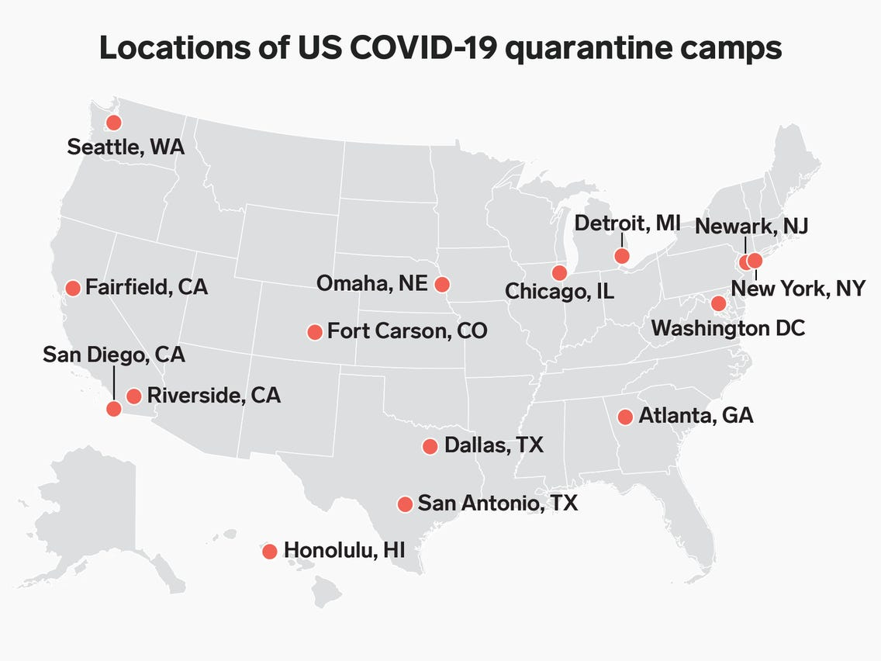

[**Via the CDC**](https://www.cdc.gov/quarantine/quarantine-stations-us.html)

“I have certain rules I live by. My first rule: I don’t believe anything the government tells me. Sooner or later the people in this country are going to realize: the government does not give a fuck about them. The government doesn’t care about you, or your children, or your rights, or your welfare, or your safety. It simply doesn’t give a fuck about you. It’s interested in its own power. That’s the only thing keeping it and expanding it wherever possible.” – **George Carlin**

In a previous article – [**Cascade of Consequences**](https://www.theburningplatform.com/2021/07/25/cascade-of-consequences/) – I attempted to make the case the ruthless billionaire oligarchs and their bought off lackey whores in government, media, academia, corporations, the military industrial complex, sickcare industry, and  Federal Reserve have used this engineered covid pandemia to further consolidate and expand their wealth, power and control over a frightened, willfully ignorant, compliant populace. In the month since that article the “powers that be” have ramped up the fear, increased their coercive mandates, reinstated mask mandates, and instituted vaccine passports in liberal bastion cities across America.

I see these ham-handed authoritarian dictates as a sign of weakness and their false narrative falling apart. A sense of desperation wafts from the halls of power in DC, corporate executive suites, and left-wing media outlets on the coasts who have overplayed their tyrannical hand. Resistance is building among an irate minority of critical thinking individuals who follow George Carlin’s first rule.

Their narrative is unraveling as everything they have avowed to be true is being revealed to be false. No matter how many truth tellers Facebook, Twitter and Youtube censor, de-platform, and suppress, there are many more stepping up and destroying their mendacious provably false plot line. Despite half the country, indoctrinated by the government education system to feel rather than think, still shuddering in fear despite being double jabbed, voluntarily locked down and masked, the global elite game plan is self-destructing under the weight of an avalanche of deceptions.

Despite an all out authoritarian fear campaign, to mandate these unproven dangerous gene therapies disguised as vaccines, orchestrated by our corrupt political class, bought off medical industry, Big Tech censorship media outlets, woke mega-corporations, cowardly universities, and left wing fake news propaganda outlets, more than 40% of the population is resisting this tyrannical medical apartheid.

This past week had a surreal quality as false narrative after false narrative was annihilated by unequivocal facts presented by a minority of truth-seeking bloggers, uncaptured doctors (Robert Malone, Pierre Kory, Martin Kuldorff), and a few remaining real journalists (Glenn Greenwald, Tucker Carlson, Alex Berenson, Joe Rogan). The mainstream media and their social media co-conspirators are nothing but highly compensated mouthpieces for the Deep State, Big Pharma, and the billionaire oligarchs calling the shots.

The resistance is coming from alternative media websites, independent bloggers, and individuals seeking the truth. Online communities of like- minded individuals are the modern-day Committees of Correspondence, as we head towards inevitable conflict. A revolution is in the offing and those trapped in their own cognitive dissonance trance, with a dash of normalcy bias, are going to be shocked out of their self-induced stupor by the suddenness and extreme violence of the push back set in motion by the power elite.

These sociopath global tyrants actually believe they can dictate and control the actions of seven billion human beings through their capture of politicians, the military, universities, corporations, the banking system, the media and now the medical industrial complex. The maniacal determination of those controlling the levers of power behind the scenes to coerce these “experimental” gene therapies upon the populations of the developed world should make any critical thinking person pause and ask why.

This flu has a 99.7% survival rate and has a fatality rate less than the annual flu for those under 21. But universities are mandating vaccination to attend their $60,000 per year woke indoctrination centers to get a degree in gender fluidity studies. Meanwhile, with vaccination rates of 98% on campuses, “cases” from the worthless recalled (as of 12/31) PCR test are surging. The Big Pharma captured vaxx cheerleaders in the medical and media industry do not allow the facts to interfere with their scripted narrative. Their solution – vaxx harder and blame those who choose to let their immune systems do their job for the “surge” in cases. Why not go with the Big Lie – it has worked so well thus far.



The truth is cases peaked in early January at 260,000 per day. Miraculously, with virtually no one vaccinated, daily cases fell by 60% in the next month to 110,000 per day. By early March, with only a 10% national vaccination rate, daily cases fell by another 40% to 64,000, down 75% from the January peak. The vaccine had absolutely nothing to do with this decline in cases. By early summer this pandemic had lost its mojo. The threat of a return to normal was unthinkable to the power elite.

Their master plan called for the vaccination of all. But less than 50% of the adult population had succumbed to the fear propaganda campaign. It was time for Biden and his controllers to turn up the heat on corporations, hospitals and universities to enforce vaccine mandates by either bribing them with Federal funds or threatening to withhold Federal funds. Money talks. The un-Constitutional demand that employees and students inject themselves with an untested chemical concoction to retain their jobs or get an education is legally, morally, and medically unethical, violating the Nuremberg Code.

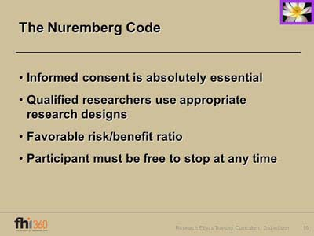

They invented their new variant – Delta – and rolled out our present-day Mengele, mass murderer Anthony Fauci, to lie, obfuscate, and instill fear in his feeble-minded worshipers. Day after day Fauci appeared on the fake news networks promoting his new variant, which many renowned doctors, including one of the inventors of the mRNA vaccines – Dr. Robert Malone, theorize has been created and made more infectious by the vaccines. Are they that diabolical or just plain stupid? Natural immunity through infection has proven to be 20x as effective as the vaccines.

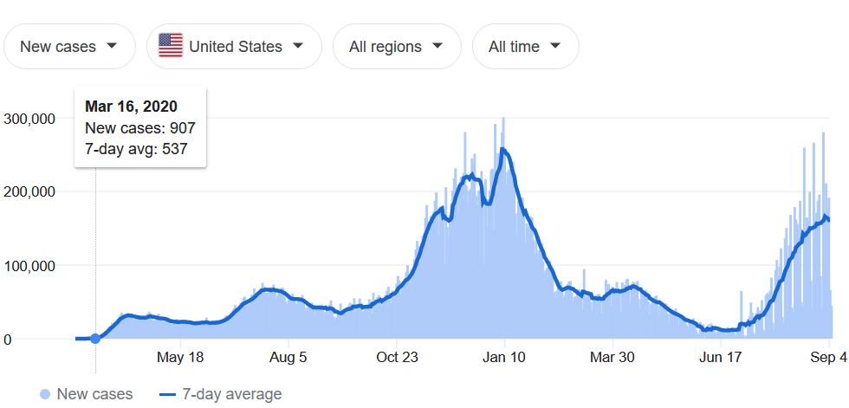

With a huge surge in testing, they were able to generate an increase in cases, but with 50% less hospitalizations and deaths, than when cases were at the same level in January. And now the cases have peaked on the same timeline as India and the UK experienced in June/July. This explains the desperate nature of their actions, as their window of opportunity is closing, and their fear narrative unravels. There are millions of people beginning to make a stand against the government and employer authoritarian mandates.

This past week has not been a good one for the purveyors of pandemia, as their story line collapses under the weight of their duplicity. The entire case for vaccinations (not the revisionist history case being made today) was they were 96% effective in keeping you from contracting the Covid virus. In January that was what we were told by the “experts” like Fauci and Walensky. They did not tout the vaccines as a way to reduce the symptoms when you still caught it, after being vaccinated.

The surge in cases was declared to be a “pandemic of the unvaccinated” in the shame campaign peddled by the fake news media and government apparatchiks spouting provable falsities. It seems Israel has become ground zero in destroying the globalist narrative. As the first country to mass vaccinate, with over 84% fully vaccinated, how could 86% of all the cases in July be among the vaxxed if the vaccinations work? And the tripe about the cases not being as severe has been destroyed, as the vaxxed are being hospitalized and dying too. Whenever you see the MSM using the term “rare” you can be sure they are lying.

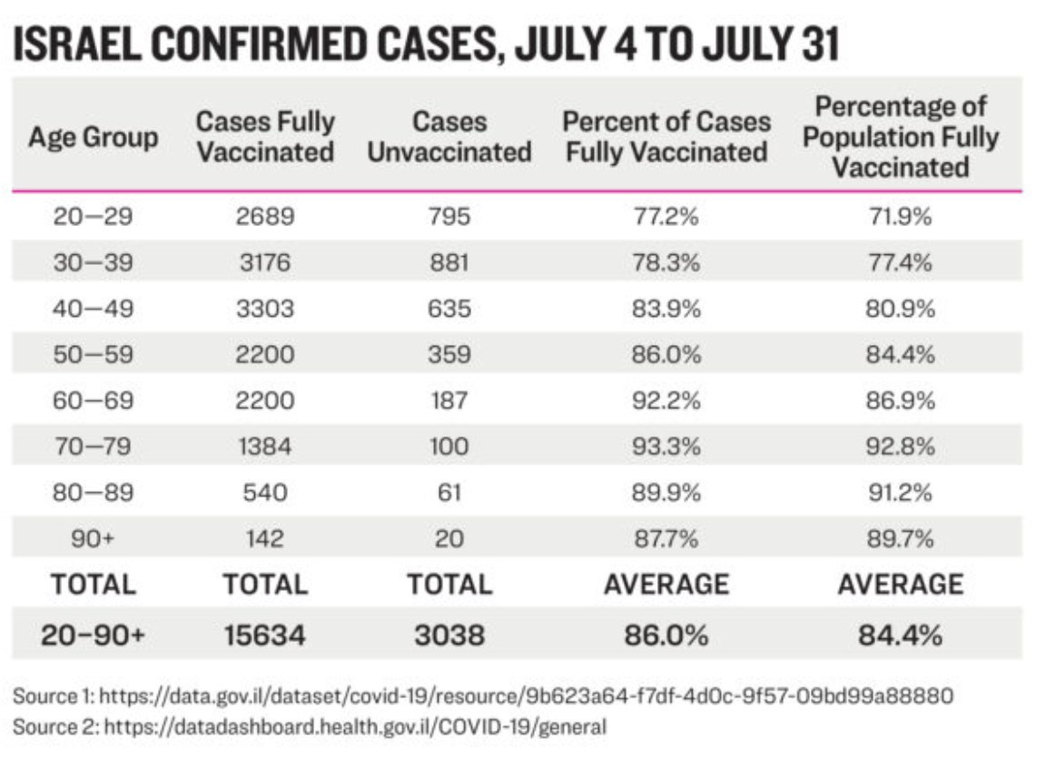

A critical thinking person might wonder which country on this chart is fully vaxxed and which country has very few vaxxed, but distributed ivermectin in mass quantities. The powers that be do not want people to see this chart. If it is posted on Twitter or Facebook, the odds of a permanent ban are high. Facts and truth are treason in an empire of lies.

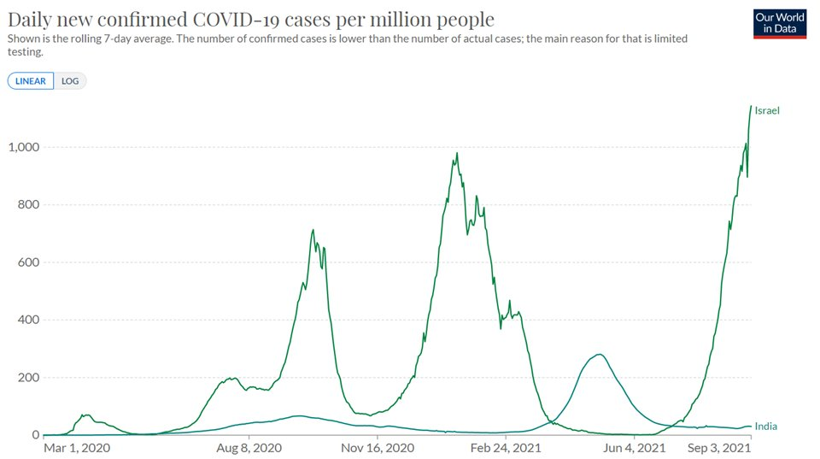

If you really want to make a vaxx proponent’s head explode, bring up the country that did the opposite of the Soros, Gates, Schwab authoritarian lockdown formula – black sheep Sweden. They never locked down. They never mandated masks. They never closed schools. They never closed businesses. They have not pushed vaccines on those who choose not to vaccinate.

Cases in Israel with mask mandates and vaccine passports are 1,191% higher than Sweden where no one is wearing masks and there are no vaccine passports. How inconvenient to the establishment narrative. Since they can’t deny these facts, they just don’t allow Sweden and India to be discussed. Silence is complicity.

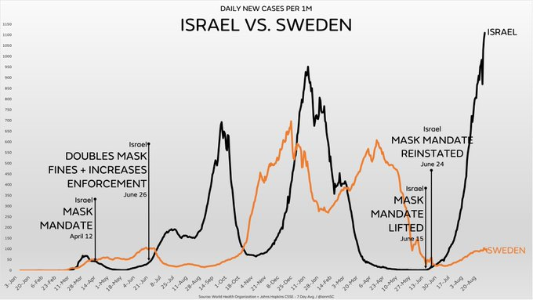

The Joe Rogan saga has again shattered their plot line of the covidian cultists. He had infuriated them previously by telling his young audience they don’t need to be vaccinated. Their survival rate is 99.9975%. The cost/benefit analysis clearly comes down on the side of not getting vaxxed. The fifty-four-year-old un-vaxxed Rogan caught covid and treated himself with monoclonal antibodies, ivermectin, Z-Pak, prednisone, an NAD drip, and a vitamin D drip. He fully recovered in three days.

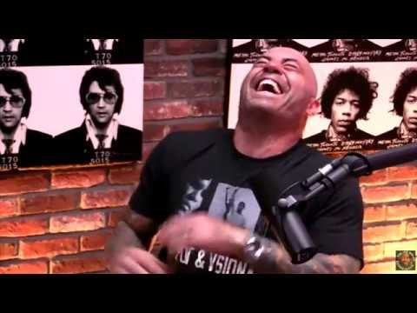

This was after a full-court press of misinformation from the FDA, Big Pharma media whores, and Silicon Valley censorship police about ivermectin being a dangerous cow and horse medicine. Despite this safe, life saving drug being used by humans for decades and winning a Nobel prize in medicine for its inventor in 2015, it had to be discredited in order to keep the vaccine train chugging along. The 63 studies proving its efficacy in drastically reducing the impact of covid had to be demeaned and derided. When you see this level of vitriol, you know the opposite must be true – time to buy as much ivermectin as you can.

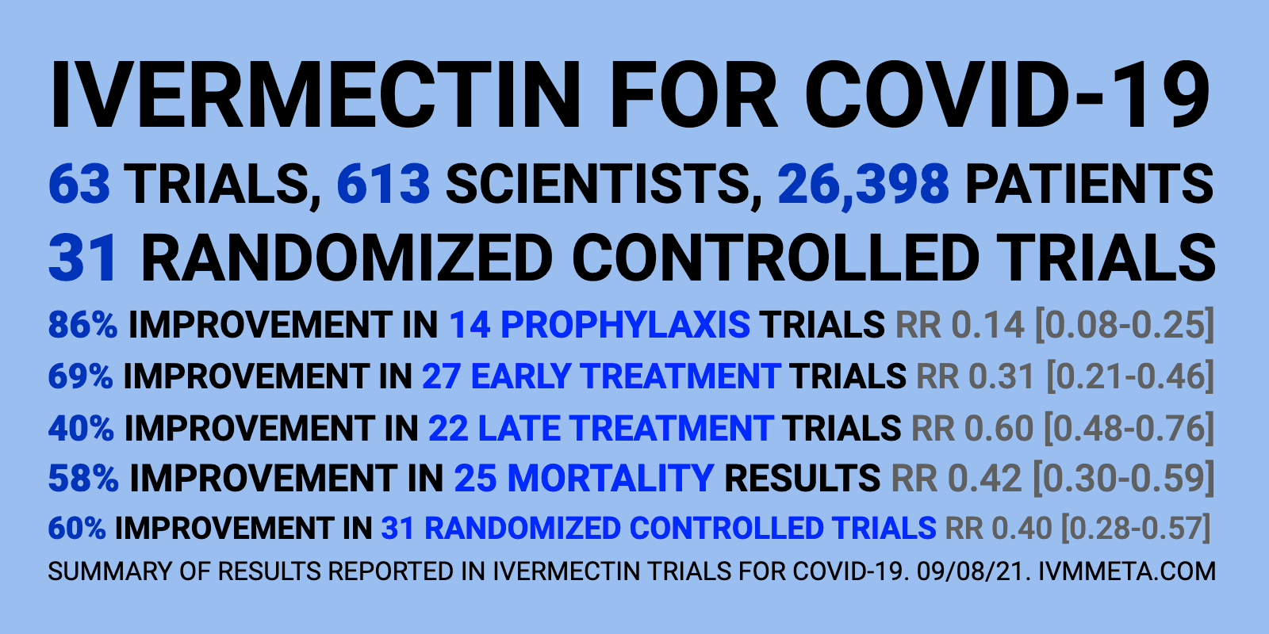

The only thing that infuriates a vaxx disciple more than Sweden or Joe Rogan is the name Ron DeSantis. He has continuously pushed back on the covid fear narrative, telling Fauci and Biden to shove their mandate bullshit and masking of children with no danger from covid. They were cheering on the surge in cases, praying for a mass casualty event in Florida to discredit DeSantis, as he appears to be the front runner in the 2024 presidential race against Kackling Kamala.

Oops. It seems cases in Florida are crashing, down almost 50% in three weeks. There goes the Deathsantis memes on twitter. The lefty control freaks are in a full, frothing at the mouth, frenzy of hate reminiscent of Orwell’s Two Minutes Hate in which they vent their existential anguish and personal hatreds towards their politically expedient enemies – the un-vaxxed. Meanwhile, in the leftist bastions of Oregon and Hawaii, with high vaccination rates and mandatory masking, cases are soaring to all-time highs. You don’t hear that news from Maddow or Acosta.

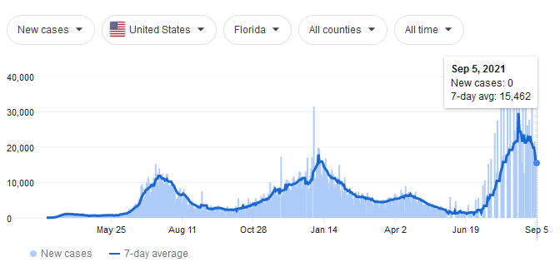

Now universities are back in session, with 95% or more of their campuses vaccinated, and cases are exploding higher than last year at this same time. How could this be if vaccines work? The vaxx nazis are losing the high ground rapidly. The vaccines do not keep you from contracting covid. They do not keep you from spreading covid. They do not reduce the viral load if you get covid. They don’t keep you from being hospitalized from covid. They don’t even ensure you will not die from covid.

As the narrative police like to say, it is rare that a vaxxed person dies from covid or the vaccine. It is rare to have an adverse reaction to the jab. Of course, there have been more deaths and adverse reactions to these vaccines in eight months than all vaccines combined in the last forty years. So there is that.

The last I checked it was rare to die from covid, unless you are really old and already sick with some other fatal ailment. Only 6% of all the covid deaths were from covid alone. I would classify 40,000 deaths in a population of 330 million to be pretty rare, and by any reasonable assessment should not have invoked a planetary lockdown and mass vaccination of billions of people.

This war on covid is no different than our previous war on poverty, war on drugs, and war on terrorism. All they do is give government more power over our lives, restrict our freedoms, strip our liberties, and abscond with more of our hard-earned dollars. As Orwell foresaw, these wars are never meant to be won, just as Big Pharma never wants to cure any disease.

*“The war is not meant to be won;* ***it is meant to be continuous****. Hierarchical society is only possible on the basis of poverty and ignorance. … The war is waged by the ruling group against its own subjects and its object is not the victory over either Eurasia or East Asia, but to keep the very structure of society intact.”* **– Orwell – 1984**



This war on covid will never end. Thereare a myriad of Greek letters once they have milked Delta dry. Personally, I can’t hear Delta and not be reminded of Animal House and Dean Wormer telling Flounder “Fat, drunk and stupid is no way to go through life, son.” If I could give advice to the millions of people who have been deceived by this eighteen-month exercise in dictatorial government tyranny by paraphrasing Dean Wormer, it would be, “Fearful, deluded and willfully ignorant is no way to go through life, people.”

We are approaching a point of no return. If we don’t resist now, we may never get another chance. As the authorities push the limits of their power and trash what remains of our Constitution, we should heed the words of Aleksandr Solzhenitsyn:

*“And how we burned in the camps later, thinking: What would things have been like if every Security operative, when he went out at night to make an arrest, had been uncertain whether he would return alive and had to say good-bye to his family?”*

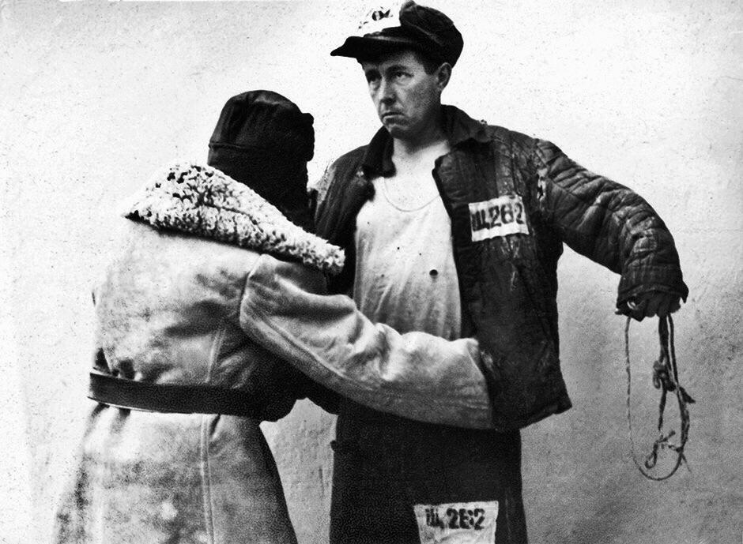

Fauci is already prepping the ignorant masses for the double deadly, extra potent, vaccine resistant Mu variant. They are already doing focus group studies to best scare the bejeezus out of the most people. They must keep the vaccine machine rolling. But why? What is their end game? Australia and New Zealand appear to be the testing ground for turning countries into techno-pharma gulags where you will get your quarterly booster and like it – or else.

This concocted global health scare over a relatively non-lethal virus has been used to destroy our existing economic system and replace it with a Fed created digital currency, universal basic income for the plebs, mandatory bio-surveillance by Big Tech on behalf of the government surveillance state, a Chinese-like social credit system based on your willingness to do as you are told, and a never ending stream of obscene profits for Big Pharma and the oligarchs pulling the levers. You will own nothing, cower in fear, obey, consume and be happy. This is the inconvenient truth, but I already know most will line up for their jabs and the reassuring lies of their masters.

I suppose myself and a few others will stay in the inconvenient truth line until this mass deception and a financial system, built on a foundation of sand as a hurricane approaches, suddenly collapses, because an unsustainable system will not be sustained. I’m not a team player. I don’t follow the crowd. I have a funny thing I do. I think for myself. I invoke Carlin’s first rule and add a second rule.

I don’t believe anything my government says and I never believe anything emanating from the talking heads and vacuous bimbos pretending to be journalists in the legacy corporate media. By disregarding everything these propagandizers spout, I am able to maintain my independence, individuality, and integrity.

*“I don’t like ass kissers, flag wavers, or team players. I like people who buck the system. Individualists. I often warn people: Somewhere along the way, someone is going to tell you: ‘There is no I in team.’ What you should tell them is: ‘Maybe not. But there is an I in independence, individuality, and integrity.’”* **– George Carlin**

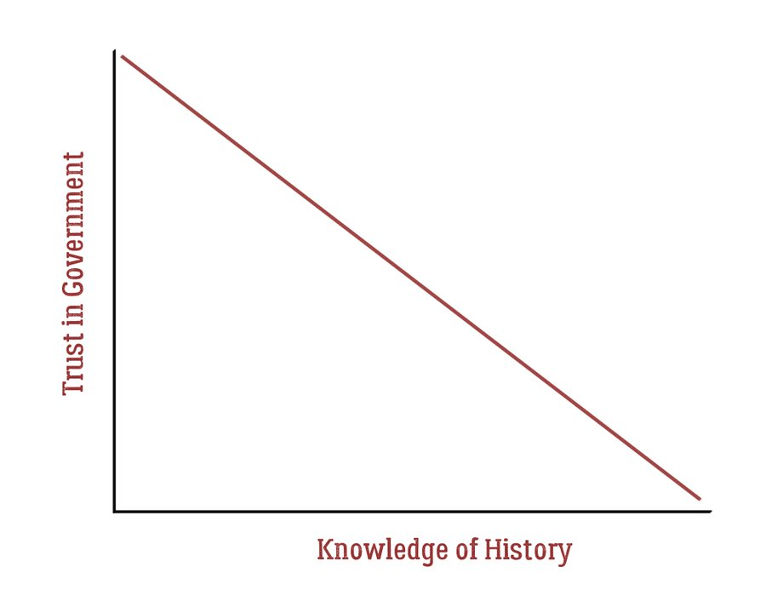

*“Political correctness is America’s newest form of intolerance, and it is especially pernicious because it comes disguised as tolerance. It presents itself as fairness yet attempts to restrict and control people’s language with strict codes and rigid rules. I’m not sure that’s the way to fight discrimination. I’m not sure silencing people or forcing them to alter their speech is the best method for solving problems that go much deeper than speech.”* **– George Carlin**

Everything that has reared its ugly head in the last two years, from this covid scheme to force injections into every human being, to the woke mantra being forced down our throats by Hollywood weirdos, to BLM and Antifa terrorists being loosed on our streets, to a presidential election being stolen through the collusion of the Deep State and Big Tech, to the anti-racist lies being peddled to school children, to gender misinformation and glorification of the abnormal and freaks of society, to a military purging itself of normal white males, to demolishing nation states and replacing them with globalist rule, has been part of a larger plan.

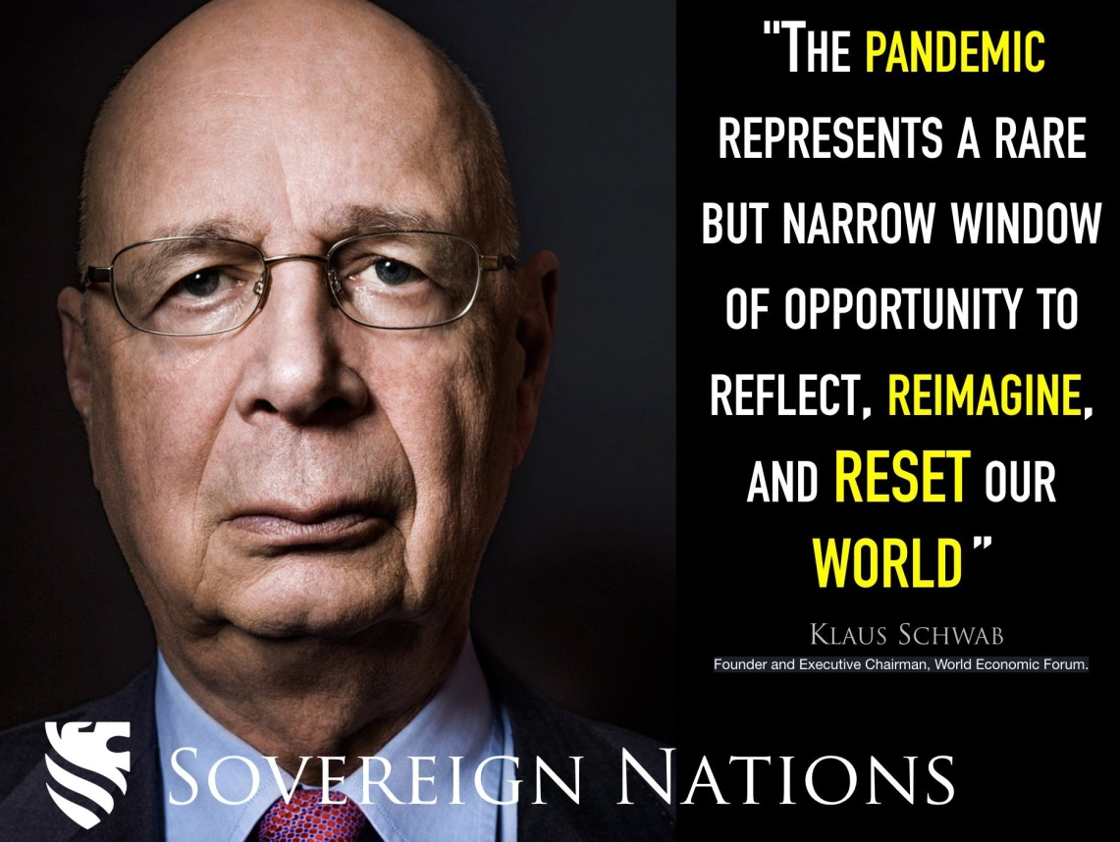

The Great Reset is real. They want to tear our society apart to build it back into a dystopian techno-gulag where the few rule over the many. We will not vote our way out of this. Saying just wait until 2022 or 2024 elections is delusional thinking.

I’m not sure how these vaccines play into the broader plan, but when a sociopath like Gates, who has pushed for global population control for decades, is the leading proponent and funder of these vaccines, you should be concerned. Several prominent physicians have hypothesized that ADE (Anti-body Dependent Enhancement) will negatively impact the health of the vaxxed this Fall, as they enhance new variants and create stronger respiratory diseases. We shall see. Stay tuned.

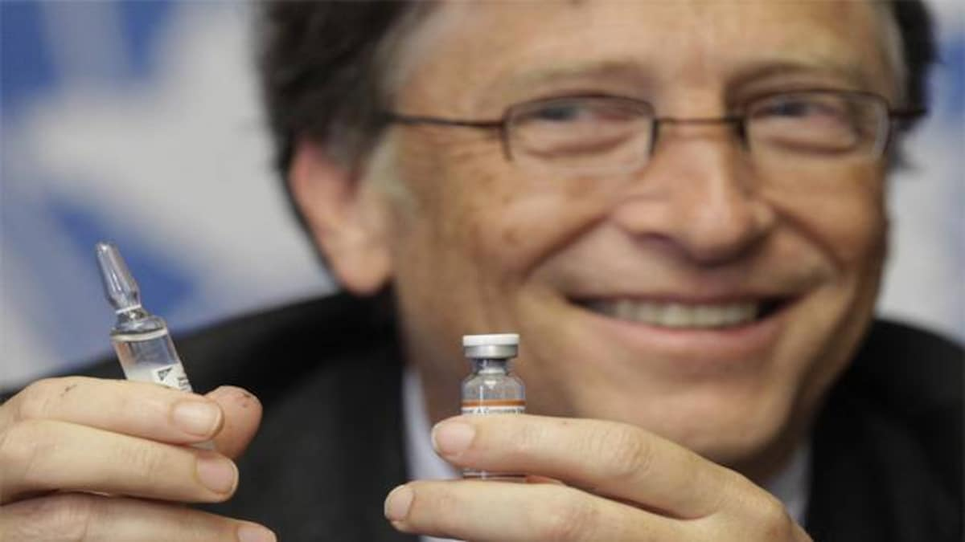

With inflation now raging out of control in a “transitory” manner, financial markets stretched to the outer limits, debt being created by the Fed and US Treasury at a rate of $350 million per hour, and Congress about to ramp up spending at hyper-speed, a financial crisis of epic proportions looms like storm clouds on the horizon. I see no way out of the predicament we’ve allowed ourselves to create. I don’t see how this teetering edifice of debt, deceit and delusion holds together until the 2022 mid-term elections.

Yeats Second Coming has arrived. Things are falling apart, the center cannot hold, and anarchy will be loosed upon the world. They have planted seeds of discontent and will reap a whirlwind of unintended consequences. A malevolent darkness envelopes our world. I am haunted by the possible dire outcomes of this Fourth Turning. We can’t let the sociopaths destroy our world.



*“As the Crisis catalyzes, these fears will rush to the surface, jagged and exposed. Distrustful of some things, individuals will feel that their survival requires them to distrust more things. This behavior could cascade into a sudden downward spiral, an implosion of societal trust. If so, this implosion will strike financial markets—and, with that, the economy.”*

*“This Fourth Turning could mark the end of man. It could be an omnicidal Armageddon, destroying everything, leaving nothing. If mankind ever extinguishes itself, this will probably happen when its dominant civilization triggers a Fourth Turning that ends horribly. For this Fourth Turning to put an end to all this would require an extremely unlikely blend of social disaster, human malevolence, technological perfection, and bad luck.” –* **Strauss & Howe – The Fourth Turning**

-----------------------------------------------------  
The corrupt establishment will do anything to suppress sites like the Burning Platform from revealing the truth. The corporate media does this by demonetizing sites like mine by blackballing the site from advertising revenue. If you get value from this site, please keep it running with a donation. [Burning Platform LLC - PO Box 1520 Kulpsville, PA 19443] or Paypal

Top of Form

Bottom of Form

[***Emigrate While You Still Can!***](https://www.fincabayano.net/1_emigration/introduction/)

You Might Also Like