**We Don't Have Amnesia, So You Won't Have Your Amnesty!**

by Ray Jason - Wednesday, November 2, 2022

[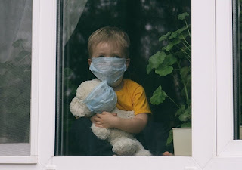](https://blogger.googleusercontent.com/img/b/R29vZ2xl/AVvXsEhHpu8LojegIOVcWnosJPWQshK_ao3dWE_sGnD-oBkIYJH_5qB1JQphjhVDp3F3BFl163qlzclzU5Wy3Q_wGM77ovcv9aOjNATooSTgG_zk-QtctSG7_kt2zHSi9ExgDqsc_3gwhsjZNI0jzSJN3NS5IL7krEFryAZSqV6J1pEn2vFxD5akmr38DUF6/s1000/SAD%20COVID%20CHILD%20(2).jpg)

This is my response to the recent article in THE ATLANTIC magazine entitled “Let’s Declare a Pandemic Amnesty.” I have a superior idea. Let’s arrest, try and prosecute those who committed Crimes against Decency, Common Sense and Humanity.

The essay is written by Emily Oster, who most definitely was not an innocent bystander during the WuFlu Paranoia Op. In fact, she might easily qualify for the Obnoxious Karen Hall of Fame. In her Twitter comments she sounds like a kindergarten teacher scolding us for breaking our crayons. Here are some examples:

“*I think governors should consider a short term lock-down over Thanksgiving week”*

*“If you’re pregnant and un-vaccinated, get vaccinated.”*

*“Maybe vaccine requirements for things you want to do – domestic air/train travel, work, sports events. Yes.”*

But she would prefer that these tweets disappear down the Memory Hole. That’s because her motivation in writing this essay is not to make a heart-felt confession that could lead to societal healing. Her actual desire is to … **cover her ass!**

And since THE ATLANTIC magazine is a mouthpiece for our ruling elites, who I prefer to call our **Malignant** **Overlords**, my guess is that Ms. Oster’s article was also a trial balloon to see how easy it might be for them to escape the Jaws of Justice.

Their hope is that we, the regular folk, have somehow forgotten the evil lies and commandments that they rained down upon us for over two years. **But we do not have amnesia – and there will be no amnesty.** Because forgiveness without justice is appeasement! And that just leads to further crimes by the predatory class.

**WE VIVIDLY REMEMBER**

We have not forgotten what you did to us because of a virus with about a 99% survival rate. We clearly remember the bogus PCR tests and the stupid masks that might stop an olive – but would never stop a microscopic virus particle.

We know that you violated hundreds of years of contagious disease protocols, when you locked down the healthy instead of quarantining the sick. And when you would not allow us to go outdoors and receive the healing power of vitamin D in the sunlight.

We recall vividly the crimes you committed against our children. How could we forget that you isolated them from their playmates, and made them fear each other as contagious disease carriers. We look at the clear decline in cognitive ability that they have suffered, and we know that you caused this.

Nor have we forgotten how you treated our elderly, even as you maliciously called **us** the Granny Killers. Our images of them having to die alone and terrified, because of a disease no worse than the flu, have not been erased.

Surely, we will never forget the scorn you heaped upon us for questioning whether the disease was as virulent as you insisted. And we know – yes we **know** - that there were thousands of courageous doctors and virologists and common sense skeptics that took to the internet watch-towers and tried to shout out warnings. But you shamed and silenced their messages. In many cases you ruined their lives to make an example of them.

And we will never forget how you tore apart our communities. How so many mom-and-pop stores were ordered closed and could never re-open. And this while the big box chain stores reaped record profits because they were allowed to stay open.

Plus we recall what you did to the family unit. Suicide rates sky-rocketed as did domestic violence, alcoholism, drug abuse and overdoses. You shredded the cornerstones of society.

It did not escape our notice that the areas that locked down their people the most, also had the highest fatality rates. And we certainly noticed that even as you screamed that the hospitals were over-flowing, the internet was overflowing with nurses dancing in Tik Tok videos.

**THIS TOO WE REMEMBER**

There were many of us who recognized early on that all of the horrors of this “Pandemic” were not due to bad planning, they were due to **precise planning.**

The entire emergency was a scam designed to steer us into a Worldwide Bio-Medical Tyranny. Look at who the dominant players in the fraud were:

At the top is the U.N. through the World Health Organization. Tedros, its leader, is noteworthy for at least two ironic reasons. He is not a doctor. And his home country of Ethiopia is hardly a gleaming beacon of hygiene and health.

Just below them is the World Economic Forum, that envisions a future where you will “Own nothing and be happy.” Their leader is Klaus Schwab, who could easily be cast as the megalomaniac villain in any B movie. His true desire is to turn you into an Android Serf.

Then there is the American medical bureaucracy, which includes the CDC, the NIH and the FDA. Anthony Fauci is the high potentate of this Octopus of Ill Health. As the Mesmerizer-in-chief, this grand deceiver should fear the Jaws of Justice more than anyone.

Surely, we cannot exclude Bill Gates and his foundation that spreads lies and disease to almost every continent. His “philanthropy” is banned from several countries because of the grim results of his “helpfulness.”

**THE MOST ENDURING MEMORY**

I have saved our memories of the Covid “vaccines” for the end of this essay. That’s because we won’t just remember the Clot Shot, but will actually be suffering the consequences of it through either disease or death for many years.

We will not forget your lies claiming that you “could not get Covid” if you were vaccinated. And your false statements that you cannot “transmit it” if vaxxed up, have not faded away as you wish they would.

And don’t expect us to ever forget how many people suffered under vaccine mandates. We could not travel. We could not go to restaurants or gyms. And we lost our jobs and the means to support our families.

Nor will we ever forget the side effects. The online videos of people’s bodies shaking uncontrollably and constantly. The needle sites on the shoulder that became magnetized. The ugly facial distortions caused by Bell’s Palsey.

And above all, we will not forget **the death.** The young athletes in peak health falling down dead on playing fields. The many victims who died while still in the vaccine administration centers. The cancers tearing through bodies far faster than ever before. The huge rise in all-cause mortality.

We **will not forget** what you did to us. And we **will not forgive** what you did to us

In conclusion, Emily, here is my suggestion to you.

Stand in front of your college classes and sincerely apologize to them for the part you played in supporting this atrocity. Then do your best to see to it that the real masterminds of this evil have their day in court and after that … **their dose of justice.**

~ fin ~

**MY FIRST BOOK - lots of fun!**

[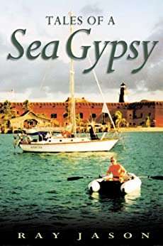](https://www.amazon.com/Tales-Sea-Gypsy-Ray-Jason-ebook/dp/B004C447PE/ref=sr_1_1?dchild=1&keywords=Tales+of+a+Sea+Gypsy&qid=1589299639&sr=8-1http://)  
in both paper and e-book

[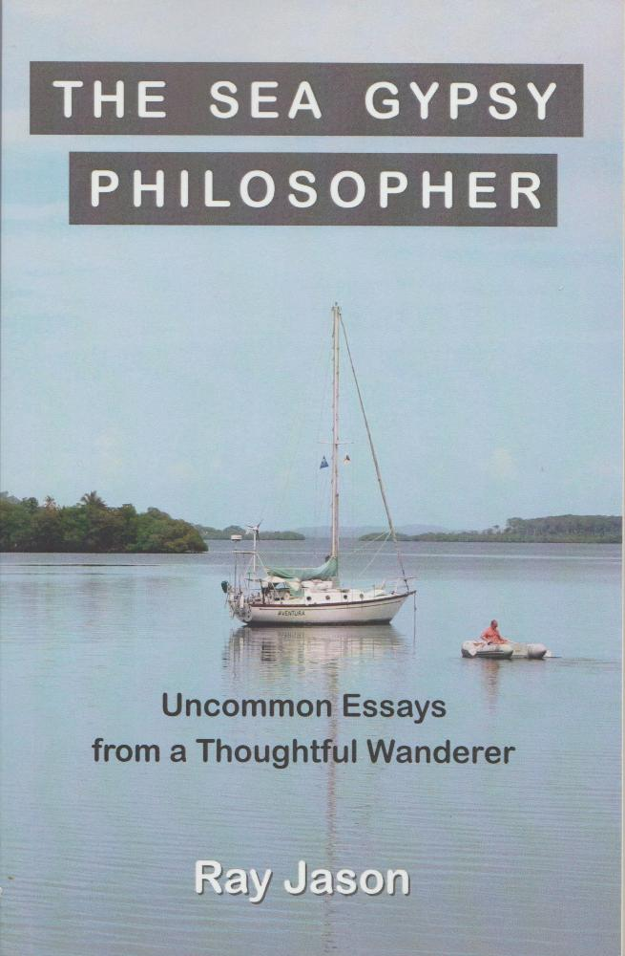](http://www.amazon.com/Sea-Gypsy-Philosopher-Uncommon-Thoughtful-ebook/dp/B01AATDVYC)

**AVENTURA at anchor**



**AVENTURA'S INTERIOR**



**AVENTURA under way**

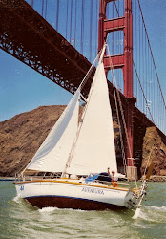

**AVENTURA'S lovely lines**



**RAY JASON**

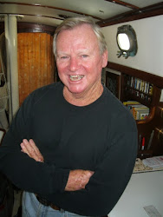

I live aboard my beautiful sailboat, AVENTURA, and wander the wide waters as an itinerant philosopher. My life is simple, free and joyous.