**12 Essentials We Love Using**



**Frankincense**

Rejuvenates skin and helps reduce the visible appearance of skin imperfections, promotes feelings of peace and wellbeing, balances mood and supports healthy cellular functioning.

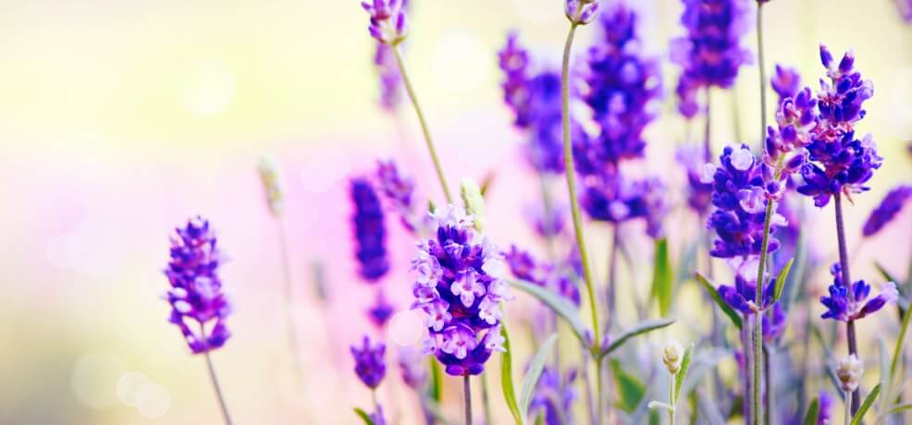

**LAVENDER**

Has been clinically shown to improve sleep quality through inhalation, promotes feelings of relaxation & peaceful rest, soothes the skin, eases tension with its calming aroma.

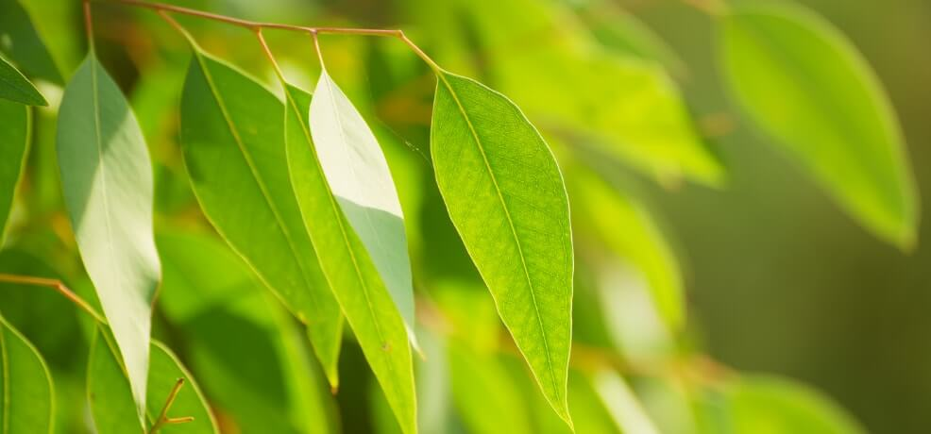

**EUCALYPTUS**

Revitalizes the skin, invigorates the senses, promotes feelings of relaxation and peace, supports clearing of nasal passages for healthy breathing, freshens the breath.

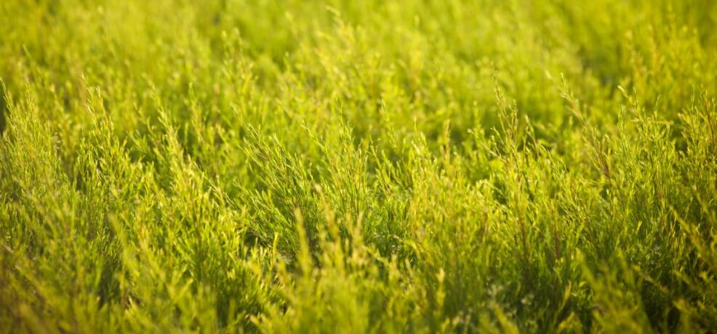

**TEA TREE (MALALEUCA)**

Acts as a natural skin cleanser, soothes and supports healthy-looking skin, provides a cooling effect, purifies the air, and is perfect for homemade cleaning solutions.

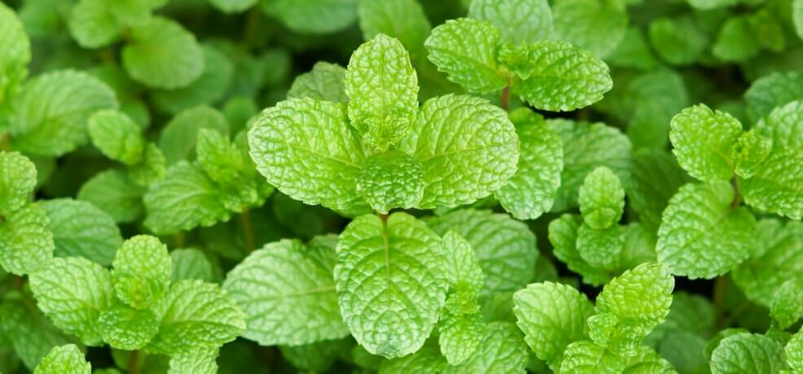

**PEPPERMINT**

Invigorates the senses, boosts mood, freshens breath, soothes the digestive system.

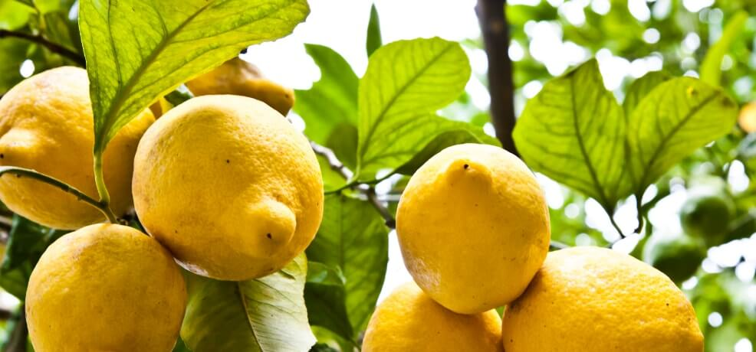

**LEMON**

Reduces the visible appearance of blemishes, calms tension with its soothing scent, promotes vitality and boosts energy. Serves as a non-toxic cleaning solution to purify the home.

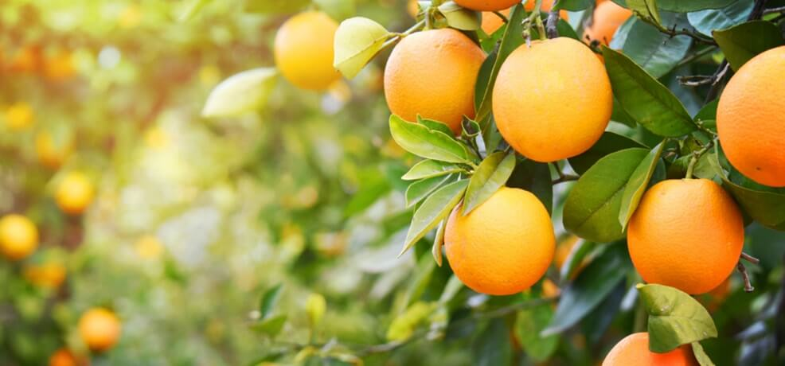

**ORANGE**

Makes the perfect addition to homemade cleaning solutions, freshens the air, uplifts mood, revitalizes energy levels and maximizes skin’s radiant appearance.

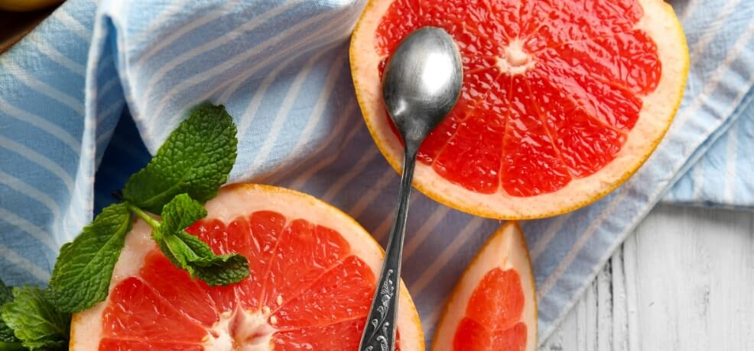

**PINK GRAPEFRUIT**

Cleanses & purifies the skin, reduces the visible appearance and signs of blemishes, invigorates the senses, stimulates clear thinking, promotes vitality and boosts energy. Non-toxic cleaning solution to purify the home.

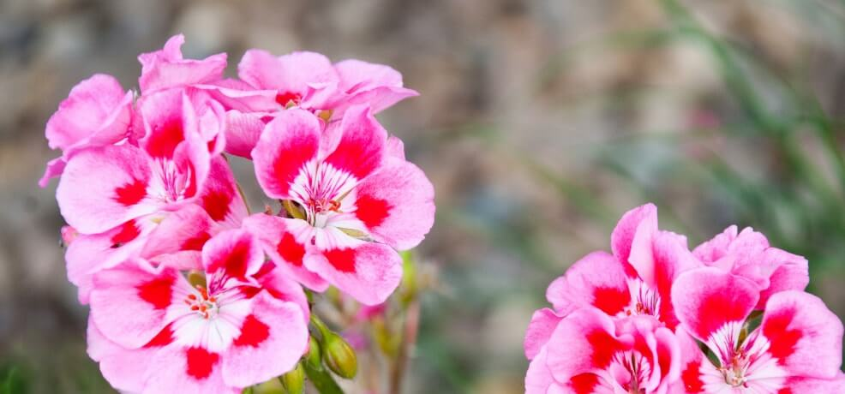

**GERANIUM ROSE**

Beautifies the skin, promotes healthy-looking hair and skin, calms the nervous system.

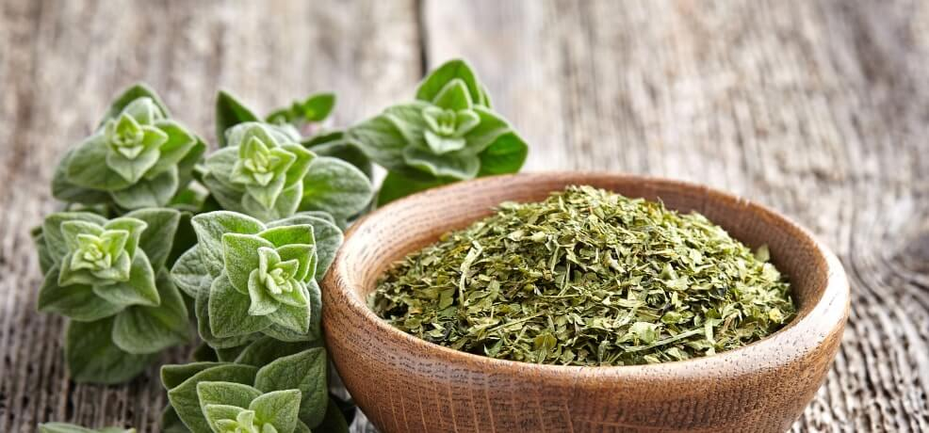

**OREGANO**

Possesses powerful antioxidant, antifungal and antibacterial properties. Purifies the home, and is antiparasitic and antiviral.

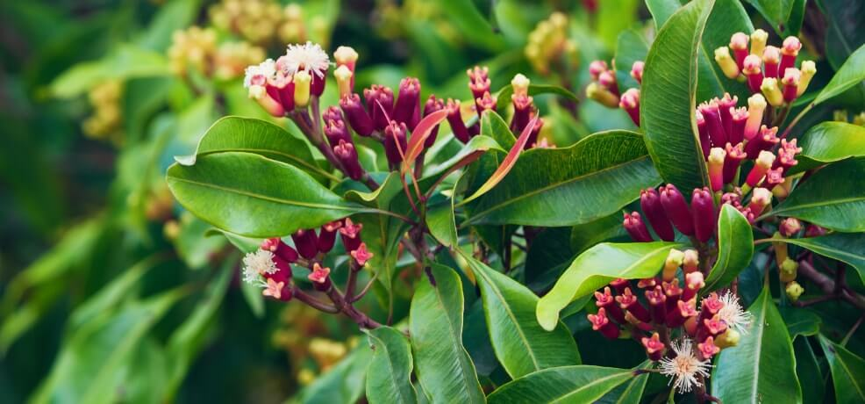

**CLOVE**

Freshens the breath, cleanses the mouth, contains natural antioxidants, improves blood circulation, natural anti-inflammatory, kills mold and fungus.

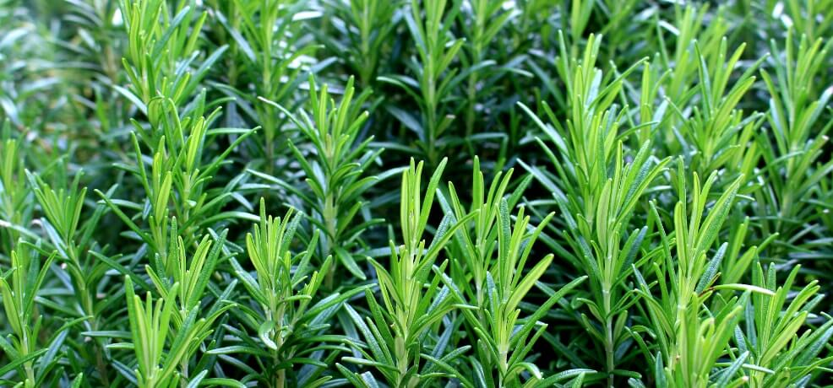

**ROSEMARY**

Energizes the body and mind, reduces nervous tension with its calming properties, promotes hair growth, improves memory.

**5 Essential Oils We Can't Live Without**

And 5 Oils You Can Easily Start Using Today!

**Frankincense**

A powerful essential oil that can affect you neurologically making it a powerful essential oil for meditation. It’s also fantastic topically on the skin, known for it’s strong healing and anti-aging properties. If meditation & stress reduction is important for you, this is one of the oils you’ll want to use daily.

**Eucalyptus (Melaleuca)**

This is a great oil for opening the respiratory tract. If you’ve been suffering from a cold and feeling really congested, this oil will help clear that congestion. Just place a few drops in a bowl with hot water, put a towel over your head and the bowl, and breathe in. Also great for brain fog and has antiviral properties.

**Peppermint**

Peppermint essential oil is great for improving your mood, clarity and mental focus. Just inhaling the smell of this oil can instantly help you achieve this. It’s also really great for helping to improve the uptake of oxygen in the body. Makes a wonderful natural breath freshener that will help stimulate your digestive system.

**Lavender**

One of the most popular oils globally. Great for calming and destressing the body! We love using it in baths, topically with a carrier oil and diffusing it in Hugo’s room just before bedtime.

**Tea Tree**

Derived from a native Australian plant, this is one of the most powerful antiseptic, antifungal, and immune boosting essential oils. A great one to have in your natural medicine cabinet. We also love using this in homemade cleaning products.