12 of Nature’s Most Beneficial Essential Oils Available in Their Purest State Like Never Before

When the creators of Epigenetics Essential Oils started their journey, they knew the long, labor-intensive process required to meet their standards would force them to choose a collection of the most popular, beneficial oils for the very first release of their line. So after months spent researching customer needs, vetting suppliers, and testing manufacturing methods, they decided on 12 types of oils to produce using their groundbreaking process.

Remember, each of these oils are:

* From 100% Certified USDA Organic plants and manufacturing processes, seed to bottle
* Non-GMO and compliant with ultra-strict purity standards
* Made with indigenously sourced plants retrieved from the world’s best sources, no matter how remote

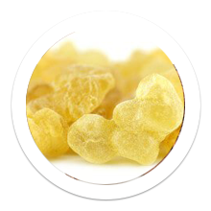

**Frankincense**

Pure frankincense was treasured by the ancients and considered to be worth its weight in gold. Now you can experience it in its purest form:

* Potent balancer of inflammation,6 which many researchers now believe to be the trigger behind most, if not all, chronic disease.7
* Witnessed in clinical studies to potentially reverse effects of aging on the skin.8
* Great addition to any oral hygiene regimen†

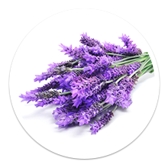

**Lavender Maillette**

Widely known for its enchanting fragrance, lavender possesses a wide range of additional benefits aside from being a pleasant natural air freshener:

* Clinically shown to improve sleep quality through inhalation9
* Witnessed in studies to close wounds faster and stimulate healing10
* Soothes skin abrasions and irritation†

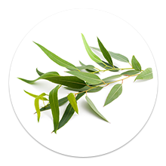

**Eucalyptus**

The natural compounds in eucalyptus that give it such a distinct and soothing smell make it useful for several therapeutic purposes:

* Shown to assist in clearing excess mucus and congestion11
* Supports the lungs†
* Fosters better overall sinus and upper respiratory health†

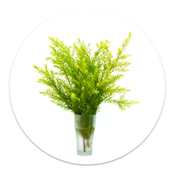

**Tea Tree (Melaleuca)**

Used as a medicinal extract for centuries, millions keep tea tree oil as a medicine cabinet staple for its numerous uses and benefits:

* Acts as natural anti-bacterial, anti-fungal, and anti-viral agent12
* Aids skin healing13
* Possesses anti-skin cancer properties14

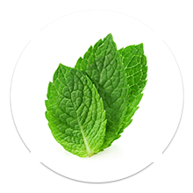

**Peppermint**

Beloved for its cooling, and refreshing nature, peppermint has dozens of applications:

* Serves as drug-free headache remedy15
* Provides healthy digestion support†
* Can be applied topically to sore muscles†

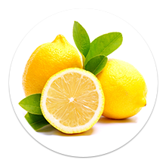

**Lemon**

Derived straight from fresh, organic lemon peel, essential lemon oil is a powerful therapeutic tool with a variety of uses:

* Contains D-Limonene, a clinically proven anti-cancer agent.16
* Encourages lymphatic health†
* Supports a healthy immune response†

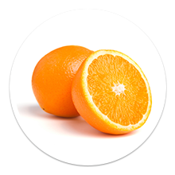

**Orange**

The power of citrus fruits lie in their peel where the majority of their active compounds reside. Pure essential orange oil from organic peel is:

* Perfect addition to homemade cleaning solutions
* Potent antioxidant support†
* Encourages a healthy immune system†

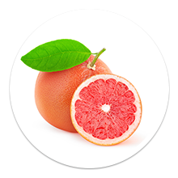

**Grapefruit Pink**

Yet another botanical treasure from the citrus fruit family, grapefruit possesses a whole host of benefits as an essential oil:

* Supports a healthy metabolism†
* Blood sugar support†
* Offers lymphatic cleansing support†



**Geranium Rose**

Aside from its beautiful flowers, geranium is a powerful tool when distilled into essential oil:

* Amazing alternative to chemical bug sprays. One study found it to repel 90% of ticks!17
* Stress support†
* Promotes healthy hair and skin†

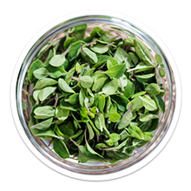

**Oregano**

Although it may not taste like it, oregano is actually a member of the mint family. And just like its cousin, it has some amazing abilities:

* Powerful promoter of a healthy immune system†
* Natural anti-microbial and anti-fungal†
* Allergy support

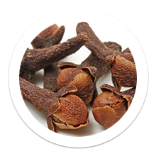

**Clove**

While you might associate clove with the smell and taste of holiday food and drink, clove oil actually has health benefits too:

* Researched as a viable oral anesthetic18
* Encourages overall mouth health†
* Natural anti-microbial†

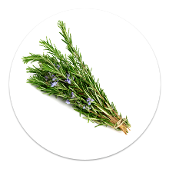

**Rosemary**

Used in many traditional cuisines, rosemary is good for a lot more than flavoring:

* Natural anti-inflammatory†
* Encourages healthy hair and skin†
* Promotes relaxation†

And these are just a few of the thousands of uses for these natural treasures!

*CAUTION: Certain oils can be used internally and others cannot. Certain essential oils suitable for adults are not healthy for children. In-depth questions about internal dosage should be directed to a qualified nutritionist or physician. The following essential oils should never be taken internally: anise, basil, fennel, hyssop, pine, cypress, arborvitae, birch, cedarwood, eucalyptus, white fir and wintergreen.