Container size – liquid conversion

There are approximately 85 drops in a 5-ml bottle

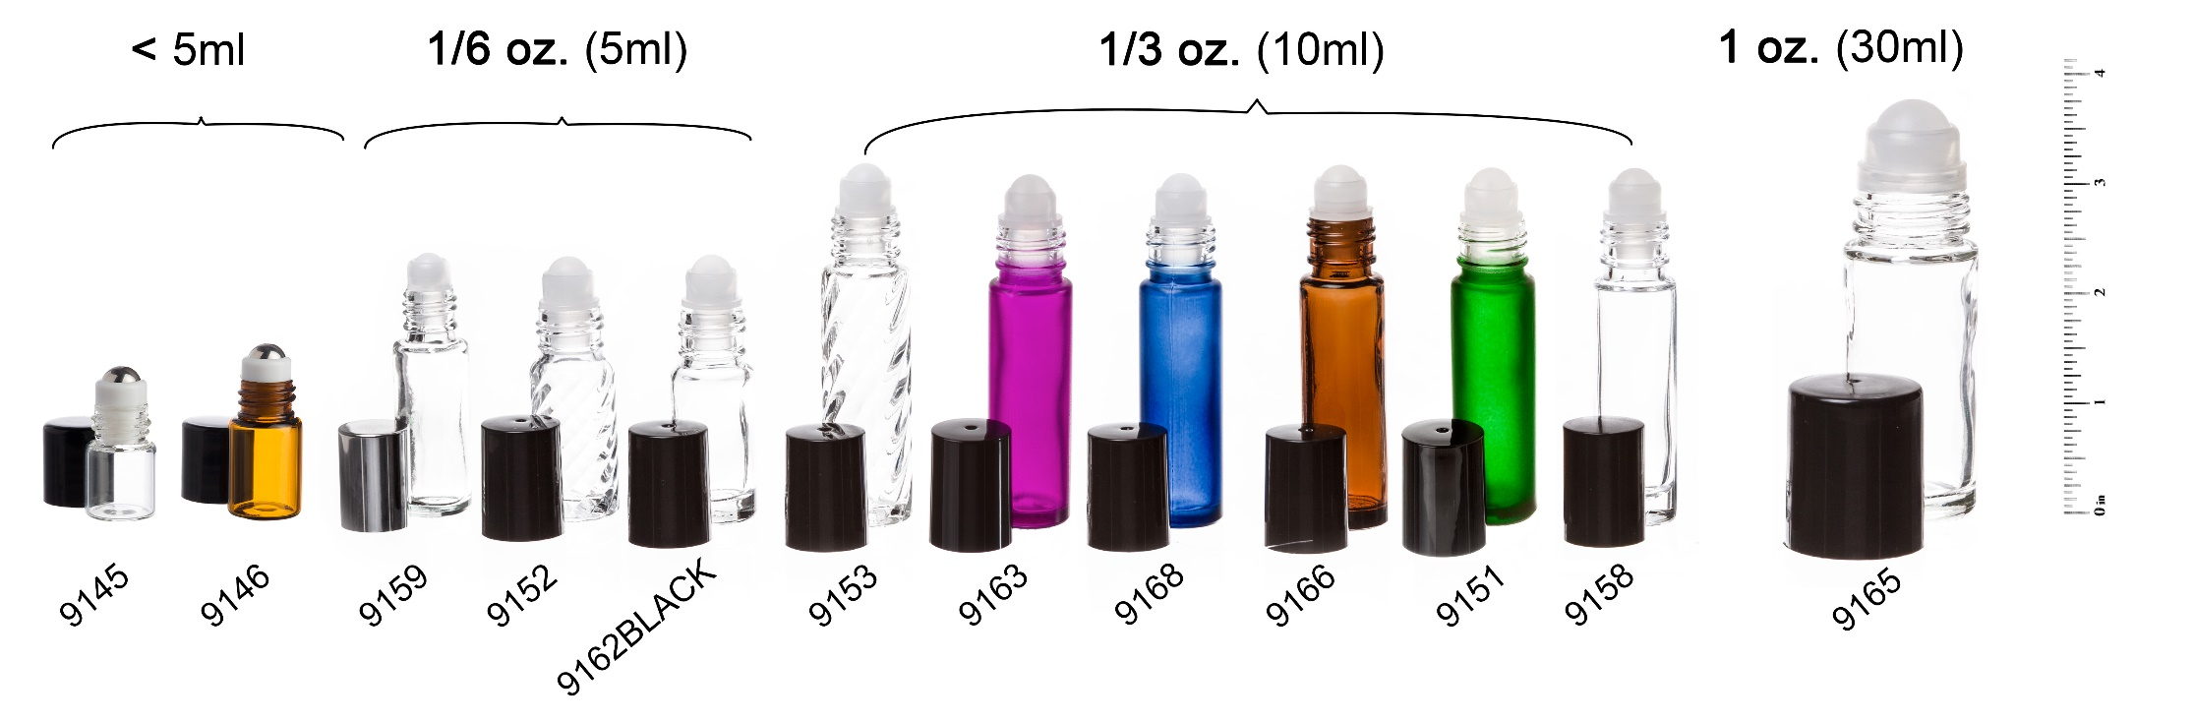

Learn more about the basics of creating blends in roll-on bottles, including: which carrier oils are best to use, recommended dilution oils, which essential oils to use, and step by step directions on how to create your own blend. This article also includes some great roll-on blend recipe ideas!

Young Living’s essential oils do not expire and will maintain their integrity, efficacy, and beneficial properties virtually indefinitely, provided they are stored properly in a dark-glass bottle, upright and tightly sealed, out of sunlight, and in cool temperatures.

The cracks in essential oil bottle lids can be caused by turning the lid too much and repeated flexing from opening and closing the lids. Some oils may also cause the plastic in the lids to soften, which over time may result in cracking.

Low temperatures will not damage or freeze your essential oils, but they may change their appearance. For example, citrus oils may become cloudy when cold but this occurs naturally and you may continue to use them as usual.

V exposure will cause the greatest damage to the constituents of the oils, and heat and light combined will affect them even more quickly. If the oil has been sitting in a hot car for a few hours, but the oil has not been directly exposed to UV light, the efficacy will not be compromised. Essential oils should be sealed tightly and stored upright in a cool, dark, dry location. Cool temperatures should be considered near room temperature at 72 degrees Fahrenheit. You will also want to make sure that the oils are stored in a location where they will be kept safe from fluctuations in temperature.
Instructions
- Transfer your favorite eo blend or essential oil into the bottle. You can use our pipette plastic droppers or glass droppers to accomplish this easily! Make sure to dilute your essential oils for the best results.
- After the eo is in the bottle, place the rollerball insert in the opening. Press down firmly until the roll on insert snaps into place. Try not to press down directly on the rollerball. We recommend using our amazing Roller Insert Tool to help you ensure your bottles does not leak!
- Please try to keep your bottles in the upright position. During normal use the bottles should not leak. But the oil is meant to come out of the rollerball. We cannot be responsible for any damage due to any leaks from the bottles.
- Make sure you keep the lids securely tightened. This will help the rollerball to stay in place and help prevent any leakage! We sell labels that you can use to identify which oil is in each container. Please shop for the labels here!

